IEEE P802.15
Wireless Personal Area Networks
Project | IEEE P802.15 Working Group for Wireless Personal Area Networks (WPANs)
Title
Date Submitted | [24 February, 2010]
Source | [Sridhar Rajagopal, Shadi Abu-Surra, Eran Pisek] [Samsung Electronics]  [Dallas, TX ] | Voice:[ ]  Fax: [ ]  E-mail:[srajagop@sta.samsung.com]
Re: | []
Abstract | [Text Subclauses 6.6.3.4 – channel coding text]
Purpose | [Description of what the authors wants P802.15 to do with the information in the document.]
Notice | This document has been prepared to assist the IEEE P802.15. It is offered as a basis for discussion and is not binding on the contributing individual(s) or organization(s). The material in this document is subject to change in form and content after further study. The contributor(s) reserve(s) the right to add, amend or withdraw material contained herein.
Release | The contributor acknowledges and accepts that this contribution becomes the property of IEEE and may be made publicly available by P802.15.

Change Requests

Update data rate tables in D1

Table 1: Data rates for PHY I
 | Modulation | Line coding | Optical rate | FEC | Data rate
PHY I | OOK | Manchester | 200 kHz | (15, 3) RS + ¼ CC | 5 kbps
 |  |  |  | (15, 7) RS + ¼ CC | 11.67 kbps
 |  |  |  | (15, 11) RS + 1/3 CC | 24.44 kbps
 |  |  |  | (15, 11) RS + 2/3 CC | 48.89 kbps
 |  |  |  | (15, 11) RS | 73.3 kbps
 |  |  |  | 1 | 100 kbps
PHY I | VPM | 4B6B | 400 kHz | (15, 2) RS | 35.56 kbps
 |  |  |  | (15, 4) RS | 71.11 kbps
 |  |  |  | (15, 7) RS | 124.4 kbps
 |  |  |  | 1 | 266.6 kbps

Table 2: Data rates for PHY II
 | Modulation | Line coding | Optical rate | FEC | Data rate
PHY II | VPM | 4B6B | 3.75 MHz | (64, 32) RS | 1.25 Mbps
 |  |  |  | (160, 128) RS | 2 Mbps
PHY II | VPM | 4B6B | 7.5 MHz | (64, 32) RS | 2.5 Mbps
 |  |  |  | (160, 128) RS | 4 Mbps
 |  |  |  | 1 | 5 Mbps
PHY II | OOK | 8B10B | 15 MHz | (64, 32) RS | 6 Mbps
 |  |  |  | (160, 128) RS | 9.6 Mbps
PHY II | OOK | 8B10B | 30 MHz | (64, 32) RS | 12 Mbps
 |  |  |  | (160, 128) RS | 19.2 Mbps
PHY II | OOK | 8B10B | 60 MHz | (64, 32) RS | 24 Mbps
 |  |  |  | (160, 128) RS | 38.4 Mbps
PHY II | OOK | 8B10B | 120 MHz | (64, 32) RS | 48 Mbps
 |  |  |  | (160, 128) RS | 76.8 Mbps
 |  |  |  | 1 | 96 Mbps

Update channel coding section in D1

6.6.3.4 Channel coding

6.6.3.4.1 Channel coding for PHY I
Figure 1 Concatenated channel coding modes for PHY I

For PHY I, concatenated coding is used with a combination of convolutional outer code and a RS inner code. GF(16) RS codes are used for PHY I. The GF(16) generated by the polynomial : x⁴+x+1. The generators for the (n, k) RS codes is given by the following narrow sense generators in Table 3

Table 3 : Narrowsense generator polynomials
(n, k) RS | g(x)
(15, 11) | x⁴+α¹³x³+α⁶x²+α³x+α¹⁰
(15, 7) | x⁸+α¹⁴x⁷+α²x⁶+α⁴x⁵+α²x⁴+α¹³x³+α⁵x²+α¹¹x¹+α⁶
(15, 4) | x¹¹+α⁹x¹⁰+α⁸x⁹+α⁴x⁸+α⁹x⁷+α¹³x⁶+α⁴x⁵+α¹²x⁴+α⁴x³+α⁵x²+α³x+α⁶
(15, 3) | x¹²+α⁸x¹¹+α¹⁴x¹⁰+α⁸x⁹+α³x⁸+α⁰x⁷+α²x⁶+α¹³x⁵+α¹⁴x⁴+α²x³+α⁶x²+α¹³x+α³
(15, 2) | x¹³+α³x¹²+α⁸x¹¹+α⁹x¹⁰+α²x⁹+α⁴x⁸+α¹⁴x⁷+α⁶x⁶+α¹⁰x⁵+ α⁷x⁴+ α¹³x³+ α¹¹x²+ α⁵x+α

where, α is a primitive element in GF(16). Note: The narrow-sense generator polynomial is (x-α) (x-α²)…(x-α^{n-k})
The Reed Solomon code proposed is a systematic RS code. The Reed-Solomon code may be shorted for the last block if it does not meet the block size requirements. No zero padding is required for the RS code. A shortened RS code is used for packet sizes not matching codeword boundaries via the following operation to minimize padding overhead:

"Start by (n, k) RS code, one can get an (n-s, k-s) shortened RS code as follows:
  - Pad the k-s symbols with s zero symbols.
  - Encode using (n, k) RS encoder.
  - Delete the padded zeros (don't transmit them).
  - At the decoder, add the zeros, then decode.”

The convolutional encoder for the rate ¼ code is used with the following parameters:
Rate 1/4 ; k=7 ; g₀ = 135₈ ; g₁ = 135₈ ; g₃ = 147₈ ; g₄ = 163₈

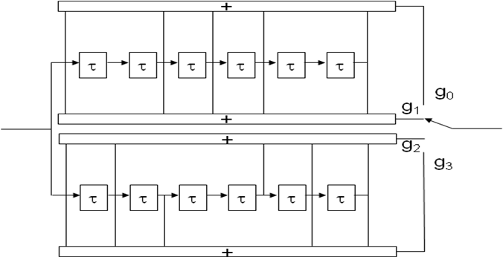
Figure 2 Rate 1/4 convolutional encoder

The convolutional encoder for the rate 1/3 code is used with the following parameters:
Rate 1/3 ; k=7 ; g₀ = 133₈ ; g₁ = 145₈ ; g2 = 175₈

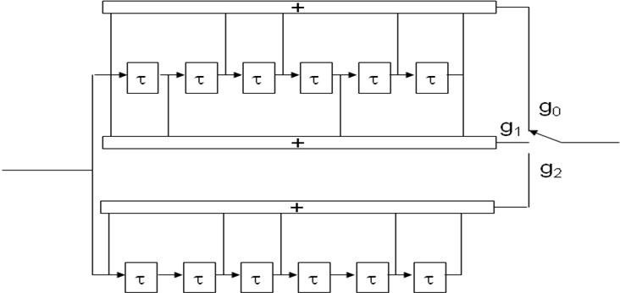
Figure 3 Rate 1/3 convolutional code

The convolutional encoder for the rate 1/2 code is used with the following parameters:
Rate 1/2 ; k=7 ; g₀ = 133₈ ; g₁ = 171₈

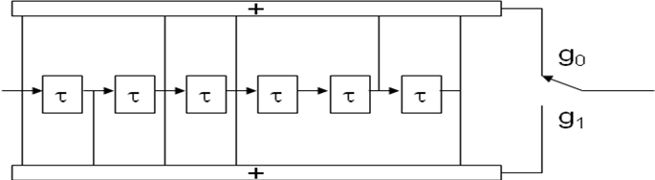
Figure 4 Rate 1/2 convolutional code

The rate 2/3 code is obtained by puncturing the rate ½ code as shown below
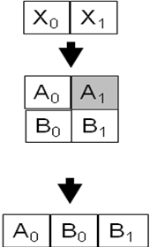
Figure 5 Puncturing to obtain rate 2/3 convolutional code from rate 1/2 code

A block interleaver is used as an interleaver between the convolutional code and RS code. The interleaver is of a fixed height n but has a flexible depth D, dependent on the packet size to optimize to eliminate padding overhead.
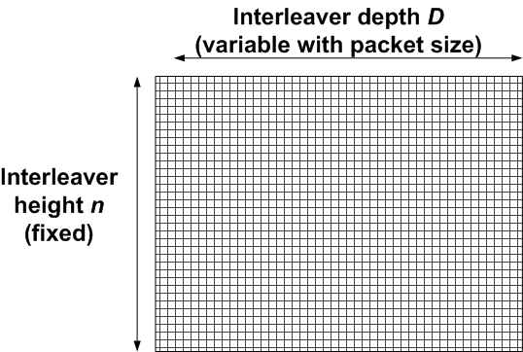
Figure 6 Interleaver for PHY I

The following parameters are used to describe the interleaver:
n : RS codeword length.
k : number of information data symbols in a RS codeword.
q : Number of elements in the Galois field : GF(q)
L_{packet}: Input packet size in bytes
S_{packet} : number of symbols at the input of the RS encoder
S : number of symbols from the output of the shortened RS encoder.
S_{block} : The size of the interleaver used
D : the interleaving depth.
i : ordered indices take the values 0, 1, …, S_{block}-1.
l(i) : interleaved indices.
p : number of zero symbols
t : ordered indices take the values 0, 1, …, p.
z(t): locations of the bits to be punctured at the output of the interleaver before transmission

$\begin{aligned}S_{\text{packet}}=\left\lceil \frac{L_{\text{packet}}∗8}{{\text{log}}_{2}(q)}\right\rceil \\ \text{S = n}∗\left\lceil \frac{S_{\text{packet}}}{k}\right\rceil −\left(\text{k - }\left(S_{\text{packet}}\text{mod}k\right)\right) \\ D=\left\lceil \frac{S}{n}\right\rceil \\ S_{\text{block}} =\text{ n*D} \\ \text{p }=\text{ n- }(\text{S }\text{mod}\text{ n}) \\ l(i)\text{ = }(\text{i }\text{mod}\text{ D})∗\text{n + }\left\lfloor \frac{i}{D}\right\rfloor \text{ ; for i}=\text{0,1, }\text{.}\text{.}\text{, }(S_{\text{block}}−1) \\ z(t)\text{ = }(n−p+1)\text{*D}+\text{t*D}−1;\text{ for t}=\text{0,1, }\text{.}\text{.}\text{, p-1}\end{aligned}$The interleaver and the locations to be punctured are described by the following equations:

The length of the packet is communicated to the receiver in the header so that the receiver can adaptively adjust the interleaver based on the packet sizes. When the data rates corresponding to the robust transmissions using the concatenated codes are used, the header shall also be interleaved according to the above procedure. Since the length of the header is fixed, the receiver can deinterleave the header without explicit transmission of the header length.

6.9.2.3.2 Channel coding for PHY II

A Reed-Solomon code is proposed operating on GF(256) for PHY II to correct errors and increase robustness of the system. The Reed-Solomon code may be shorted for the last block if it does not meet the block size requirements as specified for PHY I. No zero padding is required for the RS code.
The Reed Solomon code proposed is a systematic RS code. The Reed-Solomon code is defined over GF(256) with a primitive polynomial x⁸+x⁴+x³+x²+1. The generator for the (160, 128) RS code and the (64, 32) RS code is given by
g(x) = x³²+α¹¹x³¹+α⁸x³⁰+α¹⁰⁹x²⁹+α¹⁹⁴x²⁸+α²⁵⁴x²⁷+α¹⁷³x²⁶+α¹¹x²⁵+α⁷⁵x²⁴+α²¹⁸x²³+α¹⁴⁸x²³+α¹⁴⁹x²¹+α⁴⁴x²⁰+α⁰x¹⁹+α¹³⁷x¹⁸+α¹⁰⁴x¹⁷+α⁴³x¹⁶+α¹³⁷x¹⁵+α²⁰³x¹⁴+α⁹⁹x¹³+α¹⁷⁶x¹²+a⁵⁹x¹¹+α⁹¹x¹⁰+α¹⁹⁴x⁹+α⁸⁴x⁸+α⁵³x⁷+α²⁴⁸x⁶+α¹⁰⁷x⁵+α⁸⁰x⁴+α²⁸x³+α²¹⁵x²+α²⁵¹x+α¹⁸
where, α is a primitive element in GF(256) .

6.9.2.3.3 Channel coding for alternate CSK PHY

The rate ½ FEC for the alternate CSK PHY is obtained from the RS (64, 32) code as defined in PHY II.

