IEEE P802.15
Wireless Personal Area Networks

Project | IEEE P802.15 Working Group for Wireless Personal Area Networks (WPANs)
Title | TG7 ConCall Minutes – Jan 2010 to March 2010
Date Submitted
Source | [Richard D Roberts]  [Intel Corporation]  [address] | Voice: [ ]  Fax: [ ]  E-mail: [ ]
Re:
Abstract
Purpose
Notice | This document has been prepared to assist the IEEE P802.15. It is offered as a basis for discussion and is not binding on the contributing individual(s) or organization(s). The material in this document is subject to change in form and content after further study. The contributor(s) reserve(s) the right to add, amend or withdraw material contained herein.
Release | The contributor acknowledges and accepts that this contribution becomes the property of IEEE and may be made publicly available by P802.15.
ConCall 11 February 2010
Attendance …
Shinichiro Haruyama, Keio University
Soo-Young Chang, CSUS
Jaeseung Son, Samsung
Sang Kyu Lim, ETRI
Kim Dae Ho, ETRI
Ill Soon Jang, ETRI
Sridhar Rajagopal, Samsung
Richard Roberts, Intel
Joachim Walewski, Siemens

Agenda … TE report out on comment closure status
TE report for 11 Feb conference call

1. Reference document 10/47r5 to see comment closure details

2. The percentage of comments CLOSED or PENDING CLOSURE (text submitted) are:
- Technical Comments: 77% (i.e. 23% open)
- Editorial Comments: 73% (i.e. 27% open)

3. Many of the comments that are not closed are not “hard” or “missing text” … I just have not had the time to implement the remedy, but they will get done!

4. The two comments that took an extraordinary amount of time to implement were comments Tech Comments 40 and 145 (implementing the remedy of 145 resulted in some major reshuffling of clauses).

5. As is usual when going from daft D0 to D1, the document has been re-organized to improve the content flow, but it is becoming increasingly difficult to edit because comments against the structure of D0 have to be translated into the new structure for D1. But as I indicated, this is par-for-the-course and we should see less and less major re-organization as time goes by.

6. Also, I’ll be proposing that we hold another ConCall on the 17th of February (which is Wednesday – I’m not available on the 18th) to ascertain the status of draft D1 prior to starting LB1.

AR to TE – what is the length of the authorized letter ballot? 40 days? (TE to contact James Gilb to verify).

Special conference call to ascertain status prior to LB1
Wednesday, February 17, 2010, 11:00 PM GMT
916-356-2663, Bridge: 4, Passcode: 3246367

Next regularly scheduled Conference Call … 4 March 2010-02-11
- Tentative agenda: Joachim Walewski - discussion of color compensation scheme
ConCall 11 February 2010
Attendance …
Soo-Young Chang, CSUS
Taehan Bae, Samsung
Sang-Kyu Lim, ETRI
Dae Ho Kim, ETRI
Tae-Gyu Kang, ETRI
Sridhar Rajagopal, Samsung
Richard Roberts, Intel

Agenda … TE report out on comment closure status
TE report for 17 Feb conference call

1. The percentage status of comments

- Technical Comments:
    - Closed: 77%
    - Pending Closure: 1%
    - Resolved pending edits: 19%
    - Open: 3%
- Editorial Comments:
    - Closed: 47%
    - Pending Closure: 30%
    - Resolved pending edits: 23%
    - Open: 0%

Closed means the text has been edited into the document and we are done with that comment
Pending closure means the text has been submitted to the TE for inclusion (I just haven’t had time to do it yet)
Resolved pending edits means everything I need for editing was included in the resolution remedy and I just haven’t had time to make the edits as of yet.
Open means I don’t know what to do and need input from experts (these are identified as YELLOW in column L with no GREEN in the row).

2. Letter Ballot Status

We are on track for a letter ballot starting 1 March 2010. The website has been set up by Rick Alfvin and he is just waiting for me to post the draft document. It is anticipated that I’ll send him the draft on 28 Feb for posting and the LB will start on 1 March.

3. Comment on figures

The editing of the figures has become too difficult to follow the SA style guide rules at this time. To explain, the problem is that so many sections have moved in the document that figure numbers from D0 seldom match the corresponding figure in D1. Therefore, I’ve decided to continue embedding the figures in D1 and I’ll wait until the document “settles down” before I start linking figures to the external figure files (as per the style guide). This means that in some cases the color figures will still be in place in the document even though some of you may have submitted black and white “color correct” figures. Not to worry – I have the files that you submitted. These are editorial issues and I’ll get to them in a later draft. Editorial problems should not cause a letter ballot to fail, so technically we can make significant progress.

The committee worked real-time to close out the few remaining open items …
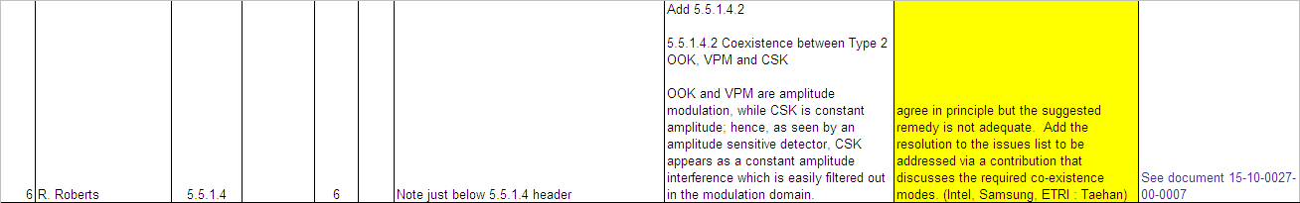
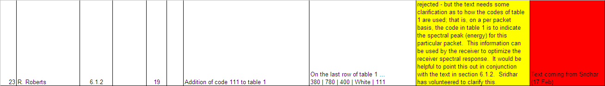
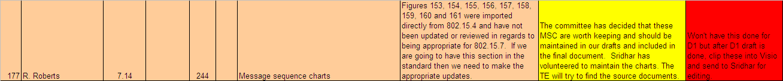

AR to TE – what is the length of the authorized letter ballot? 40 days? (TE to contact James Gilb to verify). It was verified to be 40 days via email from Bob Heile.

Next regularly scheduled Conference Call … 4 March 2010
- Tentative agenda: Joachim Walewski - discussion of color compensation scheme
- March 04, 2010, 11:00 PM GMT, 916-356-2663, Bridge: 4, Passcode: 8310924

