IEEE P802.15
Wireless Personal Area Networks

Project | IEEE P802.15 Working Group for Wireless Personal Area Networks (WPANs)
Title | ETRI + Samsung Physical layer proposal
Date Submitted | January, 2010
Source | Kiran Bynam(1), Noh-Gyoung Kang(1), Chihong Cho(1), Seung-Hoon Park(1), Sridhar Rajagopal(1), Eun Tae Won(1), Giriraj Goyal(1), Arun Naniyat(1), Mi-Kyung Oh(2), Hyung Soo Lee(2), Chul-Hyo Lee(2), Jae-Young Kim(2)  [(1) Samsung Electronics, (2) ETRI] | etwon@samsung.com
Re: | IEEE 802.15 TG6 Body Area Networks (BAN).
Abstract | ETRI + Samsung PHY proposal Presentation to TG6 group
Purpose | This document is intended to explain the overview and details of the ETRI + Samsung PHY proposal
Notice | This document has been prepared to assist the IEEE P802.15. It is offered as a basis for discussion and is not binding on the contributing individual(s) or organization(s). The material in this document is subject to change in form and content after further study. The contributor(s) reserve(s) the right to add, amend or withdraw material contained herein.
Release | The contributor acknowledges and accepts that this contribution becomes the property of IEEE and may be made publicly available by P802.15.

Draft for 802.15.6 PHY

(ETRI + Samsung Electronics)

Contents

1. Introduction 4
2. Technical Requirements for IEEE 802.15.6 4
3. Overview of the proposal 4
4. General block Diagram 5
5. BC-GPPM Modulation 5
6. Pulse Shapes 14
7. Data Rates 16
8. Co-existence 17
9. Frame Format 23
10. PER Results and Link Budget 24
11. Power Consumption 27
12. Self Evaluation 28
13. Summary 28
14. References 28

Introduction

The scope of this document is the proposal for physical Layer for on-body communications as response to the Call for Proposals issued by the IEEE 802.15.6. This document will address the modulation schemes, preambles required for the 802.15.6 physical layer. It also addresses how the proposal meets different technical requirements documented by TG6. Finally, it summarizes the proposal capabilities in meeting the technical requirements and the different metrics set forward by TG6 as the comparison criterion.

Technical Requirements for IEEE 802.15.6

The requirements that are set forward by the IEEE 802.15.6 are

- Scalability of data rates from 120 kbps to 10 Mbps
- Shall support a range of 3 m at lowest mandatory rate
- 10 piconet co-existence at the lowest mandatory data rate
- Low Power & complexity
- Regulatory Compliance

The comparison criterion relevant to PHY layer is

- Power consumption estimates
- Range for all the data rates
- Co-existence with other networks like ECMA 368

The performance of the proposal with respect to the requirements and comparison criteria is summarized at the end

Overview of the proposal
This proposal is designed to satisfy the technical requirements of the BAN and also to optimize the Power consumption. The features of this proposal are as follows

- Pulse position based modulation
- Non-coherent receiver
- Different Pulse shapes including Chaotic, Gaussian monocycle, Raised Cosine
- Scalable data rate: 500Kbps~10Mbps
- Low Power due to duty cycling
- Kasami preamble code

General block Diagram

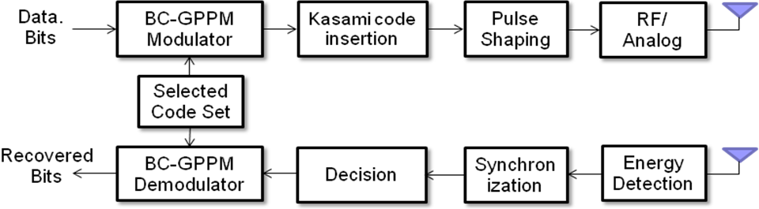
Figure. 4.1: Block Diagram

Block Coded Group Pulse Position Modulation (BC-GPPM)

Block Coded Group Pulse Position Modulation (BC-GPPM) is a pulse position based modulation scheme for UWB signal. In addition to modulation, error correction capability is inserted without lowering the data rate, which is performed by grouping information bits and assigning to pulse positions. If N grouping is considered, it is required to have 2^{N} cases for symbol mapping and the BC-GPPM signal for i-th case is mathematically given by
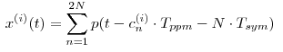
where p(t) is any UWB signal, Tsym = 2Tppm and c^{(i)} =[c₁^{(i)}, c₂^{(i)}, …c_{2N}^{(i)}] with c_{n}^{(i)} ⊆{0,1}. Notice that the number of ones in c^{(i)} equals to the number of UWB signals for transmitting N bits. Since the energy should be same for all x^{(i)}(t), where i=1,2,…2^{N}, we restrict the number of ones in c^{(i)} for N BC-GPPM to N. Then the number of all possible sequences is _{2N}C_{N}. Among the set of sequences, 2^{N} cases for transmitting N bits are selected. The extraction of 2^{N} cases out of _{2N}C_{N} can be considered as codebook design and conducted by maximizing the minimum Hamming distance.

For example, consider 2-bit grouping. In this case, all possible sequences are six which are {1100,1010,1001,0110,0101,0011} as shown in Fig. 2. Among these 6 sequences, selection of {0011,0101,0110,1001} for 2-bit transmission turns out to be 2 BC-GPPM since those sequences are selected by maximizing the minimum Hamming distances to have error correction capability. We note that selection of {1010,1001,0101,0110} is equivalent to two PPM signals. However, those are not optimized in the sense of error correction capability. This concept is illustrated in Figure 3. BC-GPPM and PPM are basically position based on-off signaling. The only difference is which table is used for signaling.

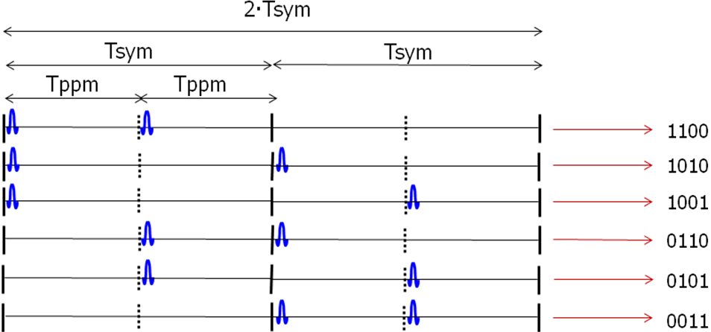
Figure 2. 6 sequences of 2-bit grouping

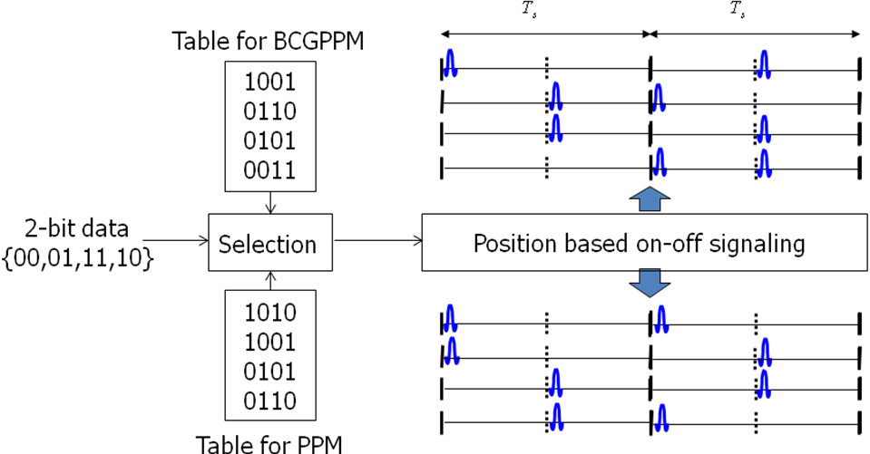
Figure 3. BC-GPPM v.s. PPM

In this proposal, we use 6 BC-GPPM, where 6 bits are grouped to be transmitted. The selected 2⁶ =64 sequences for 6 BC-GPPM have length 12 and are given below. Since the minimum Hamming distance for these sequences is 4, it achieves more than 1 bit error correction per 6 bits. This modulation is applied to all the data rates specified in the data rates section.

BC-GPPM Sequences for all data rates

0 0 0 0 0 0 1 1 1 1 1 1
0 0 0 0 1 1 0 1 1 0 1 1
0 0 0 1 1 1 0 0 0 1 1 1
0 0 0 0 1 1 1 0 1 1 0 1
0 0 0 1 1 1 1 1 1 0 0 0
0 0 0 0 1 1 1 1 0 1 1 0
0 1 1 0 0 1 1 1 0 1 0 0
0 0 1 0 0 1 0 1 0 1 1 1
0 1 1 0 0 1 0 0 1 0 1 1
0 0 0 1 0 1 1 0 1 0 1 1
0 0 0 1 0 1 0 1 1 1 0 1
1 1 0 1 0 0 0 1 1 0 0 1
0 0 1 1 0 0 0 1 1 0 1 1
1 0 1 0 1 0 0 1 0 0 1 1
0 0 0 1 1 0 1 1 0 0 1 1
0 0 0 1 1 0 0 1 1 1 1 0
0 1 1 1 1 0 0 0 1 1 0 0
0 0 1 0 1 0 0 0 1 1 1 1
0 0 1 0 0 1 1 0 1 1 1 0
0 0 1 0 0 1 1 1 1 0 0 1
0 0 1 0 1 0 1 1 0 1 0 1
1 0 1 1 0 0 1 0 0 1 0 1
0 0 1 1 0 0 1 1 0 1 1 0
0 0 1 0 1 0 1 1 1 0 1 0
0 0 1 0 1 1 0 1 1 1 0 0
0 0 1 1 1 1 0 0 1 0 1 0
0 0 1 0 1 1 1 0 0 0 1 1
0 0 1 1 1 0 1 0 1 0 0 1
0 0 1 1 1 1 0 1 0 0 0 1
0 0 1 1 1 1 1 0 0 1 0 0
0 1 0 1 0 1 1 0 1 1 0 0
0 1 0 0 0 1 0 1 1 1 1 0

0 1 0 0 0 1 1 0 0 1 1 1
1 1 0 0 1 0 1 0 0 1 1 0
0 1 0 0 1 0 0 1 0 1 1 1
0 1 0 0 1 0 1 0 1 0 1 1
0 1 0 0 1 0 1 1 1 1 0 0
0 1 0 0 1 1 1 1 0 0 0 1
0 1 0 1 0 0 1 1 0 1 0 1
0 1 0 1 0 0 0 0 1 1 1 1
0 1 0 1 0 0 1 1 1 0 1 0
0 1 0 1 0 1 0 1 0 0 1 1
0 1 0 1 1 1 0 0 1 0 0 1
0 1 0 1 1 1 0 1 0 1 0 0
0 1 0 1 1 1 1 0 0 0 1 0
0 1 1 0 1 1 0 1 0 0 1 0
0 1 1 0 0 0 1 1 0 0 1 1
0 1 1 0 0 0 0 1 1 1 0 1
0 1 1 0 1 1 0 0 0 1 0 1
0 1 1 0 1 1 1 0 1 0 0 0
0 1 1 1 0 1 0 1 1 0 0 0
0 1 1 1 0 1 0 0 0 1 1 0
0 1 1 1 0 1 1 0 0 0 0 1
0 1 1 1 1 0 0 0 0 0 1 1
0 1 1 1 1 0 1 1 0 0 0 0
1 0 0 0 0 1 1 1 0 0 1 1
1 0 0 0 0 1 0 0 1 1 1 1
1 0 0 0 0 1 1 1 1 1 0 0
1 0 0 0 1 0 0 1 1 1 0 1
1 0 0 1 0 0 0 1 0 1 1 1
1 0 0 1 0 0 1 0 1 1 1 0
1 0 0 0 1 1 1 0 1 0 1 0
1 0 0 1 0 1 0 1 1 0 1 0
1 0 0 1 1 0 0 0 1 0 1 1
Symbol structure: Since 6 bits are grouped, the symbol period for 6 BC-GPPM is 6·Tsym or 12·Tppm as shown in Figure 3. Each Tppm period has the burst for Tburst period. The 8 UWB impulse signals of 16 nsec width or the chaotic pulse of 16nsec width is placed in the Tburst position. Only a portion of Tburst can be used for signaling to enable the energy efficiency by virtue of duty cycling.

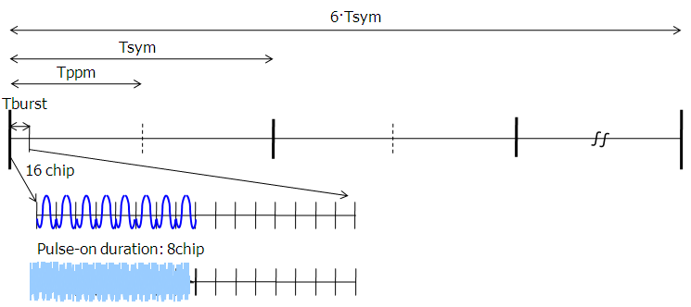
Figure 3. Symbol structure for 6 BC-GPPM

At the receiver, energy detection is carried out for each Tburst to yield 2N energy detection outputs. Then, N outputs with the maximum energy are detected as ‘1’s and others as zero. With these decision values, Hamming distances between all the possible sequences are calculated to determine which sequence has the maximum.

Pulse Shapes

Pulse shape can be anything that satisfies the UWB regulations and spans the bandwidth of 500 MHz. Some of the pulse shapes that we find suitable are Gaussian Monocycle, Chaos signal and the raised cosine pulses. This section talks about the chaos pulses and their suitability and advantages to the Body area networks. Chaos pulses are near constant envelope signals that are produced by mixing 4 different triangular/saw-tooth waveforms. The sum of these triangular or saw-tooth waveforms will be fed as input to the voltage controlled oscillator. This is similar to frequency modulating a carrier signal with the summation of the triangular signals. The center frequency of the oscillator is directly proportional to the DC offset of the VCO.

Figure 6.1. Chaos Generator using triangular waveform

The width of the triangular pulses and the peak to peak amplitudes are chosen to achieve the 500 MHz bandwidth. The period of the 4 triangular pulses are chose as 3, 19, 53 and 59 nsec respectively. Amplitudes are chosen in the ratio of 0.5, 0.2, 0.8,1 respectively .This summation will result in a spectrum shape with 10 dB bandwidth of 500 MHz. The spectrum of the chaos signal thus generated is given below.

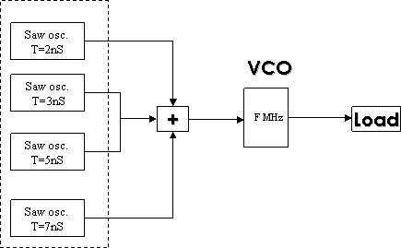

Figure 6.2: Chaos generator using saw tooth pulses.

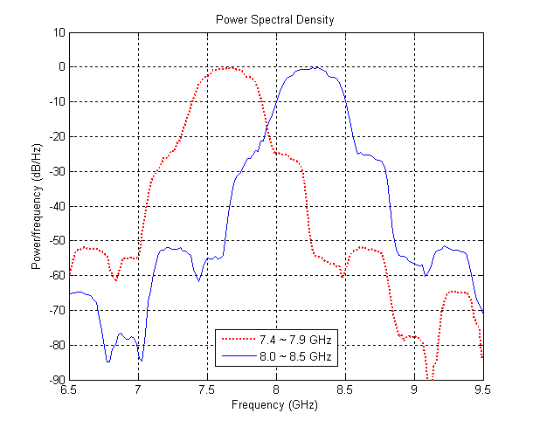
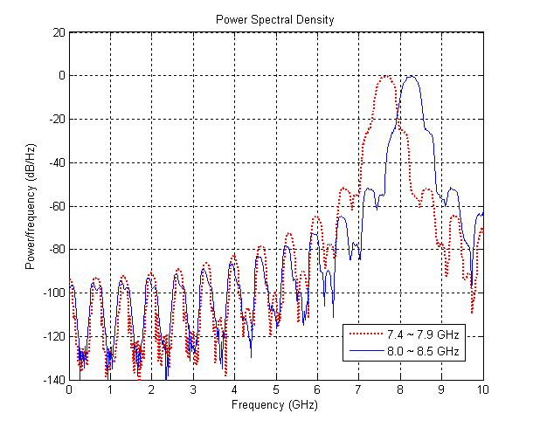
10dB BW = 500MHz
Figure 6.3.: Spectrum of the Chaos Pulses

Data Rates

Data rates proposed in this proposal are listed below.

Mod-Type | Chip rate  (Fc) | # of chips per symbol  (Ncps) | # of chips for pulse-on duration  (Ncpo) | Symbol Rate  (MHz) | Bit Rate  (Mbps) | Modulation  Used
00 | 499.2MHz | 1024 | 16 | 0.49 | 0.49 | 6 BC GPPM
01 | 499.2MHz | 512 | 16 | 0.98 | 0.98 | 6 BC GPPM
10 | 499.2MHz | 128 | 16 | 3.9 | 3.9 | 6 BC GPPM
11 | 499.2MHz | 48 | 16 | 10.4 | 10.4 | 6 BC GPPM

Co-existence

The co-existence of the 10 BAN networks is one of the requirements for IEEE 802.15.6. The regulations on UWB spectrum are different in different regions of the world. Some countries like China, Europe etc will mandate the use of Detect and Avoid mechanisms to save the primary services from getting affected. But, such detect and avoid mechanisms are complex and could be very power consuming and, hence not suitable for the BAN. The spectrum that is allowed in different parts of the region without any such stringent regulations is 7.25 to 8.5 GHz.

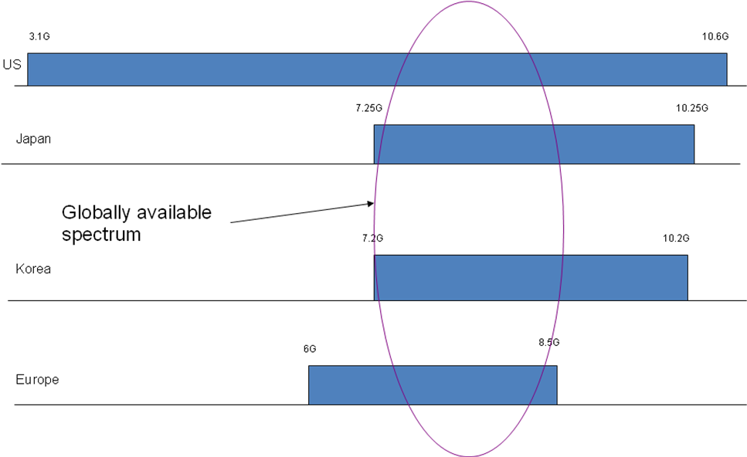
Figure 8.1 : DAA-free world-wide UWB spectrum allocation in different bands

Since, UWB also has a requirement of 500 MHz minimum bandwidth, effectively, 2 bands are possible in this region. We propose to use the duty cycling of the modulation scheme to assist in the co-existence of the multiple piconets. The lowest duty cycling factor used in the proposed UWB scheme is 1/32. With this duty cycling and the preambles proposed here will together assist the co-existence of the 5 piconets in a single frequency band of 500 MHz. Since, the piconets are asynchronously overlapped in time in the same frequency band as shown in figure below, there is a need for synchronization in the presence of interference.
Figure 8.2: Piconet interference between piconets P1 and P2

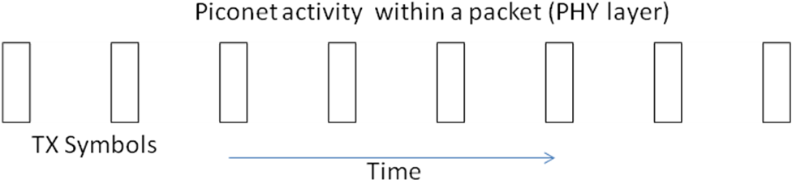
Figure8.3 activity within a packet in PHY mode with low duty cycle

Figure 8.4: Piconet co-existence

It is also possible for the MAC to provide better support when piconets can communicate with each other. For example, in such cases, piconets could share time resources based on requests and also could synchronize to an offset in the low duty cycle case. An example is as shown below. We consider such cases in more detail in the Samsung MAC proposal.

Figure 8.5: Offset piconet synchronization for co-existence with overlapping packets

Sequences:
The preamble sequences for these piconets operating together should have good cross correlation properties with each other. Another requirement for these preambles is to have good autocorrelation gain at zero lag to detect the data frame synchronization accurately. Eight preamble sequences of length 63 are designed to suit these requirements are shown below. The constraints used in the sequence design are as follows:

- Need to have at least 5 piconet codes
- Codes need to binary to support non-coherent reception for power savings in BAN
- Codes should not assume synchronization (for example, codes such as Walsh codes cannot be used)
- Code length should be as short as possible, not exceeding 64 bits or so for power savings
- Must have excellent auto and cross correlation properties within the signal set

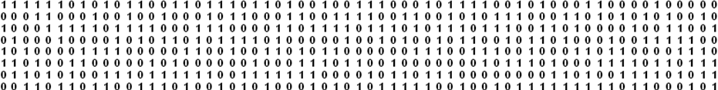
Figure 8.6: 8 preamble sequences for piconet selection

With the help of these 8 sequences, co-existence of 16 piconets is possible within the 1 GHz frequency band. The auto correlation and cross correlation properties of these sequences are shown below.

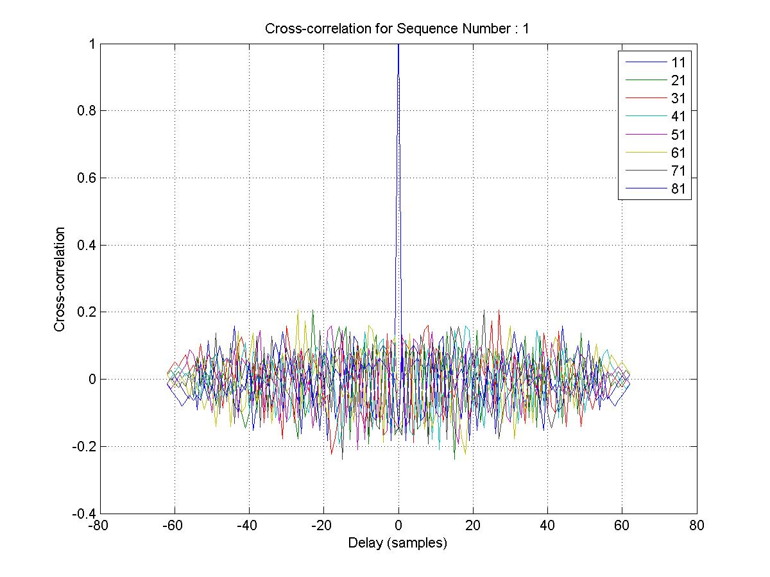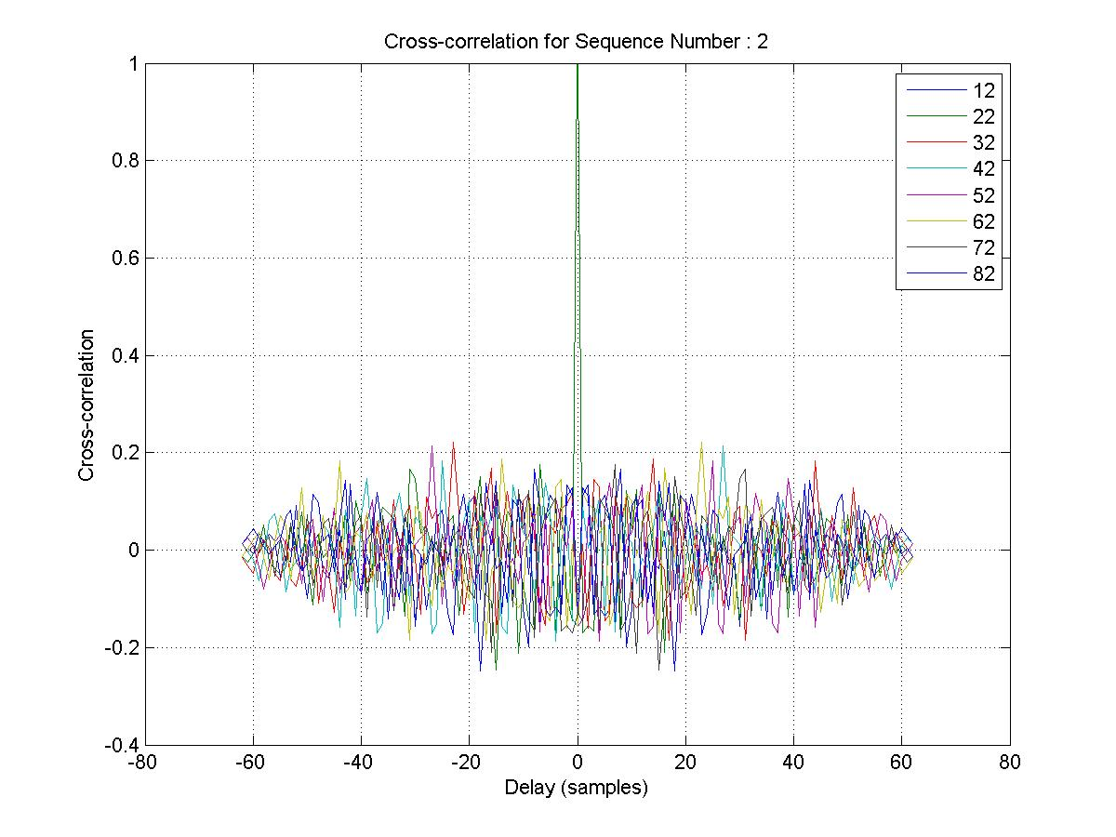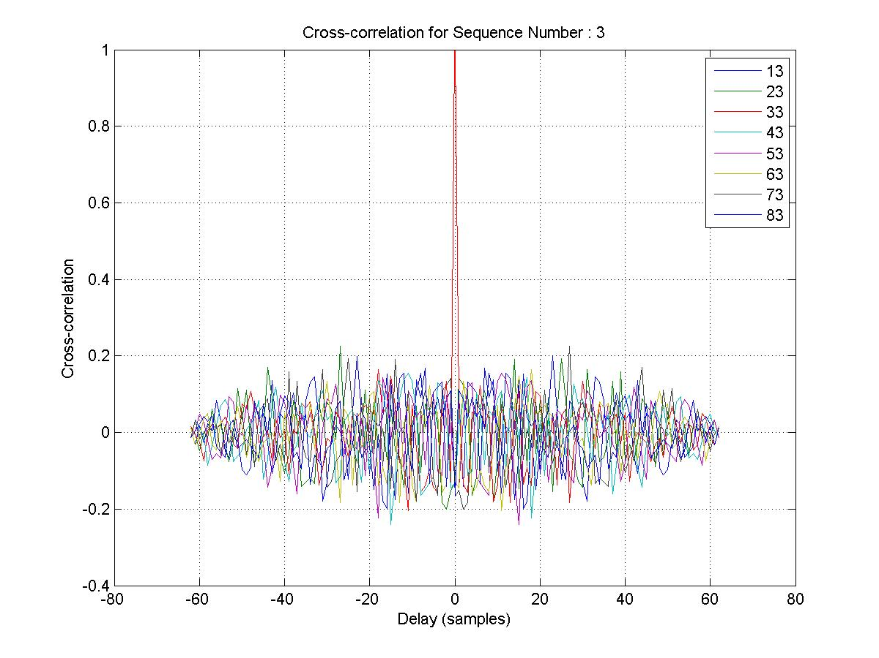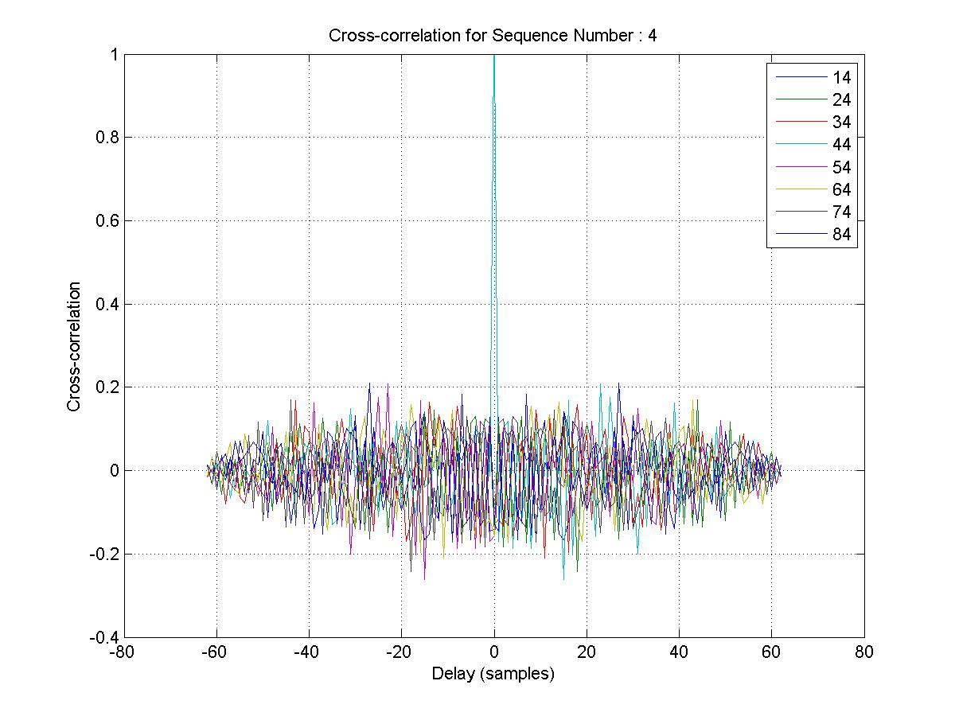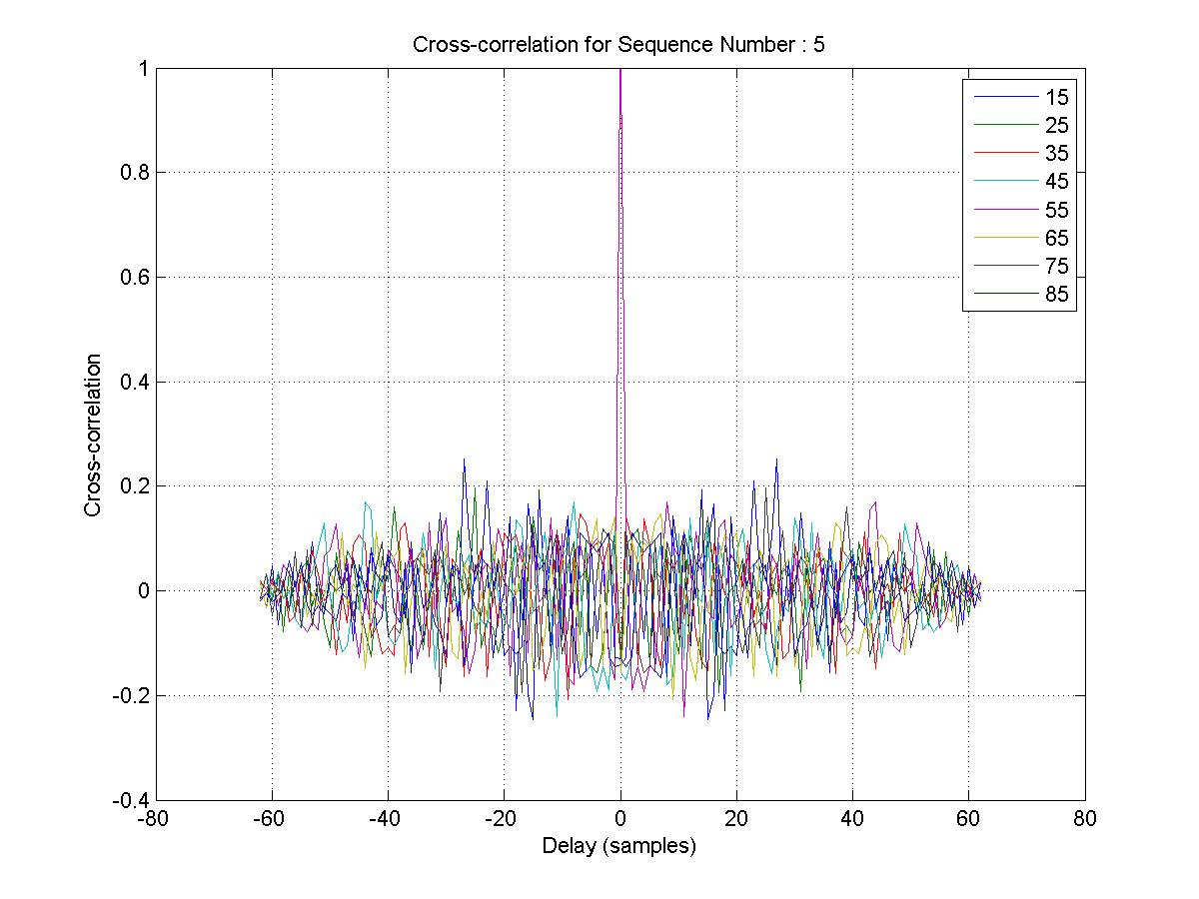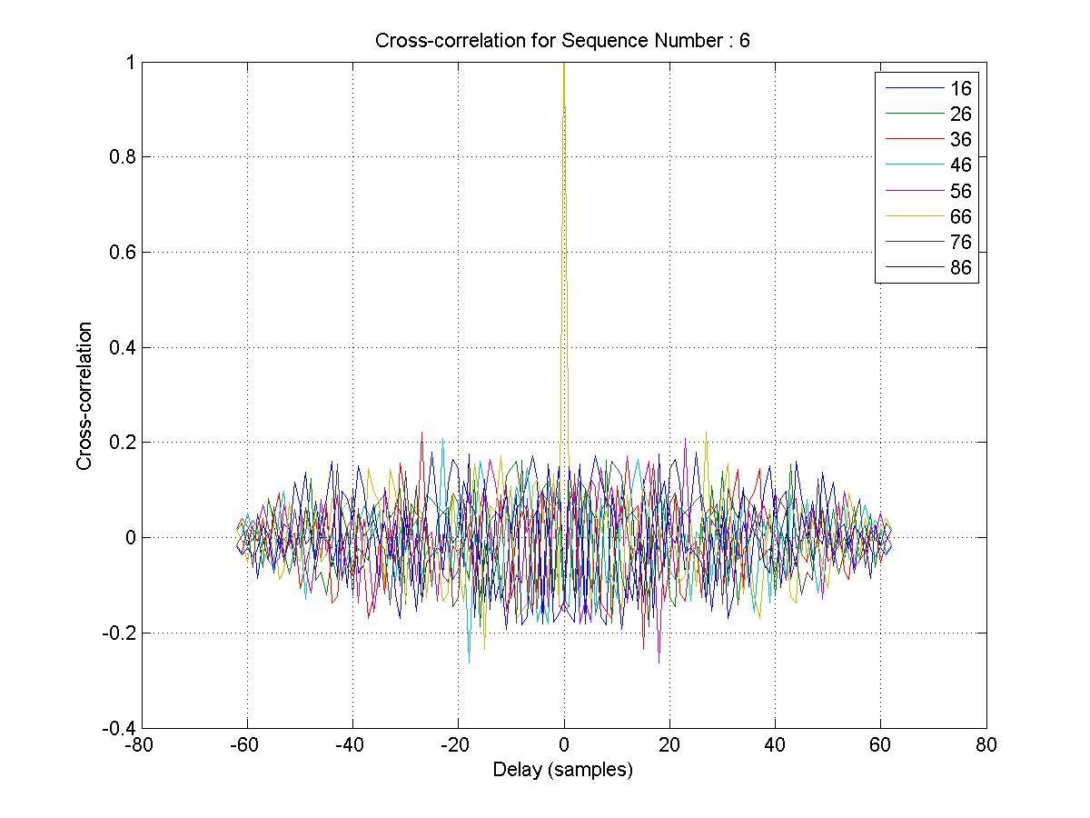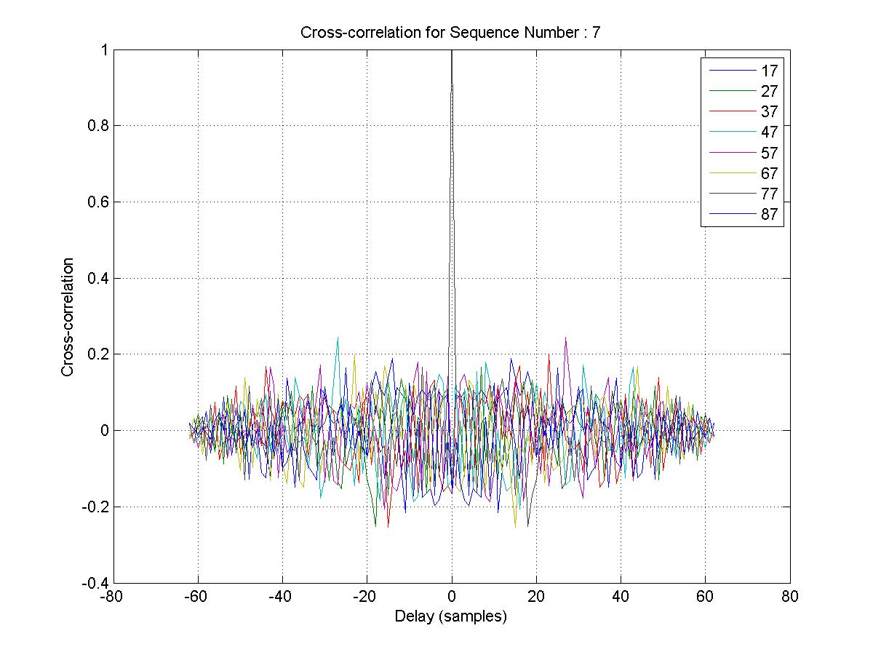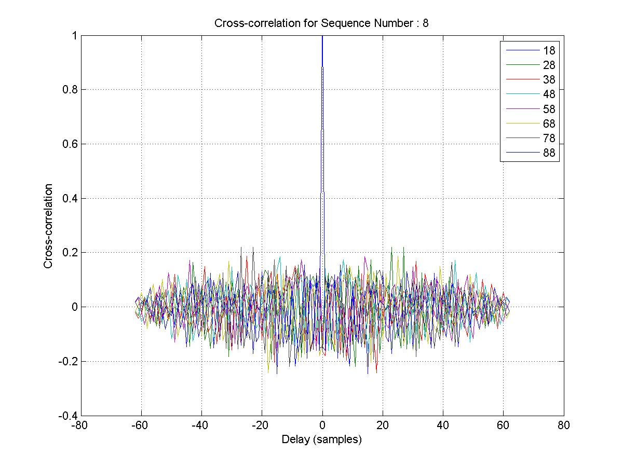
Figure 8.7 : Auto- and cross- correlation properties

Also, the CRC of the header can be masked with the preamble ID to ensure that packet received belongs to the piconet. Even the mention of preamble ID explicitly in header will help in avoiding the complete decoding of wrong packets (packets belonging to other piconets).

Rationale for chip rate, Duty cycling:

The chip rate and duty cycle for this preamble depends on the lowest chip rate of the system. The current system works with the lowest chip rate of 10 kcps with the duty cycle of 1/32. For higher data rates, the width of the chip is very small. Hence, it is required to detect the frame synchronization with a resolution of less than ½ times the chip width. Hence the width of the chip in the preamble should be less than or equal to the width of the chip for highest data rate. The duty cycling of the preamble should be 1/32, equal to that of the lowest data rate. The preamble performance will not be a limiting factor for the performance of the lowest data rate.

Results:
Uses of the preamble are two fold. First, detect the data frame synchronization with the desired preamble. Second use is to allow the co-existence of more than 10 piconets in the available limited band of 7.25 to 8.5 GHz. The auto-correlation and cross-correlation of these preambles for these two scenarios are plotted in Figure 8.7. The mis-detection probability of the preambles made of 63-bit kasami sequences are given below. Figure 8.8 depicts the mis-detection probability of the preambles in the presence of AWGN and channel model 4. Figure 8.9 depicts the mis-detection probability of the preambles in channel model 4 in different interference limited scenarios.

Figure8.8. Mis-detection of the preamble for different SINR conditions in CM4 channel model

Figure 8.9. Mis-detection of the preamble for different SNR conditions at 0 dB SIR

Frame Format

The Frame format of the 802.15.6 consists of a 63 bit preamble, few bytes of PHY Header, Data, followed by a 16-bit CRC.
Preamble (63 bits)
PHY
Header
----------Data ---------
16-bit
CRC

63 bit preamble will run at the duty cycle of the 1/32 with the chip period equal to that of the lowest data rate. The pulse shape can be Gaussian monocycle, raised cosine or chaotic, spanning 500 MHz bandwidth. PHY header comprises of information like the 4 bit Preamble Identifier to check the correct acquisition, 4-bits of information for Modulation and coding used for the data packet, 16 bit Length of the Payload, and 8 bit CRC (Header Check Sequence) to check the validity of the PHY header. The receiver will go on decoding the packet only after the PHY header validity is checked.

PER Results and Link Budget

Figure 10.1: PER results for mod-type 3 modulation scheme in AWGN channel
Figure 10.2: PER results for type 0,1,2 modulation scheme in AWGN channel

Figure 10.3: PER results for modulation type 0,1,2 modulation schemes for CM3.

Figure 10.4: PER results for modulation type 0,1,2 modulation schemes for CM4.

Link Budget for different modulation schemes in AWGN channel(type 0,1 and 2):

Link Budget (AWGN)
Parameters | Unit |  |  |  | We have limited the Tx  Power to reduce the power  Consumption. Actual Link margin for  10 kbps and 100 kbps can be higher  by 18 and 9 dB respectively
Symbol Rate [Rb] | MHz | 0.015 | 0.12 | 0.976 | 7.8
Distance [d] | M | 5 | 5 | 5 | 5
Bandwidth [BW] | MHz | 500 | 500 | 500 | 500
Emission [E=dBm/MHz] | dBm/MHz | -59.4 | -50.4 | -41.3 | -41.3
Average TX Power [Pt_avg=E+10log(BW)] | dBm | -32.4 | -23.4 | -14.3 | -14.3
Pulse-on duration [Tp] | Usec | 0.016 | 0.016 | 0.016 | 0.016
Peak TX Power [Pt_peak = Pt_avg+10*log10(1/Rb*Tp)] | dBm | 3.8 | 3.8 | 3.8 | -5.3
TX antenna gain [Gt] | dBi | 0.0 | 0.0 | 0.0 | 0.0
Center frequency [fc] | GHz | 7.5 | 7.5 | 7.5 | 7.5
Path loss d meter  [L=20log(4pi*fc/c)+20log(d)] for AWGN and CM4 | dB | 63.9 | 63.9 | 63.9 | 63.9
RX antenna gain [Gr] | dBi | 0.0 | 0.0 | 0.0 | 0.0
RX power [Pr=Pt_avg+Gt+Gr-L] | dBm | -96.4 | -87.3 | -78.2 | -78.2
Receiver AWGN noise floor [N=-174+10log(BW)] | dBm | -132.2 | -123.2 | -114.1 | -105.1
RF noise figure [Nf] | dB | 10.0 | 10.0 | 10.0 | 10.0
Average noise power [Pn=N+Nf] | dBm | -126.2 | -117.2 | -108.1 | -99.1
Minimum SNR per symbol [S] | dB | 11.5 | 11.5 | 11.5 | 13.0
Implementation loss [I] | dB | 3.0 | 3.0 | 3.0 | 3.0
Link Margin [LM=Pr-Pn-S-I] | dB | 15.4 | 15.4 | 15.4 | 4.8
Proposed Min. Rx Sensitivity Level [Pmin] | dBm | -97.7 | -98.7 | -89.6 | -79.1

Link Budget (CM3 Pathloss)
Parameters | Unit
Symbol Rate [Rb] | MHz | 0.015 | 0.12 | 0.976 | 7.8
Distance [d] | M | 3 | 3 | 3 | 3
Bandwidth [BW] | MHz | 500 | 500 | 500 | 500
Emission [E=dBm/MHz] | dBm/MHz | -59.4 | -50.4 | -41.3 | -41.3
Average TX Power [Pt_avg=E+10log(BW)] | dBm | -32.4 | -23.4 | -14.3 | -14.3
Pulse-on duration [Tp] | Usec | 0.016 | 0.016 | 0.016 | 0.016
Peak TX Power [Pt_peak = Pt_avg+10*log10(1/Rb*Tp)] | dBm | 3.8 | 3.8 | 3.8 | -5.3
TX antenna gain [Gt] | dBi | 0.0 | 0.0 | 0.0 | 0.0
Path loss d meter  [L=19.2*log10(d*1000)+3.38] for CM3 | dB | 70.1 | 70.1 | 70.1 | 64.1(@1.5m)
RX antenna gain [Gr] | dBi | 0.0 | 0.0 | 0.0 | 0.0
RX power [Pr=Pt_avg+Gt+Gr-L] | dBm | -102.6 | -93.6 | -84.5 | -78.5
Receiver AWGN noise floor [N=-174+10log(BW)] | dBm | -132.2 | -123.2 | -114.1 | -105.1
RF noise figure [Nf] | dB | 10.0 | 10.0 | 10.0 | 10.0
Average noise power [Pn=N+Nf] | dBm | -126.2 | -117.2 | -108.1 | -99.1
Minimum SNR per symbol [S] | dB | 11.5 | 11.5 | 11.5 | 13.0
Implementation loss [I] | dB | 3.0 | 3.0 | 3.0 | 3.0
Link Margin [LM=Pr-Pn-S-I] | dB | 9.2 | 9.2 | 9.2 | 4.6
Proposed Min. Rx Sensitivity Level [Pmin] | dBm | -97.7 | -98.7 | -89.6 | -79.1

Power Consumption
Parameter |  | Value | Note
Bit rate |  | 1 Mbps
Bandwidth |  | 500 MHz
Rx Sensitivity |  | -93.6 dBm | @ PER 10%
Tx | Chaotic generator | 9 mW | -43dBm/MHz (w/o duty cycling)
Tx | Power amp | 18 mW | (w/o duty cycling)
Tx | Modulator | 1.8 mW
Rx | Low Noise Amp | 7 mW
Rx | Energy detector | 4 mW | 50mV sensitivity
Rx | Variable Gain amplifier | 8 mW

Self Evaluation

Parameter | Addressed | Comments
Range | Yes | 300 m
Power consumption | Yes | Below 25 mW for 1 Mbps
Co-existence of 10 piconets | Yes | 16 piconets can co-exist
Scalability | Yes | 10 kbps to 8 Mbps
PER of 10 % | Yes
Link Budget | Yes
Regulatory | Yes | 7.25 to 8.5 GHz

Summary

The proposal contains the details of the G-PPM modulation scheme and the co-existence in the UWB spectrum. We have shown how this proposal will meet different criteria required for the body area networks by IEEE 802.15.6 Task group.

This proposal excels in achieving the range of 3m required for the operation of body area networks and has considerable scalability of data rates from few tens of kbps to 10 Mbps. It also demonstrates how we can achieve the co-existence of 10 different networks.

References

- TG6 Technical Requirements Document, https://mentor.ieee.org/802.15/dcn/08/15-08-0644-09-0006-tg6-technical-requirements-document.doc, IEEE, 2008
- 802.15-08-0780-05-0006-Channel model document of TG6
- TG6 Channel model document, https://mentor.ieee.org/802.15/file/08/15-08-0780-09-0006-tg6-channel-model.pdf, IEEE, 2008
- Amal Ekbal, Jun Shi, Zhanfeng Jia, Jason Ellis, Channel model considerations for IEEE 802.15.6, https://mentor.ieee.org/802.15/dcn/08/15-08-0792-00-0006-channel-model-updates-for-802-15-6.ppt, IEEE 2008
- “15-09-0141-01-0006-preliminary-wban-proposal-using-ir-uwb-etri.pdf” Cheolhyo Lee1 et al.
- “15-09-0171-04-0006-samsung-preliminary-phy-proposal.ppt”, Kiran Bynam et al
- Sang-Min Han, Mi-Hyun Son, Yong-Hwan Kim, and Seong-Soo Lee, “Low-Rate Chaotic UWB Transceiver System Based on IEEE 802.15.4a”, 36th European Microwave Conference, pp.1837-1840, Sep. 2006
- K. Lee, S. Kyeong, J. Kim, Y. Kim and H. Park, “The Chaotic On-off Keying with Guard Interval for Ultra-Wideband Communication”, IEEE VTS Asia Pacific Wireless Communications Symposium, Daejeon, Korea, August 2006
- Sang-Min Han, O. Popov and A.S. Dmitriev, “Flexible Chaotic UWB Communication System With Adjustable Channel Bandwidth in CMOS Technology”, IEEE Transactions on Microwave Theory and Techniques, Vol. 56, Issue 10, pp.2229-2236, Oct. 2008

