IEEE P802.15
Wireless Personal Area Network

Project | IEEE P802.15 Working Group for Wireless Personal Area Networks (WPANs)
Title | Documentation of the NICT UWB-PHY Proposal
Date submitted | October 2009
Source | Marco Hernandez¹, Igor Dotlic¹, Tetsushi Ikegami², Ruyji Kohno^{1,3}, Haruka Suzuki³.  Medical ICT Group, NICT, Marco@nict.go.jp, Dotlic@nict.go.jp, Tel +81-46-847-5439, 3-4 Hikarino-oka, Yokosuka 239-0847 Japan.  Meiji University, Ikegami@isc.meiji.ac.jp, Tel+81-44-934-2312, Institute of Computer Sciences, 1-1 Higashi Mita, Kawasaki 214-8571 Japan.  Yokohama National University, Kohno@ynu.ac.jp, Tel +81-45-339-4116, Graduate School of Electrical Engineering, 79-5 Tokiwadai, Yokohama 240-8501 Japan.
Resp: | Response to the Call for Proposals: IEEE 15-08-0811-03-0006-tg6-call-proposals
Abstract | Documentation of the NICT UWB-PHY Proposal.
Purpose | To provide documentation of the NICT UWB-PHY Proposal for further discussion towards merging of the TG6 wideband PHY.
Notice | This document has been prepared to assist the IEEE P802.15. It is offered as a basis for discussion and is not binding on the contributing individual(s) or organization(s). The material in this document is subject to change in form and content after further study. The contributor(s) reserve(s) the right to add, amend or withdraw material contained herein.
Release | The contributor acknowledges and accepts that this contribution becomes the property of IEEE and may be made publicly available by P802.15.

Contents

General Description 4

Modes of operation 5
Rules for use of modes and options 5

UWB Frame Format 6

UWB PHY Symbol Structure 6
Non-coherent mode 7
Differentially coherent mode 8
Operating frequency bands 9
Transmission bandwidth 9
Data Rates 9
PSDU timing parameters 10
PRF Parameter 10
Basis pulse waveform position parameter 10
Hop Parameter 11
Basis pulse waveform duration parameter 11
Symbol duration parameter 11
Symbol rate parameter 11
FEC rate parameter 11
Modulation mode 1 parameter 11
Bit rate parameter 11
Number of short pulses parameter 11
Peak PRF parameter 11
SHR Preamble 12
Start frame delimiter 13
FEC 14
Reed-Solomon codes 14
Hybrid Type II ARQ Mechanism. 15
Pulse Shape Waveform 17
Short Pulse Waveforms 17
Chirp Pulse Waveform 17
References 19

General Description

The IR-UWB-BAN specification is designed to provide robust performance for BAN. Indeed, UWB transceivers allow low implementation complexity (critical for low power consumption), low duty cycling operation (letting significant reduction on the average power consumption), the signal power levels are in the order of those used in the MICS band (safety power levels for the human body, besides of low interference to other devices).
The use of this spectrum combined with novel low complexity transceiver architectures, allow the implementation of low cost and low power devices for BANs. Moreover, such devices provide robust operation in multipath fading and interference.
The band of operation is 7.25 GHz to 8.5 GHz, which is available globally without regulatory restrictions like DAA systems. However, the use of channel 3 of the IEEE 802.15.4a band plan is contemplated as mandatory as well.
The UWB PHY allows operation from a list of variables as:
Center frequencies
PRF
Data rates
Preamble code length
FEC (systematic RS codes)
HARQ
Pulse shape waveforms
The broad range of options let support an equally range of applications. More specifically, applications with high QoS and lower QoS are contemplated. QoS parameters are defined as:
Applications that require a minimal average throughput of "" and minimal average end-to-end delay of "" shall implement differentially coherent modulation.
Applications that are not bounded by the minimal average throughput of "" and minimal average end-to-end delay of "" shall implement non-coherent modulation.

These QoS parameters can discriminate applications that require a critical guarantee throughput and end-to-end delay.

Modes of operation

In order to ensure interoperability, a mandatory mode is required. Therefore, a compliant UWB PHY shall support the following:
One mandatory center frequency in the low band and high band of UWB(see ).
One mandatory bandwidth (see ).
One mandatory data rate (see ).
One mandatory preamble length (see ).
One mandatory basis waveform duration(see ).
One mandatory FEC (see ).
One mandatory HARQ (see ).

Rules for use of modes and options

The UWB specification allows operation in the UWB band. Such UWB band is divided in sub-bands or channels according to IEEE 802.15.4a band plan. The implementer is free to select any sub-band for implementation. However, channel 3 and channel 9 are mandatory and the rest are optional.
There are two types of waveforms supported. Namely, a concatenation or burst of short pulses and long pulse shape waveforms are proposed. There is not mandatory pulse shape as the architecture of non-coherent and differentially coherent detectors are pulse shape blind. Therefore, all beacon preambles employ the waveform more suitable for implementers. However, during association, a flag indicates the type of waveform employed by the transmitter and data rate. Moreover, all beacon preambles are transmitted at the mandatory data rate during association.
For synchronization, the preamble consists of perfect balance ternary sequences as those can be reused for non-coherent and differentially coherent detectors. Therefore, a preamble’s length is mandatory only.
FEC is mandatory at the transmitter, but optional during association (transmission of beacons). Also, it is optional to decode at the receiver as systematic encoding is employed. That is, a receiver simply would ignore parity bits.

A combination of pulse position modulation and differentially encoded binary/quaternary phase shift keying is proposed in order to support non-coherent and differently coherent receivers. However, such combination is not coupled as in the hybrid modulation proposed in IEEE 802.15.4a standard. Each modulation symbol is composed of UWB pulses. Different data rates are obtained by changing pulse duration, PRF and modulation scheme.

UWB Frame Format
The UWB frame format or physical layer protocol data unit (PPDU) is formed by appending the preamble synchronization header (SHR), physical layer header (PHR) and physical layer service data unit (PSDU), respectively.
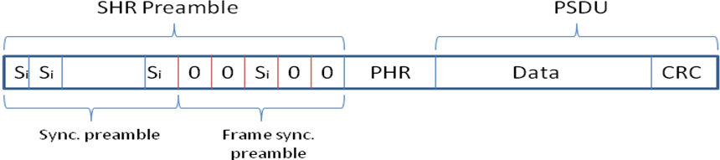

The SHR preamble is formed of repetitions of PBTS for timing synchronization (sync preamble) and frame synchronization preamble for frame synchronization. The physical layer header (PHR) contains information about the data rate of the PSDU, duration of the SHR preamble and length of the payload. The PHR is protected with parity check bits appended at the end against channel errors. The modulation during SHR preamble and PHR is the same utilized for data modulation at mandatory data rate.

UWB PHY Symbol Structure

The UWB symbol structure supports PPM and DBPSK or DQPSK. The modulation has two modes of operation: differentially coherent mode (Mode 1) and non-coherent mode (Mode 2).
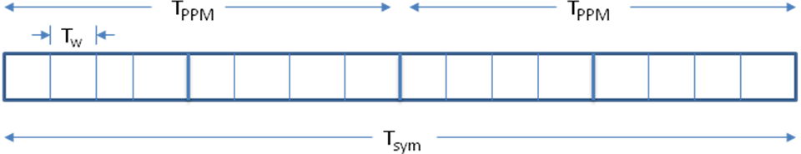
Figure 1. UWB symbol structure.
The transmitted signal is given by
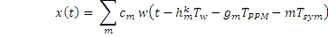
where
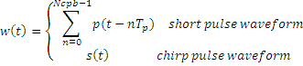
Each symbol time, , consists of an integer number of basis waveform positions, , each of duration . Each symbol duration is divided into two intervals of duration in order to enable pulse position modulation, . represents a differentially encoded BPSK or QPSK symbol. Finally, is a time hopping sequence for the th BAN.

The pulse shape basis waveform has duration , where in case of chirp pulse waveform. is pulse shape waveform duration for either short pulses (typically 2 nsec) and chirp pulse waveform.

Non-coherent mode

It carries one bit of information in the form of pulse position modulation. The pulse shape waveform can be either a burst of short pulses or a chirp pulse. In this case, the information bits coincide with the PPM symbol values. There is not DBPSK or DQPSK modulation: .

Differentially coherent mode

It carries either one bit of information (differentially encoded BPSK) or two bits of information (differentially encoded QPSK). The pulse shape is a chirp pulse. In this case is a differentially encoded BPSK or QPSK symbol. There is not pulse position modulation:
The differentially encoded transmitting symbols are given by
where M=2 for DBPSK and M=4 for DQPSK.
The mapping between information bits onto is given in tables 1 and 2.

Table 1. Mapping of information bits onto for DQPSK.
1 | 1 | 4
0 | 1 | 2
0 | 0 | 0 | 0
1 | 0 | -2

Table 2. Mapping of information bits onto for DBPSK.
0 | 0 | 0
1 | 2

Operating frequency bands

The operating frequency bands are taken from table 39i of the IEEE 802.15.4a standard.
The mandatory center frequencies are 7987.2 MHz (channel 9) and 4492.8 MHz (channel 3).

Transmission bandwidth

The mandatory bandwidth satisfies the IEEE 802.15.4a spectral mask of 620 MHz at -10 dB.
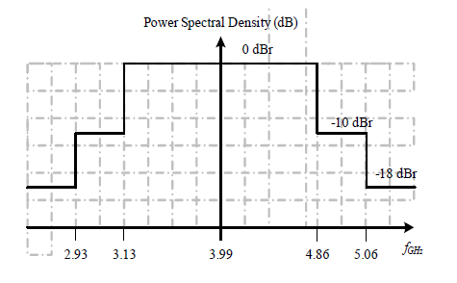
Figure 2. Spectral mask for pulse shape waveform (IEEE 802.16.4a).

Data Rates

Data rates range from 1 Mbps up to 10 Mbps. The mandatory data rate is 1 Mbps.

PSDU timing parameters

The PSDU timing and data rate parameters are given in table 4. Notice that in case of long pulse shape waveform option, the pulse repetition frequency (number of pulses transmitted in one second) or PRF coincides with the mean PRF (number of pulses transmitted in a symbol period divided by the symbol period). In case of short pulse shape option, the peak PRF is defined as the maximum rate at which a transmitter emits pulses. This definition is not applicable for the long pulse shape option.

PRF Parameter
In case of long pulse shape option, PRF indicates the number of pulses transmitted in one second. It is equal to the mean PRF (number of pulses transmitted in a symbol period divided by the symbol period).

Basis pulse waveform position parameter
indicates the number of possible basis pulse waveform positions in a symbol duration.

Hop Parameter
is the number of basis waveform positions that can contain an active basis pulse waveform.

Basis pulse waveform duration parameter
is the basis pulse waveform duration. It is computed as . In case of long pulse shape waveform option: . Notice is either the short or long pulse shape waveform.

Symbol duration parameter
is the PSDU symbol duration.

Symbol rate parameter
It is the number of information symbols transmitted per second. It is computed as .

FEC rate parameter
It is the channel coding rate, i.e., No of information bits divided by the No of coded bits.

Modulation mode 1 parameter
It is either, differentially encoded BPSK or QPSK.

Bit rate parameter
It is the bit rate on the air and computed as in case of PPM or DBSPK modulation and in case of DQPSK.

Number of short pulses parameter
is the number of short pulses such that , where is the pulse shape duration.

Peak PRF parameter
It is defined as the maximum rate at which a transmitter emits short pulse waveforms. This definition is not applicable to the long pulse shape waveform.

SHR Preamble

In order to perform coarse synchronization, data aided in the form of a preamble is employed. Such preamble is detectable for non-coherent and coherent receivers. Perfect balance ternary sequences (PBTS) can achieve this. Therefore, there is no need to define two types of preambles, one for non-coherent receivers. The autocorrelation function for coherent receivers is given by
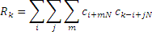
and the autocorrelation function for non-coherent receivers is given by

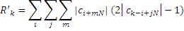
Both and periodic auto-correlations are perfect. That is, the side lobes of their periodic correlation are zero, .
Table 5. PBTS sequences.
Codeword index | Sequence
 | -0000+0-0+++0+-000+-+++00-+0-00
 | 0+0+-0+0+000-++0-+—00+00++000
 | -+0++000-+-++00++0+00-0000-0+0-
 | 0000+-00-00-++++0+-+000+0-0++0-
 | -0+-00+++-+000-+0+++0-0+0000-00
 | ++00+00—+-0++-000+0+0-+0+0000
 | ++00+00—+-0++-000+0+0-+0+0000
 | 0+00-0-0++0000–+00-+0++-++0+00

Figure 1. Illustration of the periodic auto-correlation of .

Start frame delimiter
After the preamble, a start frame delimiter (SFD) sequence is transmitted for frame synchronization. The SFD sequence is also balance, i.e., when its correlation window is running through the preamble the output is zero. Thus, the transition of correlation from preamble to SFD does not degrade the detection of SFD.
Table 6. SFD sequences.
SFD index | Sequence
 | 0+0-+00-0+0-+00–00+0-0+0+000-0-0-00+0–0-+0000++00—+-++0000++
 | 0+0-+00-

There is not mandatory pulse shape for the transmission of the preamble and SFD. The modulation is the same as the modulation employed for the PSDU. The data rate transmission is the mandatory data rate 1 Mbps.

FEC

Contrary to IEEE 802.15.4a standard, parity bits of a FEC are not used to be modulated in phase (BPSK) and systematic bits to be modulated in position (BPM).
In order to save power consumption a linear block code in the form of a systematic RS codes is proposed only. The transmitter shall encode with RS codes the information bits. Although, decoding is optional at the receiver (parity bits might be ignored). For high QoS applications, the combination of a ARQ mechanism is proposed. See HARQ Section.

Reed-Solomon codes
A systematic RS(63,55) code over GF() with primitive polynomial is proposed. The polynom generator is and. This code consists of 330 systematic bits plus 48 parity bits. That is, the code rate is 0.87.

Figure 3. Systematic RS(63,55) code.

Hybrid Type II ARQ Mechanism.

In this configuration, only parity bits are sent in each retransmission. Particularly a RS invertible code is proposed. A code is said invertible if knowing only parity bits, the information bits can be determine by an inversion process. Packets detected in error by a CRC code are not discarded, but rather stored for posterior use at the decoder. The coding overhead at the transmitter remains low. This scheme is especially robust to burst and time varying channels. These channel conditions are expected when a subject with a BAN moves, besides that is imperative to reduce latency as much as possible especially in emergency cases.
Figure 4. Schematic diagram of the proposed usage of HARQ for BANs.
Figure 4 illustrates the proposed scheme of HARQ Type II with TG6 BANs. Essentially, devices whose applications require high QoS and low latency are HARQ enable. That is, the RS code and ARQ mechanism in the PHY and MAC follow the flow chart shown in Figure 3. In case of devices are not HARQ enable, simply use the conventional flow of RS coding and ARQ in the PHY and MAC, respectively.
Figure 3. Schematic flow chart of the proposed HARQ Type II.

The cyclic redundancy check code (CRC) is the standardized CRC-16-CCITT. The maximum number of retransmissions is two.

Pulse Shape Waveform

There is not mandatory pulse shape. However, the basis waveform duration and PRF are mandatory according to table 4. Notice the pulse shape waveform needs to fulfill the spectral mask illustrated in Figure 2. This fixes the maximum transmitting power.

Short Pulse Waveforms
Conventional short pulses for UWB transmission are supported, especially for legacy. However, the UWB symbol structure is different from IEEE 802.15.4a. Therefore, the mandatory pulse duration shall be an integer multiple of the basis waveform duration, according to table 3.
Considered pulse shapes can be those defined in IEEE 802.15.4a.

Chirp Pulse Waveform
As part of the basis function definition, a chirp pulse waveform is proposed and given by
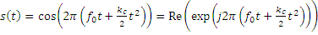
where is the central frequency, is the chirp duration, is the chirp slope defined as
and is the chirp frequency sweep.

Figure 4. Spectral mask for the proposed chirp pulse.

References

