IEEE P802.15
Wireless Personal Area Networks

Project | IEEE P802.15 Working Group for Wireless Personal Area Networks (WPANs)
Title | Annex M.6 Channel Diversity
Date Submitted | Dec. 17, 2009 (TBD)
Source | Wun-Cheol Jeong, Chang-Sub Shin, Ahnseok Lee, Seong-Soon Joo  [ETRI, 138 Gajeongno, Yuseong-gu, Daejeon, 305-700, Korea] | Voice: [+82 42-860-5104]  E-mail: [wjeong@etri.re.kr]
Re: | []
Abstract | [Annex M.6 draft]
Purpose | []
Notice | This document has been prepared to assist the IEEE P802.15. It is offered as a basis for discussion and is not binding on the contributing individual(s) or organization(s). The material in this document is subject to change in form and content after further study. The contributor(s) reserve(s) the right to add, amend or withdraw material contained herein.
Release | The contributor acknowledges and accepts that this contribution becomes the property of IEEE and may be made publicly available by P802.15.
Table of Content
1. Annex M 3
1.1 Channel Diversity 3

- Annex M
  - Channel Diversity

Wireless PAN suffers severe receiver channel variation which results in poor signal reception quality. The main cause of physical impairments is called multi-path fading, and mutual RF interferences.

IEEE802.15.4e MAC provides two types of channel diversity methods to overcome these impairments: channel adaption and channel hopping. Channel adaptation does not change a channel in use until the received signal quality drops down lower than a threshold value. When channel quality is poor, it switches the channel to another one which is expected to show statistically different reception quality. On the other hand, channel hopping enforce the channel to switch at each time slots at most according to predefined channel hopping pattern. Channel hopping pattern, called channel hopping sequence, is set by NHL. Basic idea behind these channel diversity methods is to exploit the nature of receiver channel quality varying over whole available RF channel spectrum. A chance for a channel suffering channel impairments is statistically much lower than another one suffering deep fading located far apart. Thus, the reception signal quality is expected to be improved significantly by switching a channel with poor quality to other one located far apart.

IEEE 802.15.4 provides two types of PAN operation modes: beacon enabled mode and non beacon enabled mode. In IEEE802.15.4e MAC, channel adaptation is implemented over EGTS structure in beacon enabled PAN, while channel hopping can be implemented in either of PAN operation modes. See section 7.1.21 and 7.1.23 for more detail.

Channel diversity methods herein can coexist with channel hopping method performed in PHY such as physical layer frequency hopping (PHY-FH) in SUN. The fundamental difference of channel hopping method as in MAC and PHY is whether channel switching occurs during the transmission of a PPDU. Fig. M1 illustrates the hopping methods in two layers. In MAC channel hopping (MAC-CH) scheme, each PPDU is transmitted in different frequency channel (Fig. M1 (a)), while a PPDU is fragmented into segments and each segment is transmitted in different sub time slots with different frequency channel in PHY-FH (Fig. M1 (b)).

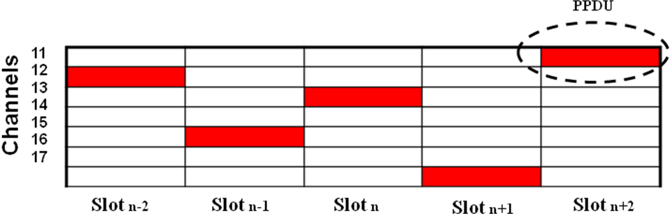
(a)
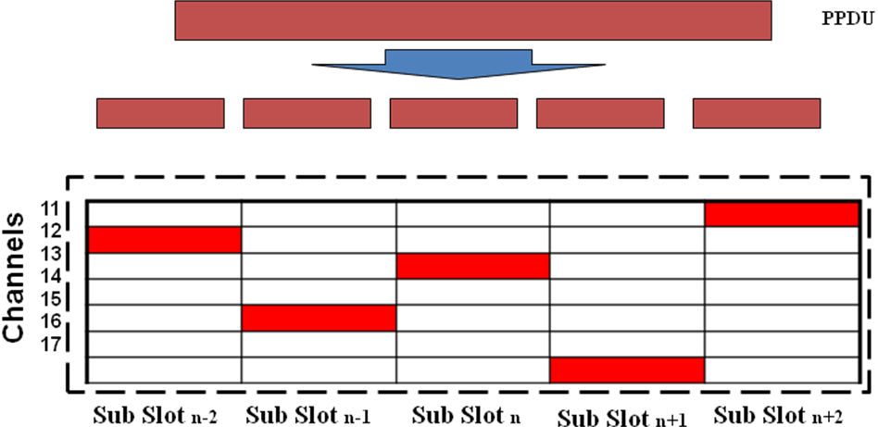
(b)
Figure M1—Illustration of channel hopping in (a) MAC (b) PHY Layer
However, the notion of channel number is not clear when this cooperative channel diversity scheme is applied. To understand this, let us consider channel hopping sequence of {1,2,3,4} for MAC-CH. Before the transmission of the first PPDU, PHY would set physical channel information obtained from channel hopping sequence for MAC-CH and from that for PHY-FH. Now, PHY cannot determine using which channel a frame is transmitted. In order to resolve this, we introduce a notion of logical channel number. Table M1 shows how a logical channel number maps into a channel hopping sequence used for PHY-FH. For instance, if PHY-FH employs channel hopping sequences, {1,3,5,7}, {2,4,6,8}, {9,11,13,15} and {10,12,14,16}, each sequence is numbered as logical channel numbers 1 through 4. Thus, when MAC sets logical channel number of 1, PHY uses channel hopping sequence {1,3,5,7} for the transmission of a PPDU, and so forth. An example of PHY channel hopping sequence for the given sequence of logical channel numbers are illustrated in Table M2.

Table M1. Logical channel numbering
PHY Hopping Sequence | Logical Channel Number
{1,3,5,7} | 1
{2,4,6,8} | 2
{9,11,13,15} | 3
{10,12,14,16} | 4

Table M2. PHY channel hopping sequences using the notion of logical channel
MAC Hopping Sequence | PHY Channel Hopping Sequences
{1,2,3,4} | {{1,3,5,7},{2,4,6,8},{9,11,13,15}, {10,12,14,16}}
{2,3,4,1} | {{2,4,6,8},{9,11,13,15}, {10,12,14,16},{1,3,5,7}}
{3,4,1,2}, | {{9,11,13,15},{10,12,14,16},{1,3,5,7}, {2,4,6,8}}
{4,1,2,3}, | {{10,12,14,16},{1,3,5,7}, {2,4,6,8},{9,11,13,15}}

