IEEE 802.15
Wireless Personal Area Networks
Project | IEEE 802.15 Working Group for Wireless Personal Area Networks
Title | IEEE 802.15.7 VLC PHY/MAC Specification Proposal
Date Submitted | October 29, 2009
Source | Tae Gyu Kang, Sang-Kyu Lim, Dae Ho Kim, Ill Soon Jang, Dong Won Han | [tgkang@etri.re.kr]
Re:
Abstract | This document proposes IEEE 802.15.7 VLC PHY/MAC Specification.
Purpose | [This document is intent to propose TG7 specification.]
Notice | This document has been prepared to assist the IEEE 802.15. It is offered as a basis for discussion and is not binding on the contributing individual(s) or organization(s). The material in this document is subject to change in form and content after further study. The contributor(s) reserve(s) the right to add, amend or withdraw material contained herein.
Release | The contributor acknowledges and accepts that this contribution becomes the property of IEEE and may be made publicly available by 802.15.

IEEE 802.15.7 VLC PHY/MAC Specification

ETRI LED Communication Research Team Proposals;
- A PHY and MAC Proposal of Visible Light Communications with LED Lighting, 678-00, Tae-Gyu Kang
- ETRI PHY Proposal on VLC TDM for LED Signboard, 677-01, Dae Ho Kim
- ETRI PHY proposal on VLC band plan and modulation schemes for illumination, 674-00, Sang-Kyu Lim
- ETRI PHY Proposal on VLC Line Code for Illumination, 675-00, Dae Ho Kim
- ETRI PHY proposal on color channel tolerance of receiver sensitivity, 676-00, Sang-Kyu Lim
- ETRI MAC Proposal on Color Packet, 679-00, Ill Soon Jang

Contents

1. Definitions 3
2. Acronyms and abbreviations 3
3. General description [678] 3
3.1. VLC Architecture 3
3.2. VLC Applications 4
4. Layer Management 5
4.1. VLC Network topologies 5
4.2. VLC Interfaces on Protocol Stack 5
5. MAC frame format 5
6. MAC functional description 6
6.1. Color Packet Scheme [679] 6
7. PHY specification for VLC 13
7.1. Data rate 13
7.2. Line Coding [675] 13
7.2.1. Flickering issue at LED illumination 13
7.2.2. Modified-4B5B 15
7.2.3. 4B6B 17
7.3. Band Plan & Modulation Scheme [674] 19
7.4. Variable PPM: VPM [674] 22
7.5. Reverse-RZ with Variable Duty: RRZ [674] 25
7.6. VLC TDM for LED Signboard: Multiplexing [677] 28
7.7. Color Channel Tolerance [676] 31
8. Protocol implementation conformance statement (PICS) proforma 35
9. Regulation 35

Definitions
FFS

Acronyms and abbreviations
FOV | Field of View
LED | Light Emitting Diode
LOS | Line of Sight
PWM | Pulse Width Modulation
P2P | Peer to Peer
R-RZ | Reverse-Return to Zero
TDM | Time Division Multiplexing
VLC | Visible Light Communication
VPM | Variable Pulse Position Modulation

General description [678]
[678-00 Kang]
VLC (Visible Light Communications) can provide a kind of fusion functions from 2 Area: LED Lighting, Communications. LED Lighting Communications can provide new communication with LED applications such like lighting, signboard, streetlight, vehicle, and traffic signal. VLC provides new functions with color lighting wireless communications. Unfortunately, VLC can make side effects of LED illumination such as a flickering, a restricted dimming, and effect of illumination Pulse Width Modulation (PWM). There is no an standard for an LED interface and a VLC interface.

VLC Architecture
There are two part of VLC Architecture. One is a sending part of VLC. the other is a receiving part. The sending part can use any kind of LED illumination. The sending part of VLC MUST have PHY/MAC functions for illumination and transmission performance.
The receiving Part of VLC can support any kind of Photo Diode (PD) with avoidance from any other light interference. As a common part of two parts, there are a PHY and a MAC of VLC. VLC PHY has a modulation and a line coding for a wireless communication. VLC MAC has to support different Applications.

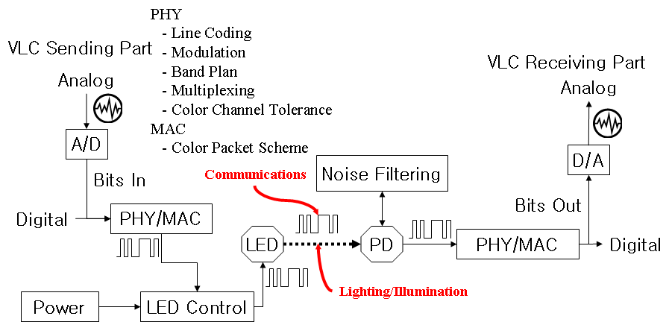
- VLC PHY Architecture with Lighting

VLC Applications
VLC provide three applications: LED illumination, Broadcasting, and Machine-to-machine. LED illumination can be an office/home illumination, streetlight, and vehicle lamp. Broadcasting can be a signboard, an office/home illumination, and a streetlight. Machine-to-machine can be a cellular phone to a cellular phone, a vehicle to a vehicle, a vehicle to a traffic signal, and a vehicle to a streetlight.
VLC can make a lot of applications. To support all kind of application, VLC PHY and MAC should support different scheme according to application requirement.
LED illumination with VLC MUST support as followings;
- Dimming Control Scheme
- Flicker Removal Scheme : 4B6B
- Full Brightness Scheme
Broadcasting with VLC MUST support as followings;
- TDM: Signboard
Machine-to-machine with VLC MUST support as followings;
- Color Packet according to PER

Layer Management

VLC Network topologies
VLC can support two different network topologies: star network and peer-to-peer network. Star network provides information from one lighting source to one more different receiving destination. The one light source can be an LED lighting/illumination or a sign board for broadcasting data transfers.
Peer-to-peer network can provide from one lighting source to one receiving destination. This is similar to a kind of machine to machine for peer-to-peer data transfers.

VLC Interfaces on Protocol Stack
The VLC specification supports illumination, broadcasting, and M-to-M.
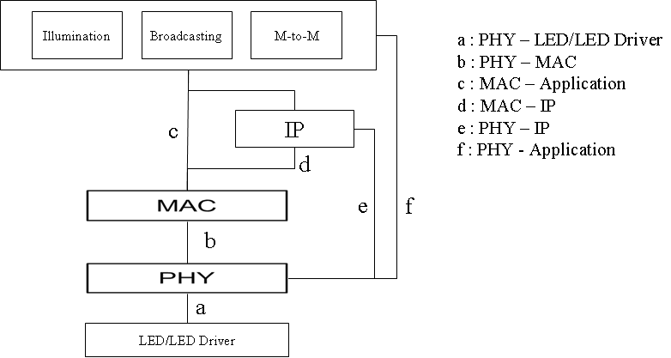

MAC frame format
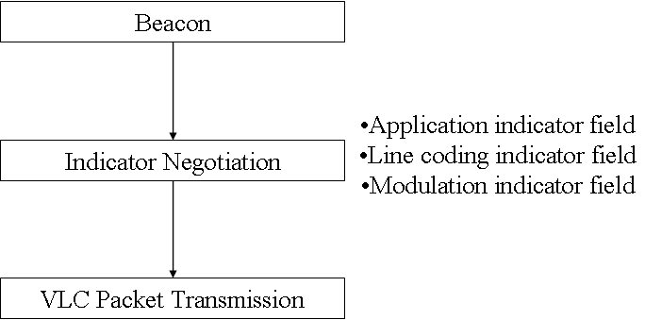
- VLC Setup Procedure

- Indicator Negotiation format
Application indicator field
0001 | Lighting (illumination)
0010 | Signboard
0011 | Machine-to-machine
0100 - 1111 | Reserved
Line coding indicator field
0001 | Modified 4B5B
0010 | 4B6B
0011 | 8B10B
0100 - 1111 | Reserved
Modulation indicator field
0001 | OOK
0010 | VPM
0011 | R-RZ
0100 - 1111 | Reserved

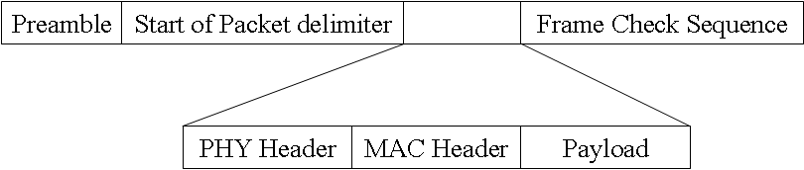
- VLC frame format

MAC functional description

Color Packet Scheme [679]
Ill Soon Jang [679]
Color Packet is a packet to provide information such as device status and channel quality to the user intuitively. We can use Color Packet in VLC applications with various colors.
Examples of VLC applications with Color Packet are mobile to mobile VLC, VLC between toys, remote controller, and application with asymmetric data transfer.
When we use Color Packet in VLC, we can supply information to user intuitively and transfer messages to peer device. For examples, in communication between application and user, we can directly see the status information such as current step of communication procedure, data transmission quality (PER, BER), transferred file size or remained file size with our eyes by using color packet. For an example, in communication between device and device, device can transfer coarse link adaptation information to peer device by using color packet.
There are needed basic communication procedures for a color packet usage. MAC States consist of IDLE state, Connection state, Data Exchange state.
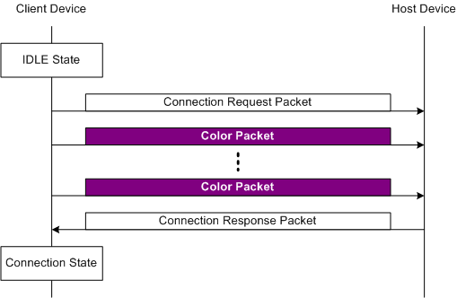
- Step1 – A Color Packet Usage for Connection procedure
From Basic Communication Procedures, first Step1, Client Device transfer “Connection Request Packet” to Host Device. This step finished when Client Device receives “Connection Response Packet” from Host Device. Client device transfer purple color packet during transition between two states. User knows the current state of client device intuitively by purple color.
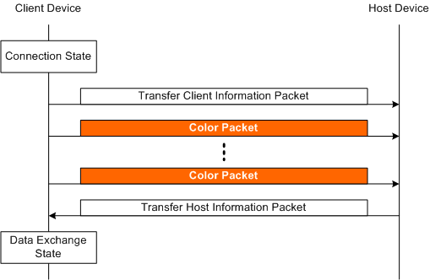
- Step 2 – A Color Packet Usage for Exchange Information Procedure
At step2, client device state transit from connection state to data exchange state. During state transition, client device transfer Orange Color packet to host device. User knows client state intuitively by orange color.
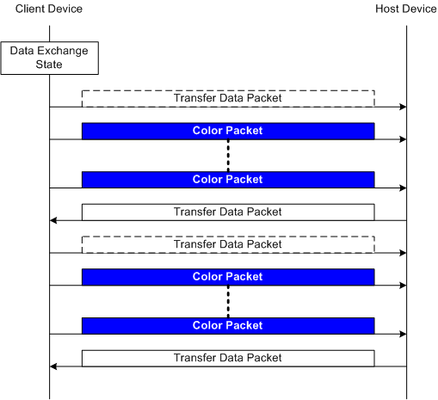
- Step 3 – A Color Packet Usage for Transfer Data Procedure
At Step3, Client Device receive data packet from Host Device. Client Device held Data Exchange State while receiving data packet from Host Device. During Data Exchange State, client device transfer blue color packet to host device.
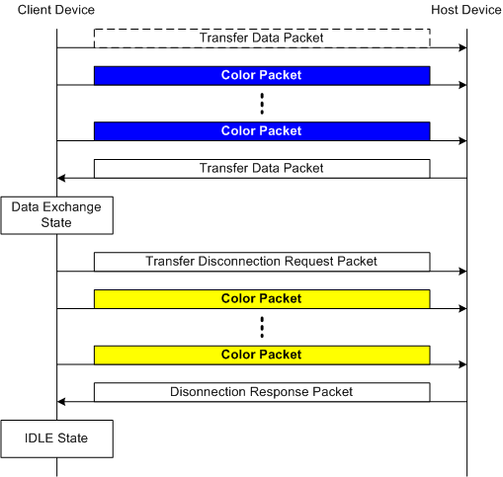
- Step 4 – A Color Packet Usage for Transfer Disconnection Procedure
At last step, client device state transit from data exchange state to IDLE state. Client device transfer Yellow Color packet to host device during state transition. User can know the current step of communication procedure by using Color Packet during these communication procedures.
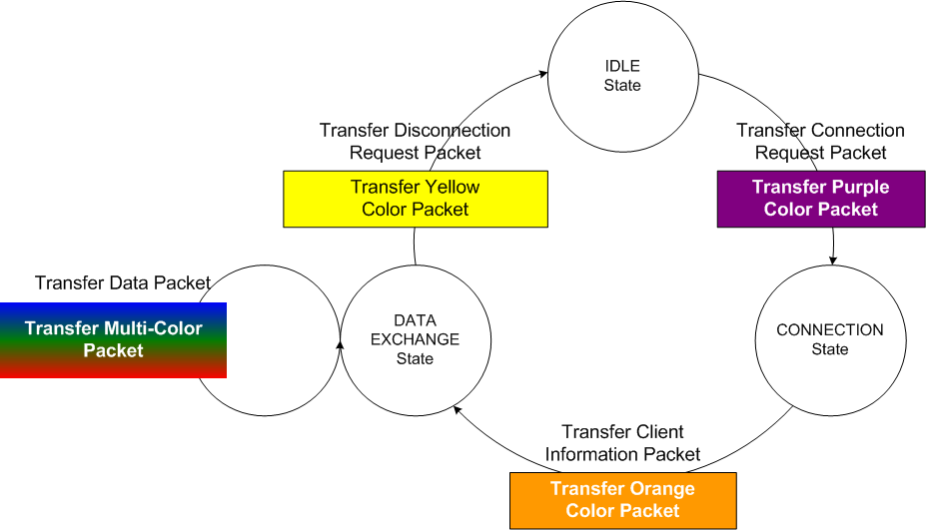
- Color Packet Client State Diagram
This slide shows Client State Diagram in Previous Basic Communication Procedures. Each color packet is transferred during each state transition.
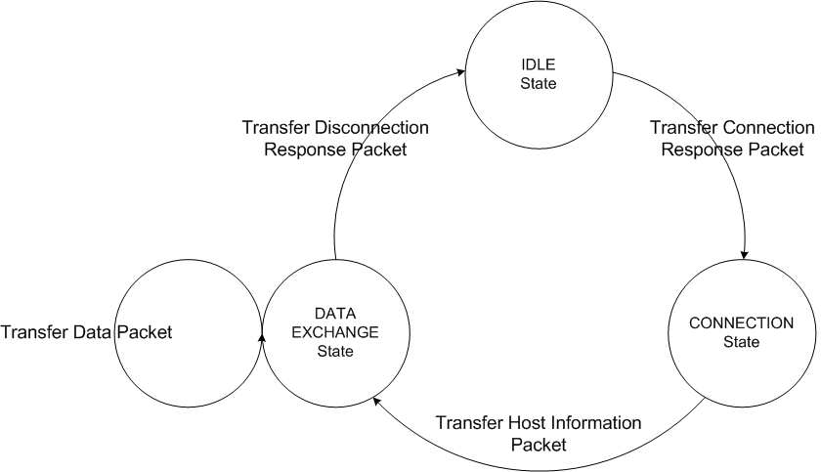
- Color Packet Host State Diagram
In case of asymmetric data transfer, host doesn’t transfer color packet to client for the transmission of data packet.
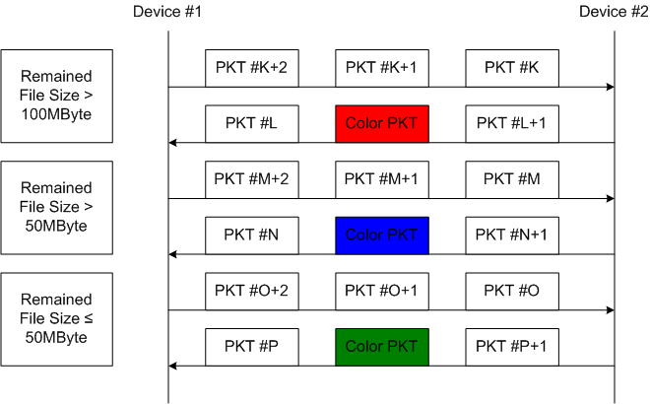
- A Color Packet usage in File Transfer Application
This figure shows a color packet usage in file transfer application. User knows remained or transferred file size by using color packet in VLC.
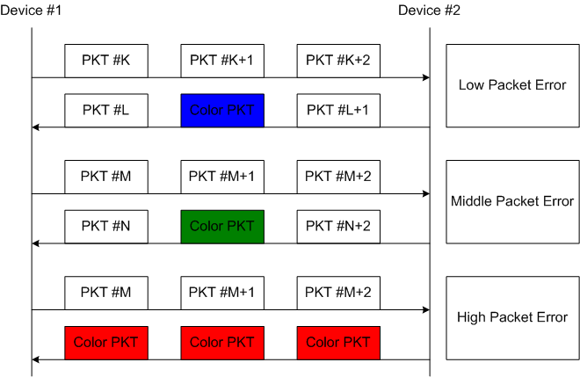
- A Color Packet usage for Informing Data Transmission Quality to User
This figure shows a color packet usage when the color of color packet inform user to data transmission quality. User can know PER by using color packet in VLC. Low Packet Error shows green color packet. Middle Packet Error shows blue color packet. High Packet Error shows red color packet. Until now, examples are to communicate between application and user.
- Color Status Table in Coarse Link Adaptation
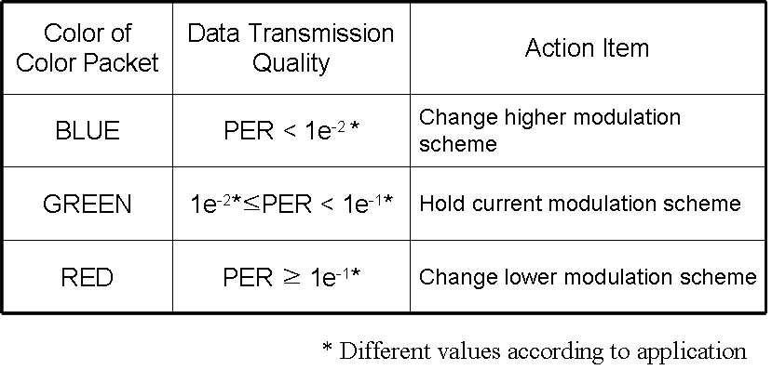
This is a color status table to coarse link adaptation between device and device. User can know PER by using Color Packet. The Device received color packet knows it, too. Consequently, device can transfer coarse link adaptation information to peer device by using color packet. The device received color packet can change other data rate scheme by color status table.

- Color Packet Structure
Color Packet Header must include next indicators. First color packet indicator means that transmitted packet is color packet, itself. Secondly, peer device information indicator show whether color packet include the message for peer device or not.
Color Packet provides the function of the visibility which is one of VLC's advantages. Color packet has the effects that informs intuitively to user without additional indicator. Device can use Color Packet to transfer the information messages to peer device. There is need an interface between Upper layer and MAC layer to support Color Packet Configuration.

PHY specification for VLC
LED office illumination can support an wireless communication such as LED illumination infrastructure to mobile. The LEDs for transmission device are two types: white LED (yellow phosphor) and R-G-B LED. A white LED (yellow phosphor) is more popular than R-G-B LED due to the price. A white LED (yellow phosphor) has less communication quality than R-G-B LED due to the response time of phosphor materials.
VLC PHY Line code can use 4B6B, 8B10B, and Modified-4B5B. VLC PHY modulation supports On/off Keying, Variable Pulse Position Modulation (VPM), and Reverse-Return to Zero (R-RZ). PHY supports also Time Division Multiplexing(TDM) for LED signboard.

Data rate
The data rate of the IEEE 802.15.7PHY shall be from 160 kbps to 6 Mbps in uncoded data rate.
- VLC data rate
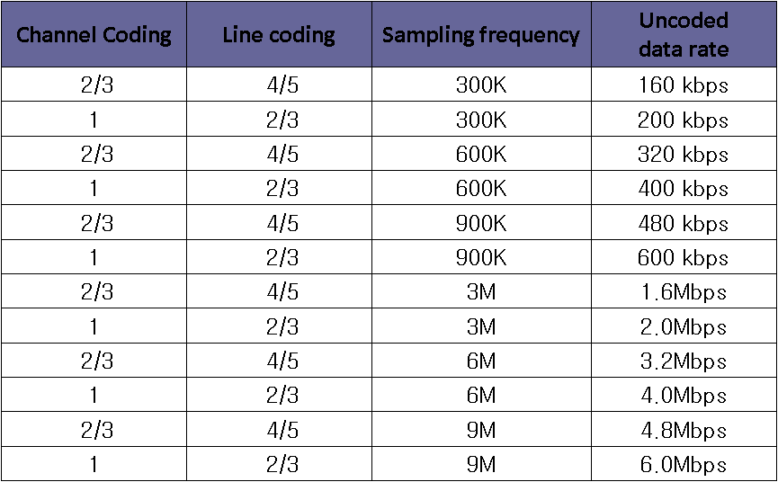

Line Coding [675]

Flickering issue at LED illumination
Target application of PHY for VLC is the communication using an illumination at office or home environments. The target light source for VLC is white LED with yellow phosphor and RGB LED. The divergence angle of LED illumination is very various. LED fluorescent has 110 degree to 310 degree. PAR type has 60 to 140 degree. PAR type is similar to halogen lamp. 3 meter is a general distance between light on the ceiling and on the table at office or home.
LED illumination MUST satisfy three functions; non-flickering, dimming control, and full brightness.
There is a possible simple model of VLC PHY. PHY frame generation, 4B5B line code, NRZ OOK for modulation, LED driving circuit and LED. This model has a problem when combination of 4B5B and NRZ is used for illumination. First problem is flickering when we transmit data, flickering effect is possible according to data pattern and existence of data frame. Second is a difficulty of dimming control.

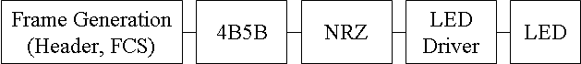
- A example of simple VLC PHY
To provide three functions of LED illumination, there are two alternative models. One is VPM (Variable PPM) without line coding, the other is R-RZ (Reverse-RZ) with 4B6B or modified 4B5B.
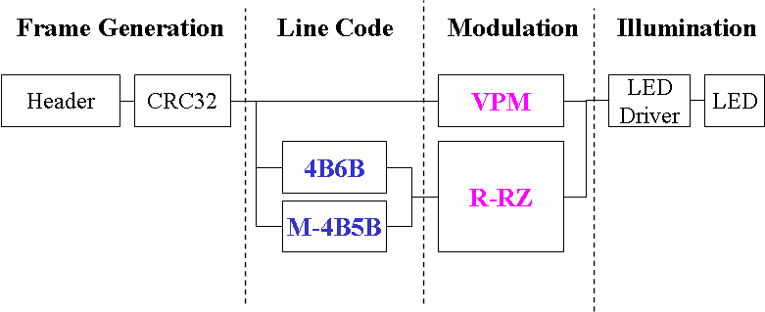
- PHY models for dimmable and non-flickering illumination
Flickering of illumination is a harmful for human eyes. Some modulations make a flickering. Flickering defines an unexpected and unpredictable light intensity change recognized by human eyes. The flickering causes from a repetition of lighting on and off or slow change of brightness in a time period. There is a flickering in VLC lower data rate than 200 bps. Human eye can recognize the light status of on or off from light source. Some data pattern like long sequence of 1 or 0 produce off time and on time repeatedly.
0000 0001 0101 0111 1111 1110 1010 1000 0000
Maximum Flickering Time Period (MFTP) is a period that light intensity can be changed, but that can not be recognized the change of brightness by human eyes;
MFTP: 1/minimum flickering free frequency (200Hz) = 5ms
To avoid a flickering from VLC, a brightness of each MFTP must be all equal. There are needed a flickering definition and MFTF (Max Flickering Time Period) by VLC or human eye safety regulation.
A solution for flickering removal is that we make a ratio of positive and negative level per MFTP to be constant with constant-weight code such as Manchester code, 2 PPM, and 4PPM. Manchester code has 50% duty cycle always. 2 PPM is 50% and 4 PPM is 25%. If we use this line code or modulation scheme for data stream and at idle time we use same waveform, flickering will not occur. But if we use NRZ OOK, we need another solution. Second solution is we make a ratio of 1 and 0 per MFTP to be constant at data stream such as scrambler, modified 4B-5B, and 4B6B.

Modified-4B5B
Line code is the waveform pattern of voltage or current used to represent the 1s and 0s of a digital signal on a transmission link is called line encoding. It is for reliable clock recovery at the receiver or for eliminating DC component which eliminates long sequences consisting of '0' or '1' only.
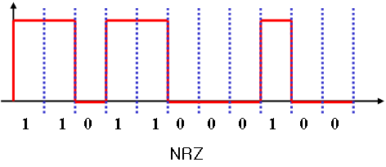
- An example of flickering from NRZ
NRZ is a very simple and general technology at fiber optical communication. NRZ can make Flickering by data pattern or existence of data frame.
4B5B is a line code that maps 4-bit symbols to 5-bit symbols. 4B5B provides a function of a DC-balance and bounded disparity, and yet provide enough state changes to allow reasonable clock recovery. 4B5B is used at PCI Express, Gigabit Ethernet, and USB 3.0.
- Modified-4B5B (M-4B5B)
 | 4B | 5B | M-4B5B
0 | 0000 | 11110 | 00101
1 | 0001 | 01001 | 10011
2 | 0010 | 10100 | 00110
3 | 0011 | 10101 | 10101
4 | 0100 | 01010 | 01001
5 | 0101 | 01011 | 10110
6 | 0110 | 01110 | 01010
7 | 0111 | 01111 | 11001
8 | 1000 | 10010 | 01100
9 | 1001 | 10011 | 11010
A | 1010 | 10110 | 10001
B | 1011 | 10111 | 01011
C | 1100 | 11010 | 10010
D | 1101 | 11011 | 01101
E | 1110 | 11100 | 10100
F | 1111 | 11101 | 01110
4B5B can not support non-flickering because 4B5B is not even pattern at the ration of 1 and 0. 4B5B has three types of 1 and 0 ratio at its output results, 4:1(80%,5), 3:2(60%,7) and 2:3(40%,4). This percentage means brightness when 1 is on and 0 is off. Brightness difference of 4:1 and 2:3 is too big. Modified-4B5B does not have 4:1 pattern, such as 0, 7, B, C, D, F in case 4B5B. Modified-4B5B produces the output pattern of 4B5B to be 3:2 or 2:3
- Idle time pattern : 00011 00111
- Preamble pattern : 11000 11100
Features of M-4B5B are almost 50% duty cycle more than 4B5B, reduced run length 8 to 4 that maintains a coding rate 4/5.
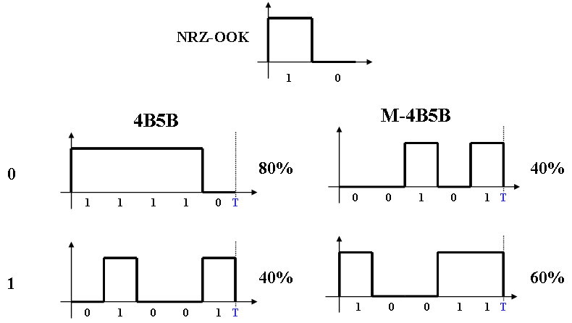
- An example of 4B5B and M-4B5B at NRZ OOK
We can see an example of flickering at NRZ using 4B5B and M-4B5B due to the difference of brightness.
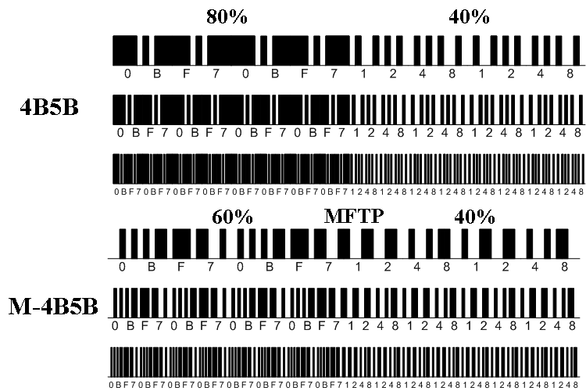
- An example of a flickering at NRZ OOK using 4B5B and M-4B5B

4B6B
4B6B expands 4-bit codes to 6-bit symbols with same ratio of 1 and 0 (3:3) and 50% duty cycle.
- Idle time pattern : 111000 000111
- Preamble pattern : Combination of 110100 and 001011
- 4B6B
 | 4B | 5B | 6B
0 | 0000 | 11110 | 001110
1 | 0001 | 01001 | 001101
2 | 0010 | 10100 | 010011
3 | 0011 | 10101 | 010110
4 | 0100 | 01010 | 010101
5 | 0101 | 01011 | 100011
6 | 0110 | 01110 | 100110
7 | 0111 | 01111 | 100101
8 | 1000 | 10010 | 011001
9 | 1001 | 10011 | 011010
A | 1010 | 10110 | 011100
B | 1011 | 10111 | 110001
C | 1100 | 11010 | 110010
D | 1101 | 11011 | 101001
E | 1110 | 11100 | 101010
F | 1111 | 11101 | 101100
Features of 4B6B are always 50% duty cycle, reduced run length 8 to 4, and error detection. 4B6B can detect error by number of 1 and 0, but can not detect the position change of 1 and 0:
0: 001110 ↔ 001101 : 1
4B6B supports clock recovery and DC-balanced waveform.
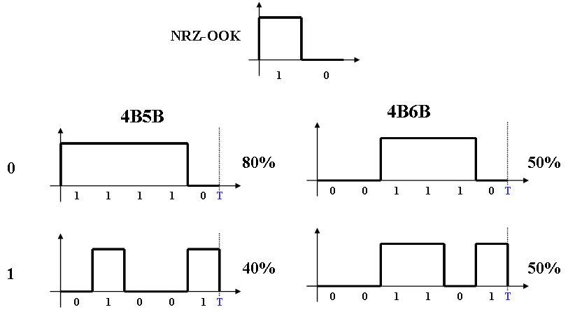
- An example of 4B5B and 4B6B at NRZ OOK
There are difference between 4B5B and 4B6B in terms of a flickering. The difference is up to 80% from 40%. 4B6B is always same as 50%.
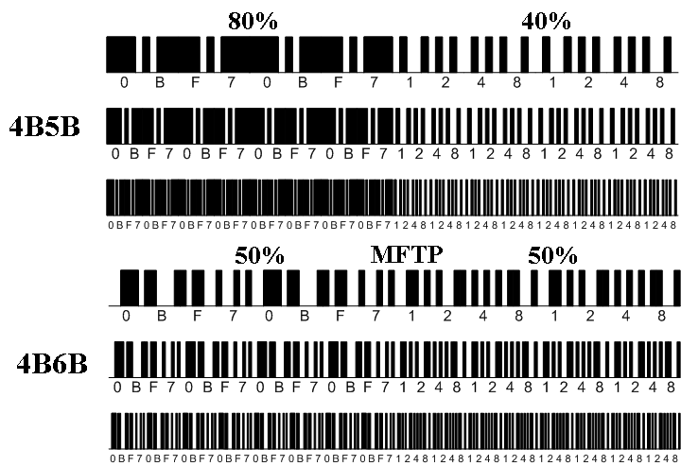
- A flickering comparison at NRZ OOK using 4B5B and 4B6B
Flickering is a very important factor in terms of illumination. Flickering free technology is required.

Band Plan & Modulation Scheme [674]
Band Plan & Modulation Scheme - Sang-Kyu Lim[674]
These are the basis of our band plan, spectrum characteristics of light source and optical filter characteristics. We focus on these characteristics when we design band plan because the band plan itself, is for the communication rather than other light inherent functions. Spectrum characteristics of LED light source are directly related to VLC communication signal. We think Optical channel filter can be used at receiver when we use the various color channels in VLC as it used at fiber optic communication using WDM technology. But we estimated there is no problem to control or realize the optical filter characteristic depending on wavelength.
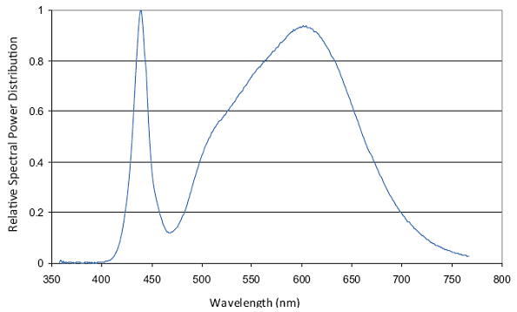
- Spectrum Characteristics of Commercial White LED for Illumination: Example 1
There are not standard for the spectrum characteristics of commercial white LED for illumination. White LED with yellow phosphor or other materials are used for illumination. The figure is an example of spectrum characteristics of commercial white LED with phosphor for illumination. There are two peaks in this spectrum. This peak is related to blue LED and this peak comes from phosphor. It has been reported the peak coming from the phosphor is the source of VLC data rate limitation. It is desirable to use only this blue peak for VLC. The positions of this main blue peak are different a little bit according to the LED companies.
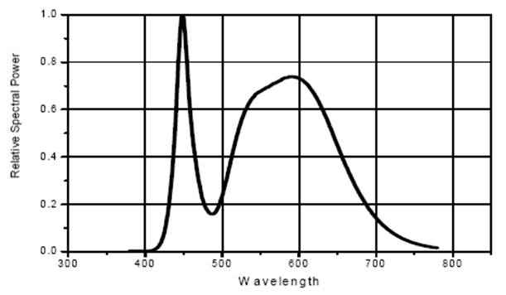
- Spectrum Characteristics of Commercial White LED for Illumination: Example 2

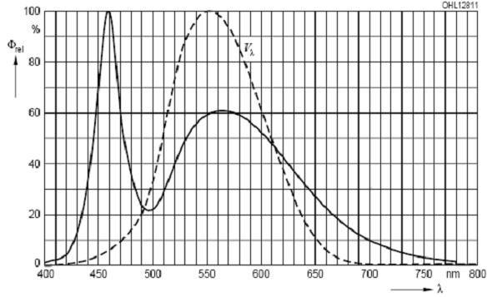
- Spectrum Characteristics of Commercial White LED for Illumination: Example 3
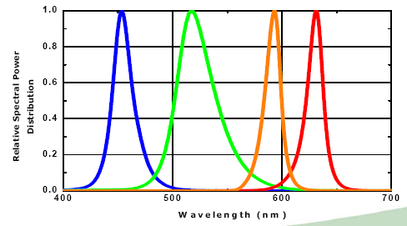
- Spectrum Characteristics of Commercial Colorful LED: Example 1
The figure shows the spectrum characteristics of various LED colors besides white LED. These other bands are also different a little bit. So, we make a band plan with a blue band of 400 nm to 500 nm. The other band was designed by the commercial various color LED and CIE coordinate.

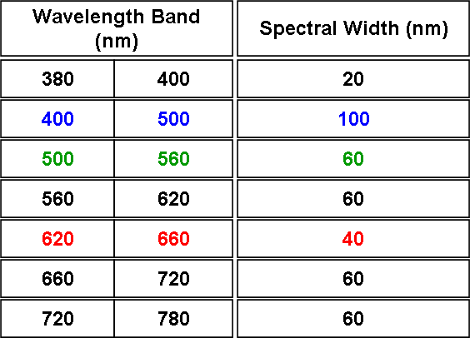
- VLC Color Band Plan

Variable PPM: VPM [674]
There are main three factors that are non-flickering, dimming control, and full brightness in VLC modulation scheme for illumination.
A flicker LED light due to VLC modulation is not good for eye safety. We need a modulation to remove the flicker for eye safety. If we cannot remove the flicker in VLC for illumination, no one use a VLC as an illumination.
LED illumination can control brightness with a dimming scheme. The dimming function is a mandatory for LED illumination. There are needed a modulation to support the dimming control function of LED light for VLC and illumination.
Full brightness is a primary function of LED illumination. A modulation of VLC might be decrease the brightness of LED illumination. There are needed a modulation to support full brightness in terms of illumination. It is desirable that VLC for illumination achieve the full brightness as much as LED light only for illumination do.
There are several candidates of VLC modulation as well as LED illumination. We can consider the modulation such as NRZ – OOK, RZ – OOK, PPM, I-PPM, PWM, and VPM.
NRZ-OOK(Non Return to Zero – On Off Keying) is one of the simple modulation scheme and a kind of amplitude-shift keying (ASK) modulation that represents digital data of “1” or “0” as the “on” or “off” states with non return to zero on off keying. Without line code, the flicker may be appeared. It is also difficult to achieve the dimming control and full brightness.
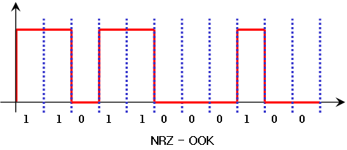
- An example of NRZ - OOK
RZ-OOK(Return to Zero – On Off Keying) is one of the simple modulation scheme and a kind of amplitude-shift keying (ASK) modulation that represents digital data of “1” or “0” as the “on” or “off” states with return to zero on off keying.. Without line code, the flicker may be appeared. It is also difficult to achieve the dimming control and full brightness.
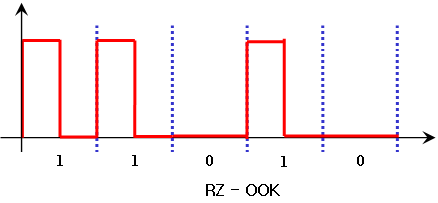
- An example of RZ - OOK
PPM (Pulse Position Modulation) is that M message bits are encoded by transmitting a single pulse in one of 2^{M} possible time-shifts. PPM is a good modulation for the non-flickering. But, it is difficult to achieve the dimming control and full brightness.
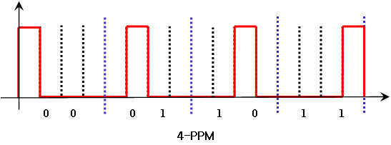
- An example of PPM (Pulse Position Modulation)
I - PPM (Inverse - PPM) is that M message bits are encoded by transmitting a single pulse in one of 2^{M} possible time-shifts. I-PPM is a good modulation for the non-flickering and the full brightness. But it is difficult to achieve the dimming control.
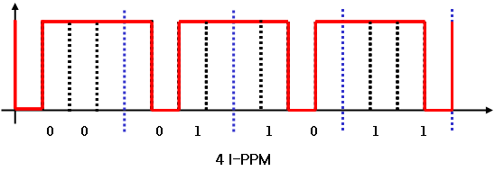
- An example of I-PPM (Inverse Pulse Position Modulation)
PWM (Pulse Width Modulation) is the modulation scheme widely used in LED illumination for itself. So, we can basically achieve the flicker-free, the dimming control, and the full brightness by using PWM. If we use PWM only itself for VLC, we cannot obtain the flickering-free, the dimming control, or the full brightness.
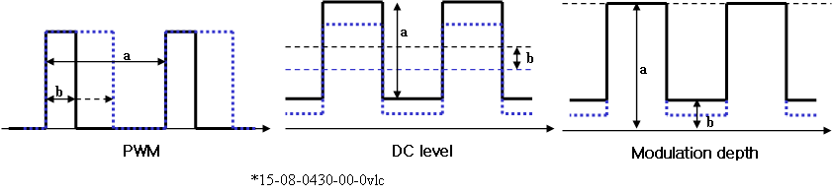
- An example of PWM (Pulse Width Modulation)
VPM (Variable PPM) provides three main functions of illumination: non-flickering, dimming control, and full brightness. The basic concept of VPM is a combination of PWM and 2-PPM. 2-PPM(Pulse Position Modulation) provides a function without flickering. PWM (Pulse Width Modulation) provides a brightness control using duty cycle control. VPM equals to 2-PPM when the duty of VPM is 50 %.
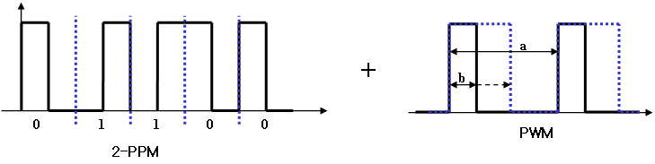
- The basic concept of Variable PPM
We make an example waveform of proposed VPM with 75 % duty cycle. As you can see, In VPM, the flicker is free because the “on” state area is constant (same ratio) during each time period.
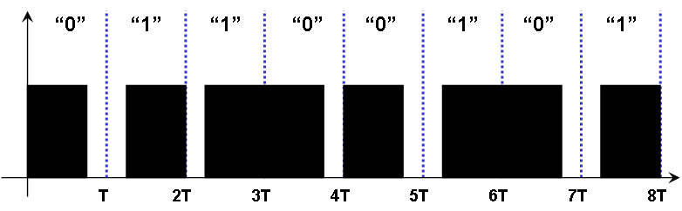
- Example Waveform of Proposed VPM with 75% duty
We can make the VPM waveforms showing dimming control according to duty cycle. VPM provides the dimming control by adjusting the duty and the full brightness by increase of duty cycle resolution.
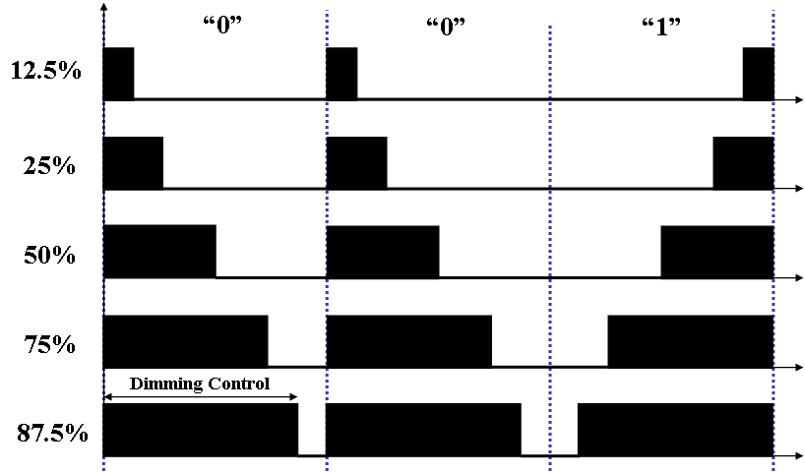
- An example of Dimming Control by VPM Signal
VPM provides both functions of illumination and communications with non-flickering, dimming control, and full brightness. VPM does not need a line code scheme for flicker-free signal. VPM is that the “on” state area of LED light is always constant under the given duty cycle. The dimming control of VPM can be provided by the duty cycle adjustment. The full brightness of VPM can be provided by the increase of the duty cycle resolution.

Reverse-RZ with Variable Duty: RRZ [674]
Reverse-RZ with variable duty provides a dimming control, but not supports function of non-flickering. Reverse-RZ is an advanced modulation scheme from RZ (Return to Zero) and IRZ (Inverse Return to Zero). The waveforms of conventional RZ defines 0 zero to zero and 1 zero to one to zero. The waveform of Inverse RZ is the inversed one from RZ.
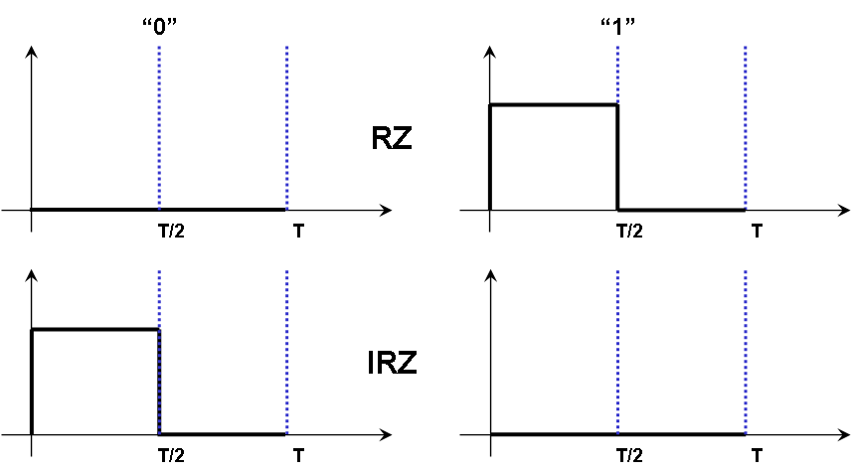
- A basic signal of Typical RZ and IRZ
Reverse-RZ defines that digit “0” signal is no transition signal or this one and digit “1” signal can be controlled by the duty cycle. The controlling of the duty cycle provides the dimming scheme for LED illumination.

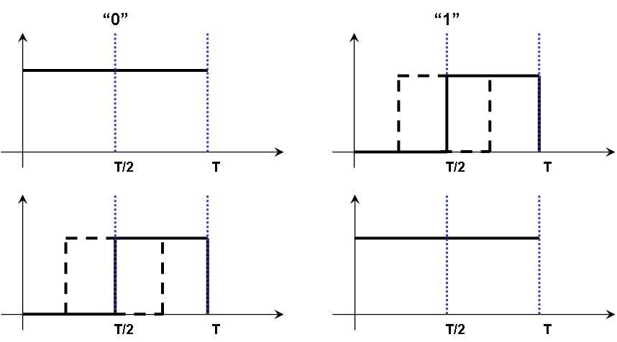
- A basic signal of Reverse RZ with 50% dimming
We can control the waveform of R-RZ with 50 % duty cycle when we need dimming the illumination lighting with 50%.
In R-RZ, the flicker may happen because the “on” state area may not be constant during each time period. When we need a flicker free signal in R-RZ, 4B6B provides it.
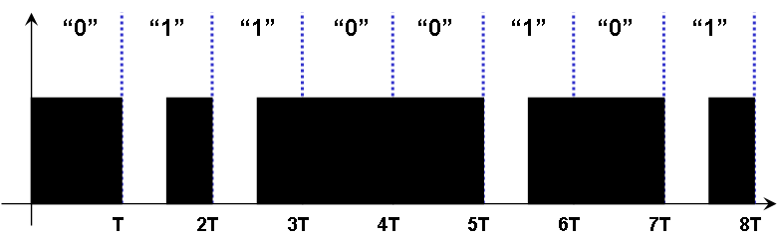
- Example Waveform of Proposed Reverse-RZ Signal with 50% duty
R-RZ waveforms provide the dimming function according to controlling of duty cycle. The dimming control can be achieved by adjusting of a duty and the full brightness by increase of duty cycle resolution. Dimming control in this modulation scheme is similar to the VPM.
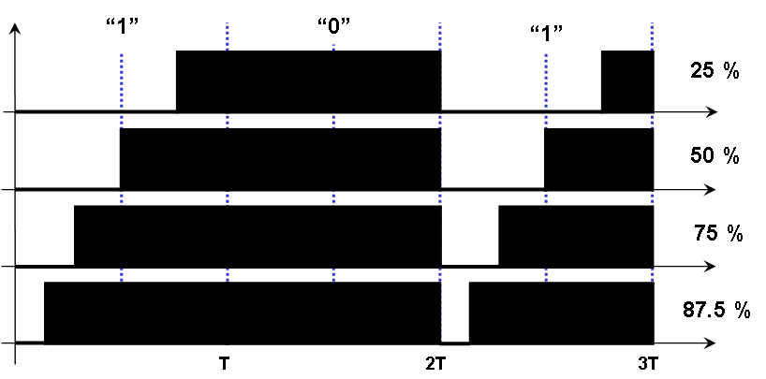
- Dimming Control of Reverse-RZ Signal with Variable Duty
Advantages of Reverse-RZ with variable duty can provide dimming control by the duty cycle adjustment and full brightness by the increase of the duty cycle resolution. It also provide flicker-free signal by using R-RZ with 4B6B or advanced 4B-5B line codes. 4B6B or advanced 4B-5B line codes makes the “on” state area of LED light be always constant under the given duty cycle.
We can choose a specific modulation depending on VLC application. There are several applications with different requirement. A VLC application such as cellular phone to cellular phone needs only high speed regardless flickering, dimming, and full brightness. The other application such as LED illumination needs non-flickering, dimming, and full brightness regardless communication speed. The table shows the comparison of modulations: NRZ-OOK, RZ-OOK, PPM, I-PPM, PWM, VPM, R-RZ.
- Comparison and Our Proposal of VLC Modulation Scheme for Illumination
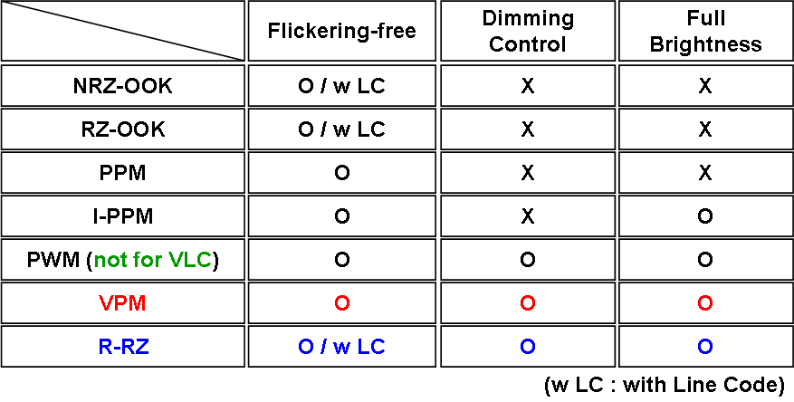
VPM provide the function of a flicker-free, dimmable and full brightness VLC signal for illumination. R-RZ also provide dimmable and full brightness VLC signal for illumination.

VLC TDM for LED Signboard: Multiplexing [677]
Multiplexing - Dae Ho Kim[677]
It consists with a host controller, line scan IC, Data IC and led matrix. Line scan IC selects a line for specific data stream and data IC transmit on/off or color selection information of each dot on the selected line. Line scan is active high, and data is active low. Line scan determines the operating time of each line. Operating time means LED On time duration of selected line.
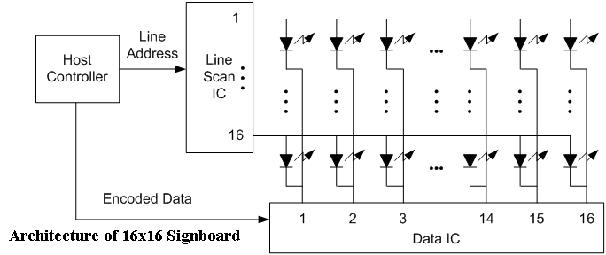
- Architecture of general LED signboard
General PC monitor and TV transmit 60 frames per second. One frame is transmitted twice, it is same with transmission of 30 different frame per second. At LED signboard, frame transmission mechanism is similar to PC monitor and TV. 16 Lines have to operate 60 times during 1 second in case of 16 by 16 LED signboard. The operating time for 1 line is about 1ms: (1s/60f)/16fpl ≈ 1ms/l. At the signboard industry, generally 25 to 60 fps is used.
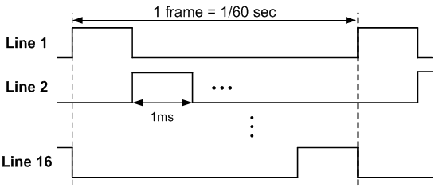
- Operation of 16x16 Signboard
Line operating time 1ms is fixed at one signboard. So, we can arrange 1 ms for 1 time slot.
16 time slots are possible. For example, if we consider 1Mbps, 1 time slot can transmit 125bytes.
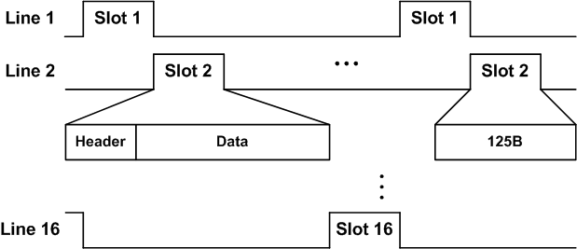
- TDM for Signboard
VLC MUST support non-flickering and same brightness at each time slot and any time. To support flickering free technology, we need 4B6B line code and Manchester code. To keep same brightness whenever data is transmitted or not, we need idle slot modulation. To satisfy same brightness even though VLC data stream reduce the brightness to half, we need to increase of operating time per line such as 100% duty of 1ms = 50% duty of 2ms = 1ms on time per second. The simple frame structure makes increase the link efficiency.
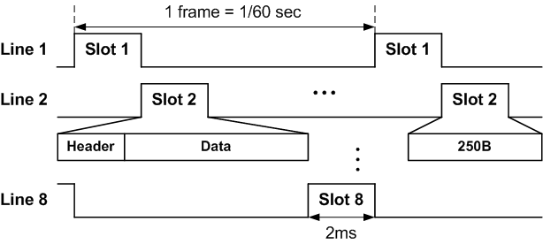
- TDM 1 for Signboard
For third requirement, operating time of selected line is increased to 2ms. But 1 frame period is fixed, so we need to reduce time slot and divide led block so if we consider 1Mbps, 1 time slot is extended 2ms and can transmit 250bytes.
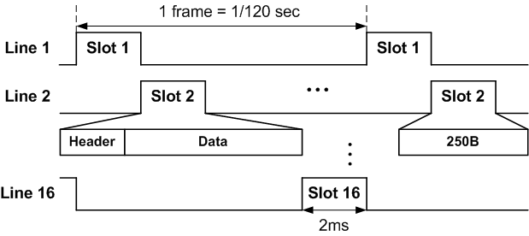
- TDM 1 for Signboard
TDM2 is same at the incensement of operating time of selected line to 2ms. Difference is not reduced time slot but increase period. So frame rate is changed 60fps to 30fps. Whatever TDM1 or TDM2 is used, there are needed TDM for multiplexing at LED signboard.
Beacon can be used to inform that the following frame is a TDM time slot: number of time slot and length of time slot. The TDM time slot can be allocated according to a service, a user, and QoS policy by multiple slot allocation according to service level.
TDM Time slot consists of Beacon slot and Data slot. Beacon slot TS0 is a VLC header for compatibility information with source address and destination address, length field of beacon slot, service type(information broadcast service, data download service), and time slot information.
Data slot TS1 to end of TS is simple header with destination address (only for data download service) and no length field.
TDM and beacon make Applications with a multiple broadcast service at Food court, department as follows;
- TS1 (Korean), TS2(Japanese), … , TS16(information)
- TS1 (1’st floor), TS2(2’nd floor), …
QoS supported membership service with different data download speed by membership level can be applied as follows;
- Gold member allocates 3 time slots
- Silver member allocates 2 time slots
- Bronze member allocates 1 time slot
If we use VPM for LED signboard, we can control brightness of signboard.

Color Channel Tolerance [676]
VLC is needed a different scheme in terms of color communication. We have to consider color channel tolerance of receiver sensitivity at receiver side. There are receiver requirements for VLC applications using color channels. Color channel tolerance is considered according to sources and mechanism of color channel difference in receiver sensitivity.
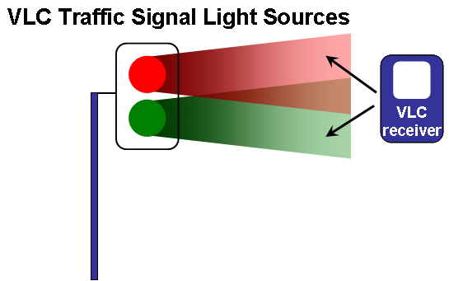
- A case of VLC Application using Color Channels: single color at one snap time
There are various VLC scenarios using many color channels.
- Single color at one time
- Single color at one lamp
- Multiple color at one lamp
In case of single color at one time, a receiver receives only one color.

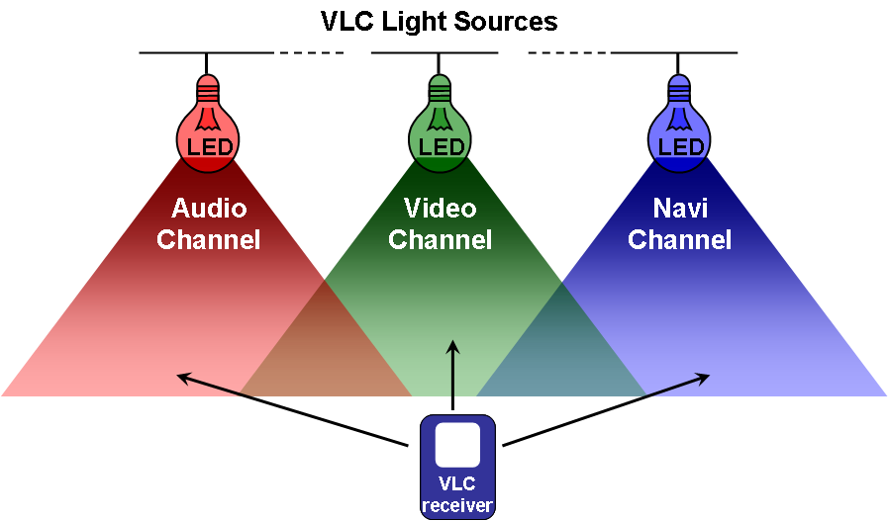
- A case of VLC Application using Color Channels: single color of a lamp
In case of single color from one lamp, a receiver receives several colors from different lamps. A VLC receiver supports every color channels. When audio, video, and navigation services are given by the respective R, G, B channels.
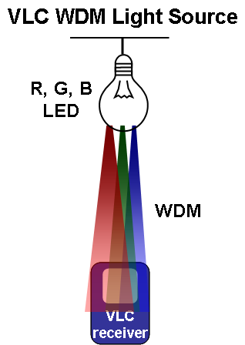
- A case of VLC Application using Color Channels: multiple colors of a lamp
In case of multiple colors from one lamp, a receiver has to support a WDM technology as well as multiple color receiving capability.

There are basic receiver requirements for VLC applications using color channels.
The first thing is A VLC receiver must support the various color channels according to VLC band plan when we use the various color channels.
The second thing is A VLC receiver must have constant receiver sensitivities in a tolerance range for the respective color channels because it will be in trouble if a VLC receiver operates well on a certain color channel but it do not operates on another color channel.
The color channel tolerance of receiver sensitivity is needed for a better communication. We need to know the sources of color channel differences in receiver sensitivity for the color channel tolerance. These are the sources of color channel differences in receiver sensitivity. Of course, besides this source, other things can make the color channel differences. VLC using color channels basically has the color channel difference because of the relation between the radiometric and photometric units. VLC transmitters using various color channels has so different light powers (Watt) at respective color channel even under the same conditions because even under the VLC environment, human eye have to feels that each VLC color channel source emit each color light at the same brightness. The same condition means the same brightness and divergence angle at the same distance. A green color channel has less radiant flux (Watt) than a red or blue channel at the same brightness (lumen).
Most of Si-photo detectors show different sensitivities depending on the visible wavelength region.
- Calculated Color Channel Difference Table @ Receiver Input
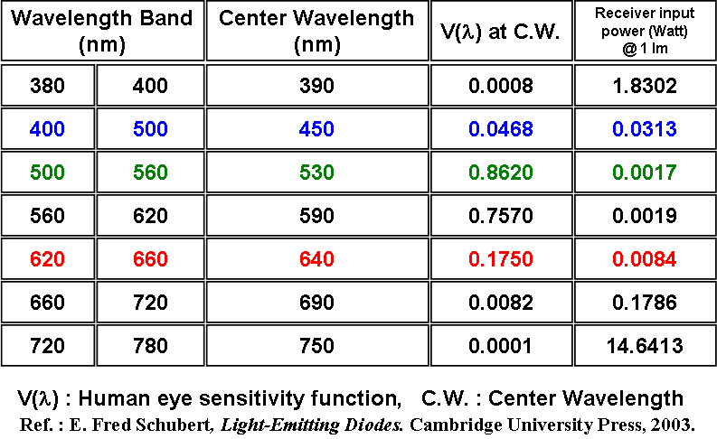
This table is calculated table showing how much receiver input power difference for each color channel happens when we consider.
V lamda is relative eye sensitivity function at center wavelength. For simple calculation, we calculated the receiver input power for only each center frequency. Here we suppose 1 lumen enter into the receiver.
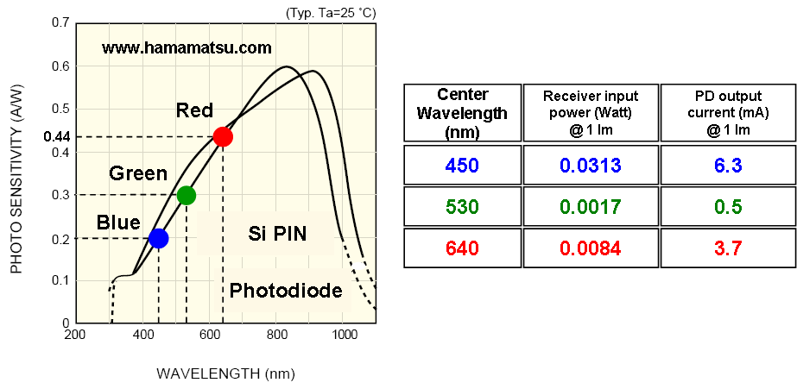
- Calculated Color Channel Difference Table @ Photo detector Output
This table is calculated table showing how much receiver output current difference for each color channel after O/E (Optical to Electronic) power conversion happens when we consider both the photometry to radiometry conversion and the wavelength dependence on photo diode (PD).
Calculation was done only three R, G, B color channels. VLC using color channels basically has the color channel difference in receiver sensitivity because of the relation between the radiometric and photometric units and the wavelength dependence of a VLC receiver. We propose we need to make the concept of the color channel tolerance of receiver sensitivity.
- Proposal on Color Channel Tolerance (2)
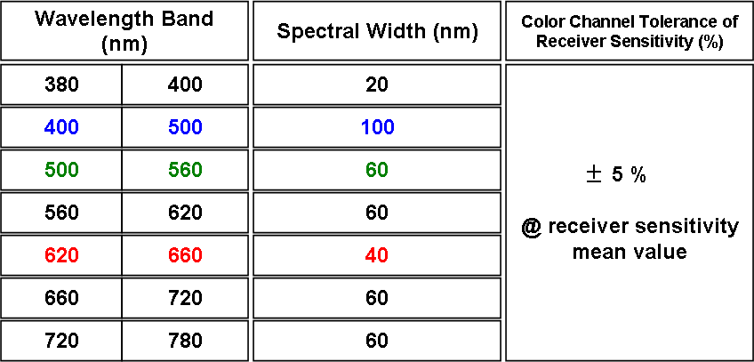
We propose that we, VLC, determine the Color channel tolerance receiver sensitivity in VLC using color channels as plus minus 5 % of receiver sensitivity mean value. Receiver sensitivity mean value means the average values of receiver sensitivities for each color channel.

Protocol implementation conformance statement (PICS) proforma
FFS

Regulation
There are two eye/skin safety issues related to regulation.
- Visible light flickering
- Visible light strength
The PHY modulation of Visible Light Communication can make light flickering. The light flicker can have harmful health impacts on humans/animals.
A light flicker is an impression of unsteadiness of visual sensation induced by a light stimulus whose luminance or spectral distribution fluctuates with time [IEC 1000-3-3] Critical fusion frequency (CFF, a.k.a. flicker fusion threshold) is a frequency at which an intermittent light stimulus appears to be completely steady to the observer [Wikipedia].
A light flicker causes harmful health impacts: Visual discomfort [Stone, 1990], Eyestrain [Lindner, 1993], Headache [Wilkins, 1989], Increase in speed and decrease in performance of mental tasks (reading comprehension) [Küller, 1998], Repetitive behaviour of autistic children [Colman, 1976], Photosensitive epilepsy (2% of all epilepsy cases) [Harding, 1995].
Requirement: Even though low-bit-rate transmission or bunching data, the modulation frequency of VLC MUST be higher than CFF (critical fusion frequency) threshold.
The CFF (critical fusion frequency) threshold is :
- The 1/minimum flickering frequency is 200 Hz ( = 5ms).
- Brightness of each Maximum Flickering Time Period (MFTP) must be all equal

-------------------------

