IEEE P802.15
Wireless Personal Area Networks

Project | IEEE P802.15 Working Group for Wireless Personal Area Networks (WPANs)
Title | Proposal for selected VLC features: Multiplexing, MAC Architecture, Dimming
Date Submitted | 12 October 2009
Source | Doug Castor, Samian Kaur,  Weimin Liu  InterDigital Communications Corporation LLC  781 Third Ave.  King Of Prussia, PA 19406 | Voice: 610 878 7800  Fax: [ NA ]  E-mail: douglas.castor@interdigital.com;  Samian.Kaur@interdigital.com;Weimin.Liu@interdigital.com
Re: | Response to call for proposals on 25th August, 2009.  Support for InterDigital Proposal “VLC Dimming Proposal”, IEEE 802.15-09-0641-00-0007. September 2009.  Support for InterDigital Proposal “VLC Proposal for Multiplexing and MAC features”, IEEE 802.15-09-0642-00-0007. September 2009.
Abstract | Multiplexing is needed in VLC mobile-infrastructure systems. This proposal presents methods for both intra-luminary and inter-luminary multiplexing. Additionally, MAC concepts for PDU structure, MAC functional entities, and uplink coordination, and dimming are presented.
Purpose | Proposal to IEEE 802.15.7. VLC TG
Notice | This document has been prepared to assist the IEEE P802.15. It is offered as a basis for discussion and is not binding on the contributing individual(s) or organization(s). The material in this document is subject to change in form and content after further study. The contributor(s) reserve(s) the right to add, amend or withdraw material contained herein.
Release | The contributor acknowledges and accepts that this contribution becomes the property of IEEE and may be made publicly available by P802.15.

Contents
1 Overview 3
1.1 General 3
1.2 Scope 3
1.3 Purpose 3
2 References 3
3 Definitions 3
4 Network Description 4
4.1 Topologies 4
4.2 Modes 5
4.3 Uni-directional Support (Simplex Mode) 5
5 PHY Features 5
5.1 PHY Band Separation and Aggregation 6
5.1.1 Color bands 7
5.2 PHY Multiplexing 7
5.2.1 CDM 7
5.3 Transport Channels 8
5.4 Dimming 8
5.4.1 Brightness and Data Duty Cycle 8
5.4.2 Duty Cycle Alignment Across Luminaries 10
6 MAC Features 10
6.1 MAC Architecture 11
6.2 MAC PDU Format 12
6.3 MAC Multiplexing and Multiple Access 12
6.4 Device Discovery 13
6.5 Dimming 14
7 Appendix: Example VLC Simplex Use Case with Adaptation Layer 16

Overview

General
Visible Light Communications (VLC) is envisioned to be used in a variety of applications generally falling into one of the following topology classifications: peer-to-peer, where peers may be fixed, mobile or vehicular mounted, and infrastructure-to-mobile/vehicular. For VLC in infrastructure topologies, it is essential to support communications features that coexist without interruption to the primary use of LEDs for lighting. In many cases, this lighting will be diffuse with overlapping footprints of coverage.

Scope
In this document we described several essential features for the use of VLC in infrastructure systems, including
- Multiplexing and multiple access in VLC communication channel
- Dimming
- Support of multiple bands through data separation/aggregation
- MAC architecture
- MAC PDU format
- Optional adaptation layer for alternative PHY support

Purpose
The purpose of this document is to provide written text for the InterDigital features proposed for the IEEE 802.15.7 standard.

References
- Sridhar Rajagopal, Ying Li, Farooq Khan (Samsung), Dimming considerations for visible light communication, IEEE 802.15-09-0369-00-0007, May 2009.
- Taehan Bae, et.al. (Samsung), Samsung PHY proposal to 802.15.7, IEEE 802.15.09-0660-00-0007, September 2009.

Definitions
M Number of bands (e.g. colors)
N Size of MAC PDU
$α$ Forward Error Correction (FEC) Coding Rate
SF Spreading factor
N_{F} Number of bits in a data frame
N_{PDU} Number of bits in a data frame
B Average Brightness of a given modulation
L Average Illumination level desired by user
$γ$ Data duty cycle after dimming is applied
T Duration of the data frame in the physical layer

Network Description

Topologies
Applications of visible light communications include communication node types among the categories listed in Table 4-1.
Table 4-1 Node Types
Node | Definition | Application Examples
Infrastructure | Networked Communications node installed at a permanent location | VLAN, ATM Machine
Mobile | Low mobility device, may include Fixed devices | PDA
Vehicular | High mobility node associated with transportation applications | automobile

Figure 4-1 shows a combined representation of the network topology and illustrates the communication interfaces to be considered in this document. The Q interface exists between an infrastructure node and a technology (e.g. PLC, Ethernet) for connectivity to a network. The R interface is the VLC link between an infrastructure node and a fixed, mobile or vehicle node. The R_{xy} interface is considered for representing either inter-luminary interference or for spatial multiplexing in future IEEE 802.15.7. The P interface is for Peer-to-Peer communication without connectivity to a network.
Figure 4-1 VLC network topology
The scope of 802.15.7 is the MAC and PHY. Above the MAC, the IEEE 802.2 Logical Link Control (LLC) or other LLC sublayer may be used, as shown in the architecture reference model of Figure 4-2 .
Figure 4-2 Layered Architecture

Modes
The topology and application requirements for the various node types lends itself to defining two different modes for the IEEE 802.15.7 system: Infrastructure mode and peer-to-peer mode.
In infrastructure mode, the IEEE 802.15.7 provides features for communications while respecting that illumination is the primary function of the LED source. Dimming is implemented such that data throughput is maximized given the available “on time” of the LED. Physical channels are constructed under the assumption that lighting may be diffuse with overlapping footprints, such that interferences from an unintended luminary can be rejected. Multiplexing capabilities are established to support multiple end users under an infrastructure light source.
In peer-to-peer mode, the IEEE 802.15.7 assumes sufficient spatial separation to limit interference from other VLC sources. This allows for maximizing data rate by eliminating the need for added signaling and physical layer redundancy.

Uni-directional Support (Simplex Mode)
VLC Simplex mode is defined to allow visible light links to work as a complementary wireless access technology with uni-directional support, and to allow visible light links to operate as a uni-directional broadcast-only channel. In Simplex mode, the MAC protocols allow control information including acknowledgements, channel quality measurements to be received from an external entity outside the 802.15.7 MAC. In the special case of Simplex-broadcast mode, retransmissions may be a fixed repetition (e.g. retransmit three times), and there is no dependency on the external entity.

PHY Features
Among several features, the PHY is responsible for providing a detectable communications channel within the constraints of the network topology. In the case of infrastructure topologies, this includes support of multiple wavelengths or bands. These bands may be associated with colors of the visible light spectrum (e.g. red, green, blue). Additionally for infrastructure mode support, multiplexing data from more than one luminary and dimming support is required.
Figure 5-3 is a block diagram of the data flow to illustrate the interference in the channel. In each luminary, band separation divides the data $x_{n}$into M bands of data,$b_{m}$. The channelization code C is applied followed by a scrambling or line code $s_{m}$. Conversion to unipolar data is performed for consistency with the OOK of the LED light source. Dimming is applied by adding either “1” or “0” filler values to the data path prior to conversion to light by the single or multi-band LED device.

Figure 5-3 VLC PHY Data Flow

PHY Band Separation and Aggregation
For infrastructure VLC, single-chip (band) based LEDs may be used for the most energy efficient solution, while three-chip(band) (e.g. RGB) LEDs may provide increased data rate. In the case of RGB, white light is still desired for the primary function of illumination meaning that all bands are active. Therefore, in the interest of maximizing data capacity, each band should be used by each luminary. Any band that remains active for the purpose of illumination, and does not carry data, adds to the system interference and lowers overall capacity.
To provide maximum capacity in infrastructure systems when multiple bands of light are used, the PHY separates (at transmitter) and aggregates (at receiver) data through a bit separator. Each data symbol sent in parallel over the air interface is converted to a serial data stream starting with the symbol at the lowest wavelength band to the highest wavelength band.
An input vector of length $N$ is passed into the PHY band separator. Bit padding with ‘0’ is employed to ensure a length N’ which is a multiple of M.
$$N'=M\left\lceil \frac{N}{M}\right\rceil$$
Bits into the band separator block are denoted as$x_{1},x_{2},x_{3},\text{.}\text{.}\text{.}x_{N}$. At the output of the band separator are M bands (e.g. for M=3 for an RGB triplet LED) with bits designated
$b_{m,k}=x_{M(k−1)+m}$ $k=1,2,3,\text{.}\text{.}\text{.},X$ $X=\frac{N'}{M}$ $m=1,2,\text{.}\text{.}\text{.},M$

Color bands
See other proposals for color band designations. For example, see reference [2].

PHY Multiplexing
The purpose of the physical layer multiplexing capability is to provide independent channels among multiple luminary sources (inter-luminary). In infrastructure topologies particularly, interference (including the common “near-far” problem) can be mitigated using Code Division Multiplexing (CDM). Variable length spreading codes are defined where the spreading factor is equal to the reuse factor, or number of channels desirable within a geographic area such as a room.
Figure 5-4 shows the architecture for a multi-luminary system (two luminaries shown for simplicity) with the interference paths that occur in the channel.
Figure 5-4 Multi-Luminary Architecture

CDM
The CDM codes are chosen from Walsh spreading codes as shown in the code tree of Figure 5-5.
Walsh spreading codes are orthogonal, i.e., if luminaries are assigned different spreading codes and identical scrambling code, and if they are transmitting synchronously, they can be perfectly separated by the receiver, and they do not interfere with each other. This orthogonality property can be used to solve the “near-far” problem commonly encountered in wireless transmission.
The channelization codes are defined as $C(k,\text{SF})$where SF is the spreading factor of the code and k is the channel number, 0 ≤ k ≤ SF-1.

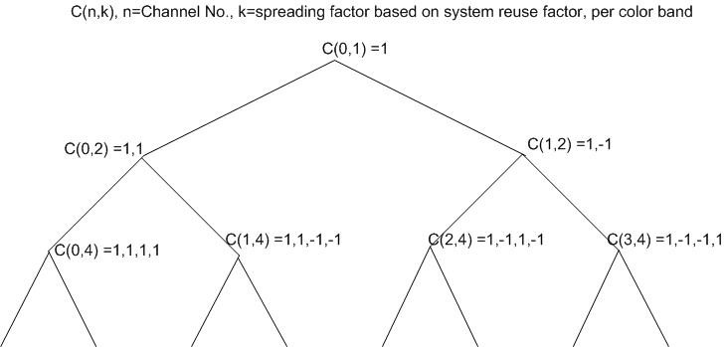
Figure 5-5 Walsh Code Tree
Figure 5-3 describes the physical channel data generation. For each band M, the data $b_{m,k}$is spread by channelization code C(k,SF) which is specific to a luminary. Optionally, a scrambling code (or line code) $s_{m}$is applied. A DC offset or conversion to unipolar signaling may then necessary for driving the light source (e.g. LED). If there are more luminaries than spreading codes, then at least two luminaries will have the same spreading code. In that case, different scrambling codes must be used. At the receiver, there will be interference among the luminaries. However, the interference is reduced by the spreading factor SF compared to no spreading.
Walsh codes have a property such that C(0,SF) is pure DC while all other codes have no DC component. After scrambling, each code will result in a random DC component. Low-frequency ambient noise can still interfere with transmission, however, the impact is reduced by a factor of SF compared to OOK.

Transport Channels
Data transmission and reception are performed using transport channels provided by the VLC physical layer. There are different types of transport channels according to their objectives and characteristics, as below:-
- Broadcast Channel (BCH): BCH is a downlink channel that broadcasts current status of the system and cells to entire cells
- Shared Traffic Channel (STCH): STCH is a channel used for user data transmission. Since this channel is shared by many users, data flow loaded on this channel is managed by the scheduler & medium access mechanism as described in Section 6.3. This channel is used for both uplink and downlink.

Dimming

Brightness and Data Duty Cycle
As an example, Figure 5-6 illustrates the relationship between the average brightness, B, of LEDs and the duty cycle of data transmission. For simplicity we assume data transmission is on-off-keying (OOK), where the average brightness during data transmission is 50% of the peak brightness. Examples of the average brightness, B, of other modulations is given in Table 5-2.
Table 5-2 Average Brightness of Other Modulations
Modulation | Average Brightness Level, B
OOK | 0.5
Manchester | 0.5
4-PPM | 0.25

As shown in Figure 5-6, over a time interval T, the data duty cycle is highest when the brightness is half of the maximum, and the duty cycle is the lowest when the brightness is highest or lowest. The average illumination level, L, over the time interval T is a function of the data transmission duty cycle $γ_{B}$and the LED filler level when no data is transmitted.
Figure 5-6. Brightness and OOK data transmission duty cycle.
Figure 5-7 shows the data transmission duty cycle as a function of the desired dimming or brightness level. When the brightness is above 50% of the maximum, further dimming allows data duty cycle to increase, while when the brightness is below 50% of the maximum, further dimming forces the data duty cycle to decrease. Data transmission is at the highest rate when the brightness is at 50%, and at the absolute maximum brightness level and in total darkness, no data transmission is possible.
A provisional illumination level below the absolute maximum LED brightness is specified when the illumination infrastructure is installed so that a minimum level of data transmission is possible at the provisioned maximum brightness.
Because of the near-logarithmic relationship between the perceived brightness by the human eye and the optical power, the desired brightness may need to be dimmed down to 0.1% of the maximum illumination level. Such a level poses a serious limitation on the data transmission duty cycle and thereby the data rate.
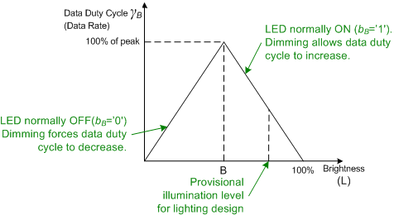
Figure 5-7. OOK data duty cycle as a function of brightness.

Duty Cycle Alignment Across Luminaries
When multiple luminaries are dimmed separately, they will in general have different data duty cycles. Optimum performance in terms of interference is achieved when their data transmission duty cycles have minimum overlap, because the filler bit can be estimated and removed completely. When the filler bit is zero, there is no interference at all. For the general case, coordination and synchronization is needed to minimize interference across luminaries.

MAC Features
The MAC sublayer is responsible for all access to the physical channels and is responsible for the following tasks:
- Dimming Control
- Broadcast and Common Data
- Packet Scheduling
- Employing TDM multiplexing for multiple access within a luminary
- Data framing: segmentation and assembly

MAC Architecture
The MAC subsystem interfaces with the upper layer via control and data signaling. The MAC subsystem performs various functions including classification and distribution of control and traffic packets for interfacing with the upper layer, state management of the UEs depending on the existence of data to be transmitted, packet scheduling, downlink broadcasting for information delivery. In order to perform the above functions, the 802.15.7 has several functional blocks as below :-

- Control/Traffic Packet Classifier & Distributor Block
- State Management Block
- Broadcasting/Paging/Common Control
- Buffer Management Block
- Transmission Control Block
- Packet Scheduling Block.

As shown in Figure 6-1, the mobile equipment MAC is a subset of the Infrastructure MAC.

Figure 6-8 VLC MAC Architecture

MAC PDU Format
Figure 6-9 shows the format of the MAC Protocol Data Unit (PDU) of size N_{PDU}. The size of each subfield is for future study (FFS).

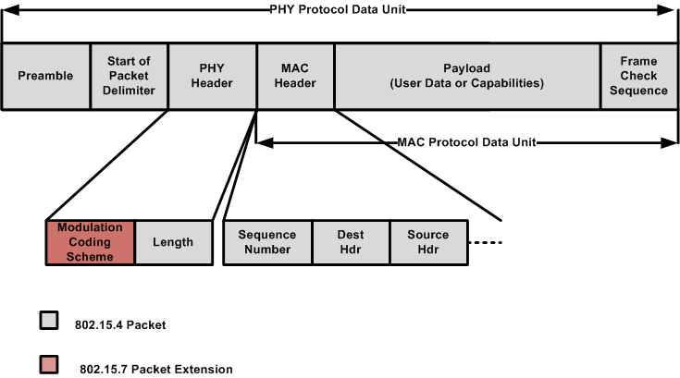
Figure 6-9 MAC Frame Structure

MAC Multiplexing and Multiple Access
The MAC multiple access feature is used within a luminary (intra-luminary) for the purpose of providing data service to multiple users under a luminary. TDM is used where the end user decodes and identifies an intended PDU from the Source and Destination fields of the MAC header, as shown in Figure 6-9.
The logical channels are channels that related to the types and contents of data transferred over the radio interface. There would be three categories of data traffic mapped to three logical channels –
- Broadcast: Broadcast channel is a downlink only channel that is used to broadcast capabilities of the infrastructure node, and current status of the system to the entire luminary domain. It is mapped to Broadcast Control Channel (BCH).
- Multicast: Multicast channel is a downlink only channel that is used to send common user-data transmission to a subgroup of users. It is mapped to shared traffic channel (STCH), and the per-packet identification of the group is made using a multicast MAC address.
- Unicast: Unicast channel is the point-to-point duplex channel between the infrastructure node and each of the end-user nodes. It is to carry user data transmission and is mapped to the shared traffic channel (STCH).

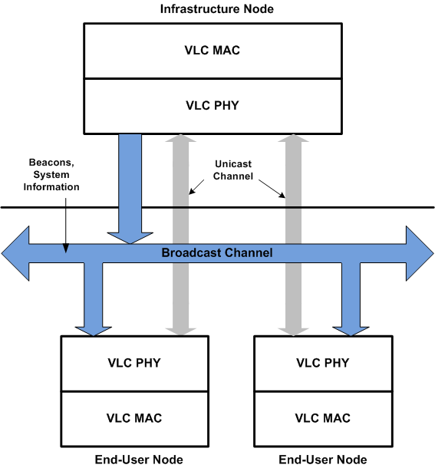
Figure 6-10 MAC Multiplexing and Multiple Accces

Device Discovery
As shown in Figure 6-11, the discovery procedure encompasses the process by which an end-user discovers the luminary to associate with. The Discovery and Association process starts with a newly turned on end-user device receiving beacon from all the nearby infrastructure luminaries. The end-user device then performs a selection algorithm to decide on the luminary it wants to associate with based on the advertised capabilities, signal measurements, data rate requirements, etc. The end-user device sends a request-to-associate with the selected luminary, and the association process is initiated. Once the luminary confirms that it has associated the end-user, it sends its resource allocation and details on how to use the channels for TX and RX access, CDMA parameters, bands to be used, etc. to the end-user. Now, the end-user is able to exchange data with the Luminary on the agreed upon channels.

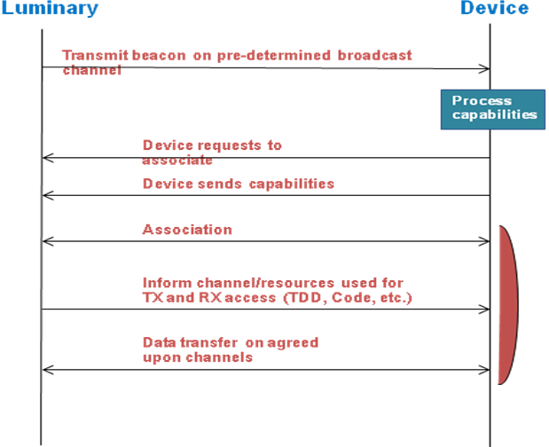
Figure 6-11 Discovery Procedure

Dimming
The MAC controls dimming by accepting a desired average illumination level, L, as a MAC input, and determining the duty cycle, $γ_{B}$ from the equation
$$γ_{B}=\left\{\begin{matrix}\frac{L}{B}, & L<B \\ \frac{1}{1−B}\left(1−L\right), & L≥B\end{matrix}\right.$$
The value of the filler bits, $b_{B}$is determine from the equation
$$b_{B}=\left\{\begin{matrix}0, & L<B \\ 1, & L≥B\end{matrix}\right.$$
The size of the MAC PDU is then computed as
$$N_{\text{PDU}}=N_{F}γ_{B}α$$
Where N_{F} is the size of the physical layer data frame (including filler bits), $γ_{B}$is the data duty cycle and $α$ is the FEC code rate.
Figure 6-12 is a block diagram showing the dimming . The MAC determines the ‘switchpoint’ based on the duty cycle $γ_{B}$ .

Figure 6-12 Dimming controlled by MAC

Appendix: Example VLC Simplex Use Case with Adaptation Layer
One of the problems with technologies like Visible Light Communications is that the availability of an uplink and downlink are independent due to device restrictions. In some environments, high intensity visible light based downlink can easily be provided from infrastructure lighting fixtures, while uplink is limited to the transmit power of a portable device and may need to be provided using spectrum other then visible light (e.g. RF).
Another feature of visible light is that the optical confinement of LED light can provide localized high bandwidth density. This can be leveraged by allowing spectrum aggregation and using multiple access technologies in a single direction.
It is envisioned that visible light would operate as a complementary communication link between two devices using, for example, visible light communications in the downlink and InfraRED in the uplink, or by creating hybrid topologies performing control and data communication over different access technologies, or by creating an “hotspot” functionality with multiple access technologies co-working in each direction.

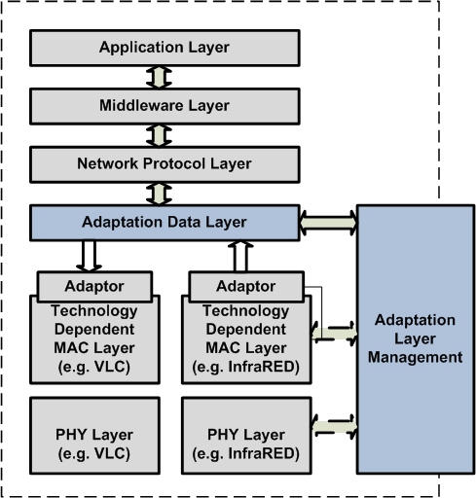

Figure 7-13 Use of Adaptation Layer within VLC Architecture

