IEEE P802.15
Wireless Personal Area Networks

Project | IEEE P802.15 Working Group for Wireless Personal Area Networks (WPANs)
Title | VLC Call for Contributions: Link Budget Reference Signal and Noise Spectral Distributions
Date Submitted | September 2009
Source | [Richard D Roberts]  [Intel]  [address] | Voice: [503-929-5624]  Fax: [ ]  E-mail: [ ]
Re:
Abstract
Purpose
Notice | This document has been prepared to assist the IEEE P802.15. It is offered as a basis for discussion and is not binding on the contributing individual(s) or organization(s). The material in this document is subject to change in form and content after further study. The contributor(s) reserve(s) the right to add, amend or withdraw material contained herein.
Release | The contributor acknowledges and accepts that this contribution becomes the property of IEEE and may be made publicly available by P802.15.

Call for Contribution – Link Budget Signal and Noise Spectral Distributions

At the September 2009 IEEE802.15.7 meeting an ad-hoc group met to discuss VLC link budget issues. Arising from this meeting was the identification of two primary issues:

1. We lack typical radiometer descriptions of LED flux spectral distributions (watts/Hz)

2. We lack detailed information about the noise density spectral distribution (watts/Hz), referenced to the modulation domain, as measured in various environments.

In this Call for Contributions, IEEE802.15.7 is soliciting contributions that provide LED radiant flux spectral distributions that can be used for link budget evaluation of proposals. Also, IEEE802.15.7 is soliciting contributions that provide modulation domain noise density spectral distributions, which can be used for link budget evaluation of proposals, taking into consideration background noise, photodetector noise and TIA (transimpedance amplifier) noise.

Reference Documents

Document 15-09-0597-02-0007, “Some comments on the power of LED light source for VLC”, Sang-KyuLim, Kang Tae-Gyu, DaeHo Kim, Ill Soon Jang

Document 15-09-0635-01-0007, “Update on VLC Link Budget Work”, Rick Roberts, Zhengyuan Xu

Document 15-09-0680-00-0007, “VLC Link Budget Ad Hoc Minutes”

Back Ground Information

The spectral distribution of the LED radiant flux and the modulation domain noise density are of prime interest.

Radiant Flux Spectrum

Below is an example of the spectral data typically provided by LED vendors. Notice that this plot provides relative luminous intensity.

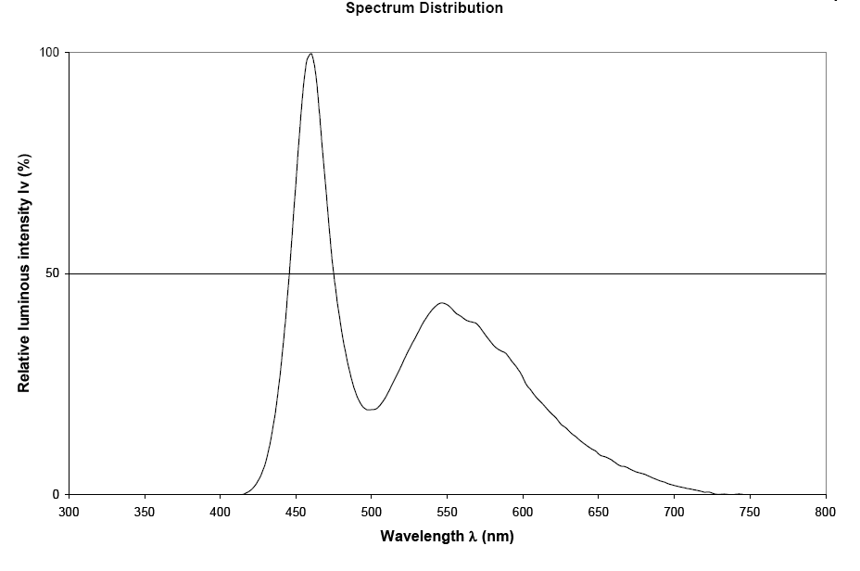

But what we actually want for link budget purposes is the radiant flux spectrum as shown in the next figure.

Committee IEEE802.15.7 is requesting contributions that provide a bona fide typical LED radiant flux spectral distribution that can be used for link budget evaluation of proposals.

Noise Density Spectral Distribution

Committee IEEE802.15.7 is interested in contributions that provide bona fide typical noise density spectral distributions as measured at the output of the TIA (transimpedance amplifier) as shown below.
Some sources that contribute to the noise density spectrum, as measured at the output of the TIA, are:
- Photodetector Noise
- Transimpedance Amplifier Noise
- Ambient light source AM envelope noise

Below is an example of what the noise density spectrum might look like based upon reasonable assumptions.

Again, committee IEEE802.15.7 is requesting contributions that provide a bona fide modulation domain noise density spectral distribution that can be used for link budget evaluation of proposals.

Contribution Formatting and Submittal

All submissions should be provided in softcopy, written in MS Word and/or MS PowerPoint, following the IEEE802.15 approved templates available at http://grouper.ieee.org/groups/802/15/pub/Download.html.

Please obtain a valid IEEE802.15.7 document number and upload your contribution to the document server at https://mentor.ieee.org/802.15/documents.

In addition, please notify the IEEE802.15.7 chair, Dr. E.T. Won (etwon@samsung.com) that the contribution is available for presentation scheduling at the next IEEE802.15.7 meeting. Please direction any clarification inquiries to Dr. R.D. Roberts at richard.d.roberts@intel.com .

