July 2009 IEEE P802.15-09-0511-03-0006

IEEE P802.15

Wireless Personal Area Networks

Project | IEEE P802.15 Working Group for Wireless Personal Area Networks (WPANs)
Title | FCC Comments Supporting MBANS NPRM ET Docket 08-59
Date Submitted | 14 July 2009
Source | David Davenport, GE Global Research, davenport@research.ge.com,  518-387-5041, 1 Research Circle, Niskayuna, NY, USA
Re: | IEEE P802.15-09-0510-01-0006, 15-08-0108-01-0006, 15-0254-02-0006, 15-0491-00-0006, 15-0537-01-0006 and 15-08-0761-01-0006.
Abstract | This document contains draft comments supporting FCC NPRM to allocate spectrum for Medical Body Area Networks.
Purpose | Discussion
Notice | This document has been prepared to assist the IEEE P802.15. It is offered as a basis for discussion and is not binding on the contributing individual(s) or organization(s). The material in this document is subject to change in form and content after further study. The contributor(s) reserve(s) the right to add, amend or withdraw material contained herein.

IEEE 802.15 Task Group 6 voted to engage 802.18 to submit comments in support of FCC’s Notice of Proposed Rulemaking to allocate spectrum for operation of Medical Body Area Networks. This motion will be made to 802.15 Working Group during the midweek session. The following pages include a draft document for review by 802.18 and for submission to the FCC as part of docket ET 08-59.

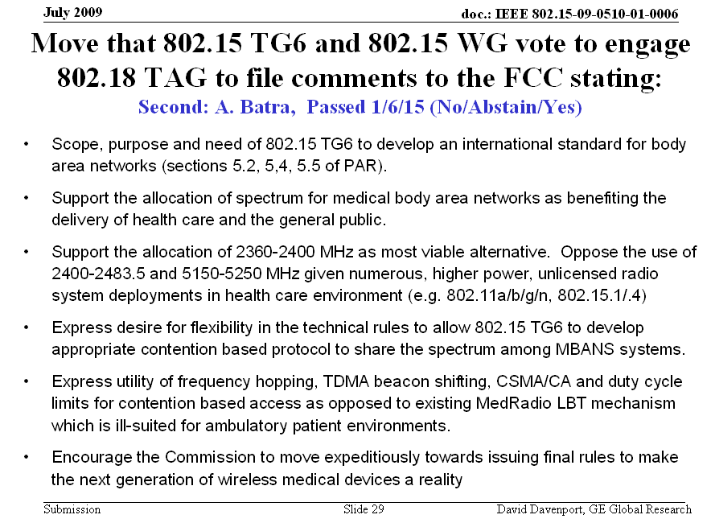

Before the
FEDERAL COMMUNICATIONS COMMISSION
Washington, D.C. 20554

In the Matter of )  )  Amendment of the Commission’s Rules )  to Provide Spectrum for the Operation of )  Medical Body Area Networks )  ) |  | ET Docket No. 08-59

Via the ECFS

To: The Commission

Comments Of IEEE 802.18
IEEE 802 hereby submits its Comments in the above-captioned Proceeding.

IEEE 802, as a leading consensus-based industry standards body, produces standards for wireless networking devices, including wireless local area networks “WLANs”), wireless personal area networks (“WPANs”), and wireless metropolitan area networks (“Wireless MANs”). We appreciate the opportunity to provide these comments to the Commission.
introduction
- On June 29, 2009 the Commission issued a Notice of Proposed Rulemaking, under ET Docket 08-59, in which the Commission seeks comment on allocating spectrum and establishing service and technical rules for the operation of Medical Body Area Network (or MBAN) systems using body sensor devices.

2. The IEEE 802.15 WPAN Task Group 6 was formed to define a standard for Body Area Networks. The scope, needs and objectives of the 802.15 Task Group 6 are defined in the group’s project authorization request (PAR) and include highly reliable, medical body area networks as proposed by the GEHC petition.

- Scope: This is a standard for short range, wireless communication in the vicinity of, or inside, a human body (but not limited to humans). It can use existing ISM bands as well as frequency bands approved by national medical and/or regulatory authorities. Support for Quality of Service (QoS), extremely low power, and data rates up to 10 Mbps is required while simultaneously complying with strict non-interference guidelines where needed. This standard considers effects on portable antennas due to the presence of a person (varying with male, female, skinny, heavy, etc.), radiation pattern shaping to minimize Specific Absorption Rate into the body, and changes in characteristics as a result of the user motions.

- Purpose: The purpose is to provide an international standard for a short range (i.e. about human body range), low power and highly reliable wireless communication for use in close proximity to, or inside, a human body. Data rates, typically up to 10 Mbps, can be offered to satisfy an evolutionary set of entertainment and healthcare services. Current Personal Area Networks (PANs) do not meet the medical (proximity to human tissue) and relevant communication regulations for some application environments. They also do not support the combination of reliability (QoS), low power, data rate and noninterference required to broadly address the breadth of body area network applications.

- Need for the Project: There is a need for a standard optimized for ultra low power devices and operation on, in or around the human body to serve a variety of applications including medical and personal entertainment. Examples of the applications served by the proposed standard are: Electroencephalogram (EEG), Electrocardiogram (ECG), Electromyography (EMG), vital signals monitoring (temperature (wearable thermometer), respiratory, wearable heart rate monitor, wearable pulse oximeter, wearable blood pressure monitor, oxygen, pH value, wearable glucose sensor, implanted glucose sensor, cardiac arrhythmia), wireless capsule endoscope (gastrointestinal), wireless capsule for drug delivery, deep brain stimulator, cortical stimulator (visual neuro-stimulator, audio neuro stimulator, Parkinson’s disease, etc…), remote control of medical devices such as pacemaker, actuators, insulin pump, hearing aid (wearable and implanted), retina implants, disability assistance, such as muscle tension sensing and stimulation, wearable weighing scale, fall detection, aiding sport training. This will include body-centric solutions for future wearable computers. In a similar vein, the same technology can provide effective solutions for personal entertainment as well. The existence of a body area network standard will provide opportunities to expand these product features, better healthcare and well being for the users. It will therefore result in economic opportunity for technology component suppliers and equipment manufacturers.

- IEEE 802 notes that the allocation of specialized, protected spectrum will benefit the coexistence and noninterference of medical body area networks. IEEE 802 further notes that such an allocation of spectrum will afford benefits to the efficient delivery of health care and the general public.

- IEEE 802 support the use of 2360-2400 MHz on a non-interfering basis for Medical Body Area Network applications.

- IEEE 802 recommends flexibility and technology neutrality in the technical rules to allow industry to develop appropriate access protocol to share the spectrum among MBANS systems.

CONCLUSION
6. IEEE 802 encourages the Commission to move expeditiously towards issuing final rules allocating spectrum for the operation of Medical Body Area Networks to enable the next generation of wireless medical devices and to realize benefit to the general public.

Respectfully submitted,

Michael Lynch

/s/
Michael Lynch
Chair, IEEE 802.18 Radio Regulatory TAG
2221 Lakeside Blvd.
Richardson, TX 75082
(972) 684-7518
freqmgr@ieee.org

The IEEE Local and Metropolitan Area Networks Standards Committee (“IEEE 802” or the “LMSC”).
This document represents the views of IEEE 802. It does not necessarily represent the views of the IEEE as a whole or the IEEE Standards Association as a whole.
https://development.standards.ieee.org/P625900033/par

