IEEE P802.15
Wireless Personal Area Networks

Project | IEEE P802.15 Working Group for Wireless Personal Area Networks (WPANs)
Title | FPP-SUN Detailed Proposal
Date Submitted | [6 July, 2009]
Source | [Choi, Mohindra, Monnerie, Shearer, Murali et al.]  [ETRI, Maxim, Landis+Gyr, Redpine Signals Inc.]  [address] | Voice: [ ]  Fax: [ ]  E-mail: [ ]
Re: | IEEE 802.15 Task Group 4g Call for Proposals (CFP) on 22 January, 2009
Abstract | Detailed Proposal of the Future-Proof Platform for the TG4g SUN
Purpose | Technical Description
Notice | This document has been prepared to assist the IEEE P802.15. It is offered as a basis for discussion and is not binding on the contributing individual(s) or organization(s). The material in this document is subject to change in form and content after further study. The contributor(s) reserve(s) the right to add, amend or withdraw material contained herein.
Release | The contributor acknowledges and accepts that this contribution becomes the property of IEEE and may be made publicly available by P802.15.
The following document is based on 802.15.4-2006, with 4c and 4d amendments. The sections that include text (with title highlighted in yellow) denote proposed amendments. The sections that do not require to be modified are left empty in this document.
Table of Contents
1 Overview 6
1.1 General 6
1.2 Scope 6
1.3 Purpose 6
2. Normative References 6
3. Definitions 6
4. Acronyms and Abbreviations 6
5. General Description 6
5.1 Introduction 6
5.2 Components of the IEEE 802.15.4 WPAN 6
5.3 Network topologies 6
5.3.1 Start network formation 6
5.3.2 Peer-to-peer network formation 6
5.4 Architecture 7
5.4.1 Physical layer (PHY) 7
5.4.2 MAC sublayer 7
5.5 Functional Overview 7
5.5.1 Superframe structure 7
5.5.2 Data transfer model 7
5.5.3 Frame structure 7
5.5.4 Improving probability of successful delivery 7
5.5.5 Power consumption considerations 7
5.5.6 Security 7
5.6 Concept of Primitives 7
6. PHY Specification(s) 7
6.1 General requirements and definitions 7
6.1.1 Operating frequency range 8
6.1.2 Channel assignments 8
6.1.3 Minimum long interframe spacing (LIFS) and short interframe spacing (SIFS) periods 8
6.1.4 RF power measurement 8
6.1.5 Transmit power 8
6.1.6 Out-of-band spurious emission 8
6.1.7 Receiver sensitivity definitions 8
6.2 PHY service specifications 8
6.2.1 PHY data service 8
6.2.2 PHY management service 8
6.2.3 PHY enumerations description 8
6.3 PPDU format 8
6.3.1 Preamble field 9
6.3.1a STF Field 9
6.3.2 SFD field 11
6.3.2a LTF Field 11
6.3.3 PHR field 11
6.3.4 PSDU field 12
6.4 PHY constants and PIB attributes 12
6.4.1 PHY constants 12
6.4.2 PHY PIB attributes 12
6.5 2450 MHz PHY specifications 12
6.5.1 Data rate 12
6.5.2 Modulation and spreading 12
6.5.3 2450 MHz band radio specification 12
6.5b OFDM PHY specifications 13
6.5b.1 Data rate 13
6.5b.2 Modulation and spreading 13
6.5b.3 Radio specification 14
6.6 868/915/950 MHz band binary phase – shift keying (BPSK) PHY specifications 14
6.6.1 868/915/950 MHz band data rates 14
6.6.2 Modulation and spreading 14
6.6.3 868/915/950 MHz band radio specification 15
6.6a 780 MHz band (optional) O-QPSK PHY specifications 15
6.6a.1 780 MHz band data rates 15
6.6a.2 Modulation and spreading 15
6.6a.3 780 MHz band radio specification 15
6.6b 950 MHz band Gaussian frequency-shift keying (GFSK) PHY specifications 15
6.6b.1 950 MHz band data rates 15
6.6b.2 Modulation and spreading 15
6.6b.3 950 MHz band radio specification 15
6.6 868/915 MHz band binary phase – shift keying (BPSK) PHY specifications 16
6.6.1 868/915 MHz band data rates 16
6.6.2 Modulation and spreading 16
6.6.3 868/915 MHz band radio specification 16
6.7 868/915 MHz band (optional) amplitude shift keying (ASK) PHY specifications 16
6.7.1 868/915 MHz band data rates 16
6.7.2 Modulation and spreading 16
6.7.3 868/915 MHz band radio specifications 16
6.7.4 SHR for ASK PHY 16
6.8 868/915 MHz band (optional) O-QPSK PHY specifications 16
6.8.1 868/915 MHz band data rates 16
6.8.2 Modulation and spreading 16
6.8.3 868/915 MHz band radio specifications 16
6.9 General radio specifications 17
6.9.1 TX-to-RX turnaround time 17
6.9.2 RX-to-TX turnaround time 17
6.9.3 Error-vector magnitude (EVM) definition 17
6.9.4 Transmit center frequency tolerance 17
6.9.5 Transmit power 17
6.9.6 Receiver maximum input level of desired signal 17
6.9.7 Receiver ED 17
6.9.8 Link quality indicator (LQI) 17
6.9.9 Clear channel assessment (CCA) 17
7. MAC Sublayer Specification 17
7.1 MAC sublayer service specification 17
7.1.1 MAC data service 18
7.1.2 MAC management service 18
7.1.3 Associated primitives 18
7.1.4 Disassociation primitives 18
7.1.5 Beacon notification primitives 18
7.1.6 Primitives for reading PIB attributes 18
7.1.7 GTS management primitives 18
7.1.8 Primitives for orphan notification 18
7.1.9 Primitives for resetting the MAC sublayer 18
7.1.10 Primitives for specifying the receiver enable time 18
7.1.11 Primitives for channel scanning 18
7.1.12 Communication status primitive 18
7.1.13 Primitives for writing PIB attributes 18
7.1.14 Primitives for updating the superframe configuration 18
7.1.15 Primitives for synchronizing with a coordinator 18
7.1.16 Primitives for requesting data from a coordinator 18
7.1.17 MAC enumeration description 18
7.2 MAC frame formats 19
7.2.1 General MAC frame format 19
7.2.2 Format of individual frame types 19
7.2.3 Frame compatibility 19
7.3 MAC command frames 19
7.3.1 Association request command 19
7.3.2 Association response command 19
7.3.3 Disassociation notification command 19
7.3.4 Data request command 19
7.3.5 PAN ID conflict notification command 19
7.3.6 Orphan notification command 19
7.3.7 Beacon request command 19
7.3.8 Coordinator realignment command 19
7.3.9 GTS request command 19
7.4 MAC constants and PIB attributes 19
7.4.1 MAC constants 19
7.4.2 MAC PIB attributes 19
7.5 MAC functional description 19
7.5.1 Channel access 19
7.5.2 Starting and maintaining PAN networks 19
7.5.2a Starting and maintaining SUN networks 20
7.5.3 Association and disassociation 20
7.5.4 Synchronizing 20
7.5.5 Transaction handling 20
7.5.6 Transmission, reception and acknowledgement 20
7.5.7 GTS allocation and management 20
7.5.8 Frame Security 20
7.6 Security suite specification 20
7.6.1 PIB security material 20
7.6.2 Auxiliary security header 20
7.6.3 Security operations 20
7.7 Message sequence charts illustrating MAC-PHY interaction 20
Annex A (normative) Service-specific convergence sublayer (SSCS) 21
Annex B (Normative) CCM* mode of operation 21
Annex C (Informative) Test vectors for cryptographic building block 21
Annex D (normative) Protocol implementation Conformance statement (PICS) proforma 21
Annex E (informative) Coexistence with other IEEE standards and proposed standards 21
Annex F (informative) IEEE 802.15.4G regulatory requirements 21
Annex G (informative) Bibliography 21
Annex K (informative) Considerations for 950MHz band 21
Annex J (informative) MPSK PHY requirements 21

1 Overview

1.1 General

1.2 Scope

1.3 Purpose

2. Normative References

3. Definitions

4. Acronyms and Abbreviations

5. General Description

5.1 Introduction
This amendment specifies alternate PHYs in addition to those of IEEE Std 802.15.4-2006, IEEE Std 802.15.4c-2009 and IEEE Std 802.15.4d-2009. These alternate PHYs are specified for the Smart Utility Networks.

5.2 Components of the IEEE 802.15.4 WPAN

5.3 Network topologies

5.3.1 Start network formation

5.3.2 Peer-to-peer network formation

5.4 Architecture

5.4.1 Physical layer (PHY)

Typically the OFDM PHY can be implemented on a radio that operates at one or more of the following unlicensed bands:
- 779-787 (e.g., China)
- 863-870 MHz (e.g., Europe)
- 902-928 MHz (e.g., North America)
- 917-923 MHz (e.g., Korea)
- 951-956 MHz (e.g., Japan)
- 2400–2483.5 MHz (worldwide)
- TV White Space (Multiple Regions)
- Others domains thanks to a band agnostic approach

Illustration of Band Agnostic Scalable OFDM

The beautiful property of scalable FFT OFDM is that the OFDM Symbol Time and OFDM Frequency Subcarrier spacing can be maintained “constant” irrespective of the Bandwidth Option that is chosen. Bandwidth scaling from 1MHz down to less than 100KHz is achieved in this fashion by scaling the FFT options from 128 point FFT down to 8 point. Because of this, the OFDM Physical layer definition is “Band Agnostic”.
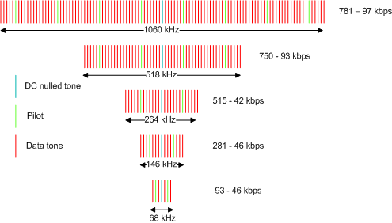

5.4.2 MAC sublayer

5.5 Functional Overview

5.5.1 Superframe structure

5.5.2 Data transfer model

5.5.3 Frame structure

5.5.4 Improving probability of successful delivery

5.5.5 Power consumption considerations

5.5.6 Security

5.6 Concept of Primitives

6. PHY Specification(s)

General requirements and definitions

(add this in addition to the existing PHY’s)
- A RF Band agnostic OFDM PHY which supports signal bandwidths from 1MHz down to <100KHz

6.1.1 Operating frequency range

The center of the signal covers the frequency bands defined in section 5.4.1.

6.1.2 Channel assignments
The channel map of the signal is defined through the programming of the center frequency of the first channel in a regional band and through the programming of the channel spacing and channel index.

6.1.3 Minimum long interframe spacing (LIFS) and short interframe spacing (SIFS) periods

6.1.4 RF power measurement

6.1.5 Transmit power

6.1.6 Out-of-band spurious emission

6.1.7 Receiver sensitivity definitions

6.2 PHY service specifications

6.2.1 PHY data service

6.2.2 PHY management service

6.2.3 PHY enumerations description

6.3 PPDU format
Each OFDM PPDU packet consists of the following basic components:
- A Short Training Field (STF), which allows a receiving device to do AGC, Packet detection, De-assertion of CCA (Clear Channel Assessment) based on CCA-Modes (Mode 1,2 or 3 as defined in section 6.9.9 of 802.15.4-2006) and Coarse Synchronization
- A Long Training Field (LTF), which allows a receiving device to do fine synchronization and perform channel estimation
- A PHY header (PHR), which contains frame data-rate and frame-length information. The PHY Header is encoded at the lowest data-rate supported for each bandwidth option.
- A variable length PSDU, which carries
  - The MAC sub-layer frame (MAC Header, MAC Payload and MAC-CRC-32 as defined in section 7.2 of 802.15.4-2006
  - Convolutional encoder tail-bits (6-zeros) and
  - Zero Pad-bits to extend the data fill an integer number of OFDM symbols

The Tail-bits and Pad-bits are stripped out by the Rx PHY before passing the MPDU to the Rx MAC.
The Tail-bits are 6 zeros that are not passed through the scrambler and are used for zero truncation of the convolutional decoder trellis state.
The Pad-bits are N zeros where, N is such that the total bit-length of the frame fills an integer number of OFDM symbols.

6.3.1 Preamble field
This field is replaced by the STF in OFDM mode. The following sub-section should be added:

6.3.1a STF Field

Frequency Domain STF:

The STF for the five scalable bandwidth OFDM options are defined by the following Matlab equations in the Frequency Domain:

STF_freq(Option-1) = sqrt(108/24)*[0, zeros(1,7), -1-j, zeros(1,7), -1-j, zeros(1,7), 1+j, zeros(1,7), 1+j, zeros(1,7), 1+j zeros(1,7), 1+j, zeros(1,15), zeros(1,16), 1+j, zeros(1,7), -1-j, zeros(1,7), 1+j, zeros(1,7), -1-j, zeros(1,7), -1-j, zeros(1,7), 1+j, zeros(1,7)];

STF_freq(Option-2) = sqrt(52/24)*[0, zeros(1,3), -1-j, zeros(1,3), -1-j, zeros(1,3), 1+j, zeros(1,3), 1+j, zeros(1,3), 1+j, zeros(1,3), 1+j, zeros(1,7), zeros(1,8),1+j, zeros(1,3) -1-j, zeros(1,3) 1+j, zeros(1,3) -1-j, zeros(1,3) -1-j, zeros(1,3) 1+j, zeros(1,3) ];

STF_freq(Option-3) = sqrt(26/12)*[0,zeros(1,3),-1-j, zeros(1,3), 1+j, zeros(1,3), 1+j, zeros(1,3), zeros(1,4), 1+j, zeros(1,3),-1-j,zeros(1,3),-1-j,zeros(1,3)]

STF_freq(Option-4) = sqrt(14/12)*[0,0,-1-j,0,1+j,0,1+j,0,0,0,1+j,0,-1-j,0,-1-j,0]

STF_freq(Option-5) = sqrt(6/4)*[0,0,1+j,0,0,0,-1-j,0]

STF Normalization
The STF uses lesser number of tones than the data-portion. Hence, Normalization of the frequency domain STF is required to ensure that the STF power is same as the rest of the data-frame. The Normalization value is sqrt(Nactive/ (2*Nstf)) where Nactive is the number of used subcarriers in rest of the OFDM frame for the particular FFT option and Nstf is the number of subcarriers used in the STF.

The following plots give an overview of the Sign of the STF in the frequency domain for all FFT options:
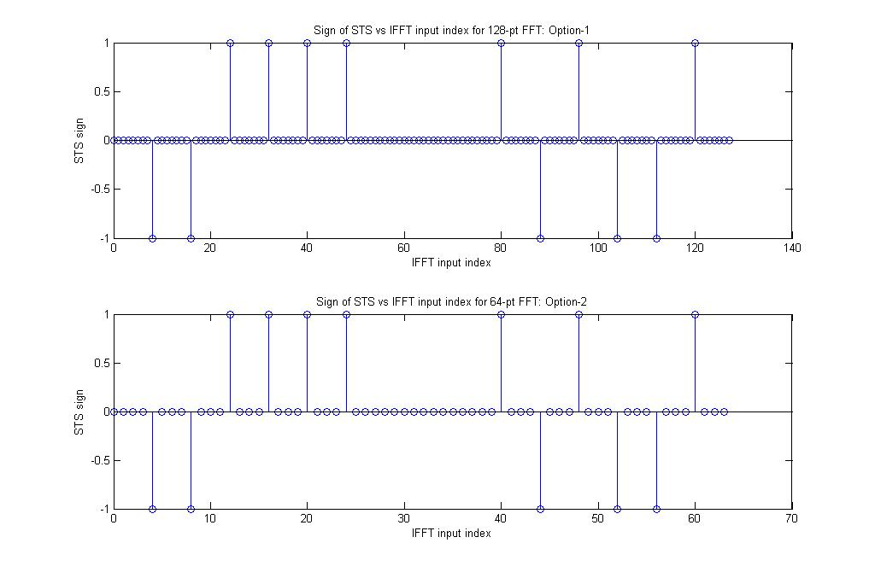

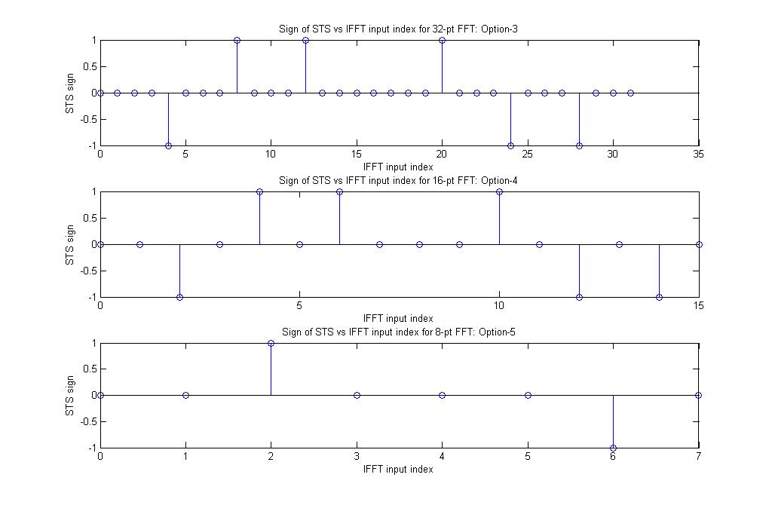

Time Domain STF Generation:

The Time-Domain STF for Option-n (n=1,2,3,4,5) is obtained as follows:
STF_time(Option-n) = IFFT(STF_freq(Option-n))

Time Domain STF Repetition:

The time-domain STF is repeated to fill 2-OFDM symbols (256us) or 4-OFDM symbols (512us) before transmission.

6.3.2 SFD field
This field is replaced by the LTF in OFDM mode. The following sub-section should be added:

6.3.2a LTF Field

Frequency Domain LTF:
The LTF for the five scalable bandwidth OFDM options are defined by the following Matlab equations in the Frequency Domain:

LTF_freq(Option-1)= {0,0,-1,1,1,-1,1,1,-1,-1,1,1,-1,1,-1,1,1,1,1,1,1,-1,-1,1,1,-1,1,-1,1,1,1,1,1,1,-1,-1,1,1,-1,1,-1,1,-1,-1,-1,-1,-1,1,1,-1,-1,1,-1,1,-1, zeros(1,17),1,1,-1,1,-1,1,1,1,1,1,1,-1,-1,1,1,-1,1,-1,1,1,1,1,1,1,-1,-1,1,1,-1,1,-1,1,-1,-1,-1,-1,-1,1,1,-1,-1,1,-1,1,-1,1,1,1,1,-1,-1,-1,1,0}

LTF_freq(Option-2)= {0,1,–1,–1,1,1,–1,1,–1,1,–1,–1,–1,–1,–1,1,1,–1,–1,1,–1,1, –1,1,1,1,1,zeros(1,11),1,1,–1,–1,1,1,–1,1,–1,1,1,1,1,1,1,–1,–1,1,1,–1,1,–1,1, 1,1,1}

LTF_freq(Option-3)= {0,1,-1,-1,1,1,-1,1,-1,1,-1,-1,-1,-1,zeros(1,5),1,1,-1,-1,1,1,-1,1,-1,1,1,1,1}

LTF_freq(Option-4)= {0,1,-1,-1,1,1,-1,1,zeros(1,1),-1,1,-1,1,1,-1,1}

LTF_freq(Option-5)= {0,1,-1,-1, zeros(1,1),1,-1,1}

Time Domain LTF Generation:

The Time-Domain LTF for Option-n (n=1,2,3,4,5) is obtained as follows:
LTF_time(Option-n) = IFFT(LTF_freq(Option-n))

Time Domain LTF Repetition:

The time-domain LTF is repeated to fill 2-OFDM symbols (256us) before transmission.

6.3.3 PHR field

The PHY Header (PHR) field is encoded using the lowest data-rate in each OFDM bandwidth option for Robustness. The list of data-rates for each OFDM bandwidth option can be found in the section: 6.5b.1.

The PHR field structure shall be formatted as illustrated in the following figure:

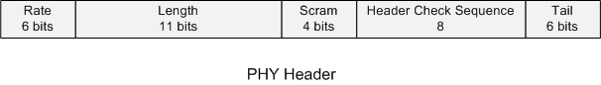
- Rate field specifies the data rate of the payload frame (6 bits)
- Length specifies the length of the payload (11 bits)
- Scrambling seed (4 bits)
- Header Check sequence 8 bit CRC taken over the data fields only
- Tail bits for Viterbi decoder flushing

The PHY Header would occupy M OFDM symbols. The value of M varies from 2 to 4 depending on the OFDM bandwidth option. The exact value of M would be derived once the PHY header is frozen.

6.3.4 PSDU field
In OFDM mode, the PSDU field structure shall be formatted as illustrated in the following figure:

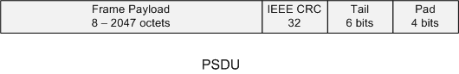
The variable length OFDM PSDU packet consists of the following basic components:
- The Frame Payload (MPDU) which contains the MAC Header, MAC Payload and MAC-CRC-32 as defined in section 7.2 of 802.15.4-2006
- Convolutional encoder tail-bits (6-zeros) and
- Zero Pad-bits to extend the data fill an integer number of OFDM symbols

The Tail-bits are 6 zeros that are not passed through the scrambler and are used for zero truncation of the convolutional decoder trellis state.
The Pad-bits are N zeros where, N is such that the total bit-length of the frame that fills an integer number of OFDM symbols.
The Tail-bits and Pad-bits are stripped out by the Rx PHY before passing the MPDU to the Rx MAC.

6.4 PHY constants and PIB attributes

6.4.1 PHY constants

6.4.2 PHY PIB attributes

6.5 2450 MHz PHY specifications

6.5.1 Data rate

6.5.2 Modulation and spreading

6.5.3 2450 MHz band radio specification

6.5b OFDM PHY specifications

6.5b.1 Data rate
The device shall support one or several of the following data rates:

Parameter | OFDM Option 1 | OFDM Option 2 | OFDM Option 3 | OFDM Option 4 | OFDM  Option 5 | Unit
FFT size | 128 | 64 | 32 | 16 | 8
Active Tones | 108 | 52 | 26 | 14 | 6
# Pilots tones | 8 | 4 | 4 | 2 | 2
# Data Tones | 100 | 48 | 22 | 12 | 4
Approximate Signal BW | 1064 | 518 | 264 | 146 | 68 | kHz
BPSK 1/2 rate coded and 4x repetition | 98 |  |  |  |  | kbps
BPSK 1/2 rate coded and 2x repetition | 195 | 94 | 43 |  |  | kbps
BPSK 1/2 rate coded | 391 | 187 | 86 | 47 |  | kbps
BPSK 3/4 rate coded | 586 | 281 | 129 | 70 |  | kbps
QPSK 1/2 rate coded | 781 | 375 | 172 | 94 |  | kbps
QPSK 3/4 rate coded |  | 562 | 258 | 141 | 47 | kbps
16-QAM 1/2 rate coded |  | 750 | 344 | 187 | 62 | kbps
16-QAM 3/4 rate coded |  |  | 516 | 281 | 94 | kbps

6.5b.2 Modulation and spreading

6.5b.2.1 Reference modulator diagram

6.5b.2.2 Encoding & Puncturing
The device shall use a binary convolution coding with K = 7, r = 1/2 and industry standard generator polynomial G_{1,2} = [133, 171]
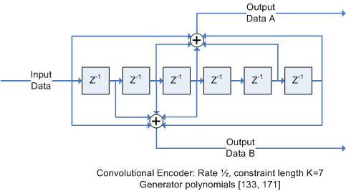

The device shall support also coding rates of ¾, derived by puncturing as follows:

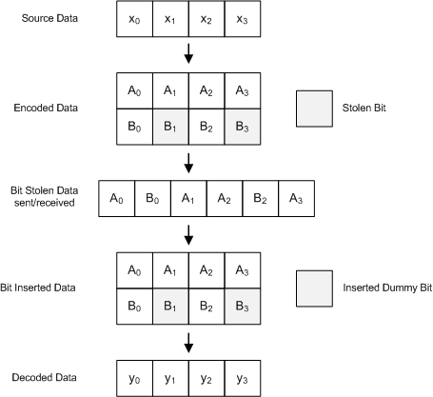

6.5b.2.3 Interleaving

The interleaving is defined for each one of the 5 OFDM options, through the following Matlab scripts:

Nbpsc => (BPSK =1, QPSK= 2, 16QAM = 4)

OFDM Option 1:
Ncbps = 100*{1,2}

i = (Ncbps/20)(k mod 20) + floor(k/20), k = 0, 1, 2, … Ncbps -1
j = s*floor(i/s) + (i + Ncbps - floor(20*i/Ncbps) ) mod s, i = 0, 1, 2, …, Ncbps
s = max(Nbpsc/2, 1)

OFDM Option 2:
Ncbps = 48*{1,2,4}

i = (Ncbps/16)(k mod 16) + floor(k/16), k = 0, 1, 2, … Ncbps -1
j = s*floor(i/s) + (i + Ncbps - floor(16*i/Ncbps) ) mod s, i = 0, 1, 2, …, Ncbps
s = max(Ncbps/2, 1)

OFDM Option 3:
Ncbps = 22*{1,2,4}

i = (Ncbps/12)(k mod 12) + floor(k/12), k = 0, 1, 2, … Ncbps -1

OFDM Option 4:
Ncbps = 12*{1,2,4}

i = (Ncbps/6)(k mod 6) + floor(k/6), k = 0, 1, 2, … Ncbps -1

OFDM Option 5:
[To Be Defined]

6.5b.2.4 Subcarrier Modulation Mapping

The modulation for the OFDM subcarriers can be BPSK, QPSK, or 16-QAM.
The input to the mapper is the bit-stream bi (where i is the bit index)
In case of BPSK 1-bit (b0) is mapped per subcarrier. In case of QPSK 2-bits (b1,b0) are mapped per subcarrier. In case of 16-QAM 4-bits (b3,b2,b1,b0) are mapped per subcarrier.
There is a normalization factor “c” for each constellation.

Bit mapping on the constellation is defined as below
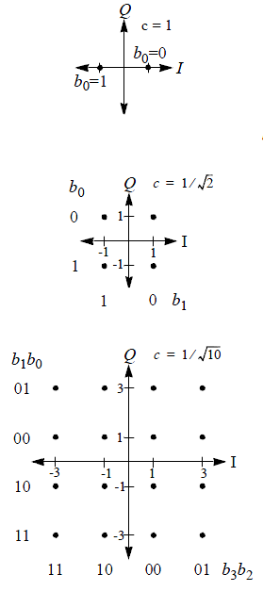

6.5b.2.5 Frequency spreading
Frequency spreading is a method of replicating PSK symbols on different carriers

The device shall offer the possibility to create a 2x repetition through frequency spreading.

The spreading is performed by repeating the data on one side of the DC tone to the other side, using the conjugate value of the data.

The diagram indicates how the left half of the spectrum is replicated using conjugated versions of the PSK symbols

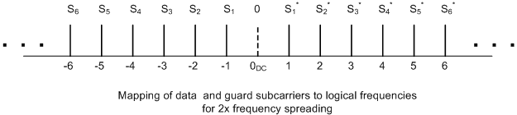

6.5b.2.6 Time spreading
Time spreading is a method of replicating PSK symbols on consecutive OFDM symbols.

The device shall offer the possibility to create a 2x repetition through time spreading. When time spreading is used, frequency spreading shall also be used. The effective repetition rate when time spreading is activated is 4x.

The diagram indicates how symbols are repeated
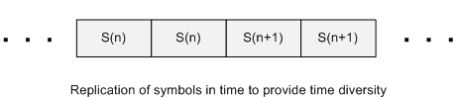

6.5b.2.7 Pilot Tones/Null Tones
The pilots tones and null tones are defined as follow:

 | OFDM Option 1 | OFDM Option 2 | OFDM Option 3 | OFDM Option 4 | OFDM  Option 5
Active Tones | 108 | 52 | 26 | 14 | 6
# Pilots tones | 8 | 4 | 4 | 2 | 2
# Data Tones | 100 | 48 | 22 | 12 | 4
# DC null tones | 1 | 1 | 1 | 1 | 1

OFDM Option 1:
P-54,54 = {0, 0, 0, 0, 0, -1, 0, 0, 0, 0, 0, 0, 0, 0, 0, 0, 0, 0, 0, 1, 0, 0, 0, 0, 0, 0, 0, 0, 0, 0, 0, 0, 0, -1, 0, 0, 0, 0, 0, 0, 0, 0, 0, 0, 0, 0, 0, -1, 0, 0, 0, 0, 0, 0, 0, 0, 0, 0, 0, 0, 0, -1, 0, 0, 0, 0, 0, 0, 0, 0, 0, 0, 0, 0, 0, -1, 0, 0, 0, 0, 0, 0, 0, 0, 0, 0, 0, 0, 0, 1, 0, 0, 0, 0, 0, 0, 0, 0, 0, 0, 0, 0, 0, -1, 0, 0, 0, 0, 0};

OFDM Option 2 and Option3:
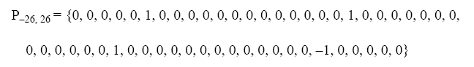
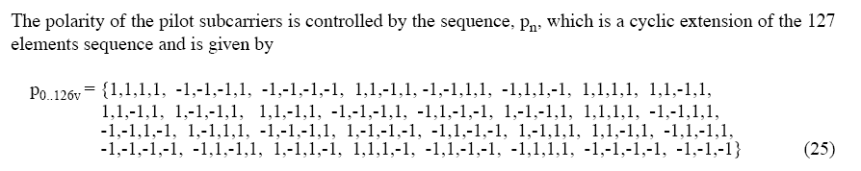

OFDM Option 4:
[To Be Defined]

OFDM Option 5:
[To Be Defined]

6.5b.2.8 IFFT
The suggested IFFT sizes are defined as follow:
 | OFDM Option 1 | OFDM Option 2 | OFDM Option 3 | OFDM Option 4 | OFDM  Option 5
FFT size | 128 | 64 | 32 | 16 | 8

Note: The standard implementer is free to implement a larger FFT/IFFT for any option (an example is for filtering purposes). This can be done as long as the tone spacing, data/pilot tone assignments and symbol rate are respected.

6.5b.2.9 Cyclic Prefix/Guard Interval
A cyclic Prefix (Guard Interval) should be inserted before each symbol. The duration of the CP shall be ¼ the symbol rate (25.6 us). It is a replication of the last part of the data symbol.

6.5b.3 Radio specification

6.5b.3.1 Operating Frequency range
The center of the signal should cover the frequency bands defined in section 5.4.1. The accuracy of the center frequency setting should be [To Be Defined]

6.5b.3.2 Transmit PSD mask
[To Be Defined]

6.5b.3.3 Symbol rate

The OFDM PHY symbol rate shall be 7.8125 kSymbol/s ±”ClockAccuracy”ppm
“ClockAccuracy” will be either 10, 20 or 40ppm depending on FFT-size and local regulations.

+/-40ppm for 900MHz & 2.4GHz ISM bands for 64-FFT.
Clock Accuracy for other FFT-sizes and Local regulations – [TBD]

6.5b.3.4 Receiver sensitivity
[To Be Defined]

6.5b.3.5 Receiver jamming resistance
[To Be Defined]

6.6 868/915/950 MHz band binary phase – shift keying (BPSK) PHY specifications

6.6.1 868/915/950 MHz band data rates

6.6.2 Modulation and spreading

6.6.2.1 Reference modulator diagram

6.6.2.2 Differential Encoding

6.6.2.3 Bit-to-chip mapping

6.6.2.4 BPSK modulation

6.6.3 868/915/950 MHz band radio specification

6.6.3.1 Operating Frequency range

6.6.3.2 915/950MHz band transmit PSD mask

6.6.3.3 Symbol rate

6.6.3.4 Receiver sensitivity

6.6.3.5 Receiver jamming resistance

6.6a 780 MHz band (optional) O-QPSK PHY specifications

6.6a.1 780 MHz band data rates

6.6a.2 Modulation and spreading

6.6a.2.1 Reference modulator diagram

6.6a.2.2 Bit-to-Symbol mapping

6.6a.2.3 Symbol-to-chip mapping

6.6a.2.4 O-QPSK modulation

6.6a.2.5 Pulse Shape

6.6a.2.6 Chip Transmission order

6.6a.3 780 MHz band radio specification

6.6a.3.1 Operating Frequency range

6.6a.3.2 Transmit PSD mask

6.6a.3.3 Symbol rate

6.6a.3.4 Receiver sensitivity

6.6a.3.5 Receiver jamming resistance

6.6b 950 MHz band Gaussian frequency-shift keying (GFSK) PHY specifications

6.6b.1 950 MHz band data rates

6.6b.2 Modulation and spreading

6.6b.2.1 Reference modulator diagram

6.6b.2.2 Data whitening

6.6b.2.3 GFSK modulation

6.6b.3 950 MHz band radio specification

6.6b.3.1 Operating Frequency range

6.6b.3.2 950 MHz band transmit PSD mask

6.6b.3.3 Symbol rate

6.6b.3.4 Receiver sensitivity

6.6b.3.5 Receiver jamming resistance

6.6 868/915 MHz band binary phase – shift keying (BPSK) PHY specifications

6.6.1 868/915 MHz band data rates

6.6.2 Modulation and spreading

6.6.3 868/915 MHz band radio specification

6.7 868/915 MHz band (optional) amplitude shift keying (ASK) PHY specifications

6.7.1 868/915 MHz band data rates

6.7.2 Modulation and spreading

6.7.3 868/915 MHz band radio specifications

6.7.4 SHR for ASK PHY

6.8 868/915 MHz band (optional) O-QPSK PHY specifications

6.8.1 868/915 MHz band data rates

6.8.2 Modulation and spreading

6.8.3 868/915 MHz band radio specifications

6.9 General radio specifications

6.9.1 TX-to-RX turnaround time

6.9.2 RX-to-TX turnaround time

6.9.3 Error-vector magnitude (EVM) definition

6.9.4 Transmit center frequency tolerance

6.9.5 Transmit power

6.9.6 Receiver maximum input level of desired signal

6.9.7 Receiver ED

6.9.8 Link quality indicator (LQI)

6.9.9 Clear channel assessment (CCA)

7. MAC Sublayer Specification

7.1 MAC sublayer service specification

7.1.1 MAC data service

7.1.2 MAC management service

7.1.3 Associated primitives

7.1.4 Disassociation primitives

7.1.5 Beacon notification primitives

7.1.6 Primitives for reading PIB attributes

7.1.7 GTS management primitives

7.1.8 Primitives for orphan notification

7.1.9 Primitives for resetting the MAC sublayer

7.1.10 Primitives for specifying the receiver enable time

7.1.11 Primitives for channel scanning

7.1.12 Communication status primitive

7.1.13 Primitives for writing PIB attributes

7.1.14 Primitives for updating the superframe configuration

7.1.15 Primitives for synchronizing with a coordinator

7.1.16 Primitives for requesting data from a coordinator

7.1.17 MAC enumeration description

7.2 MAC frame formats

7.2.1 General MAC frame format

7.2.2 Format of individual frame types

7.2.3 Frame compatibility

7.3 MAC command frames

7.3.1 Association request command

7.3.2 Association response command

7.3.3 Disassociation notification command

7.3.4 Data request command

7.3.5 PAN ID conflict notification command

7.3.6 Orphan notification command

7.3.7 Beacon request command

7.3.8 Coordinator realignment command

7.3.9 GTS request command

7.4 MAC constants and PIB attributes

7.4.1 MAC constants

7.4.2 MAC PIB attributes

7.5 MAC functional description

7.5.1 Channel access

7.5.2 Starting and maintaining PAN networks

7.5.2a Starting and maintaining SUN networks
TBD

7.5.3 Association and disassociation

7.5.4 Synchronizing

7.5.5 Transaction handling

7.5.6 Transmission, reception and acknowledgement

7.5.7 GTS allocation and management

7.5.8 Frame Security

7.6 Security suite specification

7.6.1 PIB security material

7.6.2 Auxiliary security header

7.6.3 Security operations

7.7 Message sequence charts illustrating MAC-PHY interaction

Annex A (normative) Service-specific convergence sublayer (SSCS)

Annex B (Normative) CCM* mode of operation

Annex C (Informative) Test vectors for cryptographic building block

Annex D (normative) Protocol implementation Conformance statement (PICS) proforma

Annex E (informative) Coexistence with other IEEE standards and proposed standards

Annex F (informative) IEEE 802.15.4G regulatory requirements

Annex G (informative) Bibliography

Annex K (informative) Considerations for 950MHz band

Annex J (informative) MPSK PHY requirements

