IEEE P802.15
Wireless Personal Area Networks

Project | IEEE P802.15 Working Group for Wireless Personal Area Networks (WPANs)
Title | IMEC Narrowband PHY Proposal
Date Submitted | [04 May, 2009]
Source | [Li Huang, IMEC]  [Guido Dolmans, IMEC]  [Yan Zhang, IMEC]  [Xiongchuan Huang, IMEC] | E-mail: [Li.Huang@imec-nl.nl]  [Guido.Dolmans@imec-nl.nl]  [Yan.Zhang@imec-nl.nl]  [Xiongchuan.Huang@imec-nl.nl]
Re: | Call for Proposals for IEEE 802.15 TG6.
Abstract | This presentation is the first part of IMEC’s narrowband proposal for IEEE 802.15.6. It focuses on the PHY proposal.
Purpose | For discussion by the group in order to provide applications scenarios, develop channel models and discuss radio architectures for IEEE P802.15.6.
Notice | This document has been prepared to assist the IEEE P802.15. It is offered as a basis for discussion and is not binding on the contributing individual(s) or organization(s). The material in this document is subject to change in form and content after further study. The contributor(s) reserve(s) the right to add, amend or withdraw material contained herein.
Release | The contributor acknowledges and accepts that this contribution becomes the property of IEEE and may be made publicly available by P802.15.

List of Abbreviation

BER | Bit Error Rate
SAR | Specific Absorption Rate
TRD | Technical Requirement Document
CRC | Cyclic Redundancy Check
DSSS | Direct Sequence Spreading Spectrum
ISI | Intersymbol Interference
LOS | Line-Of-Sight
MAC | Media Access Control
NF | Noise Figure
PER | Packet Error Rate
PHY | Physical Layer
PSDU | Physical layer Service Data Unit
QoS | Quality of Service
RF | Radio-Frequency
SAR | Specific Absorption Rate
SFD | Start Frame Delimiter
SIR | Signal-to-Interference Ratio
SNR | Signal-to-Noise Ratio
WBAN | Wireless Body Area Network

Dual Radio Overview

In the domain of health and comfort monitoring, the new IEEE 802.15.6 task-group, focusing on wireless body area network (WBAN) technology, endows a future generation of short-range electronics – both in body and on or around it – with a wireless communication standard for exchanging information. The WBAN short-range design will ideally reduce the chances of interference and eavesdropping. The need for security is also prevalent, given the sensitive nature of some of WBAN applications. Furthermore different levels of Quality of Service (QoS) are foreseen in order to meet the fundamentally different requirements of medical and non-medical applications, in terms of delay, data rate and reliability for instance.

Figure 1. A block diagram of a dual radio system.

To meet heterogeneous QoS requirements while ensuring ultra-low-power consumption, we propose to use a dual radio system as shown in Figure 1. In this system, the wakeup radio generates an instantaneous trigger signal, which wakes up the main radio only when necessary. It has been shown that wake-up radio could consume around 50 µW [1]. Thus, this dual radio system could solve one of the main problems in low-power wireless sensor network, namely the vast amount of energy wasted in idle listening mode in the case of low average traffic network. Furthermore, the wake-up radio circumvents the usual tradeoff between latency and energy efficiency requirements.

This document describes the first part of our IMEC narrowband proposal. We will focus on the physical layer (PHY) proposal in the main radio. In the second part of our narrowband proposal, we will discuss the media access control (MAC) in the main radio and the wakeup radio.

PHY Proposal Overview

Our proposed PHY includes a duty-cycled main radio with reliable wake-up radio for achieving key requirements of IEEE 802.15.6 WBAN. Our proposal could be summarized as follows:

- Frequency band: ISM band 2.4 – 2.485 GHz with possible 2.36 – 2.4 GHz extension
- Transmit power should be below 1 mW to satisfy local specific absorption rate (SAR) regulation
- Scalable date rate ranged from 16 kbps to 16 Mbps
- Receiver sensitivity should be better than -75 dBm
- 19 channels are allocated in the ISM band to support the coexistence of piconets
- 40 channels are allocated in the 2.36 – 2.4 GHz band to support the coexistence of piconets
- OOK/GFSK transmission with direct sequence spreading spectrum (DSSS) is used
- Root raised cosine or Gaussian is used as the reference pulse shaper
- Optional error correction is used to achieve flexibility and reliability
- Cyclic redundancy check (CRC) is used to verify the packet integrity

PHY Proposal Description

This section describes the PHY proposal in the main radio in detail.

Packet Structure

Figure 2. Structure of a packet.

The packet structure includes the synchronization (SHR) preamble, PHY header, and data field as shown in Figure 2.

The SHR preamble includes synchronization header and start frame delimiter (SFD).

The PHR header conveys information necessary for a successful decoding of the packet to the receiver.

The data field includes MAC header, payload, and CRC. We propose to use a systematic block code, which allows for optional decoding in the receiver depending on the link quality, to encode the data field. The (15,10) shortened Hamming code is proposed to use here. This code can correct all single errors and detect all double errors in each code word. CRC is used to check whether the packet has been correctively received. We choose CRC-16-CCITT as it is also widely used in 802.15.4, X.25, V.41, CDMA, Bluetooth, XMODEM, HDLC, PPP, IrDA, BACnet.

The length of different parts in the packet is summarized in Table 1.
Table 1. Length of different parts in the packet.

Channel Number

We propose to use 40 channels in 2.36-2.4 GHz band. Each of the channels occupies 1 MHz bandwidth. The channel is numbered as follows:

 | , | (1)

The choice of 1 MHz is due to the current frequency band proposal, which limits the bandwidth of 1 MHz. This is reasonable as the band is licensed and normally operates low-data rate applications.

We propose 19 channels in 2.4 GHz ISM band with 4 MHz bandwidth each. The channel is numbered as follows:
 | , | (2)

In this ISM band, higher bandwidth is used to support higher data rate. There are lower guardband (2400-2402 MHz) and higher guard band (2482-2483.5 MHz) to avoid interferences with other bands.

Modulation

Choosing modulation scheme is a trade off between bandwidth efficiency and energy per bit requirement. On the one hand, low power design desires low energy per bit requirement. On the other hand, low power design desires simple implementation, which normally requires higher energy per bit requirement. The bit error rate (BER) of different modulation schemes are plotted in Figure 3.

Bluetooth 3Mb/s
WiFi, Zigbee
Bluetooth 2Mb/s
Bluetooth 1Mb/s
Figure 3. BER of different modulation schemes.

We propose to use OOK or GFSK as a trade-off. They have reasonable energy per bit requirement, which is proved to be valid in successful standards (Bluetooth 2Mb/s). Moreover, it has been proved to facilitate ultra-low power receiver design. As shown in , Current commercial low power receivers consume more than 30 mW. While with OOK, it is shown that the receiver could consume less than 1mW [2].

Table 2. Overview of commercial chipsets and their main parameters.

Standard | Propr. | IEEE 802.15.4 |  | Bluetooth | Wibree
Manufacturer | Nordic | Chipcon | Freescale | Skyworks
Part number | RF24L01 | CC2420 | MC13192 | CX72303
RX power [mW] | 33.3 | 33.8 | 99.9 | 43.2 | 11.5
TX power [mW] | 33.9 | 31.3 | 82.0 | 34.2 | 12.0
max data-rate [kbps] | 2000 | 250 | 250 | 1000 | 200

Direct-Sequence Spread Spectrum

Direct-Sequence Spread Spectrum (DSSS) is applicable as our proposed bandwidth is normally wider than the minimum required bandwidth for the 802.15.6 supported data rate. The use of DSSS is desirable to achieve scalability since for a given bandwidth and modulation scheme, the change of the length of spreading code could result in the change of data rate. Moreover, the use of DSSS could achieve scalable processing gain since the longer length of spreading code could result in larger processing gain. As will be shown in Section 5.1, we limit the maximum length of spread code to be 64.

Duty Cycling

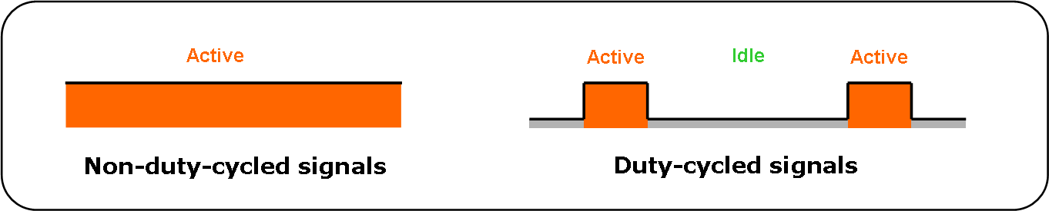
Figure 4. Non-duty-cycled and duty-cycled signals.

The duty cycling allows switching on the radio front-ends only for the instants where signals must be transmitted or received, and could thus significantly reduce the average power consumption. In principle, the duty cycling requires that the bandwidth should be larger than the symbol rate. The larger ratio of the bandwidth over the symbol rate could result in the more significant power consumption reduction. Our proposed bandwidth is normally wider than the minimum required bandwidth for the 802.15.6 supported data rate and thus allows the use of duty cycling.

The use of duty cycling is desirable to achieve scalability. The change of duty cycle results in the change of data rate. Moreover, the change of duty cycle results in the change of power consumption. As will be discussed in Section 5.1, our proposal could achieve the duty cycle as low as 0.39%. This is very desirable for ultra-low power design. Thus, energy scavenging could be used to achieve autonomous systems.

Table 3. Characteristics of various energy sources available in the ambient and harvested power.

Source | Source power | Efficiency | Harvested power
Ambient light  Indoor  Outdoor | 0.1mW/cm2  100mW/cm2 | 10-24% | 10 µW/cm2  10mW/cm2
Vibration/motion  Human  Industrial | 0.5m@1Hz 1m/s2@50Hz  1m@5Hz 10m/s2@1kHz | 1-10% | 4 µW/cm2  100 µW/cm2
Thermal Energy  Human  Industrial | 20mW/cm2  100 mW/cm2 | ± 0.1 %  ±3 % | 25µW/cm2  1-10mW/cm2
RF  Cell phone | 0.3 µW/cm2 | ± 50 % | 0.1 µW /cm2

In Table 3, the harvested power is listed for different sources, considering a 1 cm2 area for the device. It suggests that energy harvesters can be used effectively in the 10 µW – 1 mW range, which is a typical power consumed in our proposal. Therefore, our proposal is very suitable to achieve autonomous functionality of the wireless sensor node.

Pulse Shaping

For narrowband communication systems, efficient use of frequency spectrum is important. Pure OOK/FSK modulation is poor in spectrum efficiency: modulated signal exhibits high level side-lobe and slow roll-off. Pulse-shaping helps to improve spectrum efficiency by smoothening the transitions between bit “0” and “1”.

The typical pulse shapes include trapezoidal, exponential, Gaussian, and Raised cosine shapes. They feature different spectrum efficiency and hardware complexity. Trapezoidal pulse shapes are easy to generate, however they suffer from slow roll-off and high sideband level. Exponential pulse shapes can be generated in analog domain conveniently (RC filtering). Their envelopes are asymmetric, and have faster roll-off and lower sideband compared to trapezoidal pulses. Gaussian pulse shapes are mainly used in frequency/phase modulation instead of OOK/amplitude modulation to suppress sideband but increase the intersymbol interference (ISI). Raised-cosine pulse shapes are widely used pulse-shaping. They have definitive bandwidth and minimized sidebands, and are immunity to ISI. They are realizable in digital domain with moderate complexity;

We propose different reference pulse shapes in different modulations. In OOK modulation, we propose to use raised-cosine shape. The roll-off factor = 0.2, and thus the system has small leakage outside of the bandwidth. This factor is also used in 802.15.4. In FSK modulation, we propose to use Gaussian shape. The bandwidth time is 0.5 and the modulation index is 0.3. These parameters are also adopted in 802.15.1.

A standard compliant transmitter should make the main lobe of the cross-correlation function between the transmitted pulse shape and the reference pulse shape greater or equal to 0.8 over one fourth of the chip duration, and any sidelobes not greater than 0.3.

PHY Proposal Characteristics

This section describes the proposal characteristics for the purpose of comparison with other proposals.

Data Rate

The duty cycle and DSSS could achieve scalable data rate for a fixed bandwidth. In our proposal, five data rates are supported: 16Mbps, 4Mbps, 1Mbps, 256 Kbps, 64 Kbps, and 16 Kbps to meet the requirement of 10 kbps - 10 Mbps discussed in [3]. The different operating modes are listed from Table 4 - Table 6. Note that each channel has a bandwidth of 4 MHz in the 2.4 GHz band and 1 MHz in the 2.36-2.4 GHz band. Thus, channel bounding, which has been supported in 802.11n, is used to support the highest data rate (i.e. 16 Mbps). In our proposal, the channel bounding simultaneously uses four separate channels to transmit data in the 2.4 GHz band to support Mode 1.a1 in Table 4.

Table 4. Operating modes at high and middle data rates.

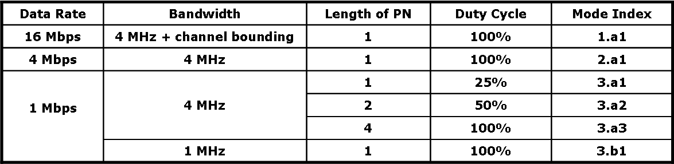

Table 5. Operating modes at low data rate.

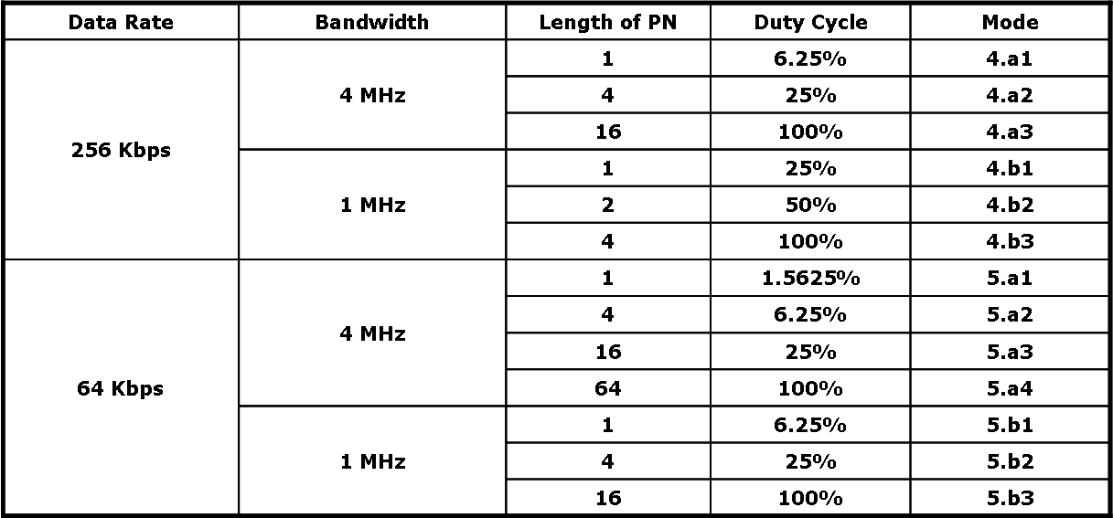

Table 6. Operating modes at very low data rate.

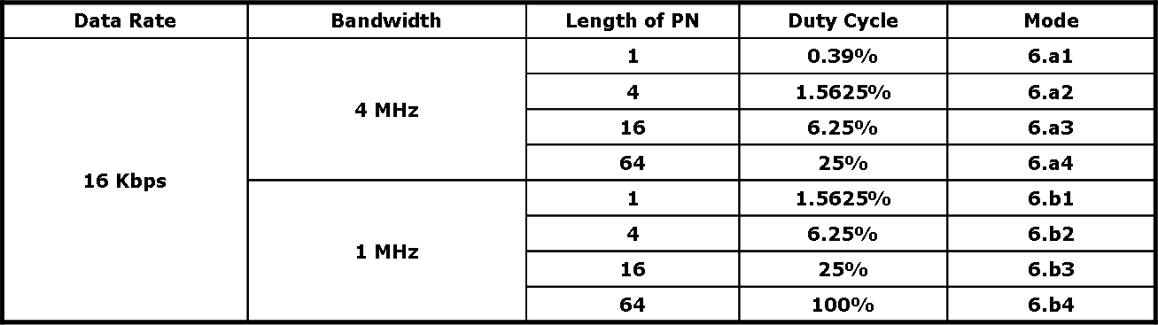

From the above tables, it is clear that our proposal could achieve scalable power consumption ranged from 0.39%~100%, and the scalable processing gain plus the duty cycling gain could be up to 24 dB.

Power Emission Level

Maximum 1 mW for effective radiated power is proposed to meet the local specific absorption rate (SAR) regulation where the transmit power should be in US < 1.6 mW and in EU < 20 mW [3]. This power also obeys the power regulation in GE’s proposed 2.36-2.4 GHz band, which limits the power below 1 mW [4]. In addition, pulse shape is used to reduce power leakage to adjacent channels.

Link Budget Analysis

Receiver Sensitivity
The receiver sensitivity in 802.15.6 is considered as the minimum input signal required to produce a specified packet error rate (PER) of 0.1 with a 256 octet PHY service data unit (PSDU) [3]. The receiver sensitivity could be computed as follows:

 | , | (3)

Value of Noise Floor: The noise floor could be typically computed as Noisefloor = -174 dBm + 10log(B). In our proposal, there are two possible bandwidths, i.e. 1 and 4 MHz. Therefore, the noise floor could be -114 or -108 dBm.

Value of SNR: For PER=0.1 with a 256 octet PSDU, the BER becomes 5.1444e-005 for uncoded systems. For OOK/GFSK modulation, the noncoherent demodulation requires Eb/No=13 dB. As required signal-to-noise ratio (SNR) is computed as SNR = (Eb/No)*(R/B), the different operating modes in our proposal could yield scalable SNRs, i.e. 13, 7, 1, -5, -11 dB.

Value of Noise Figure (NF): a value of 20 dB is achievable.

From the above, in the worst case, the receiver sensitivity is -75 dBm. Thus, we propose a receiver sensitivity of -75 dBm for IEEE 802.15.6.

Tolerable Pathloss
The tolerable pathloss of the system is computed as follows:

 | , | (4)
where the transmit power P_{t} is set to 0 dBm, receiver sensitivity P_{r} is set to -75 dBm, the scalable processing gain (P_{p}) plus the duty cycling gain (P_{d}) is listed in Table 7. Thus, the tolerable pathlosses could be ranged from 75 dB to 99 dB depending on the chosen operating mode.

Table 7. Tolerable pathlosses in different operating modes.

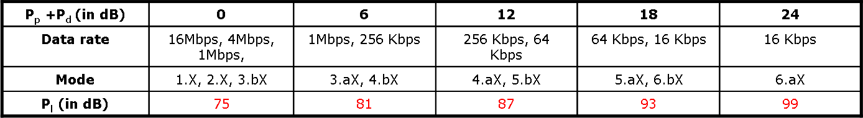

For the channel model of CM4 2.4 GHz at a distance of 3m introduced in [6], we find that all the pathlosses are below 75 dB. Thus, our proposal could operate in all the modes. In other words, the data rate could be up to 16 Mbps in all the channel scenarios as shown in Table 8.

Table 8. Supported data rates in different channel scearios.

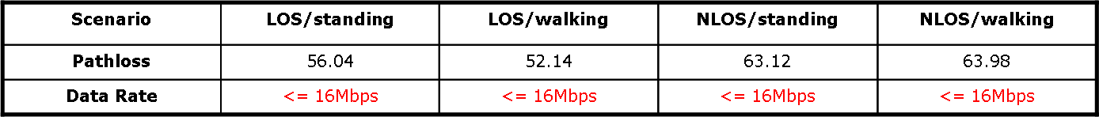

Packet Error Rate

The packet error rate is obtained by simulation. In simulation, we first compute the SNR for each packet as shown below

 | , | (5)

where the transmit power P_{t} is 0 dBm, antenna gain P_{a} is 3 dBi, processing gain (P_{p}) plus duty cycling gain (P_{d}) is chosen from 0, 6, 12, 18 or 24 dB, noise floor is chosen as -114 or -108 dBm depending on the employed bandwidth, noise figure is set to 20 dB, and additional losses (L) that includes matched filter loss and board/digital losses is set to 7 dB, and the pathloss (P_{l}) is changed every packet due to the small-scale fading. We then theoretically compute the coded or uncoded BER and thus the corresponding PER by assuming that the packet has a length of 256 octet payload. The final PER we obtain is the averaged PER over all the simulated packets.

The distribution of the pathloss uses the parameters in Section 8.2.9 in [6]. Since the Ricean factors in line-of-sight (LOS) scenarios are not provided, we assume all the scenarios follow Rayleigh fading for the worst case consideration. In addition, we ignore the packets whose corresponding pathlosses exceeds the 5% largest point since a link success probability of 95% is considered [3].

Figure 5 and Figure 6 plot the PERs for high data rate modes (> 1Mbps). As shown, in most of the cases, the PER is below 0.1 and sufficient to satisfy the requirement of 802.15.6 systems. Figure 7 and Figure 8 plot PERs for mid data rate modes (1Mbps). As shown, in almost all the cases, the PER is below 0.1 and sufficient to satisfy the requirement of 802.15.6 systems. Although not shown here, in all the cases in low data rate modes (<1Mbps), the PER is below 0.1 and sufficient to satisfy the requirement of 802.15.6 systems.

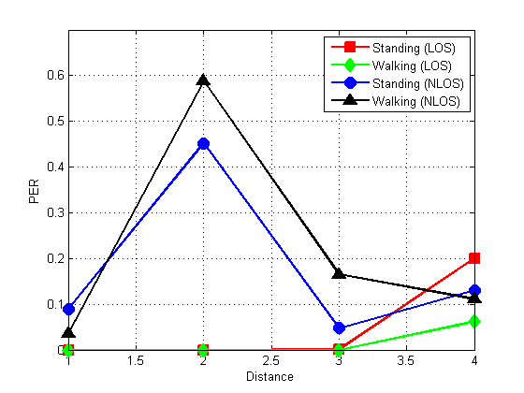

Figure 5. Uncoded PER in different scenarios for high data rates (4 Mbps or 16 Mbps).

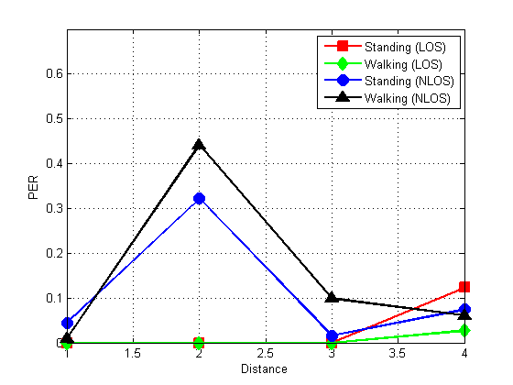
Figure 6. Coded PER in different scenarios for high data rates (4 Mbps or 16 Mbps).

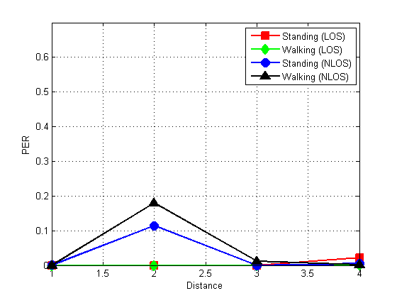

Figure 7. Uncoded PER in different scenarios for mid data rates (1 Mbps).

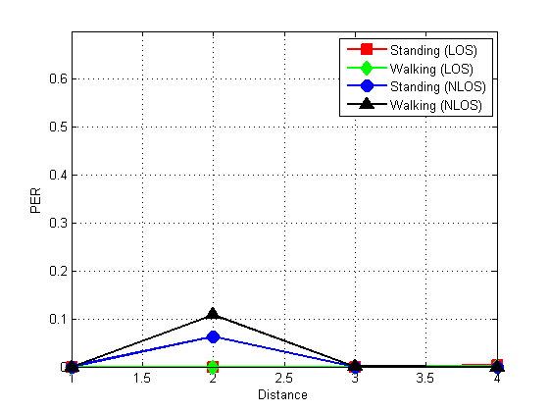
Figure 8. Coded PER in different scenarios for mid data rates (1 Mbps).

Interference & Coexistance

Link budget calculation shows that interference will be the main factor to degrade performance. In our proposal, the signal-to-interference ratio (SIR) should be above 13 dB for uncoded systems, and above 10 dB for coded systems.
We have the following to deal with the interference to and from other systems:

First, the DSSS is used to protect interferences from other systems by providing processing gain. The DSSS also spreads the signal over a larger bandwidth and thus equivalently reduces the interferences to narrowband systems.

Second, the duty cycling is used to provide duty cycling gain and could reduce the interference to and from continuous-time systems.

Third, pulse shaping is used to reduce interferences to adjacent channels.

Fourth, low transmission power (i.e. below 0 dBm) is used to reduce interferences to others.

Fifth, sufficient channels are assigned to allow the coexistence of 10 piconets. There are 19 channels in the 2.4 GHz ISM band and 40 channels in the 2.36-2.4 GHz.

Sixth, block codes are optionally used, which could minimize interferences from other systems.

Reliability

The reliability is guaranteed by the use of the duty cycling to achieve duty-cycling gain, by the use of DSSS to achieve processing gain, and by the use of optional error correction.

Scalability

In our proposal, the duty cycling and DSSS is used to achieve scalable data rate, scalable processing gain, and scalable duty cycling gain. In addition, channel bounding is used to support higher data rate.

Power Consumption

The scalable duty cycling allows different power consumption in different modes: 0.39%~100%.

Bonus Point

Our proposal could be supported by the superregenarative receiver, which has been shown to achieve a power consumption of 380 µW [2]. As shown in Figure 9, the main block is the radio-frequency (RF) oscillator which periodically starts up and shuts off oscillation controlled by a quench oscillator. The start up time of the RF oscillator is exponentially dependent on the magnitude of the input signal and could thus determine the presence of the signal. The main advantage of the super-regenerative receiver is the use of few components to achieve low-power and low-cost circuit design. Further, the use of the quench oscillator is inherently to use the concept of duty-cycling.

Figure 9. Architecture of a super-regenerative receiver.

References

- N. Pletcher, S. Gambini, and J. M. Rabaey, “A 2GHz 52µW Wake-Up Receiver with -72dBm Sensitivity Using Uncertain-IF Architecture,” Conference Proceedings, IEEE International Solid-State Circuits Conference, pp. 525 - 526, Feb. 2008, San Francisco, CA.

- B. P. Otis and J. M. Rabaey, "Ultra-low power wireless technologies for sensor networks" – Springer, 2007.

- B. Zhen, M. Patel, S. Lee, E. Won, and A. Astrin. (2008, Nov.). TG6 Technical Requirements Document. Available: https://mentor.ieee.org/802.15/dcn/08/15-08-0644-06-0006-tg6-technical-requirements-document.doc.

- D. Davenport. (2008, Nov.). Status of 2360 to 2400 MHz MBANS Proposal to the FCC. Available: https://mentor.ieee.org/802.15/dcn/08/15-08-0761-01-0006-status-of-2360-to-2400-mhz-mbans-proposal-to-the-fcc.pdf.

- A. Astrin. (2008, Nov.). TG6 Proposal Comparison Criteria. Available: https://mentor.ieee.org/802.15/dcn/08/15-08-0831-05-0006-tg6-proposal-comparison-criteria.doc.

- K. Y. Yazdandoost and K. S.-Pour. (2009, Apr.). Channel Model for Body Area Network. [Online]. Available: https://mentor.ieee.org/802.15/dcn/08/15-08-0780-08-0006-tg6-channel-model.pdf.

