IEEE P802.15
Wireless Personal Area Networks

Project | IEEE P802.15 Working Group for Wireless Personal Area Networks (WPANs)
Title | <title>
Date Submitted | [4 May, 2009]
Source | [J.S.Yoon, G.S. Ahn, M.J. Lee, S.S. Joo]  [CUNY, ETRI]  [140th St. and Convent Ave, New York, NY, USA] | Voice: [+1-212-650-7180 ]  Fax: [ ]  E-mail: [jsyoon@ee.ccny.cuny.edu gahn@ccny.cuny.edu, lee@ccny.cuny.edu, ssjoo@etri.re.kr ]
Re: | Versatile MAC for BAN proposal responding to TG6 Call for Proposals (15-08-0811-03-0006-tg6-call-proposals)
Abstract | This document describes a Versatile MAC that is being proposed to the TG6 group.
Purpose | Discussion in 802.15.6 Task Group
Notice | This document has been prepared to assist the IEEE P802.15. It is offered as a basis for discussion and is not binding on the contributing individual(s) or organization(s). The material in this document is subject to change in form and content after further study. The contributor(s) reserve(s) the right to add, amend or withdraw material contained herein.
Release | The contributor acknowledges and accepts that this contribution becomes the property of IEEE and may be made publicly available by P802.15.
Table of content
- General description…………………………………………………………………………………….3
- Features of Versatile MAC…………………………………………………………………………….3
  - Versatile…………………………………………………………………………………………...3
  - Expeditious………………………………………………………………………………………...3
  - Emergency treatment…………………………………………………………………....................3
  - Priority supported………………………………………………………………………………….3
  - Low energy consumption………………………………………………………………………….3
- Functional descriptions……………………..………………………………………………………….4
  - BAN Superframe (BSF)…………………………………………………………………………...4
  - Advertisement…………………………………………………………………………...................4
  - Contention Access Period (CAP)………………………………………………………………….4
  - Beacon……………………………………………………………………………………………..5
  - Data Transmit Period (DTP)…………………………………………………………....................5
    - Data Transmit Slot (DTS)…………………………………………………………………...5
    - Emergency Data Transmit Slot (ETS)………………………………………………………5
  - Optional……………………………………………………………………………………………5
    - ECAP……………………………………………………………………………...................5
    - BACK………………………………………………………………………………………..5
    - DACK………………………………………………………………………………………..5
- Energy saving………………………………………………………………………………..................6
- Prioritization…………………………………………………………………………………………...6
  - Priority classification………………………………………………………………………………6
  - Prioritized data transmit ………...………………………………………………………………...7
    - Priority based DTS allocation……………………………………………………………….7
    - Prioritized data transmit in ETS……………………………………………………………..7
    - Prioritized data transmit in CAP…………………………………………………………….7
- Versatile MAC functionality overview………………………………………………………………...8
- Numerical delay comparison………………………………………………………………..................9
  - Reservation delay………………………………………………………………………………….9
  - Emergency alarm delay…………………………………………………………………………..10

- General description

Body area network is the smallest personal area network covering body and near-body area. In comparison with other personal area networks, body area network is a much simpler and shorter range network that supports diverse applications, wide range data rate, low power consumption, and high level of QoS. In the light of the characteristics the medium access protocol for body area network is mainly concerned with lightweight, flexibility, and QoS assurance.

- Features of Versatile MAC

  - Versatility
As requirement indicates BAN MAC supports diverse applications such as medical and non-medical entertainment and different types of data such as continuous, periodic, non-periodic and burst along with high level QoS for each application. In order to digest the distinctive applications and data types in single MAC, the MAC should equip with techniques of both contention-based and time division-based schemes. This enables MAC to support all types of applications and traffics as well as satisfy QoS requirement.

  - Expeditious
Especially in medical emergency situation, for instance, at ER or battle fields, instant reporting of current vital status is extremely important. Straightway slot reservation and transmit with less latency is one of the major important requirements in BAN. Versatile Mac’s concatenate advertisement-CAP-beacon allows straightway reservation, prompt adaption to changes and it allows latency reduction of time sensitive real time data.

  - Emergency treatment
In consideration of urgency, emergency alarm should be treated specially. Versatile MAC equips with ETS (Emergency data transmit slot) in TDMA data transmit period. ETS is highly adaptable to abrupt emergency data and supports high QoS and reliability.

  - Priority supported
Versatile MAC handles data based on their priority. Prioritized back-off, carrier sense and data slot allocation are applied to all data transmission to serve higher priority data first.

  - Low energy consumption
One of the inherited advantages of TDMA is exact scheduling, when to transmit, receive, wakeup and sleep is allowed. Once scheduling is done, the nodes in the network can maximize battery lifetime using the transmit/receive schedule.

- Functional descriptions

  - BAN Superframe (BSF)
Ban superframe consists of five periods; advertisement, contention access period, data transmit period that consists of DTS and ETS, and inactive period or optional CAP Extension.

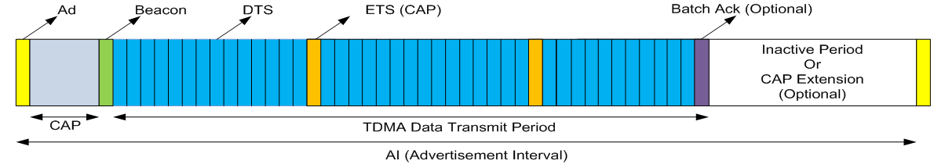
Figure 1 BAN Superframe

  - Advertisement (Ad)
Advertisement is the first period of BSF (BAN Superframe) followed by contention access period. Advertisement frame contains basic information on coordinator and superframe such as synchronization, coordinator address, ad interval, length of periods. The nodes that intend to use CAP period for data transmission and DTS reservation should listen ad frame first. Newly joined node adjusts its clock, obtains information on BC, BSF and prepares transmission. Once reservation is successfully done, the node can sleep during Ad and CAP period from next AI.

Initially superframe begins with only Ad and CAP period. Beacon and DTP are triggered only when DTS request is received during CAP. The duration of DTP is determined by the number of DTP request. If available, remaining time would be inactive period or optional CAP Extension period.

  - Contention Access Period (CAP)
This period is for non-periodic data, emergency alarm and command frames. The nodes intending to transmit packet during this period performs back-off and carrier sense so as to avoid collision. For fast access to channel, emergency alarm performs prioritized back-off and carrier sense.

BC collects all the DTS requests which contains priority and then allocates DTS slots according to their priorities. To prevent DTS shortage, BC allocates higher priority first from the first available slot. In case of insufficient DTS, lower priority slots may be preempted by higher priority data.

  - Beacon
BC Broadcasts beacon after CAP period. It synchronizes all the network members and informs interval, length of period and DTS reservation status. All the nodes that reserved DTS should listen beacon every AI to check reservation status changes. Through the concatenate ‘Ad-CAP-Beacon’ period, nodes can do straightway DTS reservation and transmission with less latency. It is also helpful for prompt accommodation to changes.

  - Data Transmit Period (DTP)
DTP is a TDMA Period for the latency-critical continuous and periodic data. It consists of multiple DTS (Data Transmit Slot) TDMA slots and configurable a few number of ETS (Emergency Data Transmit slot) contention access slots. BC allocate time slots sequentially from the first available ones regardless of DTS or ETS.

    - Data Transmit Slot (DTS)
This is an exclusive times slot. Only the node that is allocated this slot can transmit packet as soon as the slot time begins.

    - Emergency Data Transmit Slot (ETS)
This is a contention access slot that is for the sake of fast delivery of unexpectable emergency data. A node assigned to this slot performs carrier sense first so as to prevent possible collision with emergency alarm. If any, emergency data can be transmitted at this slot while the owner of the slot performs carrier sense. ETS slots enable urgent transmission for abrupt emergency alarm. The number of ETS is configurable.

  - Optional

    - CAP Extension (ECAP)
ECAP is the duration between the end of DTP and AI. If power is not a concern for BC, it can stay awake and maintain CAP. All kinds of traffic can be transmitted in this period and nodes failed to transmit during CAP or DTP can try retransmission.

    - Batch ACK (BACK)
BC broadcast Ack at the last active slot for all data transmission in DTP.

    - Delayed ACK (DACK)
BC acknowledges once for multiple-slot transmission from a same source.

- Energy saving

  - BAN Coordinator
BC goes into inactive, if no activity is scheduled after CAP or DTP and wakes up next advertisement period.

  - Sensor (continuous data)
Once DTS reservation is done, the node stay in inactive except for beacon and its reserved transmit time.

  - Sensor (routine data)
Wakeup only for report and transmit during CAP or CAP Extension whichever available first.

  - Sensor (alarm)
Wakeup only for report and transmit during CAP, CAP Extension or ETS whichever available first.

- Prioritization

  - Priority classification

Classification of priority is determined by QoS (latency) requirement of applications. General rule is that emergency reaction alarm has the highest priority and medical data has next higher priority. Considering data type, continuous, periodic and non-periodic data are in order of importance. Based on the rules we can make priority classification table like in Table 1 but priority classes are dictated by applications.

Priority | Data Types | Examples
0 | Emergency reaction alarm | Emergency vital signs, Battery depletion
1 | Medical continuous | EEG/ECG/EMG
2 | Medical routine | Temperature, Blood pressure
3 | Non-medical continuous | Real time audio, video
4 | Others | File transfer
Table 1 Priority classes

  - Prioritized data transmit

    - Priority based DTS allocation
Higher priority data is served first in case of contention among different priority traffics. To prevent DTS shortage, BC allocates higher priority first from the first available slot. If remaining DTS is insufficient to meet all requests, lower priority slots may be preempted by higher priority data.

    - Prioritized data transmission in ETS
The ETS is for both normal data and emergency alarm. Number of ETS is configurable and they are distributed in DTP with same interval. If emergency alarm is generated during DTP, it captures first coming ETS and transmits it. The owner of the ETS slot performs carrier sense first to avoid collision with emergency alarm.

For the prevention of collision among emergency alarms, they also need to confirm the availability of the slot before transmission. Alarms perform short prioritized random back-off and carrier sense. The winner takes the slot and loser try again at the next ETS or CAPS whichever available first. The relationship of back-off and carrier sense between emergency alarm and slot owner is like eqn. (1).
T(Back-off + Carrier sense + Tx)Alarm < T_{(Carrier sense)Owner} Eqn. (1)

    - Prioritized data transmit in CAP
Prioritized back-off and carrier sense is also applied to contention access period. All nodes intending to transmit during CAP performs back-off and carrier sense but higher priority data like an emergency alarm does prioritized back-off and carrier sense.

Min. Back-off exponent = Prioritized Back-off exponent + 1 Eqn. (2)
Carrier sense duration = Prioritized Carrier sense duration x 2 Eqn. (3)

To give chance to access channel earlier, the prioritized back-off exponent is one less than the minimum normal back-off exponent. Normal back-off exponent is increases whenever it fails to transmit but prioritized back-off exponent keeps same value. This raises the probability that emergency alarm takes less back-off duration than others.

Prioritized carrier sense duration is half of the normal carrier sense duration. So that even the situation that normal and prioritized back-off starts at the same time with same duration, emergency alarm can take channel earlier.

- Versatile MAC functionality overview

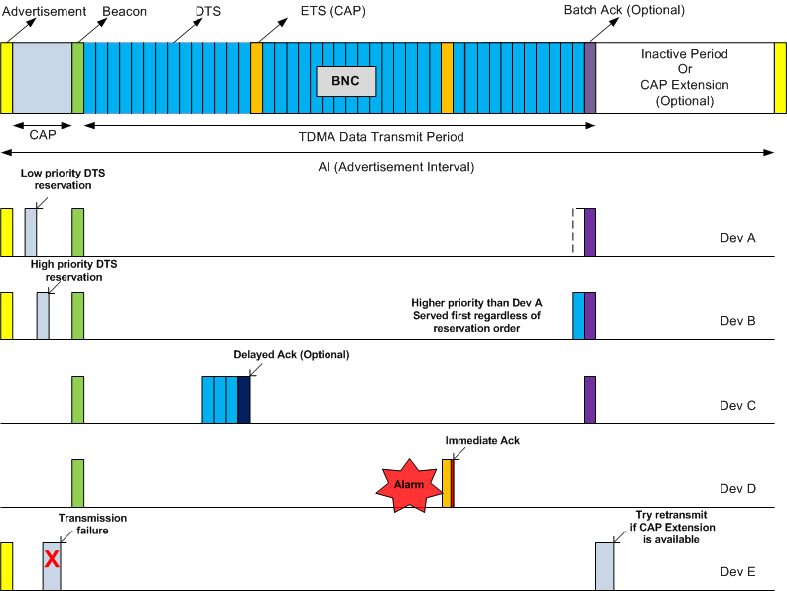
Figure 2 Versatile MAC functionality overview

- Numerical delay comparison

  - Reservation delay
Reservation delay is the duration from data generation to slot allocation confirm by beacon. To make a fair condition assume slot size and AI are same as the slot size and BI of IEEE15.4 when BO=6, SO=3. The total number of slots in AI and BI are 128 slots. And assume reservation is done right away if data is generated during CAP.

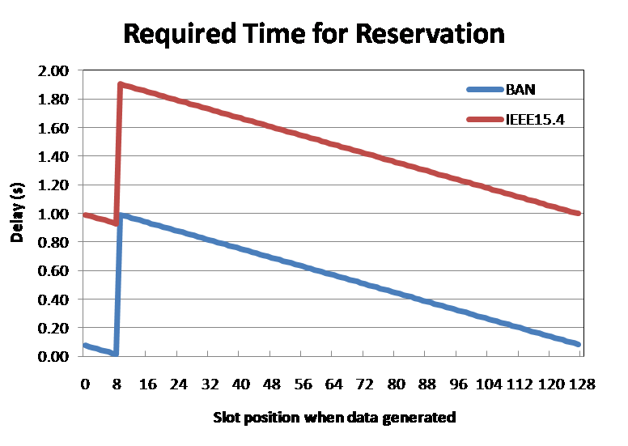
Figure 3 Reservation delay comparison

In IEEE15.4 reservation is done during CAP period and reservation status is announced by the next beacon. Therefore, the minimum reservation delay in IEEE15.4 is 120 slots when data is generated just before the end of CAP. However, unlike the IEEE15.4, since Versatile MAC does straightway reservation, in the same condition, the delay is just following next one slot beacon period. Likewise, if data is generated at the beginning of beacon slot in Versatile MAC which corresponds to first CFP slot of IEEE15.4 the maximum reservation delays are 129 slots and 248 slots repeatedly. The delay difference between Versatile MAC and IEEE15.4 is 119 slots (0.91sec)

Delay | Versatile MAC | IEEE15.4 MAC
Min | 1 slot (7.68ms)  (Data generation at the end of CAP) | 120 slots (0.922sec)  CFP & Inactive(119)+ Beacon(1)  (Data generation at the end of CAP)
Max | 129 slots (0.991sec)  Beacon (1)+ AI (128)  (Data generation at the beginning of beacon) | 248 slots (1.905sec)  CFP & inactive(119)+BI(128)+Beacon(1)  (Data generation at the beginning of CFP)
Table 2 Reservation delay comparison

  - Emergency alarm delay
Emergency alarm delay is the time duration between alarm generation and its transmission. Assumption in 7.1 is also applies here and no available slots in CFP and DTP is assumed, too.
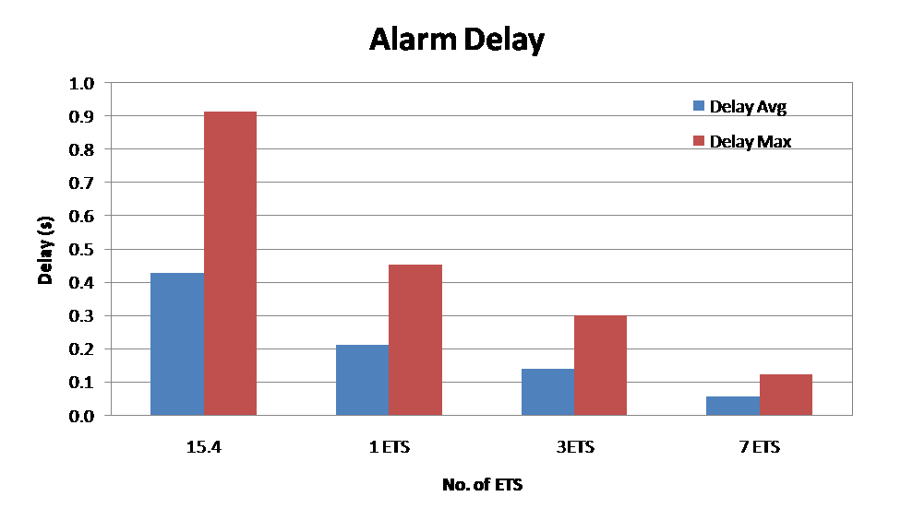
Figure 4 Emergency alarm delay

IEEE15.4 shows highest delay since all GTS in the CFP are occupied by other nodes, CAP is the only available period for alarm transmission. However, in Versatile MAC, CAP along with ETS are available for alarm transmission.

Alarm delay decreases as the number of ETS slot increases, however, at the expense of increased delay (carrier sense time) of the ETS slot owners.

