IEEE P802.15
Wireless Personal Area Networks

Project | IEEE P802.15 Working Group for Wireless Personal Area Networks (WPANs)
Title | IMEC Ultra-wide Band MAC Proposal for IEEE 802.15.6
Date Submitted | [4 May, 2009]
Source | [Feng Shu, Dries Neirynck, Olivier Rousseaux]  [Holst Centre / IMEC-NL]  [High Tech Campus 31, Eindhoven, the Netherlands] | Voice: [+31 40 2774382]  Fax: [ +31 40 2746400]  E-mail: [feng.shu, dries.neirynck, olivier.rousseaux@imec-nl.nl ]
Re:
Abstract | [This is the MAC proposal from IMEC for the IEEE 802.15.6 task group. It is based on the UWB technology.]
Purpose | [The purpose of this document is to provide detailed description and evaluation results of our MAC proposal.]
Notice | This document has been prepared to assist the IEEE P802.15. It is offered as a basis for discussion and is not binding on the contributing individual(s) or organization(s). The material in this document is subject to change in form and content after further study. The contributor(s) reserve(s) the right to add, amend or withdraw material contained herein.
Release | The contributor acknowledges and accepts that this contribution becomes the property of IEEE and may be made publicly available by P802.15.

- Introduction

In IEEE 802.15.6 wireless body area networks (WBANs), a collection of sensor nodes would be deployed in/on or around human body to perform various communication functions required by both medical and non-medical applications. Typical medical applications include signal monitoring of Electrocardiogram (ECG), Electromyography (EMG), Electroencephalogram (EEG), heart rate, blood pressure, respiration, and oxygen saturation in blood (SpO2). Non-medical applications may include audio and video streaming.

Different types of medical and non-medical applications are expected to co-exist in a single WBAN and each application may exhibit its unique characteristics such as traffic pattern and quality of service (QoS) requirements. For example, EEG sensors can transmit data periodically and they may have very critical medical information which requires instant and reliable delivery. Sensor nodes recording temperature information may have periodical signals but with much larger intervals compared to EEG sensors, and also need less strict latency but still high reliability. By contrast, applications like video streaming have continuous traffic and can tolerate longer latency and relaxed reliability compared to medical applications.

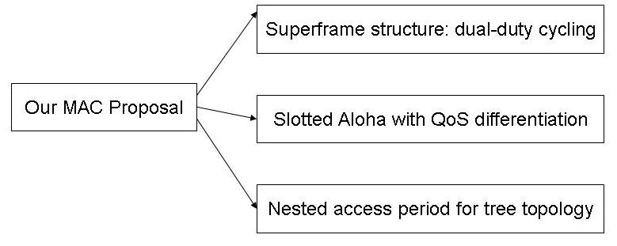
Figure 1 Structure of our MAC proposal for IEEE 802.15.6.

The IEEE 802.15.6 medium access control (MAC) protocol is required to support the varied QoS requirements imposed by different applications in an energy efficient manner. Figure 1 shows the structure of our MAC proposal for IEEE 802.15.6. In this MAC proposal, we propose a new superframe structure which is flexible and efficient enough to accommodate applications with various traffic characteristics and QoS requirements. We also propose an enhanced slotted Aloha protocol with QoS differentiation which gives priorities to nodes with critical messages. Finally, we introduce a nested access period (NAP) method to extend our superframe structure to support tree topologies.

The remainder of the document is structured as follows. In Section 2, we introduce our MAC proposal in detail. In Section 3, we present the performance evaluation for the proposed superframe structure and the enhanced slotted Aloha protocol. We conclude this proposal in Section 4.

The MAC proposal described in this document is a part of IMEC’s UWB PHY/MAC proposal. The complete proposal is made of this MAC used in combination with the UWB PHY presented in doc: 15-09-0330-00-006.

- Description of Our MAC Proposal

  - The Superframe Structure: Dual Duty-Cycling

In WBANs, different traffic sources are expected to exhibit different duty-cycling fashions. As shown in Figure 2, some sensor nodes transmit bulky and delay-insensitive data, and other nodes transmit delay-sensitive data much more frequently but with a small amount for each time. The aim of our new superframe structure is to accommodate these various traffic sources by interleaving their duty cycles in an integrated and energy efficient manner.

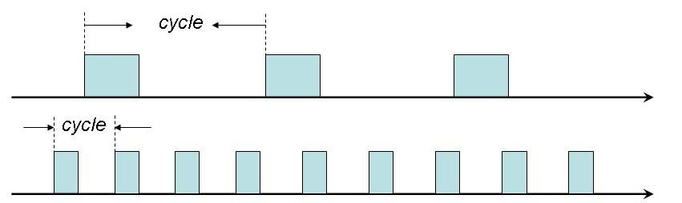
Figure 2 Different duty-cycling fashions for different traffic sources.

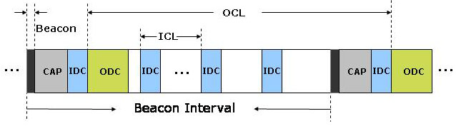
Figure 3 Superframe structure of dual-duty cycling.
Our superframe structure is based on a dual-duty cycling (DDC) mechanism. Figure 3 shows the new superframe structure. Let time be divided into equally-sized beacon intervals (BI’s). At the beginning of a BI, all the sensor nodes simultaneously wake up, and the network coordinator broadcasts a message called beacon to the nodes. The beacon includes, among other things, the next wake-up time, which is used to establish network synchronization. The beacon is immediately followed by a contention access period (CAP). We propose an enhanced slotted Aloha protocol for the CAP period, which will be introduced later.

Following the CAP, the first inner duty cycle (IDC) is inserted. After the first IDC, appears the outer duty cycle (ODC). The rest of the IDC’s are inserted with a fixed interval. All other time periods can be set to be inactive. The CAP and ODC time periods can be interrupted by the IDC’s, but they can overlap with each other if the UWB receiver is capable of receiving multiple transmissions simultaneously.

The time duration between two neighbouring IDC’s is called inner cycle length (ICL), and the time duration between two neighbouring ODC’s, which span two BI’s, is called outer cycle length (OCL). We define K as a variable to describe the ratio between the length of ICL, TICL and the length of OCL, TOCL:
.
It is clear to see that K varies in the range of [0, 1] and it serves as an indicator to show the relative intensity of IDC’s in a given BI.

Transmitting critical data in IDC’s

Sensor nodes with delay-sensitive and critical data are allowed to transmit in IDC’s. The structure of an IDC should be designed to be as simple as possible. Nodes can reserve one or multiple time slots in an IDC for periodic data transmission. For a node with life-critical messages which require instant delivery, a time slot in every IDC can be exclusively reserved.

A critical node can choose to reserve time slot(s) in each IDC, but it is also allowed to skip IDC’s between two neighbouring transmissions. In this way, multiple duty cycling can be implemented using our scheme.

Backward compatibility with IEEE 802.15.4

In the dual-duty cycling superframe structure, the periodic IDC’s are strategically “embedded” into an IEEE 802.15.4-like superframe to accommodate latency-sensitive data, while other data are able to be transmitted in an energy efficient manner as in the IEEE 802.15.4 MAC [1].

Our superframe can be easily made compatible with the IEEE 802.15.4 MAC by setting the superframe duration (SD) to span the whole BI, and scheduling time slots to nodes in the contention free period (CFP) according to the rules used in our DDC scheme.

  - Slotted ALOHA with QoS Differentiation

The Aloha protocol has the appealing feature of simplicity, and has been adopted by the IEEE 802.15.4a standard which is based on an ultra-wide band (UWB) physical layer [2]. Aloha requires no carrier sensing techniques and is considered to be suitable for the UWB technology. This is because carrier sensing, although used by many listen before talk protocols, cannot be effectively supported by the UWB technology.

One of the limitations of the existing Aloha protocols is that it cannot provide QoS differentiation; in other words, it treats every node in the same way, and the critical nodes are given the same priorities when competing with non-critical nodes. Our aim is to enhance the slotted Aloha by introducing QoS differentiation mechanisms to make it suitable for IEEE 802.15.6 networks.

We focus on the QoS requirements of latency and reliability, as they are the two primary QoS metrics which are typically considered in WBANs [3]. There may exist different definitions for latency and reliability, and in this document, we define them in the following.

- Latency -- It measures how fast data can be transmitted. It refers to the duration of time between the moment when a packet is ready to be sent and the moment at which it is received at the receiver.

- Reliability – It measures how reliable the data transmission is, and we use the average packet success rate as an indicator.

The principle of the conventional Aloha is simple. A node with a packet to transmit is allowed to send it immediately, and if the packet is involved in a collision, it will be transmitted after a random period of time. In slotted Aloha, time is partitioned into equally-sized time slots, and each slot is big enough to accommodate a whole packet. Figure 4 illustrates a simple example of the slotted Aloha. The two packets transmitted in slot 4 are involved in a collision and thus need to be retransmitted.

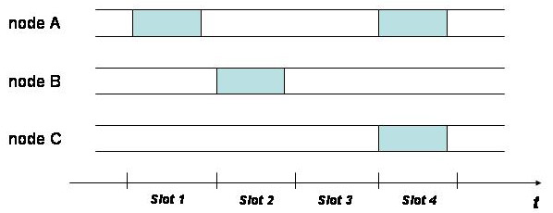

Figure 4 Data transmission example in slotted Aloha.

Our enhanced slotted Aloha achieves QoS differentiation by incorporating two strategies:
- Discriminated Packet Transmission (DPT), in which we assign different probabilities for packet transmission and different maximum number of retransmissions to different nodes.
- Hierarchical Contention Access (HCA): dividing the CAP period into different portions for hierarchical channel access.

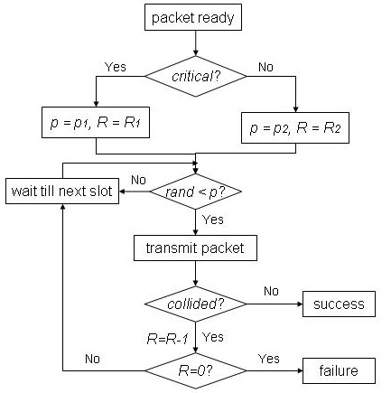
Figure 5 Flow chart of DPT.

Discriminated packet transmission (DPT)

When a node has a packet to transmit, the node performs a process of “coin-tossing” based on a given probability p at the beginning of every slot. If the result of the process is positive, the packet will be immediately sent in the current time slot. If the result is negative, the node will keep performing the process at the next slot until the result is positive. The critical nodes are given higher priorities by being assigned a larger probability p1. By contrast, the non-critical nodes are given a smaller probability p2.
In case of a collision, the node will try to retransmit the packet with the same given probability. However, if a packet has been involved in R collisions, it will be discarded by the node. Critical nodes are given a larger R1 such that their packets can be given more opportunities of retransmissions to have better chance to get through. Non-critical nodes are given a relatively smaller R2. The details of DPT are summarized in the flow chart shown in Figure 5.

Hierarchical Contention Access (HCA)

In the second strategy, the CAP period is divided into two time periods as shown in Figure 6. The critical nodes are allowed to transmit exclusively in the first period T1, in which the non-critical are forbidden to compete. In the second time period T2, all nodes (both critical and non-critical nodes) are allowed to compete for data transmission. In this way, the critical packets are given the chance to be transmitted in an environment with reduced contention levels. And if they cannot finish in the T1, they can keep trying in the following period.

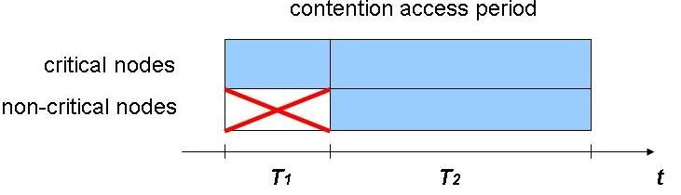
Figure 6 Illustration of HCA.

  - Supporting Tree Topology in WBANs

The way in which the nodes are interconnected is referred to as network topology. A star topology is typically used in WBANs where all communication is centrally organized and every sensor node is directly linked to a master node. However, besides its simplicity, the star topology cannot always satisfy the desired requirements, because:

- When the communication link between a sensor and the master is non-line-of-sight (NLOS), (e.g., the sensor is attached on the back of a patient, and the human body blocks the link and makes the channel NLOS), it may significantly degrade the quality of communication.

- A common solution to improve the communication link is increase the transmission power. But this is not possible because there is strict limit of radiation power around human body, which is defined by specific absorption rate (SAR). The maximum transmission power in the USA and EU are 1.6mW and 20mW, respectively [5].

Restrained Tree Topology

Wireless networks are typically laid out in star and ad hoc topologies. Typically used ad hoc networks include mesh and tree topologies (see Figure 7 for topology examples). Each network topology has advantages and disadvantages. In this proposal, we integrate star and retrained tree topology seamlessly by using a nested access period method.

In our method, the network normally operates using a star topology. When the communication link between a senor and the master degrade to a predefined level, it triggers a procedure to form a restrained tree topology. As depicted in Figure 8, suitable sensor node(s) (or special-purpose relay nodes) are chosen to act as relay node for the subgroups where the sensor(s) have degraded channel with the master. Due to the typical requirements of strict latency (e.g., for medical vital signals) in WBANs, the tree topology is restrained such that

- the tree depth, i.e., the maximum number of hops from any end node to the master, is limited to be two.

- the maximum number of relay nodes in a network is limited to be five.

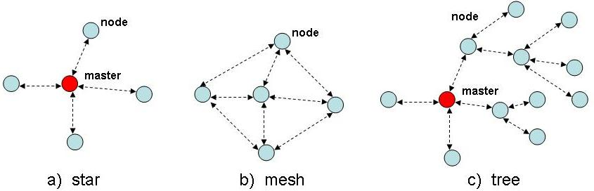
Figure 7 Typical topology choices for wireless networks

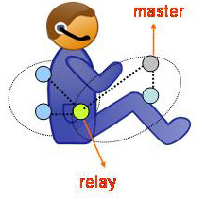
Figure 8 Example of tree topology for WBANs.

Nested Access Period (NAP)

The nested access period (NAP) establishment phase starts with a node which experiences a very low quality channel with the master. The node then broadcasts a message for an association request. The pre-specified relay node for the node receives the request and sends a message to the master to ask for allocation of a NAP. If the master finds enough resources for the NAP request, it approves the NAP request. The relay then confirms with the node about the successful association, and then the relay also sends a confirmation to the master. During this phase, the size and position of the NAP, and the frequency channel of operation of the NAP are also determined. Multiple NAPs can coexist in a network, and the approval of a NAP is decided by the master depending on the network resources.

After the relay and the associated node(s) have formed a sub-network and reserved a NAP in the superframe, the relay maintains the operation of the NAP by sending beacon frames at the beginning of each NAP. The associated node(s) then transmit the data to the gateway in the following timeslots in NAP. The structure of a NAP and the medium access methods therein can be tailored according to the nature of traffic. The relay gathers data from the nodes in its subgroup, and then forwards the data (after data fusion if necessary) to the master. A time diagram which describes the NAP establishment and uplink (from node to master) data transmission is illustrated in Figure 9. Note that the downlink (from master to node) transmission can be performed in a similar way. Note also that using NAP and a restrained tree topology in a combined way can meet the strict latency and reliability, and meanwhile minimize the network complexity around a particular human body environment.

We consider an example of using the NAP method in the DDC Superframe structure, as depicted in Figure 10. One way to integrate the NAP is to arrange NAPs in the inactive period to avoid interference to other nodes. The position and the recurring frequency in the cycles can be flexible and centrally controlled by the master. In our example, two NAPs are inserted. Each NAP consists of a NAP beacon, a CAP and a CFP.

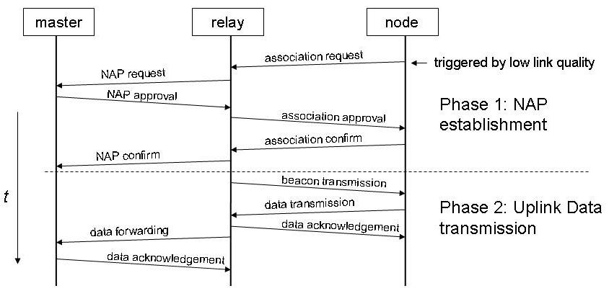
Figure 9 Time diagram of NAP establishment and uplink data transmission.

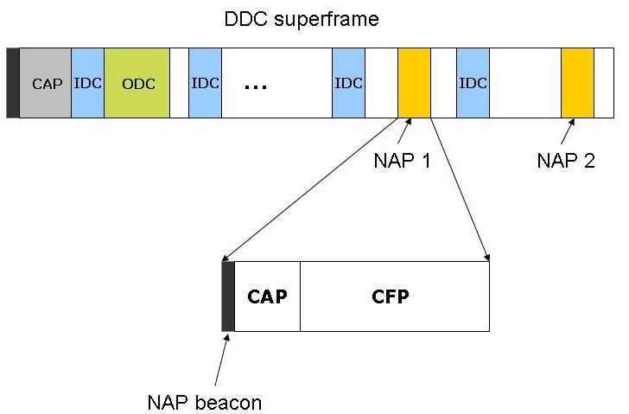

Figure 10 Example of using NAP in a DDC Superframe structure.

- Performance Evaluation

In this section, we give a performance evaluation of the proposed DDC superframe structure and the enhanced slotted Aloha protocol.

  - Superframe structure evaluation

We introduce the following notation:

- N: Number of total sensor nodes (excluding network coordinator)
- Nc: Number of critical nodes
- Nnc: Number of non-critical nodes
- Tbcn: Time duration of a beacon
- Tidc: Average transmission time of a node in one IDC period
- Ptx: Transmit power
- Prx: Receive power
- Pidle: Idle power
- Enc: Energy consumption for nodes transmitting in a superframe
- Eidle: Energy consumption for all nodes during idle in a superframe

Power consumption

In the DDC superframe structure, every node needs to wake up to listen to the beacon and consume NT_{bcn}P_{rx} energy in total. For nodes that transmit in IDC’s, transmitting the packets costs N_{c}T_{idc}P_{tx} for a single IDC. For the non-critical nodes, the energy costs in total are assumed to be E_{nc}. Finally, every node goes to sleep if it is not transmitting or receiving, and the overall energy spent in idle states is E_{idle}. Summing up all these energy costs and dividing by the total number of nodes N and the superframe length Tddc, we get the average power consumption for a node in a DDC superframe as follows:

(1)

To consider a superframe structure with SDC, we use an IEEE 802.15.4-like superframe. We consider the energy consumption of SDC in a Tddc time period, and then we can assume the energy consumption in data transmission and idle remains unchanged. Assuming the cycle length of SDC is Tsdc. The average node power consumption under the SDC superframe structure can then be given by

(2)

From (1) and (2), it is easy to see that difference of power consumption of the two schemes comes from beacon listening when Tddc and Tsdc have different values. To evaluate the energy efficiency of the schemes, we adopt the electrical parameters (shown in Table 1) of commonly used UWB and narrow-band radio transceivers. We assume that the number of critical nodes is three, each with 10 kbps continuous traffic flow. And the number of non-critical nodes is variable, each having 5 kB data. The sizes of beacons and data packets are assumed to be 256 B. The length of a DDC superframe is fixed to 1 s. The value of K is fixed to be 0.1.

Parameter | UWB | Narrow-band
Transmit power, Ptx | 5 mW | 21 mW
Receive power, Irx | 15 mW | 23 mW
Idle power, Iidle | 0 mW | 0.04 mW
Data rate | 6.6 Mbps | 2 Mbps
Table 1 System parameters of UWB and narrow-band transceivers.
In Figure 11, we show the comparison of power efficiency for the UWB transceiver. It can be seen that when the cycle length in SDC is chosen to be small to reduce latency, its energy consumption increases significantly. This is because all nodes are required to wake up more often for shorter SDC superframe length. When the superframe length of SDC is bigger, its energy consumption is closer to the DDC scheme. However, this will make the packets suffer from prolonged latency. It can be seen that our DDC superframe structure is able to achieve a good balance between power consumption and latency. Similar results can be seen for the narrow-band transceiver, but the power consumption is much higher than the UWB transceiver.

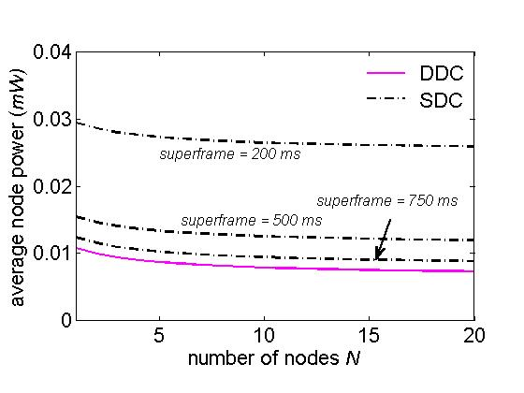
Figure 11 Power consumption for UWB transmitter.

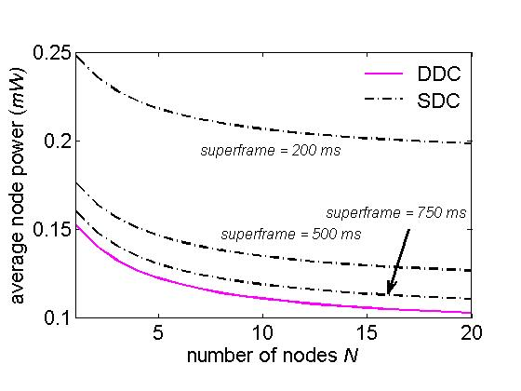
Figure 12 Power consumption for narrow-band transceiver.

  - Evaluation of slotted Aloha with QoS Differentiation

We wrote a simulator in C++ to evaluate the performance of the enhanced slotted Aloha protocol. We assume the CAP period contains 100 time slots, each of which is 0.2 ms long. The number of nodes in the network, N, is variable, and 33% of the nodes are considered to be critical, and all the rest are non-critical.

Each node is assumed to have one packet to transmit at the beginning of the CAP period. Every simulation point is obtained by averaging over 1000 independent simulation runs. To evaluate the DPT scheme, we let p1 = 0.2, p2 = 0.1, R1 = 10, and R2 = 5. Figure 13 and Figure 14 show that critical nodes always have less delay and higher packet success rate than the non-critical nodes.

We then combine DPT with HCA, and set T1 = 30 and T2 = 70. Figure 15 and Figure 16 show that the delay and packet success rate of the critical nodes are significantly improved without sacrificing the performance of the non-critical nodes.

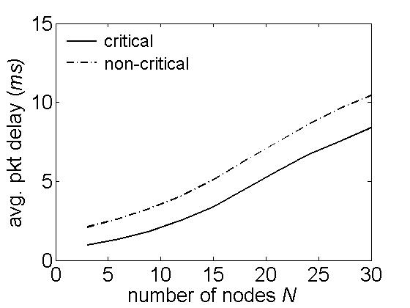
Figure 13 Average packet access delay under DPT scheme.

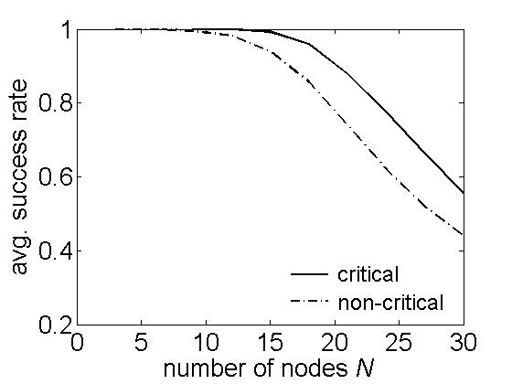
Figure 14 Average packet success rate under DPT scheme.
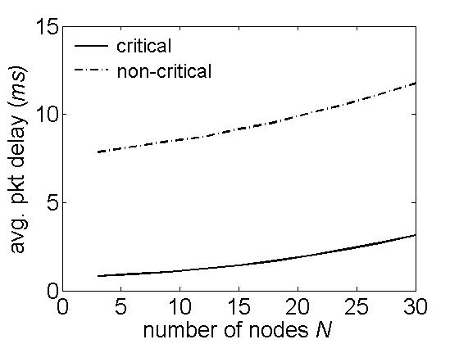
Figure 15 Average packet access delay under both DPT and HCA.

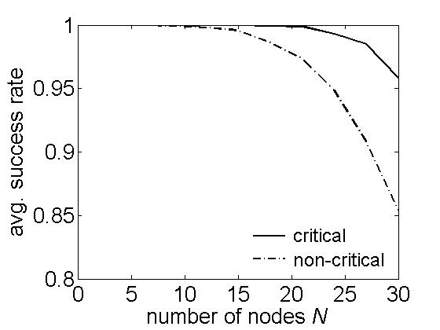
Figure 16 Average packet success rate under both DPT and HCA.
- Conclusion

In this proposal, we presented our MAC proposal for the IEEE 802.15.6. We introduced the three components of our proposal. Firstly, the new superframe structure of our MAC proposal is based on a dual-duty cycling mechanism, which aims to support coexisting traffic sources with different duty cycling fashions in a flexible and energy efficient way.

Secondly, a slotted Aloha protocol with QoS differentiation was introduced as a contention-based channel access method in our MAC proposal. The DPT and HCA strategies have been proposed to give priority to critical nodes when multiple types of nodes compete for the channel resources. Finally, we proposed a NAP mechanism to support tree topology in WBANs.

We then presented performance evaluation for the proposed superframe structure in terms of delay and power efficiency. The enhanced slotted Aloha protocol was simulated and results show that it can successfully differentiate priority levels for different nodes.

Note that the MAC proposal described in this document is a part of IMEC’s UWB PHY/MAC proposal. The complete proposal is made of this MAC used in combination with the UWB PHY presented in doc 15-09-0330-00-006.

- Reference
- IEEE 802.15.4, “Part 15.4: Wireless Medium Access Control (MAC) and Physical Layer (PHY) Specifications for Low-Rate Wireless Personal Area Networks (WPANs),” September, 2006.
- IEEE 802.15.4a (Amendment of IEEE Standard 802.15.4), “Part 15.4:Wireless Medium Access Control (MAC) and Physical Layer (PHY) Specifications for Low-Rate Wireless Personal Area Networks (WPANs),” August, 2007.
- B. Zhen, M. Patel, S. H. Lee, E. T. Won, and A. Astrin, “TG6 Technical Requirements Document (TRD), ” IEEE P802.15-08-0644-09-0006.
- D. Miniutti, L. Hanlen, D. Smith, A. Zhang, D. Lewis, D. Rodda, B. Gilbert, “Narrowband on body to off body channel characterization for ban,” IEEE 802.15-08-0559-00-0006, August 2008.
- A. Astrin, “TG6 Closing Report for the Session in May 2008,” IEEE 802.15-08-0366-00-0006, May, 2008.

