IEEE P802.15
Wireless Personal Area Networks

Project | IEEE P802.15 Working Group for Wireless Personal Area Networks (WPANs)
Title | Common Platform for narrow band frequency hopping PHY
Date Submitted | 2 May 2009
Source | [Jean Schwoerer, John Rouse, Christophe Dugas] Company [France Telecom R&D, Coronis]  Address [28 chemin du vieux chênes 38240 FRANCE ] | Voice: [+33 4 76 76 44 83]  Fax: [+33 4 76 76 44 50] [ ]  E-mail: [jean.schwoerer@francetelecom.fr] : [christophe.dugas @coronis.com]
Re: | [802.15.4g] TG4g Call for Proposals, 2 February, 2009
Abstract | PHY proposal for TG4g amendment. This is based on prior guidance document, IEEE P802.15-15-09-0261-00-004g
Purpose | Proposal for TG4g PHY amendment
Notice | This document has been prepared to assist the IEEE P802.15. It is offered as a basis for discussion and is not binding on the contributing individual(s) or organization(s). The material in this document is subject to change in form and content after further study. The contributor(s) reserve(s) the right to add, amend or withdraw material contained herein.
Release | The contributor acknowledges and accepts that this contribution becomes the property of IEEE and may be made publicly available by P802.15.

Smart Utility Networks (802.15.4g) PHY Amendment:

Table of Contents
1. Overview 3
1.1 General 3
1.2 Scope 3
1.3 Purpose 3
2. Normative References 3
3. Definitions 3
4. Acronyms and Abbreviations 3
5. General Description 3
5.1 Introduction 3
5.2 Architecture 3
5.2.1 Physical layer (PHY) 3
5.2.2 MAC sublayer 3
5.3 Functional Overview (Informative) 3
5.4 Concept of Primitives 3
6. PHY Specification(s) 3
6.1 General requirements and definitions 3
6.1.1 Operating frequency range 3
6.1.2 Channel assignments 3
6.1.3 Minimum long interframe spacing (LIFS) and short interframe spacing (SIFS) periods 3
6.1.4 RF power measurement 3
6.1.5 Transmit power 3
6.1.6 Out-of-band spurious emission 3
6.1.7 Receiver sensitivity definitions 3
6.2 PHY service specifications 3
6.3 PPDU format 3
6.3.1 Synchronization Header (SHR) 3
6.3.2 PHY Header (PHR) 3
6.3.3 Data Payload ( PSDU) 3
6.4 PHY constants and PIB attributes 3
6.4.1 PHY constants 3
6.4.2 PHY PIB attributes 3
6.5 2450 MHz PHY specifications 3
6.6 868/915 MHz band binary phase-shift keying (BPSK) PHY specifications 3
6.7 868/915 MHz band (optional) amplitude shift keying (ASK) PHY specifications 3
6.8 868/915 MHz band (optional) O-QPSK PHY specifications 3
6.9 OFDM PHY Specifications 3
6.9.1 Data rate 3
6.9.2 Modulation 3
6.9.3 Radio Specification 3
6.10 General radio specifications 3
6.10.1 TX-to-RX turnaround time 3
6.10.2 RX-to-TX turnaround time 3
6.10.3 Error-vector magnitude (EVM) definition 3
6.10.4 Transmit center frequency tolerance 3
6.10.5 Transmit power 3
6.10.6 Receiver maximum input level of desired signal 3
6.10.7 Receiver Energy Detection (RSSI) 3
6.10.8 Link quality indicator (LQI) 3
6.10.9 Clear channel assessment (CCA) 3
7. MAC Sublayer Specification 3
7.1 MAC sublayer service specification 3
7.1.1 MAC data service 3
7.1.2 MAC management service 3
7.1.3 MAC enumeration description 3
7.2 MAC constants and PIB attributes 3
7.2.1 MAC constants 3
7.2.2 MAC PIB attributes 3
7.3 MAC functional description 3
7.3.1 Channel access 3
7.3.2 Starting and maintaining SUN networks 3
7.4 Message sequence charts illustrating MAC-PHY interaction 3

DRAFT TOC

Overview

General

Scope

Purpose

Normative References

Definitions

Acronyms and Abbreviations

General Description

Introduction

Architecture

Physical layer (PHY)

MAC sublayer

Functional Overview (Informative)

Concept of Primitives

Overview

General

Purpose

Scope

PPDU Format

Enhanced DSSS PHY

Moderate Data Rate Narrow PHY Specifications

6.7 Very low energy, low data rate narrow band PHY mode
The focus of the very low energy (VLE) mode is on reduced energy consumption over data rate. In some applications identified for SUN energy consumption is more important than data rate. This PHY mode employs fast frequency hopping (the PSDU is spread to multiple frequencies), 20 kbps and mechanisms to enable very low duty cycle operation.
The low data rate PHY uses a frequency hopping scheme where the PPDU is spread across multiple frequencies operating in available sub-GHz bands, with support for ultra-low power management.

Data rates
A base data rate of 19.2 kbps is supported.
Data Transfer
The MAC Interface Data Packet Description is the structure of the frame passed from the MAC Layer to the PHY Layer. The structure is the following:

GIW | DA | SA | PN | CB | LGF | DTF | Payload
32 bits | 6 bytes | 6 bytes | 1 byte | 1 byte | 1 byte | 1 byte | N bytes
GIW (FL + EX-FT + FT + Ext) is coded with BCH(21,31) + Parity
Following data are protected with a BCH(21,31) code, a parity bit and Interleaving
GIW: composed of four fields representing 21 bits, encoded with BCH(21,31) + parity → 32 bits
FL: Frame length giving the number of blocks on 4 bits (1 block is 21 bytes),
EX-FT: Extended frame type (4 bits)
FT: Frame Type (8 bits)
Ext: Extended (5 bits)

b20b19b18b17b16 | Extension | - | Reserved for future
b15 | (FT) Multiple Command | 0 | Last command
b15 | (FT) Multiple Command | 1 | Other command to come
b14b13 | (FT) Addressing Mode | 00b | Point to point
b14b13 | (FT) Addressing Mode | 01b | Broadcast
b14b13 | (FT) Addressing Mode | 10b | Reach The Root
b14b13 | (FT) Addressing Mode | 11b | Polling
b12 | (FT) Frame Type | 0 | Control Frame
b12 | (FT) Frame Type | 1 | Data Frame
B11b10b9 | (FT) Protocol Identification | 000b | Version 1,0
b8 | (FT) Request/Answer | 0 | Request Frame
b8 | (FT) Request/Answer | 1 | Answer Frame
b7 | (EX-FT) Not used | - | Reserved for future
b6 | (EX-FT) Synchronized Frame | 0 | Not synchronized frame
b6 | (EX-FT) Synchronized Frame | 1 | Synchronized frame
b5 | (EX-FT) Not used | - | Reserved for future
b4 | (EX-FT) Transmission Type | 0 | Bi-direction
b4 | (EX-FT) Transmission Type | 1 | Mono-direction
B3b2b1b0 | (FL) Frame Length |  | Number of blocks (1 block is 21 bytes)
DA: Destination address (6 bytes)

SA: Source address (6 bytes)

PN: Packet Number (1 byte)

CB: Control Byte (1 byte)

b7 | reserved | - | -
b6 | RELAY | 0 | Packet is not relayed
b6 | RELAY | 1 | Packet is relayed
b5 | EXT : Extension | 0 | CB is 1 byte length
b5 | EXT : Extension | 1 | CB is 2 bytes length (not used in actual Wavenis)
b4 | reserved | - | -
b3b2b1 | PP : Packet Position | 000b | Not used
b3b2b1 | PP : Packet Position | 001b | FirstP : First Packet
b3b2b1 | PP : Packet Position | 010b | MidP : Middle Packet
b3b2b1 | PP : Packet Position | 011b | Not used
b3b2b1 | PP : Packet Position | 100b | LastP : Last Packet
b3b2b1 | PP : Packet Position | 101b | UniP : Unique Packet
b0 | WACK : Window ACK | 0 | Data packet must be acknowledged by LLC layer
b0 | WACK : Window ACK | 1 | Data packet must not be acknowledged by LLC layer

LGF: Frame length (1 byte). This is N+2 where N is the Length of the Payload field

DTF: Frame Type (1 byte). 0x03 for Application frame and 0x04 for Service frame.

Modulation and spreading

Bit to symbol mapping
Each GFSK modulated symbol encodes one information bit.

FSK Modulation
The VLE mode uses GFSK modulation as described in Error: Reference source not found. The modulation parameters used in the VLE mode are shown in Table 1.
 | GFSK
Mod. Index | 1
f_{dev}
BT | 0.5
H
Table 1: VLE FSK Parameters

Error Correcting Code
BCH(31,21) coding (1/3 redundancy) is used, with data whitening and interleaving to enhance reliability

BCH(21,31)
The frame is divided in n 21 bits words. On each 21 bits word, a BCH(21,31) is applied giving as a result 10 bits of redundancy. A parity bit is added which gives the following 32 bits result:
31 | 30 21 | 20 0
Parity | 10 redundancy bits | 21 data bits

Encoding structure (To be verified):
(R(x) = R₀ + R₁x + R₂x²+ R₃ x³+ R₄ x⁴+ R₅ x⁵+ R₆ x⁶ + R₇ x⁷ + R₈ x⁸ + R₉ x⁹)

Parity

The parity bit is not used

Data Interleaving
Each 256 bit data block (GIW not concerned) is placed in a 16x16 matrix as follow :

 | → | Output
→ | 0 | 1 | 2 | 3 | 4 | 5 | 6 | 7 | 8 | 9 | 10 | 11 | 12 | 13 | 14 | 15
Input | 16 | 17 | 18 | 19 | 20 | 21 | 22 | 23 | 24 | 25 | 26 | 27 | 28 | 29 | 30 | 31
Input | 32 | 33 | 34 | 35 | 36 | 37 | 38 | 39 | 40 | 41 | 42 | 43 | 44 | 45 | 46 | 47
Input | 48 | 49 | 50 | 51 | 52 | 53 | 54 | 55 | 56 | 57 | 58 | 59 | 60 | 61 | 62 | 63
Input | 64 | 65 | 66 | 67 | 68 | 69 | 70 | 71 | 72 | 73 | 74 | 75 | 76 | 77 | 78 | 79
Input | 80 | 81 | 82 | 83 | 84 | 85 | 86 | 87 | 88 | 89 | 90 | 91 | 92 | 93 | 94 | 95
Input | 96 | 97 | 98 | 99 | 100 | 101 | 102 | 103 | 104 | 105 | 106 | 107 | 108 | 109 | 110 | 111
Input | 112 | 113 | 114 | 115 | 116 | 117 | 118 | 119 | 120 | 121 | 122 | 123 | 124 | 125 | 126 | 127
Input | 128 | 129 | 130 | 131 | 132 | 133 | 134 | 135 | 136 | 137 | 138 | 139 | 140 | 141 | 142 | 143
Input | 144 | 145 | 146 | 147 | 148 | 149 | 150 | 151 | 152 | 153 | 154 | 155 | 156 | 157 | 158 | 159
Input | 160 | 161 | 162 | 163 | 164 | 165 | 166 | 167 | 168 | 169 | 170 | 171 | 172 | 173 | 174 | 175
Input | 176 | 177 | 178 | 179 | 180 | 181 | 182 | 183 | 184 | 185 | 186 | 187 | 188 | 189 | 190 | 191
Input | 192 | 193 | 194 | 195 | 196 | 197 | 198 | 199 | 200 | 201 | 202 | 203 | 204 | 205 | 206 | 207
Input | 208 | 209 | 210 | 211 | 212 | 213 | 214 | 215 | 216 | 217 | 218 | 219 | 220 | 221 | 222 | 223
Input | 224 | 225 | 226 | 227 | 228 | 229 | 230 | 231 | 232 | 233 | 234 | 235 | 236 | 237 | 238 | 239
Input | 240 | 241 | 242 | 243 | 244 | 245 | 246 | 247 | 248 | 249 | 250 | 251 | 252 | 253 | 254 | 255
Input : First 32 bit word in input is 0,1,2,3,...,28,29,30,31
Output : First 32 bit word in output is 0,16,32,48,...,193,209,225,241
Etc...

Operating frequency range

Channel assignments
Channel assignment is defined through a combination of
-channel mode
-channel page
-channel number
Radio_mode = channel mode + channel page

Channel numbering
A total of 512 channels numbered 0 to 511 are available per channel page.
K = channel number
 | Channel mode 1/ page 0
K | Frequency
0 | 868,07525
1 | 868,12520
2 | 868,17515
3 | 868,22510
4 | 868,32500
5 | 868,37495
6 | 868,42490
7 | 868,47485
8 | 868,52480
9 | 868,77455
10 | 868,82450
11 | 868,87445
12 | 868,92440
13 | 868,97435
14 | 869,02430
15 | 869,07425
16 | 869,12420
Channel mode 2/ page 0
Fc (Mhz) = 902,1312 Mhz * k * CS (kHz) /1000
CS = 57,6 (kHz)
Channel ∈ [0 ; 448]
Fc (Mhz) ∈ [902,1312 ; 927,936]

Channel pages
channel pages are available per channel mode

Channel modes
Three channel modes are available, corresponding to the available frequency bands.
Channel mode and channel page
Channel mode 0 | 868 multifrequency
 | Page 0 | GFSK modulation | 19,2 kb/s
Channel mode 1 | 915 FHSS
 |  | GFSK modulation | 19,2 kb/s
Channel mode 2 to TBD | Reseved for evolution (ex 863-870 FHSS)

Frequency hopping

On the 868 MHz band
Frequency hopping is sequence is defined by the following table. Preample frequency is used to transmit PHR other carrier frequencies are used in ascending order of the hop number.
Fixe Hopping table
Preamble frequency | 868,32500
Hop number | Frequency (Mhz)
1 | 868,07525
2 | 868,87445
3 | 868,37495
4 | 868,92440
5 | 868,22510
6 | 868,77455
7 | 869,12420
8 | 868,47485
9 | 868,97435
10 | 868,42490
11 | 869,02430
12 | 868,17515
13 | 869,07425
14 | 868,52480
15 | 868,12520
16 | 868,82450

On the 915 MHz band
Frequency hopping is sequence is defined by the following table. Preample frequency is used to transmit PHR other carrier frequencies are used in ascending order of the hop number.
Fixe Hopping table
Hop Number | Frequency (Mhz) | Hop Number | Frequency (Mhz)
0 | 915,3216 | 43 | 922,0608
1 | 904,8384 | 44 | 911,1744
2 | 915,9552 | 45 | 922,2336
3 | 905,2992 | 46 | 911,3472
4 | 916,1856 | 47 | 922,4064
5 | 905,6448 | 48 | 911,52
6 | 916,3584 | 49 | 913,0176
7 | 905,8176 | 50 | 924,2496
8 | 916,704 | 51 | 913,3632
9 | 907,3152 | 52 | 924,768
10 | 918,5472 | 53 | 913,7088
11 | 907,6608 | 54 | 925,1136
12 | 918,8928 | 55 | 913,8816
13 | 907,8336 | 56 | 925,4592
14 | 919,0656 | 57 | 920,2752
15 | 908,0064 | 58 | 909,216
16 | 919,2384 | 59 | 920,448
17 | 922,5792 | 60 | 909,3888
18 | 912,0384 | 61 | 920,6208
19 | 923,1552 | 62 | 909,7344
20 | 912,4992 | 63 | 920,7936
21 | 923,5584 | 64 | 910,656
22 | 912,672
23 | 923,7312
24 | 912,8448
25 | 908,1792
26 | 919,4112
27 | 908,5248
28 | 919,584
29 | 908,8704
30 | 919,9296
31 | 909,0432
32 | 920,2752
33 | 905,9904
34 | 917,0496
35 | 906,1632
36 | 917,2224
37 | 906,336
38 | 917,3952
39 | 906,5088
40 | 917,568
41 | 921,1392
42 | 911,0016

Transmit Power Control
Not implemented

VLE Parameters
Insert specification table

General radio specifications

TX-to-RX turnaround time
The Tx to Rx turnaround ime should be better than 1ms

RX-to-TX turnaround time
The Rx to Tx turnaround ime should be better than 100µs

Receiver sensitivity

Term | Definition of term | Conditions
Bit error rate (BER) | On no corrected data | 1%
Sensitivity (dBm) should be lower than -105dBm

Transmit center frequency tolerance
+/- 10ppm from -20 to +70°C

Transmit power limits

RF power measurement
For power measurement (power, spurious), the power is a radiated measurement
The power is defined as radiated power ERP or EIRP with the following relation :
-EIRP (dBm) = ERP (dBm) + 2,1 dB
For product without antenna but with antenna connector, the relation between conducted power (Pc) measured at the antenna connector matched at the impedance of the antenna is
EIRP = Pc +Ga (dBi)
where Ga is the isotropic antenna Gain expressed in dBi.

RF Power limit
Maximum EIRP is 1W, or less, in order to comply with local regulations

Receiver maximum input level of desired signal
Maximum signal level at the receiver should not excess +10 dBm

Receiver ED
The energy detector should detect 5 dB below sensitivity. After receiver activating, the energy detector should return a busy medium in 1ms

Link quality indicator (LQI)
RSSI is used as LQI

Clear channel assessment (CCA)

Transmit & power amplifier rise and fall times (max)
TBD

MAC Sublayer Specification

Receiving data

For describing reception of data, two main configurations are studied:
- periodic wake-up mode (used for implementing standard low power network management),
- full reception mode (used for implementing a snooping application for instance).

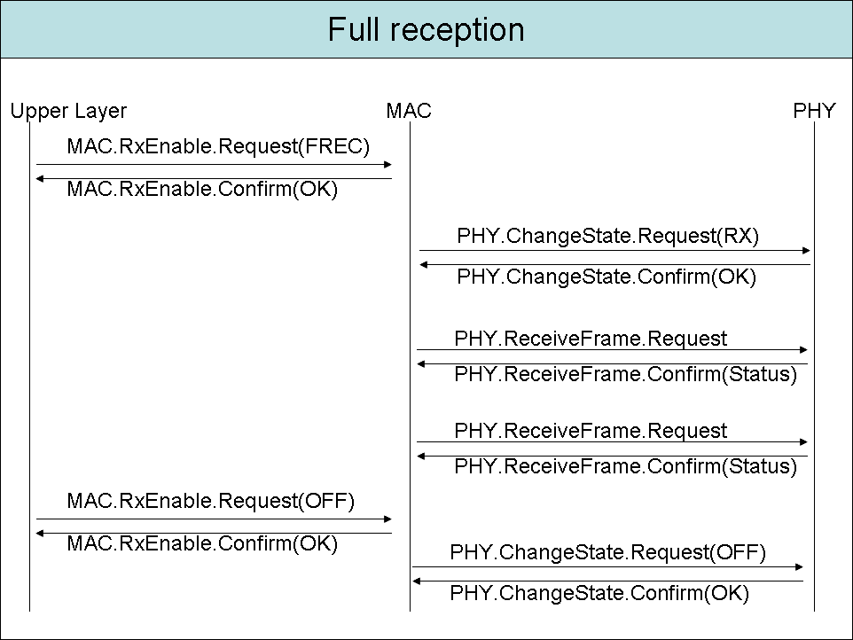

Emitting data

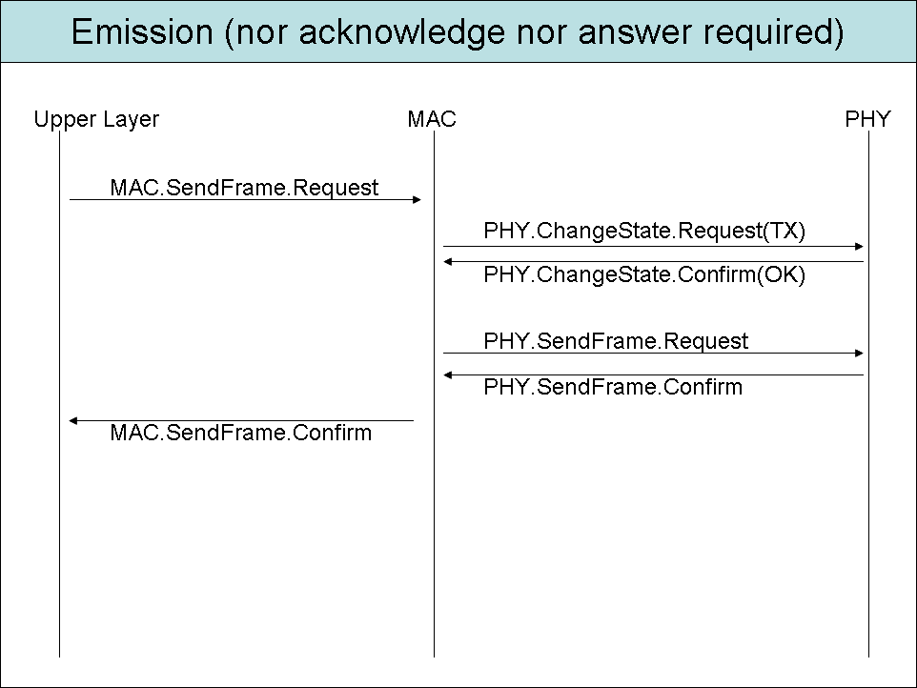

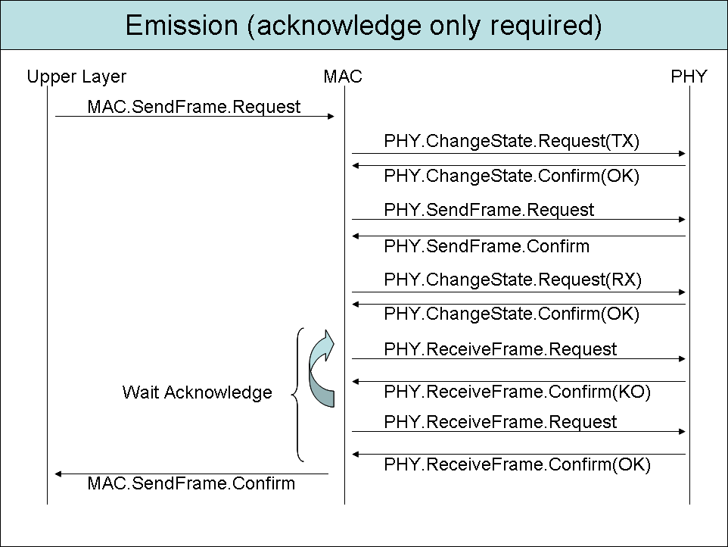

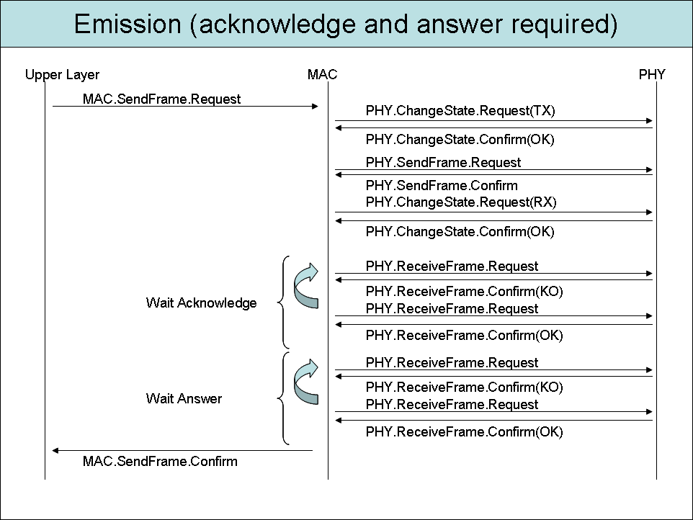

7.3 MAC Layer services definition

MAC.Reset.Request

MAC.Reset.Confirm

MAC.RxEnable.Request

The MAC.RxEnable.Request primitive allows managing the MAC Layer reception mode. There are three different reception modes:
- STANDBY: no reception is performed,
- PERIODIC_WAKE_UP: the MAC Layer periodically performs RF Medium probing,
- FULL_RECEPTION: the MAC Layer continuously performs reception attempts.

Semantics and attributes usage

MAC.RxEnable.Request (
Reception Type
)

Reception Type is of type enumeration with the following possible values: STANDBY, PERIODIC_WAKE_UP and FULL_RECEPTION.

If the PERIODIC_WAKE_UP Reception Type is selected, the MAC Layer attributes [macWakeUpPeriod] and [macPreambleDuration] define respectively the RF medium probing period and the standard Wake up preamble duration.

Appropriate usage

The MAC.RxEnable.Request primitive is generated by the Next Upper Layer and issued to the MAC Layer when the reception state of the MAC Layer needs to be changed.

Effect on receipt

When the MAC Layer receives the MAC.RxEnable.Request primitive, it will change the MAC Layer reception state immediately. It will then generate a MAC.RxEnable.Confirm primitive with a status given by the following table.

Requested state  Current state | STANDBY | PERIODIC_WAKE_UP | FULL_RECEPTION
STANDBY | STANDBY | SUCCESS | SUCCESS
PERIODIC_WAKE_UP | SUCCESS | PERIODIC_WAKE_UP | SUCCESS
FULL_RECEPTION | SUCCESS | SUCCESS | FULL_RECEPTION

MAC.RxEnable.Confirm

The MAC.RxEnable.Confirm primitive reports the status of the modification of the MAC Layer reception state performed on reception of the MAC.RxEnable.Request.

Semantics and attributes usage

MAC.RxEnable.Confirm (
Status
)

Status is of type enumeration with the following possible values: SUCCESS, STANDBY, PERIODIC_WAKE_UP, FULL_RECEPTION.
When generated

The MAC.RxEnable.Confirm primitive is generated by the MAC Layer and issued to the next Upper Layer in response to a MAC.RxEnable.Request.

It will return a Status value SUCCESS if the requested state is different from the previous state. If the requested state is the same as the previous state, Status will have one of the following values according to the MAC Layer reception state: STANDBY, PERIODIC_WAKE_UP, FULL_RECEPTION.

Appropriate usage

On receipt of the MAC.RxEnable.Confirm primitive, the next Upper Layer is notified of the result of the state modification. If required state is different from the previous state, a SUCCESS status is returned else one of the following statuses according to the MAC Layer reception state: STANDBY, PERIODIC_WAKE_UP and FULL_RECEPTION.

MAC.SendFrame.Request

The MAC.SendFrame.Request primitive requests that the MAC Layer performs the transmission of a Wavenis frame. This primitive is not only used for triggering the emission of a frame but also for managing a complete communication cycle according to the parameters used, that could involve the reception to the answer to the request performed for instance.

Semantics and attributes usage

MAC.SendFrame.Request (
Destination Address,
Exchange Mode,
Exchange Status,
Reception Timeout,
Packet Number,
Frame Type,
Length,
Data
)

Destination Address is 6 bytes long. It is the Wavenis MAC Address of the destination equipment.

Exchange Mode is of type unsigned char. It gives the Wavenis Communication mode required for the transmission. It can take one of the following values: POINT_TO_POINT, RELAYING, POLLING, BROADCAST.

Exchange Status is of type unsigned char. It gives the options required for the emission through its different bits defined above:
b0: 1 = Answer expected
b1 1 = Low level Acknowledge required
b2: 1 = Short Wake-up is used, 0 = standard Wake-up is used
b3: 1 = Carrier Sense has to be used
b4: 1 = Answer to a request
b5: 1 = mono-directional emission (in this case, bits b0 and b1 are not relevant)
b6 1 = CSMA/CA emission (usage of RTS/CTS)
b7 1 = multi-frame emission, at least one frame will follow

Reception Timeout is of type unsigned char, expressed in multiples of 100ms. It is only relevant in Point to point communication mode.

Packet Number is of type unsigned char. It represents the number of the packet currently being sent.

Frame Type is of type enumeration. It can take the following values: APPLICATION and SERVICE.

Length is of type unsigned char and indicates the number of bytes of Data. In Point to point communication mode, it can take values up to 5 + (N-1) * 21 where N is the maximum number of blocks. For instance, for a standard Wavenis implementation accepting up to 8 blocks, the maximum value for Length in Point to Point communication mode is 152.

Data is a byte vector, representing the payload data to be transferred.

Appropriate usage

MAC.SendFrame.Request primitive is generated by the Upper Layers and issued to the MAC Layer for requesting the transmission of a Wavenis frame and the management of the implied communication cycle.

Effect on receipt

On receipt of the MAC.SendFrame.Request primitive, the MAC Layer entity enters into the required communication cycle using the supplied arguments and data.

MAC Interface Data Packet generation:

The MAC Layer builds a PHY Layer data packet to transmit from the supplied arguments. The fields to be built for this purpose are the following:
- GIW: General Information Word
- DA: Destination Address
- SA: Source Address
- PN: Packet Number
- CB: Control Byte
- LGF: Frame Length
- DTF: Frame Type

DA field is generated from the Destination Address parameter.
SA field is generated from an attribute of the MAC Layer: [macRFAddress].
PN field is generated from the Packet Number parameter.
GIW and CB fields are generated from Exchange Mode and Exchange Status parameters.
LGF field is generated from the Length parameter.
DTF field is generated from the Frame Type parameter.

Exchange Mode usage:

By now, the only considered value for Exchange Mode is POINT_TO_POINT.

Exchange Status usage:

If b0 bit of Exchange Status is set, the MAC Layer entity will enter into reception phase for a time defined by the Reception Timeout parameter for waiting the answer to the request.

If b1bit of Exchange Status is set, a low level acknowledge is required. The MAC Layer entity will enter into reception phase for 300ms for waiting the acknowledge to the frame. If the acknowledge is not received, up to 2 automatic retries will be performed (thus giving up to 3 emissions of the request). The b0 bit of the CB field will be reset.

If b2 bit of Exchange Status is set, short wake-up length (40ms) has to be used for sending the frame else the standard wake-up length (defined by [macPreambleDuration]) is used.

If b3 bit of Exchange Status is set, a Carrier Sense process must be used before emission.

If b4 bit of Exchange Status is set, the b8 bit of GIW is set (answer frame).

If b5 bit of Exchange Status is set, the b4 bit of GIW is set. In this case, b0 and b1 bits of Exchange status are not relevant (mono-directional frame).

If b6 bit of Exchange Status is set, the CSMA/CA mechanism is used for sending the frame (usage of RTS/CTS). This mechanism will be described later.

If b7 bit of Exchange Status is set, the PP field (Packet Position) of CB (Control Byte) field is generated according to the Packet Number parameter.

Reception Timeout usage:

Reception Timeout specifies to the MAC Layer how much time it will have to wait for an answer before generating an error when an answer is required (if b0 bit of Exchange Status is set).

Packet Number usage:

In case of multi-frame transmission, this parameter allows specifying It represents the number of packets that will follow the current packet in a multi-frame session. In coordination with the b7 bit of Exchange status, it allows the MAC Layer generating the PP field (Packet Position) of the CB field (Control Byte).

Frame Type usage:

The Frame Type parameter allows generating the DTF field.

Length usage:

The Length parameter represents the quantity of relevant data contained into the Payload field. It allows the MAC Layer entity generating the LGF field.

MAC.SendFrame.Confim primitive generation:

If an acknowledge is required and is not received after 3 transmissions, a MAC.SendFrame.Confirm primitive is generated with a status of NO_ACK.

If an answer is required and is not received within the Reception Timeout given as parameters, a MAC.SendFrame.Confirm primitive is generated with a status of NO_ANSWER.

If CSMA/CA or Carrier Sense emission method is required and is not successful, a MAC.SendFrame.Confirm primitive is generated with a status of MEDIUM_ACCESS_FAILURE.

If any parameter in the MAC.SendFrame.Request primitive is not supported or out of range, a MAC.SendFrame.Confirm primitive is generated with a status of INVALID_PARAMETER.

If the MAC Interface Data Packet is successfully transmitted (acknowledge is received if required and answer received if required), a MAC.SendFrame.Confirm primitive is generated with a status of SUCCESS.

If an answer has been required and is received, the MAC.SendFrame.Confirm primitive will be followed by a MAC.Indication primitive giving the received answer.

MAC.SendFrame.Confirm

The MAC.SendFrame.Confirm primitive reports the result of a MAC.SendFrame.Request primitive.

Semantics of the primitive

MAC.SendFrame.Confirm (
Status
)

Status is of type enumeration with the following possible values: SUCCESS, INVALID_PARAMETER, MEDIUM_ACCESS_FAILURE, NO_ANSWER and NO_ACK.

When generated

The MAC.SendFrame.Confirm primitive is generated by the MAC Layer entity in response to a MAC.SendFrame.Request primitive. The MAC.SendFrame.confirm primitive returns a status of either SUCCESS, indicating that the request to transmit was successful, or the appropriate error code.

Appropriate usage

On receipt of the MAC.SendFrame.Confirm primitive, the next upper layer is notified of the result of its request to transmit. If the transmission attempt was successful, the Status parameter will be set to SUCCESS. Otherwise, the Status parameter will indicate the error.

MAC.Indication

The MAC.Indication primitive indicates the transfer of a MAC Interface Data Packet from the MAC Layer entity to the next upper layer.

Semantics of the primitive

MAC.Indication (
Source Address,
Destination Address, (multicast analisis)
Exchange Mode,
Packet Number,
RSSI Level,
Frame Type,
Length,
Data,
)

Souce Address is 6 bytes long. It is the Wavenis MAC Address of the source equipment.

Exchange Mode is of type unsigned char. It gives the Wavenis Communication mode of the reception. It can take one of the following values: POINT_TO_POINT, RELAYING, POLLING, POLLING_ANSWER, BROADCAST and BROADCAST_ANSWER.

Packet Number is of type unsigned char and gives the number of packets that will follow the current packet in a multi-frame session.

RSSI level is of type unsigned char and gives the RSSI seen on reception of the frame.

Frame Type is of type enumeration. It can take the following values: APPLICATION and SERVICE.

Length is of type unsigned char and indicates the number of bytes of Data.

Data is a byte vector, representing the payload data received.

When generated

The MAC.Indication primitive is generated by the MAC Layer entity and issued to the next upper layer on reception of a data frame at the local MAC Layer that passes the appropriate message filtering operation (described later, could have an impact on semantics for being able to indicate also control frames).

This can happen in two different cases:
- on reception of a request when performing periodic receptions,
- on reception of an answer after performing a MAC.SendFrame.Request.

Appropriate usage

On reception of a MAC.Indication primitive, the next upper layer is notified of the arrival of data at the device.

