IEEE 802.15
Wireless Personal Area Networks
Project | IEEE 802.15 Working Group for Wireless Personal Area Networks
Title | IEEE 802.15.7 VLC Regulation Document Configuration
Date Submitted | September 25, 2009
Source | Tae Gyu Kang | [tgkang@etri.re.kr]
Re:
Abstract | This document summarizes the review and discussion results for regulation issues for Visible Light Communications.
Purpose | [This document is intent to help TG7’s discussion.]
Notice | This document has been prepared to assist the IEEE 802.15. It is offered as a basis for discussion and is not binding on the contributing individual(s) or organization(s). The material in this document is subject to change in form and content after further study. The contributor(s) reserve(s) the right to add, amend or withdraw material contained herein.
Release | The contributor acknowledges and accepts that this contribution becomes the property of IEEE and may be made publicly available by 802.15.
TABLE OF CONTENTS

1. Introduction 3
2. References 4
3. Green IT Growth 5
4. Eye Safety 6
5. Spectrum Frequency 8
6. European Union 8
7. Japan 11
8. Korea 15
9. USA 15

Introduction

This Document is the final report of VLC Regulatory Subcommittee of the TG15.7 for Visible Light Communication (VLC). It provides a summary of regulations for VLC applications in different countries and regions based on a number of review works presented (see References). The regulations are included Green Growth IT, Safety (Eye Safety), Spectrum Frequency, and National Regulations
[Kang Tae Gyu, IEEE 802.15-09-0182-00-007]

The document is divided into 12 sections. Some related references are given in section 2. Green Growth IT is described in section 3. Safety included in eye safety is described in section 4. Spectrum Frequency is described in section 5. Regulations in EU, Korea, German, Japan, UK, USA, as well as the ISM band regulation, are described respectively from sections 6 to 11. The document is shortly summarized in section 12.

The intention of this document is to help IEEE 802.15.7 VLC TG members on proposing and selecting the appropriate PHY.

References
Ref. | DCN | Title | Author(Affiliation)
[1] | 261 | Health impacts of light flicker: implications for visible-light communications | Joachim W. Walewski (Siemens AG)
[2] | 370 | VLC Regulation Issues | KANG TAE GYU(ETRI)
[3] | 653 | Eye Safety for laser and lamp | Kenichi Ikawa (Nakagawa Laboratories, inc.)
[4] | 673 | letter_to_iec_tc_76_concerning_led_wireless | Joachim W. Walewski (Siemens AG)
[5] | 676 | Motivation of proposed letter to TC 76 IEC | Joachim W. Walewski (Siemens AG)
[6] | 182 | Green IT Regulations | KANG TAE GYU(ETRI)
[7] | 523 | Optical Radiation Requirements for Light-Emitting Diodes and Implications for VLC | Joachim W. Walewski (Siemens AG)
[8] | 194 | TG7 VLC Regulation Document List and Summary | Kang Tae Gyu(ETRI)
[9] | 202 | IEEE 802.15.7 VLC Regulation Document Configuration | Kang Tae Gyu(ETRI)
[10] | 297 | VLC Frame Flicker | Rick Roberts(Intel)
[11] | 423 | Green IT Regulatory related to Tokyo Protocol | Lim Sang-Kyu(ETRI)
[12] | 408 | EU and ITU Regulations | Larry taylor, Steven ettles(Discretetime)
[13] | 425 | VLC Regulations : Korea | Kang Tae Gyu(ETRI)
[14] | 546 | Change in Japan’s Energy Saving Law, 2009] | Tom Matsumura (VLCC)
[15] | 561 | Relevant eye safety standards | Jimmy C. Chau (Boston University)

Green IT Growth

[Kang Tae Gyu, IEEE 802.15-08-0370-00-vlc]

We can make some regulations to VLC promotions. VLC has a good chance to create market according to energy crisis, climate changes, environment problem, and lack of radio resources.

[Kang Tae Gyu, IEEE 802.15-09-0182-00-0007]

- User Requirement Change from IT Environment Problem

The Kyoto Protocol is a protocol to the international Framework Convention on Climate Change with the objective of reducing greenhouse gases that cause climate change.
As of January 2008, and running through 2012, some countries (170) have to reduce their greenhouse gas emissions by a collective average of 5% below their 1990 levels.

RoHS(
Restriction of Hazardous Substances Directive, 6HS) retricts an use of material Mercury.

Fluorescent lamp has the material mercury. LED is a better waste treatment than Fluorescent lamp in terms of WEEE(Waste Electrical and Electronic Equipment Directive).

Eye Safety

There are two eye/skin safety issues related to regulation.
- Visible light flickering
- Visible light strength
The PHY modulation of Visible Light Communication can make light flickering. The light flicker can have harmful health impacts on humans/animals.

[Joachim, IEEE 802.15-08-0261-01-0vlc]
[Rick Roberts, IEEE 802.15-09-0297-01-0007]

A light flicker is an impression of unsteadiness of visual sensation induced by a light stimulus whose luminance or spectral distribution fluctuates with time [IEC 1000-3-3] Critical fusion frequency (CFF, a.k.a. flicker fusion threshold) is a frequency at which an intermittent light stimulus appears to be completely steady to the observer [Wikipedia].

A light flicker causes harmful health impacts: Visual discomfort [Stone, 1990], Eyestrain [Lindner, 1993], Headache [Wilkins, 1989], Increase in speed and decrease in performance of mental tasks (reading comprehension) [Küller, 1998], Repetitive behaviour of autistic children [Colman, 1976], Photosensitive epilepsy (2% of all epilepsy cases) [Harding, 1995].

Requirement: Even though low-bit-rate transmission or bunching data, the modulation frequency of VLC MUST be higher than CFF (critical fusion frequency) threshold.

Regulation of light flicker in standards
- IEC 1000-3-3/EN 61000-3-3: Electromagnetic compatibility. Part 3: Limits – Sect. 3: Limitation of voltage fluctuations and flicker in low-voltage power supply systems for equipment with rated current < 16 A. 1994
- IEC 1000-3-5: Electromagnetic compatibility. Part 3: Limits – Sect. 5: Limitation of voltage fluctuations and flicker in low-voltage power supply systems for equipment with rated current greater than 16 A. 1994

[Kang Tae Gyu, IEEE 802.15-08-0370-00-vlc]

Visible light strength is also harmful eye impact. Sufficiently powerful visible to near infrared laser radiation (400-1400 nm) will penetrate the eyeball and may cause heating of the retina. We can find this issue in following standards:
- IEC 60825: Laser safety
- ANSI Z136: Laser Safety Standards - ANSI
- EN 207: European norm for laser safety eyewear.
There are class 1, 1M, 2, 2M, 3R, 3B, and 4. Class 1 laser is safe under all conditions of normal use.

[Joachim, IEEE 802.15-08-0523-01-0vlc]

There are skin-damage mechanisms for visible light: Thermal and Photochemical. Thermal can be burning of skin at 3 kW/m2 over 10 s corresponds to Ostar-E3A emission focused to ~ 3 cm2. Photochemical is possible to occur at 400 nm (UVA) like Sunburn. Critical exposure is 30 J/m2 for 28 800 s (8 h), viz. 1 mW/m2, 350 times lower than cataract exposure limit for eye.

[Kenichi Ikawa IEEE 15-08-0653-00-0vlc]

Classification Rules are Wavelength, Source Size, Time duration, and Repetitive Pulse.

[15-08-0673-03-0vlc-letter-to-iec-tc-76-concerning-led-wireless]
[Joachim IEEE 802.15-08-0676-01-0vlc]

LEDs used as lamps would have to be assessed and classified according to the new lamp safety standard IEC 62471. In terms of this standard, even the relaxed requirements for GLS-sources (General Lighting Service) can be applied. Thus, the lighting part of the technique will definitely be covered by the lamp safety standard IEC 62471.

According to existing safety standards, the durations without modulation would have to be addressed by IEC 62471, while the very same LED would have to adhere to IEC 60825-12 during data transmission.

We are still open an appropriate safety assessment of communication LEDs with one standard rather than two will simplify and ease the development and market-introduction of safety-compliant products

Spectrum Frequency

[Kang Tae Gyu, IEEE 802.15-08-0370-00-vlc]

Spectrum license agreed as an intergovernmental treaty text. The spectrum covers 3 Hz to 300 GHz. There are two main communication spectrum licensing: Broadcasting licensing Cellular licensing.
There is special Non License spectrum such as ISM (Industrial, Scientific and Medical).
The spectrum of VLC is 370 THz – 870 THz beyond one which agreed inter government. Therefore, there is not issue related the spectrum frequency. VLC doesn’t need any spectrum licensing.
- VLC Spectrum

European Union

[Larry taylor, Steven ettles, 802.15-00-408-00-007]
The important point to note here is that EU regulations legislation and standardisation are not the responsibility of a single body. Consequently significant coordination is required amongst the bodies responsible. More importantly these activities are undertaken serially rather than concurrently which means the process can be quite lengthy. For example, the recent work on Ultra Wideband has taken 6 years so far and the standardisation is not yet complete.

To assure a common framework, regulations are set by the CEPT usually in the form of decisions or recommendations which are then adopted over an agreed time frame by each of the CEPT member countries. However, these regulations may be subject to national deviations which may result in additional effort for manufacturers to assure compliance with each country's requirements.

Additionally national regulations may be introduced unilaterally but presently the regulators have a remit only to regulate frequencies below 3,000GHz. This figure of 3,000GHz is also the one specified on the R&TTTE directive.

Legislation is prepared in the EU by the European Commission and becomes effective when published in the Official Journal. The common practice recently has been to take the recommendations from the CEPT and transpose these into legislation. By so doing this avoids national deviations, assuring that manufacturers have a common set of requirements in all countries in the European Union.

Should the CEPT produce a recommendation then it will be in the interests of manufacturers to lobby the European Commission to adopt the recommendation as legislation to minimize the complexity and cost of placing products on the market in Europe.

With no recommendations existing at the minute for VLC there is of course no pan-European legislation. Similarly no national legislation has been uncovered.

Market access is thus governed by the remaining relevant directives of which Safety and EMC apply. Both are well understood and defined and should present no surprises for manufacturers.

There are presently no plans to extend the frequency range of applicability of the R&TTE directive.

The significance of this initiative is that should the ITU decide that regulations are feasible then this will almost certainly trigger a CEPT study which could ultimately lead to a recommendation. Such studies are very time consuming (approx 5 years) and during this time other legislative and standardization work will be 'on hold'. These studies need support from industry experts if they are to balance the needs of the regulators with those of the manufacturers. Both the length of time of the studies and the support required mean additional cost to manufacturers.

The other consequence might be the revision of the R&TTE directive and the development of appropriate standards by ETSI.
NB Should there is any changes as a result of the ITU work then it is almost certain there would be standardization work required to support market access. Although standards are not essential for market access they are seen as the most expedient route to enter the market and of course take a number of years to develop.
Safety is defined by EN60950.
EMC will be defined by Product type. If no product specifications available, default generic emission and immunity standards will apply
RESOLUTION 955 (WRC-07) is related to consideration of procedures for free-space optical links at the World Radio communication Conference (Geneva, 2007), There are considering
- that frequencies above 3 000 GHz are already used for various optical applications from telecommunication links to satellite remote sensing;
- that optical links are currently under consideration by several ITU-R Study Groups;
- that Recommendations ITU-R P.1621, P.1622, S.1590, RA.1630; SA.1742, SA.1805, and RS.1744 contain information pertaining to free-space optical links and remote sensing;
- that the ITU-R is in the process of preparing reports regarding the possibility and relevance of including in the Radio Regulations frequency bands above 3,000 GHz as well as fixed service applications using such frequency bands,
There are recognizing
- that Resolution 118 (Marrakesh, 2002) of the Plenipotentiary Conference instructs the Director of the BR to report to world radio communication conferences on the progress of ITU-R studies concerning the use of frequencies above 3,000 GHz;
- that the ITU-R has identified technical aspects regarding the use of optical free-space telecommunications as an item requiring urgent study by the ITU-R Study Groups
There are resolves to consider possible procedures for free-space optical links, taking into account the results of ITU-R studies covering at least sharing aspects with other services, a clear definition of the band limits and measures to be considered if allocations to various services in the Radio Regulations above 3,000 GHz are considered feasible, invites ITU-R to conduct the necessary studies in time for consideration by WRC-11.

Japan
[Tom Matsumura, VLCC, IEEE 802.15-09-0546-00-0007
The Change in Japan’s Energy Saving Law in April, 2009 is focus on the energy saving in the office/household section, which has been increasing at 1.4 times between 1990 and 2005 (the largest increase in energy consumption).
There are needed strengthen the energy saving especially in the office/household section (offices/convenient stores as well as houses/buildings).
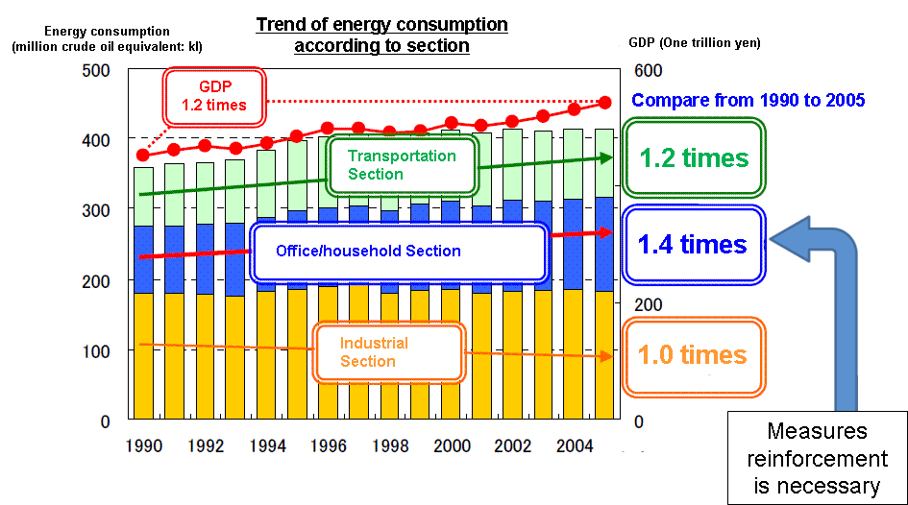
- Energy Consumption increase

One energy unit was a company unit including factories only before. From April, the company unit includes not only factories, but also offices (including head office and sales offices, etc). The unit using an energy more than 1,500 KL annually needs to be reported to Japanese government.
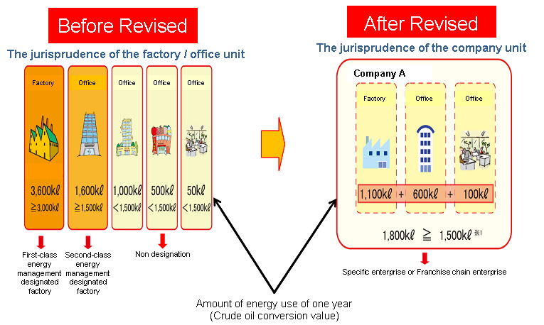
- Change of Energy Saving Target

Franchise chains were not counted before as one energy unit. From April, a franchise-chains such as convenient stores is counted as one energy unit. The unit using an energy more than 1,500 KL annually needs to be reported to Japanese government.
In order to construct a large house/building (more than 2,000 ㎡), the owner needs to report its energy saving plan to Japanese government. The sales agent of houses/buildings need to introduce the efficient energy saving methods. The energy saving methods need to be explicitly indicated.

The Prime Minister Hatoyama announced "The greenhouse gas emissions would be reduced by 25% from 1990 levels by 2020 " on September 7, 2009.

According to the material of the former Cabinet Secretariat, it is necessary for achievement of 25% reducing the greenhouse gas; spreading of the solar photovoltaic system to 55 times from today, promoting the next generation vehicle such as hybrid vehicle to 90% of new car sales and to 40% of the number of all possession, achieving 100% of conservation of energy house, etc.

It is one of the features of LED that power consumption is less than the incandescent lamp or the fluorescent lamp. The power consumption of LED is about 1/10 of that of incandescent lamp and about 1/2 of that of fluorescent lamp. Moreover, it leads to carbon dioxide (CO2) reduction because LED lighting consumes power less than other lighting.
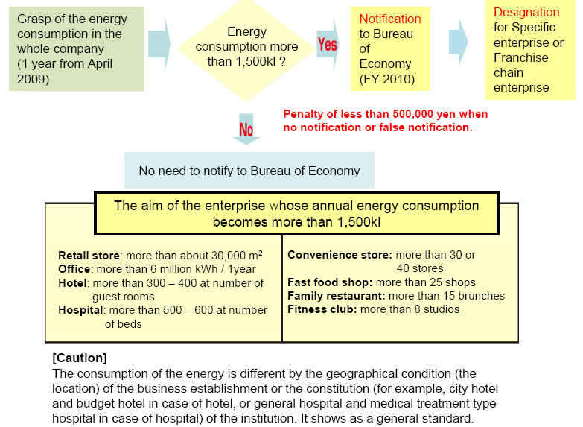
- An Energy Saving Policy in Japan

Therefore, spreading of LED lighting may help and accelerate the achievement of the goal.

In Japan, “Electrical Appliance and Material Safety Law” known as PSE (Product Safety, Electrical Appliance & Materials), which is the law that provided the technological standard related to the safety of electrical appliances, was enforced in April 2001.

The product that suits the PSE is supposed to display "PSE mark".

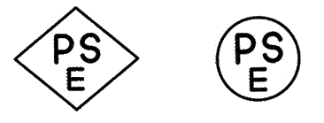
Left: PSE mark for Specified Electrical Appliance and Material
Right: PSE mark for Electrical Appliance and Material except Specified Electrical Appliance and Material
- PSE mark

After “Electrical Appliances and Materials Safety Law” is enforced in April 2001, the product that has not suited the law is supposed not to be sold in Japan.

As mentioned above, there are two types of PSE. First is “Specified Electrical Appliance and Material.” This includes such as AC adaptor, vending machine, Electric massage machine, electric toilet seat, etc. The amount of items is 115 (as of December 2007).
Second is “Electrical Appliance and Material except Specified Electrical Appliance and Material.” This includes such as lamp, fluorescent lamp, refrigerator, vacuum cleaner, electric washing machine, etc. The amount of items is 339.

Difference between two PSE is level of safety. To put it briefly, the risk of “Specified Electrical Appliance and Material” is higher than “Electrical Appliance and Material except Specified Electrical Appliance and Material.” Therefore, a maker of “Specified Electrical Appliance and Material” must pass the adaptability inspection for safety by the registration inspecting agency. On the other hand, a maker of “Electrical Appliance and Material except Specified Electrical Appliance and Material” inspects the adaptability for safety by a maker itself.

PSE applied to a desk lamp that used LED, LED lighting system, etc. On the other hand, it does not apply to LED lighting itself such as LED lamp, LED fluorescent lamp (as of September 2009). Therefore, LED lighting maker does not have to inspect the adaptability for safety. But LED lighting maker should do voluntary inspection, because a customer feels relieved by doing so.

Korea
[Tae-Gyu Kang, ETRI, IEEE 802.15-09-0425-00-0007]

There is not a VLC Regulation in Korea due to Just start up technology and beyond frequency spectrum 3,000GHz. The LED related regulations are LED Lamps for safety and EMC (Electromagnetic compatibility). LED Lamp Regulations are LED traffic signal, LED leading lamp, LED lamp with AC/DC converter. The goal of LED regulation is an energy saving, an electrical safety. Measurement items by regulation are luminous intensity, luminous intensity stability, and chromaticity.

Korea government announced in 2008 a Green Growth with LED Promotion 1530 project. The 1530 project has the plan that replaces traditional lamp with LED lamps up to 30% ratio by year 2015. The goal of the project is for the reduction of the electrical power consumption. We will not use incandescent (electric bulb) Lamp after 2013 in Korea.
Korea Regulations related to lamp are as same as following IEC documents;
- IEC 60050 - International Electro Technical Vocabulary
- IEC 60061 - Lamp caps and holders
- IEC 60360 - the standard method of measurement of lamp cap temperature
- IEC 60695-2-1-1 - Fire hazard testing
- IEC 61000-3-2 - Electromagnetic compatibility (EMC)
- IEC 61347-2-13 - Lamp control gear
- IEC 61547 - lighting equipment which is within the scope of IEC technical committee 34, such as lamps, auxiliaries and luminaries, intended either for connecting to a low voltage electricity supply or for battery operation.
- IEC 62384 - DC or AC supplied to electronic control gear for LED modules - Performance requirements
We can not yet found an eye/skin Safety in Korea. Spectrum Frequency covers 9 kHz to 300 GHz.

USA
Rick Robert, Vijay, Intel

LEDs have received a lot of attention in recent years primarily due to its promise of being a replacement to the more traditional illumination methods (incandescent and fluorescent) due to its lower energy consumption. Energy use and its management has become a national priority in the U.S., and according to the National Institute of Standards and Technology (NIST), lighting accounts for 8% of the total national energy usage. Therefore, LED based lighting certainly stands to play an important role in reducing the energy usage. Apart from state, county, and city level regulations that govern the display of large LED signage, there are few national level regulations that govern the use of LEDs and LED systems. There are, however, specific international regulations that cover lamps and lamp systems (including LEDs) which must be met. The two main standards that are relevant to VLC systems are the optical radiation safety standards (1) Lamp safety standard IEC 62471, and (2) Laser safety standard IEC 60825-12. Below we will briefly outline the two standards along with additional information on LEDs that may be useful.

As stated above the optical radiation safety requirements for LEDs are covered by two standards. The free space optical communication usage is covered by the Laser safety standards IEC 60825 series primarily the IEC 60825-12, and rest of the applications are mostly covered by the Lamp safety standard IEC 62471. The IEC 62471 which covers lamps and lamp systems operating in the 200 nm to 3000 nm wavelength range also covers pulsed lighting sources such as fluorescent lighting as well as LED dimming using pulse width modulation, which implies that it covers both lighting and communication uses of LEDs. The Laser safety standard, IEC 60825-12 regulates free space optical communication, and it specifically includes LED based systems even though LEDs radiate at a much lower levels than Lasers. Thus, in a VLC system two different safety standards are applicable depending on whether the system is used for lighting only or lighting plus communications. Until this paradoxical situation is resolved, VLC systems must comply with both the standards. Another relevant standard to be considered is the IEC 61000-3-2 and IEC 61000-3-3 for harmonic emissions and flicker where all lighting products fall under Class C. ANSI lighting standard also covers harmonic emissions.

Clarifications to the existing standards and/or new standards relevant to VLC may be developed, and we will update this document as appropriate.

Enhancements in the LED technology combined with manufacturing efficiencies have significantly improved the performance of commercially available LEDs while reducing costs making it feasible to design LED lamps that offer comparable lumen output and compete with other established lighting technologies on the basis of cost of ownership. Based on market indictors, conditions appear ripe for LED lamps to accelerate market penetration in the next few years. According to Strategies Unlimited, a market research firm, the market for LED replacement lamps is still in its early stages of development, but it expects LED lamp revenues to grow at a CAGR of 107% through 2013.

According to the same report, regulations in Europe will ban the 100W incandescent clear glass lamp starting in September 2009, and will progressively ban all inefficient incandescent lamps by 2012 and all incandescent lamps by 2016. Similarly, the Energy Information and Security Act of 2007 began the process of restricting the sale of inefficient lamps in the US.

The Strategies Unlimited believes that over the next five years the advantages of LED technology over CFL will become recognized, especially with respect to the quality of light, dimmability, controllability, lamp life, and, environmental cost of ownership.

According to NIST, lighting consumes 22% of the electricity and 8 percent of the total energy spent in the U.S., and thus the energy savings in lighting will have a huge impact on the energy savings. Solid state lighting, which is expected to significantly reduce the amount of energy needed for general lighting, including residential, commercial and street lighting, is also expected to be twice as energy efficient as fluorescent lamps and 10 times more efficient than incandescent lamps. NIST is working with the U.S. Department of Energy (DOE) to support its goal of developing and introducing solid-state lighting to reduce energy consumption for lighting by 50 percent by the year 2025. The department predicts that phasing in solid-state lighting over the next 20 years could save more than $280 billion in 2007 dollars.

All lighting products sold in the United States are subject to industry standards governing safety and performance. Standards are important to ensure that products will have high quality and their performance will be specified uniformly for commerce and trade. Several standards have been developed fairly recently that detail the color specifications of LED lamps and LED light fixtures, and the test methods that manufacturers should use when testing these solid state lighting products for total light output, energy consumption and chromaticity, or color quality.

The Illuminating Engineering Society of North America (IESNA) published a documentary standard LM-79, which describes the methods for testing solid-state lighting products for their light output (lumens), energy efficiency (lumens per watt) and chromaticity, and LM-80 for lifetime, or lumen depreciation. The American National Standards Institute (ANSI) standard C78.377-2008 specifies the recommended color ranges for solid state lighting products using cool to warm white LEDs with various correlated color temperatures.

A partial list of other relevant standards for LED is provided below

The American National Standards Institute (ANSI), Washington, D.C., oversees the creation, promulgation, and use of industry norms and guidelines, including the following key standards of relevance to solid-state lighting (SSL) products.

- C78.377, “Specifications for the Chromacity of Solid State Lighting Products,” will specify the recommended chromacity ranges for white light LEDs with various correlated color temperatures (CCTs) and ensure communication of chromacities to consumers.
- C82.SSl1, “Power Supply,” will specify operational characteristics and electrical safety of SSL power supplies and drivers.
- C82.77-2002, “Harmonic Emission Limits - Related Power Quality Requirements for Lighting,” will specify the maximum allowable harmonic emission of SSL power supplies.
The Illuminating Engineering Society of North America (IESNA), New York, is the recognized North American technical authority on illumination.
- TM-16-05, “IESNA Technical Memorandum on Light-Emitting Diode (LED) Sources and Symptoms,” will provide a general description of LED devices and systems and answer common questions about the use of LEDs.
- RP-16, “Nomenclature and Definitions for Illuminating Engineering Addendum,” will provide industry-standard definitions of lighting terms, including all lighting technologies. The document is currently being updated to include definitions of SSL lighting terms.
- LM-79*, “IESNA Approved Method for the Electrical and Photometric Measurements of Solid-State Lighting Products,” will specify procedures for measuring total luminous flux, electrical power, luminous efficacy, and chromaticity of SSL luminaires and replacement lamp products.
- LM-80*, “IESNA Approved Method for Measuring Lumen Depreciation of LED Light Sources,” will specify procedures for determining lumen depreciation of LEDs and LED modules (but not luminaires) related to effective useful life of the product.
FCC specifies requirements for maximum allowable unintended radio-frequency emissions from electronic components, including SSL power supplies and electronic drivers under “47 CFR Part 15, “Radio Frequency Devices,”
Underwriters Laboratories (UL), Northbrook, Ill., has developed a safety standard, “Light-Emitting Diode (LED) Light Sources for Use in Lighting Products,” which specifies the minimum safety requirements for SSL components, including LEDs and LED arrays, power supplies, and control circuitry.

-------------------------------

