IEEE P802.15
Wireless Personal Area Networks

Project | IEEE P802.15 Working Group for Wireless Personal Area Networks (WPANs)
Title | The Discussion and Examples around MPSK Modulation and EVM
Date Submitted | Oct. 25, 2008
Source | [Liang Li] | E-mail:  [liang_1@yahoo.com]
Re:
Abstract | Answer the questions from Sponsor Ballet and Give more Discussion around MPSK Tx EVM
Purpose | [This document is to support the answers for Sponsor Ballet.]
Notice | This document has been prepared to assist the IEEE P802.15. It is offered as a basis for discussion and is not binding on the contributing individual(s) or organization(s). The material in this document is subject to change in form and content after further study. The contributor(s) reserve(s) the right to add, amend or withdraw material contained herein.
Release | The contributor acknowledges and accepts that this contribution becomes the property of IEEE and may be made publicly available by P802.15.
The Discussion and Examples around MPSK Modulation

Sponsor ballet comment: Table J.1 has numbers with PI over 16. This suggests that the receiver is expected to resolve phase shifts of 11.25 degrees (??). At 780 MHz, that's 40 pico-seconds. This doesn't make sense.

Proposed Change: Some additional discussion is needed to explain what is going on with these fine resolution phase shifts.

Oct. 9, 2008 Q&A on Conference Call

More discussion results as:

On TX end, the baseband signal is generated by amplitude modulation on inphase and quadarture channels respectively, then up-converted to 780Mhz TX signal.

While in the both of OQPSK and MPSK scheme, two modulation methods are actually the sequence modulation instead of a phase modulation. Then the sequences should be filtered by a raised-cosine filter to satisfy the spectrum mask. In theory, the two processes are equivalent and cause the same EVM values (when the modules of transmitter is perfect, the EVM values should be zero).

However, the EVM value is caused by the practical Transmitter. Not caused from the modulation. For Example, the influence to EVM by phase noise, and IQ imbalance for MPSK scheme.

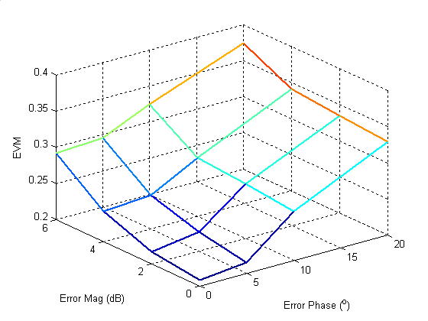

EVM value ~ IQ magnitude and phase imbalance
(with analog filter and phase noise)
(EVM value of the top curve 6dB 20 degree is 37%)

On RX end, in general, each symbol of baseband signal may be direct detected by the correlation algorithm between received signals and local symbol tables. It is not necessary to resolve the phase shifts.

The phase errors only impact the chip values, but the system performance is impacted by the sequence selection, which is determined by the correlation values. Same as described above, the MPSK scheme is similar with the OQPSK scheme, which is also a sequence modulation.

There will be some receiver performance degradation for both of MPSK and OQPSK when the EVM value is large, but the receiver can still work relatively well. CWPAN group has tested : the receiver can still work well in the worst case that the EVM value exceeds 35% (simulation condition: Error Mag=4db, Error Phase= 20⁰).

Oct. 16 2008: Q&A on Conference Call
- Performance simulation results from CWPAN that shows PER vs. EVM for MPSK PHY. For a particular EVM value, the corresponding phase and amplitude imbalance need be shown.

The EVM value is caused by the practical Transmitter performance. Not caused from the modulation.
“Probably EVM will be primarily caused by phase noise, although the modulator may add some noise also depending on how it is implemented” The email of Mr. Paul Gorday and Liang on Oct. 12.

The EVM may created by phase noise, IQ imbalance and more.

Here, suppose the EVM is created by IQ imbalance (Magnitude and Phase).

Magnitude Imbalance (dB) | Phase Imbalance (degree) | EVM Value (%)
0 | 0 | 0
2 | 10 | 1.97
4 | 20 | 7.37
6 | 30 | 15.33
8 | 40 | 25.05
10 | 50 | 35.87

On RX end, in general, each symbol of baseband signal may be direct detected by the correlation algorithm between received signals and local symbol tables.

The phase errors only impact the chip values, but the system performance is impacted by the sequence selection, which is determined by the correlation values. Same as described above, the MPSK scheme is similar with the OQPSK scheme, which is also a sequence modulation.

There will be some receiver performance degradation for both of MPSK and OQPSK when the EVM value is large.

Simulation results: the influence of EVM values to PER performance
PER ~ Eb/N0, under AWGN channel and different condition of IQ imbalance (The relations between the IQ imbalance values and the EVM values are listed in the above table.)

Simulation RX conditions: The receiver has perfect timing information, and the noncoherent detection with correlation algorithm is used.

Paul also suggests to:
“In 802.11 DSSS, and in 802.15.4, the fact that both systems are DSSS helps them tolerate higher EVM - that is, phase jitter from chip to chip will be reduced when the chips are summed together during de-spreading. Some modulations withstand EVM more than others (obviously, 64 QAM would require very small EVM), and some demodulation techniques are more robust to EVM. “

“Either way, you (Liang Li) will probably need to simulate, or at least estimate, how much phase jitter can be tolerated by the demodulator.” The email of Mr. Paul Gorday and Liang on Oct. 12.

Paul also suggests we do not some simulation as:

“The receiver simulation was as realistic as possible, including time synchronization, quantization effects, oscillator phase noise, etc. We simulated in white noise channel (no multipath). As I mentioned in the previous email, our EVM was primarily due to oscillator phase noise in the transmitter, so the simulation allowed us to adjust transmitter phase noise to various levels and determine the resulting EVM. Then we performed standard packet error rate (PER) curves to determine the degradation that resulted from different EVM levels. “ Paul email Oct. 15

“Only suggestion is to create a simulation of your modulator and include oscillator phase noise, and then run >1000 chips to evaluate EVM as the spec describes. “ Paul email Oct. 15

Some simulation for Phase noise are implemented as:

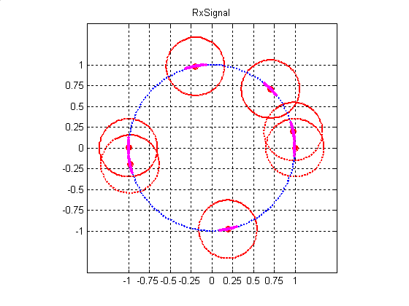
Signal constellation of the MPSK system with the phase noise

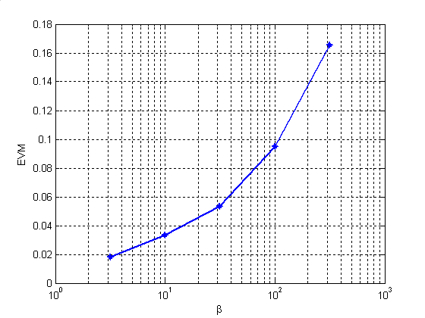
The impact of phase noise on EVM
Simulation results: the influence of EVM values to PER performance

PER ~ Eb/N0, under AWGN channel and same receiver as IQ imbalanced ones

- Minimum EVM requirement for transmitted signal that is required to avoid ambiguity in the constellation points of the transmitted signal. Michael will provide a write-up to the group to explain what needs to be done.

a) The EVM definition is given in the Section 6.9.3 of IEEE802.15.4-2006 as:

$$\text{EVM}=\sqrt{\frac{\frac{1}{N}\sum_{j}{({δI}_{j}^{2}+{δQ}_{j}^{2})}}{S^{2}}}∗\text{100}\text{\%}$$

The original EVM limitation of QPSK is defined from:

“I believe we started with the EVM spec from 802.11-1999 DSSS mode, which is also 35%. We reasoned that 802.15.4 should be able to meet the same spec because it is also DSSS with similar or higher number of chips per symbol. Motorola and Philips did perform some simulations to verify that our receivers could tolerate this level of EVM.“ The email of Mr. Paul Gorday and Liang on Oct. 12.

About the accuracy Min/Max EVM values of transmitter under MPSK modulation, I do not have the exact solution on hands.

There may be one simple and not accurate method to analysis the EVM value.

The following is the constellation of MPSK.
Signal constellation of the MPSK system

The mini phase difference between two points is Pi/16. Suppose the Pi/32 is the permitted difference for two points on TX side. (The suppose is so tight, because only one pair of points with PI/16 phase shift happen in one symbol period. The other 31 phase shifts between two adjacent points are all larger than Pi/16.)

So, the possible EVM may be estimated in the condition that all the N-points have the same Pi/32 phase shifts as (assume the simple receiver is applied):

$$\text{EVM}=\sqrt{\frac{\frac{1}{N}\sum_{j}^{N}{{δI}_{j}^{2}+{δQ}_{j}^{2})}}{S^{2}}}∗\text{100}\text{\%}=\sqrt{\frac{(\text{cos}(π/{\text{32}})−1)^{2}+(\text{sin}(π/{\text{32}})−0)^{2}}{S^{2}}}∗\text{100}\text{\%}=9\text{.}\text{81}\text{\%}$$

"S" is the magnitude of the vector to the ideal constellation point. Therefore in MPSK systems, if the transmitted power of the chip is 1, as the constellations shown in the above figure, S would also be 1.

This is a worst case!

In the above page, we list out plots for the toleration of (Non-coherent detection) demodulator. The related EVM may sourced from I,Q imbalance.

(Other analysis is provided by Michel, too).

