IEEE P802.15
Wireless Personal Area Networks

Project | IEEE P802.15 Working Group for Wireless Personal Area Networks (WPANs)
Title | TG6 Technical Requirements Document (TRD)
Date Submitted | [8 September, 2008]
Source | [Bin Zhen, NICT]  [Maulin Patel, Philips]  [SungHyup Lee, KORPA]  [EunTae Won, Samsung]  [Arthur Astrin] | E-mail: [zhen.bin@nict.go.jp]  [maulin.patel@philips.com]  [shlee@korpa.or.kr]  [etwon@samsung.com]  [astrin@ieee.org]
Re: | [Body Area Network (BAN) Technical Requirements document]
Abstract | [BAN Technical Requirements]
Purpose | [This working document has been prepared to be a BAN Technical Requirements documentation
Notice | This document has been prepared to assist the IEEE P802.15. It is offered as a basis for discussion and is not binding on the contributing individual(s) or organization(s). The material in this document is subject to change in form and content after further study. The contributor(s) reserve(s) the right to add, amend or withdraw material contained herein.
Release | The contributor acknowledges and accepts that this contribution becomes the property of IEEE and may be made publicly available by P802.15.

Table of Contents

1.0 General 3
2.0 Introduction 5
3.0 BAN Technical Characteristics Summary 5
4.0 Topology 7
5.0 Bit Rates 7
6.0 Transmission range 10
7.0 Security 10
8.0 Quality of Service (QoS) 10
9.0 Power Consumption 11
10.0 Coexistence and Interference Resistance 11
11.0 Form Factor 12
12.0 Antenna 12
13.0 Complexity 12
14. Mobility 12
15. Specific Absorption Rate (SAR) 13
16. Regulatory Matters 13
17. References 13

1.0 General

This technical requirement document (TRD) describes the technical aspects that TG6 standard must fulfill, such as performance-related issues, reliability issues, and availability issues. These types of requirements are often called quality of service (QoS) requirements; other requirements are usually maintenance-level requirements or external constraints, sometimes called compliance. Technical requirements are summarized as any other specifications; they have a name and a unique identifier. Technical requirements are documented in the same manner as any specifications, including a description, an example, a source or references to related technical requirements, and a revision history.
TG6 needs to effectively define and manage requirements to ensure they are meeting needs of the BAN users, while proving compliance.

Ideally, requirements are:

• Correct (technically and legally possible)
• Complete (express a whole idea or statement)
• Clear (unambiguous and not confusing)
• Consistent (not in conflict with other requirements)
• Verifiable (it can be determined that the system meets the requirement)
• Traceable (uniquely identified and trackable)
• Feasible (can be accomplished within cost and schedule)
• Modular (can be changed without excessive impact)
• Design-independent (does not pose a specific solution on design)

Each requirement must first form a complete sentence, containing a subject and a predicate. These sentences must consistently use the verb “shall”, “will” or “must” to show the requirement's mandatory nature, and “should” or “may” to show that the requirement is optional. The whole requirement specifies a desired end goal or result and contains a success criterion or other measurable indication of the quality.

TRD needs to capture these levels of user requirements, maintaining intelligent traceability and change impact analysis between them.

Typical constraint requirements can specify:

• Performance
• Interfaces
• Security
• Safety
• Reliability
• Availability
• Maintainability

An efficient way of writing better requirements is to ensure they are clearly mapped to test cases. Making sure each requirement is clearly verifiable from the start, not only helps prepare later phases of the project, it also puts the developer in the correct state of mind. Requirements and their associated tests must also indicate what the system should not do, and what happens at the limits (degraded mode).
This rule also applies for compliance requirements: indicating how they shall be tested is a good way to write better requirements.

As in most projects, requirements are subject to continual change. As a project progresses, IEEE needs to remain agile, adapt to engineering imperatives, and respond to evolving market situations and customers needs. Writing a perfect first requirement is insufficient if its evolution isn’t well-managed – poorly controlled change can lead to inadequate systems and software, rework effort, and loss of revenue.

TRD need to implement a reliable and repeatable change control process that helps turn this challenge into an opportunity.

By providing examples and counter-examples of good requirements and documents, IEEE can enhance the quality, consistency, and completeness of the requirements. These can originally be templates, industry standards and rules inside a repository, such as the IEEE server.

Requirement typical sentence construction

Defects to avoid:

- Vagueness
- Weakness
- Over specification
- Subjectivity
- Multiplicity
- Unclear meaning
- Implicit meaning

Some words to be used with caution:

“adequate”, “applicable”, “appropriate”, “approximate”, “bad”, “best practice”, “between”, “clearly”, “compatible”, “completely”, “consider”, “could”, “down to”, “easy/easily”, “effective”, “efficient”, “equivalent”, “excellent”, “good”, “his/her”, “however”, “ideal”, “etc”, “in order to”, “include but shall not be limited to”, “least”, “like”, “low”, “maximise”, “may”, “most”, “minimum/mal”, “must”, “nearly”, “necessary”, “needed”, “normal”, “or”, “possible/bly“, “practicable”, “provide”, “quality”, “readily”, “relevant”, “safe/ly“, “same”, “should”, “significant”, “similar”, “so as”, “subject to”, “substantial”, “sufficient”, “suitable”, “support”, “target”, “typical”, “up to”, “user friendly”, “whether”, “will”, “with”, “worse”.

2.0 Introduction

This document provides the technical contents of the project to develop PHY and MAC protocols for Body Area Network. This document will provide guidance on how to respond to a call for proposals. As for any communication protocol, the reference model used for this standard is the following:

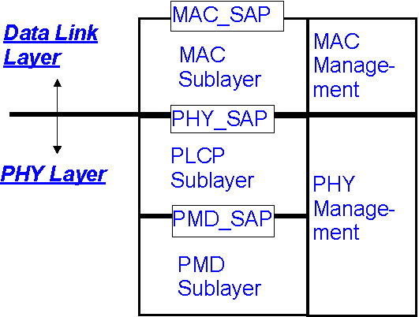
MAC_SAP: MAC Service Access Point
PHY_SAP: PHY Service Access Point
PMD: Physical Medium Dependent (radio)
PLCP: PHY Layer Convergence Protocol,
Figure 1, Reference partitioning

This document serves two purposes. First, it summarizes the applications presented in response to BAN Study group and TG6 Call for Applications. Second, it describes and defines the fundamental requirements implied by applications but not necessarily stated explicitly.

3.0 BAN Technical Characteristics Summary

The intended standard will define the PHY and MAC layers for short range, wireless communication in and around the body area. The standard aims to support a low complexity, low cost, ultra-low power and highly reliable wireless communication for use in close proximity to, or inside, a human body (but not limited to humans) to satisfy an evolutionary set of entertainment and healthcare products and services. The project will also address the coexistence.

3.1 High level description

The standard intends to address both medical/healthcare applications and other non-medical applications with diverse requirements. The medical applications cover continuous waveform sampling of biomedical signals, monitoring of vital signal information, and low rate remote control of medical devices. The non-medical applications include video and audio, bulk and small data transfer, and command and control for interactive gaming etc. Dependent on the application, the BAN may require a network of anywhere from a few sensor or actuator devices communicating to a portable handset or PDA, to potentially hundreds of sensors and actuators (e.g. EEG) communicating to a gateway device through which is connected to the Internet or a local or wide area network.

Devices for the above applications are usually highly constrained in terms of resource such as CPU processing power, battery capacity and memory size and operate in unstable environments. At the same time, medical sensors and actuators have to be physically small to be wearable or implantable. The wearable gateway device may also have some form of resource constraint. However, it is relatively more powerful than the medical sensor and actuator.

The devices would operate indoor, outdoor in home, hospital, small clinic, fitness center etc. There may be interference from and to the other devices in the environment. Patients may simultaneously have both medical application and non-medical application, and both wearable and implantable applications on/in its body.

Because of the space limitation and location dependent characteristics of medical information, it is unlikely to deploy redundant medical sensors for vital information collection. As a result, there is little redundancy in the traffic. Depending on the philosophy of medical application, the major traffic tends to be point-to-multipoint (e.g. stimuli) and multipoint-to-point (e.g. ECG). Therefore the traffic flow can be asymmetric. During diagnosis, doctor may investigate a parameter in a command/response mode. The “downstream” traffic (commands) is coming from the gateway to a particular sensor or actuator.

Most of biomedical and vital signals tend to be periodic and of low frequency. The packet generation interval can vary from 1ms to 1000s. Other applications, such as motion detection and fall detection for the elderly or infirm, can be event-based/bursty. Some applications may involve transmitting a log file once a day, with typically Kbytes of data. Some medical sensors may detect alarm conditions. Time crucial alarm packets are expected to have higher priority than sensing data.

Remote medical monitoring and control applications can be “open loop” or “closed loop”. In the former case, sensor data makes its way through the gateway to the caregiver who may decides to take an action, and control information is sent out to the actuator in the network. It is envisioned that the “closed loop” control is the future trend, in which packets will flow over local loops without intervention from the caregiver. Close loop control may have a latency requirement that can be 100ms to seconds. In many of these applications, if the packets do not arrive within the specified interval, the system will enter an emergency alarm state, often with live or dead indication.

Non-medical applications are generally point-to-point. The real time video and audio traffic are particular sensitive to the end-to-end delay and delay variant. For example, the end-to-end delay in interactive game should be less than 250 msec.

3.2 Overall requirements

Given the broad range of possible applications space, the key feature for this standard must be to address the issue of scalability in terms of data rates, power consumption, network size, and security. In some cases the tradeoff for speed or security may increase power consumption or indeed for improved quality of service. Other tradeoffs will need to be addressed in either or both the MAC or Physical layers. This project should formulate and propose the methods that this can be achieved, whilst demonstrating the key goals of improved energy efficiency is indeed achieved.

Anticipated high-level characteristics of the MAC and PHY layers are summarized as follows.
- The BAN should be self-forming, (good management) self-healing, secure, robust and reliable;
- Typical link throughput should be some tens of kb/s in most of the cases. However, raw data rate up to 10 Mbps is expected in some applications, and low data rate less than 10kb/s should be supported in some medical applications;
- The power consumption should allow for self-powered operating time without intervention from several hours to several years, depending on applications. Power management should covers duty cycle from 0.1% or less to a medium/high value;
- The QoS management and reliability should be provided for high priority alarm message and real time vital information;
- Security should be lightweight, scalable and energy efficient;
- Co-existence between wearable and implant BANs, coexistence between BAN and other wireless technologies, and coexistence of BAN in medical environments (EMC/EMI) should be addressed;
- Minimization of SAR into the body to satisfy the local regulatory requirements.

Specific detailed requirements associated with these characteristics are described in the sections that follow.

4.0 Topology

The network components may be in close proximity to, or inside, a human body. In some cases, support for multi-hop communication may be needed to enable connectivity between devices hidden by body. In other cases, a simple star network is sufficient. In either case, bi-directional communication is required; however, it may not be necessarily symmetric.

The network should be workable without requiring complex set up procedure and should tolerate dynamic insertion and de-insertion of nodes into a network. No single point of failure should be guaranteed in life-critical applications.

Typical medical network consists of 6 nodes. The network configuration should be efficiently scalable (e.g. 256 nodes) to support some integrated medical applications.

Typical applications imply data collection by a unique or a set of coordinated data collectors. Thus the corresponding network component may have to sustain a much higher throughput than the ones of the other nodes. The data collectors should be able to transmit multicast messages to a set of nodes. For example, an ECG/EMG collector may issue a start (broadcast) command to all the electrodes asking them to start sampling and transmitting.

5.0 Bit Rates

Some examples of body area network links are shown below:

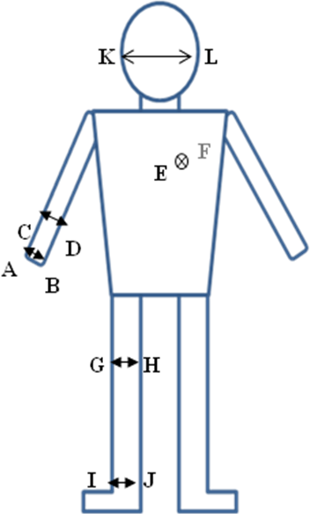

Link | Description
A - B | Through the hand
C - D | Through the wrist
E - F | Torso, front to back
G - H | Through the thigh
I - J | Through the ankle
K - L | Left ear to right ear

Figure 2.

The medical applications cover continuous waveform sampling of biomedical signals, monitoring of vital signal information, and low rate remote control of medical devices. The non-medical applications include video and audio, bulk and small data transfer, and command and control for interactive gaming etc.

The bit rate is categorized the following way:

- One such requirement is to transmit one bit reliably to signal an “Emergency” condition that the BAN node detected. In medical applications this might be BAN sensor detection of heart beat stoppage, excessively low or high blood pressure or temperature, excessively low or high blood glucose level in a diabetic patient, battery dying, etc.
- Another requirement is to transmit reliably a “Wake-up” signal to a sleeping BAN node to wake it up, in order to transmit and receive more data. What one hopes to achieve is a considerably lower power consumption of monitoring for the wake up signal, orders of magnitude lower than the normal transceiver operation power.
- Finally, it is desirable to be able to recharge a BAN node via an RF signal. This requires a low-loss link through the body channel for power delivery.
- Because the body tissue conductivity is between .1 and 10 S/m (dependent on frequency) as can be seen in Fig. 3, there is concern with high loss, which would require a high power levels, which in turn is detrimental to the meeting the requirement of complying with specific absorption rate (SAR) standards. SAR is a measure of the rate at which radio frequency energy is absorbed by the body tissue, when exposed to an electromagnetic field.

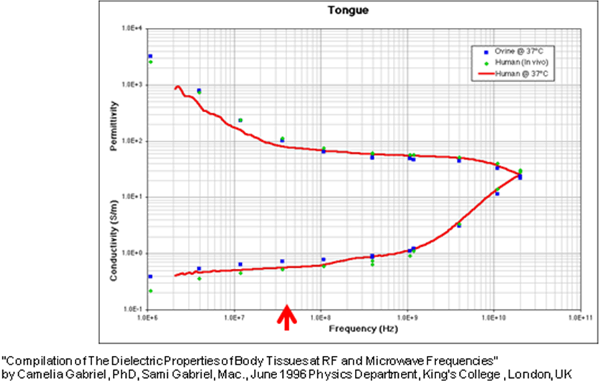

- Individual link bit rate. This is related to a peer to peer link, typically between a device and an information collector or between two devices.
- Aggregated bit rate. This is typically the average bit rate concentrated from many devices to a data collector during a short period of time (can be during specific situations when many devices need to update their information at the same time. For example, alarm or emergency situations, ECG/EMG devices have many electrodes and one aggregator etc). Typically, data collectors might gather data from around 5 nodes, in the future the upper limit is expected to grow. The data collector should be capable of acquiring up to 1 Mb/s of effective data for configurations that require this feature. The aggregate bit rate is related with the overhead associated with MAC mechanism, frame structure, collisions, and implementation processing delays. The aggregate data rate may saturate in a heavy duty cycle network.

Typical selected figures:
- Individual link bit rate: 1 kb/s (medical applications) and 10 kb/s (non-medical applications) at the low end, and 10 Mb/s at the high end at PHY-SAP.

Monitoring of vital signal information from sensors
Remote control of BAN devices (control and telemetry)

The medical applications cover continuous waveform sampling of biomedical signals, monitoring of vital signal information, and low rate remote control of medical devices. The non-medical applications include video and audio, bulk and small data transfer, and command and control for interactive gaming etc.

- Aggregated bit rate (data collector only): 1 Mb/s or less (medical applications) and 10 Mb/s or less (non-medical applications) at PHY-SAP.

6.0 Transmission range

The application analysis suggests that up to 3 meters of transmission range is sufficient for most applications. However, the range should be extendable up to 5 meters for some medical applications such as bed side monitoring in hospital, clinic, healthcare center or home. In this case, consideration should be given to how this can be achieved within the spectral masks and channel link budgets that will apply.

7.0 Security

Medical BAN applications have substantial financial, privacy and human safety implications. Security and privacy are key concerns of patients, doctors and medical service providers. During the transmission of encrypted physiological data, patient identifiers should be particularly protected from overhearing. Denial of Service (DoS) occurs when network traffic is beyond the capacity of the systems. DoS is associated with the effects of both intentional act of malicious users and unintentional excessive peak network utilization.

Multi-level security is desired so that each application can choose a level that best suits its needs. For example camera pill may not need strong encryption and authentication process. However, pacemakers may need strong authentication process. Devices need to be interrogated by authorized personnel for the lifecycle of the product. The highest level of security should be equal to or stronger than those specified by IEEE 802.15.4-2006 standard.

Because security and privacy protection mechanism require a significant amount of computational resource and storage resource, the mechanism should be energy efficient and lightweight.

Novel security mechanisms are needed for applications to account for
- The longevity of implanted devices. (Doctor may need to calibrate the device once a year or so. Patients may relocate to a different geographic region.)
- Average person cannot be expected to play the role of network administrator who can set up and manage authentication process. Hence, limited user interaction during security configuration is desirable.
- Inability of the user to provide passkeys when needed. (e.g. Devices should be accessible to paramedics/medics in a trauma condition. However, in such situations, the user may not be able to provide authentication information)

Biometric identification based security mechanism could be useful for BAN. In general, non-medical applications have relaxed security requirements compared with the medical applications.

8.0 Quality of Service (QoS)

QoS is an important part in the framework of risk management for BAN applications. QoS support should be a major focus of PHY and MAC. The critical factor is the reliability of the transmission, meaning that appropriate error detection and correction methods, interference avoidance methods, or any other suitable techniques should be provided at PHY and MAC level. Other QoS measurements include point-to-point delay and delay variation. QoS provisions should be flexible such that they can be tailored to suit application needs.

Other QoS parameters have a strong impact on MAC and PHY layers:
- Support of real time communication is required for some applications;
- Capability of providing fast and reliable reaction in emergency situations and alarm message, which usually have higher priority than others, should be provided;
- Support of congestion control and admission control are expected;
- Adaptive duty cycling and reservation to match the application load and latency requirement while maintaining low power operation;
- Link quality detection and channel migration should be considered when the channel gets crowded or noisy;

9.0 Power Consumption

In some applications, the device (complete communication system including PHY and MAC) should operate while supporting a battery life of months or years without intervention; whereas others may require a battery life of tens of hours due to the nature of the application and/or physical constraints on the size of the devices. For example, cardiac defibrillators and pacemakers have a lifetime of more than 5 years, whereas swallowable camera pills typically have lifetime of 12 hrs. Most of the non-medical applications have stand-by power requirement of 100-200 hours and active power requirement of several hours.

Ultra-low power operation is crucial for longevity of implanted devices. In some applications energy scavenging techniques may be employed which may alleviate the need for a battery.

It is common for low duty cycle devices to shut down radio and CPU resource for most of the time. In a typical wireless system idle listening and overhearing consumes a significant amount of power. Efficient and flexible duty cycling techniques are required to minimize idle listening, overhearing, packet collision and control overhead. An efficient power saving (sleep) mode is desirable, in particular for low duty cycle devices that transmit sporadically. In addition the coordination of nodes should not induce frequent wake up of nodes. These mechanisms should be supported by the MAC and PHY layers.

The maximization of whole network life time should consider the different power constraints of nodes in the piconet.

10.0 Coexistence and Interference Resistance

BAN devices shall co-exist with other BAN devices and legacy devices. The devices may need to operate in an interference environment by having attributes to deal with interference ingress (interference coming into the PHY layer) and interference egress (interference caused by the PHY layer). The attributes may be adjusted by higher layer (above PHY layer) management.

The devices must be able to operate in high noise, high multipath and dynamic environment. The PHY layer must be able to sustain an appropriate level of co-channel and out-of-band interference. Both medical application in hospital, small clinic, healthcare center and home have to be considered, along with wearable entertainment applications.

MAC should support simultaneous co-located operation of multiple BANs in crowded places such as subways, hospital ward, music concert etc. In particular, implantable BAN and wearable BAN should gracefully coexist in-and-around the body. A fair bandwidth sharing among collocated BANs and graceful degradation of service is highly desirable for high duty cycle application, while uncoordinated operation is acceptable for low duty cycle applications. Medical applications can be given higher priority than entertainment non-medical applications when bandwidth is scarce.

11.0 Form Factor

The PHY components should be capable of fitting into form factors consistent with wearable and implant applications. The critical point is that this generally includes the battery and the antenna parts.

12.0 Antenna

No assumption is made about antenna propagation pattern. The antenna(s) should be specifically designed to operate in a body centric environment and handle the issues resulting therein, such as propagation through and around the body. Other factors such as body movement, body shadowing, size, MR, SAR, safety etc should be taken into consideration. In medical applications, the antennas (devices) may be put where is best for underlying application, which is not always the best for radio wave propagation. Besides, the antennas for implant applications are covered by tissue compatible material.

13.0 Complexity

Complexity should be minimal to enable mass commercial adoption for a variety of cost sensitive products. Complexity (gate count, die size) and BOM should be minimized. In a number of applications, the components are to be considered as throwaway after use.

14. Mobility

Nodes should be capable of reliable communication when on the move. It is accepted that the data capacity of a network might be reduced in such cases because of unstable channel conditions but data should not be lost. The considered applications may involve body movement induced by (e.g. twisting, turning, sitting, walking, waving arms, running etc.) which induce channel fading and shadowing effect. Doppler Effect is out of the scope. While individual nodes may move relative to each other, an entire BAN may move its absolute location. This absolute movement leads to a dynamic interference and coexistence environment.

15. Specific Absorption Rate (SAR)

At the frequencies of operation of most wireless devices, the known health effects that centre around tissue is heating. BAN devices are quite low power and there is not enough power available for whole-body SAR to be a concern. However, since the device may be in close proximity to, or inside, a human body, the localized SAR could be quite large if all the available power is deposited in a small volume. The localized SAR into the body must be minimized. BAN devices shall comply with international or local SAR regulations. SAR is regulated, with limits for local exposure (Head) of: in US: 1.6 W/kg in 1 gram and in EU: 2 W/kg in 10 gram. This limits the TX power in US < 1.6 mW and in EU < 20 mW.

16. Regulatory Matters

The transmit spectrum mask (measured by EIRP or ERP) at PHY layer shall comply with necessary geopolitical or regional regulations. This is defined in greater detail in 15-08-0034-05-0006-ieee-802-15-6-regulation-subcommittee-report. Ref [6].

Devices shall comply with the regulatory requirements specified for the chosen frequency band by competent authorities. If possible, a common worldwide frequency band is desirable for harmonization worldwide.

17. References

- IEEE 802.15.4-006 standard
- BAN application matrix (07-0735-08)
- 15-07-0735-08-0ban-application-requirement-analysis.xls
- 15-08-0406-00-0006-tg6-applications-matrix.xls
- 15-08-0407-00-0006-tg6-applications-summary.doc
- 15-08-0034-05-0006-ieee-802-15-6-regulation-subcommittee-report.doc

