IEEE P802.15
Wireless Personal Area Networks

Project | IEEE P802.15 Working Group for Wireless Personal Area Networks (WPANs) (Body Area Networks)
Title | Measurements of body channel at 13.5 MHz
Date Submitted | 15 August 2008
Source | [Arthur Astrin]  [Astrin Radio]  [Palo Alto, CA, USA] | Voice: [+1 650 704-2517]  Fax: [1 650 328-7721]  E-mail: [astrin@ieee.org]
Re: | TG6 BAN Channel Model
Abstract | This paper describes measurements of body channel taken at 13.5 MHz frequency.
Purpose | To provide TG6 with results of measurements of body channel at 13.5 MHz
Notice | This document has been prepared to assist the IEEE P802.15. It is offered as a basis for discussion and is not binding on the contributing individual(s) or organization(s). The material in this document is subject to change in form and content after further study. The contributor(s) reserve(s) the right to add, amend or withdraw material contained herein.
Release | The contributor acknowledges and accepts that this contribution becomes the property of IEEE and may be made publicly available by P802.15.

Measurements of body channel at 13.5 MHz

Introduction

In order to aid development of standard proposals, the TG6 task group requested channel models for body area networks. This information will be invaluable in determining the best choice of transmission in and around the body.

This paper describes measurements of body channel taken at 13.56 MHz frequency.

The ISM bands in HF spectrum at 6.78 MHz, 13.56 MHz and 27.15 MHz are referred to as Industry, Scientific, and Medical and Short Range Device Telemetry and Telecommand usage. They are shown in Table 1.

Band low frequency | Band high frequency | Bandwidth
6.765 MHz | 6.795 MHz | 30 kHz
13.550 MHz | 13.571 MHz | 21 kHz
26.950 MHz | 27.300 MHz | 350 kHz

Table 1.

The interest in these bands was caused by BAN very low data rates requirements for some fundamental applications. These were to transmit rarely a few bits of relatively high importance.
Although the bandwidths there are relatively small, there are requirements for BAN, where good propagation in the body may be traded off against available low data bit rates.
One such requirement is to transmit one bit reliably to signal an emergency condition that the BAN node detected. In medical applications this might be BAN sensor detection of heart beat stoppage, excessively low or high blood pressure or temperature, excessively low or high blood glucose level in a diabetic patient, etc.
Another requirement is to transmit reliably a “Wake up” signal to a sleeping BAN node to wake it up, in order to transmit and receive more data. What one hopes to achieve is a considerably lower power consumption of monitoring for the wake up signal, orders of magnitude lower than the normal transceiver operation power.
Finally, it is desirable to be able to recharge a BAN node via an RF signal. This requires a low-loss link through the body channel for power delivery.
Because the body tissue conductivity at 13 MHz is between .1 and 1 S/m (see Figure 1), there is concern with high loss which would require a high power levels, which in turn is detrimental to the meeting the requirements of specific absorption rate (SAR) standards. SAR is a measure of the rate at which radio frequency energy is absorbed by the body when exposed to an electromagnetic field.
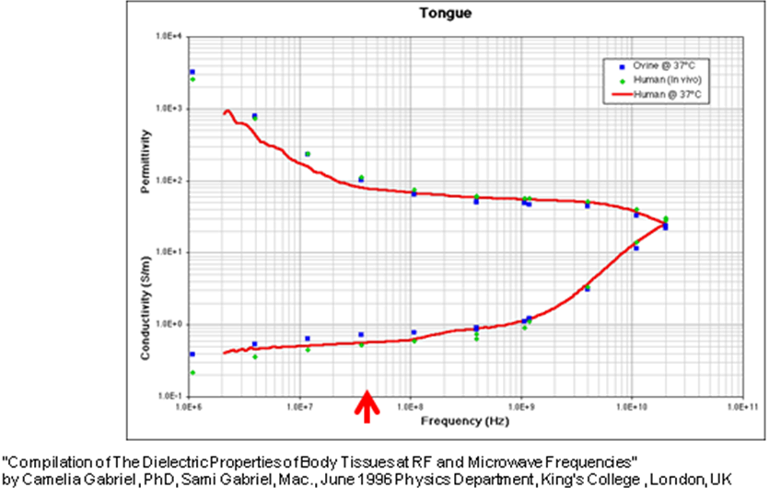

Figure 1.

Due to concerns with body tissue absorption and ionizing radiation the loop antenna was used.

Transmitter and Receiver setup

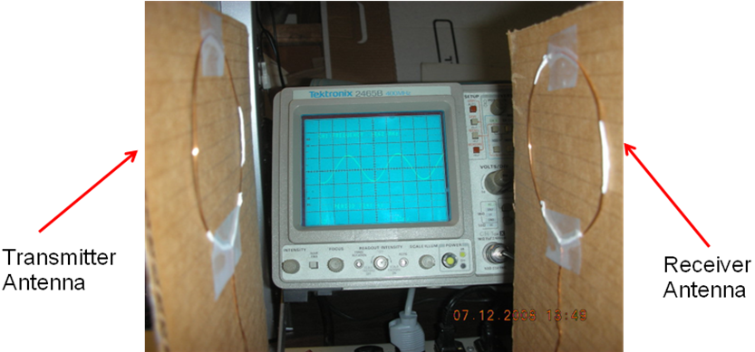

Figure 2.

The transmitter and receiver antenna were pointed at each other and the transmitter was set to transmit 13.56 MHz CW signal. The received signal was measured and the system was calibrated in the air.

The body channel test setup

The measurements were taken on a live human body of a volunteer (the author) at the locations shown in Figure 3.

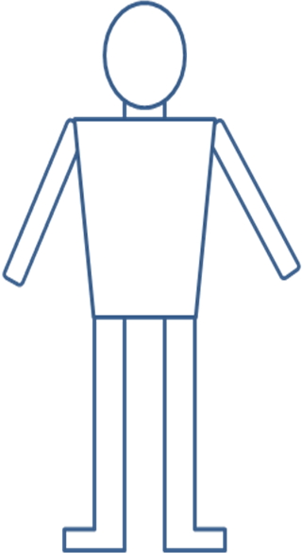
A
B
C
D
E
F
H
G
I
J
K
L

Figure 3.

The links measured are shown in the table 2,
Link | Description
A - B | Through the hand
C - D | Through the wrist
E - F | Torso, front to back
G - H | Through the thigh
I - J | Through the ankle
K - L | Left ear to right ear

Table 2.

Results:

The results of measurements are shown in the table 3.

Link | Description | Signal amplitude reduction | dB loss in relation to air
A - B | Through the hand | 3.3% | -0.15
C - D | Through the wrist | 2.8% | -0.12
E - F | Torso, front to back | 3.4% | -0.15
G - H | Through the thigh | 1.9% | -0.08
I - J | Through the ankle | 2.8% | -0.12
K - L | Left ear to right ear | 2.0% | -0.09
K - L | Left ear to right ear, wearing metal glasses | 1.5% | -0.07

Table 3.

Measurement of exponent of the link

The signal was then received through body tissue at various distances to estimate the link exponent.

Distance  (inch) | Received Signal mV pk-pk
3 | 6.93
4 | 4.74
5 | 2.93
6 | 1.86
7 | 1.25
8 | 0.837
9 | 0.633
10 | 0.471
11 | 0.384
12 | 0.305

Table 4.

Plotting these data and fitting it to x^{n} is shown in Figure 4.

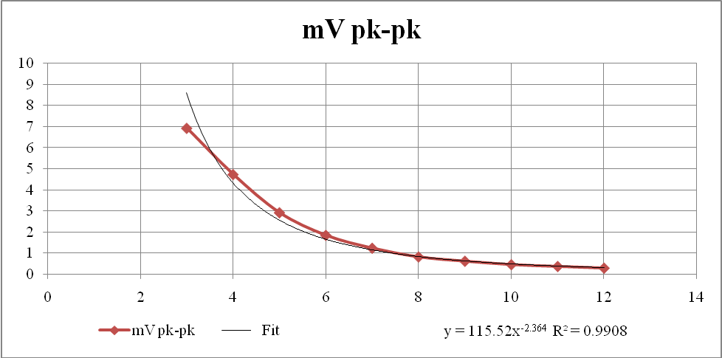
Figure 4.

The regression of this data to x^{n}, where x is the distance between transmitter and receiver, gives 115.52x^{-2.364} with R² = 0.9908.
This leads to an estimate of the link exponent of 2.4.

Conclusion

The body channel at 13.56 MHz frequency has a link loss nearly that of the air and so it is well suited for body area network.
However the available bandwidth is relatively small, so can only be used for data rates up to few kbps. For example, for BPSK modulation with 1 bps per Hz, with 10 channels in the band, one could get up to 2 kbps data links in a channel. This is adequate to signal an emergency condition or to transmit reliably a “Wake up” signal to a sleeping BAN node.

