IEEE P802.15
Wireless Personal Area Networks

Project | IEEE P802.15 Working Group for Wireless Personal Area Networks (WPANs)
Title | Channel model for human body communication
Date Submitted | [5 July, 2008]
Source | [Jung-Hwan Hwang, Il-Hyoung Park, Sung-Weon Kang]  [ETRI]  [138 Gajeongno, Yuseong-gu, Daejeon, 305-700, KOREA ] | Voice: [+82-42-860-1176 ]  Fax: [+82-42-860-3905 ]  E-mail: [jhhwang@etri.re.kr]
Re: | [TG6 Body Area Networks (BAN) channel model document]
Abstract | [The channel model for human body communication is presented in this document]
Purpose | [The purpose of this document is to provide a channel model for human body communication]
Notice | This document has been prepared to assist the IEEE P802.15. It is offered as a basis for discussion and is not binding on the contributing individual(s) or organization(s). The material in this document is subject to change in form and content after further study. The contributor(s) reserve(s) the right to add, amend or withdraw material contained herein.
Release | The contributor acknowledges and accepts that this contribution becomes the property of IEEE and may be made publicly available by P802.15.
Document information and revision history
[Document information]

Version | 1.0s
Written by | JH Hwang
Reviewed by | Human body communication SoC Team
Issue Date | 2008-08-11
Status | Draft

[Revision history]

Revision Date | Version | Revision Contents | Written By | Supervised by
2008-08-11 | 1.0s | Draft | JH Hwang | SW Kang

1. Introduction
1.1. Contents of document
In this document, the channel model for HBC(Human Body Communication) is presented.
1.2. Definitions of terms
The channel model for HBC is composed of the frequency response and the noise characteristics as shown in Fig. 1-1.
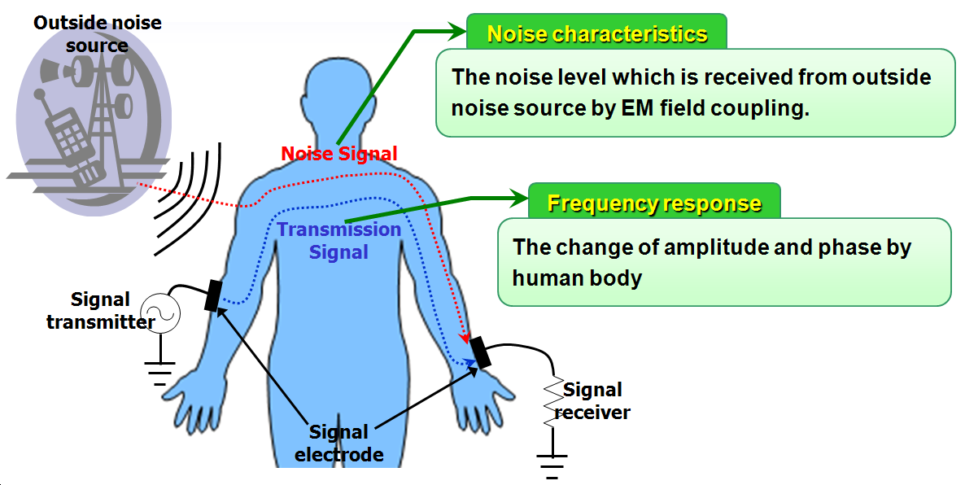
Fig.1-1. Channel model for HBC
In the HBC, a data signal is transmitted through the body of user, so a data communication can be accomplished without wire and wireless. To transfer a signal between transmitter and body or receiver and body, the transmitter and the receiver for the HBC have a signal electrode defined as follows.
- Signal electrode: It is attached to the body and transfers a signal from the transmitter to the body while transmitting signal or from the body to the receiver while receiving signal. It is composed of metal plate which has a certain size.
1.2.1. Frequency response
The HBC is a communication system where a voltage signal is transmitted; that is, in the transmitter, a voltage is induced to the body through the signal electrode, so, in the receiver, an attenuated voltage is induced on a load of receiver through the signal electrode. The human body is lossy dielectric material, so the voltage signal has a change in its amplitude due to the loss component of body during the transmission. Also, the voltage signal has a change in its phase due to the capacitive component of body. The change of amplitude and phase is defined as the frequency response.

- Frequency response: It means the change of amplitude and phase which is present in the voltage signal during its transmission. Here,
Change of amplitude = (Magnitude of output voltage at receiver / Magnitude of input voltage at transmitter) in dB
Change of phase = (Phase of output voltage at receiver – Phase of input voltage at transmitter) in degree.

Individual users of HBC have a different frequency response. The limbs of each user have a different physical length, so each user has a different transmission distance. Also, each user has a different composition of tissues. For example, the more weight the user has, the more composition ratio of muscle and fat tissues the user has. Hence, the frequency response has a deviation range defined as follows.
- Deviation range of the frequency response: It means the change range of frequency response accompanied by different electrical characteristics of users. The frequency response has a uniform distribution in this deviation range. The deviation range is decided to include all measured frequency responses and to be constant irrespective of frequency.
1.2.2. Noise characteristics
An EM(Electro-Magnetic) wave is radiated from a lot of electronic devices and the usres of HBC are exposed to this EM wave during the data communication. Hence, the EM wave causes a noise signal inside body, so this noise signal as well as the data signal is received at the receiver. The noise has different characteristics according to site and time, so its characteristic has to be defined statistically for exact modeling.

- Noise characteristics: It defines statistical characteristics of noise voltage induced on a load of receiver due to the radiated EM fields from outside noise source.

The noise voltage is measured with multiple locations for a longtime, so the site where the largest noise voltage is measured for the longest time is selected and its statistical parameters are defined as the noise characteristics.
2. Channel model of HBC
The conditions for channel modeling are as follows.
Parameters | Conditions
Locations of transmitter and receiver  (Transmission distance) | Fingertips of each hand  (about 150 cm)
Contact location of signal electrode | Fingertip of thumb
Size of signal electrode | 2 × 2 cm²
Load impedance of receiver | 10 Mohm
Table. 2-1. Conditions for channel modeling
2.1. Frequency response
The frequency response has been modeled in the frequency range of 5 MHz – 50 MHz as follows.
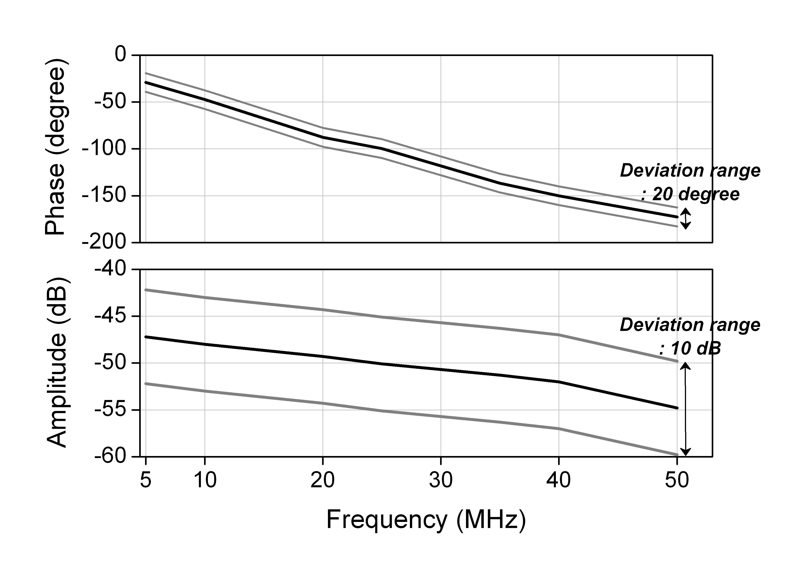
Fig. 2-1. Frequency response
2.2. Noise characteristics
The measured noise has a Gaussian distribution as follows. The mean and variance values are zero and 2.55×10⁻⁵ respectively.
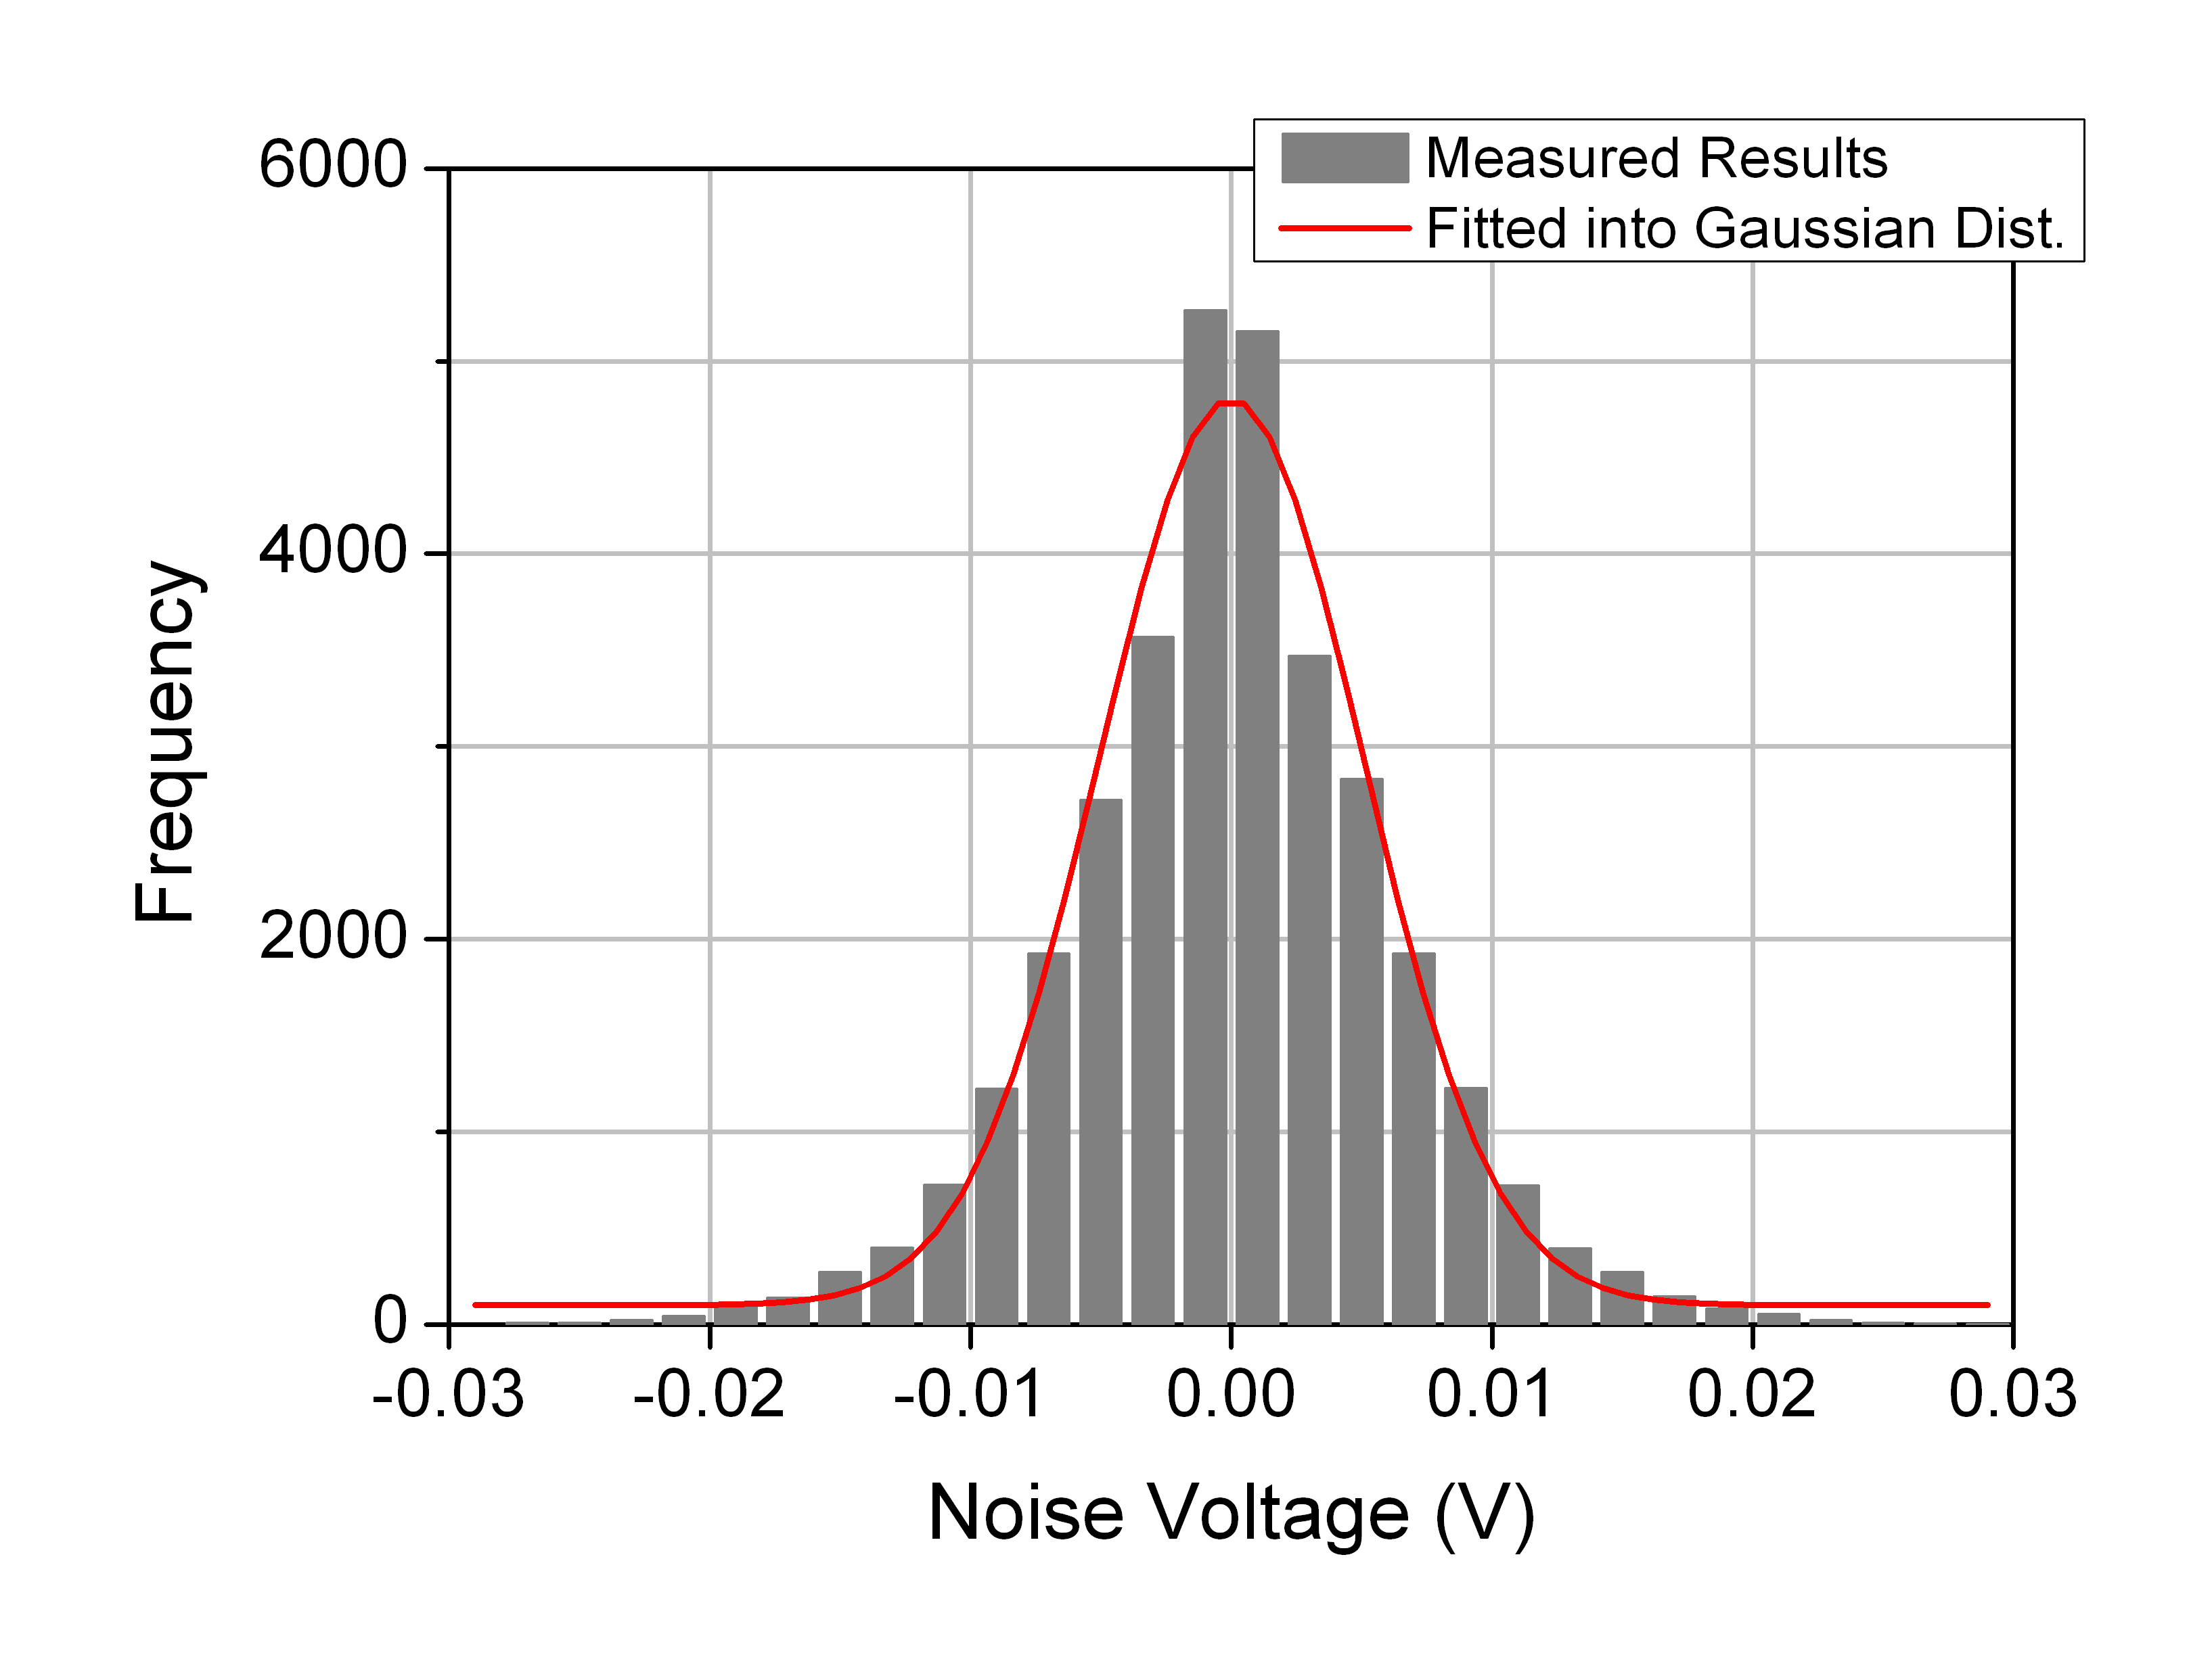
Fig. 2-2. Noise characteristics

1. Model structure
The HBC channel model consists of a channel filter and a channel noise as shown in Fig. 1-1.
Channel filter
Channel input
+
Channel noise
Channel output

Fig. 1-2. HBC channel model
- Channel filter: It represents a signal loss by the human body. In the HBC channel model, its characteristics are represented by an impulse response to simultaneously model changes of transmitting signal’s amplitude and phase by the channel filter. Frequency components of the impulse response are valid only between 0 MHz and 50 MHz, so an input signal should be filtered with a low-pass filter to remove the frequency components out of the range. Also, when sampling the impulse response, a sampling rate should be over 250 MHz to accurately model the impulse response.
- Channel noise: The electromagnetic waves generated from various electronic devices cause a noise inside body due to an antenna effect of the human body, so the noise is added to a transmitting signal. In the HBC channel model, a power spectral density is used to represent level of the noise.
There are two kinds of the parameter which affects the HBC channel: distance and size of ground plane.

Distance
The HBC uses a near-field coupling for data communication, and there are two coupling mediums between a transmitter and a receiver: air and a body. The two mediums affect the HBC channel in combination, so two distances at each medium should be defined respectively as shown in Fig. 1-2. However, the channel noise is not affected by the distance in the current channel model.
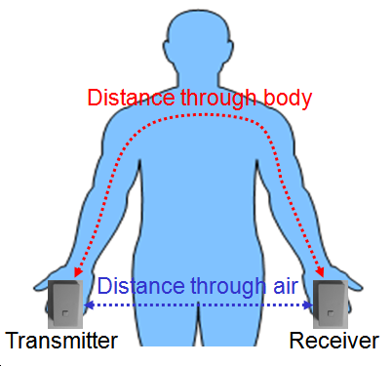
Fig. 3-2. Distance in HBC channel model
- Distance through body(d_{body}): It is defined as a minimum distance along the human body between a transmitter and a receiver.
- Distance through air(d_{air}): It is defined as a minimum distance in air between a transmitter and a receiver.

Size of ground plane
Level of the near-field coupling is affected by sizes of ground planes in a transmitter and a receiver because the near-field is coupled with the air and the human body more and more as the sizes of the ground planes increase. When it is impossible to define the size of the ground plane because the ground plane is inside a device, the maximum size of the device’s outline should be defined as the size of the ground plane. Like the distance, the channel noise is not affected by the distance in the current channel model.
- Transmitter’s ground size(G_{T}): It is defined as a size of a ground plane in a transmitter’s device.
- Receiver’s ground size(G_{R}): It is defined as a size of a ground plane in a receiver’s device.

2. HBC channel model
HBC Channel Model
Channel filter
Channel input
+
Channel noise
Channel output

- The channel filter is represented by an impulse response.
$$h\left(t\right)=h_{R}\left(t\right)⋅C_{h}$$
Here, h_{R}(t) is a reference impulse response and C_{h} is a coefficient related to sizes of ground planes and distances between Tx and Rx. The impulse response is valid only between 0 MHz and 50 MHz, and its sampling rate should be over 250 MHz.
- The channel noise is represented by a specific power spectral density(S_{N}).

Channel filter | h_{R}(t) | $$h_{R}\left(t\right)=A_{V}⋅A⋅\text{exp}\left({−\left(t−t_{r}\right)}/{t_{0}}\right)⋅\text{sin}\left({π⋅\left(t−t_{r}−x_{c}\right)}/w\right)$$  - The A_{v} is a coefficient to represent fluctuation of signal loss. It has a Gaussian distribution as follows:  A_{v} ∼ N(1, 0.16²)  - The A, t_{r}, t₀, x_{c} and w has constant values as follows:
  Time range (μs) | A | t_{r} | t₀ | x_{c} | w
  0 ≤ t < 0.025 | 0.00032 | 0.00000 | 0.00621 | -0.00097 | 0.00735
  0.025 ≤ t < 0.058 | 0.00003 | 0.02500 | 0.01684 | -0.01225 | 0.00944
  0.058 ≤ t | 0.00002 | 0.05800 | 0.05610 | 0.00100 | 0.01109
Channel filter | C_{h} | $$C_{h}=\left(0\text{.}\text{0422}⋅G_{T}−0\text{.}\text{184}\right)⋅\left(0\text{.}\text{0078}⋅G_{R}+0\text{.}\text{782}\right)⋅{\left(\frac{\text{120}\text{.}\text{49}}{d_{\text{body}}+d_{\text{body}}⋅{\left({d_{\text{air}}}/{d_{\text{body}}}\right)}^{5}}\right)}^{2}$$  - The G_{T} and G_{R} are ground plane’s size at Tx and Rx respectively in cm² and the d_{air} and d_{body} are distance between Tx and Rx through air and body respectively in cm. Also, each value is limited for validity of the channel model as follows:  10cm² ≤ G_{T}, G_{R} ≤ 270 cm², 10 cm ≤ d_{air}, d_{body} ≤ 200 cm
Channel noise | S_{N} | -148 dBm/Hz

