IEEE P802.15
Wireless Personal Area Networks

Project | IEEE P802.15 Working Group for Wireless Personal Area Networks (WPANs)
Title | Channel Models between body surface and wireless access point for UWB Band
Date Submitted | [15 August, 2008]
Source | [Hirokazu Sawada 1, Takahiro Aoyagi 2, Jun-ichi Takada 2, Kamya Yekeh Yazdandoost 2, Ryuji Kohno 2]  2: Tohoku Institute of Technology  Sendai  Japan  2: NICT  3-4 Hikarino-oka  Yokosuka 2390847  Japan | Voice : +81-46-847-5431  Fax : +31-46-847-5431  E-mail: [aoyagi@nict.go.jp]
Re: | [Body Area Network (BAN) Channel Model document]
Abstract | [This is a contribution to make a channel between body surface and wireless acess point. It provides a channel model for wireless body area network.
Purpose | [The purpose of this document is to provide a channel model between body surface and wireless access point for UWB band.
Notice
Release

Channel Modeling Subcommittee Report

Date | Revision No.
08/15/2008 | 15-08-0576-00-0006

Table of Contents

1. Introduction………………….………………………………………………………………4

2. Antenna characteristics……………...……………………………………………………4

3. Propagation measurement and analysis........................................................……..8

4. BAN channel model ...............................................................................……………11

5. List of contributors……....…………………………………………………………….…13

6. Conclusion……....…………………………………………………………………...........13

7. References ……….……....………………………………………………………………..13

1. Introduction

Today, the range of medical devices and systems for wireless medical applications is increasing rapidly. Medical telemeter system and wireless capsule endoscopy have been implemented. The wireless body area network integrating the medical and entertainment applications will be considered in near future, however, current communication bandwidth is too narrow for large data transmission like a video streaming. A solution for wideband BAN communication is to use the UWB technology. The BAN channel model for body surface communications was discussed in channel model subgroup of IEEE802.15.4a (Low rate UWB) [1, 2]. However, it is not suitable to be used for medical body area network.
At the proximity of the human body, there is a strong interaction of the electromagnetic field between the antenna and the human body. Therefore, the characteristic of the antenna becomes important for BAN channel [3]. Since the transmitter is attached on body, the antenna characteristics will be changed unavoidably. The channel model of 15.4a considered infinitesimally small electric dipole in the simulation and the absolute path gain was calibrated by a commercial UWB antenna. Therefore, the channel model did not consider the more complicated behaviour of the antenna - human body interaction.
In this report a BAN channel model between body surface and wireless access point using UWB frequency band (3.1 - 10.6 GHz) is presented. We examine antenna characteristics on human body and measure the propagation characteristics to develop the channel model in office environment. Both line-of-sight and non-line-of-sight situations are considered in measurement, because human body may turn around in the real scenario. The channel model is assumed as a single cluster model with K-factor. Parameter of the model is extracted by statistical analysis.
The organization is as follows: Section 2 will show the antenna characteristics on body. Then BAN propagation measurement and analysis will be described in section 3, and a BAN channel model will be presented in Section 4. Finally, a conclusion will be given in Section 5.

2. Antenna Characteristics on body

Antenna characteristic on body was measured in anechoic chamber. Configuration of the measurement is shown in Fig.1. For antenna pattern measurement in far field, distance between antennas was 6 m, and height of antennas was 2 m. We used vertically polarized omni-directional antennas for both Tx and Rx at UWB frequency band. Tx antenna was teardrop type wideband monopole antenna [4]. Planar UWB antenna (SkyCross SMT-3TO10M-A) has been selected for Rx side, since flat type antenna is better for attaching to the body surface. Fig.2 shows the attached Rx antenna on body. The antenna was fixed at the center of body.
For evaluating of human body effects, antenna pattern without human body is shown in Fig.3. Antenna pattern in H-plane was omni-directional, and the difference of maximum- and minimum-gain was 10dB. Antenna patterns on body are shown in Fig.4. We measured a few antenna patterns by changing the gap between antenna and body. Antenna pattern of front side was almost same as omni-directional, however, the gain of back side in 180 degree was decreased about 20dB by shadowing of body. Antenna patterns were only changed within 60 to +60 degree from the center of back side.
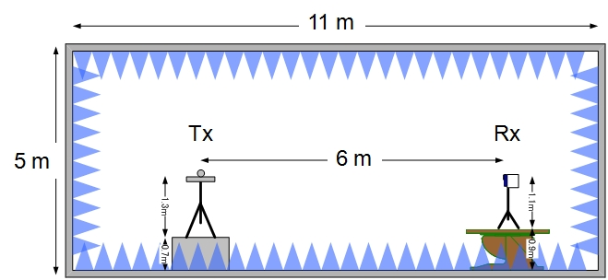

Figure 1: Configuration of antenna measurement.

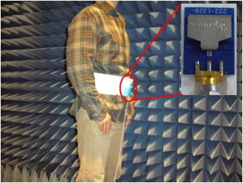
Figure 2: Attached antenna on body.

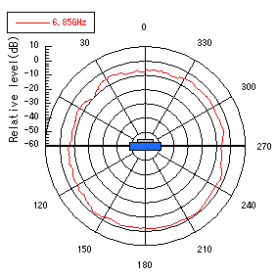
Figure 3: Antenna pattern in air.
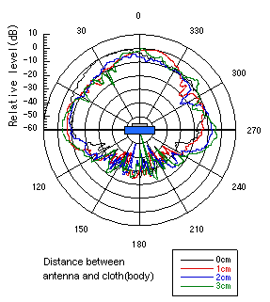
Figure 4: Antenna characteristics on body at 6.85GHz.

3. Propagation measurement and analysis

We measure the delay profile by using vector network analyzer. The complex impulse response was calculated from the measured complex transfer function in the frequency domain by FFT function of the instrument. Frequency range was 3.1-10.6 GHz for UWB band. Recently this measurement method is getting major rather than pulse generator and oscilloscope measurement. Measurements were done in office environment for medical health care applications. The room was surrounded by metal walls and windows, and was furnished by desks, chairs and PC monitors, as shown in Fig.5. Floor was made of concrete board covered by carpet. The measurement configuration is shown in Fig.6 with positions of Tx and Rx antennas. Tx position was fixed near the wall, and Rx positions were changed in human movement area. In this measurement, human direction was also changed for considering shadowing by human body. Rx antenna on body was aligned to Tx antenna at 0 degree as in the geometry of Fig.6.
Impulse responses are shown in Figs.7 in case of three body directions. In 0 degree case (Fig.7a), the direct path component can be seen as the first impulse response, and other multi-path responses became a cluster. On the other hand, in side (Fig.7b) and backside (Fig.7c) cases, the direct path components were attenuated and vanishing respectively. Thus only one cluster can be seen in both cases.
For PHY layer simulation in wide band system design, statistical channel model is often used. Since the statistical channel model can generate various channel realizations with some parameter, the system performance as bit error rate (BER) can be estimated by using the model. To obtain the channel model parameters, the ray information of measured data was required. In this report, CLEAN algorithm was used to extract the ray information from measurement data [5]. This algorithm is based on a peak detection method, and was used in some previous researches. The response of the ray extracted from all the measurement data is shown in Fig.8. We considered the effect of ground in our measurements. However, all data were averaged for statically analysis. Hence; the detail data of each measurement is not described. Since transmission distance is different for each Rx position, all responses were normalized by the maximum value, and the delay time of the first response was shifted to 0. From these figures, the cluster decay factor  was estimated by regression line in each body direction. Then the effect of K-factor k was also estimated by the difference of averaged first response level. Another parameter, the lognormal standard deviation  of normalized ray amplitude was estimated by curve fitting as shown in Fig.9.

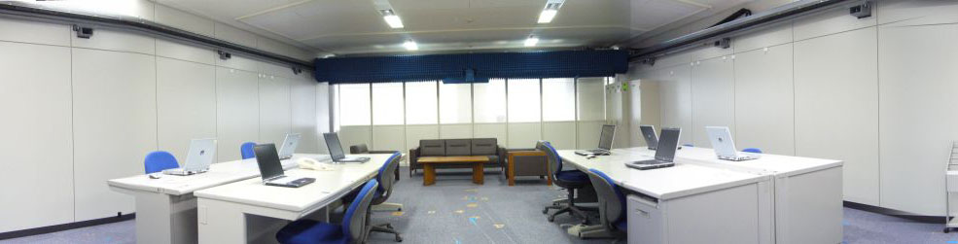
(a) View from wall side.

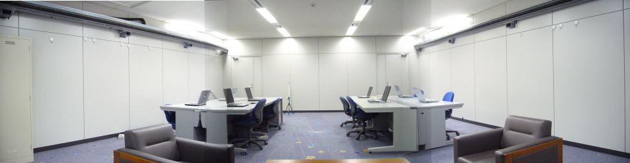
(b)View from window side.
Figure 5: Measurement room.

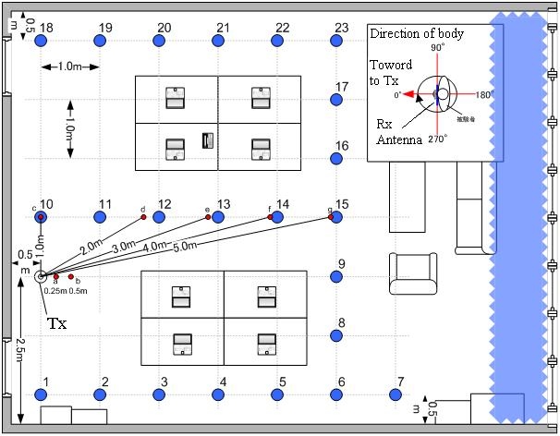
Figure 6: Configuration of propagation measurement.
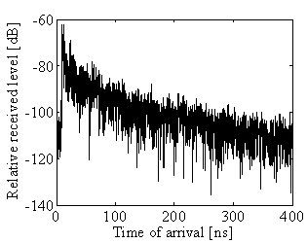
(a) θ = 0 deg (Front of body).
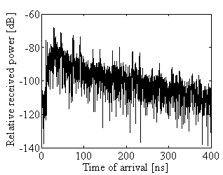
(b) θ = 90 deg (Side of body).
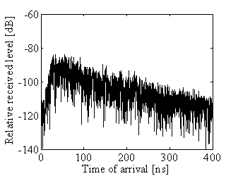
(c) θ = 180 deg (Backside of body).
Figure 7: Example delay profile for each body position.

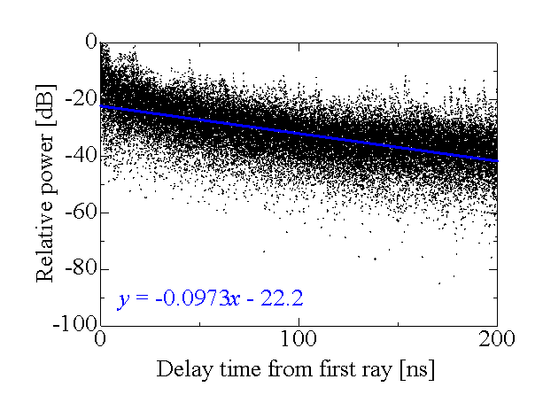
(a) θ = 0 deg (Front of body).
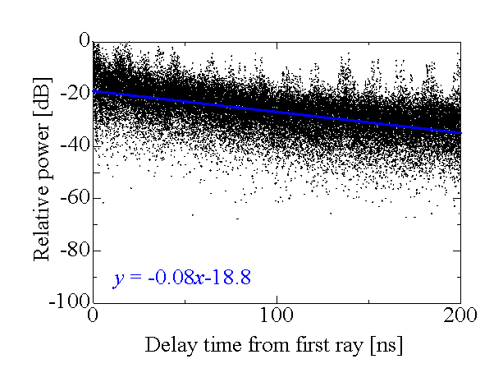
(b) θ = 90 deg (Side of body).
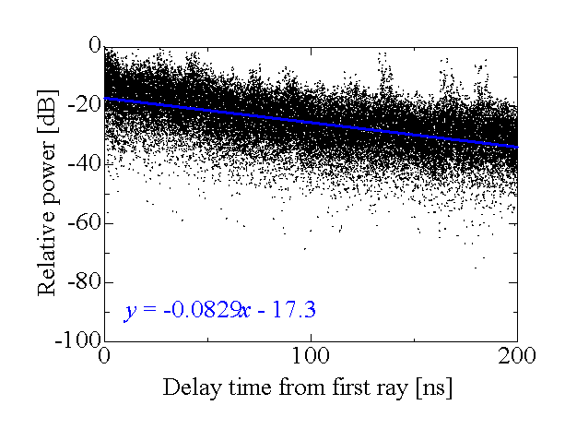
(c) θ = 270 deg (Side of body).
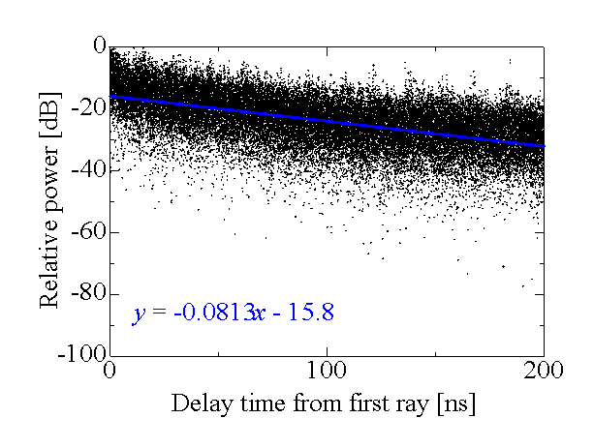
(d) θ = 180 deg (Backside of body).
Figure 8: Statistical analysis of delay components for each body position.

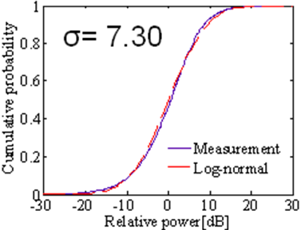
(a) θ = 0 deg (Front of body).
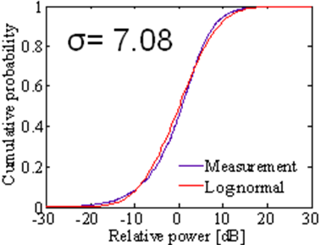
(b) θ = 90 deg (Side of body).
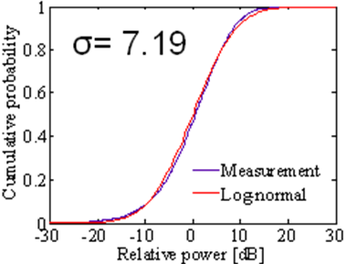
(c) θ = 270 deg (Side of body).
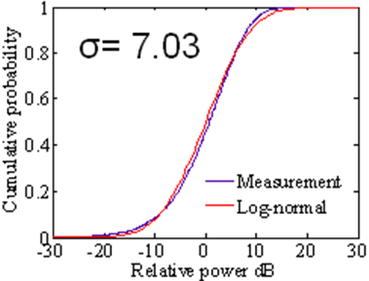
(d) θ = 180 deg (Backside of body).
Figure 9: CDF of delay components.

4. BAN Channel model

From results of Section 3, we assumed the one cluster with direct path component as a generic BAN channel model for both line-of-sight and non-line-of-sight situations. The equation of the model is expressed as follows.
(1)
(2)
(3)
Here h(t) is complex impulse response, m is number of the ray, am is the amplitude of each ray, τm is a sampling rate of system, the phase of each ray is assumed as random, and k as the effect of K-factor is included[6]. The path loss Ω0 depends on the environment and line-of-sight situation. In this report, the value of Ω0 can be calculated by adding the intercept value in Y-axis of fig.8a to path loss of direct path for line-of sight situation. For non-line-of-sight situation, k was already considered in Eq.1 for including path loss effect. The effect k is calculated by the difference (Δk) of averaged first impulse responses in Fig.8. Relationship of Δk and k is shown as
(4).
The channel response which is obtained by Eq.1 is shown in Fig.10. For line-of-sight situation, τ0 can be calculated by following equation.
(5)
Here d is transmission distance, and c is light wave speed. For non-line-of-sight situation, τ0 is assumed as random. Model parameters were calculated by statistical analysis in Section 3. Parameter set is shown in Table 1.
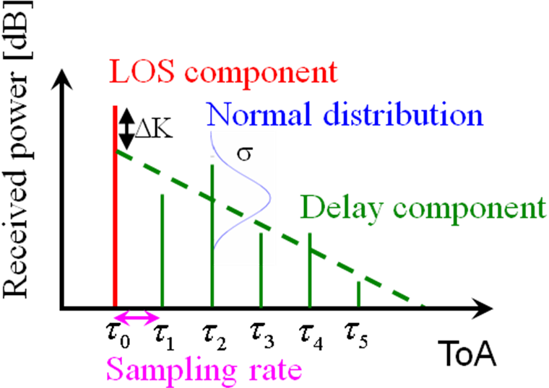
Figure 10: Channel model of one cluster with LOS component.
Table 1: Channel model parameters for each body position.
Direction of Body | Γ[ns] | k (Δk[dB]) | σ[dB]
0 | 0.224 | 1.47  (6.4 [dB]) | 7.30
90 | 0.184 | 0.691  (3.0 [dB]) | 7.08
180 | 0.187 | 0  (0 [dB]) | 7.03
270 | 0.191 | 0.345  (1.5 [dB]) | 7.19

5. Conclusion
In this report, a BAN channel model between body surface and wireless access point is proposed. The model is a single cluster model with K-factor. This model can be applied for not only line-of-sight, but also non-line-of-sight situation by body shadowing. Parameters of the model was extracted for each body direction. The antenna pattern on body is shown to describe the importance of antenna in BAN. An antenna for wireless body area network faces numerous RF challenges.

6. List of contributors
Hirokazu Sawada, Takahiro Aoyagi, Jun-ichi Takada, Kamya Yekeh Yazdandoost, and Ryuji Kohno

7. References
- IEEE 802.15 Working Group for WPAN, http://ieee802.org/15/
- A. F. Molisch et al., “IEEE 802.15.4a channel model - final report,” 15-04-0662-04-004a-channel-model-final-report-r1, http://www.802wirelessworld.com/
- Peter S. Hall Yang Hao, “Antennas and Propagation for Body-centric Wireless Communications,” Artech House Aug.2006
- T. Taniguchi and T. Kobayashi,“An omni-directional and low-VSWR antenna for the FCC-approved UWB frequency band,” in Proc. IEEE AP-S Int. Symp. AP-S’03, Columbus, OH, Jun. 2003, pp. 460–463.
- J.A. Högbom, “Aperture Synthesis with Non-Regular Distribution of Interferometer Baselines”, Astronomy and Astrophysics, 15:417, 1974
- Hirokazu Sawada, Yozo Shoji, Chang-Soon Choi, “Proposal of Novel Statistic Channel Model for Millimeter-wave WPAN,” Proceedings of Asia-Pacific Microwave Conference 2006, no. FR4D-3, Nov. 2006.
- Hirokazu Sawada, Yozo Shoji, Chang-Soon Choi, “Proposal of Novel Statistic Channel Model for Millimeter-wave WPAN,” Proceedings of Asia-Pacific Microwave Conference 2006, no. FR4D-3, Nov. 2006.
[8] Hirokazu Sawada, Takahiro Aoyagi, Jun-ichi Takada, Kamya Yekeh Yazdandoost, and Ryuji Kohno, “Channel model for wireless body area network,” The Second International Symposium on Medical Information and Communication Technology, Dec. 2006.

