IEEE P802.15
Wireless Personal Area Networks

Project | IEEE P802.15 Working Group for Wireless Personal Area Networks (WPANs)
Title | Statistical Property of Dynamic BAN Channel Gain at 4.5GHz
Date Submitted | [20 June, 2010]
Source | [Minseok Kim¹, Jun-ichi Takada^{1,2}, Bin Zhen², Lawrence Materum¹, Tomoshige Kan¹, Yuuki Terao¹, Yohei Konishi¹, Kenji Nakai¹, and Takahiro Aoyagi^{1,2}, Kohno Ryuji²]  1: Tokyo Institute of Technology,  S6-4, 2-12-1, O-okayama, Meguro-ku, Tokyo 152-8550, JAPAN  2: NICT  3-4 Hikarino-oka  Yokosuka 2390847  Japan | Voice:[+81 3 57343633],  FAX: [+81 3 57343282],  E-Mail:[mskim@ide.titech.ac.jp]
Re: | [Body Area Network (BAN) Channel Model document]
Abstract | [The contribution provides the statistical property of dynamic ban channel gain.]
Purpose | To provide information on body area network use cases, typical requirements, and to start the process on possibly starting a study group in 802.15 on this topic.]
Notice | This document has been prepared to assist the IEEE P802.15. It is offered as a basis for discussion and is not binding on the contributing individual(s) or organization(s). The material in this document is subject to change in form and content after further study. The contributor(s) reserve(s) the right to add, amend or withdraw material contained herein.
Release | The contributor acknowledges and accepts that this contribution becomes the property of IEEE and may be made publicly available by P802.15.

Date | Revision No.
09/30/2008 | 15-08-0489-01-0006
06/20/2010 | 15-08-0489-02-0006

Table of Contents

1. Introduction 4
2. Measurement Configuration 5
2.1 Measurement overview 5
2.1.1 Channel Sounder 5
2.1.2 Antennas 5
2.1.3 Human specimen 6
2.2 Experiment Setup 6
3. Measurement Results and Analysis 10
3.1 Relative Path Gain 10
3.2 Statistical Models 10
3.3 Probability distribution fitting results 11
4. Finite State Markov Model [7] 16
5. Conclusion 19
Acknowledgement 20
References 20
Appendix A: Time variation and cumulative distribution function (CDF) of path gain 22
Appendix B: Probability density function (PDF) of path gain 33

Introduction

So far, some efforts have been made to characterize the body area propagation channel [1][2][3] where the static channel characteristics at various frequency bands with a vector network analyzer using a human specimen as well as a phantom and a simple path loss model have been investigated. In addition, dynamic narrowband channel measurements around 2.4 GHz with custom equipments have been investigated in [4].

In this article, dynamic wireless body area network (BAN) channel measurement results are introduced and modeling of the channel behavior by the movement of the human body is proposed. It describes the measurement campaign using a human specimen in an anechoic chamber and the investigations on the characteristics of body surface propagation in dynamic conditions. In this article, “dynamic channel” means a quasi-static channel, which can be considered to be static during the burst period of the measurements. Based on this fact, the authors propose the statistical model of the path gain in various positions on the surface of the human body.

The purpose of this document is contribution to dynamic channel modeling for the IEEE802.15.6 based on the measurement using a realtime channel sounding system. The models shown in this document include only CM3 (body surface to body surface) of the scenarios as shown in Table 1 [1], [2]. For the CM3, we measured the channel transfer function at the frequency bands of 4.5 GHz with the bandwidth of 120 MHz. Thanks to the fast acquisition time of the sounder it is much suitable to measure the fading dynamic due to the body movement on body-surface wireless channel.

Table 1 List of scenarios and their descriptions

Channel Model | Description | Frequency band(s)
CM1 | Implant to Implant | 402-405 MHz
CM2 | Implant to Body Surface | 402-405 MHz
CM3 | Body Surface to Body Surface (LOS) | 13.5, 50, 400, 600, 900 MHz, 2.4, 3.1-10.6 GHZ
CM3 | Body Surface to Body Surface (NLOS) | 13.5, 50, 400, 600, 900 MHz, 2.4, 3.1-10.6 GHZ
CM4 | Body Surface to External (LOS) | 900 MHz, 2.4, 3.1-10.6 GHZ
CM4 | Body Surface to External (NLOS) | 900 MHz, 2.4, 3.1-10.6 GHZ

Measurement Configuration

This section describes the measurement configuration. The channel measurements were performed in a radio anechoic chamber using a real-time channel sounding system at 4.5 GHz. The channel transfer functions of 120 MHz (193 multi-tones) were obtained every 1 millisecond for around 10 seconds.

Measurement overview

In the body-surface wireless channel there are some possible propagation mechanisms between the antennas, including the refraction and diffraction around the human body surface besides the direct path. These paths can experience fading due to the movement of the human body as well as the multi-paths originated from around the body and from the surrounding objects. In order to simulate outdoor environments focusing on the fading effect due to the movement of the human body, the measurements were conducted in a radio anechoic chamber where the multi-path from the surrounding objects is negligible simulating open space.

2.1.1 Channel Sounder

In this time, a real-time channel sounder was used for the measurement to capture the dynamic channel behavior [5][6]. It was originally designed for MIMO directional channel measurement but used in a SISO (Single-Input Single-Output) measurement where the test signal was a periodic multi-tone signal (193 tones) with the center frequency and bandwidth of the transmitting signal were 4.5GHz and 120 MHz, respectively.

2.1.2 Antennas

The antenna (SkyCrossTM SMT-3TO10M-A) was small meander line type that is commercially available at present for UWB (ultra wideband) from SkyCross. It covers wide frequency range between 3.1 to 10 GHz. The channel variation can be affected by the change of the alignment and distance between the antennas as well as the shadowing effect that the LOS path can be excluded by the movement of human body in dynamic scenarios introducing obstacles between them. In BAN channel measurement, the problem is that it is very difficult to separate only the propagation channel response from the antenna effect. In this work, the antenna effect has been considered as a propagation channel component itself and embedding the antenna effect will be one of some significant future works.

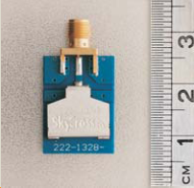

Fig. 1 Antenna (SkyCrossTM SMT-3TO10M-A)

2.1.3 Human specimen

A man in his early twenties whose height, bust and waist are 171.5, 89.5 and 76.5 cm respectively served as a human specimen.

Experiment Setup

The measurements were performed in a radio anechoic chamber to avoid some multi-path effects by reflection from the surrounding objects assuming outdoor environments. The Tx antenna was fixed on around navel and the measurements were conducted one by one at 10 Rx positions, respectively as shown in Fig. 2 (a). The antennas were attached by using a spacer made by formed styrol and a belt to tie up the antenna on the body surface as illustrated in Fig. 2 (b). The distances between Tx and Rx antennas are given in Table 2. The values were measured in still posture but ranged in case that the antenna was on a part with large movement (e.g. wrist and ankle).
shows the anechoic chamber configuration with the location of the human specimen and measurement equipments. Considering the fluctuation of the characteristics the RF cable would be fixed not to move much when the specimen was moving.

The measurement at each Rx antenna position includes the three postures (still, walking on the spot, repeatedly stand up and seat down). Fig. 4 shows those three postures in case that Rx antenna is at shoulder. About 10,000 snapshots (10 seconds) at every Rx and every posture were captured by the channel sounder. The detail measurement specifications are given in Table 3.

(a) Measurement positions on the human body | 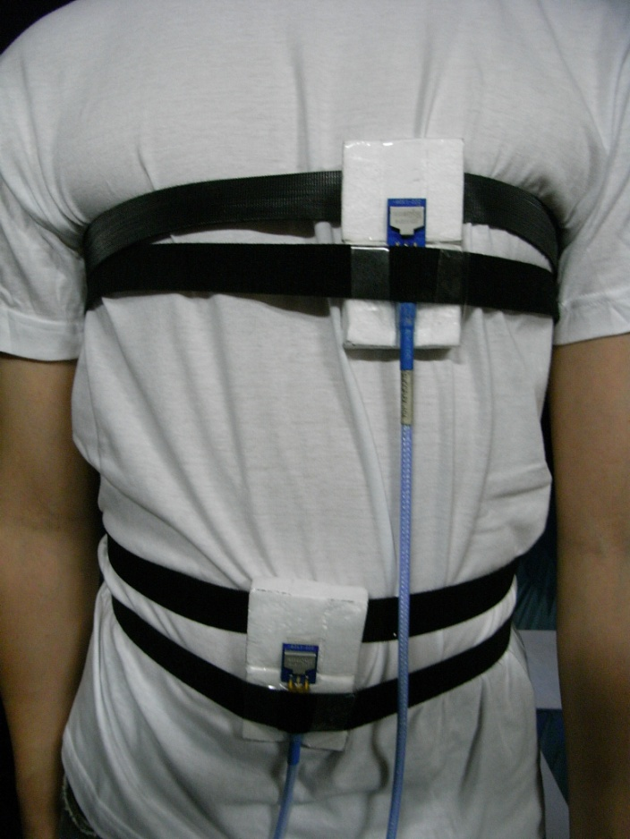  (b) Antenna attachment on the body
Fig. 2 Measurement locations on the human body (A: right wrist, B: right upper arm, C: left ear, D: head, E: shoulder, F: chest, G: right rib, H: left waist, I: Thigh, J: Ankle)

Table 2 Distance between Rx’s and Tx

Position  Index | Position | Distance d [mm]
A | Right wrist | 440 ~ 525
B | Right upper arm | 360
C | Left ear | 650
D | Head | 710
E | Shoulder | 310
F | Chest | 230
G | Right rib | 183
H | Left waist | 140
I | Thigh | 340
J | Ankle | 815 ~ 940

Table 3 Measurement specification

Parameter | Value
Sounder | Medav channel sounder
Antenna positions | Tx : navel (fixed),  Rx : 10 positions
Number of snapshots | about 10,000
Postures | Still,  walking on the spot,  Standing up/Sitting down
Acquisition time | about 10 seconds
Calibration | Back to back

Fig. 3 Layout of the measurement room (anechoic chamber)

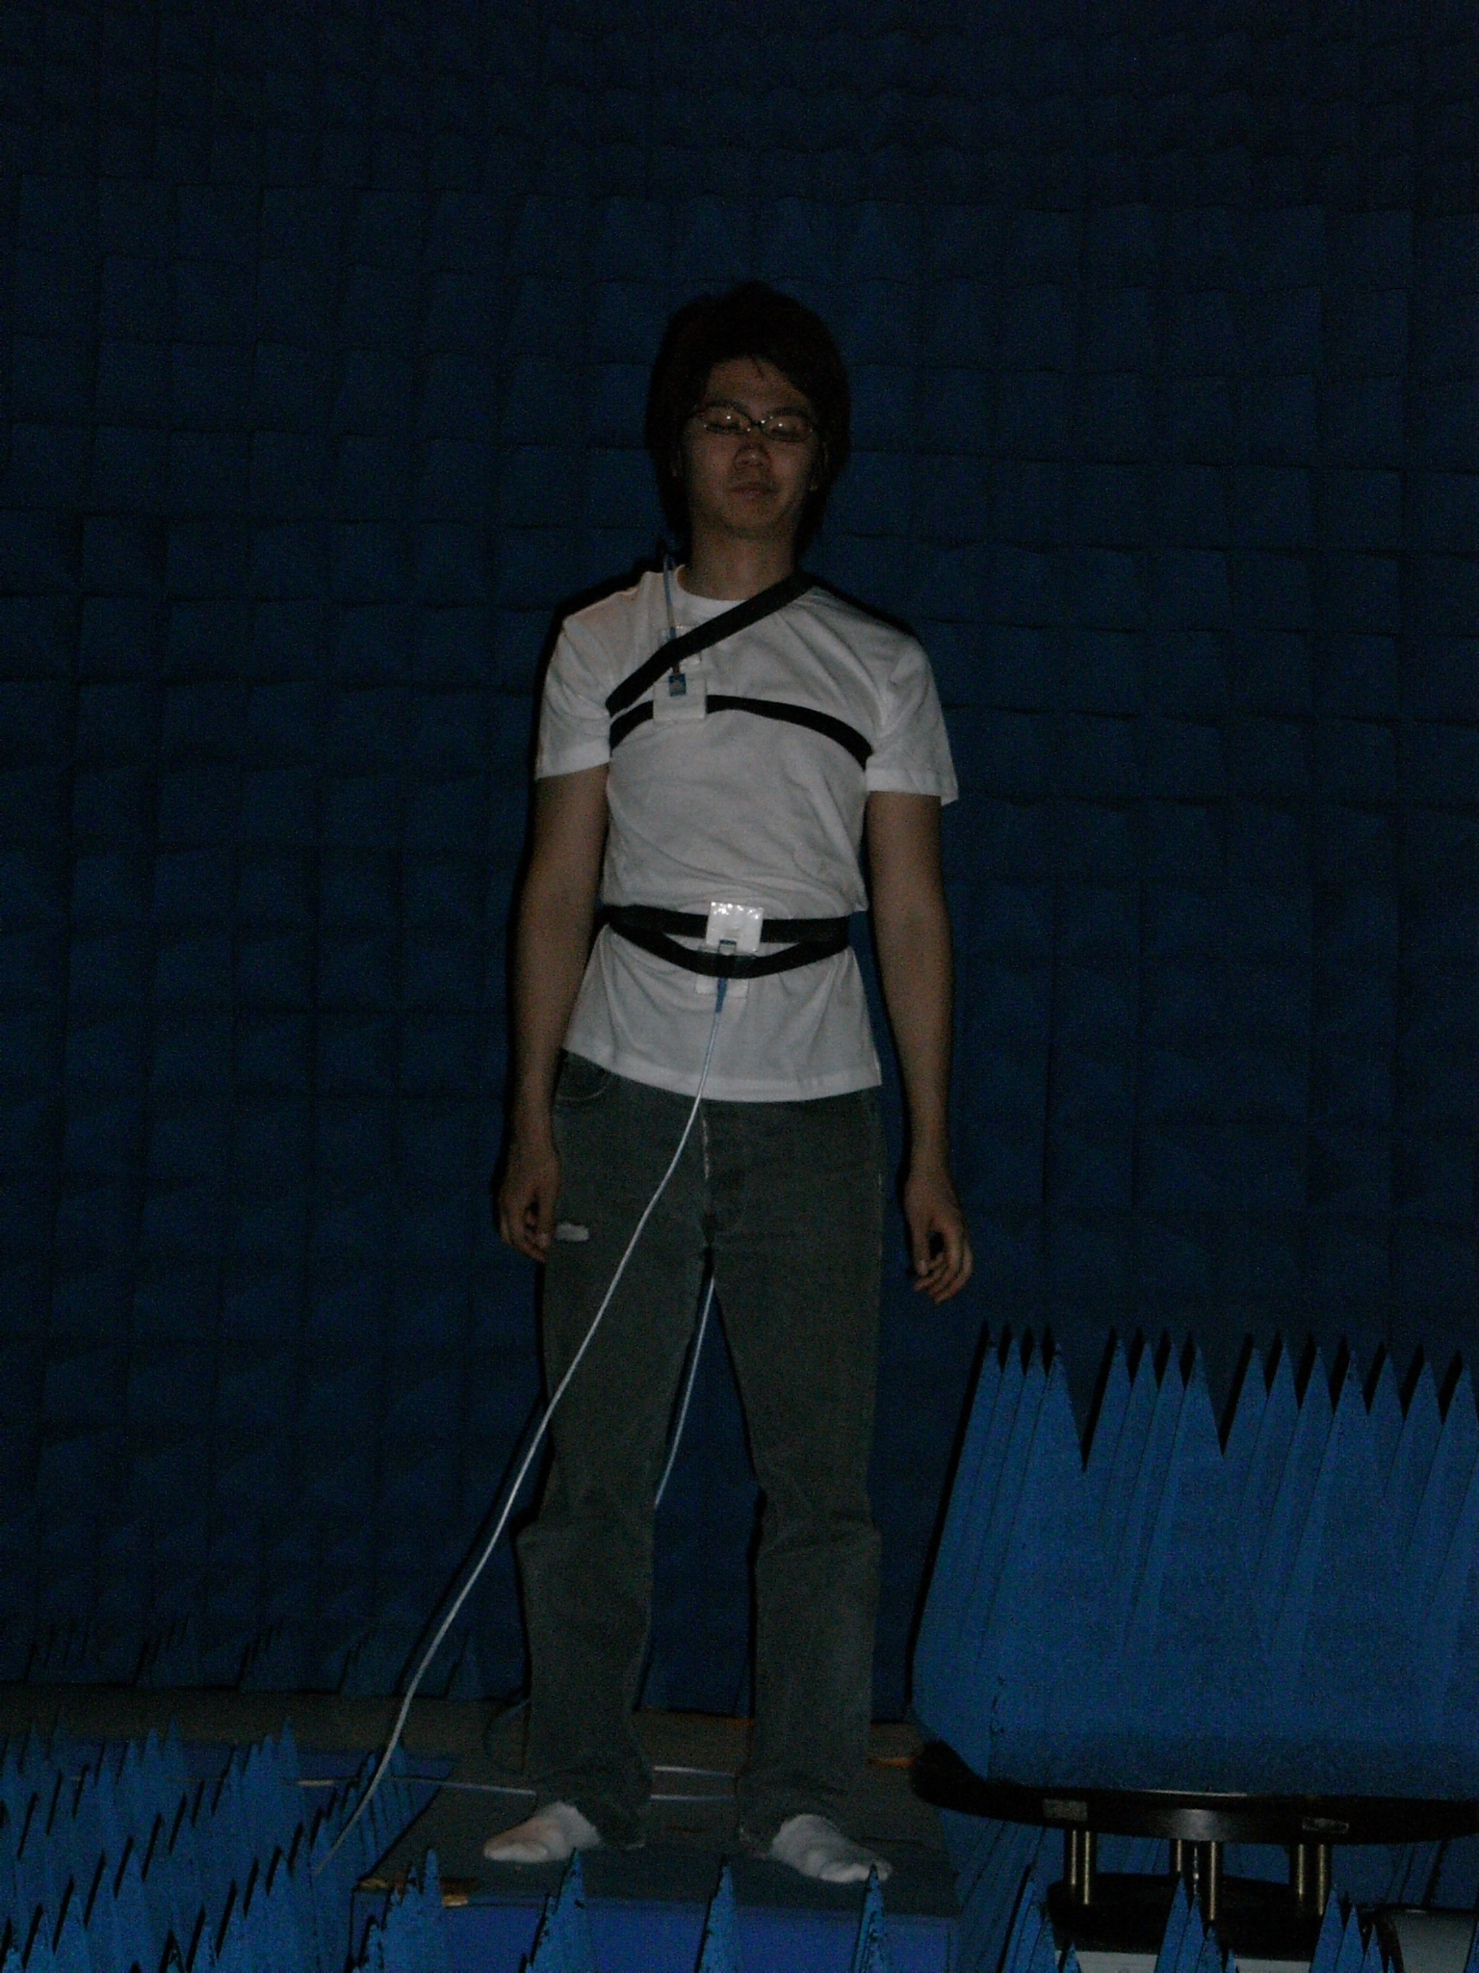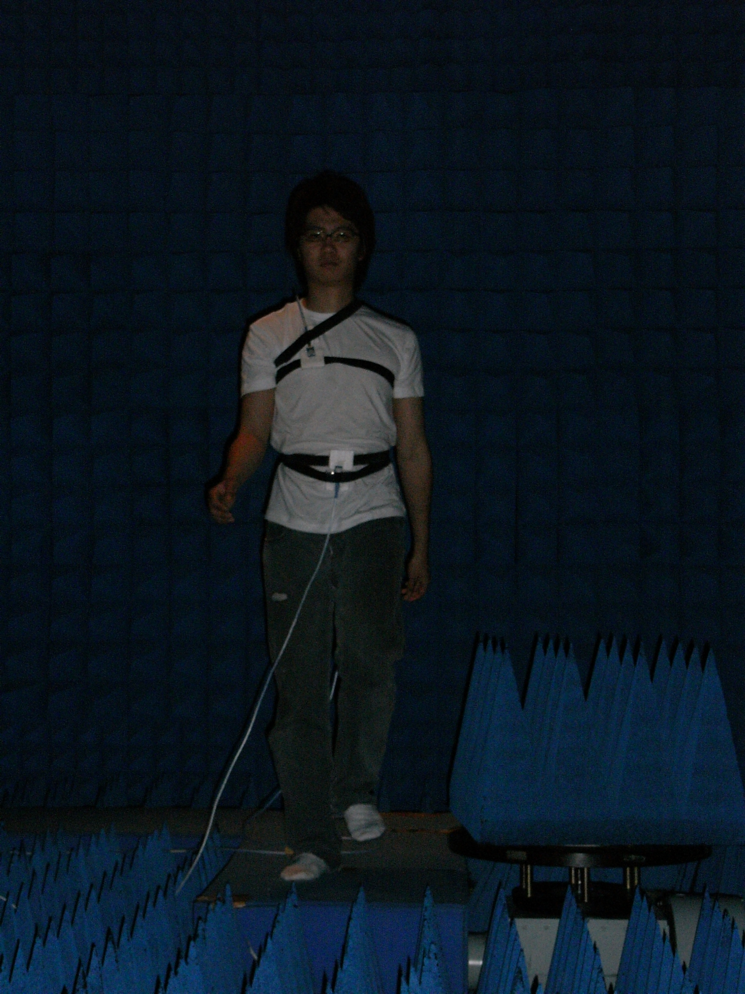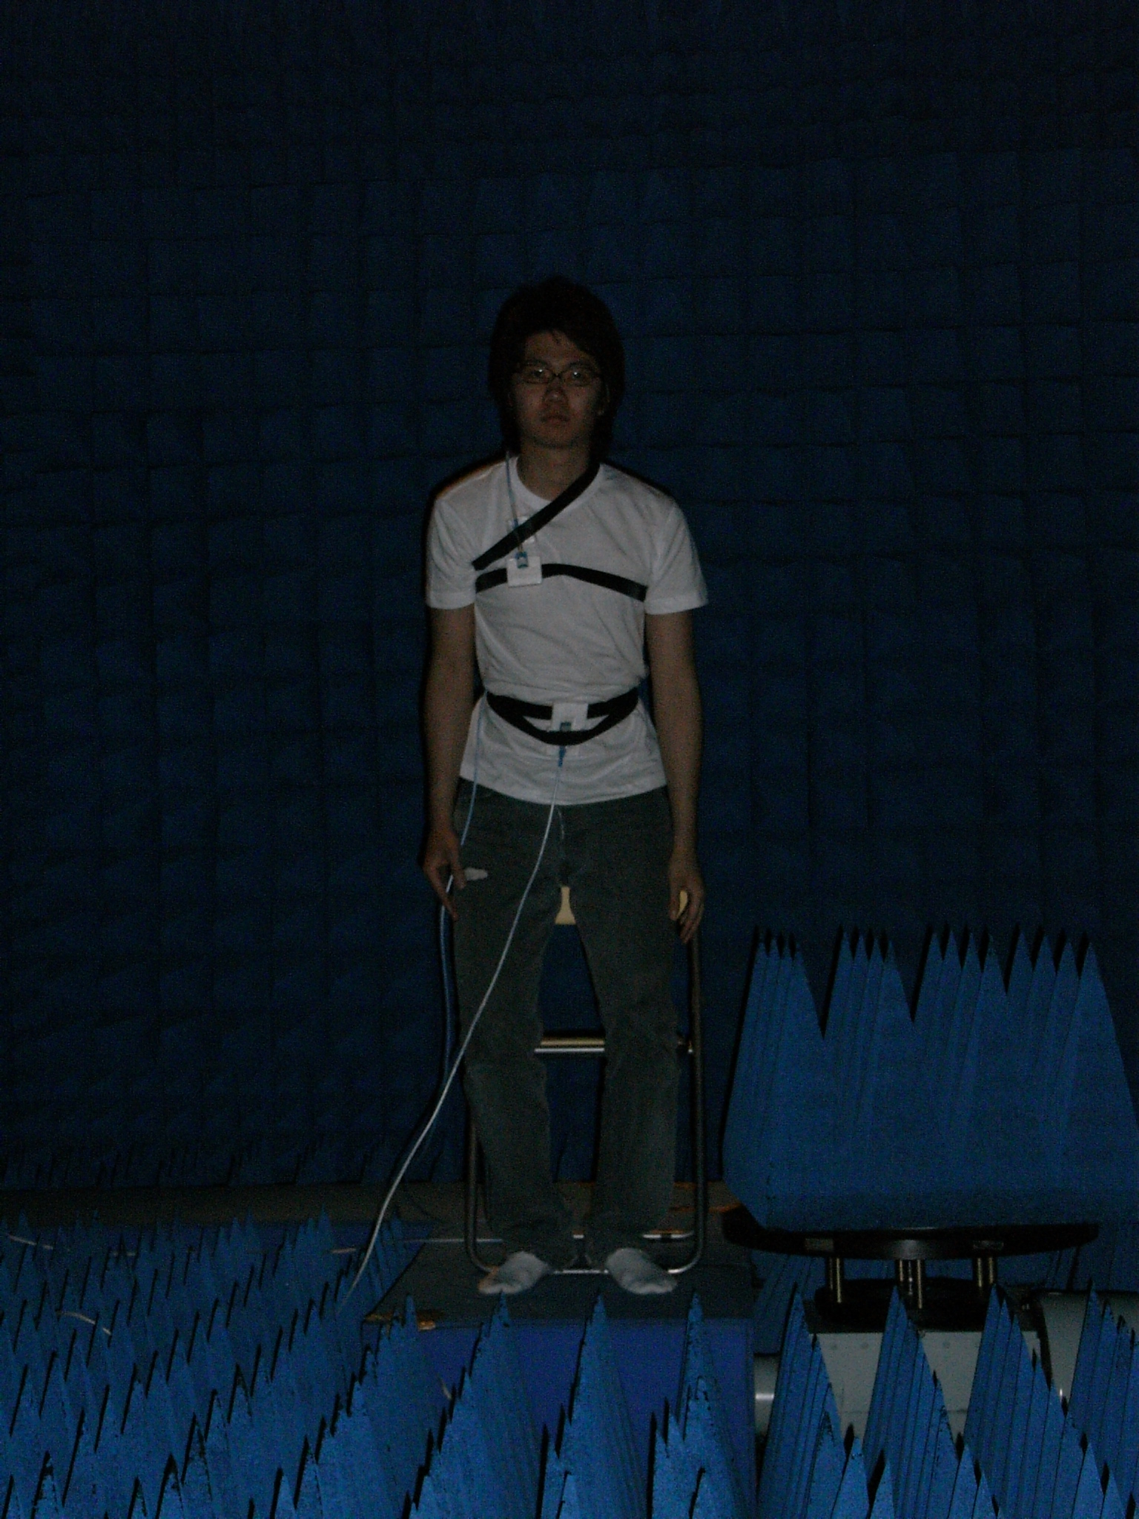
(a) still (b) walking on the spot (c) Standing up/Sitting down

Fig. 4 Three postures (Rx: shoulder)

Measurement Results and Analysis

This section presents the measurement results and the investigation on the statistical property. A number of measurement snapshots (about 10,000 for 10 seconds) make us model the movement of the human body statistically. As mentioned previously, the body surface channel can be thought as a quasi-static channel, which can be considered to be static during the burst period of the measurements. The authors propose the statistical model of the dynamic movement of the human body with the path gain in various positions on the body surface.

It notes that all measurements results that obtained at all scenarios are presented as the Appendix at the end of this article.

Relative Path Gain

We computed the path gain of the first arrival component (peak value) in the channel impulse responses that were obtained by FFT (fast Fourier transform) of the measured frequency domain channel transfer functions. Each path gain at every Rx antenna position was normalized by the mean value of the still posture. Fig. 7 (a) ~ Fig. 16 (a) in Appendix A show the variation over time of the relative path gains of each Rx position and posture. It could be found that the channel experiences fading following the actions of the movements in regular base. However, in spite of the still posture, irregular and abrupt fading could be also found in some points by involuntary movements of the human being such as Fig. 7 (a); right wrist (A) and Fig. 10 (a); right ear (D).

Statistical Models

We tried to fit the relative path gain of the measurement data by using some well known probability density functions such as normal, log-normal and Weibull distributions using some functions of MATLAB, MathWorks. And we found the best match of them. As a matter of fact, in dynamic scenarios, it can be expected that the movement of human body produces shadowing-like effects because the channel is varying by the change of the alignment and distance between the antennas as well as by the fact that the LOS path can be blinded introducing some obstacles on the LOS path. In that meaning, it is natural to use log-normal distribution to represent the dynamic behavior.

The probability density distribution functions used in this work are given as following.

Normal distribution: μ and σ denote the mean and variable, respectively
$$f(x|μ,σ)=\frac{1}{σ\sqrt{2π}}e^{−\frac{{\left(x−μ\right)}^{2}}{2σ^{2}}}$$ | (1)

Log-normal distribution: μ and σ denote the mean and variable in decibel, respectively
$$f(x|μ,σ)=\frac{\text{10}\text{/ln}\text{10}}{xσ\sqrt{2π}}e^{−\frac{{\left(\text{10}{\text{log}}_{\text{10}}x−μ\right)}^{2}}{2σ^{2}}}$$ | (2)

Weibull distribution: it is well known that various distributions can be fit by using the scale (a) and shape (b) factors, respectively
$$f(x|a,b)=\frac{b}{a}{\left(\frac{x}{a}\right)}^{b−1}e^{−{\left(\frac{x}{a}\right)}^{b}}$$ | (3)

Probability distribution fitting results

Fig. 7 (b) ~ Fig. 16 (b) in Appendix A show the cumulative distribution functions (CDF) of the relative path gain of each Rx position and posture normalized by the mean value of still posture. The dashed and dotted lines denote the log-normal and Weibull distribution fitting results, respectively. For the readability, the normal distribution fitting results were omitted. Fig. 18 ~ Fig. 26 in Appendix B also illustrate the probability density function (PDF) of the path gain.

The estimated parameters of log-normal and Weibull distribution for every scenario are given in Table 5 and Table 6, respectively. The values of the log-normal distribution in Table 5 are in decibel. The values in parenthesis are negative log likelihood values by which the best fit distribution were judged (less means better fit). The best fit distributions are summarized in Table 7.

According to Table 7, it can be found as following.
- Normal distribution seems to fit the still postures best but it can be seen that the fittings with any distributions have large error from the PDFs.
- Log-normal distribution shows good match in cases of still postures and small movements such as walking posture in case of head (C), right ear (D), chest (F), right rib (G), left waist (H), right thigh (I) and stand up/down posture in case of head (C).
- Weibull distribution can represent much better large movement behaviors such as walking posture in case of right wrist (A), right upper arm (B), shoulder (F), right ankle (K) and all stand up/down postures except for head (C).

Table 4 Fitting Results (normal Distribution)

μ / σ  (-LogL) |  | Normal fitting
 |  | Still | walking | Standing up/  Sitting down
A | Right wrist | 1.0000 / 0.1279  (-6303) | 3.0875 / 4.4063  (28972) | 8.9461 / 5.1576  (30220)
B | Right upper arm | 1.0000 / 0.1500  (-4735) | 3.2443 / 1.7012  (19332) | 7.3374 / 6.1415  (32061)
C | Head | 1.0000 / 0.0666  (-12706) | 0.4477 / 0.2445  (4535) | 0.9058 / 1.2629  (16207)
D | Right ear | 1.0000 / 0.1349  (-5826) | 0.7303 / 0.3014  (101) | 0.8205 / 0.8232  (12148)
E | Shoulder | 1.0000 / 0.0335  (-19782) | 2.6849 / 1.4627  (2153) | 1.5437 / 1.3265  (17519)
F | Chest | 1.0000 / 0.3481  (3600) | 3.6360 / 2.4688  (17849) | 7.1082 / 9.2594  (36609)
G | Right rib | 1.0000 / 0.1654  (-3812 ) | 0.8572 / 0.2744  (1256) | 4.7043 / 2.9597  (24784)
H | Left waist | 1.0000 / 0.0399  (-17978 ) | 0.7264 / 0.1609  (-4018) | 0.5458 / 0.3105  (2456)
I | Right thigh | 1.0000 / 0.0964  (-9254 ) | 0.6500 / 0.4388  (5831) | 1.1357 / 0.6949  (10272)
J | Right ankle | 1.0000 / 0.0787  (-11025) | 1.6070 / 0.9968  (14248) | 1.2489 / 1.2220  (16122)

Table 5 Fitting Results (Log-normal Distribution)

μ / σ [dB]  (-LogL) |  | Log-normal fitting
 |  | Still | walking | Standing up/  Sitting down
A | Right wrist | -0.0652 / 0.9531  (-1114.1) | -3.9908 / 11.7727  (14948) | 8.4456 / 3.4836  (31047)
B | Right upper arm | -0.0491 / 0.6544  (-4800.9) | 4.4491 / 2.4972  (18735) | 6.3009 / 5.6692  (31093)
C | Head | -0.0100 / 0.2969  (-12476) | -3.5392 / 3.2052  (2983.8) | -3.6932 / 5.3385  (7601)
D | Right ear | -0.0400 / 0.5921  (-5815.6) | -4.1465 / 2.4654  (-1005.5) | -3.3130 / 5.2458  (8384.1)
E | Shoulder | -0.0024 / 0.1453  (-19806) | -1.8011 / 2.0549  (2507.8) | 0.2165 / 4.1023  (14537)
F | Chest | -0.2359 / 1.4019  (2315) | 3.6360 / 2.4688  (16779) | 5.0788 / 6.4077  (29907)
G | Right rib | -0.0470 / 0.6043  (-5657.3 ) | -0.8883 / 1.3994  (818.79) | 5.7033 / 3.2101  (24051)
H | Left waist | -0.0035 / 0.1742  (-17942 ) | -1.4965 / 0.9770  (-4109.5) | -3.5588 / 3.3466  (3337.8)
I | Right thigh | -0.0191 / 0.4017  (-9717 ) | -2.6924 / 2.6453  (2970.7) | -0.5995 / 3.7712  (11098)
J | Right ankle | -0.0131 / 0.3352  (-11251 ) | 0.9424 / 3.7030  (14861) | -1.1303 / 4.7167  (12357)

Table 6 Fitting Results (Weibull Distribution)

a / b  (-LogL) |  | Weibull fitting
 |  | Still | walking | Standing up/  Sitting down
A | Right wrist | 1.0478 / 7.7411  (-5770.3) | 1.4690 / 0.4510  (14629) | 10.0006 / 1.7319  (29786)
B | Right upper arm | 1.0655 / 7.3618  (-4529.3) | 3.6759 / 2.0325  (18625) | 7.5368 / 1.0787  (29631)
C | Head | 1.0297 / 17.9473  (-13029) | 0.6360 / 1.5519  (3061.7) | 0.8015 / 0.8228  (8458.3)
D | Right ear | 1.0594 / 7.7870  (-5394.6) | 0.5071 / 1.9516  (-840.12) | 0.8224 / 1.0055  (7959.7)
E | Shoulder | 1.0165 / 29.8877  (-18940) | 0.8237 / 2.6536  (1913.3) | 1.6534 / 1.2203  (14452)
F | Chest | 1.1203 / 2.9913  (3487.2) | 3.0419 / 1.9575  (16909) | 6.3808 / 0.8247  (29393)
G | Right rib | 1.0742 / 4.9107  (-1979.2) | 0.9539 / 3.2009  (1357.2 ) | 5.2709 / 1.6440  (23654)
H | Left waist | 1.0190 / 28.9055  (-17946) | 0.7915 / 4.9572  (-3903.2 ) | 0.6117 / 1.7907  (1823.7)
I | Right thigh | 1.0464 / 9.6410  (-7951.2) | 0.7325 / 1.6297  (3867.9) | 1.2626 / 1.6251  (9539.3)
J | Right ankle | 1.0379 / 11.8572  (-9813.1) | 1.7880 / 1.6227  (13323) | 1.2867 / 1.0759  (12124)

Table 7 Best fit distributions

 |  | Still | walking | Standing up/  Sitting down
A | Right wrist | Normal | Weibull | Weibull
B | Right upper arm | Log-normal | Weibull | Weibull
C | Head | Weibull | Log-normal | Log-normal
D | Right ear | Normal | Log-normal | Weibull
E | Shoulder | Log-normal | Weibull | Weibull
F | Chest | Log-normal | Log-normal | Weibull
G | Right rib | Log-normal | Log-normal | Weibull
H | Left waist | Normal | Log-normal | Weibull
I | Right thigh | Log-normal | Log-normal | Weibull
J | Right ankle | Log-normal | Weibull | Weibull

Finite State Markov Model [7]
The combined effect of time-varying fading, path loss and noise of the on-body channel results in a discrete channel with memory, in which the error occurs in clusters separated by error-free gaps. Finite-state Markov chain (FSMC) is the preferred mathematical tool to describe the burst behavior of time-varying channels. The FSMC-based models allow system performance evaluation over flat fading channels in a closed form. A generalized Gilbert-Elliott model partitions channel per its quality into a finite number of intervals, each of which corresponds to one of state of the channel [10]-[12]. This section models the burst behavior of dynamic characteristics of wireless on-body channel with continuous body movements by using a partitioned Fritchman model.
The simplest Gilbert channel has two states that correspond to the absence of errors and error occurrence with a defined probability, respectively [8]. For binary channels, Fritchman’s framework divides the state space into k error-free states and N-k error states according to the signal-to-noise ratio (SNR) at receiver [10]-[12]. The measured data shown in Table I show that the on-body channel dwells in good channel and bad channel with different patterns. The channel dwelling pattern should be considered for determining the state as well as the SNR. Figure 5 shows a five-state Fritchman model for describing the burst behaviors of on-body channels:
- S1: unstable error-free state, good channels which last less than 20 ms;
- S2: semi-constant error-free state, good channel which are over 20 ms and less than 400 ms;
- S3: constant error-free state, good channel which are over 400 ms;
- S4:unstable error state, bad channel which last less than 20 ms, and
- S5: semi-constant error state, bad channel which are less than 400 ms.
The state of on-body channel at time t is given by
$Π_{t}=Π_{t−1}A\begin{matrix} & t≥1\end{matrix}$, | (4)
where
$A=\left[\begin{matrix}a_{\text{11}} & 0 & 0 & a_{\text{14}} & a_{\text{15}} \\ 0 & a_{\text{22}} & 0 & a_{\text{24}} & a_{\text{25}} \\ 0 & 0 & a_{\text{33}} & a_{\text{34}} & a_{\text{35}} \\ a_{\text{41}} & a_{\text{42}} & a_{\text{43}} & a_{\text{44}} & 0 \\ a_{\text{51}} & a_{\text{52}} & a_{\text{53}} & 0 & a_{\text{55}}\end{matrix}\right]$
is the state transit matrix and ∏₀ is the initial state probability vector. The error generation matrix takes a very simple form
$B=\left[\begin{matrix}1 & 1 & 1 & 0 & 0 \\ 0 & 0 & 0 & 1 & 1\end{matrix}\right]$, | (5)
Table 9 lists statistical parameters of channel in different states for θ = -10 dB. By categorizing good channels and bad channels into different states per their durations, we applied Baum-Welch algorithm to estimate the parameters in (1) [13]. Table 10 shows results for different actions. Comparing two actions, the biggest difference is in S1. The walking action dwells in S1 more time, and the action of standing up/down is more easily to transit to S4. By selecting corresponding data, both action independent and position dependent state transit matrix can be obtained.
A 200 seconds segment of dynamic on-body channel was generated using values listed in Table III. The channel state was calculated every 1 ms. Figure 6 compares the CDF of the simulated channel dwelling times (θ = –10 dB) with that of the measured ones. The initial state was S1. A good fit between them was obtained. Comparing Fig. 6(a) with (b), the walking action leads to more bad channels with short duration, but fewer good channels with short duration. This is in agreement with the results in Table I.

Fig. 5 5-state Fritchman model for dynamic on-body channels

Fig. 6 CDF of the simulated duration and the measured channel duration for θ=-10 dB in walking (a) and standing up/down (b)

Table 8 Statistical parameters for the dynamic on-body channel (θ=-10 dB)

Positions | Distance (mm) | Walking |  |  | Standing up/sitting down
Positions | Distance (mm) | Relative path gain (dB) | Duration (ms) |  | Relative path gain (dB) | Duration (ms)
Positions | Distance (mm) | Relative path gain (dB) | Good channels | Bad channels | Relative path gain (dB) | Good channels | Bad channels
A | 440~525 | -3.99±11.8 | 204.23±252.37 | 99.03±155.97 | 8.45±3.48 | 10,000 | 0
B | 360 | 4.45±2.50 | 10,000 | 0 | 6.30±5.67 | 423.33±851.80 | 12.6±21.98
C | 710 | -4.15±2.47 | 159.03±509.90 | 1.65±2.68 | -3.13±5.25 | 37.56±171.64 | 7.15±25.70
D | 650 | -3.54±3.21 | 67.64±251.40 | 2.83±3.75 | -3.69±3.21 | 62.06±265.87 | 10.23±43.57
E | 310 | -1.80±2.05 | 10,000 | 0 | 0.22±4.10 | 1666.7±250.6 | 2.1±5.8
F | 230 | 3.64±2.47 | 10,000 | 0 | 5.08±6.41 | 572.56±779.69 | 14.12±18.13
G | 183 | -0.89±1.40 | 10,000 | 0 | 5.70±3.21 | 10,000 | 0
H | 140 | -1.50±0.98 | 10,000 | 0 | -3.56±3.35 | 862.71±1174.41 | 51.88±71.44
I | 340 | -2.69±2.65 | 750.35±1403.24 | 2.00±2.45 | -0.60±3.77 | 710.08±840.69 | 25.15±26.94
J | 815~940 | 0.94±3.70 | 574.12±459.97 | 10.82±4.75 | -1.13±4.72 | 262.48±538.37 | 20.17±47.19

Table 9 Statistical parameters for dynamic on-body channel in different states (θ=-10 dB)

Parameters |  | State samples |  | State durations (ms)
 |  | Walking | Standing up/sitting down | Walking | Standing up/sitting down
Good channels | S1 | 93 | 337 | 3.31±3.66 | 2.38±3.05
Good channels | S2 | 29 | 34 | 99.41±65.15 | 161.1±132.3
Good channels | S3 | 32 | 38 | 2515.5±3342.9 | 1771.7±2082.4
Bad channels | S4 | 145 | 371 | 3.45±4.38 | 3.48±4.20
Bad channels | S5 | 10 | 38 | 287.1±139.3 | 80.68±87.26

Table 10 Parameters of the 5-state Fritchman model for different action scenarios

Threshold θ=-10 (dB) | A and ∏₀
Walking | $$A=\left[\begin{matrix}0\text{.}\text{772} & 0 & 0 & 0\text{.}\text{223} & 0\text{.}\text{005} \\ 0 & 0\text{.}\text{991} & 0 & 0\text{.}\text{0082} & 0\text{.}\text{00087} \\ 0 & 0 & 0\text{.}\text{9997} & 0\text{.}\text{00025} & 0\text{.}\text{00007} \\ 0\text{.}\text{137} & 0\text{.}\text{047} & 0\text{.}\text{043} & 0\text{.}\text{773} & 0 \\ 0\text{.}\text{00189} & 0\text{.}\text{0009} & 0\text{.}\text{00063} & 0 & 0\text{.}\text{996}\end{matrix}\right]$$  $$Π_{0}=\left[\begin{matrix}0\text{.}\text{00415} & 0\text{.}\text{0346} & 0\text{.}\text{923} & 0\text{.}\text{0064} & 0\text{.}\text{032}\end{matrix}\right]$$
Standing up/sitting down | $$A=\left[\begin{matrix}0\text{.}\text{69} & 0 & 0 & 0\text{.}\text{29} & 0\text{.}\text{019} \\ 0 & 0\text{.}\text{993} & 0 & 0\text{.}\text{005} & 0\text{.}\text{0017} \\ 0 & 0 & 0\text{.}\text{9995} & 0\text{.}\text{00032} & 0\text{.}\text{00016} \\ 0\text{.}\text{195} & 0\text{.}\text{0209} & 0\text{.}\text{0183} & 0\text{.}\text{766} & 0 \\ 0\text{.}\text{0076} & 0\text{.}\text{00147} & 0\text{.}\text{0044} & 0 & 0\text{.}\text{986}\end{matrix}\right]$$  $$Π_{0}=\left[\begin{matrix}0\text{.}\text{011} & 0\text{.}\text{058} & 0\text{.}\text{882} & 0\text{.}\text{0158} & 0\text{.}\text{034}\end{matrix}\right]$$
Actions combined | $$A=\left[\begin{matrix}0\text{.}\text{7131} & 0 & 0 & 0\text{.}\text{2715} & 0\text{.}\text{1542} \\ 0 & 0\text{.}\text{9924} & 0 & 0\text{.}\text{006169} & 0\text{.}\text{00140} \\ 0 & 0 & 0\text{.}\text{9996} & 0\text{.}\text{000283} & 0\text{.}\text{00012} \\ 0\text{.}\text{1783} & 0\text{.}\text{0284} & 0\text{.}\text{0252} & 0\text{.}\text{768} & 0 \\ 0\text{.}\text{00486} & 0\text{.}\text{00122} & 0\text{.}\text{00258} & 0 & 0\text{.}\text{9913}\end{matrix}\right]$$  $$Π_{0}=\left[\begin{matrix}0\text{.}\text{0075} & 0\text{.}\text{046} & 0\text{.}\text{902} & 0\text{.}\text{011} & 0\text{.}\text{033}\end{matrix}\right]$$

Conclusion

In this article, dynamic wireless BAN channel measurement results using a male specimen in a radio anechoic chamber assuming outdoor environments and the investigations on the statistical characteristics of body surface propagation in dynamic movement of a human being were presented. Considering that the body surface channel is quasi-static, the authors proposed the statistical model of the dynamic movement of the human body with the path gain in various positions on the body surface. We found that the log-normal and Weibull distribution can provide a characterization measure of dynamic behavior on human surface in the BAN channel. Further, based on statistical analysis of fading duration a five-state Fritchman model which classifies channel states according to the dwelling time in different channel qualities has been proposed to quantitatively describe the time-varying property of on-body channels. The burst characteristics simulated from estimated parameters match well with measurements.

Acknowledgement

The authors would like to thank the members of medical ICT group of NICT for the suggestion and advices about this research. In addition, we would like to thank all members of Takada lab, Tokyo tech who spent their valuable time to help us for this measurement campaign.

References
- K. Y. Yazdandoost, et al., “Channel Model for Body Area Network (BAN),” IEEE 802.15-08-0033-04, Jan. 2008.
- Kenichi Takizawa, Kamya Yekeh Yazdandoost, Takahiro Aoyagi, Norihiko Katayama, Jun-ichi Takada, Takehiko Kobayashi, Huan-bang Li and Ryuji Kohno, "Preliminary channel models for wearable WBAN,” IEEE 802.15-08-0416-02-0006, Mar. 2008.
- Takahiro Aoyagi, Jun-ichi Takada, Kenichi Takizawa, Hirokazu Sawada, Norihiko Katayama, Kamya Yekeh Yazdandoost, Takehiko Kobayashi, Huan-Bang Li, and Ryuji Kohno, ” Channel models for wearable and implantable WBANs,” IEEE 802.15-08-0416-03-0006, Sept. 2008.
- Dino Miniutti, Leif Hanlen, David Smith, Andrew Zhang, Daniel Lewis, David Rodda, Ben Gilbert, “Dynamic narrowband channel measurements around 2.4 GHz for body area networks,” IEEE P802.15-08-0033-00-0006, Jan. 2008.
- Channel Sounder, MEDAV, http://www.channelsounder.de/
- Kriangsak Sivasondhivat, Jun-ichi Takada, Ichirou Ida, and Yasuyuki Oishi, "Experimental Analysis and Site-Specific Modeling of Channel Parameters at Mobile Station in an Urban Macrocellular Environment," IEICE Transactions on Communications, vol. E91-B, no. 4, pp. 1132-1144, Apr. 2008.
- Bin Zhen, Minseok Kim, Jun-ichi Takada and Ryuji Kohno, “Finite-state Markov model for on-body channels with human movements,” IEEE International Conference on Communications (ICC), Cape Town, South Africa, May 2010.
- J. Ryckaert, P. De Doncker and R. Meys et al, “Channel model for wireless communication around human body,” Electronics Letters, vol. 40, no. 9, p. 543-544, 2004.
- E. N. Gilbert, “Capacity of burst-noise channel,” Bell Syst. Tech. J., vol. 39, p. 1253-1266, 1960.
- E. O. Elliott, “Estimates of error rates for codes on burst-noise channels,” Bell Syst. Tech. J., vol. 42, p. 1977-1997, 1963.
- B. D. Fritchman, “A binary channel characterization using partitioned Markov chains,” IEEE Tran. Information Theory, vol. 13, no. 2, p. 221-227, 1967.
- H. S. Wang and N. Moayeri, “Finite-state Markov channels - a useful model for radio communications channels,” IEEE Tran. Vehicular technology, vol. 44, no. 1, p. 163-171, 1995.
- L. E. Baum, T. Petrie, G. Soules and N. Weiss, “A maximization techniques occurring in the statistical analysis of probability functions of Markov chain,” Annuals of Mathematical Statistics, vol. 41, no. 1, p. 164-171, 1970.

Appendix A: Time variation and cumulative distribution function (CDF) of path gain

(a) Path gain variation over time
(b) Cumulative distribution of the path gain (dash dotted line: normal dist. fitting, dashed line : log-normal dist. fitting and dotted line: Weibull dist. fitting)

Fig. 7 Right wrist (A)

(a) Path gain variation over time
(b) Cumulative distribution of the path gain (dash dotted line: normal dist. fitting, dashed line : log-normal dist. fitting and dotted line: Weibull dist. fitting)

Fig. 8 Right upper arm (B)

(a) Path gain variation over time
(b) Cumulative distribution of the path gain (dash dotted line: normal dist. fitting, dashed line : log-normal dist. fitting and dotted line: Weibull dist. fitting)

Fig. 9 Right ear (C)

(a) Path gain variation over time
(b) Cumulative distribution of the path gain (dash dotted line: normal dist. fitting, dashed line : log-normal dist. fitting and dotted line: Weibull dist. fitting)

Fig. 10 Head (D)

(a) Path gain variation over time
(b) Cumulative distribution of the path gain (dash dotted line: normal dist. fitting, dashed line : log-normal dist. fitting and dotted line: Weibull dist. fitting)

Fig. 11 Shoulder (E)

(a) Path gain variation over time
(b) Cumulative distribution of the path gain (dash dotted line: normal dist. fitting, dashed line : log-normal dist. fitting and dotted line: Weibull dist. fitting)

Fig. 12 Chest (F)

(a) Path gain variation over time
(b) Cumulative distribution of the path gain (dash dotted line: normal dist. fitting, dashed line : log-normal dist. fitting and dotted line: Weibull dist. fitting)

Fig. 13 Right rib (G)

(a) Path gain variation over time
(b) Cumulative distribution of the path gain (dash dotted line: normal dist. fitting, dashed line : log-normal dist. fitting and dotted line: Weibull dist. fitting)

Fig. 14 Left waist (H)

(a) Path gain variation over time
(b) Cumulative distribution of the path gain (dash dotted line: normal dist. fitting, dashed line : log-normal dist. fitting and dotted line: Weibull dist. fitting)

Fig. 15 Right thigh (I)

(a) Path gain variation over time
(b) Cumulative distribution of the path gain (dashed line : log-normal distribution fitting and dotted line: Weibull distribution fitting)

Fig. 16 Right ankle (J)

Appendix B: Probability density function (PDF) of path gain

Fig. 18 Right wrist (A) | Fig. 17 Right upper (B)

Fig. 19 Right ear (C) | Fig. 20 Head (D)

Fig. 21 Shoulder (E) | Fig. 22 Chest (F)

Fig. 23 Right rib (G) | Fig. 24 Left waist (H)

Fig. 25 Right thigh (I) | Fig. 26 Right ankle (J)

The antenna used in this article is the same antenna that used in static channel measurement of NICT.
The positions of receiving antennas were chosen following the same configuration of NICT [2][3]. The symbols of them are also same.
The absolute values of path loss modeled by NICT [2][3] can be referred because the path gains were measured at the same positions using the same antenna with NICT.
When (a, b) is a Weibull parameters for power distribution (y=x^2), (sqrt(a), 2b) is those for envelope distribution of x.

