IEEE P802.15
Wireless Personal Area Networks

Project | IEEE P802.15 Working Group for Wireless Personal Area Networks (WPANs)
Title | Channel Model for Body Area Network (BAN)
Date Submitted | [30 October, 2008]
Source | [Kamya Yekeh Yazdandoost]  Medical ICT Institute, NICT  New Generation Wireless Communication research Center, 3-4 Hikarino-oka  Yokosuka 239-0847, Japan  [Kamran Sayrafian-Pour]  Information Technology Laboratory  National Institute of Standard & Technology  Gaithersburg, MD 20899  USA | Voice : +81-45-847-5435  Fax : +81-45-847-5431  E-mail: [yazdandoost@nict.go.jp]  Voice : +1-301-975-5479  E-mail :[ksayrafian@nist.gov]
Re: | [Body Area Network (BAN) Channel Model document]
Abstract | [This is a draft document of the IEEE802.15.6 channel modeling subcommittee. It provides how channel model should be developed for body area network.
Purpose | [The purpose of this document is to provide the work of the channel modeling subcommittee and recommendations on how the channel model for BAN can be used.
Notice | This document has been prepared to assist the IEEE P802.15. It is offered as a basis for discussion and is not binding on the contributing individual(s) or organization(s). The material in this document is subject to change in form and content after further study. The contributor(s) reserve(s) the right to add, amend or withdraw material contained herein.
Release | The contributor acknowledges and accepts that this contribution becomes the property of IEEE and may be made publicly available by P802.15.

Channel Modeling Subcommittee Report

Date | Revision No.
11/15/2007 | 15-07-0943-00-0ban
01/11/2008 | 15-08-0033-00-0006
05/14/2008 | 15-08-0033-01-0006
05/15/2008 | 15-08-0033-02-0006
07/16/2008 | 15-08-0033-03-0006
09/09/2008 |  | 15-08-0033-04-0006
09/10/2008 |  | 15-08-0033-05-0006

Table of Contents

1. List of contributors 6
2. Introduction 7
3. Definitions & Overview 8
4. Scenarios 9
5. Antenna Effect 10
6. Electrical Properties of Body Tissues 11
7. Channel Characterization 11
7.1. Model Types 11
7.2. Path Loss 12
7.3. Shadowing 12
7.4. Power Delay Profile 12
7.5. Fading 13
7.5.1. Small Scale Fading 13
7.5.2 Large Scale Fading 13
8. Models and Scenarios 13
8.1. In-Body 13
8.1.1. Implant to Implant CM1 (Scenario S1) for 402-405 MHz 14
8.1.2. Implant to body surface CM2 (Scenario S2 ) for 402-405 MHz 14
8.1.3. Implant to external CM2 (Scenario S3) for 402-405 MHz 14
8.2. On-body 15
8.2.1. Body surface to body surface CM3 (Scenarios S4 & S5) for 13.5 MHz 15
8.2.2. Body surface to body surface CM3 (Scenario S4 & S5) for 5-50 MHz 15
8.2.3. Body surface to body surface CM3 (Scenario S4 & S5) for 400 MHz 17
8.2.4. Body surface to body surface CM3 (Scenario S4 & S5) for 600 MHz 17
8.2.5. Body surface to body surface CM3 (Scenario S4 & S5) for 900 MHz 18
8.2.5. A ……………………………………………………………………………………………………...18
8.2.5. B ……………………………………………………………………………………………………...18
8.2.5. C ……………………………………………………………………………………………………...19
8.2.6. Body surface to body surface CM3 (Scenario S4 & S5) for 2.4 GHz 23
8.2.6. A ……………………………………………………………………………………………………...23
8.2.6. B ……………………………………………………………………………………………………...23
8.2.6. C ……………………………………………………………………………………………………...24
8.2.7. Body surface to body surface CM3 (Scenario S4 & S5) for 3.1-10.6 GHz 25
8.2.7. A ……………………………………………………………………………………………………...25
8.2.7. B ……………………………………………………………………………………………………...26
8.2.7. C ……………………………………………………………………………………………………...26
8.2.7.C.A 26
a. 3.1-5.1 GHz 26
b. 7.25-8.5 GHZ 27
8.2.7.C.B 27
a. 3.1-5.1 GHz 27
b. 7.25-8.5 GHz 27
8.2.8. Body surface to external CM4 (Scenario S6 & S7) for 900 MHz 28
8.2.9. Body surface to external CM4 (Scenario S6 & S7) for 2.4 GHz 28
8.2.10. Body surface to external CM4 (Scenario S6 & S7) for 3.1-10.6 GHz 28
8.2.10.A ……………………………………………………………………………………………………...28
8.2.10.B ……………………………………………………………………………………………………...29
8.2.10. B. A. Effect of receiver antenna height 30
a. 3.1-5.1 GHz 30
b. 7.25-8.5 GHz 30
8.2.10. B.B. Effect of body posture 30
a. 3.1-5.1 GHz 30
b. 7.25-8.5 GHz 30
8.2.10. B. C Effect of body movement 30
a. 3.1-5.1 GHz 31
b. 7.25-8.5 GHz 31
8.3. Real time channel for body surface to body surface CM3 (Scenario S4 & S5) at 4.5 GHz 31
9. MATLAB code program 36
9.1. In-body 36
9.2. On-body 36
10. References 41

1. List of contributors

Major contributions were received from the following individuals:

Arthur Astrin
Takahiro Aoyagi
Chihong Cho
Rob J Davise
Guido Dolmans
Andrew Fort
Ban Gilbert
Leif Hanlen
Jung-Hwan Hwang
John Hagedorn
Marco Hernandez
Joon-Seeng Kang
Noh-Gyoung Kang
Sung-Weon Kang
Norihiko Katayama
Jaehwan Kim
Jeong-Wook Kim
Seong-Cheol Kim
Tae Hong Kim

Takehiko Kobayashi
Ryuji Kohno
Hyung Soo Lee
Huan-bang Li
Daniel Lewis
Dino Miniutti
Jeong Ki Pac
Il-Hyoung Park
Seung-Hoon Park
David Rodda
Kamran Sayrafian-Pour
David Smith
Jun-ichi Takada
Kenichi Takizawa
Judith Terrill
Eun Tae Won
Kamya Yekeh Yazdandoost
Wenbin Yang
Andrew Zhang

2. Introduction

This document summarizes the activities and recommendations of the channel modeling subgroup of IEEE802.15.6 (Body Area Network). The Task Group TG6 is intended to develop Body Area Network for medical and non-medical devices that could be placed inside or on the surface of human body.

The models discussed generally characterize the path loss of BAN devices taking into account possible shadowing due to the human body or obstacles near the human body and postures of human body.

The channel model is needed to evaluate the performance of different physical layer proposals. The main goal of these channel models is a fair comparison of different proposals. They are not intended to provide information of absolute performance in different environments or body postures. The list of frequency band and number of available measurements on which the model can be based is shown in Table 1.

Description |  | Frequency Band
Implant |  | 402-405
On-Body |  | 13.5 MHz
On-Body |  | 5-50 MHz (HBC)
On-Body |  | 400 MHz
On-Body | 600 MHz
On-Body | 900 MHz
On-Body | 2.4 GHz
On-Body | 3.1-10.6 GHz

Table 1: List of frequency band

Since the subgroup was formed, a large number of documents has been submitted to the channel modeling subgroup or presented and discussed at IEEE802.15.6 meetings and teleconference calls. They can be found on the https://mentor.ieee.org/802.15/documents, and are cited where appropriate in this document. The channel model subgroup started its activities at the meeting in January 2007 (Taipei), and is submitting this final report in November 2008 (Dallas). Appreciation is extended to all the participants from academia and industry, whose efforts made this model possible.

Despite of significant efforts have been carried out to make models as realistic as possible, the number of available measurements on which the model can be based for wide range of frequencies (see Table 1) are insufficient.

To facilitate the use of the model, this document also includes a MATLAB program for the generation of each channel model.

The reminder of the document is organized in the following way: section 3 gives an overview as well as definition. Section 4 describes different scenarios and range of frequencies. Section 5 gives a short discussion of antenna. Section 6 gives an overview of medium. Section 7 provides channel characterization. Section 8 gives full detail on models and scenarios.

3. Definitions & Overview

An important step in the development of a wireless body area network is the characterization of the electromagnetic wave propagation from devices that are close to or inside the human body. The complexity of the human tissues structure and body shape make it difficult to drive a simple path loss model for BAN. As the antennas for BAN applications are placed on or inside the body, the BAN channel model needs to take into account the influence of the body on the radio propagation.

For the purpose of this document, we define 3 types of nodes as follows:

- Implant node: A node that is placed inside the human body. This could be immediately below the skin to further deeper inside the body tissue
- Body Surface node: A node that is placed on the surface of the human skin or at most 2 centimeters away
- External node: A node that is not in contact with human skin (between a few centimeters and up to 5 meters away from the body)

For body surface communication, the distance between the transmitting and receiving nodes shall consider the distance around the body if transmitter and receiver are not placed in the same side rather than straight line through the body. This allows creeping wave diffraction to be also considered. For external node communication, the distance between transmitter and receiver shall be from the body vicinity or inside body to 2 meters away. In some cases, the maximum range for medical device shall be 5 meters.

The maximum power limitation for on-body medical device shall be TBD.
The maximum power limitation for MICS is [1], [2]:
- ETSI (European Telecommunications Standards Institute): The output power is set to a maximum of 25 uW ERP.
- FCC & ITU-R: The output power is set to a maximum of 25 uW EIRP, which is ≈ 2.2 dB lower than the ERP level.
- The 25 uW limit applies to the signal level outside of the body (total radiating system), which allows for implant power levels to be increased to compensate for body losses.

Frequency band for implant devices (i.e. MICS) shall be 402-405 MHz as specified in [3].
The structure of the channel model for scenarios involving body surface and implant is not similar. The channel model for implant device is fundamentally different.

4. Scenarios

From [4,5], a list of scenarios can be identified in which IEEE802.15.6 devices will be operating. These scenarios along with their description and frequency band are listed in Table 2. The scenarios are determined based on the location of the communicating nodes (i.e. implant, body surface and external). The scenarios are grouped into classes that can be represented by the same Channel Models (CM).

Scenario | Description | Frequency Band | Channel Model
S1 | Implant to Implant | 402-405 MHz | CM1
S2 | Implant to Body Surface | 402-405 MHz | CM2
S3 | Implant to External | 402-405 MHz | CM2
S4 | Body Surface to Body Surface (LOS) | 13.5, 50, 400, 600, 900 MHz  2.4, 3.1-10.6 GHZ | CM3
S5 | Body Surface to Body Surface (NLOS) | 13.5, 50, 400, 600, 900 MHz  2.4, 3.1-10.6 GHZ | CM3
S6 | Body Surface to External (LOS) | 13.5, 50, 400, 600, 900 MHz  2.4, 3.1-10.6 GHZ | CM4
S7 | Body Surface to External (NLOS) | 13.5, 50, 400, 600, 900 MHz  2.4, 3.1-10.6 GHZ | CM4

Table 2: List of scenarios and their descriptions

The distance of external devices is considered to be a maximum of 5 meters. Possible channel models described above are graphically displayed in Fig. 1.

Fig. 1: Possible communication links for Body Area Networking

5. Antenna Effect

An antenna placed on the surface or inside a body will be heavily influenced by its surroundings [6]. The consequent changes in antenna pattern and other characteristics needs to be understood and accounted for during any propagation measurement campaign.

The form factor of an antenna will be highly dependent on the requirements of the application. For MICS applications, for example, a circular antenna may be suitable for a pacemaker implant, while a helix antenna may be required for a stent or urinary implant. The form factor will affect the performance of the antenna and, the antenna performance will be very important to the overall system performance. Therefore, an antenna which has been designed with respect to the body tissues (or considered the effect of human body) shall be used for the channel model measurements [7].

The BAN antennas may be classified into two main groups [8]:
- Electrical antennas, such as dipole
Electrical antenna- typically generates large components of E-field normal to the tissues interface, which overheat the fat tissue. This is because boundary conditions require the normal E-field at the interface to be discontinuous by the ratio of the permittivities, and since fat has a lower permittivity than muscle, the E-field in the fat tissue is higher.

- Magnetic antennas, such as loop
Magnetic antenna produces an E-field mostly tangential to the tissues, which seem not to couple as strongly to the body as electrical antennas. Therefore, does not overheat the fat.
There are antennas same as helical-coil, which is similar to a magnetic antenna in some respect, but its heating characteristics appear to be more like an electrical antenna. The strong E-field generated between the turns of coil is mainly responsible for tissue heating.

It should be noted that SAR in the near field of the transmitting antenna depends mainly on the H-field; however, SAR in the far field of the transmitting antenna depends mainly on the E-field.

6. Electrical Properties of Body Tissues

The human body is not an ideal medium for radio frequency wave transmission. It is partially conductive and consists of materials of different dielectric constants, thickness, and characteristic impedance. Therefore depending on the frequency of operation, the human body can lead to high losses caused by power absorption, central frequency shift, and radiation pattern destruction. The absorption effects vary in magnitude with both frequency of applied field and the characteristics of the tissue [10, 11, 12, 13].

7. Channel Characterization

7.1. Model Types
In all cases, two types of model may be generated:
- A theoretical or mathematical model
- An empirical model

A theoretical model may be traceable back to first principles and will permit precise modeling of a specific situation at radio link level. It is intended for detailed exploration of, for example, the influence of body structures on antenna patterns. It will require a detailed description of the propagation environment and is therefore probably not suitable for modeling of macro environments.

An empirical model may be traceable to an agreed set of propagation measurements and is intended to provide a convenient basis for statistical modeling of networks. Compared to the theoretical model, the empirical model will use a greatly simplified description of the environment and, although statistically accurate at network level, will not be precise at link level.
Appropriate efforts will be made to ensure that the two sets of models are consistent with each other.

7.2. Path Loss
Unlike traditional wireless communications, the path loss for body area network system (on body applications), is both distance and frequency dependent. The frequency dependence of body tissues shall be considered.
The path loss model in dB between the transmitting and the receiving antenna as a function of the distance d based on the Friis formula in free space is described by [14, 15]:

$\text{PL}(d)={\text{PL}}_{0}+\text{10}n{\text{log}}_{\text{10}}\left(\frac{d}{d_{0}}\right)$ (1)

where PL₀ is the path loss at a reference distance d₀ which is set to TBD, and n is the path-loss exponent, TBD.

The reference path loss near the antenna depends on the separation between the antenna and the body due to antenna mismatch. This mismatch indicates that a body-aware antenna design could improve system performance.

7.3. Shadowing
Due to the variation in the surrounding of human body or even movement of body parts, the received power will be different from the mean value for a given distance as shown in equation (1). This phenomenon is called shadowing, reflects the path loss variation around the mean. The shadowing should be considered for stationary position of human as well as for the body movements.

When considering shadowing, the total path loss PL can be expressed by:

$\text{PL}=\text{PL}(d)+S$ (3)

where PL(d) is expressed by the equation (1) and S represents the shadowing component.

7.4. Power Delay Profile
Because of multipath reflections, the channel response of a wireless body area network channel looks likes a series of pulses. In practice the number of pulses that can be distinguished is very large, and depends on the time resolution of the measurement system. The power delay profile of channel is an average power of the channel as a function of an excess delay with respect to the first arrival path.

7.5. Fading
In the body area network communications, propagation paths can experience fading due to different reasons, such as energy absorption, reflection, diffraction, and shadowing by body, and as well as body posture. The other possible reason for fading is due to multipath, because of office environment and environment around the body. Fading can be categorized to two groups; small scale fading and large scale fading.

Channel Fading

Large Scale Fading
Small Scale Fading

7.5.1. Small Scale Fading
Small scale fading refers to the rapid changes of the amplitude and phase of the received signals within a small local area due to small changes in location of the on body device or body positions, in a given short period of time. The small scale fading based on multipath time delay spread can be divided to the flat fading and frequency selective fading.

7.5.2 Large Scale Fading
Large scale fading refers to the fading due to motion over large areas; this is referring to the distance between antenna position on the body and at location in the room (home, office, or hospital).
Averaging the attenuation between each antenna position on the body and each antenna location in the room will removes the effect of small scale fading due to small changes in the user position around the room.

8. Models and Scenarios

8.1. In-Body
Since physical measurement and experimental study inside human body is not feasible [17], a 3D simulation & visualization scheme was used to study the propagation characteristics of MICS. The human body model used in this study includes (frequency dependent) dielectric properties of 300+ parts in a male human body with a maximum resolution of 2mm. The implant antenna used in this study is a multi-thread loop antenna with the following characteristics [18]:

- Size: 8.2 x 8.1 x 1 mm
- Metallic Layer: Copper, t=0.036 mm
- Substrate: D51 (NTK), $ε_{r}$=30,$\text{tan} θ$ = 0.000038, and t=1mm
- The metallic layer is covered by RH-5, $ε_{r}$=1.0006, $\text{tan} θ$= 0, t =1mm

Parameters of a statistical path loss model have been extracted that fits the following equation.

$\text{PL}(d) = \text{PL}(d_{0}) + \text{10}n{\text{log}}_{\text{10}}(d/{d_{0}}) + S$ where $S \text{\sim } N(0, σ_{s})$ and $d_{0} = \text{50}\text{mm}$

The parameters corresponding to CM1 and CM2 are expressed in the tables in section 8.1.1 and 8.1.2. Details of the model derivation can be found in [19,20].

8.1.1. Implant to Implant CM1 (Scenario S1) for 402-405 MHz

Implant to Implant | $$\text{PL}(d_{0})(\text{dB})$$ | $$n$$ | $$σ_{s}(\text{dB})$$
Deep Tissue | 35.04 | 6.26 | 8.18
Near Surface | 40.94 | 4.99 | 9.05

8.1.2. Implant to body surface CM2 (Scenario S2 ) for 402-405 MHz

Implant to Body Surface | $$\text{PL}(d_{0})(\text{dB})$$ | $$n$$ | $$σ_{s}(\text{dB})$$
Deep Tissue | 47.14 | 4.26 | 7.85
Near Surface | 49.81 | 4.22 | 6.81

Remark: A distance of up to 20mm directly from the body surface has been considered in the derivation of the above parameters. One should keep in mind that layers of clothing could cause additional loss to the signal.

8.1.3. Implant to external CM2 (Scenario S3) for 402-405 MHz
The scenario S3 for CM2 can be approximated by considering a combination of scenarios S2 and S6 (or S7). In the simple case of an environment where there are no objects or obstacles, a free space path loss can be added to CM2 to account for the additional loss that the implant signal will go through once it leaves the body. This usually occurs after around 10 cm away from the body surface.

On the other hand, if there are objects within the 5 meter distance of the human body, a channel model for scenarios S6 or S7 (at 400 MHz) can account for the impact of these objects; and therefore, such model can be added to CM2 to emulate scenario S3. (Remark: the path loss model for S6 (or S7) in this case should not include the on-body TX antenna gain pattern.)

8.2. On-body

8.2.1. Body surface to body surface CM3 (Scenarios S4 & S5) for 13.5 MHz
Measurement for frequency range of 13.550-13.571 MHz has been performed in [21]. The important observation at these frequencies is that the body channel exhibits path loss that is nearly similar to free space. However, the available bandwidth is quite small (21 KHz). The following table summarizes the measurement results. Further detail on set-up, derivation and data analysis can also be found in [21].

Description | Signal amplitude reduction |  |  |  |  |  |  | dB loss in relation to air
Through the hand | 3.3% |  |  |  |  |  |  | -0.15
Through the wrist | 2.8% |  |  |  |  |  |  | -0.12
Torso, front to back | 3.4% |  |  |  |  |  |  | -0.15
Through the thigh | 1.9% |  |  |  |  |  |  | -0.08
Through the ankle |  | 2.8% |  |  |  |  |  |  | -0.12
Left ear to right ear |  | 2.0% |  |  |  |  |  |  | -0.09
Left ear to right ear, wearing metal glasses |  | 1.5% |  |  |  |  |  |  | -0.07
Distance through body (cm) |  | 7.6 | 10.2 | 12.7 | 15.2 | 17.8 | 20.3 |  | 22.9 | 25.4 | 27.9 | 30.5
Received signal  P-P (mV) |  | 6.93 | 4.74 | 2.93 | 1.86 | 1.25 | 0.837 |  | 0.633 | 0.471 | 0.384 | 0.305

8.2.2. Body surface to body surface CM3 (Scenario S4 & S5) for 5-50 MHz
Human body can also be used as a communication media over the range of frequencies 5-50MHz. No modulation is needed in this form of communication which is referred to as Human Body Communication (HBC). The channel model for HBC is composed of the frequency response and the noise characteristics. Measurement process to obtain this frequency response has been outlined in [22].

The following table and transfer function summarizes the result of this measurement that corresponds to fingertips of one hand to the other. Since, this scenario causes the most amplitude attenuation, these results have been chosen for the HBC channel model.

Parameters |  | Conditions
Locations of transmitter and receiver |  | Fingertips of each hand
Transmission distance (cm) |  | 150
Contact location of signal electrode |  | Fingertip of thumb
Size of signal electrode (cm²) | 2x2
Load impedance of receiver | 10 MΩ

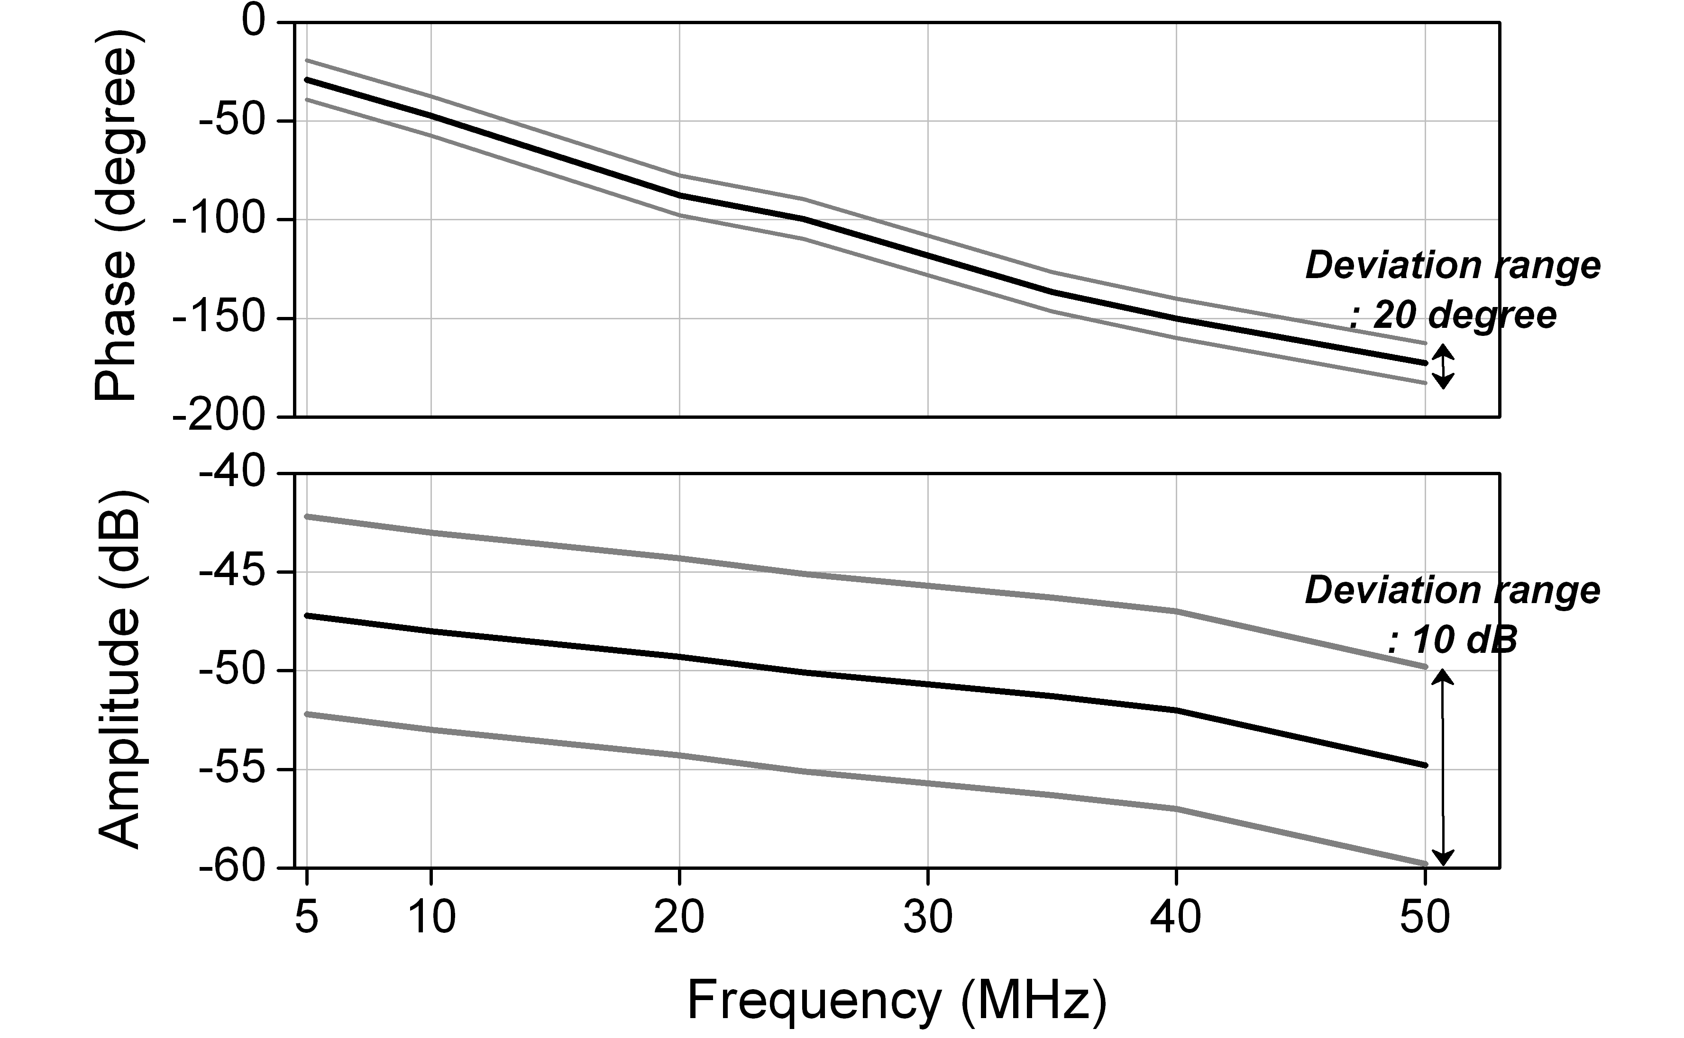

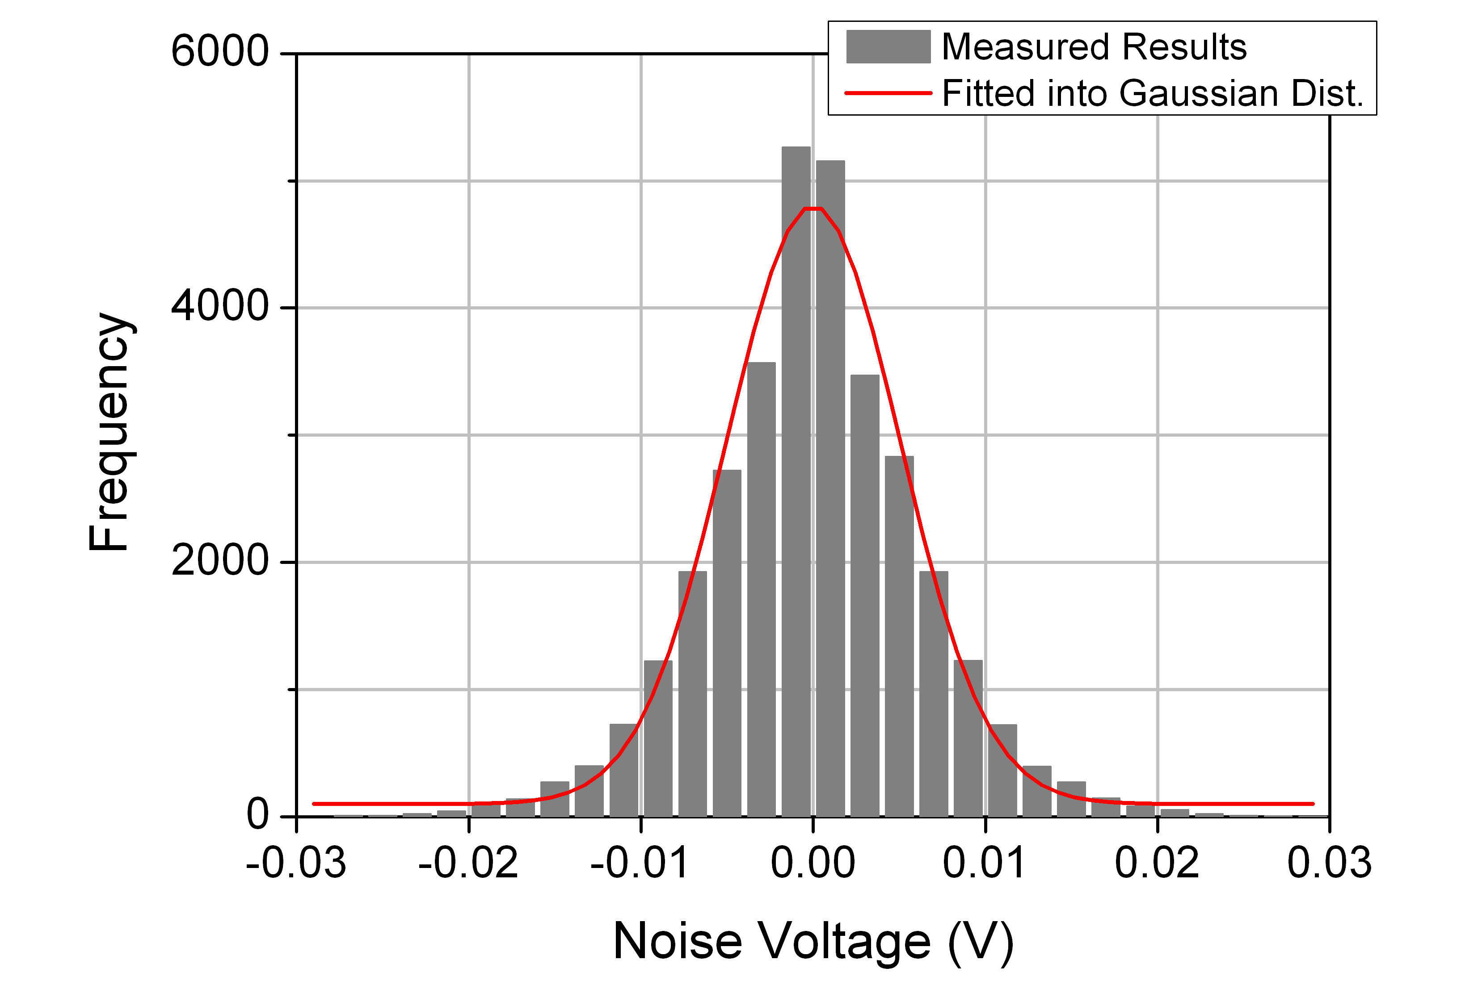
Noise Characteristics

8.2.3. Body surface to body surface CM3 (Scenario S4 & S5) for 400 MHz
The following path loss model is based on measurements that cover frequencies of 400-450 MHz. Further measurement set up, derivation and data analysis can be found in [23]. The table below summarizes the model and corresponding parameters.

 |  | Hospital Room |  | Anechoic Chamber
Path loss model |  | $$\text{PL}\left(d\right) [\text{dB}]\text{=a}⋅{\text{log}}_{\text{10}}\left(d\right)\text{+b+c}+N$$
a |  | 20.6 |  | 46.4
b |  | 12.4 |  | -40.4
c |  | -16.5 |  | -16.5
σ_{N} | 7.2 |  | 2.7

- a and b : Coefficients of linear fitting
- d : Tx-Rx distance in mm.
- N : Normally distributed variable with standard deviation σ_{N}
- c: The difference between the averaged signal levels of the dipole or colinear antenna used in the whole measurement and that of the chip antenna

8.2.4. Body surface to body surface CM3 (Scenario S4 & S5) for 600 MHz

The following path loss model is based on measurements that cover frequencies of 608-614 MHz. Further measurement set up, derivation and data analysis can be found in [23]. The table below summarizes the model and corresponding parameters.

 |  | Hospital Room |  | Anechoic Chamber
Path loss model |  | $$\text{PL}\left(d\right) [\text{dB}]\text{=a}⋅{\text{log}}_{\text{10}}\left(d\right)\text{+b+c}+N$$
a |  | 21.1 |  | 46.9
b |  | -10.5 |  | -80.0
c |  | -0.9 |  | -0.9
σ_{N} | 6.0 |  | 3.3

  - a and b : Coefficients of linear fitting
  - d : Tx-Rx distance in mm.
  - N : Normally distributed variable with standard deviation σ_{N}
  - c: The difference between the averaged signal levels of the dipole or colinear antenna used in the whole measurement and that of the chip antenna

8.2.5. Body surface to body surface CM3 (Scenario S4 & S5) for 900 MHz

8.2.5. A
The following path loss model is based on measurements that cover frequencies of 950-956 MHz. Further measurement set up, derivation and data analysis can also be found in [23]. The table below summarizes the model and corresponding parameters.

 |  | Hospital Room |  | Anechoic Chamber
Path loss model |  | $$\text{PL}\left(d\right) [\text{dB}]\text{=a}⋅{\text{log}}_{\text{10}}\left(d\right)\text{+b+c}+N$$
a |  | 24.2 |  | 45.8
b |  | -8.9 |  | -54.5
c |  | -7.0 |  | -7.0
σ_{N} | 3.9 |  | 8.3

  - a and b : Coefficients of linear fitting
  - d : Tx-Rx distance in mm.
  - N : Normally distributed variable with standard deviation σ_{N}
  - c: The difference between the averaged signal levels of the dipole or colinear antenna used in the whole measurement and that of the chip antenna

8.2.5. B
The following model is based on measurements at frequency of 915 MHz. Details of the measurement set up, derivation and data analysis can be found in [24]. The path loss follows an exponential decay around the perimeter of the body. It flattens out for large distance due to the contribution of multipath components from indoor environment. The table below summarizes the model and corresponding parameters.

Path loss model | $$\text{PL}(d)[\text{dB}]= −\text{10}{\text{log}}_{\text{10}}\left(P_{0} e^{−m_{0}d} + P_{1}\right) + σ_{P}n_{P}$$
P₀ [dB] | -1.9
M₀ [dB/cm] | 2.1
P₁ [dB] | -59.4
σ_{p} [dB] | 3.9
- P₀ : The average loss close to the antenna
- M₀ : The average decay rate in dB/cm for the surface wave traveling around the perimeter of the body
- P₁ : The average attenuation of components in an indoor environment radiated away from the body and reflected back towards the receiving antenna
- σ_{p} : The log-normal variance in dB around the mean, representing the variations measured at different body and room locations. This parameter will depend on variations in the body curvature, tissue properties and antenna radiation properties at different body locations.

The small scale fading is represented by a Ricean distribution with K factor that decreases as the path loss increases. The delay spread is normally distributed. The table below summarizes the model and corresponding parameters.

Small-scale fading | $$K_{\text{dB}}= K_{0} − m_{K}P_{\text{dB}} + σ_{K}n_{K}$$
K₀ [dB] | 40.1
m_{k} [dB] | 0.61
σ_{k} [dB] | 2.4
Parameters of the mean value of the delay spread
Distance [cm] | t_{rms} [ns]
15 | 3
45 | 9
Parameters of the 90% cumulative value of the delay spread
Distance [cm] | t_{rms} [ns]
15 | 5
45 | 15

- K₀ : The fit with measurement data for the K-factor for low path loss
- m_{k} : The slope of the linear correlation between path loss and K-factor
- P_{dB} : Path loss in dB
- σ_{k} : The log-normal variance of the measured data between path loss and K-factor
- n_{k} : A unit mean and variance Gaussian random variable ?

8.2.5. C
The following path loss measurements is at frequency of 820 MHz. Details of the measurement set up, derivation and data analysis can be found in [25]. The table below summarizes the results.
As observed, the dominant factor affecting fading in the channel appears to be the movement of the test subject. This is to be expected as movement causes the separation and orientation of the antennas to change.

Path loss | $$\text{PL}[\text{dB}]= P_{\text{tx}}−P_{\text{rx}} + G_{\text{amplifiers}}−L_{\text{cable}}$$
 | Receiver at right hip |  |  |  |  |  |  |  |  |  |  |  | Receiver at chest
Action | Chest |  | Right Wrist |  | Left Wrist |  | Right Ankle |  | Left Ankle |  | Back |  | Back |  | Right Wrist |  | Right Ankle
Standing | 57.4 |  | 50.2 |  | 59.8 |  | 54.3 |  | 68.7 |  | 61.8 |  | 66.3 |  | 54.5 |  | 54.3
Walking |  | 52.9 |  | 38.4 |  | 63.6 |  | 48.1 |  | 55.5 |  | 57.1 |  | 63.8 |  | 51.3 |  | 56.9
Running |  | 44.1 |  | 37.2 |  | 60.2 |  | 48.9 |  | 54.2 |  | 62.3 |  | 66.3 |  | 49.4 |  | 54.1

- P_{tx}: Transmitted power
- P_{rx}: The RMS received power
- G_{amplifiers}: Amplifier gain
- L_{cable}: Cable loss
The characterization of large-scale fading at 820 MHz for a dynamic BAN channel where devices are placed on body surface can be found in [26]. The fading Rate (number of fades per second), Duration (time below threshold), and Magnitude (attenuation below mean) are measured for four different speeds (walking: 3 kph and 6 kph, Running: 9 kph and 12 kph) of object test. The location of transmitters and receivers on human body are shown in blow table.

Receiver Location | Transmitter Location
Receiver Location | Chest | Right Wrist | Left Wrist | Right Ankle | Left Ankle | Back
Right Hip
Chest

The following figures summarize the result of this measurement. The Gamma distribution is the best fit to average fade duration. The inverse Gaussian distribution is the best fit to find fade magnitude over all measurements.

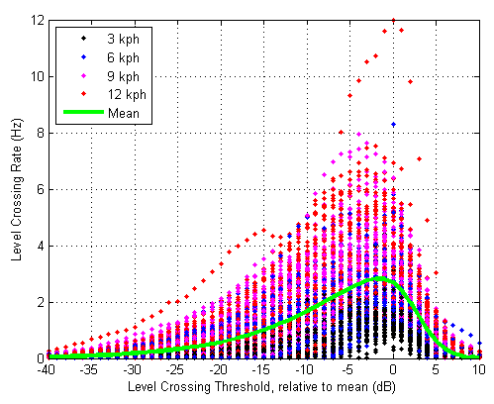
Fading rate

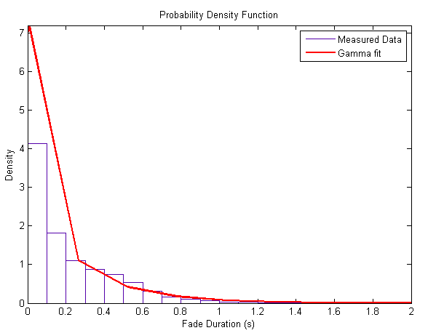
Fading duration

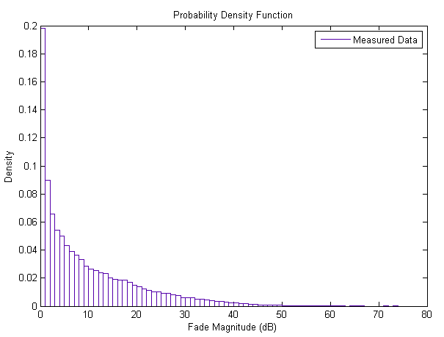
Fading magnitude

The outage probability represents the probability of a minimum requirement on the satisfactory reception over the intended coverage area..

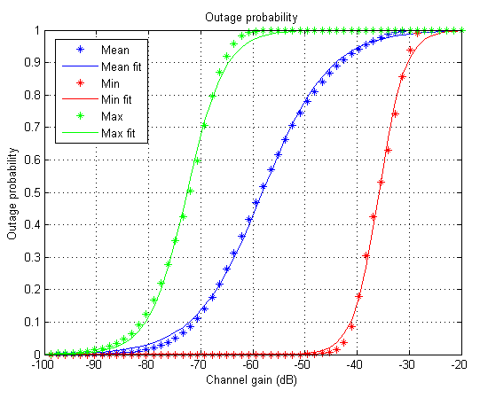
Outage probability

8.2.6. Body surface to body surface CM3 (Scenario S4 & S5) for 2.4 GHz

8.2.6. A
The following path loss model is based on measurements that cover frequencies of 2.4-2.5GHz. Details of the measurement set up, derivation and data analysis can be found in [23]. The table below summarizes the model and corresponding parameters.

 |  | Hospital Room |  | Anechoic Chamber
Path loss model |  | $$\text{PL}\left(d\right) [\text{dB}]\text{=a}⋅{\text{log}}_{\text{10}}\left(d\right)\text{+b+c}+N$$
a |  | 8.32 |  | 46.4
b |  | 37.2 |  | -49.4
c |  | -7.5 |  | -7.5
σ_{N} | 2.5 |  | 2.7

  - a and b : Coefficients of linear fitting
  - d : Tx-Rx distance in mm.
  - N : Normally distributed variable with standard deviation σ_{N}
  - c: The difference between the averaged signal levels of the dipole or colinear antenna used in the whole measurement and that of the chip antenna

8.2.6. B
The following model is based on measurements at frequency of 2.45 GHz. Details of the measurement set up, derivation and data analysis can be found in [24]. The path loss follows an exponential decay around the perimeter of the body. It flattens out for large distance due to the contribution of multipath components from indoor environment. The table below summarizes the model and corresponding parameters.

Path loss model |  | $$\text{PL}(d)[\text{dB}]= −\text{10}{\text{log}}_{\text{10}}\left(P_{0} e^{−m_{0}d} + P_{1}\right) + σ_{P}n_{P}$$
P₀ [dB] |  | -25.8
m₀ [dB/cm] |  | 2.0
P₁ [dB] |  | -71.3
σ_{p} [dB] | 3.6

- P₀ : The average loss close to the antenna
- M₀ : The average decay rate in dB/cm for the surface wave traveling around the perimeter of the body
- P₁ : The average attenuation of components in an indoor environment radiated away from the body and reflected back towards the receiving antenna
- σ_{p} : The log-normal variance in dB around the mean, representing the variations measured at different body and room locations. This parameter will depend on variations in the body curvature, tissue properties and antenna radiation properties at different body locations.

The small scale fading is represented by a Ricean distribution with K factor that decreases as the path loss increases. The delay spread is normally distributed. The table below summarizes the model and corresponding parameters.

Small-scale fading |  | $$K_{\text{dB}}= K_{0} − m_{K}P_{\text{dB}} + σ_{K}n_{K}$$
K₀ [dB] | 30.6
m_{k} [dB] | 0.43
σ_{k} [dB] | 3.4
Parameters of the mean value of the delay spread
Distance [cm] | t_{rms} [ns]
15 | 6
45 | 16
Parameters of the 90% cumulative value of the delay spread
Distance [cm] | t_{rms} [ns]
15 | 11
45 | 22

- K₀ : The fit with measurement data for the K-factor for low path loss
- m_{k} : The slope of the linear correlation between path loss and K-factor
- P_{dB} : Path loss in dB
- σ_{k} : The log-normal variance of the measured data between path loss and K-factor
- n_{k} : A unit mean and variance Gaussian random variable ?

8.2.6. C
The following path loss measurements is at frequency of 2.36 GHz. Details of the measurement set up, derivation and data analysis can be found in [25]. The table below summarizes the results.
As observed, the dominant factor affecting fading in the channel appears to be the movement of the test subject. This is to be expected as movement causes the separation and orientation of the antennas to change.

Path loss | $$\text{PL}[\text{dB}]= P_{\text{tx}}−P_{\text{rx}} + G_{\text{amplifiers}}−L_{\text{cable}}$$
 | Receiver at right hip |  |  |  |  |  |  |  |  |  |  |  | Receiver at chest
Action | Chest |  | Right Wrist |  | Left Wrist |  | Right Ankle |  | Left Ankle |  | Back |  | Back |  | Right Wrist |  | Right Ankle
Standing | 65.3 |  | 44.5 |  | 74.7 |  | 60.9 |  | 70.7 |  | 75.3 |  | 73 |  | 70.5 |  | 66.3
Walking |  | 59.1 |  | 47.3 |  | 59.8 |  | 53.9 |  | 58.5 |  | 67.4 |  | 72 |  | 64.9 |  | 62.4
Running |  | 55.9 |  | 36.3 |  | 52.5 |  | 55 |  | 59 |  | 68.5 |  | 71.7 |  | 57.4 |  | 63.3

- P_{tx}: Transmitted power
- P_{rx}: The RMS received power
- G_{amplifiers}: Amplifier gain
- L_{cable}: Cable loss

8.2.7. Body surface to body surface CM3 (Scenario S4 & S5) for 3.1-10.6 GHz

8.2.7. A
The following path loss model is based on measurements that cover frequencies of 3.1-10.6 GHz. Measurement set up, derivation and data analysis can be found in [23]. The table below summarizes the model and corresponding parameters.

 |  | Hospital Room |  | Anechoic Chamber
Path loss model |  | $$\text{PL}\left(d\right) [\text{dB}]\text{=a}⋅{\text{log}}_{\text{10}}\left(d\right)\text{+b}+N$$
a |  | 8.43 |  | 17.0
b |  | 31.8 |  | 9.8
σ_{N} | 2.8 |  | 4.66

  - a and b : Coefficients of linear fitting
  - d : Tx-Rx distance in mm
  - N : Normally distributed variable with zero mean and standard deviation σ_{N}

8.2.7. B
The following path loss model is based on measurements that cover frequencies of 3.1-10.6 GHz. Measurement set up, derivation and data analysis can be found in [24]. The table below summarizes the corresponding parameters.

Around torso
Antenna separation from body surface |  | 0 mm |  |  | 5 mm |  |  | 10 mm
P₀ [dB] |  | 56.1 |  |  | 48.4 |  |  | 45.8
d₀ [m] |  | 0.1 |  |  | 0.1 |  |  | 0.1
n | 5.8 |  |  | 5.9 |  |  | 6.0
Along torso
Antenna separation from body surface |  |  | 0 mm |  |  | 5 mm
P₀ [dB] |  |  | 56.5 |  |  | 44.6
d₀ [m] |  |  | 0.1 |  |  | 0.1
n |  |  | 3.1 |  |  | 3.1

- n: Path loss exponent
- P₀: TBD
- d₀: TBD

8.2.7. C
Measurement for the UWB frequency band ranges of 3.1-5.1 GHz and 7.25-8.5 GHz has been performed in [27]. The following table summarizes the measurement results. Further detail on set-up, derivation and data analysis can also be found in [27].

8.2.7.C.A
Transmitter antenna is placed in left waist and receiver antennas are located in several different positions to observe the effect of body posture.

a. 3.1-5.1 GHz
 | Action | left  ear(dB) | right  ear(dB) | left  wrist(dB) | right  wrist(dB) | right  waist(dB) | left  ankle(dB) | right  ankle(dB)
Anechoic Chamber | Standing | 62.2 | 61.6 | 64.9 | 67.5 | 64.2 | 72.8 | 69.1
Anechoic Chamber | Sitting | 71.9 | 65.7 | 55.6 | 69.9 | 65.9 | 76.3 | 73.9
Office Room | Standing | 73.8 | 70.4 | 61.4 | 70.9 | 74.3 | 76.4 | 68.3
Office Room | Sitting | 62.3 | 72.1 | 65.6 | 76.3 | 74.7 | 79.8 | 75.7

b. 7.25-8.5 GHZ
 | Action | left  ear(dB) | right  ear(dB) | left  wrist(dB) | right  wrist(dB) | right  waist(dB) | left  ankle(dB) | right  ankle(dB)
Anechoic Chamber | Standing | 81.7 | 83.9 | 69.3 | 63.9 | 76.1 | 76.8 | 77.1
Anechoic Chamber | Sitting | 84.4 | 85.2 | 73.6 | 75.5 | 82.38 | 79.8 | 95.2
Office Room | Standing | 75.5 | 75.6 | 80.6 | 66.4 | 71.9 | 74.4 | 75.8
Office Room | Sitting | 67.1 | 84.5 | 67.0 | 67.1 | 67.5 | 70.6 | 83.4

8.2.7.C.B
To study the effect of body movement on channel model, the transmitter antenna is placed in left waist and receiver antennas are located in several different positions, while arm and leg are moved in forward or side directions.

a. 3.1-5.1 GHz
 |  | Anechoic Chamber |  | Office Room
 |  | mean | stdev | mean | stdev
Left wrist | Forward direction | 65.7 | 4.3 | 71.7 | 5.8
Left wrist | Side direction | 70.9 | 6.0 | 76.6 | 7.7
Right wrist | Forward direction | 72.9 | 4.4 | 73.6 | 2.3
Right wrist | Side direction | 71.8 | 5.9 | 75.1 | 3.1
Left ankle | Forward direction | 74.6 | 2.5 | 76.4 | 0.1
Left ankle | Side direction | 67.9 | 6.8 | 70.4 | 8.4
Right ankle | Forward direction | 70.8 | 2.5 | 69.9 | 2.3
Right ankle | Side direction | 72.8 | 5.3 | 69.6 | 1.9

b. 7.25-8.5 GHz
 |  | Anechoic Chamber |  | Office Room
 |  | mean | stdev | mean | stdev
Left wrist | Forward direction | 76.9 | 6.6 | 74.1 | 3.4
Left wrist | Side direction | 77.4 | 10.1 | 78.1 | 4.7
Right wrist | Forward direction | 79.7 | 7.1 | 73.0 | 7.1
Right wrist | Side direction | 79.5 | 8.1 | 75.9 | 6.0
Left ankle | Forward direction | 82.4 | 7.9 | 75.9 | 2.2
Left ankle | Side direction | 77.4 | 0.8 | 75.7 | 1.9
Right ankle | Forward direction | 85.4 | 11.7 | 77.5 | 2.5
Right ankle | Side direction | 82.0 | 6.9 | 78.1 | 3.3

8.2.8. Body surface to external CM4 (Scenario S6 & S7) for 900 MHz
The following path loss measurements is at frequency of 820 MHz. Details of the measurement set up, derivation and data analysis can be found in [28]. The table below summarizes the results.
The transmitter is placed on the chest and the receiver is away from the body with various distances as outlined.

 | LOS |  |  |  |  |  | NLOS
Distance (m) | 1 |  | 2 |  | 3 | 4 | 1 | 2 | 3 | 4
Standing | 5.187 |  | 14.037 |  | 16.611 | 11.492 | 20.626 | 18.356 | 26.718 | 20.122
Walking | 4.481 | 9.567 |  | 16.395 |  | 16.755 | 7.437 | 19.416 | 25.272 | 25.646

8.2.9. Body surface to external CM4 (Scenario S6 & S7) for 2.4 GHz
The following path loss measurements is at frequency of 2.36 GHz. Details of the measurement set up, derivation and data analysis can be found in [28]. The table below summarizes the results.
The transmitter is placed on the chest and the receiver is away from the body with various distances as outlined.

 | LOS |  |  |  |  |  | NLOS
Distance (m) | 1 |  | 2 |  | 3 | 4 | 1 | 2 | 3 | 4
Standing | 17.068 |  | 16.070 |  | 18.602 | 27.576 | 23.989 | 31.562 | 22.851 | 26.184
Walking | 7.991 | 14.269 |  | 15.243 |  | 20.930 | 22.137 | 33.266 | 29.863 | 31.208

8.2.10. Body surface to external CM4 (Scenario S6 & S7) for 3.1-10.6 GHz

8.2.10.A
Measurement for the UWB frequency band of 3.1-10.6 GHz has been performed in [29]. On-body antenna characteristics were measured in anechoic chamber, while channel measurements were done in office environment. For this measurement, the Tx antenna is fixed near to wall, while the Rx antenna (placed 0n body) positions were changed in office area. The effect of ground is considered in measurements. All data were averaged for statically analysis, therefore, the detail data of each measurement is not provided. The Further detail on set-up, derivation and data analysis can be found in [29]. The following figures summarize the delay profile of front, side, and backside of body while the Tx antenna is in the front of body.

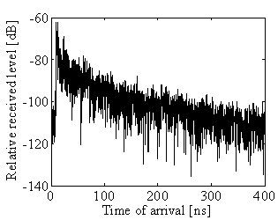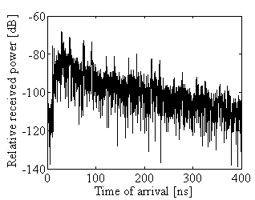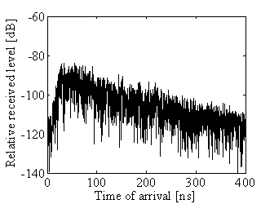

Front of body side of body Backside of body

 | Model |  |  | $$h(t)= \sum_{m=0}^{∞}{α_{m}}δ\left(t−τ_{m}\right)$$  $${\overline{\left|α_{m}\right|}}^{2}= Ω_{0}{e^{−τ_{m}}}/Γ−k\left[1−δ\left(m\right)\right]$$  $$k=Δk\left(\text{ln}{\text{10}}/{\text{10}}\right)$$  $$τ_{0}=d/c$$
Direction of Body |  | Г[ns] | K (Δk[dB]) |  | σ[dB]
0 |  | 0.224 | 1.47 (6.4) |  | 7.30
90 |  | 0.184 | 0.691 (3.0) |  | 7.08
 | 180 |  |  | 0.187 |  | 0 (0) |  | 7.03
 | 270 |  |  | 0.191 |  | 0.345 (1.5) |  | 7.19

  - h(t : Complex impulse response
  - m : Number of ray
  - a_{m} : Amplitude of each ray
  - τ_{m}: Sampling rate of system
  - k: Effect of K-factor
  - Ω₀: Path loss
  - D: Tx-Rx distance
  - C: Velocity of light

8.2.10.B
Measurement for the UWB frequency band ranges of 3.1-5.1 GHz and 7.25-8.5 GHz has been performed in [27]. Further detail on set-up, derivation and data analysis can also be found in [27].

8.2.10. B. A. Effect of receiver antenna height
The transmitter antenna is placed on wooden stand at fixed height of 1 m from ground and receiver antenna is located at different height, from 0.25 to 1.5 m with step of 0.25 m. The distance between transmitter and receiver are 1 m and 3 m. The tables below summarize the results. (Rx antenna on-body?)

a. 3.1-5.1 GHz
Rx Antenna Height | 0.25m | 0.5m | 0.75m | 1.0m | 1.25m | 1.5m
Tx-Rx Distance 1m | 45.5 | 45.4 | 44.2 | 43.8 | 44.5 | 44.2
Tx-Rx Distance 3m | 54.5 | 53.7 | 53.0 | 52.9 | 53.7 | 53.7

b. 7.25-8.5 GHz
Rx Antenna Height | 0.25m | 0.5m | 0.75m | 1.0m | 1.25m | 1.5m
Tx-Rx Distance 1m | 61.2 | 60.2 | 61.6 | 60.4 | 60.4 | 60.8
Tx-Rx Distance 3m | 62.9 | 63.1 | 69.9 | 70.4 | 69.9 | 63.5

8.2.10. B.B. Effect of body posture
The transmitter antenna is placed on wooden stand at fixed height of 1 m from ground and receiver antenna is located on body with 3 m away from transmitter. The measurements have been performed for standing and sitting positions. The tables below summarize the results.

a. 3.1-5.1 GHz
 | Anechoic Chamber (dB) |  |  |  | Office Room (dB)
Action | Right ear | Right wrist | Right waist | Right ankle | Right ear | Right wrist | Right waist | Right ankle
Standing | 66.9 | 63.3 | 56.1 | 59.4 | 62.8 | 61.9 | 55.1 | 60.7
Sitting | 60.4 | 61.1 | 60.6 | 55.7 | 60.4 | 61.6 | 54.5 | 57.1

b. 7.25-8.5 GHz
 | Anechoic Chamber (dB) |  |  |  | Office Room (dB)
Action | Right ear | Right wrist | Right waist | Right ankle | Right ear | Right wrist | Right waist | Right ankle
Standing | 69.3 | 63.7 | 70.4 | 69.5 | 72.4 | 72.1 | 75.7 | 68.1
Sitting | 71.5 | 64.2 | 71.9 | 63.8 | 74.4 | 73.9 | 76.3 | 73.7

8.2.10. B. C Effect of body movement
The transmitter antenna is placed on wooden stand at fixed height of 1 m from ground and receiver antenna is located on body with 3 m away from transmitter. The measurements have been performed while arm and leg are moved in forward or side directions. The tables below summarize the results.

a. 3.1-5.1 GHz
 |  | Anechoic Chamber |  | Office Room
 |  | Mean (dB) | Stdev (dB) | Mean (dB) | Stdev (dB)
Wrist | Forward direction | 58.2 | 4.2 | 60.7 | 3.9
Wrist | Side direction | 63.6 | 3.5 | 64.5 | 2.2
Ankle | Forward direction | 64.0 | 6.5 | 61.4 | 1.1
Ankle | Side direction | 57.2 | 3.1 | 61.0 | 0.5

b. 7.25-8.5 GHz
 |  | Anechoic Chamber |  | Office Room
 |  | Mean (dB) | Stdev (dB) | Mean (dB) | Stdev (dB)
Wrist | Forward direction | 64.6 | 2.3 | 73.1 | 2.0
Wrist | Side direction | 64.0 | 1.8 | 73.9 | 2.5
Ankle | Forward direction | 66.1 | 4.8 | 65.4 | 3.8
Ankle | Side direction | 66.0 | 4.8 | 69.1 | 1.4

8.3. Real time channel for body surface to body surface CM3 (Scenario S4 & S5) at 4.5 GHz

A real time channel measurements by use of channel sounder has been performed in [30]. The channel measurements were carried out in an anechoic chamber with center frequency of 4.5 GHz and bandwidth of 120 MHz. Details of the measurement set up, derivation and data analysis can be found in [30]. The measurements are focusing on the fading effect due to movements of the human body, therefore conducted in an anechoic chamber, where the mutipath from the surrounding objects are negligible.
The transmitter antenna was fixed on around navel. The table below summarize the position of receiving antennas and distance between Tx and Rx antennas.

Position | Distance [mm]
Right wrist | 440 ~ 525
Right upper arm | 360
Left ear | 710
Head | 650
Shoulder | 310
Chest | 230
Right rib | 183
Left waist | 140
Thigh | 340
Ankle | 815 ~ 940

To provide a statistical model, the probability distribution functions such as normal, log-normal and Weibull distributions have been tried to fill the measurement results. The tables below summarize the normal, log-normal and Weibull distributions.

Position | (Normal) $f(x|μ,σ)=\frac{1}{σ\sqrt{2π}}e^{−\frac{{\left(x−μ\right)}^{2}}{2σ^{2}}}$
Position | Still  µ/σ [dB]  (-log L) | Walking  µ/σ [dB]  (-log L) | Up-down  µ/σ [dB]  (-log L)
Right wrist | 1.0000 / 0.1279  (-6303) | 3.0875 / 4.4063 (28972) | 8.9461 / 5.1576  (30220)
Right upper arm | 1.0000 / 0.1500  (-4735) | 3.2443 / 1.7012 (19332) | 7.3374 / 6.1415  (32061)
Head | 1.0000 / 0.0666  (-12706) | 0.4477 / 0.2445 (4535) | 0.9058 / 1.2629  (16207)
Right ear | 1.0000 / 0.1349  (-5826) | 0.7303 / 0.3014  (101) | 0.8205 / 0.8232  (12148)
Shoulder | 1.0000 / 0.0335  (-19782) | 2.6849 / 1.4627 (2153) | 1.5437 / 1.3265  (17519)
Chest | 1.0000 / 0.3481  (3600) | 3.6360 / 2.4688 (17849) | 7.1082 / 9.2594  (36609)
Right rib | 1.0000 / 0.1654  (-3812 ) | 0.8572 / 0.2744 (1256) | 4.7043 / 2.9597  (24784)
Left waist | 1.0000 / 0.0399  (-17978 ) | 0.7264 / 0.1609  (-4018) | 0.5458 / 0.3105  (2456)
Right thigh | 1.0000 / 0.0964  (-9254 ) | 0.6500 / 0.4388  (5831) | 1.1357 / 0.6949  (10272)
Right ankle | 1.0000 / 0.0787  (-11025) | 1.6070 / 0.9968  (14248) | 1.2489 / 1.2220  (16122)

  - µ : Mean value
  - σ : Variable value
  - -LogL: Negative log liklihood

Position | (Log-Normal) $f(x|μ,σ)=\frac{\text{10}\text{/ln}\text{10}}{xσ\sqrt{2π}}e^{−\frac{{\left(\text{10}{\text{log}}_{\text{10}}x−μ\right)}^{2}}{2σ^{2}}}$
Position | Still  µ/σ [dB]  (-log L) | Walking  µ/σ [dB]  (-log L) | Up-down  µ/σ [dB]  (-log L)
Right wrist | -0.0652 / 0.9531  (-1114.1) | -3.9908 / 11.7727 (14948) | 8.4456 / 3.4836 (31047)
Right upper arm | -0.0491 / 0.6544  (-4800.9) | 4.4491 / 2.4972 (18735) | 6.3009 / 5.6692 (31093)
Head | -0.0100 / 0.2969  (-12476) | -3.5392 / 3.2052 (2983.8) | -3.6932 / 5.3385 (7601)
Right ear | -0.0400 / 0.5921  (-5815.6) | -4.1465 / 2.4654  (-1005.5) | -3.3130 / 5.2458 (8384.1)
Shoulder | -0.0024 / 0.1453  (-19806) | -1.8011 / 2.0549 (2507.8) | 0.2165 / 4.1023 (14537)
Chest | -0.2359 / 1.4019 (2315) | 3.6360 / 2.4688 (16779) | 5.0788 / 6.4077 (29907)
Right rib | -0.0470 / 0.6043  (-5657.3 ) | -0.8883 / 1.3994 (818.79) | 5.7033 / 3.2101 (24051)
Left waist | -0.0035 / 0.1742  (-17942 ) | -1.4965 / 0.9770  (-4109.5) | -3.5588 / 3.3466 (3337.8)
Right thigh | -0.0191/ 0.4017  (-9717 ) | -2.6924 / 2.6453 (2970.7) | -0.5995 / 3.7712 (11098)
Right ankle | -0.0131/ 0.3352  (-11251 ) | 0.9424 / 3.7030 (14861) | -1.1303 / 4.7167 (12357)

  - µ : Mean value
  - σ : Variable value
  - -LogL: Negative log liklihood

Position | (Weibull) $f(x|a,b)=\frac{b}{a}{\left(\frac{x}{a}\right)}^{b−1}e^{−{\left(\frac{x}{a}\right)}^{b}}$
Position | Still  a/b  (_-LogL) | Walking  a/b  (_-LogL) | Updn  a/b  (_-LogL)
Right wrist | 1.0478 / 7.7411  (-5770.3) | 1.4690 / 0.4510  (14629) | 10.0006 / 1.7319  (29786)
Right upper arm | 1.0655 / 7.3618  (-4529.3) | 3.6759 / 2.0325  (18625) | 7.5368 / 1.0787  (29631)
Head | 1.0297 / 17.9473  (-13029) | 0.6360 / 1.5519  (3061.7) | 0.8015 / 0.8228  (8458.3)
Right ear | 1.0594 / 7.7870  (-5394.6) | 0.5071 / 1.9516  (-840.12) | 0.8224 / 1.0055  (7959.7)
Shoulder | 1.0165 / 29.8877  (-18940) | 0.8237 / 2.6536  (1913.3) | 1.6534 / 1.2203  (14452)
Chest | 1.1203 / 2.9913 (3487.2) | 3.0419 / 1.9575  (16909) | 6.3808 / 0.8247  (29393)
Right rib | 1.0742 / 4.9107  (-1979.2) | 0.9539 / 3.2009  (1357.2 ) | 5.2709 / 1.6440  (23654)
Left waist | 1.0190 / 28.9055  (-17946) | 0.7915 / 4.9572  (-3903.2 ) | 0.6117 / 1.7907  (1823.7)
Right thigh | 1.0464 / 9.6410  (-7951.2) | 0.7325 / 1.6297  (3867.9) | 1.2626 / 1.6251  (9539.3)
Right ankle | 1.0379 / 11.8572  (-9813.1) | 1.7880 / 1.6227  (13323) | 1.2867 / 1.0759  (12124)

  - a : Scale factor
  - b : Shape factor
  - -LogL: Negative log liklihood

The below table summarize the best fitting distributions for dynamic channel at 4.5 GHz.

Position | Still | Walking | Up-down
Right wrist | Normal | Weibull | Weibull
Right upper arm | Log-normal | Weibull | Weibull
Head | weibull | Log-normal | Log-normal
Right ear | Normal | Log-normal | Weibull
Shoulder | Log-normal | Weibull | Weibull
Chest | Log-normal | Log-normal | Weibull
Right rib | Log-normal | Log-normal | Weibull
Left waist | Normal | Log-normal | Weibull
Right thigh | Log-normal | Log-normal | Weibull
Right ankle | Log-normal | Weibull | Weibull

- Normal distribution seems to fit the still posture best, but it can be seen that fittings with any distributions have large from the PDFs.
- Log-normal distribution shows good match in cases of still postures and small movements such as walking posture in case of head , right ear, chest, right rib, left waist, right thigh, and stand up/down posture in case of head.
- Weibull distribution can represent much better large movement behaviors such as walking posture in case of right wrist, right upper arm, shoulder, right ankle, and all stand up/down postures except for head.

9. MATLAB code program

9.1. In-body

9.2. On-body

A. Human body communication (HBC) [22]

function channel_output_data = channel(channel_description, vin, input_data)
% ================================================================
% Parameter setting
% ================================================================
% - channel_description
% 1 -> Average value: Frequency response has mean value.
% 2 -> Uniformly distributed value: Frequency response has
% uniform distribution in the deviation range.
% - vin: Voltage of transmitting signal
% - input_data: Unipolar NRG Signaling Data (ex/[1 0 1 0 0 1....0 ])

if(channel_description==1)
channel_mag = 0;
channel_pha = 0;
elseif(channel_description==2)
channel_mag= sign(rand(1)-0.5).*rand(1)*5;
channel_pha= sign(rand(1)-0.5).*rand(1)*10;
end
input_data = input_data*vin;

% ================================================================
% Intrinsic Channel Model
% ================================================================
% Channel (FIR filter) Sampling frequency: 100 Mhz
mesh = 0.5 ;
Fchip = 50*1e6;
Fchip = Fchip / 1e6 ;
% Values at 0 Mhz & 55 Mhz are interpolated
f=[0 5 10 15 20 25 30 35 40 45 50 55];
AmpdB=[-45 -47.2 -48 -48.65 -49.3 -50 -50.7 -51.35 -52 -53.4 -54.8 -57.5];
PhaseDegree=[-15 -29.2 -47.4 -67.55 -87.7 -102.65 -117.6 -133.8 -150 -161.35 -172.7 -177.5] ;
% For compensation of simulation channel response
compensation = 6.5;
Amp = 10.^((AmpdB+channel_mag+compensation)/20);
Phaseradian = (pi/180)*(PhaseDegree+channel_pha);
Amptmp = zeros(0,0);
Phasetmp = zeros(0,0);
for i=2:length(f)
step = ((f(i)-f(i-1))/mesh);
Ampstep = (Amp(i)-Amp(i-1))/step;
Phasestep = (Phaseradian(i)-Phaseradian(i-1))/step;
tmp0 = [Amp(i-1): Ampstep : Amp(i)];
if i==length(f)
Amptmp = [Amptmp tmp0(1:length(tmp0))];
else
Amptmp = [Amptmp tmp0(1:length(tmp0)-1)];
end
tmp1 = [Phaseradian(i-1): Phasestep : Phaseradian(i)];
if i==length(f)
Phasetmp = [Phasetmp tmp1(1:length(tmp1)) ];
else
Phasetmp = [Phasetmp tmp1(1:length(tmp1)-1) ];
end
end
Amptmp_ext = [Amptmp(1:(Fchip/mesh+1)) fliplr(Amptmp(2:(Fchip/mesh+1)))];
Phasetmp_ext = [Phasetmp(1:(Fchip/mesh+1)) (-fliplr(Phasetmp(2:(Fchip/mesh+1))))];
Freq_response = Amptmp_ext.*exp(j*Phasetmp_ext);
Time_res = ifft(Freq_response, length(Freq_response));
Fsample = (length(Time_res)-1) * (mesh*10^(6));
Max_index = find(Time_res==max(Time_res));
h = [Time_res(Max_index : 1 : Max_index+32)];
h= real(h);
ch_delay = (length(h)-1)/2;
% ================================================================
% Channel and Noise
% ================================================================
tmp = conv(input_data, h);
data_channel = tmp(1: length(tmp)-ch_delay*2 ) ;
%Noise variance
Var_NB = 2.545e-005;
Noise = randn(length(data_channel),1)* sqrt(Var_NB);
data_channel_noise = data_channel + Noise';
% Human Body Channel Response Output
channel_output_data = data_channel_noise;

B. [23]
- CM3
1.1 Path loss
N_ch = 100; % # of path loss realizations
distance = 1000; % unit: mm

% =================== Channel parameter ===============
frequency = 1; % 1: 400MHz, 2: 600MHz, 3: 900MHz, 4: 2450MHz, 5: UWB
if frequency == 1
a = 5.13;
b = 29.6;
sigma_s = 5.49;
elseif frequency == 2
a = 15.5;
b = 3.08;
sigma_s = 6.56;
elseif frequency == 3
a = 16.2;
b = 4.27;
sigma_s = 5.55;
elseif frequency == 4
a = 7.84;
b = 34.1;
sigma_s = 3.98;
elseif frequency == 5
a = 19.8;
b = 5.97;
sigma_s = 4.17;
end
% =====================================================
% =============== Path loss realizations ==============
% -- Path loss in dB
PL = a*log10(distance)+b+sigma_s*randn(1,N_ch);
% =====================================================

1.2 Power delay profile

N_ch = 100; % # of realization on channel impulse response (CIR)

% ================== Parameters ==================
L_av = 20.2; % Average number of the arrival paths
sigma_s = 5.94; % Standard deviation on the amplitude level
Gamma = 61.3; % Exponential decay factor
gamma_0 = -3.3; % Rice factor
lambda = 6.18; % Time difference between neighboring arrival paths
ts = 5.0125*10^-10; % Sampling time
% ============= Calculate CIR realizations =============
for n_ch = 1 :N_ch
T_p = 0;
N_path = max(1,poissrnd(L_av));
for n_p = 1 :N_path
if T_p == 0
amp_path = 1;
else
amp_path = 10^((10*log10(exp(-T_p/Gamma))+gamma_0+sigma_s*randn)/20);
end
t(n_ch,n_p) = T_p;
h(n_ch,n_p) = amp_path*rand(1)*2*pi;
T_p = T_p + poissrnd(lambda)*ts;
end
h_norm(n_ch,1:N_path) = h(n_ch,1:N_path)/sqrt(sum(abs(h(n_ch,:))));
end

- CM4
N_ch = 100;

% ================== Parameters ==================
L = 200; % # of arrival paths
body_direction = 1; % 1: 0 deg, 2: 90 deg, 3: 180 deg, 4: 270 deg
ts = 5.0125*10^-10; % Sampling time
% ---
if body_direction == 1
Gamma = 0.224; % [ns]
delta_k = 6.4; % [dB]
sigma = 7.30; % [dB]
elseif body_direction == 2
Gamma = 0.184; % [ns]
delta_k = 3.0; % [dB]
sigma = 7.08; % [dB]
elseif body_direction == 3
Gamma = 0.187; % [ns]
delta_k = 0; % [dB]
sigma = 7.03; % [dB]
elseif body_direction == 4
Gamma = 0.191; % [ns]
delta_k = 1.5; % [dB]
sigma = 7.19; % [dB]
end
% =================================================
% ================= Realizations ==================
for n_ch = 1 :N_ch
T_p = 0;
for n_p = 1 :L
if T_p == 0
amp_path = 1;
else
amp_path = exp(-T_p*10^9/Gamma-delta_k*log(10)/10);
end
t(n_ch,n_p) = T_p;
h(n_ch,n_p) = amp_path*rand(1)*2*pi;
T_p = T_p + ts;
end
h_norm(n_ch,1:L) = h(n_ch,1:L)/sqrt(sum(abs(h(n_ch,1:L)).^2));
end
% =================================================

- CM2
N_ch = 100; % # of path loss realizations
distance = 10; % unit: cm
theta = 0; % Antenna angle between implanted and outside antennas [rad]

% =================== Channel parameter ===============
a = 1.92;
b = 39.85;
sigma_N = 6.59;
x_c = 0.145;
% ====================================================
% =============== Path loss realizations ==============
% -- Path loss in dB
P_theta = 20*log10(cos(theta)*(1-x_c)+x_c);
PL = a*distance+b+P_theta+sigma_N*randn(1,N_ch);
% ====================================================

10. References
- ERC Recommendation 70-03 relating to the use of Short Range Device (SRD), European Conference of Postal and Telecommunications Administrations, CEPT/ERC 70-03, Tromsø, Norway, 1997.
- FCC, Medical implant communications, January 2003,
http://wireless.fcc.gov/services/index.htm?job=service_home&id=medical_implant
- 15-07-0939-01-0ban-ieee-802-15-6-regulation-subcommittee-report
- Kamya Y. Yazdandoost et al, “Channel Characterization for BAN Communications,” IEEE802.15-07-0641-00-0ban.
- 15-07-0735-06-0ban-ban-application-matrix_amaledit
- W.-T. Chen; H.-R. Chuang, “Numerical computation of human interaction with arbitrarily oriented superquadric loop antennas in personal communications,” IEEE Trans. on Antenna and Propagation, vol.46, no. 6, pp. 821-828, June 1998.
- Kamya Y. Yazdandoost and Ryuji Kohno, “The Effect of Human Body on UWB BAN Antennas,” IEEE802.15-07-0546-00-0ban.
- Kamya Y. Yazdandoost and Ryuji Kohno, “Wireless Communications for Body Implanted Medical Device,” Asia Pacific Microwave Conference, APMC2007.
- Andreas F. Molisch et al, “A Comprehensive Model for Ultrawideband Propagation Channels,” IEEE Global Telecommunications Conference, GLOBECOM '05. Vol.6, pp. 3648-3653.
- C. H. Duney, H. Massoudi, and M. F. Iskander, “Radiofrequency radiation dosimetry handbook,” USAF School of Aerospace Medicine, October 1986.
- C. Gabriel and S. Gabriel, “Compilation of the dielectric properties of body tissues at RF and microwave frequencies,” AL/OE-TR-1996-0037, June 1996, http://www.brooks.af.mil/AFRL/HED/hedr/reports/dielectricReport/Report.html.
- Italian National Research Council, Institute for Applied Physics, “Dielectric properties of body tissues,” http://niremf.ifac.cnr.it
- P. Gandhi, “.Biological effects and medical applications of electromagnetic energy,” Prentice Hall, Englewood Cliffs, N.J., 1990.
- E. Reusens, W. Joseph, G. Vermeeren, and L. Martens, „On-body measurements and characterization of wireless communication channel fro arm and torso of human,“ International Workshop on Wearable and Implantabel Body Sensor Networks, BSN07, Achen, March 2007, pp. 26-28.
- A. Fort, J. Ryckaert, C. Desset, P. De Doncker, P. Wambacq, and L. Van Biesen, “ Ultra-wideband channel model for communication around the human body, ” IEEE Journal on Selected Areas in Communications, vol. 24, pp.927-933, April 2006.
- Bernard Sklar, “Rayleigh fading channels in mobile digital communication system part I: characterization”, IEEE Communication Magazine, pp.90-100, July 1997.
- Jaehwan Kim, Hyung Soo Lee, Jeong Ki Pack, Tae Hong Kim, “Channel modeling for medical implanted communication systems by numerical simulation and measurement,” IEEE 802.15-08-0274-02-0006, May 2008.
- Kamya Yekeh Yazdandoost and Ryuji Kohno, “Antenna for Medical Implanted Communications System,” IEEE 802.15-07-0785-00-0ban, July 2007.
- John Hagedorn, Judith Terrill, Wenbin Yang, Kamran Sayrafian, Kamya Yazdandoost, Ryuji Kohno, “MICS Channel Characteristics; Preliminary Results”, IEEE 802.15-08-0351-00-0006, September 2008.
- John Hagedorn, Judith Terrill, Wenbin Yang, Kamran Sayrafian, Kamya Yazdandoost, Ryuji Kohno, “A Statistical Path Loss Model for MICS”, IEEE 802.15-08-0519-01-0006, September 2008.
- Arthur Astrin, “Measurements of body channel at 13.5 MHz,” IEEE 802.15-08-0590-00-0006, August 2008.
- Jung-Hwan Hwang, Il-Hyoung Park, and Sung-Weon Kang, “Channel model for human body communication,” IEEE 802.15-08-0577-00-0006, August 2008.
- Takahiro Aoyagi, Jun-ichi Takada, Kenichi Takizawa, Norihiko Katayama, Takehiko Kobayashi, Kamya Yekeh Yazdandoost, Huan-bang Li and Ryuji Kohno, “Channel model for wearable and implantable WBANs,” IEEE 802.15-08-0416-03-0006, September 2008.
- Guido Dolmans and Andrew Fort, “Channel models WBAN-Holst centre/IMEC-NL,” IEEE 802.15-08-0418-01-0006, July 2008.
- Dino Miniutti, Leif Hanlen, David Smith, Andrew Zhang, Daniel Lewis, David Rodda, Ben Gilbert, “Narrowband channel characterization for body area network,” IEEE 802.15-08-0421-00-0006, July 2008.
- Dino Miniutti, Leif Hanlen, David Smith, Andrew Zhang, Daniel Lewis, David Rodda, Ben Gilbert, “Characterization of large-scale fading in BAN channels,” IEEE 802.15-08-0716-00-0006, October 2008.
- Noh-Gyoung Kang, Chihong Cho, Seung-Hoon Park, and Eun Tae Won, “Channel Model for WBANs,” IEEE 802.15-08-0xxx-00-0006, September 2008.
- Dino Miniutti, Leif Hanlen, David Smith, Andrew Zhang, Daniel Lewis, David Rodda, Ben Gilbert, “Narrowband on body to off body channel characterization for ban,” IEEE 802.15-08-0559-00-0006, August 2008.
- Hirokazu Sawada, Takahiro Aoyagi, Jun-ichi Takada, Kamya Yekeh Yazdandoost, Ryuji Kohno, “Channel model between body surface and wireless access point for UWB band,” IEEE 802.15-08-0567-00-0006, August 2008.
- Minseok Kim, Jun-ichi Takada, Lawrence Materum, Tomoshige Kan, Yuuki Terao, yohei Konishi, Kenji Nakai, Takahiro, Aoyagi, “Statistical property of dynamic BAN channel gain at 4.5 GHz,” IEEE 802-.15-08-0489-01-0006, September 2008.

