IEEE P802.15
Wireless Personal Area Networks

Project | IEEE P802.15 Working Group for Wireless Personal Area Networks (WPANs)
Title | Distributed Channel Time Allocation for WPAN Mesh Networks
Date Submitted | [November 04, 2006]
Source | [Young Ae Jeon, Sang Sung Choi, Seung Hyong Rhee, Byungjoo Lee, Wangjong Lee]  [Electronics & Telecommunications Research Institute / Kwangwoon University]  [161 Gajeong, Yuseong, Daejeon, 305-700, Korea] | Voice: [+82-42-860-6497]  Fax: [+82-42-860-6645]  E-mail: [yajeon@etri.re.kr]  Voice: [+82-2-943-7607]  Fax: [+82-2-943-7607]  E-mail: [rhee@ieee.org]
Re: | [Call for additional contributions: IEEE P802.15-06/0333r5]
Abstract | [This document suggests to adopt a distributed and self-managed mechanism that achieves a fair channel time allocation and admission control in WPAN mesh networks. It also provides a distributed means for providing QoS differentiation.]
Purpose | [Providing technical contributions to IEEE 802.15 TG5]
Notice | This document has been prepared to assist the IEEE P802.15. It is offered as a basis for discussion and is not binding on the contributing individual(s) or organization(s). The material in this document is subject to change in form and content after further study. The contributor(s) reserve(s) the right to add, amend or withdraw material contained herein.
Release | The contributor acknowledges and accepts that this contribution becomes the property of IEEE and may be made publicly available by P802.15.
Distributed Channel Time Allocation for WPAN Mesh Networks

1. Introduction
This document describes a self-stabilizing multiple access scheme that achieves both fair resource allocation and admission control for distributed WPAN MAC protocols and that provides a self-managed means for service differentiation. In addition, this document shows simulation results and the analytical model to prove this proposed algorithm.

2 The Proposed Mechanism
To support for simultaneously operating mesh-enabled piconet, multiple MPNCs that are operating within the same operating space shall be able to allocate channel time to perform beacon broadcast, as well as to provide CAP or CTAs. Figure 1 illustrates one example of how 2 MPNCs operating within the same operating space may allocate medium access time for beacon transmission, CAP and CTAs. If there is no non-mesh enabled 802.15.3 PNC in the operating space, MPNCs are allowed to share the entire channel time by allocating medium access time in a distributed way[3].
A set K = {1, …, K} of MPNCs is given and they use a same superframe length. The size of the superframe is set to C μsec, where the size of CAP/MCTAs and CTAs for each MPNC, T, is variable such that 0 ≤ T ≤ C. MPNC $i∈κ$ reserves a number of MAS by negotiation using the beacons. T_{i} stands for its reserved duration, and T = (T₁, …, T_{K}) stands for the reservation vector for all MPNCs in $κ$. It is further assumed that MPNC i has a maximum MAS requirement M_{i} and a minimum requirement m_{i} such that 0 ≤ m_{i} ≤ M_{i}. Then, a reservation vector T is said to be feasible if the following constraints are satisfied:
$$\begin{aligned}m_{i}≤T_{i}≤M_{i,}∀i∈κ; \\ T=\sum_{i∈κ}{T_{i}}≤C\text{.}\end{aligned}$$

Figure 1. Mesh enabled 802.15.3 piconet superframe

After the MPNC has completed the scan procedure and has synchronized its slot boundary to a reference MPNC. In their own beacon slot, the MPNC transmits the beacon frame with the reservations (T_{i}) and minimum requirements (m_{i}) as shown in figure 2. A new MPNC first computes the sum of all other MPNCs' reservations and then figures its fair share within its requirement range. α_{i} is a real number assigned to MPNC i, and it is used to differentiate the service quality or to control the convergence rate of the algorithm. MPNCs in a lower class are assigned a lower value of α and a larger value of α guarantees a relatively bigger amount of time slots in the mesh network superframe. Thus if α_{i} = α, ∀_{i}, all participating MPNCs will have an equal share within the mesh network superframe. On the other hand, the convergence time for the resource allocation is proportional to the value of α. The rationale behind the algorithm and the role of α_{i} in resource allocation will be further discussed in later sections.

Algorithm 1 (Computation of T_{i})
$$T_{\text{others}}=\sum{T_{j}};$$
$T_{i}=α_{i}(C−T_{\text{others}}),$ $0<α_{i}<1;$
If $T>M_{i},$then $T_{i}=M_{i};$
Else if $T_{i}<m_{i},$then $T_{i}=m;$

Figure 2. Available information in the beacons: Ti and mi for all i ∈ K

MPNCs are allowed to dynamically join and leave the mesh network, and thus, the number of active MPNCs in a mesh superframe is not constant and each MPNC needs to update in every superframe its neighborhood table which contains T_{i} and m_{i} of other MPNCs. Thus, the table dynamically reflects the MPNCs' join and leave, and each MPNC's MAS reservation adjusted accordingly. Admission control also can be performed by MPNCs themselves without a centralized arbitration as follows. As m_{i} is included in the beacon frames, a new comer can computes the total amount of minimum requirements by scanning other beacons, and thus it may join the mesh network only if the sum does not exceed the maximum size of superframe.

Algorithm 2 (Distributed Admission Control for MPNC i)
$$\begin{aligned}m_{i}=\sum{m_{j}}; \\ m=m+m_{i};\end{aligned}$$
If $m≤C,$then join;
Otherwise, wait;

Annex A Simulating the Convergence
Results of the resource allocation algorithm are described in this section. Figure 3 shows the procedure of allocation when there are 3 DEVs in a mesh network. The maximum size of the superframe is assumed to be 100 MAS and the value of α is set to 0.5 for all DEVs. They take turns to update their reservations, and within 5 superframes, they converges to a fair share of the superframe: all of them reserve an equal amount of MAS as they have the same value of α.
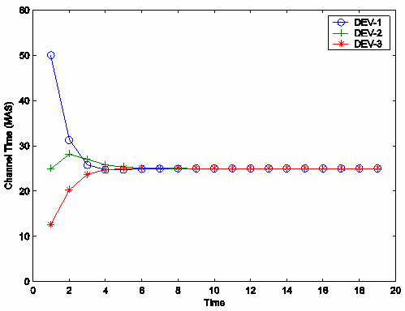
Figure 3. Three devices in a mesh network: 100 MAS and α_{i} = 0.5, ∀_{i}

Figure 4 depicts the effect of α in the distributed resource allocation. If the value of α to 0.25 is reduced then the DEVs converge to their share more quickly as in Figure 4a. If α is increased, however, it takes a longer time for the DEVs to have their stable reservations (Figure 4b). On the other hand, the value of α is related to the total amount of reserved MAS: note in the graphs that the total reservation by the DEVs increases as the value of α goes up, and vise versa.

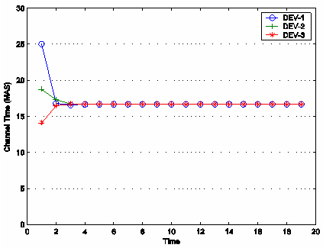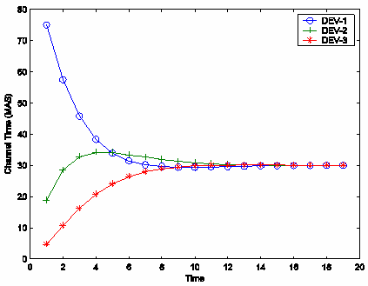
(a) α = 0.25 (b) α = 0.75
Figure 4. Effect of α in the distributed reservation
While the above simulations give a simple fairness to all DEVs, it is possible to differentiate services as in Figure 5. By assigning different values of α to the DEVs, the service classes can be differentiated. There are two DEVs in Figure 5a, whose services are discriminated by α₁ = 0.5 and α₂ = 0.66. Again, they converge to the allocation within 5 superframes. In this case, however, DEV1 reserves 50 MAS while the other occupies only 25 MAS. By adjusting the values of α, the priorities and quality of service classes can be controlled.
Service differentiation can be provided via another way: guaranteeing minimum requirements. Some applications in WPAN may require a minimum amount of time slots in a superframe in order to satisfy their basic performances. Figure 5b shows that our algorithm guarantees those requirements even when different kinds of DEVs exist in a mesh network. There are three DEVs and the minimum requirements are give by m₁ = 30 and m₂ = m₃ = 0. Within 5 superframes, they converge to an equilibrium where DEV1 satisfies its need and the others have an equal share of the channel time.
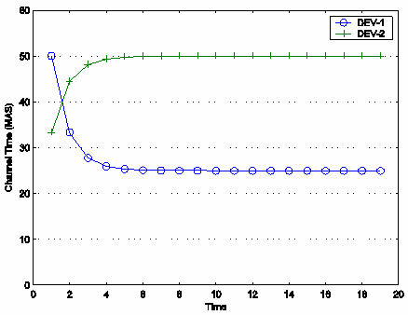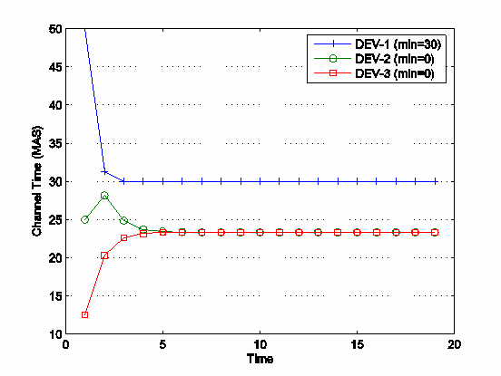
(a) α₁ = 0:5, α₂ = 0:66 (b) m₁ = 30, m₂ = m₃ = 0
Figure 5. Service differentiation by (a) α and (b) minimum requirements
WPAN DEVs may be in a dynamic environment where the DEVs join or leave a mesh network frequently, or even the mesh networks move and meet other mesh networks. Figure 6 depicts that our algorithm quickly converges to a stable state every time a DEV's state is changed. Initially there are three DEVs in the mesh network and their equal share is 25 MAS each with α_{i} = 0.5. After 20 superframes, DEV3 leaves the mesh network and the other two DEVs quickly converge to a new share. At 60 superframes, DEV3 associates again with the mesh network, and they return to their previous reservations. A new DEV joins at 70 superframes, and the four DEVs attain an equilibrium soon.
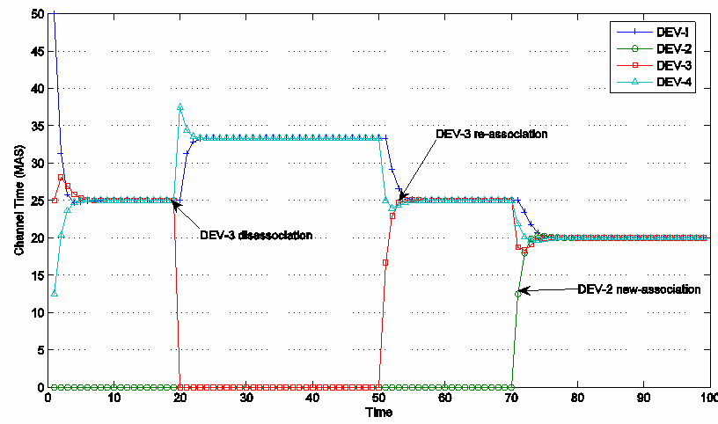
Figure 6. Devices dynamically joining or leaving a group

Annex B Analysis of the Resource Allocation

B.1 Convergence to Equilibrium
Assume that the DEVs in $κ$ independently decide the lengths of time slot reservations in a superframe, and further suppose that they compute their optimal sizes of slots based on the following optimization problem:

$\begin{aligned}\text{maximize }U_{i}(T)\text{, }∀i \\ \text{subject to }m_{i}≤T_{i}≤M_{i},\end{aligned}$ (1)
where $U_{i}$is a real function that is strictly concave with respect to $T_{i}$and has its optimal at

$\underset{T_{i}}{\text{argmax}}U_{i}(T)=α_{i}(C−\sum_{j≠i}{T_{j})}$ (2)
Every DEV in the system of (1) tries to optimize its utility function Ui, and given C and T, the optimal policy of a DEV is always determined by (2). Note that T is known to DEVs through the beacon frames. The modeling and analysis of a system of optimizations, where the users independently decide their optimal policy in order to maximize their utilities in communication networks, has been widely studied in many literatures. One can easily see that the optimization problem given by (1) is a special case of the general bandwidth allocation model investigated in [5]. According to Theorem 2 in [5], which establishes the uniqueness of the Nash equilibrium point [6] in the bandwidth allocation model, (1) also has a unique equilibrium at which point all DEV are satisfied with the allocation: i.e., no DEV can increase its utility without decreasing other DEVs' objectives.
Now consider the convergence of our algorithm. Let T(t) be a K dimensional vector whose components are MAS reservations at a discrete time t. Then the dynamics of the system (1) can be formulated by the following iterative equation:
T(t + 1) = F(T(t)), t = 0, 1, …, (3)
where F is some continuous mapping. DEVs change their reservations iteratively until T converges to the fixed point solution of (3). We adopt the Gauss-Seidel type iteration [11] by which only one component of T can be updated at a time and the most recent information is available. Thus, in this implementation, T(t) and T(t + 1) can be different only in their i^{th} element. Note that, in this system, DEV i obtains information on T(t) from previous beacons, and after computing T_{i} in its beacon slot, broadcasts T(t + 1) where only the i^{th} element is updated from T(t).
The Gauss-Seidel type algorithm can be implemented in two different ways [7]: In a synchronous implementation, DEVs update their reservations in a specified order. On the other hand, there is no pre-specified order in an asynchronous one. The iteration in our system given by (3) corresponds to the asynchronous Gauss-Seidal type, as the DEVs in K may move in and out and may not always active. It has been known that if more than two policy updates are made at the same time, then such iterations may not converge to equilibrium [6]. However, in this scheme, the reservation updates are computed one at a time in a beacon slot, always using the most recent information via the beacons. Therefore, as long as the beacon frames are delivered without an error, the reservations in our system are guaranteed to converge. Now the uniqueness of the equilibrium and convergence to the point can be easily proved for our system from the previous works, and we provide the following result without proof due to the space constraint.
Theorem 1. The equilibrium point of the distributed optimization system given by (1) uniquely exists. Moreover, under the asynchronous Gauss-Seidel scheme as in (3), the reservation vector T(t) converges to the equilibrium vector T* within a finite time.

B.2 Reserved Lengths at the Equilibrium
The analysis in this section shows the time slot allocation T* achieved at the equilibrium. If the sum of reservations at the equilibrium denotes $T∗\sum{T}∗_{i}$, then the MAS length of DEV i ∈ K can be figured out by the theorem below.
Theorem 2. For DEV i ∈ K which is an active member of a mesh network, its time slot size in a superframe is determined at the equilibrium such as
T*_{i} = M_{i} , if M_{i} < TS_{i}
T*_{i} = m_{i} , if m_{i} > TS_{i}
T*_{i} = TS_{i} , otherwise,
where the fixed point TS_{i} is given by
$\text{TS}=\frac{α_{i}}{1−α_{i}}$ (4)
Proof. By the Kuhn-Tucker conditions [12], we have the following conditions for all i at any equilibrium point T* = (T*₁, …, T*_{k}):
$λ_{i}≥0,μ∗_{i}0$ (5)
$λ∗_{i}\left(T∗_{i}−M_{i}\right)=0,μ∗_{i}$ (6)
$−α_{i}C_{i}+T∗_{i}+λ∗_{i}−μ∗_{i}0,$ (7)
Where, λ*_{i} and μ*_{i} are Lagrange multipliers, and C_{i} = C – T_{others}. From (5) and (6), we have the following implications:
λ*_{i} < μ*_{i} => μ*_{i} > 0 => T*_{i} = m_{i}
λ*_{i} > μ*_{i} => λ*_{i} > 0 => T*_{i} = M_{i}
Using the fact that C_{i} –T*_{i} = C – T*, write (7) as
$T∗−\frac{α_{i}}{1−α_{i}}$ (8)
Now let ${\text{TS}}_{i}=\frac{α_{i}}{1−α}$, then from (8) and the above conditions,
M_{i} < TS_{i} => T*_{i} < TS_{i} => λ*_{i} > μ*_{i} => T*_{i} = M_{i}
m_{i} > TS_{i} => T*_{i} < TS_{i} => λ*_{i} < μ*_{i} => T*_{i} = m_{i}
The remaining case T*_{i} = FS_{i} can be easily proved by removing the DEVs of the first two cases and computing the unconstrained equilibrium. The basic idea of the above proof is from [5]; also refer to the references therein for more details. Given α_{i}, C, and DEVs' requirements, the value of TS_{i} is uniquely determined as in Theorem 2. It represents the fair share among the DEVs in a mesh network, and is the solution of the recursive equation (4). Note that the fair share may not be a single value in a mesh network, and each DEV has a different TS_{i} according to its service differentiation factor α_{i}.
One can verify the analytic formula of Theorem 2 by the simulation results of Section 3. In Figure 4, as C = 100 and α_{i} = 0.5 for all i, TS_{i} = 100 - 75 = 25. Also in Figure 6a, α₁ = 0.5 and α₂ = 2/3 gives TS₁ = 100 - 75 = 25 and TS₂ = 2(100 - 75) = 50. Note that, in the two examples, T*_{i} = TS_{i} for all i, as the DEVs are unconstraint. In Figure 6b, however, a DEV's requirement is bounded: while T*₂ = T*₃ = $\text{23}\frac{1}{3}$, T*₁ = m₁ = 30 since m₁ > TS₁ in this case.

References
[1] IEEE P802.15.3 Standard: Wireless Medium Access Control (MAC) and Physical Layer (PHY) Specifications for High Rate Wireless Personal Area Networks (WPANs), Sep. 2003.
[2] IEEE P802.15.3b-2005: Wireless Medium Access Control (MAC) and Physical Layer (PHY) Specifications for High Rate Wireless Personal Area Networks (WPANs), July 2005.
[3] Shao et al, “IEEE P802.15.5 Draft candidate,” IEEE P802.15-06/0237r2, July 2006
[4] H. Shao, “Call for additional contribution for 802.15.5 Mesh Networking,” IEEE P802.15-06/0333r5, July 2006
[5] S. H. Rhee and T. Konstantopoulos, \A decentralized model for virtual path capacity allocation," Proc. IEEE INFOCOM, pp.497-504, 1999.
[6] A. Lazar, A. Orda, and D. Pendarakis, \Virtual path bandwidth allocation in multi-user networks," Proc. IEEE INFOCOM, pp.312-320, 1995.
[7] D. Bertsekas and J. Tsitsiklis, Parallel and Distributed Computation: Numerical Methods, 1989.

