IEEE P802.15

Wireless Personal Area Networks

Project | IEEE P802.15 Working Group for Wireless Personal Area Networks (WPANs)
Title | Adaptation of the France Telecom 60 GHz channel model to the TG3c framework
Date Submitted | [April, 2006]
Source | [Pascal Pagani, Isabelle Siaud, Nadine Malhouroux, Wei Li]  [France Telecom Research and Development Divsion]  [4 rue du Clos Courtel  BP 91226  F-35512 Cesson Sévigné  France] | Voice: [+33 2 99 12 48 72]  E-mail:[pascal.pagani@francetelecom.com]
Re: | []
Abstract | [This contribution proposes adaptations to the 60 GHz channel model proposed by France Telecom to fit the framework defined within the TG3c Channel Modeling sub-group.]
Purpose | [Contribution to IEEE 802.15.3c Channel Modeling sub-group]
Notice | This document has been prepared to assist the IEEE P802.15. It is offered as a basis for discussion and is not binding on the contributing individual(s) or organization(s). The material in this document is subject to change in form and content after further study. The contributor(s) reserve(s) the right to add, amend or withdraw material contained herein.
Release | The contributor acknowledges and accepts that this contribution becomes the property of IEEE and may be made publicly available by P802.15.
- Introduction

In previous documents provided to the IEEE 802.15.3c Channel Modeling sub-group ([1], [2]), France Telecom performed a complete analysis of the 60 GHz channel model based on an extensive set of channel measurements. The analysis covered the residential and office environments, in both Line-of-Sight (LOS) and Non-Line-of-Sight (NLOS) configurations, and used two type of antennas: sectoral, wide beam antennas with 60° to 72° beamwidth, and directive, narrow beam antennas with 10° beamwidth. Additionally, channel models were provided for all identified scenarios in the form of a tapped delay line.

Within the framework of the IEEE 802.15.3c Task Group, the Channel Modeling sub-group agreed on a representation of the channel model in the form introduced by Saleh and Valenzuela in [3]. The purpose of this document is to provide insights on how to include the France Telecom contribution into the IEEE 802.15.3c Task Group framework.

- Measurement scenarios

The measurement scenarios for the channel models proposed by France Telecom in [1] are summarized in Table Table 1. One may note that two typical environments were sounded, namely the residential and the office environment. In addition, for each environment, two types of antennas were used. In scenarios 1, a sectoral, wide beam antenna was used at both ends of the link, while in scenarios 2, one end of the radio link used a directive, narrow beam antenna. More details about the measurement scenarios may be found in [1]. A description of the measurements performed within the IST Magnet Project is available in [4].

Parameter | Scenarios
Parameter | Residential 1  Sectoral ant. | Residential 2  Directive ant. | Office 1  Sectoral ant. | Office 2  Directive ant.
Tx antenna beamwidth | 72° | 72° | 72° | 10°
Rx antenna beamwidth | 60° | 10° | 60° | 60°
Tx antenna gain | 8 dBi | 8 dBi | 8 dBi | 24.6 dBi
Rx antenna gain | 13 dBi | 24.6 dBi | 13 dBi | 13 dBi°
Length of meas. run | 150 mm (30 λ) | 150 mm (30 λ) | 90 mm (18 λ) | 90 mm (18 λ)
Number of CIR per measurement run | 76 (0.4 λ step) | 76 (0.4 λ step) | 60 (0.3 λ step) | 60 (0.3 λ step)
Frequency bandwidth | 1024 MHz | 1024 MHz | 512 MHz | 1024 MHz
Maximum CIR delay | 250 ns | 250 ns | 500 ns | 500 ns
Relative delay resolution | 0.97 ns | 0.97 ns | 1.95 ns | 0.97 ns
- Considered propagation scenarios

- Large scale fading model

The path loss models proposed by France Telecom in [1] were extracted using non-omnidirectional antennas using the following general formula:

- $\text{PL}\left(d\right)=\text{PL}\left(d_{0}\right)+\text{10}⋅n{\text{log}}_{\text{10}}\left(\frac{d}{d_{0}}\right)+S\left(d\right)$
where PL(d₀) is the path loss in dB at d = d₀, n is the environment dependent path loss exponent and S is the lognormal shadowing in dB, with zero mean and standard deviation σ_{S}.

The purpose of using non-omnidirectional antennas was to analyze the impact of the antenna directivity on the path loss parameters. Hence, in the proposed model, the antenna gains G_{Tx} and G_{Rx} were taken into account in the parameter PL(d₀). For each scenario, it is possible to exclude the effect of the particular antenna on PL(d₀) by increasing the proposed value of PL(d₀) by the quantity G_{Tx} + G_{Rx}. In this case, we may consider that both Tx and Rx antennas present a 0 dBi gain. As a result, in budget link analysis, proposers may use their own antenna gain for calculations.

However, for very narrow beam antennas, a limited number of multipath only reach the antenna, and thus the value of n and σ_{S} are impacted. This needs to be reflected in the final channel model. It seems hence sensible to keep two parameters sets (when applicable): one for omni-directional or wide beam antennas, and another for narrow beam antennas. We propose to use the parameter sets in table Table 2.

Parameter | Scenarios
Parameter | Residential |  |  | Office
Parameter | Omni or wide beam antenna |  | Narrow beam antenna | Omni or wide beam antenna
Parameter | LOS | NLOS | LOS | LOS
n | 1.53 | 2.44 | 1.73 | 0.56
PL(d₀) (dB) | 44.5 | 37.2 | 36.9 | 70.6
σ_{S} (dB) | 1.5 | 6.2 | 1.6 | 1.2

- Proposed propagation loss parameters. d₀ = 1 cm.

Note that all configurations could not be modeled due to the lack of suitable experimental data.

- Wideband parameters

  - Reference value for selected wideband parameters

In the analysis for the characterization of the 60 GHz channel Average Power Delay Profile (APDP), FT considered different scenarios, depending on the environment (Residential / Office), on the antenna type (wide beam / narrow beam), and on the visibility (LOS / NLOS), as presented in table Table 1. For each scenario, different wideband selectivity parameters were considered: the delay spread (σ_{τ}), the delay window at 90% (W_{90%}), the delay intervals at 6 dB (I _{6 dB}) and 12 dB (I _{12 dB}), and the coherence bandwidths at 50% (B_{c,50%}) and 90% (B_{c,90%}). The definition of these parameters and their extraction from the measured APDPs is described in [1] and recalled in Annex 1 for reference.

In [1], channel models were provided in the form of a tapped delay line for each considered scenario. These realistic models may serve as a reference in the final channel model document. Tapped delay line models are preferred for their ease of implementation, as the limited number of multiple propagation paths present at 60 GHz does not require a complex description as the one proposed in the Saleh and Valenzuela approach. However, in order to adopt a common framework in the IEEE 802.15.3c Channel Modeling sub-group, we propose to adapt our measurement results as follows.

We first provide typical values obtained for the wideband selectivity parameters corresponding to the selected typical measurement file for each considered scenario. The results are displayed in table Table 3.

Scenario | Link | Wideband parameters
Scenario | Link | σ_{τ}  (ns) | W_{90%}  (ns) | I _{6 dB}  (ns) | I _{12 dB}  (ns) | B_{c,50%}  (MHz) | B_{c,90%}  (MHz)
Residential 1  (wide beam antenna) | LOS | 2.2 | 2.7 | 2.1 | 3.3 | 308 | 95.7
Residential 1  (wide beam antenna) | NLOS | 6.9 | 16.2 | 4.8 | 14.3 | 130 | 23.6
Residential 2  (narrow beam antenna) | LOS | 0.6 | 1.9 | 2.1 | 2.9 | 322 | 126
Residential 2  (narrow beam antenna) | NLOS | 5.4 | 12.2 | 3.6 | 11.4 | 138 | 17.2
Office 1  (wide beam antenna) | LOS | 4.2 | 6.9 | 5.8 | 8.8 | 94.9 | 32.2
Office 1  (wide beam antenna) | NLOS | 4.9 | 6.0 | 5.2 | 7.3 | 120.3 | 37.8
Office 2  (narrow beam antenna) | LOS | 7.4 | 5.3 | 2.1 | 5.5 | 317 | 46.1
Office 2  (narrow beam antenna) | NLOS | 7.7 | 16.7 | 2.4 | 8.0 | 192 | 14.7

- Value of selected wideband parameters for typical measurements in different scenarios.

  - Extraction of decay parameters

To adapt the France Telecom channel model to the Saleh and Valenzuela framework adopted within the IEEE 802.15.3c Channel Modeling sub-group, we propose to extract the inter- and intra-cluster decay exponents, respectively noted Г and γ, and the duration ΔT between clusters, from the typical measurement files statistically selected from the measurement sets for each scenario.

We recall that the decay exponents are defined by the following generic model of the APDP P(τ) [3]:

- $\overline{β_{k,l}^{2}}=\overline{β^{2}\left(0,0\right)}\text{exp}\left(−\frac{T_{l}}{Γ}\right)\text{exp}\left(−\frac{τ_{k,l}}{γ}\right)$

where $\overline{β_{k,l}^{2}}$ represents the average power of the k^{th} ray within the l^{th} cluster, $\overline{β^{2}\left(0,0\right)}$ is a normalizing constant, T_{l} represents the time of arrival of the l^{th} cluster and τ_{k,l} represents the time of arrival of the k^{th} ray within the l^{th} cluster. We defined the number position of clusters by visually inspecting the selected file, and extracted the values of Г and γ using a linear regression technique on the APDP expressed in dB.

We generally observed one or two clusters in the APDP. The observed values of Г, γ, and ΔT are given in Table . Figure Figure 1 to Figure 8 represent the best-fit linear approximation.

Scenario | Link | Power decay parameters
Scenario | Link | Number of observed clusters | γ  (ns) * | Г  (ns) | ΔT  (ns)
Residential 1  (wide beam antenna) | LOS | 2 | 6.7 | 38.9 | 47.9
Residential 1  (wide beam antenna) | NLOS | 2 | 17.0 | 61.7 | 38.1
Residential 2  (narrow beam antenna) | LOS | 1 | 1.8 | NA | NA
Residential 2  (narrow beam antenna) | NLOS | 2 | 8.6 | 36.8 | 31.3
Office 1  (wide beam antenna) | LOS | 2 | 17.3 | 41.7 | 52.7
Office 1  (wide beam antenna) | NLOS | 2 | 21.5 | 47.7 | 39.1
Office 2  (narrow beam antenna) | LOS | 2 | 15.9 | 68.8 | 59.6
Office 2  (narrow beam antenna) | NLOS | 1 | 48.9 | NA | NA

* For files including 2 clusters, the value of γ is an average.

- Value of decay parameters for the typical measurements in different scenarios.

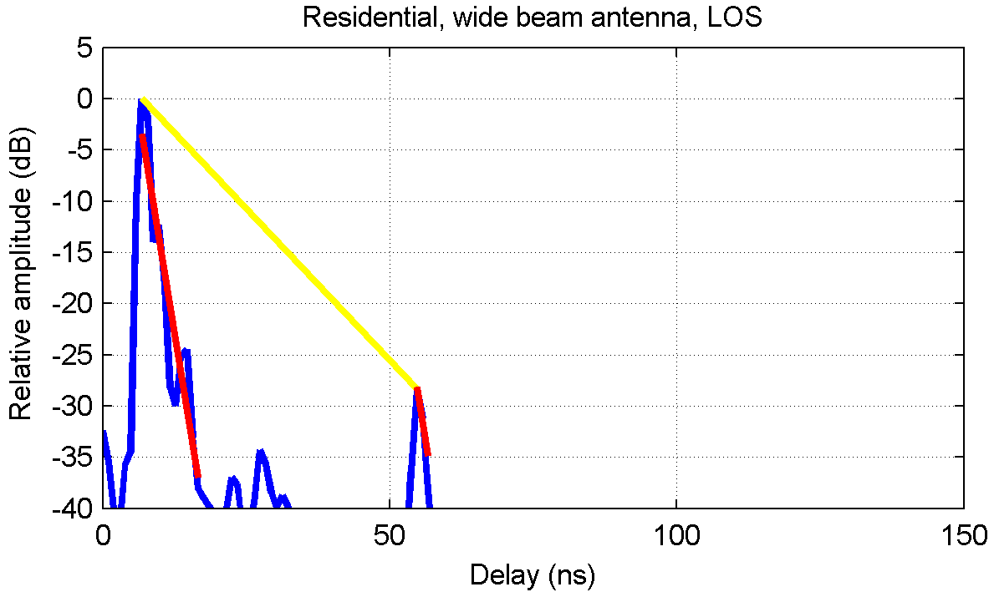
- Decay parameters extraction: Residential 1 (wide beam antenna), LOS.

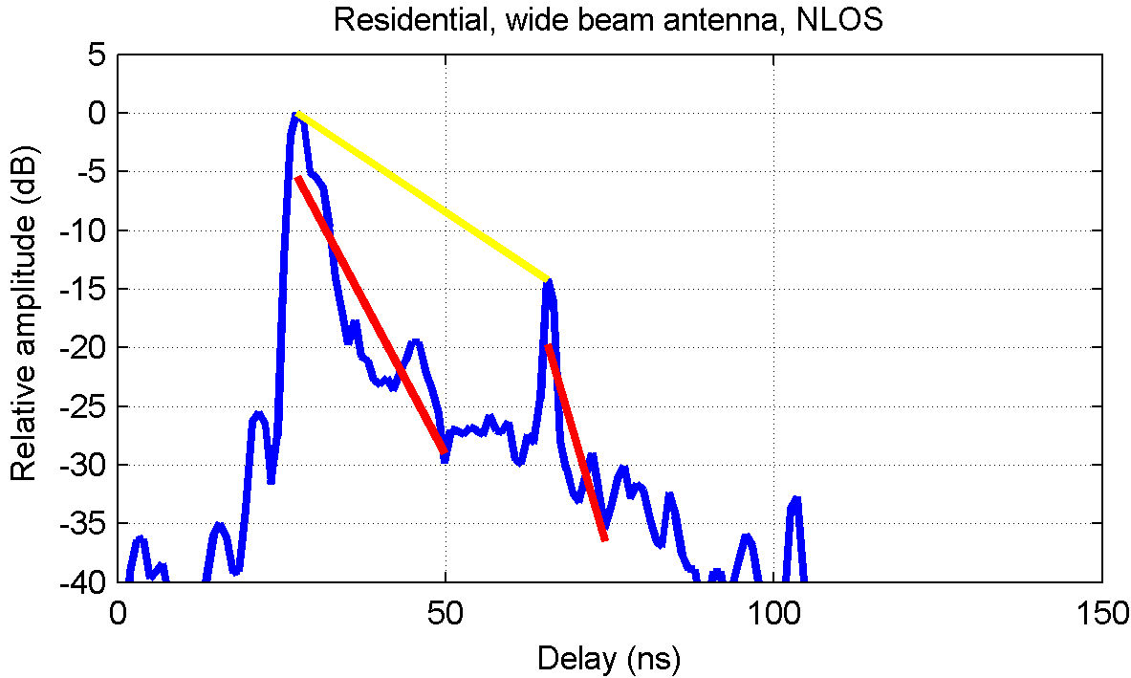
- Decay parameters extraction: Residential 1 (wide beam antenna), NLOS.

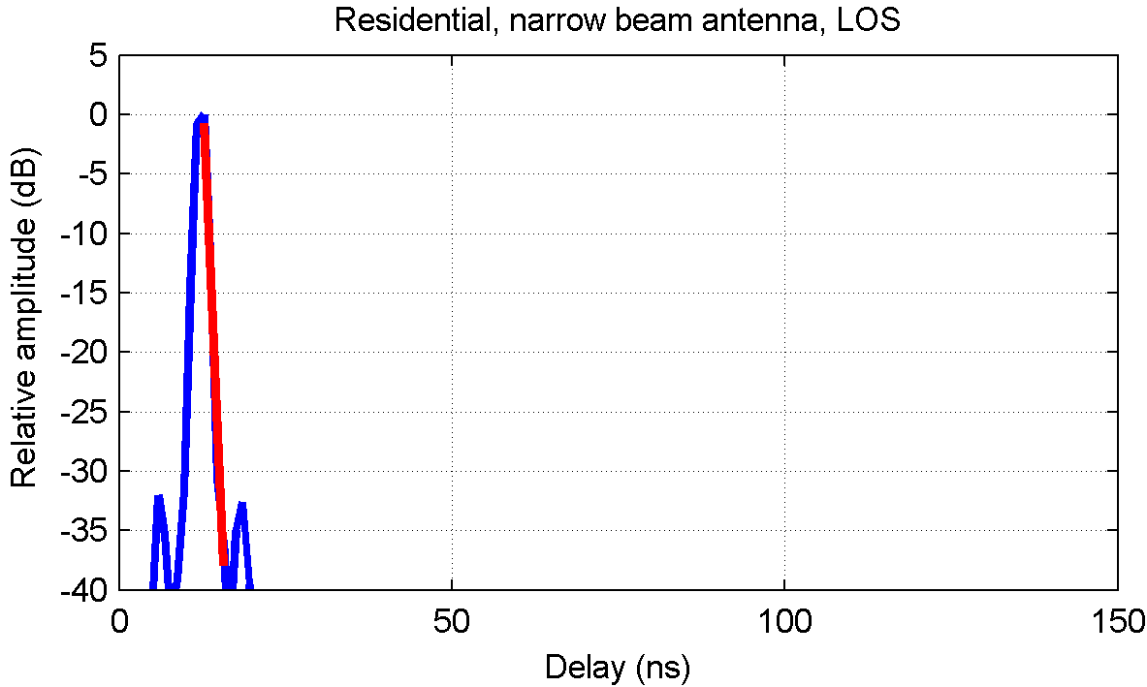
- Decay parameters extraction: Residential 2 (narrow beam antenna), LOS.

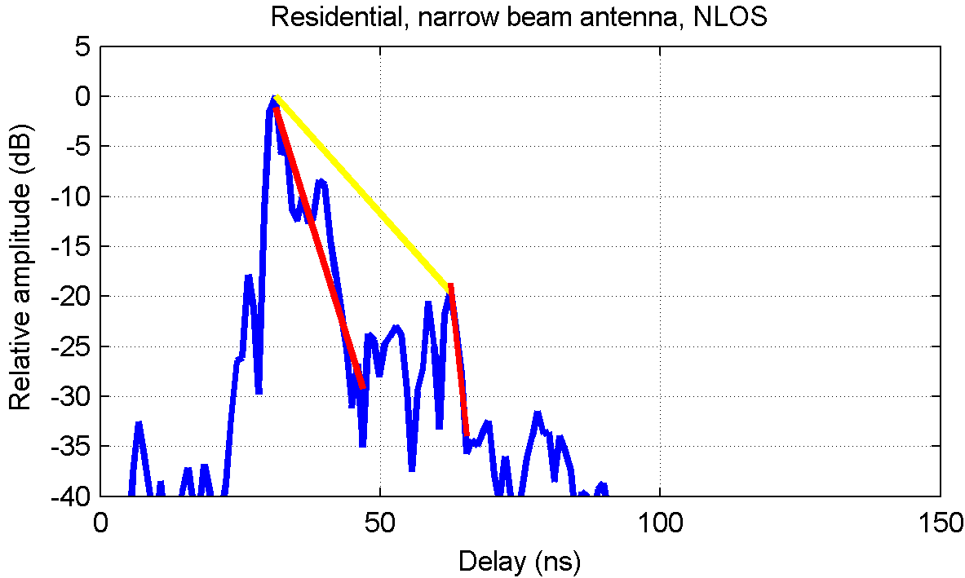
- Decay parameters extraction: Residential 2 (narrow beam antenna), NLOS.

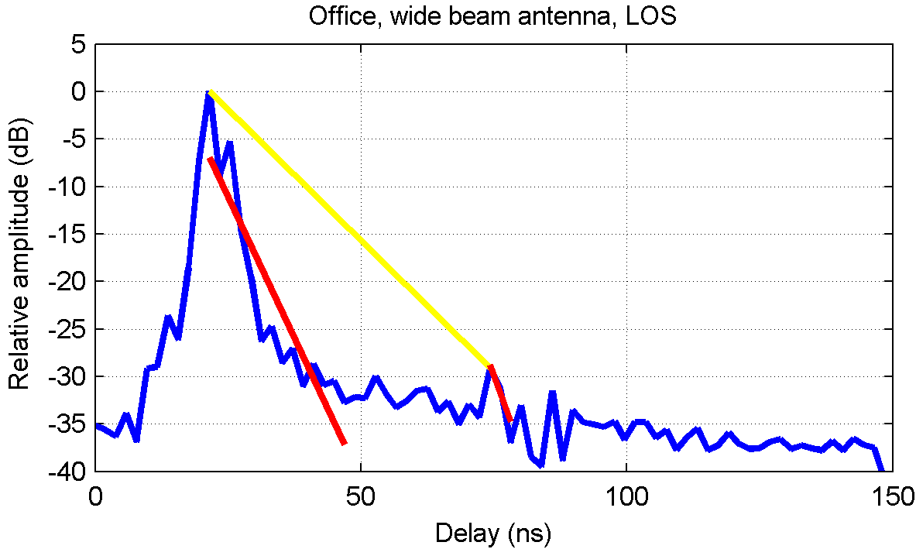
- Decay parameters extraction: Office 1 (wide beam antenna), LOS.

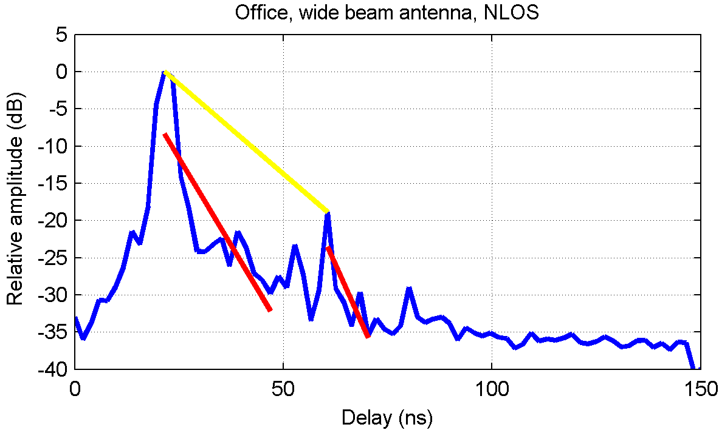
- Decay parameters extraction: Office 1 (wide beam antenna), NLOS.

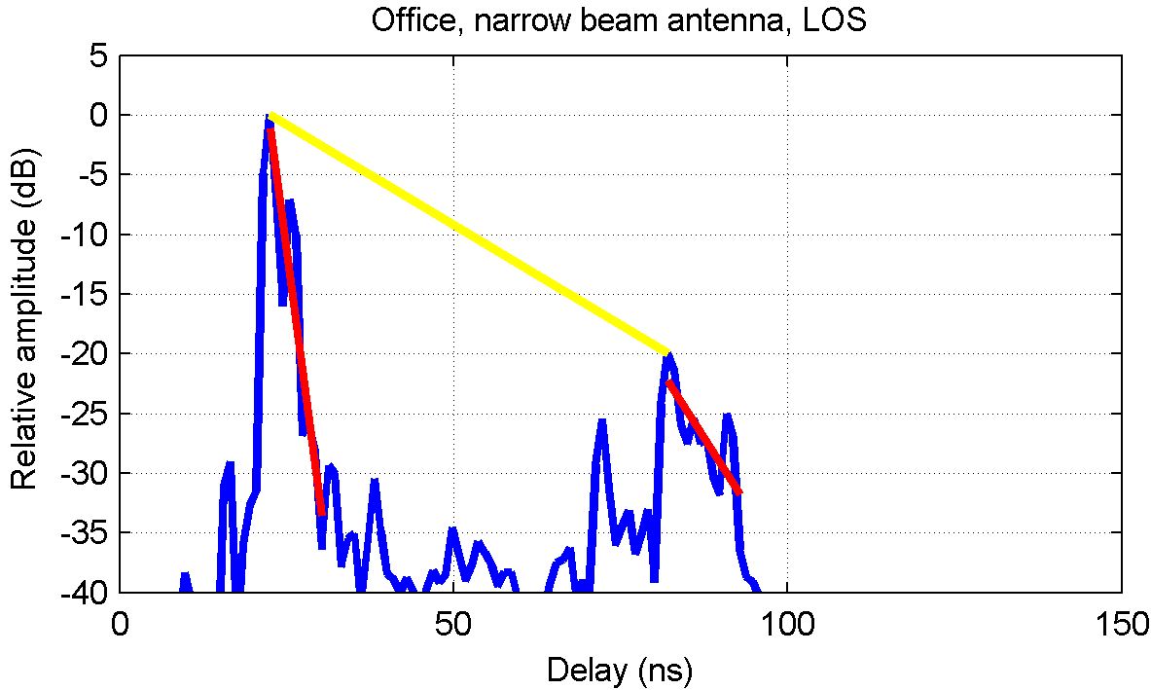
- Decay parameters extraction: Office 2 (narrow beam antenna), LOS.

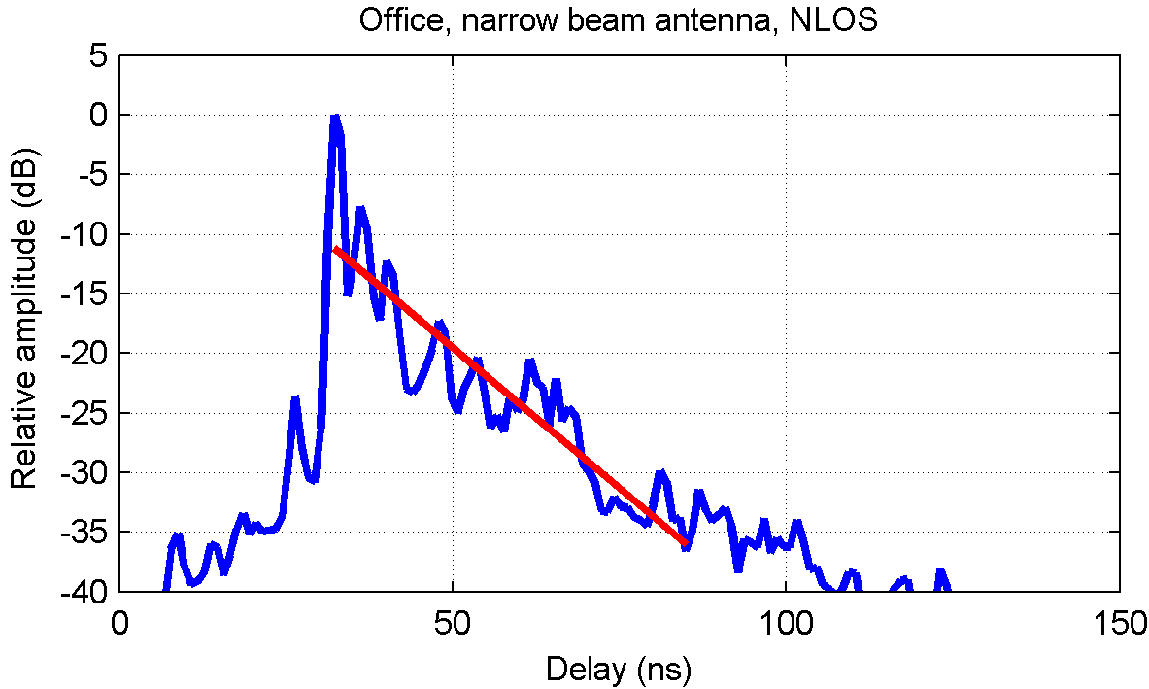
- Decay parameters extraction: Office 2 (narrow beam antenna), NLOS.

- Angle of Arrival (AoA)

This section summarizes the main results from our analysis of the angle of arrival, based on a set of measurements in the office environment [2]. Note that two types of antennas were used during the experiment. Firstly, we used horns presenting a gain of 7.3 dBi and -3 dB beamwidth of 100° in both azimuth and elevation. Secondly, we used dipoles presenting a gain of 5.5 dBi and an omnidirectional radiation pattern in azimuth with a -3 dB beamwidth of 30° in elevation, centered around the elevation of 45°.

In order to collect DoA information, spatial measurements were taken using a virtual array of 10 × 10 sensors at the Rx position, with a 2 mm step. For each measured sensor array, AoA information was extracted using a conventional capon beamforming technique [5]. The resulting function is the Angular Delay Power Spectrum (ADPS) P(θ, φ, τ), giving the distribution of the received power as a function of the elevation angle θ, the azimuth angle φ and the delay τ. Using a Chebyshev window as a weighting function, an angular resolution of 20° may be achieved. By reducing the ADPS to the elevation and azimuth domains, we computed the angular spread in the elevation plane σ_{θ}, and the angular spread in the azimuth plane σ_{φ}. Table Table 5 gives the range of observed median values for the parameters σ_{θ} and σ_{φ}, depending on the antenna configuration.

Parameter | Values
Angular spread in the azimuth plane σ_{φ} | 7° - 24°
Angular spread in the elevation plane σ_{θ} | 6° - 13°

- Range of observed median values for the parameters σ_{θ} and σ_{φ}.

We generally observed that the angular spread in the elevation plane (median value of σ_{θ} near 13°) was smaller than the angular spread in the azimuth plane (median value of σ_{φ} near 23°), revealing that multipath effects mainly affect the AoA in the azimuth plane. In order to propose a 60 GHz channel model with reduced complexity, we thus suggest to limit AoA information to the azimuth plane.

- Doppler

In this section, we provide the Doppler Power Spectrum Density associated to each tapped delay line model selected by France Telecom to describe the scenarios of interest for Office and Residential environments.
Time variations of the channel have to be taken into account in a realistic way in link level simulations. We suggest to introduce a time variability to each cluster and sub-cluster into a Saleh Valenzuela like model in considering the Average Doppler Power Spectrum Density (PSD) of each typical file. The Average Power Spectrum Density results from the integration of the scattering function of the channel R_{s}(ν,τ) upon all echoes. This model is a simplified scattering model P_{s}(ν) where ν is the Doppler frequency.
The propagation channel is described as a 2 dimensional filter depending on 2 independent variables. These variables are either {t,τ} {t,f}{ν,τ}or {ν,f} depending on the available function describing the channel.
- WSSUS channel model

When considering the scattering function of the channel, the relevant variables are the Doppler frequency ν and the relative delay τ. The following equation describes the relationship between the functions S(ν,τ) R_{s}(ν,τ) and P_{s}(ν).

In the case of a tapped delay line implementation, the Doppler impact is simulated as illustrated on the figure below. The Doppler frequency results from a filtering processing of White Gaussian process using the Doppler PSD as follows:

We suggest to extend this implementation to the SV like model since the SV approach is adopted into the IEE802.15.3c group.

The last equation provides relationships between the average Power Delay profile P(τ) and the Average Doppler PSD Ps(ν):

- Doppler Implementation in link level simulations

The Doppler models correspond to the filter gabarit of H_{Doppler}(v). The following figures provide the Doppler models for our different measurement scenarios.
- Doppler filter Residential 1 (wide beam antenna), LOS.

- Doppler filter Residential 1 (Rx wide beam antenna), NLOS.

- Doppler filter Residential 2 (Rx directive beam antenna), LOS.

- Doppler filter Residential 2 (Rx directive beam antenna), NLOS.
- Doppler filter Office 1 (Rx wide beam antenna), LOS.

- Doppler filter Office 1 (Rx wide beam antenna), NLOS.

- Doppler filter Office 2 (Tx directive beam antenna), LOS.

- Doppler filter Office 2 (Tx directive beam antenna), NLOS.

- Conclusion

This document presents an adaptation of the model provided by France Telecom to the IEEE 802.15.3c Channel Modeling sub-group for the 60 GHz propagation channel. Initially, the France Telecom model consisted of a tapped delay line model based on typical measurement files that are statistically representative of the measured data in each identified scenario. The IEEE 802.15.3c Channel Modeling sub-group adopted a representation of the channel model in the form introduced by Saleh and Valenzuela.

In this document, we adapt our large scale fading model to remove the effect of the antennas. The model may be used either for omnidirectional or wide beam antennas. However, we recommend using a specific set of parameters if narrow beam antennas are used.
Regarding wideband parameters, we provide reference values for a number of selected parameters for each considered scenario. We also extracted the inter- and intra-cluster decay exponents and the duration between clusters from the typical measurement files statistically selected from the measurement sets for each scenario.
The AoA issue was addressed by providing the range of azimuth and elevation angular spread observed during our experiments. We recommend using the azimuth AoA only for a model presenting a reduced complexity.
Finally, we provide the Average Doppler Power spectra corresponding to the typical measurement files in each scenario. This approach is a simplified scattering function model where all paths and clusters are affected with same Doppler. These Doppler spectra may be used to generate coherent temporal variability for the system simulations according to the tapped delay line implementation in link level simulations.

- References

- Pagani, P., Malhouroux, N., Siaud, I., and Guillet, V., "Characterization and modeling of the 60 GHz indoor channel in the office and residential environments", IEEE P802.15 Working Group for WPANs, no. IEEE P802.15-06/0027r3, March 2006.
- Pagani, P., Malhouroux, N., Siaud, I., and Guillet, V., "Analysis of the angular characteristics in the 60 GHz indoor propagation channel", IEEE P802.15 Working Group for WPANs, no. IEEE P802.15-06/0028r2, January 2006.
- Saleh, A.A.M. & Valenzuela, R.A., "A Statistical Model for Indoor Multipath Propagation", IEEE Journal on Selected Areas in Communications, vol. 5, no. 2, pp. 128-137, Feb. 1987.
- N. Malhouroux, I. Siaud,V. Guillet, "PAN–PD/FD Channel Characterisation and SISO modelling at 17 and 60 GHz (Part I)" MAGNET D3.1.2a Deliverable, December 2004.
- Van Veen, B.D. & Buckley, K.M., "Beamforming: a versatile approach to spatial filtering", IEEE Acoustic Speech and Signal Processing Magazine, vol. 5, no. 2, pp. 4-24, April 1988.

Annex 1 - Definition of wideband parameters

At each measurement location, a number N = 76 Channel Impulse Responses h_{n}(τ) were collected along a linear rail. From this measurement set, an Average Power Delay Profile (APDP) P(τ) is computed as follows:

- $P\left(τ\right)=\frac{1}{N}\sum_{n=1}^{N}{{\left|h_{n}\left(τ\right)\right|}^{2}}$

The delay spread σ_{τ} represents the delay dispersion in the APDP and is computed as follows:

- $σ_{τ}=\sqrt{\frac{\int{P\left(τ\right)τ^{2}dτ}}{\int{P\left(τ\right)dτ}}−{\left(\frac{\int{P\left(τ\right)τdτ}}{\int{P\left(τ\right)dτ}}\right)}^{2}}$

The coherence bandwidth B_{c} characterizes the correlation between different frequencies in the Channel Transfer Function. More specifically, the n% coherence bandwidth B_{c,n%} corresponds to the required frequency spacing that provides a statistical correlation coefficient equal to n%:

- $B_{c,n\text{\%}}=\text{min}\left\{Ω:\left|\frac{R\left(Ω\right)}{R\left(0\right)}\right|=\frac{n}{\text{100}}\right\}$
where the frequency correlation function R(Ω) is the Fourier transform of the APDP P(τ). We generally use thresholds of 50% and 90%.

The delay window at q% is the duration of the central part of the APDP containing q% of the total energy. Using the delays defined on figure Figure 19, the delay window is given by:

- $W_{q\text{\%}}=τ_{4}−τ_{2}$,
where the delays τ₂ and τ₄ are given by:

- $\int_{τ2}^{τ4}{P\left(τ\right)}dτ=\frac{q}{\text{100}}\int_{τ0}^{τ5}{P\left(τ\right)}dτ$,
and the energy situated outside the window is divided into two equal parts. Delays τ₀ and τ₅ are the delays for which the signal crosses a given noise threshold.

The delay interval at p dB is the difference between the delay at which the function P(τ) crosses for the last time a given threshold situated p dB below its maximum, and the delay at which it crosses the threshold for the first time. Following the notations given in figure Figure 19, the delay interval is given by:

- $I_{p}=τ_{3}−τ_{1}$,

The delay window at q% is the duration of the central part of the APDP containing q% of the total energy. Using the delays defined on figure 1, the delay window is given by:

- $W_{q\text{\%}}=τ_{4}−τ_{2}$,
where the delays τ₂ and τ₄ are given by:

- $\int_{τ2}^{τ4}{P\left(τ\right)}dτ=\frac{q}{\text{100}}\int_{τ0}^{τ5}{P\left(τ\right)}dτ$,
and the energy situated outside the window is divided into two equal parts. Delays τ₀ and τ₅ are the delays for which the signal crosses a given noise threshold.

- APDP illustrating the delay window and the delay interval (Parsons, "The Mobile Radio Propagation Channel", Wiley, 2000).

