IEEE P802.15
Wireless Personal Area Networks

Project | IEEE P802.15 Working Group for Wireless Personal Area Networks (WPANs)
Title | IMST data processing methodology
Date Submitted | [5 April 2006]
Source | [Alexi Davydov, Intel]  [Alexander Maltsev, Intel]  [Ali Sadri, Intel] | [alexei.davydov@intel.com]  [alexander.maltsev@intel.com]  [ali.s.sadri@intel.com]
Re: | []
Abstract | []
Purpose | []
Notice | This document has been prepared to assist the IEEE P802.15. It is offered as a basis for discussion and is not binding on the contributing individual(s) or organization(s). The material in this document is subject to change in form and content after further study. The contributor(s) reserve(s) the right to add, amend or withdraw material contained herein.
Release | The contributor acknowledges and accepts that this contribution becomes the property of IEEE and may be made publicly available by P802.15.

IMST data processing methodology
A. Davydov, A. Maltsev, A. Sadri
Intel, 2006

Scope
This document contains a brief description of the IMST data processing methodology used for time-angular parameters extraction. High level overview and the comparison of different direction of arrival estimation algorithms are given in application to IMST data analysis.

Data processing methodology
The IMST measurements of a millimeter wave channel were performed in frequency domain using a vector network analyzer in 960 MHz bandwidth with 2.4 MHz frequency step resulting to maximum time-domain resolution of ~1ns. The channel measurements were performed in different placements of the receive antenna. In each placement the antenna was moved along straight line over 501 positions with 1 mm step thus forming the virtual Uniform Linear Array (ULA) suitable for direction of arrival data analysis.
At the first step the measured frequency domain data were converted to time domain using IFFT procedure. The Blackman-Harris window was applied to frequency domain data to suppress leaking of energy from one path ray to the next one in time-domain. Note that depending on the window function shape the windowing procedure may reduce time domain resolution provided by experiment, but at the same time significantly improve the process of ray identification. The parameters of the Blackman-Harris windows used in IMST data processing are listed in table 1.

Table 1. Parameters of window functions
Blackman-Harris window | Side lobe level | 3 dB bandwidth (bins)
3-term window | -61 dB | 1.56
4-term window | -92 dB | 1.90

After collecting the impulse responses at the antenna elements of the virtual ULA the angular parameters were extracted independently for each time delay interval. It should be noted that the signal envelope delay associated with different angles of arrivals for considered aperture (about 0.5m) of the virtual ULA was less than or about time-domain resolution provided by the experiment (see Table 1). Figure 1 illustrates signal envelope delay effect for the worst case scenario when angle of arrival of direct path has maximum value (about 70⁰). It can be seen that the time arrival difference for line-of-sight component for edge elements (sensor #1 and sensor 501) of the virtual ULA is about 1ns only.

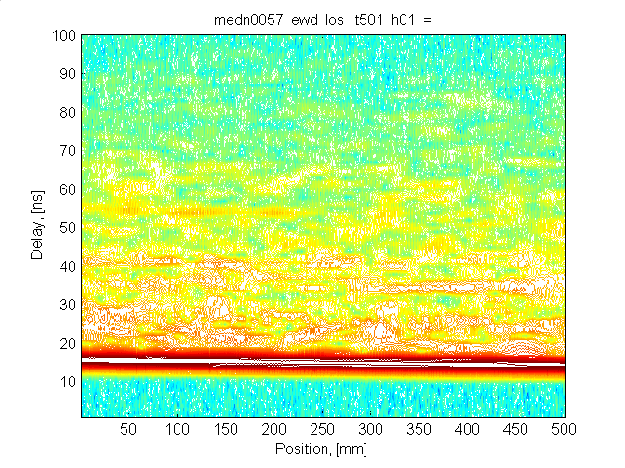
Figure 1.

For the angular measurements of the IMST data several direction of arrivals estimation methods were used (such as Fourier, Capons, MUSIC). For convenience in the next sections we provide some details and comparison of the used procedures in the scope of IMST data analysis.

Fourier angular analysis
Fourier analysis is the classical method of the angle power spectral and direction of arrival estimation. This approach is one of the simplest and robust ways for angular spectrum analysis. Fourier method estimates the direction of arrivals by calculating the ULA response with $N$ sensors and antenna spacing $d$ steered to the direction $θ$

$r\left(θ,t\right)=\sum_{n=1}^{N}{y(n,t)}\text{exp}(j\frac{2π d\text{cos}θ}{λ}n)$, (1)

where $y(n,t)$ narrowband signal received at $n^{\text{th}}$ element and $λ$ is signal wavelength. It can be seen that $r\left(θ,t\right)$ may be considered as a received spatial signal Fourier transform for the spatial frequency $s(θ)=\frac{2π}{λ}\text{cos}θ$ corresponding to the beam pointed to angle $θ$. In practice the last expression can be efficiently computed with FFT procedures for the discrete set of spatial frequencies $s_{m}=\left\{\frac{2π}{\text{Nd}}m, m=0,\text{.}\text{.}\text{.},N−1\right\}$ resulting to the grid of beam pointing angles $θ_{m}=\left\{\text{arccos}\frac{λ}{\text{Nd}}m, m=0,\text{.}\text{.}\text{.},K−1\right\}$ and $θ_{m}=\left\{\text{arccos}\frac{λ}{\text{Nd}}(m−N), m=N−K+1,\text{.}\text{.}\text{.},N−1\right\}$, where $λ$ is wavelength and $K=\left\lfloor \frac{\text{Nd}}{λ}\right\rfloor$. It can be seen that the maximum resolution provided by Fourier method for the ULA with $N$ antenna elements and antenna spacing $d$ is $Δθ=\frac{λ}{\text{Nd}}$ or for IMST data it is about $Δθ=0\text{.}{\text{57}}^{0}$! In multipath scenarios to reduce leakage problem due to multiple signals arriving from different directions prior to Fourier transform spatial windowing function may be applied. As for frequency domain windowing this procedure reduces angle resolution, but improves the process of rays identification arriving from different directions.

Figure 2. Example of Fourier method application for direction of arrival estimation for IMST data

Fig. 2 illustrates time-angular power spectrum of the IMST data obtained with Fourier method for one of the LOS scenarios.

Capon angular analysis
Another way of analyzing angular spectrum of signals relies on an estimation of the signal spatial covariance matrix. One of the popular approaches is Capon method that minimizes output mean beam power subject to unity constraint in the look direction [1]. For given spatial covariance matrix $R_{y}$ this optimization problem can be formulated mathematically as

$\left\{\begin{matrix}w{\left(θ\right)}^{H}R_{y}w\left(θ\right)→\underset{w}{\text{min}} \\ u(θ)^{H}w=1\end{matrix}\right.$, (2)

here $u\left(θ\right)$ - signal response vector of the unit plane wave incident on antenna array at angle $θ$.
The beam steering vector satisfying (2) can be found explicitly

$w_{C}\left(θ\right)=\frac{R_{y}^{−1}u(θ)}{u(θ)^{H}R_{y}^{−1}u(θ)}$. (3)

The Capon angular spectrum has a dimension of power and equals [1]

$P_{C}\left(θ\right)=\frac{1}{u{\left(θ\right)}^{H}R_{y}^{−1}u\left(θ\right)}$. (4)

Figure 3. Example of Capon method application for direction of arrival estimation for IMST data

Fig. 3 illustrates time-angular power spectrum of the IMST data obtained with Capon method for the same LOS scenario as in Fig. 2. Note that Capon method gives the similar structure of time-angular spectrum for strong rays as Fourier method, but reduces the level of background component.

MUSIC angular analysis
MUSIC (Multiple Signal Classification) method is based on examining the structure of the signal spatial covariance matrix and further decomposition of the observation space into signal and noise subspaces. The steering vectors associated with direction of arrivals are selected to be as orthogonal to noise subspace as possible. This is equivalent to searching of certain amount of peaks in MUSIC spectrum [1]

$P_{M}\left(θ\right)=\frac{1}{u(θ)^{H}U_{n}U_{n}^{H}u(θ)}$, (7)

where $U_{n}$ - noise subspace eigenvectors matrix. Note that the pseudo-spectrum given by equation (7) is not true power spectrum and is used only for angle of arrivals estimation of plane impinging waves. Once the direction of arrival has been found (as angles that give the maximum values to MUSIC spectrum (7)) the signal power associated with these angles can be found using, for example, least-squares method. It should be noted that MUSIC method requires initial estimation of number of impinging waves to split space into signal and noise subspaces. For IMST data analysis we used minimum description length method [2] to estimate the number of incident rays.

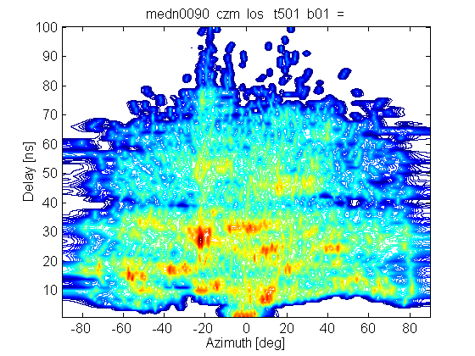

Figure 4. Example of MUSIC method application for direction of arrival estimation for IMST data

Fig. 4 illustrates time-angular spectrum of the IMST data obtained with MUSIC method for the same LOS scenario as in Fig. 2, 3.

Methodology of spatial covariance matrix estimation in Capon and MUSIC methods
For application of Capon and MUSIC methods it is necessary to estimate the spatial covariance matrix of the incident signals with rather high accuracy. However in most situations there are only a limited or even single number of signals snapshots available to estimate the correlation matrix. Moreover both of the methods fail in coherent environment when signals arrived from different directions are strongly correlated. For IMST data analysis we have had exactly this situation.
To improve the covariance matrix estimate in this case different preprocessing techniques may be applied [3]. We used the well known forward/backward spatial smoothing (averaging) technique. For this technique the original virtual ULA is subdivided into several overlapping subarrays with reduced aperture and the spatial covariance matrix estimate is obtained by averaging the spatial subarray covariance matrices (see Fig. 5 for illustration).

Figure. 5 Illustration of spatial smoothing procedure for estimation of the spatial correlation matrix

Mathematically the forward averaging process can be represented as

$R_{y}^{f}=\frac{1}{N−M+1}\sum_{i=1}^{N−M+1}{R_{y}\left(i\right)}$ (8)

where $R_{y}\left(i\right)=y_{f}(i)y_{f}(i)^{H}$ is the subarray spatial covariance matrix, $M$ number of elements in a subarray and $y_{f}(i)=[y\left(i\right),y\left(i+1\right),\text{.}\text{.}\text{.}y\left(i+M−1\right)]^{T}$ is the signal vector received by the i^{th} subarray.
The forward/backward spatial smoothed signal covariance matrix can be calculated as follows

$R_{y}^{\text{fb}}=\frac{1}{2}(R_{y}^{f}+J(R_{y}^{f})^{}J)$ (9)

where $J$ is a reflection matrix, with all its elements along the secondary diagonal equal to unity and elsewhere equal to zero.
Selection of the main spatial smoothing parameter such as a number of elements $M$ in subarrays should be based on the maximum number of recognized signals and the required resolution angle. In case of IMST data analysis we used subarays with $M=\text{150}$ elements that practically gives good tradeoff between angle resolution capabilities and maximum number of resolvable signal sources.

References
[1] H. Krim and M. Viberg, “Two decades of array signal processing research,” IEEE Signal Processing Mag., pp. 67-94, vol. 13, no. 4, July 1996.
[2] M. Wax, T. Kailath, “Detection of signals by information theoretic criteria”, IEEE Transaction Acoustic Speech Signal Processing, vol. ASSP-33, 1985
[3] L. C. Godara, “Application of antenna arrays to mobile communications, part II: beamforming and direction of arrival considerations”, Proceedings of the IEEE, Vol. 85, No. 8, August 1997

