IEEE P802.15
Wireless Personal Area Networks

Project | IEEE P802.15 Working Group for Wireless Personal Area Networks (WPANs)
Title | TG4a Coexistence Assurance
Date Submitted | [7 Mar, 2006]
Source | [Matt Welborn]  [Freescale]  [1595 Springhill Rd]  [Vienna, VA 22180] | Voice: [+1 703 269 3000]  Fax: [ ]  E-mail: []
Re: | [19-05-0028-00-0000-Estimation-of-PER-caused-by-Interference.doc and 19-05-0012-00-0000-Coexistence-Methodologies.ppt]
Abstract | [This Coexistence Assurance Document is being provided by the IEEE 802.15.4a Task Group to satisfy the requirements of the IEEE 802.19 Task Group.]
Purpose | []
Notice | This document has been prepared to assist the IEEE P802.15. It is offered as a basis for discussion and is not binding on the contributing individual(s) or organization(s). The material in this document is subject to change in form and content after further study. The contributor(s) reserve(s) the right to add, amend or withdraw material contained herein.
Release | The contributor acknowledges and accepts that this contribution becomes the property of IEEE and may be made publicly available by P802.15.

Table of Contents
1 Context and Introduction 3
2 Overview of IEEE 802.15.4b Task Group 3
3 General Coexistence Issues 4
3.1 ED, LQI and CCA 4
3.2 Spread Spectrum Modulation 5
3.3 Low Duty Cycle 5
3.4 Low Transmit Power 5
3.5 Dynamic Channel Selection 6
3.6 Coordinated Piconet Capabilities 6
4 Coexistence Assurance: Methodology and Assumptions 6
4.1 Victims and Assailants 7
4.2 Bandwidth 7
4.3 Path Loss Model 7
4.4 Temporal Model 8
5 Coexistence Assurance: Parameters and Results 9
5.1 868MHz BPSK (“2003 legacy”) 9
5.2 868MHz O-QPSK (“COBI”) 10
5.3 868MHz PSSS 12
5.4 915MHz BPSK (“2003 legacy”) 13
5.5 915MHz O-QPSK (“COBI”) 14
5.6 915MHz PSSS 16
6 References 17

Context and Introduction
As part of its charter, the IEEE 802.15.4a Task Group is developing new PHYs that operate in the designated UWB frequency bands between 3.1 and 10.6 GHz and form 250 to 750 MHz. Additionally, there will be a new PHY that operates in the 2400 MHz ISM unlicensed bands. To assure that these PHYs will provide reasonable performance when operating in the vicinity of other wireless devices, the 15.4a Task Group has adopted the policies and conventions of the IEEE 802.19 Coexistence Technical Advisory Group (TAG).
The IEEE 802.19 TAG has mandated that new wireless standards developed under IEEE 802 be accompanied by a “Coexistence Assurance” document. Documents [1] and [2] provide guidelines for how coexistence can be quantified based on predicted packet error rates among IEEE 802 wireless devices.
This Coexistence Assurance Document is being provided by the IEEE 802.15.4a Task Group to satisfy the requirements of the IEEE 802.19 Task Group. The rest of this document proceeds as follows:
Section 2 of this document provides an overview of IEEE 802.15.4 with a brief description of each of the PHYs defined in the TG4a draft standard.
Section 3 describes the mechanisms and anticipated usage of IEEE 802.15.4 (as amended by the Task Group 4a) that enhance its coexistence with other wireless devices.
Section 4 introduces the Coexistence Methodology described in [1] and [2], and details the overall assumptions made for the Methodology.
Section 5 provides the specific parameters for each of the PHYs defined in the TG4a draft standards, and shows the quantified results of the Coexistence Methodology for each PHY.

Overview of IEEE 802.15.4a Task Group
The standard for IEEE 802.15.4 [4], ratified in the spring of 2003, defines a “low-rate wireless PAN”, designed for price- and power-sensitive applications. It defined three PHYs with distinct modulation schemes:
- O-QPSK operating in the 2.4GHz ISM band, with an effective bit rate of 250 kb/s.
- BPSK operating in the 868MHz ISM (Europe) band, with an effective bit rate of 20 kb/s.
- BPSK operating in the 915MHz ISM (North America) band, with an effective bit rate of 40 kb/s.
Task Group 4b (TG4b) was formed to revise the original IEEE 802.15.4-2003 standard. Among the other work defined in the PAR, the group was given the charter to create new PHYs operating in the sub-GHz bands with improved performance. In response to this, the group has defined additional PHYs:
- O-QPSK operating in the 868MHz ISM (Europe) band, with an effective bit rate of 100 kb/s.
- O-QPSK operating in the 915MHz ISM (North America) band, with an effective bit rate of 250 kb/s.
- A form of ASK (“PSSS”) operating in the 868MHz ISM (Europe) band, with an effective bit rate of 250 kb/s.
- PSSS operating in the 915MHz ISM (North America) band, with an effective bit rate of 250 kb/s.
Subsequently, Task Group 4a was formed to build up further revise the original IEEE 802.15.4-2003 standard and the group was given the charter to create new PHYs that would provide more robust performance and also provide the capability for precision range measurements. In response to this, the group has defined additional PHYs:

- A form of combined BPSK and PPM that operates in 3 different band groups from 250 to 750 MHz, from 3100 to 4800 MHz, and from 6000 to 10,600 MHz (the “UWB PHY”) with a nominal effective bit rate of 851 kb/s.
- Chirp spread spectrum (CSS) operating in the ISM band from 2400 to 2481 MHz with an effective bit rate of [X] kb/s.

Two fundamental design goals of IEEE 802.15.4 are low cost and low power. Low cost is achieved through simple demodulation schemes, low bit rates and low transmitter power, typically under -10 dBm for the UWB PHY and X dBm for the CSS PHY. Low power is achieved through low duty cycle operation.

General Coexistence Issues for the UWB PHY
IEEE STD 802.15.4 provides several mechanisms that enhance coexistence with other wireless devices operating at 868 MHz and between 902 MHz and 928 MHz (the “sub-GHz”) band. This section describes the mechanisms that are defined in the standard, which include:
- UWB modulation with extremely low power spectral density (PSD)
- Low duty cycle
- Low transmit power
- Dynamic Channel Selection
- Coordinated Piconet Capabilities
These mechanisms are each described briefly in the subsequent sub-sections.

ED, LQI and CCA
The Energy Detect (ED), Link Quality Indication (LQI) and Clear Channel Assessment (CCA) mechanisms defined in IEEE 802.15.4 reduce the chance that a device will accidentally interfere with other network traffic, and also can help a device avoid interference.
To reduce the chance that a device will interfere with other network traffic, IEEE 802.15.4 PHYs provide the capability to perform CCA in its CSMA-CA mechanism (see IEEE Std 802.15.4-2003 6.7.9). The PHYs require at least one of the following three CCA methods: ED (Energy Detection) over a certain threshold, detection of a signal with IEEE 802.15.4 characteristics, or a combination of these methods. Use of the ED option improves coexistence by allowing transmission backoff if the channel is occupied by any device, regardless of the communication protocol it may use.
In order to avoid interference, the IEEE 802.15.4 PHYs include two measurement functions that indicate the level of interference within an IEEE 802.15.4 channel. The receiver ED measurement (see IEEE Std 802.15.4-2003 6.7.7) is an estimate of the received signal power within an IEEE 802.15.4 channel and is intended for use as part of a channel selection algorithm at the network layer. The LQI (see IEEE Std 802.15.4-2003 6.7.8) measures the received energy level and/or SNR for each received packet. When energy level and SNR information are combined, they can indicate whether a corrupt packet resulted from low signal strength or from high signal strength plus interference.

Direct Sequence Ultra-Wideband Modulation
The UWB PHY specified for IEEE STD 802.15.4a uses a UWB direct sequence modulation. These power-efficient modulation methods achieve low signal-to-noise ratio (SNR) and signal-to-interference ratio (SIR) requirements at the expense of a signal bandwidth that is significantly larger than the symbol rate. A defining feature of systems that use UWB modulation is that they are less likely to cause interference in other devices due to their reduced power spectral density. In fact, even the least restrictive regulations for UWB devices today require the emission PSD to be at or below the levels allowed for unintentional emissions by other electrical or electronic devices. In some cases the UWB PSD limits are as much as 35 dB below these same unintentional emissions limits. For the same reason, UWB devices have some degree of immunity from interfering emitters, making them a good choice for environments where coexistence is an issue.

Low Duty Cycle
The specifications of IEEE STD 802.15.4-2003 are tailored for applications with low power and low data rates (a maximum mandatory rate of 850 kb/s and down to 20 kb/s). Typical applications for IEEE 802.15.4 devices are anticipated to run with low duty cycles (under 5%). This will make IEEE 802.15.4 devices less likely to cause interference to other standards.
An important contribution of the TG4a work is definition of new PHYs with higher bits rates. In the UWB bands, the data rates have been increased to a nominal mandatory 850 kb/s. Although not designed to provide continuous higher throughputs, the UWB PHY also provides for higher optional data rates as high as 27 Mb/s. These rates are not designed to support high rate applications such video transport, but instead are provided to allow devices in close proximity to shorten their transmission duty cycle by as much as a factor of 32 relative to the mandatory rate, further reducing the likelihood that these devices will interfere with or be subject to interference by other devices.

Low Transmit Power

868MHz (Europe) band
Regulations defined by [6] and [7] limit transmitter power in the 868MHz to 25mW (13.9dBm) maximum. Although devices conforming to IEEE Std 802.15.4-2003 may transmit at this power, the economics of system-on-chip designs will limit the transmit power to around 10 dBm. At the low end, all confirming devices must be capable of at least –3 dBm transmit power. At this power, the transmit power represents a small fraction of the overall power consumed by the device, so there is no significant energy savings for operating below this level. However, the standard does encourage operating with lower power, when possible, in order to minimize interference (see Std-15.4-2003 section 6.7.5).
Consequently, it is reasonable to assume that all 868 MHz devices will transmit at a power between –3 dBm and +10 dBm.

915MHz (North American) band
Regulations defined by [8] limit transmitter power in the 868MHz to 1000mW (30 dBm) maximum. Although devices conforming to IEEE Std 802.15.4-2003 may transmit at this power, the economics of system-on-chip designs will limit the transmit power to around 10 dBm. At the low end, all confirming devices must be capable of at least –3 dBm transmit power. At this power, the transmit power represents a small fraction of the overall power consumed by the device, so there is no significant energy savings for operating below this level. However, the standard does encourage operating with lower power, when possible, in order to minimize interference (see Std-15.4-2003 section 6.7.5).
Consequently, it is reasonable to assume that all 915 MHz devices will transmit at a power between –3 dBm and +10 dBm.

Dynamic Channel Selection
When performing dynamic channel selection, either at network initialization or in response to an outage, a UWB IEEE 802.15.4 device will scan a set of channels specified by the ChannelList parameter. For UWB IEEE 802.15.4 networks that are installed in areas known to have spectrum restrictions, the ChannelList parameter can be defined as the above sets in order to enhance the coexistence of the networks.

Coordinated Piconet Capabilities
Interoperability with other systems is beyond the scope of IEEE STD 802.15.4-2003. However, certain schemes may be envisaged for this purpose, for example, the PAN coordinator can coordinate the timing of its PAN with other systems. This type of neighbor piconet support capability may further alleviate interference with other systems.

Coexistence Assurance: Methodology and Assumptions
In order to quantify the coexistence performance of the 802.14.4a UWB PHY, we have adopted the techniques described in [1], “Estimating Packet Error Rate Caused by Interference – A Coexistence Assurance Methodology”.
The Coexistence Assurance Methodology predicts the Packet Error Rate (PER) of an Affected Wireless Network (AWN, or victim) in the presence of an Interfering Wireless Network (IWN, or assailant). It its simplest form, the methodology assumes an AWN and an IWN each composed of a single transmitter and a receiver. The methodology takes as input a path loss model, a bit error rate function for the AWN, and predicted temporal models for packets generated by the AWN and for “pulses”, i.e. packets generated by the IWN. Based on these inputs, the Methodology predicts the PER of the AWN as a function of the physical spacing between the IWN transmitter and the AWN receiver.
The appeal of the Coexistence Assurance Methodology is that multiple networking standards can be characterized and compared with just a few parameters, notably:
- Bandwidth of AWN and IWN devices
- Path Loss Model for the networks
- BER as a function of Signal to Interference Ratio (SIR) of AWN devices.
- Temporal model for AWN packets and IWN “pulses” (interfering packets)
The following sub-sections describe the general assumptions made across all of the PHYs covered under this document.

Victims and Assailants
At present, the PHYs described in this document are the only wireless networking standards in the UWB band groups bands covered under IEEE 802. Since we do not attempt to characterize other wireless systems, we assume that the PHYs will serve as both ‘victims’ (participants in Affected Wireless Networks) and as ‘assailants’ (participants in Interfering Wireless Networks).

Bandwidth
The UWB PHYs that operate in each of the three UWB band groups have one or more channels, approximately 500 MHz wide or, optionally, 1300 MHz wide. In contrast, the narrowband PHYs that operate in the 2-10 GHz band have multiple defined channels, each 20 MHz wide or less. The Coexistence Methodology assumes that any UWB device in an AWN or IWN will have a much greater bandwidth than a narrowband device in a corresponding AWN or IWN (so B_{UWB} >> B_{NB}).

Path Loss Model
The Coexistence Methodology uses a variant of the path loss model described in [3], which stipulates a two-segment function with a path loss exponent of 2.0 for the first 8 meters and then a path loss model of 3.3 thereafter. The formula given in [3] is:
$$\text{pl}(d)=\left\{\begin{matrix}\text{40}\text{.}2+\text{20}{\text{Log}}_{\text{10}}(d) & d≤8m \\ \text{58}\text{.}5+\text{33}{\text{Log}}_{\text{10}}\left(\frac{d}{8}\right) & d>8m\end{matrix}\right.$$ | (4.3-1)
The constants in this formula are based on a 2.4GHz center frequency. To adapt the model to a 900MHz center frequency, we can generalize Equation (4.3-1) as:
$$\text{pl}(d)=\left\{\begin{matrix}\text{pl}(1)+\text{10}g_{1}{\text{log}}_{\text{10}}(d) & d≤8m \\ \text{pl}(8)+\text{10}g_{8}{\text{log}}_{\text{10}}\left(\frac{d}{8}\right) & d>8m\end{matrix}\right.$$ | (4.3-2)
where pl(1) is the path loss at one meter (in dB) , γ₁ is the path loss exponent at 1 meter (2.0), and γ₈ is the path loss exponent at 8 meters (3.3). We compute the initial condition of pl(1) as:
$$\text{pl}(1)=\text{10}g_{1}{\text{log}}_{\text{10}}\left(\frac{4pf}{C}\right)$$ | (4.3-3)
With γ₁=2.0, f=900MHz, and C=speed of light=299792458 ms⁻¹, we can compute pl(1)=31.53 and pl(8)=49.59. The path loss function modified for 900MHz is therefore:
$$\text{pl}(d)=\left\{\begin{matrix}\text{31}\text{.}\text{53}+\text{20}{\text{Log}}_{\text{10}}(d) & d≤8m \\ \text{49}\text{.}\text{59}+\text{33}{\text{Log}}_{\text{10}}\left(\frac{d}{8}\right) & d>8m\end{matrix}\right.$$ | (4.3-4)
A plot of the path loss function follows.

Temporal Model
In IEEE 802.15.4, packet overhead is kept to minimum. The maximum PSDU size is 128 bytes, and a typical packet may be only 32 bytes, including PSDU and synchronization bytes. For our coexistence methodology, we assume all packets, whether belonging to the AWN or IWN, to be 32 bytes.

As specified in [6] and [7], the 868MHz ISM band is limited by European regulations to operate at or under 1% duty cycle. Therefore, all 868MHz BPSK devices, whether operating in AWNs or IWNs can be assumed to be operating at 1% worst case.
Although there are no duty cycle limitations in the 915 MHz band, many 802.15.4-based networks are expected to operate at well under 1% duty cycle, particularly those devices that are battery powered. It is reasonable to expect that mains-powered devices, such as PAN coordinators and data aggregation points, may operate at duty cycles as high as 10%. For purposes of modeling coexistence, we assume that all 915MHz devices whether operating in AWNs or IWNs have a duty cycle of 10%.

Coexistence Assurance: Parameters and Results
This section describes the parameters that are particular to each PHY covered under this document, and shows the results of the Coexistence Assurance Methodology for each PHY.

868MHz BPSK (“2003 legacy”)

BER as a function of SIR
IEEE 802.15.4 868MHz BPSK modulation uses a chip rate R_{c} of 300 kc/s, a bit rate R_{b} of 20 kb/s. Conversion from SNR to E_{b}/N₀ assumes a raised cosine filter:
$$\frac{E_{b}}{N_{0}}=\frac{0\text{.}\text{75}R_{c}}{R_{b}}\text{SNR}=\frac{0\text{.}\text{75}´\text{300000}}{\text{20000}}\text{SNR}=\text{11}\text{.}\text{25}\text{SNR}$$ | (5.1-5)
Bit error rate P_{b} is computed for non-coherent BSK, e.g. from [5]:
$$P_{b}=0\text{.}5\text{exp}\left(−\frac{E_{b}}{N_{0}}\right)$$ | (5.1-6)
Rolling these together produces the bit error rate function:
$$P_{b}=0\text{.}5\text{exp}\left(−\text{11}\text{.}\text{25}\text{SNR}\right)$$ | (5.1-7)

Temporal Model
With a 1% operating duty cycle and a packet size of 32 bytes, the channel will be occupied for
$$\frac{\text{payloadSize}∗8}{\text{bitsPerSecond}}=\frac{\text{256}}{\text{20},\text{000}}s=\text{12}\text{.}8\text{ms}$$ | (5.1-8)
and the channel will be idle for 99*12.8ms = 1.2672s.

Coexistence Methodology Results
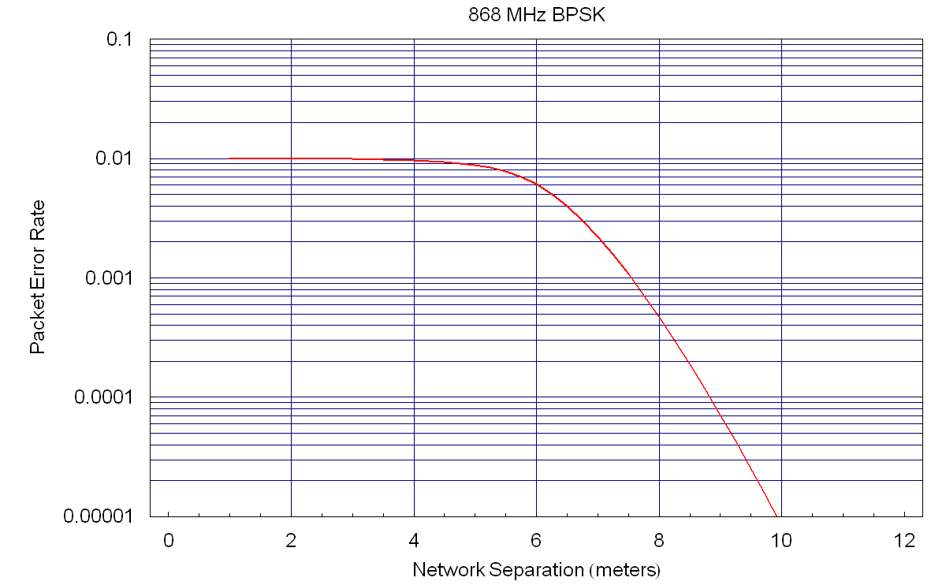

868MHz O-QPSK (“COBI”)

BER as a function of SIR
IEEE 802.15.4 868MHz O-QPSK modulation uses a chip rate R_{c} of 400 kc/s, a bit rate R_{b} of 100 kb/s and a codebook of M=16 symbols. Conversion from SNR to E_{b}/N₀ assumes matched filtering and half-sine pulse shaping:
$$\frac{E_{b}}{N_{0}}=\frac{0\text{.}\text{625}R_{c}}{R_{b}}\text{SNR}=\frac{0\text{.}\text{625}´\text{400000}}{\text{100000}}\text{SNR}=2\text{.}5\text{SNR}$$ | (5.2-9)
Conversion from bit noise density E_{s}/N₀ to symbol noise density E_{s}/N₀ is:
$$\frac{E_{s}}{N_{0}}=\text{log}2\left(M\right)\frac{E_{b}}{N_{0}}=4\frac{E_{b}}{N_{0}}$$ | (5.2-10)
Symbol error rate P_{s} is computed for non-coherent MFSK, e.g. from [5]:
$$P_{s}=\frac{1}{M}\sum_{j=2}^{M}{(−1)^{j}\left(\begin{matrix}M \\ j\end{matrix}\right)\text{exp}\left(\frac{E_{s}}{N_{0}}\left(\frac{1}{j}−1\right)\right)}$$ | (5.2-11)
Finally, conversion from symbol error rate to bit error rate P_{b} is given as:
$$P_{b}=P_{s}\left(\frac{M/2}{M−1}\right)=P_{s}\left(\frac{8}{\text{15}}\right)$$ | (5.2-12)
Rolling these together produces the bit error rate function:
$$P_{b}=\left(\frac{8}{\text{15}}\right)\left(\frac{1}{\text{16}}\right)\sum_{j=2}^{M}{(−1)^{j}\left(\begin{matrix}\text{16} \\ j\end{matrix}\right)\text{exp}\left(\text{10}\text{SNR}\left(\frac{1}{j}−1\right)\right)}$$ | (5.2-13)

Temporal Model
With a 1% operating duty cycle and a packet size of 32 bytes, the channel will be occupied for
$$\frac{\text{payloadSize}∗8}{\text{bitsPerSecond}}=\frac{\text{256}}{\text{100},\text{000}}s=2\text{.}\text{56}\text{ms}$$ | (5.2-14)
and the channel will be idle for 99*2.56ms = 253.44ms.

Coexistence Methodology Results
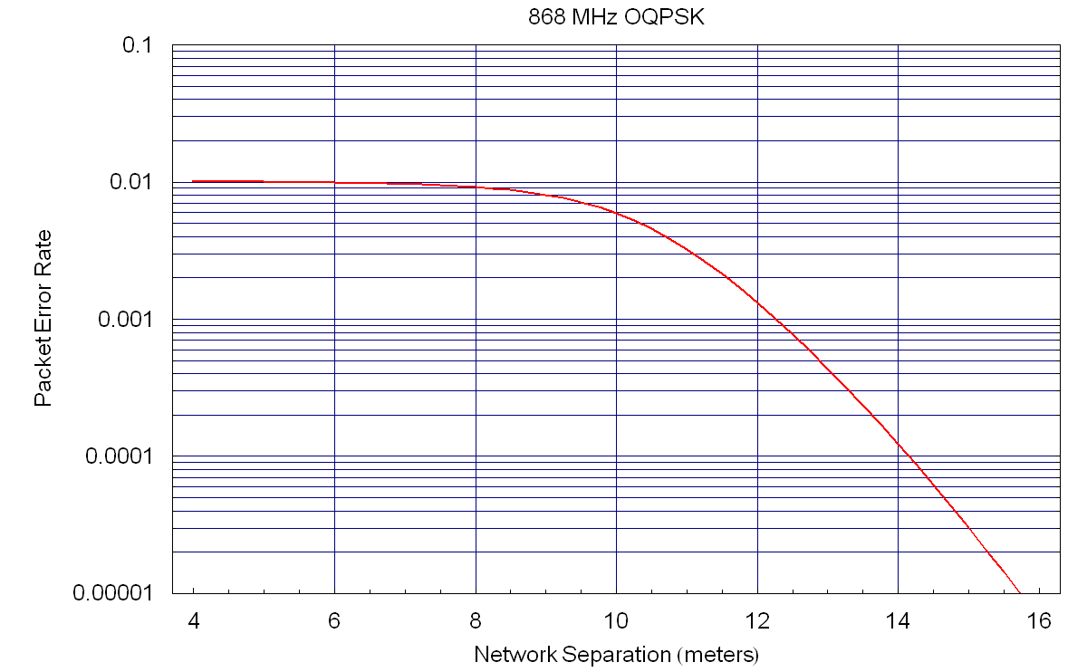

868MHz PSSS

BER as a function of SIR
IEEE 802.15.4 868MHz PSSS uses a form of ASK modulation, for which the Bit Error Rate function is most easily derived by simulation and curve fitting. For SNR values greater than -8dB, the BER function is approximated by:
$$P_{b}=0\text{.}\text{4146}\text{exp}(−6\text{.}\text{0871}\text{SNR})$$ | (5.3-15)

Temporal Model
With a 1% operating duty cycle and a packet size of 32 bytes, the channel will be occupied for
$$\frac{\text{payloadSize}∗8}{\text{bitsPerSecond}}=\frac{\text{256}}{\text{250},\text{000}}s=1\text{.}\text{024}\text{ms}$$ | (5.3-16)
and the channel will be idle for 99*1.024ms = 101.376ms.

Coexistence Methodology Results
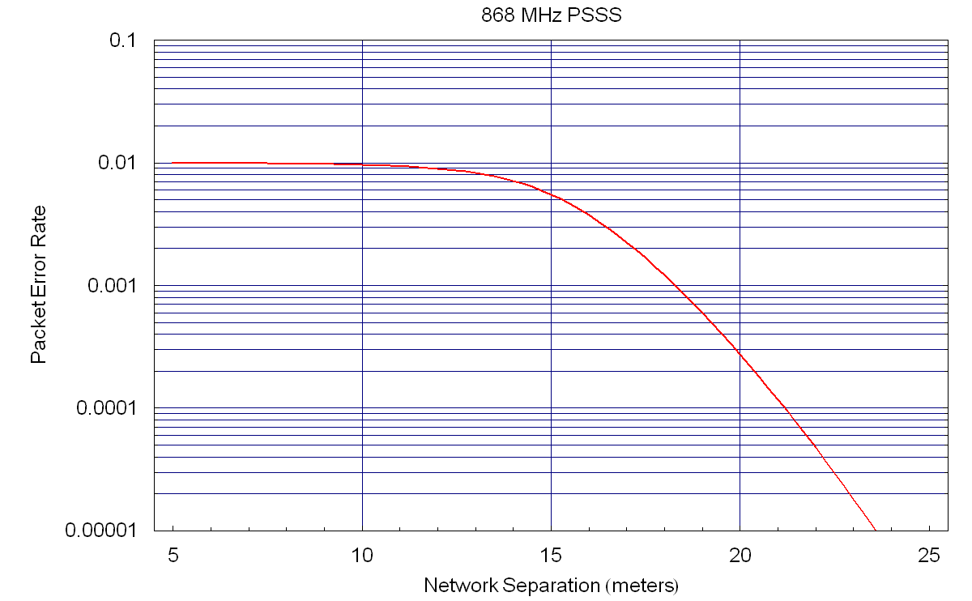

915MHz BPSK (“2003 legacy”)

BER as a function of SIR
IEEE 802.15.4 868MHz BPSK modulation uses a chip rate R_{c} of 600 kc/s, a bit rate R_{b} of 40 kb/s. Conversion from SNR to E_{b}/N₀ assumes a raised cosine filter:
$$\frac{E_{b}}{N_{0}}=\frac{0\text{.}\text{75}R_{c}}{R_{b}}\text{SNR}=\frac{0\text{.}\text{75}´\text{600000}}{\text{40000}}\text{SNR}=\text{11}\text{.}\text{25}\text{SNR}$$ | (5.4-17)
Bit error rate P_{b} is computed for non-coherent BSK, e.g. from [5]:
$$P_{b}=0\text{.}5\text{exp}\left(−\frac{E_{b}}{N_{0}}\right)$$ | (5.4-18)
Rolling these together produces the bit error rate function:
$$P_{b}=0\text{.}5\text{exp}\left(−\text{11}\text{.}\text{25}\text{SNR}\right)$$ | (5.4-19)

Temporal Model
With a 10% operating duty cycle and a packet size of 32 bytes, the channel will be occupied for
$$\frac{\text{payloadSize}∗8}{\text{bitsPerSecond}}=\frac{\text{256}}{\text{40},\text{000}}s=6\text{.}4\text{ms}$$ | (5.4-20)
and the channel will be idle for 90*6.4ms = 576ms.

Coexistence Methodology Results
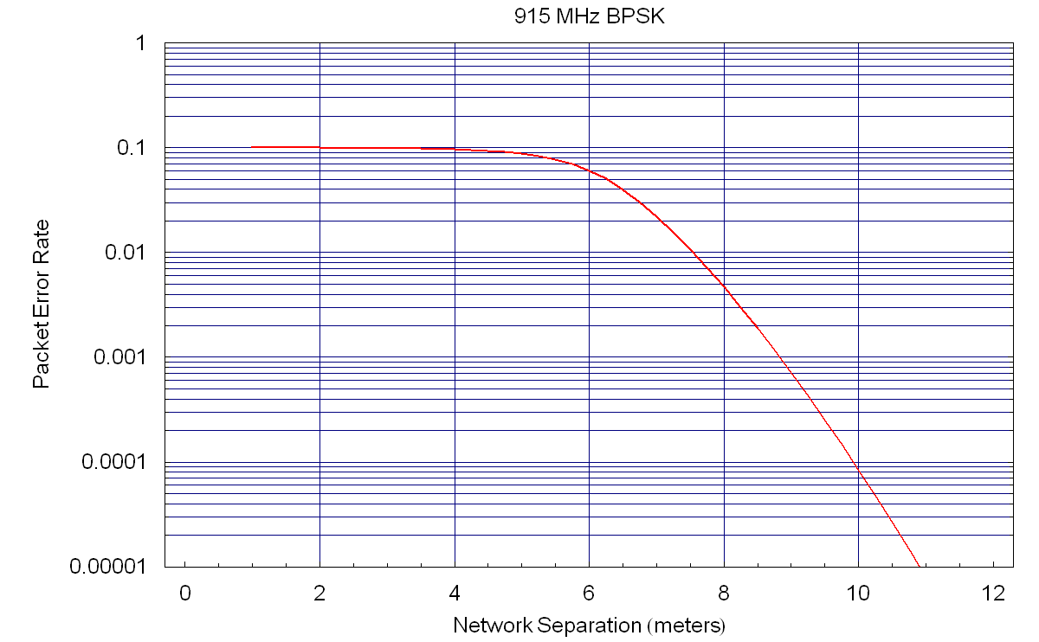

915MHz O-QPSK (“COBI”)

BER as a function of SIR
IEEE 802.15.4 868MHz O-QPSK modulation uses a chip rate R_{c} of 1000 kc/s, a bit rate R_{b} of 250 kb/s and a codebook of M=16 symbols. Conversion from SNR to E_{b}/N₀ assumes matched filtering and half-sine pulse shaping:
$$\frac{E_{b}}{N_{0}}=\frac{0\text{.}\text{625}R_{c}}{R_{b}}\text{SNR}=\frac{0\text{.}\text{625}´\text{1000000}}{\text{250000}}\text{SNR}=2\text{.}5\text{SNR}$$ | (5.5-21)
Conversion from bit noise density E_{s}/N₀ to symbol noise density E_{s}/N₀ is:
$$\frac{E_{s}}{N_{0}}=\text{log}2\left(M\right)\frac{E_{b}}{N_{0}}=4\frac{E_{b}}{N_{0}}$$ | (5.5-22)
Symbol error rate P_{s} is computed for non-coherent MFSK, e.g. from [5]:
$$P_{s}=\frac{1}{M}\sum_{j=2}^{M}{(−1)^{j}\left(\begin{matrix}M \\ j\end{matrix}\right)\text{exp}\left(\frac{E_{s}}{N_{0}}\left(\frac{1}{j}−1\right)\right)}$$ | (5.5-23)
Finally, conversion from symbol error rate to bit error rate P_{b} is given as:
$$P_{b}=P_{s}\left(\frac{M/2}{M−1}\right)=P_{s}\left(\frac{8}{\text{15}}\right)$$ | (5.5-24)
Rolling these together produces the bit error rate function:
$$P_{b}=\left(\frac{8}{\text{15}}\right)\left(\frac{1}{\text{16}}\right)\sum_{j=2}^{M}{(−1)^{j}\left(\begin{matrix}\text{16} \\ j\end{matrix}\right)\text{exp}\left(\text{10}\text{SNR}\left(\frac{1}{j}−1\right)\right)}$$ | (5.5-25)

Temporal Model
With a 10% operating duty cycle and a packet size of 32 bytes, the channel will be occupied for
$$\frac{\text{payloadSize}∗8}{\text{bitsPerSecond}}=\frac{\text{256}}{\text{250},\text{000}}s=1\text{.}\text{024}\text{ms}$$ | (5.5-26)
and the channel will be idle for 90*1.024ms = 92.16ms.

Coexistence Methodology Results
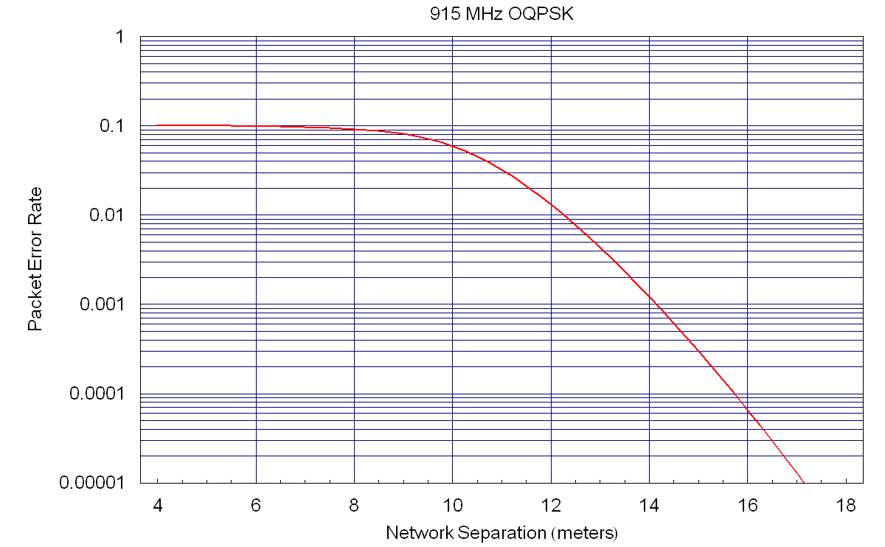

915MHz PSSS

BER as a function of SIR
IEEE 802.15.4 868MHz PSSS uses a form of ASK modulation, for which the Bit Error Rate function is most easily derived by simulation and curve fitting. For SNR values greater than -8dB, the BER function is approximated by:
$$P_{b}=7\text{.}\text{768}\text{exp}(−\text{21}\text{.}\text{93}\text{SNR})\text{+-}\text{12}\text{.}\text{85}\text{exp}(−\text{27}\text{.}\text{53}\text{SNR})$$ | (5.6-27)

Temporal Model
With a 10% operating duty cycle and a packet size of 32 bytes, the channel will be occupied for
$$\frac{\text{payloadSize}∗8}{\text{bitsPerSecond}}=\frac{\text{256}}{\text{250},\text{000}}s=1\text{.}\text{024}\text{ms}$$ | (5.6-28)
and the channel will be idle for 90*1.024ms = 92.16ms.

Coexistence Methodology Results
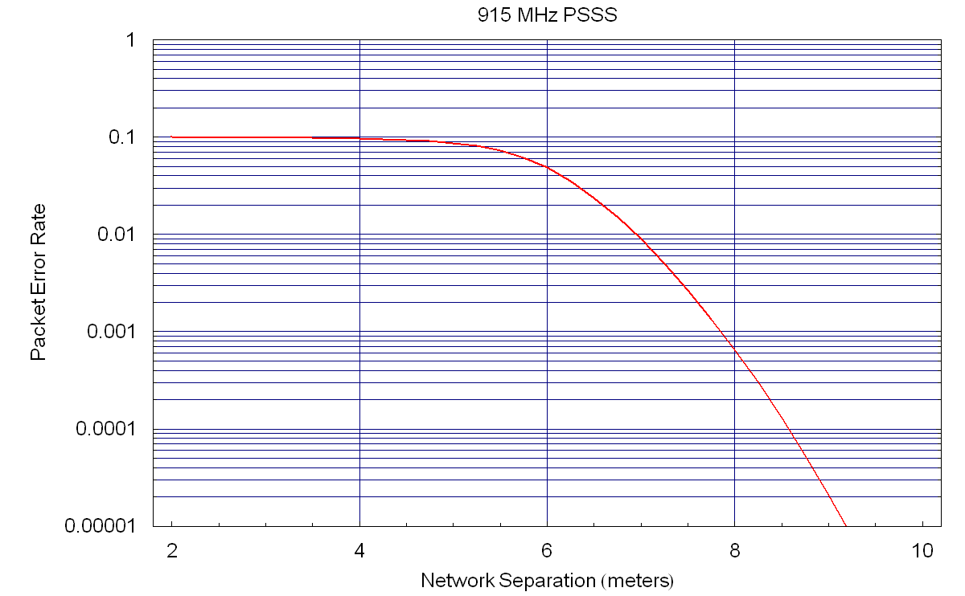

References
- S. J. Shellhammer, Estimating Packet Error Rate Caused by Interference – A Coexistence Assurance Methodology, IEEE 802.19-05/0029r0, September 14, 2005.
- S. J. Shellhammer, Estimation of Packet Error Rate Caused by Interference using Analytic Techniques – A Coexistence Assurance Methodology, IEEE 802.19-05/0028r0, September 14, 2005.
- IEEE Std 802.15.2-2003, IEEE Recommended Practice for Information technology -Telecommunications and information exchange between systems - Local and metropolitan area networks - Specific requirements. Part 15.2: Coexistence of Wireless Personal Area Networks with Other Wireless Devices Operating in Unlicensed Frequency Bands, August 28, 2003.
- IEEE LAN/MAN Standards Committee, IEEE Std 802.15.4™-2003, IEEE Standard for Information technology—Telecommunications and information exchange between systems—Local and metropolitan area networks—Specific requirements Part 15.4: Wireless Medium Access Control (MAC) and Physical Layer (PHY) Specifications for Low-Rate Wireless Personal Area Networks (LR-WPANs), IEEE, New York, NY, October 1, 2003.
- Sklar, Bernard, Digital Communications, Fundamentals and Applications (2nd Edition), Prentice Hall PTR, January 11 2001.
- ERC Recommendation 70-03, Relating to the use of Short Range Devices (SRDs), April 2002. [available from Global Engineering Documents, 15 Inverness Way East, Englewood, Colorado 80112, USA (http://global.ihs.com/)]
- ETSI EN 300 220-1, Electromagnetic Compatibility and Radio Spectrum Matters Range Devices (SRDs); Radio equipment to be used in the 25 MHz to 1 000 MHz frequency power levels ranging up to 500 mW; Part 1: Technical characteristics and test methods.
- FCC Code of Federal Register (CFR), Part 47, Section 15.35, Section 15.205, Section 15.209, Section 15.231, Section 15.247, and Section 15.249. United States.

Although the methodology described in [1] uses Symbol Error Rate (SER) to characterize PHY performance, we have chosen to use Bit Error Rate (BER) in this document instead because available error functions are more commonly defined as BER rather than SER.

