IEEE P802.15
Wireless Personal Area Networks

Project | IEEE P802.15 Working Group for Wireless Personal Area Networks (WPANs)
Title | Analysis of the angular characteristics in the 60 GHz indoor propagation channel
Date Submitted | [12 January, 2006]
Source | [Pascal Pagani, Nadine Malhouroux, Isabelle Siaud, Valery Guillet]  [France Telecom Research and Development Divsion]  [4 rue du Clos Courtel  BP 91226  F-35512 Cesson Sévigné  France] | Voice: []  E-mail:[]
Re: | []
Abstract | [This contribution presents a statistical study of the angular characteristics for the 60 GHz propagation channel in a typical indoor environment. The results may serve as a basis for a 60 GHz channel model including Direction of Arrival information.]
Purpose | [Contribution to IEEE 802.15.3c Channel Modeling sub-group]
Notice | This document has been prepared to assist the IEEE P802.15. It is offered as a basis for discussion and is not binding on the contributing individual(s) or organization(s). The material in this document is subject to change in form and content after further study. The contributor(s) reserve(s) the right to add, amend or withdraw material contained herein.
Release | The contributor acknowledges and accepts that this contribution becomes the property of IEEE and may be made publicly available by P802.15.
- Introduction

The IEEE 802.15.3c Task Group is currently studying possible solutions for High Data Rate wireless communication systems operating in the 60 GHz frequency bands [1]. In order to assess the performances of such millimeter wave systems in the context of WLAN and WPAN applications, a good knowledge of the transmission channel properties is necessary. Hence, active work is currently under process within the IEEE 802.15.3c Channel Modeling Sub-group, in order to define a realistic channel model for system level simulations. Among the key channel characteristics, Directions of Departure and Arrival (DoD, DoA) of the propagated waves represent an important parameter of the 60 GHz channel. In the case of moving terminals, DoD and DoA will directly impact the Doppler spectrum experienced at the receiver. In another hand, DoD and DoA are required in the development of dedicated models for future MIMO systems operating in the 60 GHz band. This contribution provides a statistical analysis of the angular characteristics for the millimeter wave propagation channel in a typical indoor environment. These experimental results may serve as a basis for a 60 GHz channel model including DoA information.

This research work was performed within the framework of MAGNET, an integrated project supported within the FP6 of the European Commission [2], [3]. The project groups 37 partners from 19 countries including universities, industrial partners and research centers. Fully named "My personal Adaptive Global NET", the project has a profound emphasis on user-centricity, personalization and personal networking. The objective of this approach is to improve the end-user's quality of life by introducing completely adapted new technologies. Among other technical Work Packages (WPs) spanning from user requirements to security issues, WP3 is more specifically dedicated to the design of adaptive air interfaces for WPANs. In this context, channel characterization and modeling was carried out by the project partners for different frequency bands, including the 60 GHz channel.

- Preliminary observation of the DoA characteristics at 60 GHz

A first illustrative example of the DoA properties in an indoor configuration is given in figure Figure 1. In this experiment, narrowband radio channel measurements were performed at 60.5 GHz in a 6 m × 4.65 m room of the office environment. The transmitter (Tx) and receiver (Rx) antennas were placed at a height of 1.5 m. The Tx antenna was a large beam antenna (70° beamwidth) and was oriented in two different positions: firstly, the Tx antenna was pointing towards the Rx antenna (position T1) and secondly, the Tx antenna was pointing towards one of the walls (position T2). The Rx antenna was a directive antenna with 4.4° beamwidth and was mounted on a rotating arm. We performed 360 measurements around the measurement location with a 1° angular step. It was hence possible to sketch the DoA diagram in azimuth.

(a) (b)
- Typical DoA results. Tx antenna pointing towards the Rx antenna (a) and Tx antenna pointing towards a wall (b).

The resulting DoA diagrams are presented in figure Figure 1. When the transmitter is in position T1 (a), the direct ray is clearly dominant. A number of other significant rays are also distinguishable, with contributions arriving from each wall of the room. This shows that multipath propagation is important in this configuration. When the transmitter is in position T2 (b), one may observe a first order reflected ray, corresponding to a reflection on the wall pointed by the Tx antenna, in addition to the direct ray. However, one may clearly distinguish second order reflections with a significant influence when the Tx antenna is off-axis.

This preliminary observation shows that the transmitted waves clearly propagate through different paths, and that the environment dependent DoA information is a parameter of interest for a comprehensive 60GHz indoor channel model.

- Wideband measurement campaign

A specific wideband measurement campaign was performed in order to analyze angular characteristics of the 60 GHz radio propagation channel. For this purpose, we used the Vector Network Analyzer (VNA) "AB millimètre 8-350" presenting a dynamic range of 40 dB [4]. The Channel Transfer Functions (CTFs) of the propagation channel were swept in the frequency domain over a bandwidth of 1024 MHz around a central frequency of 61 GHz. The frequency sweeping step of 4 MHz led to a maximum delay of 250 ns in the temporal domain. For each Tx-Rx configuration, the measured CTF was calibrated using a reference measurement in which the Tx and Rx ports of the sounder were directly cable-connected. The corresponding Channel Impulse Responses (CIRs) were obtained using an inverse Fourier Transform. A Hanning window was applied at this stage in order to reduce the level of secondary lobes in the temporal domain due to the limited analyzed bandwidth.

In order to collect DoA information, spatial measurements were taken using a virtual array of 10 × 10 sensors at the Rx position, as recommended in [5]. Figure Figure 2 presents the layout of this measurement gird. The Rx antenna was automatically displaced using a set of two orthogonally superimposed, linear rails. The displacement step was set to 2 mm, hence the distance separating two positions was less than λ/2 at the frequencies of interest. Depending on the Rx antenna and location, the virtual array was positioned either in a horizontal (XY) plan, or in a vertical (XZ) plan. For each measured sensor array, DoA information was extracted using a conventional beamforming technique [6]. The resulting function is the Angular Delay Power Spectrum (ADPS) P(θ, φ, τ), giving the distribution of the received power as a function of the elevation angle θ, the azimuth angle φ and the delay τ. Using a Chebyshev window as a weighting function, an angular resolution of 20° may be achieved.

- Virtual array layout (from [5]).

Two types of vertically polarized antennas were used for this experiment. Firstly, we used horns presenting a gain of 7.3 dBi and -3 dB beamwidth of 100° in both azimuth and elevation. This type of antenna is well suited for an access point (AP) situated in the angle of a room. Secondly, we used dipoles presenting a gain of 5.5 dBi and an omnidirectional radiation pattern in azimuth with a -3 dB beamwidth of 30° in elevation, centered around the elevation of 45°. This antenna was designed for a configuration where the AP is fixed at the ceiling in the middle of the room.

(a) (b)
- Office measurement environment for the DoA study. Large office (a) and small office (b). Black dots (AP1, AP 2, AP3, AP4, AP5) refer to access point positions. Red dots represent terminal positions.

The experiment took place in two furnished offices of respective sizes 5.82 m × 8.88 m and 5.82 m × 4.43 m, as presented in figure Figure 3. In both offices, the access point (AP) was fixed either at the ceiling in the middle of the room or on the top of a cupboard in a corner of the room. The terminal (T) was placed at various locations in the room at an approximate height of 1.30 m. different LOS scenarios were experimented, depending on the location of the AP (angle / middle of the room) and on the position of the sensor array (T / AP) allowing for DoA analysis. Table Table 1 summarizes the four tested scenarios.

Parameter | Scenarios
Parameter | A | B | C | D
AP position in the room | Middle | Angle | Angle | Angle
Location of the sensor array (for DoA analysis) | T | T | AP | T
Array orientation | XY | XZ | XZ | XY
AP antenna | Dipole | Horn | Horn | Horn
T antenna | Dipole | Horn | Horn | Dipole

- Considered propagation scenarios for the DoA analysis

- Angular analysis

  - Angular Delay Power Spectrum

For each measurement over the sensor array, we derived the ADPS P(θ, φ, τ) using a conventional beamforming technique. The ADPS characterizes the DoA at the terminal or at the access point depending on the location of the sensor array. In order to decompose the spatial and temporal information contained in the ADPS, we represent different reduced functions in a space-time diagram as represented in an illustrative case in figure Figure 4.
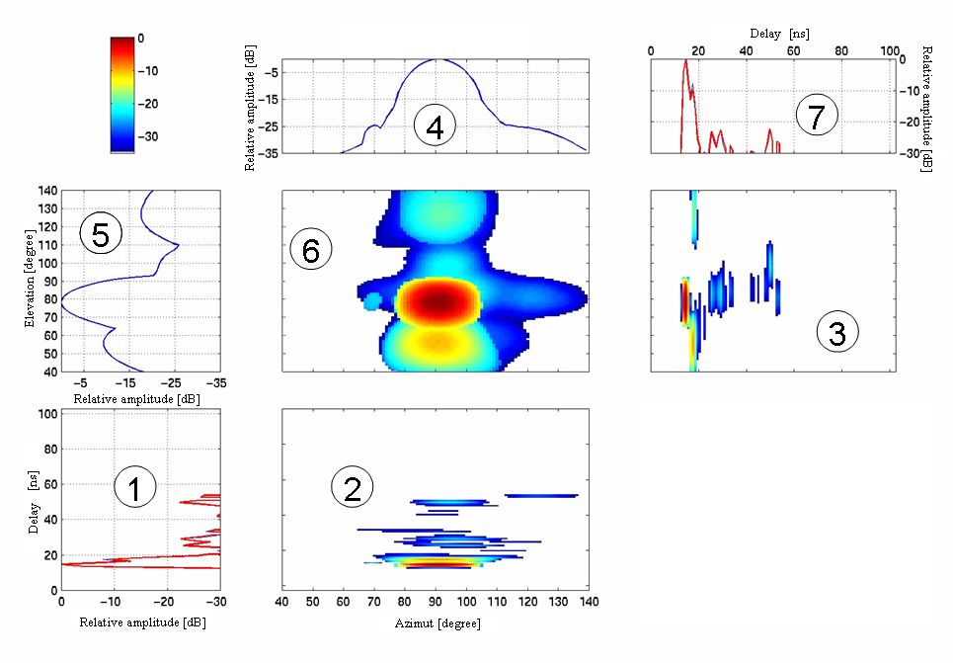
- Example of space-time diagram for an XZ array (scenario B)

The legend of the different plots is given below. In the following equations, the value D_{x} represents the definition domain for the variable x.

1. and 7. Average Power Delay Profile (APDP) P₁(τ)

The APDP P₁(τ) is computed from the N = 100 CIRs h_{n}(τ) collected over the sensor array as follows:

- $P_{1}\left(τ\right)=\frac{1}{N}\sum_{n=1}^{N}{{\left|h_{n}\left(τ\right)\right|}^{2}}$

2. Power distribution in the azimuth-delay plane P₂(φ, τ)

- $P_{2}\left(ϕ,τ\right)=\int{P\left(θ,ϕ,τ\right)dθ}$

3. Power distribution in the elevation-delay plane P₃(θ, τ)

- $P_{3}\left(θ,τ\right)=\int{P\left(θ,ϕ,τ\right)dϕ}$

4. Azimuth Power Profile P₄(φ)

- $P_{4}\left(ϕ\right)=\iint{P\left(θ,ϕ,τ\right)}dθdτ$

5. Elevation Power Profile P₅(θ)

- $P_{5}\left(θ\right)=\iint{P\left(θ,ϕ,τ\right)}dϕdτ$

6. Power distribution in the elevation-azimuth plane P₆(θ, φ)

- $P_{6}\left(θ,ϕ\right)=\int{P\left(θ,ϕ,τ\right)dτ}$

  - Angular spread and observable beams

Three main parameters are defined to characterize the channel with respect to angular distributions: the angular spread in the elevation plane σ_{θ}, the angular spread in the azimuth plane σ_{φ}, and the number of distinct beams N_{X} observable above a given power threshold.
The angular spread in the elevation plane is defined as follows:

- $σ_{θ}=\sqrt{\frac{\int{P_{5}\left(θ\right)θ^{2}dθ}}{\int{P_{5}\left(θ\right)dθ}}−{\left(\frac{\int{P_{5}\left(θ\right)θdθ}}{\int{P_{5}\left(θ\right)dθ}}\right)}^{2}}$

The angular spread in the azimuth plane is defined in a same manner as equation (7) by replacing θ by φ and P₅(θ) by P₄(φ). Finally, the number of distinct beams N_{X} corresponds to the number of observable local maxima of the power distribution in the elevation-azimuth plane P₆(θ, φ), above a given threshold situated X dB below the global maximum. Thresholds X equal to 3 dB, 10 dB, 15 dB and 20 dB were considered.
- CDF of the angular spread in the azimuth plane for different scenarios

- CDF of the angular spread in the elevation plane for different scenarios

Figures Figure 5 and Figure 6 represent the Cumulative Distribution Functions (CDFs) of the angular spread in the azimuth and elevation plane respectively, for the different considered scenarios. One can observe that a dipole antenna at the receiver (scenarios A and D) involves very large angular spread values in the azimuth plane (median value of σ_{φ} near 23°). On the contrary, a horn antenna at the receiver (scenarios B and C) generates a low angular spread in the azimuth plane (median value of σ_{θ} near 7°-9°). These results were easily predictable considering the antenna radiation pattern in the azimuth plane.

The angular spread in the elevation plane exhibits an opposite trend. This was equally foreseen, considering the antenna radiation pattern in the elevation plane. The largest angular spread in the elevation plane (median value of σ_{θ} near 13°) is much smaller than the largest angular spread in the azimuth plane (median value of σ_{φ} near 23°), revealing that multipath effects mainly affect the DoA in the azimuth plane. This suggests that azimuth DoA information could be sufficient for the building of 60 GHz channel models with a reduced complexity.

Finally, table Table 2 summarizes the median number of distinct beams N_{X} above a given threshold X, for different scenarios and threshold values. A similar behavior is observable for all considered scenarios. One may notice a strong attenuation of the reflected paths with respect to the LOS path: the second main path generally presents an attenuation of 10 dB to 15 dB with respect to the LOS path. This observation may be explained by the reflection properties of building material, in particular regarding plasterboard, which is the main constituting material in our experimental environment.

Threshold | Median N_{X} value
Threshold | Scenario A | Scenario B | Scenario C | Scenario D
X = 3 dB | 1 | 1 | 1 | 1
X = 10 dB | 1 | 1 | 1 | 1
X = 15 dB | 2 | 2 | 2 | 2
X = 20 dB | 3.5 | 4 | 3 | 6

- Number of distinct beams N_{X} for different scenarios and thresholds (median value)

- Conclusion

This contribution provides an experimental analysis of the angular characteristics for the 60 GHz propagation channel in an indoor environment. We first presented a preliminary observation of experimental DoA diagrams based on narrowband measurements. This showed that multiple echoes could propagate through different paths, leading to an important angular spread of the incoming waves. Hence the DoA of the multipath components seems a key characteristic of the 60 GHz indoor propagation channel. As a second step, wideband measurements were performed over a 1024 MHz bandwidth. A dedicated virtual sensor array permitted to characterize DoA in both elevation and azimuth planes in an office environment. The angular characteristics were studied in terms of the Angular Delay Power Spectrum, from which the angular spread in both azimuth and elevation planes, as well as the number of observable beams, were derived. Results show that multipath effects mainly affect the DoA in the azimuth plane, which could be used to reduce the complexity of 60 GHz channel models including DoA information.

- References

- IEEE 802.15.3c Task Group Webpage http://www.ieee802.org/15/pub/TG3c.html
- MAGNET Project, "MAGNET 4G Personal Area Network Air-Interfaces for Personal Networks", in: IST Mobile and Wireless Summit, Lyon, France, June 2004.
- IST MAGNET Project Webpage http://www.ist-magnet.org
- Goy, P., Caroopen, S. & Gross, M., "Vector measurements at millimeter and submillimeter wavelengths: feasibility and applications", in: ESA Workshop on Millimeter Wave Technology and Applications, Espoo, Finland, May 1998.
- Yong, S.K., Chong, C.C. & Lee, S.S., "General guidelines for measurement techniques and procedures", IEEE P802.15 Working Group for WPANs, no. IEEE P802.15-05/357, June 2005.
- Van Veen, B.D. & Buckley, K.M., "Beamforming: a versatile approach to spatial filtering", IEEE Acoustic Speech and Signal Processing Magazine, vol. 5, no. 2, pp. 4-24, April 1988.

