IEEE P802.15

Wireless Personal Area Networks

Project | IEEE P802.15 Working Group for Wireless Personal Area Networks (WPANs)
Title | Characterization and modeling of the 60 GHz indoor channel in the office and residential environments
Date Submitted | [, 2006]
Source | [Pascal Pagani, Nadine Malhouroux, Isabelle Siaud, Valery Guillet]  [France Telecom Research and Development Divsion]  [4 rue du Clos Courtel  BP 91226  F-35512 Cesson Sévigné  France] | Voice: []  E-mail:[]
Re: | []
Abstract | [This contribution presents a measurement-based analysis of the characteristics of the propagation channel at 60 GHz and provides inputs for a channel model based on typical measurement files.]
Purpose | [Contribution to IEEE 802.15.3c Channel Modeling sub-group]
Notice | This document has been prepared to assist the IEEE P802.15. It is offered as a basis for discussion and is not binding on the contributing individual(s) or organization(s). The material in this document is subject to change in form and content after further study. The contributor(s) reserve(s) the right to add, amend or withdraw material contained herein.
Release | The contributor acknowledges and accepts that this contribution becomes the property of IEEE and may be made publicly available by P802.15.
- Introduction

In the context of WLAN and WPAN systems for High Data Rate (HDR) wireless communications, the unlicensed frequency band available in the millimeter wave region has become more and more attractive. In the USA, the regulation authority FCC allows the use of a 7 GHz frequency band between 57 GHz and 64 GHz [1], while similar regulation rules are applicable in other parts of the world. Active research groups, such as the IEEE 802.15.3c Task Group [2], are currently working towards the definition of communications systems operating in the millimeter frequency bands, with a targeted data rate of 3 Gbps. In order to develop such systems, a perfect knowledge of the propagation channel is necessary. This paper provides an input to the IEEE 802.15.3c Channel Modeling Sub-group, by proposing tapped delay line models based on an extensive channel sounding campaign and on thorough analyses of the channel characteristics. Section 2 presents the different experiments conducted in both residential and office indoor environments. These experimental results served as a basis for our statistical analyses regarding the main characteristics of the 60 GHz propagation channel (Section 3). Finally, Section 4 describes a complete channel model based on the concept of tapped delay line.

This research work is derived from France Telecom R&D contributions to the IST-FP6 MAGNET project, an integrated project supported within the FP6 of the European Commission [3], [4]. The project groups 37 partners from 19 countries including universities, industrial partners and research centers. Fully named "My personal Adaptive Global NET", the project has a profound emphasis on user-centricity, personalization and personal networking. The objective of this approach is to improve the end-user's quality of life by introducing completely adapted new technologies. Among other technical Work Packages (WPs) spanning from user requirements to security issues, WP3 is more specifically dedicated to the design of adaptive air interfaces for WPANs. In this context, France Telecom R&D has promoted the concept of extended Multiband UWB-OFDM system [7] and investigated the 60 GHz frequency band to perform Very High Data rate UWB-OFDM transmissions. A 60 GHz channel characterization and CEPD propagation modeling (see section 4) has been proposed and implemented in link level simulations. In this contribution, an alternative propagation modeling is proposed with a complete paper work description well suited to low-complexity implementation and reference models.

- Propagation experiments at 60 GHz

  - Channel sounding equipment

All measurements were performed using the Vector Network Analyzer (VNA) "AB millimètre 8-350" [5], around a central frequency of 60 GHz. This equipment presents a dynamic range of 40 dB, and the channel was sampled at a rate of 0.1 Hz. The Channel Transfer Functions (CTFs) of the propagation channel were measured in a frequency sweep mode with a total frequency bandwidth of 1024 MHz for most of the measurements. Some measurements in the office environment covered a limited bandwidth of 512 MHz. The frequency sweeping step was set to 4 MHz (resp. 2 MHz for some measurements), leading to a maximum delay of 250 ns (resp. 500 ns) in the temporal domain. For each Tx-Rx configuration, the measured CTF was calibrated using a reference measurement in which the Tx and Rx ports of the sounder were directly cable-connected. The corresponding Channel Impulse Responses (CIRs) were obtained using an inverse Fourier Transform. A Hanning window was applied at this stage in order to reduce the level of secondary lobes in the temporal domain due to the limited analyzed bandwidth.

Three types of vertically polarized horn antennas were used depending on the experimental scenario. The first antenna presents a 3 dB beamwidth of 72° in the azimuth plane and 8 dBi gain. The second antenna presents a beamwidth of 60° in the azimuth plane and 13 dBi gain. The third antenna is more directive and presents a beamwidth of 10° in the azimuth plane and 24.6 dBi gain.

  - Measurement environment

Channel sounding measurements were performed in two types of indoor environments, fully addressing the scenarios identified by the IEEE 802.15.3c Channel Modeling Sub-group [6]. Our experiments involved measurements in both enterprise and residential environments, in intra closed office room / office (Line-Of-Sight, LOS) and inter closed room / office (Non Line-Of Sight, NLOS). Hence, our results are applicable to scenarios identified as Model B and Model C by the Channel Modeling Sub-group.

Residential environment

- Residential measurement environment.
Black dots (A1, A2, A3) refer to Tx positions, with the arrow indicating the direction of the antenna main beam. Red dots represent approximate Rx positions.

A first sounding campaign was carried out in a 100 m² apartment, as depicted in figure Figure 1.The apartment had a rectangular shape, with a L-shaped corridor separating different rooms. Internal walls of this residential flat were made of 7 cm thick plasterboard with 3 cm thick wooden doors. Outer walls were made of 44 cm thick concrete with double-glazing. Ceiling and floor were made of concrete. During the experiment, most of the apartment rooms were equipped with wooden furniture (tables, chairs, bed, shelves, etc.). Figure Figure 2 presents some views of the sounded environment. Both LOS and NLOS situations were investigated, with a maximum transmitter (Tx) to receiver (Rx) distance of 12 m.

At the Tx a vertically polarized antenna with a 72° beamwidth was used. At the Rx positions, a vertically polarized narrow beam antenna (10° beamwidth, 24.6 dBi gain) and a sectoral antenna (60° beamwidth) were used in order to analyze antenna radiation pattern effects. The Tx antenna was fixed to a mast at a height of 2.14 m above the floor and three different Tx positions were considered (see figure Figure 1): A1 in a corner of the living room (6.2 m × 4.1 m room); A2 at the end of the corridor (2.1 m × 7.2 m); A3 in a corner of a bedroom (3 m × 5.1 m). For all measurements, the Rx antenna was moved along a linear rail with a 2 mm step along 15 cm (30 λ) at 1.2 m height for each Rx site. The Rx antenna was pointed towards the direction of maximum received power. We considered 43 different Tx-Rx configurations using a sectoral antenna and 33 configurations using a directive antenna. In each configuration, 76 CIRs were locally measured using the linear rail.

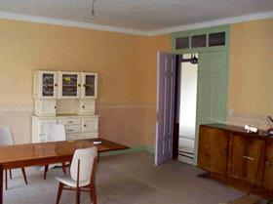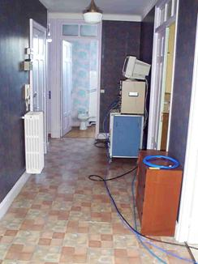
(a) (b)

- Pictures of the residential measurement environment. Living room (a) and corridor with channel sounder (b)

Office environments

The indoor enterprise area corresponds to a France Telecom R&D building associated with the NET laboratory in Belfort, France. As in the residential environment, internal walls were made of plasterboard, while outer walls were made of concrete and brick with double-glazing windows. As a main difference, the office environment was composed of larger rooms, with typical office furniture (metallic shelves, desks, PC equipment). Figure Figure 3 presents the used positioning rail in the laboratory room.

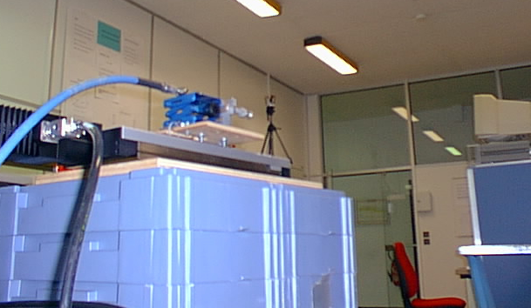

- Antenna and positioning rail in the office measurement environment.

A first sounding campaign consisted in using sectoral antennas at both Tx (72° beamwidth antenna) and Rx (60° beamwidth antenna) ends of the link. The Tx antenna was fixed at a height of 1.60 m. Figure Figure 4 presents the floor plan of the rooms where this measurement series took place. Measurements have been performed in three types of rooms: an open-plan office (Tx antenna position: E1), a corridor (Tx antenna position: E2) and a conference room (Tx antenna position : E3). A total number of 15 receiver positions have been tested, resulting in 15 sets of 60 measured CIRs. The Rx antenna was moved along a linear rail with a 1.5 mm step along 9 cm (18 λ) at 1.52 m height for each Rx site. At 60 GHz, most of the receivers are localized in the transmitter room because of the large path-loss meaning that LOS situations are favored. Some receivers are also positioned in the corridor near the transmitter room. When the receiver and the transmitter are in the same room, measurements are realized in LOS configurations. There is no furniture in the direct path. For this measurement series, the sounded bandwidth was set to 512 MHz, leading to a delay resolution equal to 1.97 ns. We consider this resolution is sufficient in the case of sectoral antenna set-up at both Tx and Rx sides.

(a) (b)

(c)

- Office 1 measurement environment.
Open-plan office (a), conference room (b) and corridor (c). Black dots (E1, E2, E3) refer to Tx positions, with the arrow indicating the direction of the antenna main beam. Red dots refer to Rx positions.

A second measurement series has been realized in the same enterprise building but measurement points were not located in the same rooms. The purpose of this experiment was to assess the 60 GHz channel in the case of a narrow beam Tx antenna (10° beamwidth). The Rx antenna was a sectoral horn with 60° beamwidth. In this directive configuration, the channel sounding bandwidth was increased to 1024 MHz in order to reduce the relative delay resolution on multipath. Figure Figure 5 presents the measurement location. Five different transmitter positions have been tested: an office (Tx antenna position: E1), a laboratory room (Tx antenna position: E2), an open-plan office (Tx antenna positions: E4 and E6) and a conference room (Tx antenna position: E5). For each measurement, the Tx antenna was fixed at a height of 2.80 m, with a 15° tilt. As in the previous measurement series in the office environment, the Rx antenna was moved along a linear rail with a 1.5 mm step along 9 cm (18 λ) for each Rx site. Using a total of 26 Rx positions and 5 Tx positions, a total of 31 sets of 60 CIRs have been mesured.

(a)

(b) (c)

- Office 2 measurement environment.
Office and laboratory (a), open-plan office (b) and conference room (c). Black dots (E1, E2, E4, E5, E6) refer to Tx positions, with the arrow indicating the direction of the antenna main beam. Red dots refer to approximate Rx positions.

  - Propagation scenarios

Table Table 1 summarizes the considered propagation scenarios, according to the environment (residential / office) and the type of antennas used at the Tx or Rx sides (directive / sectoral). For each scenario, LOS and NLOS situations were separately considered. In the modeling process, channel models will be provided for each of theses propagation scenarios. These models are based on typical cases, i.e. are representative of mean situations with respect to the wideband selectivity of the channel.

Parameter | Scenarios
Parameter | Residential 1  Sectoral ant. | Residential 2  Directive ant. | Office 1  Sectoral ant. | Office 2  Directive ant.
Tx antenna beamwidth | 60° | 60° | 72° | 10°
Rx antenna beamwidth | 72° | 10° | 60° | 60°
Tx antenna gain | 13 dBi | 13 dBi | 8 dBi | 24.6 dBi
Rx antenna gain | 8 dBi | 24.6 dBi | 13 dBi | 13 dBi°
Length of meas. run | 150 mm (30 λ) | 150 mm (30 λ) | 90 mm (18 λ) | 90 mm (18 λ)
Number of CIR per measurement run | 76 (0.4 λ step) | 76 (0.4 λ step) | 60 (0.3 λ step) | 60 (0.3 λ step)
Frequency bandwidth | 1024 MHz | 1024 MHz | 512 MHz | 1024 MHz
Maximum CIR delay | 250 ns | 250 ns | 500 ns | 500 ns
Relative delay resolution | 0.97 ns | 0.97 ns | 1.95 ns | 0.97 ns

- Considered propagation scenarios

- Characterization of the 60 GHz propagation channel

  - Path loss analysis

As a first analysis, the total power attenuation between the Tx and Rx antennas was fitted in function of the Tx-Rx distance d to the general propagation loss formula in the form [9]:

- $\text{PL}\left(d\right)=\text{PL}\left(d_{0}\right)+\text{10}⋅n{\text{log}}_{\text{10}}\left(\frac{d}{d_{0}}\right)+S\left(d\right)$
where PL(d₀) is the path loss in dB at d = d₀, n is the environment dependent path loss exponent and S is the lognormal shadowing in dB, with zero mean and standard deviation σ_{S}.

For the residential environment, the results are plotted in figure Figure 6 for the sectoral Rx antenna and in figure Figure 7 for the directive Rx antenna, for both LOS and NLOS configurations. For the sake of comparison, the theoretical curve corresponding to free space propagation has been plotted in accordance with the Friis formula:
- $\text{PL}\left(d\right)=\text{20}{\text{log}}_{\text{10}}\left(\frac{4π\text{fd}}{c}\right)−G_{\text{Tx}}−G_{\text{Rx}}$
where f denotes the central frequency, c is the speed of light and G_{Tx} and G_{Rx} respectively represent the Tx and Rx antenna gains, measured separately in an anechoic chamber.

- Measured path loss attenuation: Residential 1 scenario (sectoral Rx antenna).

- Measured path loss attenuation: Residential 2 scenario (directive Rx antenna).

Results obtained by linear regression using equation (1) with a reference distance d₀ = 1 cm are given in table Table 2. In the LOS configuration, the observed path loss is very close to the Friis formula for free space propagation. The additional attenuation of about 5 dB may be attributed to the squint antenna effect in reception, as the Tx and Rx antennas were not perfectly aligned for all measurements. However the model given by equation (1) is a satisfactory approximation, as the standard deviation of the residue S is in the order of σ_{S} = 1.5 dB.

In the NLOS configuration, measurement plots are somewhat more dispersed. In the residential case with a sectoral antenna, the standard deviation σ_{S} is 6.2 dB. This dispersion may be explained by the variety of NLOS configurations: we observed that the additional attenuation due to one wall with respect to free space is 18.6 dB on average, while this additional attenuation increases to 26.5 dB when two walls are blocking the direct Tx-Rx path. In the residential case involving a directive antenna, the high dispersion of the measured plot did not allow for a reliable model in the form given in equation (1). In this case, we also observed that the use of a directional antenna led to an average path loss reduction of 5 dB with respect to the sectoral antenna. This is well below the 15.6 dB gain which could be expected regarding the antenna gain difference. It means that in NLOS configurations, due to the large angular spread of the incoming power, the sectoral antenna is more suited to capture multipath power than the narrow beam antenna.

For the office environment, the results are plotted in figure Figure 8 for the sectoral Rx antenna and in figure Figure 9 for the directive Rx antenna, for both LOS and NLOS configurations. Again, the theoretical curve corresponding to free space propagation has been plotted in accordance with the Friis formula (equation (2)), where the Tx and Rx antenna gains were measured separately in an anechoic chamber.

- Measured path loss attenuation: Office 1 scenario (sectoral Tx antenna). Dots (○): measurements in the office and the laboratory; squares (□): measurements in the conference room; and triangles (Δ) : measurements in the corridor.

- Measured path loss attenuation: Office 2 scenario (directive Tx antenna).
Dots (○): measurements in the open-plan office; squares (□): measurements in the open-plan office; and triangles (Δ) : measurements in the conference room.

For the office 1 scenario in figure Figure 8 (corresponding to a sectoral Tx antenna), the attenuation measured in a LOS configuration is close to the free space path loss given by the Friis formula. Some differences are observable, probably due to the misalignment of the antennas. Results obtained by linear regression using equation (1) with a reference distance d₀ = 1 cm are given in table Table 2. The low path loss exponent (n = 0.56) may arise from the waveguide effect occurring in LOS situations.

For the office 2 scenario in figure Figure 9 corresponding to a directive Tx antenna, most measurements were performed in a LOS configuration. In this case, the misalignment of the antennas produce non negligible variations in the observed attenuation. Hence it was not possible to derive a consistent power decay model.

Regarding the NLOS configurations in both office scenarios, the few measurement points did not allow for a reliable statistical analysis.

Table Table 2 summarizes the propagation loss results derived from the different measurement scenarios. It should be noted that the values of the parameter PL(d₀) include both Tx and Rx antenna gains as described in table Table 1.

Parameter | Scenarios
Parameter | Residential 1  Sectoral ant. |  | Residential 2  Directive ant. |  | Office 1  Sectoral ant. |  | Office 2  Directive ant.
Parameter | LOS | NLOS | LOS | NLOS | LOS | NLOS | LOS | NLOS
n | 1.53 | 2.44 | 1.73 | N/A | 0.56 | N/A | N/A | N/A
PL(d₀) (dB) | 23.5 | 16.2 | 4.3 | N/A | 49.6 | N/A | N/A | N/A
σ_{S} (dB) | 1.5 | 6.2 | 1.6 | N/A | 1.2 | N/A | N/A | N/A

- Propagation loss results. d₀ = 1 cm.

  - Wideband parameters

At each measurement location, a number N of CIRs h_{n}(τ) were collected along a linear rail (N = 76 in the residential scenarios and N = 60 in the office scenarios). From this measurement set, an Average Power Delay Profile (APDP) P(τ) is computed as follows:

- $P\left(τ\right)=\frac{1}{N}\sum_{n=1}^{N}{{\left|h_{n}\left(τ\right)\right|}^{2}}$

Different wide band parameters are then computed. The delay spread σ_{τ} represents the delay dispersion in the APDP and is computed as follows:

- $σ_{τ}=\sqrt{\frac{\int{P\left(τ\right)τ^{2}dτ}}{\int{P\left(τ\right)dτ}}−{\left(\frac{\int{P\left(τ\right)τdτ}}{\int{P\left(τ\right)dτ}}\right)}^{2}}$

The coherence bandwidth B_{c} characterizes the correlation between different frequencies in the Channel Transfer Function. More specifically, the n% coherence bandwidth B_{c,n%} corresponds to the required frequency spacing that provides a statistical correlation coefficient equal to n%:

- $B_{c,n\text{\%}}=\text{min}\left\{Ω:\left|\frac{R\left(Ω\right)}{R\left(0\right)}\right|=\frac{n}{\text{100}}\right\}$
where the frequency correlation function R(Ω) is the Fourier transform of the APDP P(τ). We generally use thresholds of 50% and 90%.

The delay window at q% is the duration of the central part of the APDP containing q% of the total energy. Using the delays defined on figure Figure 10, the delay window is given by:

- $W_{q\text{\%}}=τ_{4}−τ_{2}$,
where the delays τ₂ and τ₄ are given by:

- $\int_{τ2}^{τ4}{P\left(τ\right)}dτ=\frac{q}{\text{100}}\int_{τ0}^{τ5}{P\left(τ\right)}dτ$,
and the energy situated outside the window is divided into two equal parts. Delays τ₀ and τ₅ are the delays for which the signal crosses a given noise threshold.

The delay interval at p dB is the difference between the delay at which the function P(τ) crosses for the last time a given threshold situated p dB below its maximum, and the delay at which it crosses the threshold for the first time. Following the notations given in figure Figure 10, the delay interval is given by:

- $I_{p}=τ_{3}−τ_{1}$,

- APDP illustrating the delay window and the delay interval ([10]).

Different wideband parameters were statistically analysed for each measurement scenario. The selected parameters are the following: the delay spread (σ_{τ}), the delay window at 90% (W_{90%}), the delay intervals at 6 dB (I _{6 dB}) and 12 dB (I _{12 dB}), and the coherence bandwidths at 50% (B_{c,50%}) and 90% (B_{c,90%}). It may be noted that in the office scenarios, all measurements were considered as a single set, due to the small number of NLOS measurements. Statistical results are given in table Table 3 in the form of the median (Q50), as well as the 10th and the 90th percentiles (Q10 and Q90).

Scenario | Link | Percentile | Wideband parameters
Scenario | Link | Percentile | σ_{τ}  (ns) | W_{90%}  (ns) | I _{6 dB}  (ns) | I _{12 dB}  (ns) | B_{c,50%}  (MHz) | B_{c,90%}  (MHz)
Residential 1  (sectoral antenna) | LOS | Q10 | 1.1 | 1.9 | 1.9 | 2.7 | 291.5 | 77
Residential 1  (sectoral antenna) | LOS | Q50 | 2.0 | 2.1 | 3.1 | 2.9 | 317.5 | 106
Residential 1  (sectoral antenna) | LOS | Q90 | 3.1 | 3.2 | 2.2 | 3.2 | 327 | 122.5
Residential 1  (sectoral antenna) | NLOS | Q10 | 3.3 | 2.8 | 2.1 | 3 | 30.5 | 6.5
Residential 1  (sectoral antenna) | NLOS | Q50 | 7.1 | 17.2 | 3 | 12.2 | 101.5 | 12.5
Residential 1  (sectoral antenna) | NLOS | Q90 | 11.8 | 34.4 | 14.8 | 33 | 297 | 84.5
Residential 2  (directive antenna) | LOS | Q10 | 0.5 | 1.9 | 2.1 | 2.9 | 318.5 | 118.5
Residential 2  (directive antenna) | LOS | Q50 | 0.7 | 1.9 | 2.2 | 2.9 | 322 | 126
Residential 2  (directive antenna) | LOS | Q90 | 1.5 | 2.1 | 2.2 | 2.9 | 323 | 126.5
Residential 2  (directive antenna) | NLOS | Q10 | 1.8 | 2.1 | 2.1 | 2.9 | 35 | 5.5
Residential 2  (directive antenna) | NLOS | Q50 | 6.3 | 11.3 | 2.1 | 11.2 | 216 | 19
Residential 2  (directive antenna) | NLOS | Q90 | 13.4 | 37 | 11.8 | 34 | 319 | 117
Office 1  (sectoral antenna) | LOS / NLOS | Q10 | 2.5 | 3.5 | 3.5 | 4.5 | 74.5 | 12.5
Office 1  (sectoral antenna) | LOS / NLOS | Q50 | 4.5 | 6.5 | 3.5 | 6.5 | 169 | 37.5
Office 1  (sectoral antenna) | LOS / NLOS | Q90 | 8.5 | 19.5 | 7.0 | 15.5 | 206 | 62
Office 2  (directive antenna) | LOS / NLOS | Q10 | 0.9 | 1.85 | 1.9 | 2.6 | 119 | 4.7
Office 2  (directive antenna) | LOS / NLOS | Q50 | 7.9 | 2.3 | 2.1 | 2.9 | 315.5 | 88
Office 2  (directive antenna) | LOS / NLOS | Q90 | 17.7 | 58.3 | 2.3 | 16.6 | 327 | 127

- Percentiles of selected wideband parameters for different scenarios.

- Tapped delay line models

In this section, we derive channel models from the sets of measurements performed in each considered scenario. To this end, typical input files were first selected from a statistical analysis of the wideband parameters related to each measurement scenario. These input files, composed of a number N of locally measured CIRs h_{n}(τ) are then analyzed to generate a tapped delay line model providing the delay and relative amplitude of the main CIR propagation paths.

We propose to select the typical impulse responses file, as an input of the model, by extracting wideband propagation parameters from measurements obtained in interest propagation scenarios. This approach is issued from the CEPD (Canal Enregistré de Propagation Déterministe) propagation model[7][8] which uses measured impulse response files to generate typical and atypical time-variant filters representative of the propagation channel connected to a specific PHY layer design. The CEPD model is based on the one hand on the digital multirate theory in connection with the filtering processing and is based on a statistical analysis of measurements to select the input files of the model providing relevant coefficients of the filter associated with a targeted scenario.
Wideband selectivity parameters are evaluated from the instantaneous impulse response h_{n}(τ) giving a quantitative description of the selective propagation channel. We selected nine wideband parameters to characterize the propagation channel: the delay spread (σ_{τ}), the coherence bandwidth at 50 % and 90% (B_{c,50%} and B_{c,90%}), the delay interval at 6 dB, 12 dB and 15 dB (I _{6 dB}, I _{12 dB} and I _{15 dB}), the delay window at 75% and 90% (W_{75%} and W_{90%}) and the standard deviation of the wideband propagation loss in dB, σ_{PL}. These parameters are representative of the decreasing shape of the average power delay profile and the energy distribution of the delayed paths.
According to the central limit theorem, the first order statistic of the j^{th} wideband parameter follows a Gaussian distribution N(m_{j}, σ_{j}) where the parameter standard deviation σ_{j} depends on the scenario definition and the size of the measurement set. Input files of the model correspond to selected measured CIRs files with overall average selectivity parameter values included within the interval I given by:

- $I=\left\{x:\frac{\left|x−m_{j}\right|}{σ_{j}}<α\right\}$, with $α∈\left[0\text{.}1;0\text{.}\text{15}\right]$.

The selected files are converted in a tapped delay line model with non-uniform time spacing. The procedure consists in fitting the model APDP to the measured APDP, taking the measurement bandwidth into account. By analyzing the different CIRs constituting the measured APDP, an indication of the amplitude fluctuations of each tap (Rayleigh, Rice) is also given. The tapped delay line principle was already employed for a 60 GHz channel model in [11]. Furthermore, in the context of the IST BROADWAY project, document [12] presents an extraction of tapped delay line models based on previous channel measurements presented in [13] and [14].

The following figures and tables present the tapped-delay line models extracted from the selected typical measurement files. The extraction of the model parameters from the selected measurement files was performed using a dedicated software tool described in the annex (section 7).

- Residential 1 (sectoral antenna), LOS channel model.

Tap number | Delay (ns) | Relative power (dB) | Small scale variations
1 | 7.00 | 0.00 | Rice
2 | 9.60 | -12.20 | Rayleigh
3 | 11.50 | -28.10 | Rayleigh
4 | 14.00 | -24.50 | Rayleigh
5 | 54.60 | -28.00 | Rice
Average measurement delay spread σ_{τ} (ns) |  |  | 0.81
Average model delay spread σ_{τ} (ns) |  |  | 0.81

- Residential 1 (sectoral antenna), LOS channel model parameters.

- Residential 1 (sectoral antenna), NLOS channel model.

Tap number | Delay (ns) | Relative power (dB) | Small scale variations
1 | 26.48 | -1.60 | Rayleigh
2 | 27.50 | -1.60 | Rayleigh
3 | 28.50 | -3.30 | Rayleigh
4 | 30.00 | -5.50 | Rayleigh
5 | 31.41 | -6.80 | Rayleigh
6 | 33.20 | -14.60 | Rayleigh
7 | 34.50 | -18.80 | Rayleigh
8 | 36.00 | -17.90 | Rayleigh
9 | 37.80 | -20.90 | Rayleigh
10 | 39.50 | -22.80 | Rayleigh
11 | 41.00 | -22.50 | Rayleigh
12 | 42.50 | -23.30 | Rayleigh
13 | 44.00 | -20.40 | Rayleigh
14 | 45.50 | -19.30 | Rayleigh
15 | 47.10 | -22.50 | Rayleigh
16 | 48.50 | -25.20 | Rayleigh
17 | 51.00 | -26.80 | Rayleigh
18 | 52.50 | -27.00 | Rayleigh
19 | 54.00 | -26.90 | Rayleigh
20 | 56.50 | -25.90 | Rayleigh
21 | 58.00 | -27.40 | Rayleigh
22 | 59.50 | -26.60 | Rayleigh
23 | 62.50 | -27.20 | Rayleigh
24 | 65.50 | -14.10 | Rayleigh
25 | 67.00 | -28.80 | Rayleigh
26 | 68.50 | -31.20 | Rayleigh
27 | 72.00 | -29.00 | Rayleigh
28 | 77.00 | -29.60 | Rayleigh
Average measurement delay spread σ_{τ} (ns) |  |  | 5.33
Average model delay spread σ_{τ} (ns) |  |  | 5.02

- Residential 1 (sectoral antenna), NLOS channel model parameters.
- Residential 2 (directive antenna), LOS channel model.

Tap number | Delay (ns) | Relative power (dB) | Small scale variations
1 | 12.1 | 0.00 | Rice
Average measurement delay spread σ_{τ} (ns) |  |  | 0.58
Average model delay spread σ_{τ} (ns) |  |  | 0.56

- Residential 2 (directive antenna), LOS channel model parameters.

- Residential 2 (directive antenna), NLOS channel model.

Tap number | Delay (ns) | Relative power (dB) | Small scale variations
1 | 26.20 | -17.50 | Rayleigh
2 | 30.20 | -4.70 | Rayleigh
3 | 31.00 | -1.00 | Rayleigh
4 | 32.60 | -5.40 | Rayleigh
5 | 33.60 | -9.80 | Rayleigh
6 | 34.80 | -16.10 | Rayleigh
7 | 35.90 | -10.10 | Rayleigh
8 | 37.70 | -11.80 | Rayleigh
9 | 39.30 | -8.30 | Rayleigh
10 | 41.00 | -14.50 | Rayleigh
11 | 42.70 | -21.40 | Rayleigh
12 | 44.50 | -27.60 | Rayleigh
13 | 45.70 | -28.90 | Rayleigh
14 | 48.20 | -23.30 | Rayleigh
15 | 50.70 | -24.30 | Rayleigh
16 | 52.00 | -25.20 | Rayleigh
17 | 53.10 | -23.30 | Rayleigh
18 | 58.60 | -20.20 | Rayleigh
19 | 62.00 | -19.40 | Rayleigh
20 | 63.50 | -25.00 | Rayleigh
21 | 78.00 | -31.40 | Rayleigh
22 | 83.00 | -33.70 | Rayleigh
23 | 86.00 | -33.50 | Rayleigh
Average measurement delay spread σ_{τ} (ns) |  |  | 3.55
Average model delay spread σ_{τ} (ns) |  |  | 3.50

- Residential 2 (directive antenna), NLOS channel model parameters.
- Office 1 (sectoral antenna), LOS channel model.

Tap number | Delay (ns) | Relative power (dB) | Small scale variations
1 | 21.50 | 0.00 | Rayleigh
2 | 25.00 | -5.70 | Rayleigh
3 | 27.00 | -13.20 | Rayleigh
4 | 74.00 | -29.20 | Rayleigh
Average measurement delay spread σ_{τ} (ns) |  |  | 2.30
Average model delay spread σ_{τ} (ns) |  |  | 1.99

- Office 1 (sectoral antenna), LOS channel model parameters.

- Office 1 (sectoral antenna), NLOS channel model.

Tap number | Delay (ns) | Relative power (dB) | Small scale variations
1 | 21.50 | -0.70 | Rayleigh
2 | 23.00 | -0.50 | Rayleigh
3 | 39.00 | -21.80 | Rayleigh
4 | 45.00 | -28.90 | Rayleigh
5 | 48.50 | -30.70 | Rayleigh
6 | 52.50 | -24.40 | Rayleigh
7 | 60.50 | -19.50 | Rayleigh
Average measurement delay spread σ_{τ} (ns) |  |  | 3.27
Average model delay spread σ_{τ} (ns) |  |  | 2.06

- Office 1 (sectoral antenna), NLOS channel model parameters.

- Office 2 (directive antenna), LOS channel model.

Tap number | Delay (ns) | Relative power (dB) | Small scale variations
1 | 22.25 | 0.00 | Rice
2 | 24.60 | -15.30 | Rayleigh
3 | 25.50 | -7.50 | Rayleigh
4 | 28.00 | -26.00 | Rayleigh
5 | 29.00 | -30.30 | Rayleigh
6 | 31.50 | -29.50 | Rayleigh
7 | 34.50 | -34.50 | Rayleigh
8 | 38.00 | -30.10 | Rayleigh
9 | 72.00 | -25.20 | Rayleigh
10 | 76.00 | -33.10 | Rayleigh
11 | 78.90 | -33.30 | Rayleigh
12 | 82.00 | -19.40 | Rayleigh
13 | 84.00 | -26.00 | Rayleigh
14 | 86.00 | -25.70 | Rayleigh
15 | 88.00 | -26.80 | Rayleigh
16 | 91.00 | -24.50 | Rayleigh
Average measurement delay spread σ_{τ} (ns) |  |  | 4.56
Average model delay spread σ_{τ} (ns) |  |  | 3.56

- Office 2 (directive antenna), LOS channel model parameters.

- Office 2 (directive antenna), NLOS channel model.

Tap number | Delay (ns) | Relative power (dB) | Small scale variations
1 | 26.50 | -23.30 | Rayleigh
2 | 32.50 | 0.00 | Rayleigh
3 | 35.00 | -11.80 | Rayleigh
4 | 36.40 | -7.70 | Rayleigh
5 | 38.00 | -16.00 | Rayleigh
6 | 39.50 | -16.80 | Rayleigh
7 | 40.50 | -13.00 | Rayleigh
8 | 42.00 | -20.20 | Rayleigh
9 | 43.50 | -23.30 | Rayleigh
10 | 45.00 | -22.50 | Rayleigh
11 | 46.50 | -20.00 | Rayleigh
12 | 48.00 | -17.20 | Rayleigh
13 | 50.20 | -23.80 | Rayleigh
14 | 52.00 | -22.50 | Rayleigh
15 | 53.50 | -20.20 | Rayleigh
16 | 56.50 | -25.60 | Rayleigh
17 | 55.00 | -25.00 | Rayleigh
18 | 58.50 | -23.30 | Rayleigh
19 | 61.50 | -20.40 | Rayleigh
20 | 60.00 | -25.00 | Rayleigh
21 | 63.00 | -22.90 | Rayleigh
22 | 65.50 | -21.90 | Rayleigh
23 | 67.50 | -24.20 | Rayleigh
24 | 81.00 | -29.50 | Rayleigh
Average measurement delay spread σ_{τ} (ns) |  |  | 3.01
Average model delay spread σ_{τ} (ns) |  |  | 2.92

- Office 2 (directive antenna), NLOS channel model parameters.
- Conclusion

This report provides a characterization and a modeling of the propagation channel at 60 GHz in the indoor residential and office environments. In each environment, both sectoral and directive antennas were used. Narrow and wideband characterization has been performed using dedicated wideband selectivity parameters extracted from extensive indoor LOS/NLOS measurements. The antenna diagram impact has been attentively regarded proving that the squint antenna involves large variations of the characteristics of the channel. Propagation loss models are provided for different experimental configurations. The wideband modeling is mainly based on the concept of typical file selection, based on a thorough statistical analysis of the main wideband channel parameters. These typical power delay profiles are then synthesized in the form of a tapped delay line model, allowing for the simulation of high data rate communication systems in the 60 GHz frequency band, in a realistic environment.

- References

- FCC, "Code of Federal Regulations, Title 47 - Telecommunications, Part 15 - Radio Frequency Devices, Section 15.255", FCC, Aug. 1998.
- IEEE 802.15.3c Task Group Webpage http://www.ieee802.org/15/pub/TG3c.html
- MAGNET Project, "MAGNET 4G Personal Area Network Air-Interfaces for Personal Networks", in: IST Mobile and Wireless Summit, Lyon, France, June 2004.
- IST MAGNET Project Webpage http://www.ist-magnet.org
- Goy, P., Caroopen, S. & Gross, M., "Vector measurements at millimeter and submillimeter wavelengths: feasibility and applications", in: ESA Workshop on Millimeter Wave Technology and Applications, Espoo, Finland, May 1998.
- Mathew, A., "Channel modeling status report", IEEE P802.15 Working Group for WPANs, no. IEEE P802.15-05/419, July 2005.
- I. Siaud, "Definition and evaluation of Millimeter short range WPANs Physical layer Systems for Very High Data Rate Applications ", WWRF#13, 2-3 March 2005, Jeju Islands.
- I .Siaud, N. Malhouroux, V. Guillet, "Flexible Ultra-WideBand versus Wideband PHY layer Design and Performance for WPANs at 60 GHz (IST MAGNET project)", European Conference Propagation and Systems, ECPS'05, 15-18 March 2005
- COST-231, "Evolution of land mobile radio (including personnal) communications", European Commission, April 1996.
- Parsons, J.D., "The Mobile Radio Propagation Channel", Wiley, Chichester, 2000.
- Hübner, J., Zeisberg, S., Koora, K. et al. , "Simple channel model for 60 GHz indoor wireless LAN design based on complex wideband measurements", in: IEEE Vehicular Technology Conference, VTC Spring, Phoenix, AZ, USA, vol. 2, pp. 1004-1008, May 1997.
- Schönthier, J., "The 60 GHz Channel and its Modelling", IST-2001-32686 BROADWAY, March 2005.
- Anderson, C.R., "Design and Implementation of an Ultrabroadband Millimeter-Wavelength Vector Sliding Correlator Channel Sounder and In-Building Multipath Measurements at 2.5 & 60 GHz", Virginia Polytechnic Institute and State University, Blacksburg, USA, May 2002.
- Lovnes, G., Reis, J. & Raekken, R., "Channel sounding measurements at 59 GHz in city streets", in: IEEE International Symposium on Personal, Indoor and Mobile Radio Communications, The Hague, Netherlands, vol. 2, pp. 496-500, Sept. 1994.
- RACE ATDMA Project, "Channels Measurement Campaign, Issue 2", RACE ATDMA Mobile Access, no. R2084, Feb. 1994

- Annex: Tapped delay line analysis tool

France Telecom Research and Development Division developed a specific software tool to provide tapped delay line models from wideband channel measurements. This software can create tapped delay line models simply described by an ASCII file. From the model, the software processes instantaneous CIRs, by simulating temporal variations following Rayleigh or Rice fading. CIRs can be filtered in a given bandwidth, with different shaping filters (Rectangle, Hanning, UMTS).

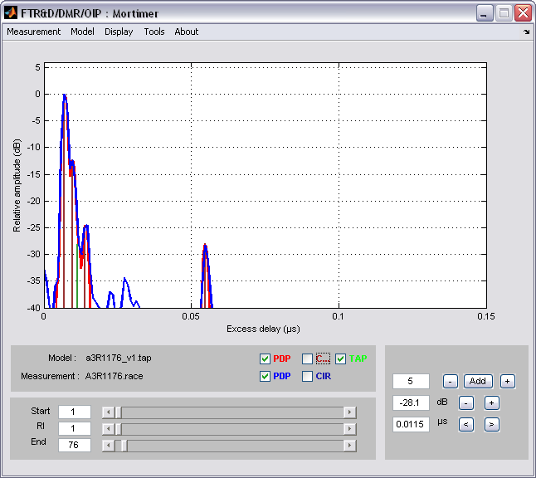

- Interface of Tapped Delay Line analysis tool.

Figure Figure 19 presents the analysis tool interface. Different plots are available to analyze data:
- Tapped delay line
- Power delay profile
- Instantaneous CIR
- Statistical distribution of delay spread
- Doppler spectrum
- Statistical distribution of received power (wideband or for a given excess delay)
- Temporal variation of wideband power (wideband or for a given excess delay)
- Optimal BER curves

  - Tapped delay line conversion

As presented in section 4, France Telecom Research and Development Division wideband channel models rely on typical measurement files, selected into a large amount of experimental data. The propagation channel is described by a set of CIRs. These files include all propagation effects (multipath, fading…).
Different ways exist to convert a measurement file into a tapped delay line model. The channel modeling by typical measurement was first introduced by RACE ATDMA projects. In the final propagation report [15], the project proposed an algorithm to convert typical measurements into tap delay line models. The problem has been splitted in two parts. The first one is to model the power delay profile using a tapped delay line (amplitude and delay). The second one is to define the statistical distribution and Doppler Spectrum of each path.
Due to the small number of paths, we used a manual method. Our Tapped Delay Line analysis tool performs a convenient interface to set and move each path of the model .The tool gives in real time the result of the model.
To set the Doppler parameters, the fading of each path is analyzed. The Doppler spectrum is plotted and the statistical distribution is evaluated. Different parameters such as delay spread distribution, wideband power distribution and optimal BER curve are used to valid Doppler parameters.

  - Example of tapped delay line model analysis

One example of the tapped delay line modeling is presented from measurements of the residential environment with a sectoral antenna in LOS configuration in figure Figure 20.
The first peak (1) corresponds to the direct path, so the variations are slow and correspond to the loss due the distance between receiver and transmitter. The two following peaks (2 and 3) correspond to reflected or diffracted paths. The peak (4) is a reflection of the direct path on a wall at the opposite of the transmitter. The amplitude variations of each peak allow for the evaluation of the small scale variation law.

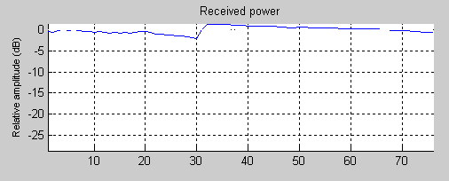
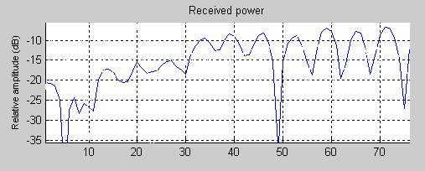
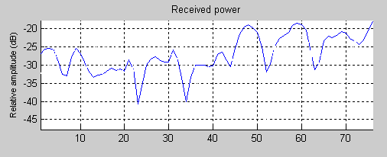
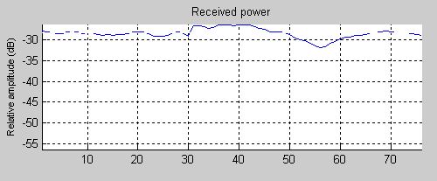
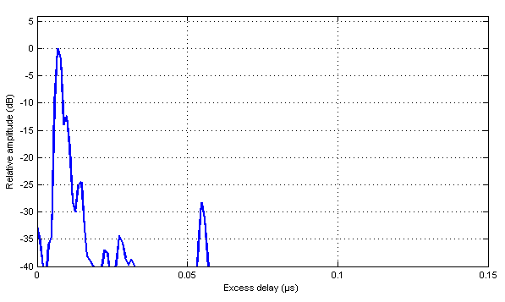
1
2
3
4

- PDP of a typical file and received power variation for each peak.

