Project | IEEE 15.4a
Title | UWB PHY Draft Optional Chaotic Pulses
Date Submitted | [Nov., 2005]
Source | [Jae-Hyon Kim,  Min-Seop Jeong]  Samsung Electronics Co., Ltd. (Samsung Advanced Institute of Technology (SAIT))  [Wan-Cheol Yang,  Sang-Yub Lee]  Samsung Electro-Mechanics Co., Ltd. (SEMCO) | Voice : [+82-31-280-9663]  Fax : [+82-31-280-9569]  E-mail : [jae.kim@samsung.com]  Voice : [+82-31-218-2163]  Fax : [+82-31-300-7900]  E-mail:[wan-chul.yang@samsung.com]
Re: | [Preliminary UWB PHY Optional Chaotic draft for further editing ]
Abstract | [Definition of the UWB Chaotic ]
Purpose | [Document to be discussed and edited]
Notice | This document has been prepared to assist the IEEE P802.15. It is offered as a basis for discussion and is not binding on the contributing individual(s) or organization(s). The material in this document is subject to change in form and content after further study. The contributor(s) reserve(s) the right to add, amend or withdraw material contained herein.
Release | The contributor acknowledges and accepts that this contribution becomes the property of IEEE and may be made publicly available by P802.15.

6.8a.3.3.5 UWB PHY Optional Chaotic pulses
As a generator of chaotic oscillations a model of ring-structure oscillator with 4.5 degrees of freedom can be represented with the combination of following first and second order differential equations.

$\begin{aligned}T{\overset{˙}{x}}_{1}+x_{1}=\text{mF}(x_{5}) \\ {\overset{¨}{x}}_{2}+α_{2}{\overset{˙}{x}}_{2}+ω_{2}^{2}x_{2}=ω_{2}^{2}x_{1} \\ {\overset{¨}{x}}_{3}+α_{3}{\overset{˙}{x}}_{3}+ω_{3}^{2}x_{3}=α_{3}{\overset{˙}{x}}_{2} \\ {\overset{¨}{x}}_{4}+α_{4}{\overset{˙}{x}}_{4}+ω_{4}^{2}x_{4}=α_{4}{\overset{˙}{x}}_{3} \\ {\overset{¨}{x}}_{5}+α_{5}{\overset{˙}{x}}_{5}+ω_{5}^{2}x_{5}=α_{5}{\overset{˙}{x}}_{4}\end{aligned}$ (1)

where, m , α_{2,} α_{3,} α₄, α₅, ω₂, ω₃, ω₄, ω₅, T, e₁, and e₂ are a set of parameters which is required to generate chaotic signal for a specific RF band, and the $F(z)$ is non-linear amplifier which is represented by a piecewise-linear function

$F(z)=\left[\left|z+E_{1}\right|−\left|z−E_{1}\right|+\frac{\left|z−E_{2}\right|−\left|z+E_{2}\right|}{2}\right]$ (2)

and the function F(z) is plotted in Figure 1

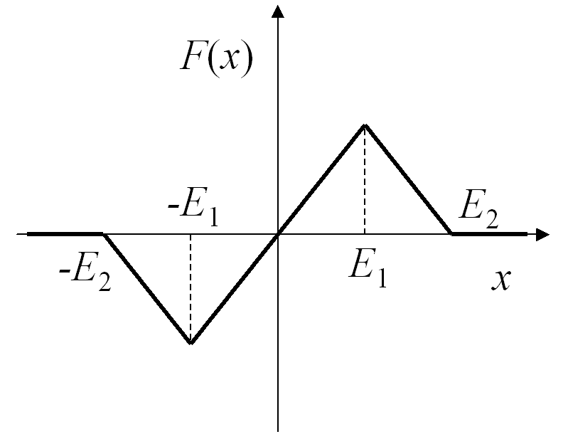
Figure 1 Nonlinear function F

The Chaotic signal is obtained from $c(t)=x_{5}(t)$, the last second order differential equations
In optional Chaotic waveform, the two possible modulation shall be used. On-off Keying (OOK) modulation which is mandatory and Differential Chaos Shift Keying (DCSK) shall be optional. The block diagram for these two kind of modulation scheme is depicted in Figure 2

Figure 2 UWB PHY Transmitter Diagram

6.8a.3.3.5.1 Frequency Bands
The numerical values of the 15 frequency bands for the Chaotic signal shall be as defined in the Section 6.1.2.1b

The recommended Chaotic signal generator parameters for the mandatory Channel 1 are m =200, T = 2.5, α₂ =0.2, α₃ =2.55, α₄ =0.3912, α₅ =2.2, ω₂ = 1, ω₃ =0.93, ω₄ = 0.989, ω₅ = 0.989, E₁ = 0.5 and E₂ = 1. Others Chaotic signals for the optional channel can be obtained by adjusting the values of the parameters.

6.8a.3.3.5.2 Preamble
All the preamble field length, and ranging/acquisition codes S_{i} shall be as defined in the Table 1 and Table 2 in Section 6.8a.2

In case of preamble modulation, a single chip bit of the S code shall be mapped to a Chaotic On-off Keying (OOK) chaotic pulse or Differential Chaos Shift Keying (DCSK) pulse as shown in Table 1 and 2 respectively. The duration of the pulse shall be T_{DC} = 32.3887 nsec.

Table 1 Ternary Code to OOK Chaotic pulse Mapping
Ternary Code Chip  (b_{i}) | OOK Chaotic Pulse
- | c(t)
0 | 0
+ | - c(t)

Table 2 Ternary Code to DCSK pulse Mapping
Ternary Code Chip  (b_{i}) | DCSK Pulse
- | Ref . & ( - Data)
0 | 0
+ | Ref . & ( + Data)

In case of the OOK (mandatory) modulation, the following equation

$\left\{\begin{matrix}\sum_{j=1}^{{\text{Code}}_{\text{length}}}{c(t)\left[p(t+j\left|s_{j}\right|T_{\text{DC}})\right]} ; s_{j}≠0 \\ 0 ; s_{j}=0, (j−1)T_{\text{DC}}≤t≤{\text{jT}}_{\text{DC}}\end{matrix}\right.$ (3)
where,
$p(t)=\left\{\begin{matrix}1; \left|t\right|≤\frac{T_{\text{DC}}}{2} \\ 0; \text{otherwise}\end{matrix}\right.$
The $c(t)$ is the waveform of chaotic symbol, s_{j} is the element of preamble code vector $S=[s_{1},…,s_{{\text{Code}}_{\text{length}}}]$ which takes the possible values are $\left\{−1, 0, +1\right\}$, p(t) is the transmitted pulse shape at the input to the antenna, and T_{PPM} is the duration of the binary pulse position modulation time slot.

In case of optional DCSK optional modulation for the Chaotic waveform preamble, we have following equations

$\left\{\begin{matrix}\sum_{j=1}^{{\text{Code}}_{\text{length}}}{c(t)\left[p(t+j\left|s_{j}\right|T_{\text{DC}})+p(t+j\left|s_{j}\right|T_{\text{DC}}−\frac{T_{\text{DC}}}{2}\right]} ; s_{j}≠0 \\ 0 ; s_{j}=0, (j−1)T_{\text{DC}}≤t≤{\text{jT}}_{\text{DC}}\end{matrix}\right.$ (4)

where, $c(t)$, s_{j} , and T_{PPM} are as same as OOK and $p(t)$ is as following

$p(t)=\left\{\begin{matrix}1; \left|t\right|≤\frac{T_{\text{DC}}}{4} \\ 0; \text{otherwise}\end{matrix}\right.$

The DCSK pulse is shown in Figure 3

Figure 3 UWB PHY Symbol Timing

6.8a.3.3.5.3 UWB PHY Symbol (Chaotic)
The UWB PHY symbol can be expressed with the following equation shown below, where, $x^{(k)}(t)$is the waveform of the k^{th} information bearing symbol, g₀, and g₁ are the modulation symbols obtained from a mapping of the coded bits, p(t) is the transmitted pulse shape at the input to the antenna, and T_{PPM} is the duration of the binary pulse position modulation time slot. The hopping sequence h^{(k)}, provides suppression of multi-user interference.

For the case of OOK modulation, the $T_{\text{PPM}}$ time shift is occurred due to the change of $g_{0}$symbol type and time slot with separation $T_{\text{DC}}$ of is determined by the hopping sequences

$x_{{\text{DC}}_{\text{OOK}}}^{(k)}(t)=c(t)\left[p(t−g_{0}^{(k)}T_{\text{PPM}}−h^{(k)}T_{\text{DC}})\right]$ (6)
where,
$$p(t)=\left\{\begin{matrix}1; \left|t\right|≤\frac{T_{\text{DC}}}{2} \\ 0; \text{otherwise}\end{matrix}\right.$$

For the case of DCSK modulation, the procedure of time shift and determination of time slot is same as OOK modulation. In this case the left half of $T_{\text{DC}}$ is occupied by the reference signal and $g_{1}$ is determined by the sing of bit. The hopping sequence remains as same as in case of OOK, and it is determined by the scrambler.

$x_{{\text{DC}}_{\text{DCSK}}}^{(k)}(t)=c(t)\left[p(t−g_{0}^{(k)}T_{\text{PPM}}−h^{(k)}T_{\text{DC}})+g_{1}^{(k)}p(t−g_{0}^{(k)}T_{\text{PPM}}−\frac{T_{\text{DC}}}{2}−h^{(k)}T_{\text{DC}})\right]$(5)

where,

$p(t)=\left\{\begin{matrix}1; \left|t\right|≤\frac{T_{\text{DC}}}{4} \\ 0; \text{otherwise}\end{matrix}\right.$

The Table 3 shows the modulation symbol bit to Chaotic pulse mapping relationship.

Table 3 UWB PHY Bit to Modulation Symbol Mapping
Information bits  (b₁b₀) | Modulation Symbols  (g₁g₀) | Chaotic Pulse  OOK | Chaotic Pulse  DCSK | Position
00 | -10 | 0 | Ref & (-Data) | Left
01 | -11 | 1 | Ref & (-Data) | Right
10 | 10 | 0 | Ref & (+Data) | Left
11 | 11 | 1 | Ref & (+Data) | Right

