IEEE P802.15.4a
Wireless Personal Area Networks

Project | IEEE P802.15 Working Group for Wireless Personal Area Networks (WPANs)
Title | Informative Annex D1 drafting
Date Submitted | Annex ENovember 28, 2005
Source | Camillo Gentile, National Institute of Standards and Technology (NIST), USA | Voice:  Fax:  E-mail:  camillo.gentile@nist.gov
Re: | Draft informative Annex on Location Topics for 802.15.4a
Abstract | This document presents a survey of techniques and algorithms to reconstruct the location of devices in a network from range (or direction) data between nodes. It also considers implementation issues such as the error induces by drift in timing crystal offsets.
Purpose | To provide a working framework document of informative annex D1 for the TG4a draft.
Notice | This document has been prepared to assist the IEEE P802.15. It is offered as a basis for discussion and is not binding on the contributing individual(s) or organization(s). The material in this document is subject to change in form and content after further study. The contributor(s) reserve(s) the right to add, amend or withdraw material contained herein.
Release | The contributor acknowledges and accepts that this contribution becomes the property of IEEE and may be made publicly available by P802.15.
Annex D1
(informative)
Location Topics for use of the IEEE 802.15.4a standard

Introduction
To be completed.

E.1 Parameter (Range or Direction) Estimation Techniques

E.1.1 Range Estimation

E.1.1a Time of Arrival (Cut and paste from Doc. 15-04/0581r7)

Asynchronous two-way ranging

TOA ranging is discussed in references [2], [3], [9], [12], [13], [15], [18].

Classical ranging transactions (namely the Two Way Ranging -TWR- and the One Way Ranging -OWR- schemes), and the corresponding synchronization requirements, are highly dependant on the communication protocol and the network topology.

The first technique enabling the measure of the signal round-trip Time-Of-Flight (TOF) between two asynchronous transceivers consists in using a classical two-way remote synchronization technique.

Device A
Device B
Two equations in two unknowns yield:
* US Naval Observatory, Telstar Satellite, circa 1962
http://www.boulder.nist.gov/timefreq/time/twoway.htm
Unmatched detect-delays in the two devices may require one-time offset calibration.
Unknown propagation delay
Unknown clock offset
Message 1
Message 2
Multiple measurements of t_{p} and t_{o} yield finer precision & accuracy, and allow frequency offset correction.
Figure 1 Two-Way Time Transfer Model

A pair of terminals are time-multiplexed with half-duplex packet exchanges. This procedure relies on a typical mechanism for fused location and communication: a requestor sends packets to a responder which replies after synchronizing with packets containing synchronous timing information. The reception of this response allows the requestor to determine the round-trip TOF information (Figure 2).

This solution seems to be particularly adapted for distributed networks (a fortiori in the lack of coordination) .
A
B
TOF
TOF
Channel
Acquisition
Synchro H
Communication Payload
Preamble Acquisition Header
Tround
Response Delay
Elapsed times measured by the system

Transmitted packets

Received packets

Figure 2: Two Way Ranging (TWR) transaction enabling to estimate the round-trip Time-OF-Flight between two asynchronous terminals (feeding TOA-based positioning algorithms)

Synchronous one-way ranging

Now, if two terminals are synchronized to a common clock (i.e. sharing the same time reference and time base), it is clear that the TOF information can be directly obtained from a simple OWR transaction (not detailed here).

The two previous transactions provide so-called TOA location metrics corresponding to the relative distance between terminals. For the considered scenarios (TOA/TWR and TOA/OWR), slot lengths and procedures, fixed by a pre-existing communication standard, represent drastic constraints for the maximum and minimum (blind distances) relative measurable distances and the ranging accuracy.

A straightforward approach to calculate the position of a mobile terminal based upon TOA uses a geometric interpretation to calculate the intersection of circles for TOA-based algorithms. Indeed, if three TOA are measured between a mobile terminal and three (or more) distinct anchors (note that anchors should be considered as nodes doted with a prior knowledge of their relative positions), the mobile position can be easily computed in the 2-D plane. These solutions (geometrical solutions or solutions based on optimization procedures) correspond to popular radiolocation methods.
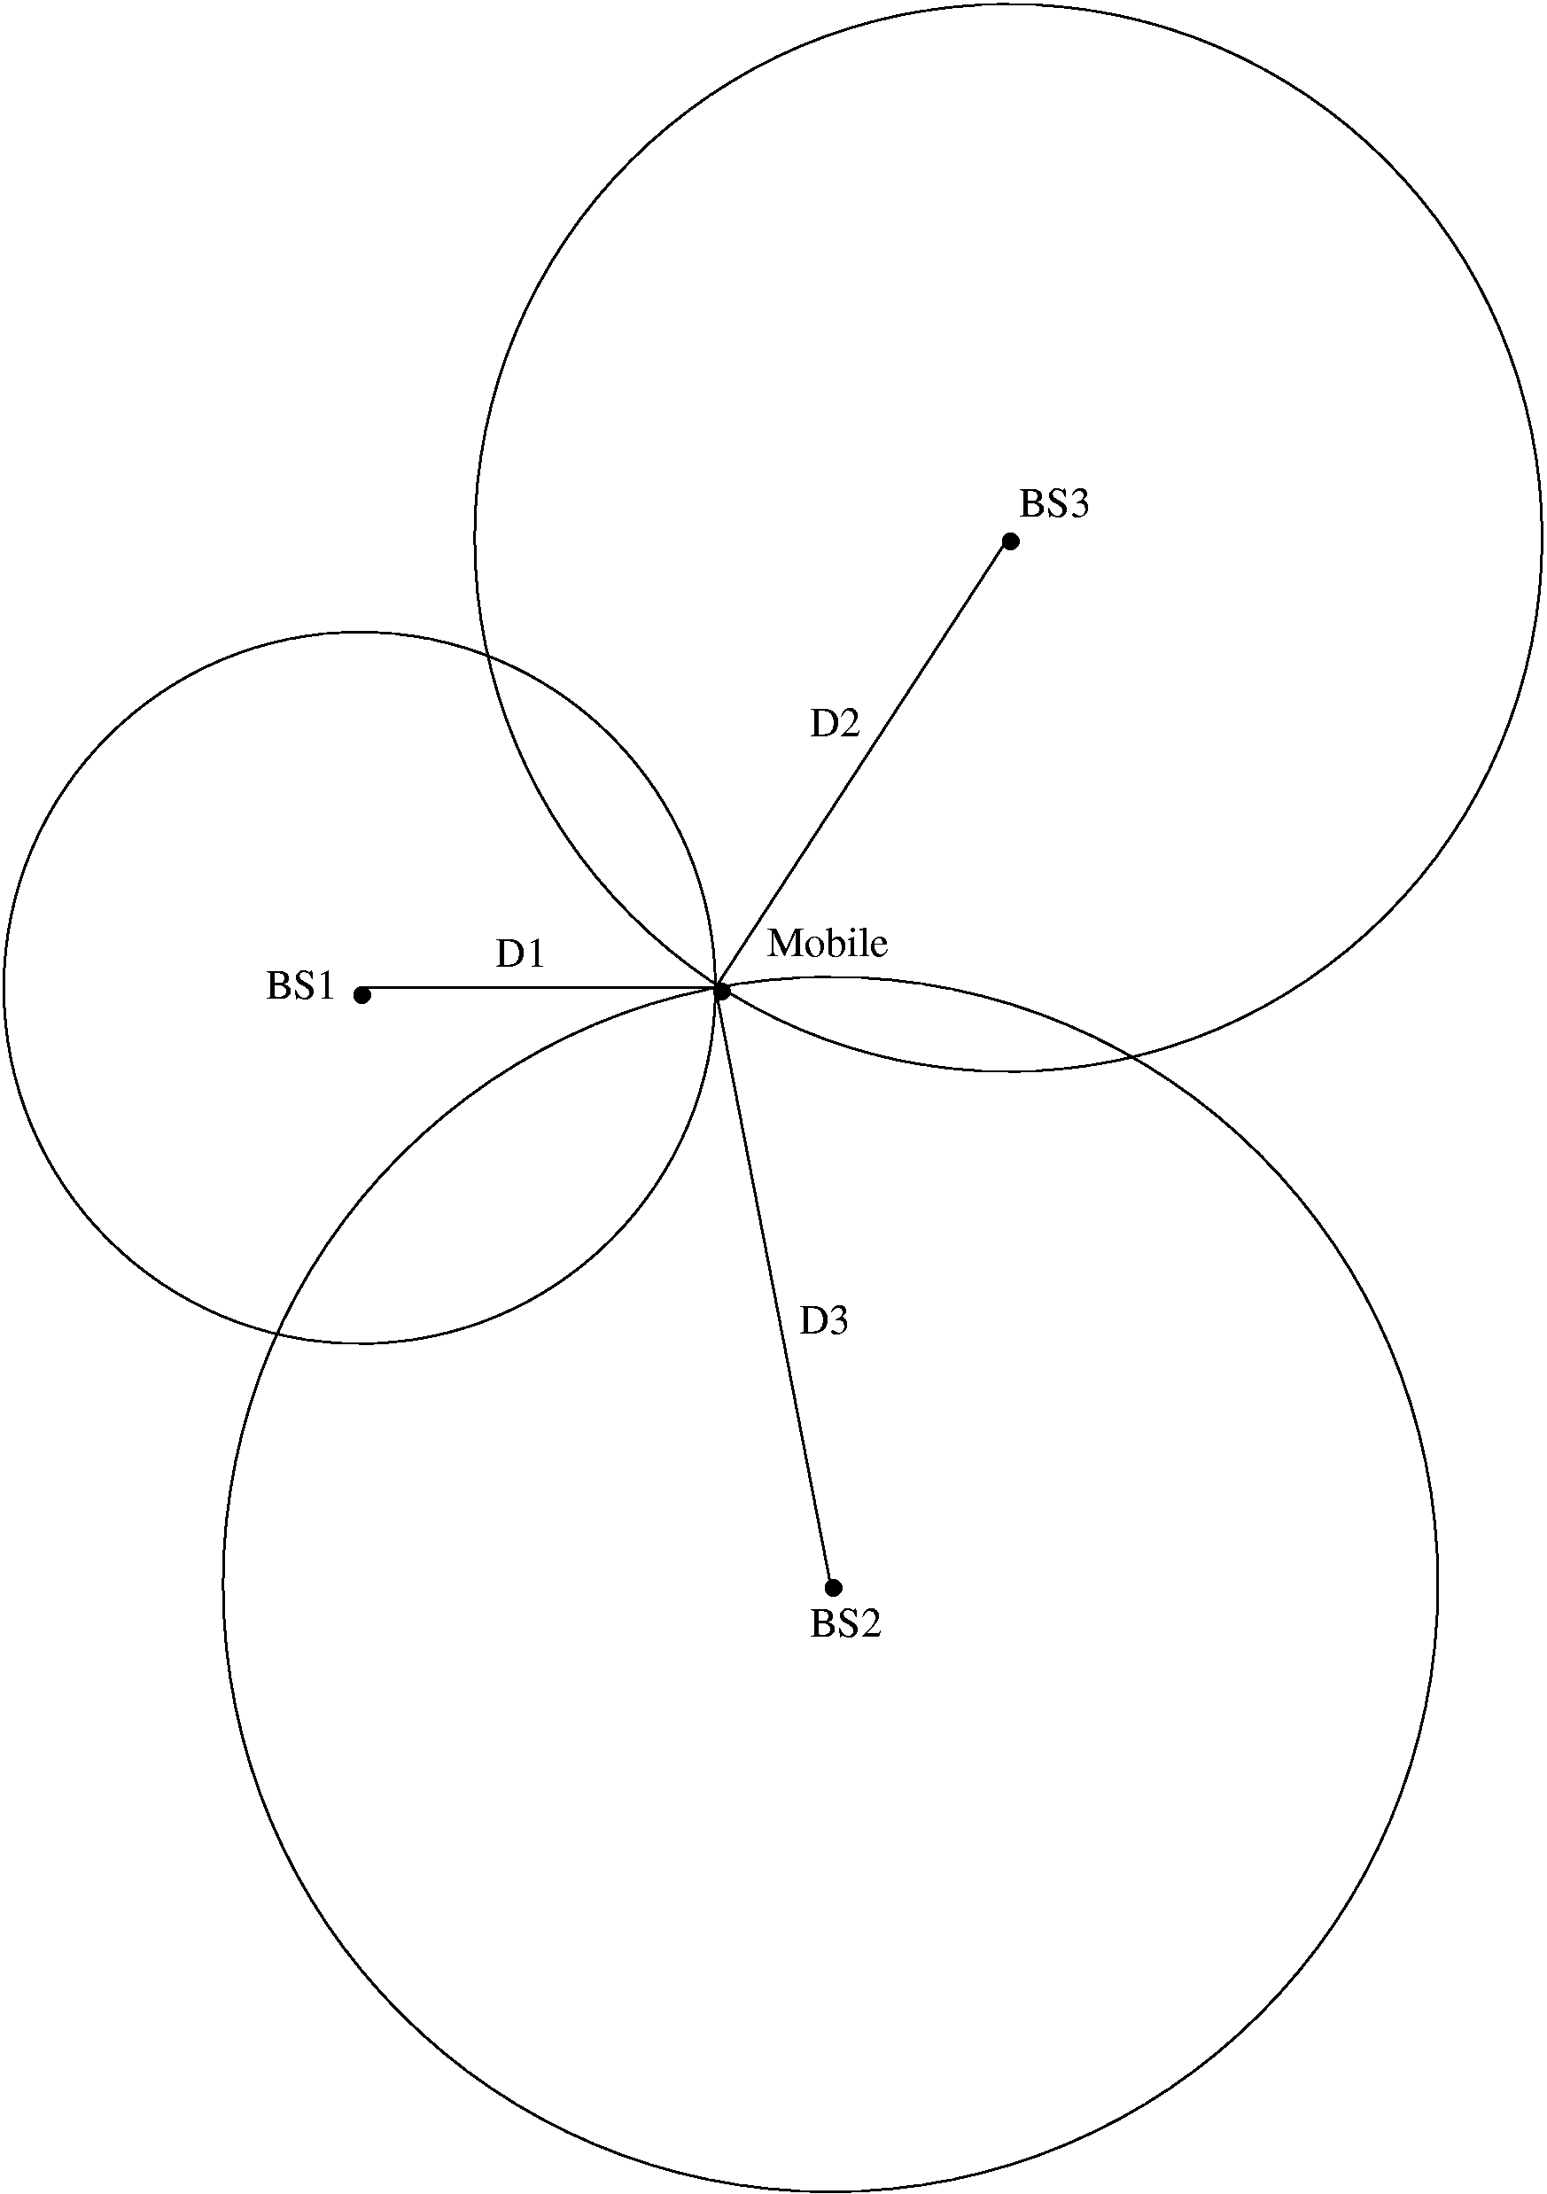
Mobile (x_{m},y_{m})
Anchor 2 (x_{A2},y_{A2})
Anchor 3 (x_{A3},y_{A3})
Anchor 1 (x_{A1},y_{A1})
Positioning from TOA
3 anchors with known positions (at least) are required to retrieve a 2D-position from 3 TOAs
Measurements
Estimated Position
Specific Positioning Algorithms
Figure 3 – Positioning from TOA

2.1 Double Token Exchange TOA (sometimes called DTOA)

A variant of TOA discussed in [15] is the token exchange method which is intended to accomplish ranging without synchronization of the local clocks. This method only requires that a ranging token be exchanged twice between two units in the following manner:

1) DEV A sends a ranging token to DEV B
2) DEV B holds onto the token for a time τ and then sends the token back to DEV A
3) Next DEV A sends a second ranging token to DEV B
4) DEV B holds onto the token for a time 2τ and then sends the token back to DEV A
5) DEV A calculates the ranging information as discussed above

Figure 4 illustrates the message sequence involved when requesting a range measurement. The ranging command initiates the precise exchange of a ranging token between the source DEV and the destination DEV as shown in the message sequence chart below.

Figure 4— MSC for ranging token exchange

The time of flight between the two devices is then calculated as

T_{flight} = {T¹(3)- T¹(0)} - [{T²(3)- T²(0)}/2]

where the time epochs are defined in Figure 4.

E.1.1b Time Difference of Arrival (TDOA) (Cut and paste from Doc. 15-04/0581r7)

TDOA ranging is discussed in references [2], [3], [8].

TDOA is related to TOA inasmuch as the time difference between synchronized reference anchor terminals is calculated and used for the localization calculations. The TDOA is traditionally obtained through OWR transactions (Figure 5). In this scheme, a pair of isochronous terminals, viewed as anchors, preliminary detect the TOA associated with packets emitted by the mobile. The TOAs are estimated relative to a common reference time (shared among references) but independent on the actual transmission time.

Time Difference Of Arrival (TDOA) & One Way Ranging (OWR)
T_{o}
Mobile TX
Anchor 1 RX
T_{OF,1}
T₁
Anchor 2 RX
T_{OF,2}
T₂
Anchor 3 RX
T_{OF,3}
T₃
Anchor 1
Anchor 2
Anchor 3
Mobile
Isochronous
Info T₂
Info T₃
Info T₂
Info T₃
TOA Estimation
TDOA Estimation
TDOA Estimation
Passive Location
TOA Estimation
Isochronous
Figure 5 – TDOA and OWR

Anchors have to be re-synchronized with an external clock or by a beacon signal periodically broadcasting packets to all the fixed references. This beacon signal may come from a coordinator or a dedicated terminal. Note that “synchronization” means “absolute synchronization” here, and implies that anchors know their relative distance to the beacon provider.

Reference Time

A
Mobile Terminal

TOF(A-B)

B

Isochronous Terminals
Transmitted packets
TOA_{B}

C
Received packets
Elapsed times measured by the system
TOF(A-C)
TOA_{C}

Figure 6: One Way Ranging (OWR) Protocol allowing to estimate differential Time of Arrival at a couple of two isochronous terminals (feeding TDOA-based positioning algorithms)

Finally, the approach taken to calculate the position of a mobile terminal for TDOA location metrics involves making two or more TDOA measurements. A straightforward approach uses a geometric interpretation to calculate the intersection of two or more hyperbolas for TDOA-based algorithms. If two or more TDOA measurements can be formed at a set of three or more distinct anchors, the mobile position can be easily computed in the 2-D plane.

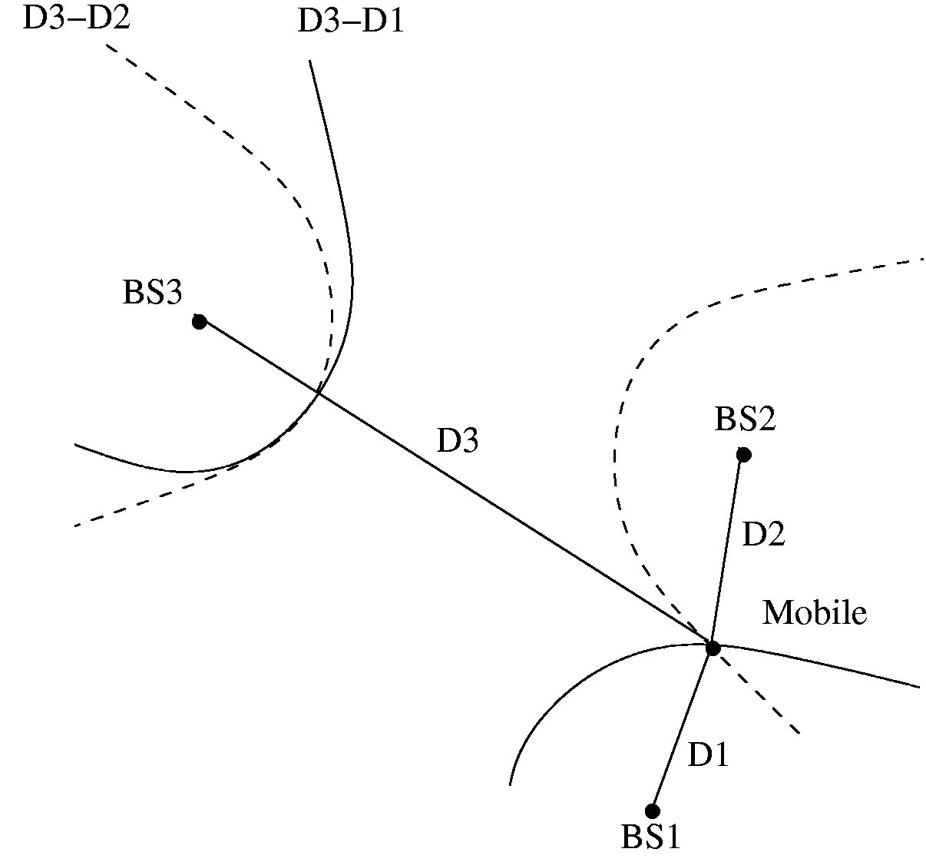
Mobile (x_{m},y_{m})
Anchor 1 (x_{A1},y_{A1})
Anchor 2 (x_{A2},y_{A2})
Anchor 3 (x_{A3},y_{A3})
Positioning from TDOA
3 anchors with known positions (at least) are required to find a 2D-position from a couple of TDOAs
Measurements
Estimated Position
Specific Positioning Algorithms

Figure 7 – Positioning from TDOA

Note that the basis for TDOA is one-way ranging (OWR). The implementation of OWR can be done in one of two forms; that is, either active OWR where the unknown station is transmitting or passive where the unknown stations is receiving. The primary implication is where the TDOA hyperbolas are collected for processing.

TDOA can operate in one of two modes …

Mode 1 – The station of interest (SOI) receives multiple reference pulses and calculates the TDOA
LORAN-C type operation and the processing burden is on the receiver to run the hyperbolic location algorithms

Mode 2 – The station of interest transmits a reference pulse which is received by multiple fixed nodes
The fixed nodes must forward the TDOA information to a workstation which then runs the hyperbolic location algorithms²
Key:
Sync Pulse
Location Pulse
Position Report
Mode 1 - Passive
Key:
Sync Pulse
Location Pulse
TDOA backhaul
Mode 2 - Active
controller
controller
reference node
reference node
SOI
SOI
Note: The sync pulse accuracy determines the TDOA accuracy and hence the sync pulse requires a wideband transmission
Figure 8 – Passive and Active TDOA OWR

E1.1c Time Sum of Arrival (TSOA)
To be completed.

E.1.1d Signal Strength Ranging (SSR) (Cut and paste from Doc. 15-04/0581r7)

SSR ranging is discussed in references [7], [17].

SSR ranging is already supported by the 802.15.4 standard because it runs off the RSSI. SSR ranging is simple and does not require the synchronization needed for TOA and TDOA based ranging; however, there are issues with attenuation variance due to multipath, etc, which require multiple measurements and measurement averaging.

We start our analysis by considering the case of free space propagation. In free space propagation, the received power, as a function of distance, is given as $P_{r}(d)=P_{t}G_{t}G_{r}{\left(\frac{λ}{4πd}\right)}^{2}\text{ Watts}$. In free space, the “large-scale” energy attenuation obeys an inverse square law relationship $L\left(d\right)=\text{10}\text{log}\text{10}\left(\frac{\text{Pr}}{\text{Pt}}\right)=\text{10}\text{log}\text{10}\left(\frac{(4πd)^{2}}{G_{t}G_{r}λ^{2}}\right)$. In practice, the far field received power is reference to a distance d₀ as $P_{r}(d)=P_{r}(d_{0}){\left(\frac{d_{0}}{d}\right)}^{2}$. In terrestrial settings, additional mechanisms such as reflection, diffraction and scattering affect wave propagation and causing “small-scale” slow and fast fading components. For ranging we’d like to extract the large-scale attenuation from the combined large and small scale attenuation.

Figure 9 – Large-scale Fading

With wideband signals the mean received power can be calculated by summing the powers of the multipath in the power delay profile. With narrowband signals, received power experiences large fluctuations over a local area and averaging must be used to estimate the mean received power. Range can be estimated via $\hat{d}=d_{0}{\text{10}}^{\frac{p_{0}−\hat{p}(d)}{\text{10}n}}=d{\text{10}}^{\frac{X_{σ}}{\text{10}n}}$. The range estimation distribution variance decreases with decreasing distance.

E.1.1d NFER
(While Rick Roberts and the ranging subcommittee did an excellent job of describing this technique, it does not seem to have much application in the standard given the high-frequencies in the band of interest (3-10GHz), and in turn the very limited (sub-meter) range the NFER offers.)

E.1.2 Direction Estimation: AOA (Cut and paste from Doc. 15-04/0581r7)

AOA ranging is discussed in reference [6].

AOA, by itself, is a localization technique as opposed to a ranging technique; however, AOA does not require the precise synchronization needed for TOA and TDOA methods. When combined with a viable ranging technique, AOA allows vector ranging which opens up interesting possibilities.

The angle of arrival is the direction to the source of an incoming wave field as measured by an array of antenna elements. The planar wave front models the incoming wave far field by measuring the phase (time) difference of the wave front at different array elements.

Y
(x,y)
Source
X
R
Range
θ
Azimuth
2D model
Array
Elements
X
R
φ
θ
(x,y,z)
Z
Y
Azimuth
Elevation
Range
Source
Array Elements
3D model
Figure 13 – 3D and 2D Localization

A phased array antenna system consists of any number of antenna elements distributed in a particular geometrical pattern, with the output of all the antenna elements vectorially added to synthesize a particular antenna pattern in the direction of the incoming source fields.

Figure 14 – Phased Array Antenna

As long as the spatial sampling requirement is met, larger arrays generally provide better resolution of the source field, but with increasing size and cost. In the case of UWB, the maturity of UWB antenna array technology must be taken into consideration.

Special consideration is needed for multipath environments and for multi-source cases since sources can be closely spaced. In non-line-of-sight environments, the measured AOA might not correspond to the direct path component of the incoming wave field which can lead to large positioning errors.

Two dimensional positioning requires measurement of the AOA by at least two antenna array systems. In practice, measurement errors arise due to: imperfect array phase and gain calibration, improper modeling of the mutual coupling between elements, and error due to the presence of a strong indirect path.

True line of position
Measurement error
DEV-A
DEV-B
DEV-C
Figure 15 – Two Dimensional Positioning

E.1.3 Combined Range and Direction Estimation
To be completed.

E.2 Location Estimation Algorithms

E.2a Location Estimation from Range Data
Given a network of nodes consisting of fully-functioning devices (FFD) (of which at least four have known locations in a three-dimensional network) and reduced-functioning devices (RFD), and a set of estimated ranges between neighboring devices in the network, estimate the locations of the unknown devices in the network.

E.2b Location Estimation from Direction Data
Given a network of nodes consisting of fully-functioning devices (FFD) (of which at least three have known locations in a three-dimensional network) and reduced-functioning devices (RFD), and a set of estimated directions between neighboring devices in the network, estimate the locations of the unknown devices in the network.

E.3. Leading Edge Detection

E.3.1 A First-arrival Detection Method (Based on Doc. 15-05/0406r0)

E.3.2 Coherent delay estimation with low sampling rate and feasible ADC
implementation (Based on Doc. 15-05/0524r1)

E.4 Error Induced by Timing Crystal Offset (Based on Doc. 15-05/0335r1)

One way ranging is scalable to large networks resulting in lower overhead.
A variation of this packet exchange technique, mentioned in [15], uses dual packet exchanges and measures the difference of TOA in an attempt to calibrate out the clock drift from the other cooperating device. In principle, this technique does not require precise clock calibration between the two ranging devices. This technique has been called Differential-Time-of-Arrival (DTOA), but in general we reframe from this nomenclature to avoid confusion with TDOA (Time-Difference-of-Arrival). Instead we’ll call it the “double token exchange” method and it is covered in section 2.1.
The source device calculates the ranging information. If the destination device wants range information it will have to send a ranging command in the reverse direction.
It is similar to SSR (signal strength ranging) in this sense.
Whether or not the far-field planar wave approximation holds well will depend on the array aperture and the minimum wavelength of the source signal. In the near field, the phase (time) difference at different array elements becomes a non-linear function of the source’s position.
There is a spatial sampling requirement that limits the inter-element spacing of antenna elements to be ≤½ minimum source wavelength.

