IEEE P802.15.4a
Wireless Personal Area Networks

Project | IEEE P802.15 Working Group for Wireless Personal Area Networks (WPANs)
Title | Informative Annex E drafting
Date Submitted | Annex ENovember 15, 2005
Source | Patricia Martigne, France Telecom R&D | Voice:  Fax:  E-mail:  patricia.martigne@francetelecom.com
Re: | Draft informative Annex on Coexistence for 802.15.4a
Abstract | Coexistence issues for TG4a are addressed in Annex E, a draft of which is provided.
Purpose | To provide a working framework document of informative annex E for the TG4a draft.
Notice | This document has been prepared to assist the IEEE P802.15. It is offered as a basis for discussion and is not binding on the contributing individual(s) or organization(s). The material in this document is subject to change in form and content after further study. The contributor(s) reserve(s) the right to add, amend or withdraw material contained herein.
Release | The contributor acknowledges and accepts that this contribution becomes the property of IEEE and may be made publicly available by P802.15.
Annex E
(informative)
Coexistence with other IEEE standards and proposed standards
While not required by the specification, IEEE 802.15.4 devices can be reasonably expected to “coexist,” that is, to operate in proximity to other wireless devices. Sections E.1 to E.4 of this annex considers issues regarding coexistence between IEEE 802.15.4 devices and other wireless IEEE-compliant devices. These sections also consider issues regarding coexistence between IEEE P802.15.4a CSS devices and other wireless IEEE-compliant devices.

Added section for TG4a :
With more and more radio services using the spectrum, coexistence is becoming a key issue. IEEE 802.19 TAG established some new procedures in 2005 which include the requirement for a Coexistence Assurance document from any IEEE 802 WG or TG drafting a new standard. Added sections in the present Annex addresses the coexistence between UWB (sections E5 to E10) 802.15.4a devices and other wireless IEEE-compliant devices.

E.1 Standards and proposed standards characterized for coexistence wrt IEEE 802.15.4 and 802.15.4a CSS devices
This clause enumerates IEEE-compliant devices that are characterized and the devices that are not characterized for operation in proximity to IEEE 802.15.4 devices.
As described in 6.1.2, the IEEE 802.15.4 PHYs are specified for operation in 27 channels. Channel 0 through channel 10 reside in frequencies in the 868 MHz and 915 MHz bands and, therefore, do not significantly interact with other wireless devices covered under the IEEE 802 wireless standards. Channel 11 through channel 26 span frequencies from 2405 MHz to 2480 MHz and, therefore, may interact with other IEEE-compliant devices operating in those frequencies.
Standards and proposed standards characterized in this annex for coexistence are
— IEEE Std 802.11b-1999 (2400 MHz DSSS)
— IEEE Std 802.15.1-2002 [2400 MHz frequency hopping spread spectrum (FHSS)]
— IEEE P802.15.3 (2400 MHz DSSS)
Standards not characterized in this annex for coexistence are:
— IEEE Std 802.11, 1999 Edition, frequency hopping (FH) (2400 MHz FHSS)
— IEEE Std 802.11, 1999 Edition, infrared (IR) (333GHz AM)
— IEEE Std 802.16-2001 (2400 MHz OFDM)
— IEEE Std 802.11a-1999 (5.2GHz DSSS)

E.1a This clause also enumerates IEEE-compliant devices that are characterized and the devices that are not characterized for operation in proximity to IEEE P802.15.4a CSS devices.

IEEE P802.15.4a CSS PHYs for ISM Band are specified for operation in 14 channels. Channel 0 through channel 14 resides in frequencies from 2412 MHz to 2484 MHz bands and, therefore, may interact with other IEEE compliant devices operating in those frequencies.

Standards and proposed standards characterized in this annex for coexistence are
IEEE Std 802.11b-1999 (2400 MHz DSSS)
IEEE Std 802.15.1-2002 [2400 MHz frequency hopping spread spectrum (FHSS)]
IEEE Std 802.15.3-2003 (2400 MHz DSSS)
IEEE Std 802.15.4-2003
IEEE P802.15.4a

Standards not characterized in this annex for coexistence are:
IEEE Std 802.11, 1999 Edition, frequency hopping (FH) (2400 MHz FHSS)
IEEE Std 802.11, 1999 Edition, infrared (IR) (333GHz AM)
IEEE Std 802.16-2001 (2400 MHz OFDM)
IEEE Std 802.11a-1999 (5.2GHz DSSS)

E.2 General coexistence issues wrt IEEE 802.15.4 and 802.15.4a CSS devices

…

E.2.6a Channel alignment
The alignment between IEEE 802.11b (nonoverlapping sets) and IEEE P802.15.4a CSS channels (overlapping sets) are shown in Figure E.1a. There are 14 IEEE P802.15.4a CSS channels (n = 1, 2, … , 14). Operating an IEEE P802.15.4a network on one of these channels will minimize interference between systems.

When performing dynamic channel selection, either at network initialization or in response to an outage, an IEEE P802.15.4a CSS device will scan a set of channels specified by the ChannelList parameter. For IEEE P802.15.4a networks that are installed in areas known to have high IEEE 802.11b activity, the ChannelList parameter can be defined as the above sets in order to enhance the coexistence of the networks.

Figure E.1a— IEEE P802.15.4a CSS channel selection

E.3 Coexistence performance wrt IEEE 802.15.4 and 802.15.4a CSS devices
The assumptions made across all standards characterized for coexistence are described in E.3.1. Subclauses E.3.2 and E.3.3 describe the assumptions made for individual standards and quantify their predicted performance when coexisting with IEEE 802.15.4 devices.
Subclauses E.3.2 and E.3.3 also describe the assumptions made for individual standards and quantify their predicted performance when coexisting with IEEE P802.15.4a CSS devices.
E.3.1 Assumptions for coexistence quantification
E.3.1.1 Channel model
E.3.1.2 Receiver sensitivity
The receiver sensitivity assumed is the reference sensitivity specified in each standards as follows:
-76 dBm for IEEE 802.11b 11 Mb/s CCK
-70 dBm for IEEE 802.15.1
-75 dBm for IEEE P802.15.3 22 Mb/s DQPSK
-85 dBm for IEEE 802.15.4
-80 dBm for IEEE 802.15.4a 1Mb/s CSS
-87 dBm for IEEE 802.15.4a 1Mb/s CSS

E.3.1.3 Transmit power
The transmitter power for each coexisting standard has been specified as follows:
14 dBm for IEEE 802.11b
0 dBm for IEEE 802.15.1
8 dBm for IEEE 802.15.3
0 dBm for IEEE 802.15.4
0 dBm for IEEE P802.15.4a (both 1Mb/s and optional 250Kb/s)

E.3.1.4 Receiver bandwidth
The receiver bandwidth is as required by each standard as follows:
a) 22 MHz for IEEE 802.11b
b) 1 MHz for IEEE 802.15.1
c) 15 MHz for IEEE P802.15.3
d) 2 MHz for IEEE 802.15.4
e) 22 MHz for IEEE P802.15.4a

E.3.1.5 Transmit spectral masks

Table E.5—Transmit mask for IEEE P802.15.4a CSS
Frequency | Relative limit
fc – 22 MHz < f < fc – 11 MHz and  fc + 11 MHz < f < fc + 22 MHz | –30 dBr
f < fc – 22 MHz and  f > fc + 22 MHz | –50 dBr

E.3.1.6 IEEE 802.11b transmit PSD
E.3.1.7 Interference characteristics
E.3.1.8 Bit error rate (BER) calculations
8) BER for IEEE 802.15.4a =

where M = 8 for 1 Mb/s, and M = 64 for optional 250 kb/s.

E.3.1.9 PER

- Average frame length for IEEE P802.15.4a = 32 bytes

E.3.2 BER model
This subclause presents the BER for standards characterized for coexistence. The BER results were obtained using the analytical model from IEEE P802.15.2. The calculation follows the approach outlined in 5.3.2 of that document and the conversion from SNR to BER uses the formulas in 5.3.6 of that document. Figure E.2 illustrates the relationship between BER and SNR for IEEE 802.11b, IEEE 802.15.3 base rate, IEEE 802.15.1, and IEEE 802.15.4.
Figure E.2a illustrates also the relationship between BER and SNR for IEEE 802.11b, IEEE 802.15.3 base rate, IEEE 802.15.1, IEEE 802.15.4, and IEEE P802.15.4a CSS.

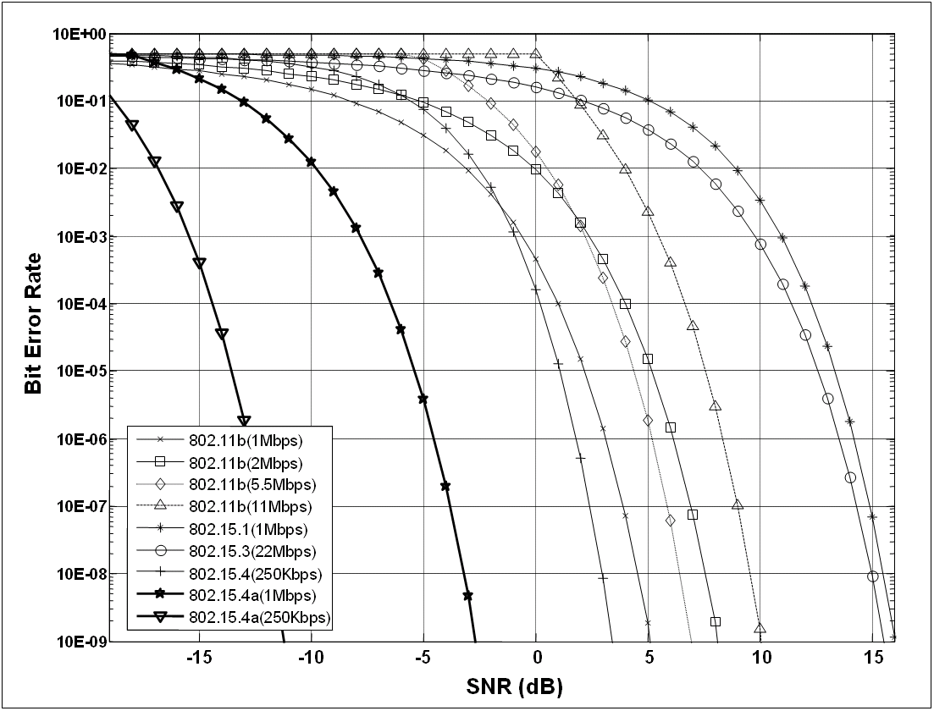
Figure E.2a—BER Results of IEEE 802.11b, IEEE 802.15.1, IEEE 802.15.3, IEEE 802.15.4 (2400 MHz PHY) and IEEE P802.15.4a CSS

E.3.3 Coexistence simulation results
E.3.3.1 Transmit and receive masks
The transmit and receive masks used are defined in Table E.6

Table E.6 – Transmit and receive masks

IEEE802 | Transmit |  | Receive
IEEE802 | Frequency offset (MHz) | Attenuation  (dB) | Frequency offset  (MHz) | Attenuation  (dB)
15.1 | 0 | 0 | 0 | 0
15.1 | 0.25 | 0 | 0.25 | 0
15.1 | 0.75 | 38 | 0.75 | 38
15.1 | 1 | 40 | 1 | 40
15.1 | 1.5 | 55 | 1.5 | 55
11b | 0 | 0 | 0 | 0
11b | 4 | 0 | 4 | 0
11b | 6 | 10 | 6 | 10
11b | 8 | 30 | 8 | 30
11b | 9 | 55 | 9 | 55
15.4 | 0 | 0 | 0 | 0
15.4 | 0.5 | 0 | 0.5 | 0
15.4 | 1 | 10 | 1 | 10
15.4 | 1.5 | 20 | 1.5 | 20
15.4 | 2 | 25 | 2 | 25
15.4 | 2.5 | 30 | 2.5 | 30
15.4 | 3 | 31 | 3 | 31
15.4 | 3.5 | 33 | 3.5 | 33
15.4 | 4 | 34 | 4 | 34
15.4 | 5 | 40 | 5 | 40
15.4 | 6 | 55 | 6 | 55
15.4a - CSS | 0 | 0 | 0 | 0
15.4a - CSS | 6 | 0 | 6 | 0
15.4a - CSS | 12 | 32 | 12 | 32
15.4a - CSS | 15 | 55 | 15 | 55

Figure E.9—IEEE P802.15.4a CSS receiver (1Mbps), IEEE 802.11b interferer

Figure E.10—IEEE 802.11b receiver, IEEE P802.15.4a CSS interferer

Figure E.11—IEEE P802.15.4a CSS receiver (1Mbps), IEEE 802.15.1 interferer

Figure E.12—IEEE 802.15.1 receiver, IEEE P802.15.4a CSS interferer

Figure E.13—IEEE P802.15.4a CSS receiver (1Mbps), IEEE 802.15.3 interferer

Figure E.14—IEEE 802.15.3 receiver, IEEE P802.15.4a CSS interferer

Figure E.15—IEEE P802.15.4a CSS receiver (1Mbps), IEEE 802.15.4 interferer

Figure E.16—IEEE 802.15.4 receiver, IEEE P802.15.4a CSS interferer

E.4 Notes on the calculations
The calculations for this annex were based on the formulas and descriptions from IEEE P802.15.2.

E.5 Standards and proposed standards characterized for coexistence wrt IEEE 802.15.4a UWB devices between 3.1 and 10.6 GHz
This clause enumerates IEEE-compliant devices that are characterized and the devices that are not characterized for operation in proximity to IEEE 802.15.4a UWB devices.
The IEEE 802.15.4a UWB PHYs other than the sub-GHz PHY are specified for operation in the 3.1 – 10.6 GHz band.
Standards and proposed standards characterized in this annex for coexistence are
• Bluetooth™ (IEEE 802.15.1) – adjacent band
• P802.15.3 - adjacent band
• IEEE 802.11b,g – adjacent band
• IEEE 802.11a – in-band
• IEEE 802.15.4 – adjacent band
- IEEE 802.16a – in-band

Standards not characterized in this annex for coexistence are:
To be completed

E.6 General coexistence issues wrt IEEE 802.15.4a UWB devices between 3.1 and 10.6 GHz
To be completed

E.7 Coexistence performance wrt IEEE 802.15.4a UWB devices between 3.1 and 10.6 GHz
To be completed

E.8 Standards and proposed standards characterized for coexistence wrt IEEE 802.15.4a sub-GHz UWB devices
To be completed.

E.9 General coexistence issues wrt IEEE 802.15.4a sub-GHz UWB devices
To be completed

E.10 Coexistence performance wrt IEEE 802.15.4a sub-GHz UWB devices
To be completed

