IEEE P802.15
Wireless Personal Area Networks

Project | IEEE P802.15 Working Group for Wireless Personal Area Networks (WPANs)
Title | TG3c Down Selection Procedure
Date Submitted | [January 18, 2006]
Source | [Alireza Seyedi]  [Philips]  [345 Scarborough Rd., Briarcliff Manor, NY, 10510, USA] | Voice: [+1 914-945-6318]  FAX: [+1 914-945-6330]  E-Mail: [alireza.seyedi@ieee.org]
Re: | []
Abstract | [Down selection voting procedure for TG3c Alternate PHY selection.]
Purpose | [This document defines the down selection voting procedure for the TG3c Alternate PHY selection effort. Some text from TG4a down selection procedure (04/247r3) has been reused in this document.]
Notice | This document has been prepared to assist the IEEE P802.15. It is offered as a basis for discussion and is not binding on the contributing individual(s) or organization(s). The material in this document is subject to change in form and content after further study. The contributor(s) reserve(s) the right to add, amend or withdraw material contained herein.
Release | The contributor acknowledges and accepts that this contribution becomes the property of IEEE and may be made publicly available by P802.15.

TG3c Down Selection Procedure (Draft)

This document defines the procedure by which the TG3c will form one base line draft for the IEEE 802.15.3c Standard, from the proposals submitted in response to the Call for Proposals (CFP), 06-nnnn-rr.

The task group reserves the right to change the selection process and selection criteria as required with a 75% approval.

- Proposer(s) can withdraw their proposal at any time during the process.
- During the down selection voting process mergers will be allowed between remaining proposals, and between remaining proposals and proposals that have been eliminated. Mergers shall not be allowed between eliminated proposals only.
- The presentation of the proposed solutions shall be limited to 60 minutes, including discussion. As per IEEE 802.15 WG’s P&P; discussion shall be limited to voting members and the presenters or their proxy, however non-voting members may participate in the discussion at the discretion of the TG3c Chair.
- Presenters of each proposal shall be given the opportunity to make a final 5 minute statement to the group advocating their proposals just before the down selection voting starts. At the TG3c Chair’s discretion, an elimination vote may then be taken to remove proposals having little support within the task group. Each voting member shall cast a vote to further consider or not to consider each individual proposal. The task group shall retain for consideration the top six proposals or any proposal that has at least 20% support of the votes cast.

A closed or open ballot may be used at the discretion of the TG3c’s chair. In the sample ballot shown below, a single registered voter has voted for Proposals A, B, and C to continue to be under consideration and Proposals D and E to no longer be under consideration.

Voting Members Name: John Smith (open vote case)
VOTE TYPE | PROPOSAL A | PROPOSAL B | PROPOSAL C | PROPOSAL D | PROPOSAL E
CONSIDER | √ | √ | √
NOT CONSIDER |  |  |  | √ | √
Note: One vote per column per voter is required for a valid ballot.

- After any voting that eliminates proposals (Item 4 and 8) or after a reset (Item 10) or after a failed confirmation vote (Item 9), the remaining proposals may undergo technical changes without having to merge with other proposals.
- During this part of the process, presenters shall have the opportunity to merge proposals with their mutual consent. As per IEEE 802.15 WG’s P&P; the TG3c chair may call a recess to facilitate mergers.
- The remaining proposers will again be given 60 minutes to present new data related to their proposals and to answer any additional questions.
- Rounds of voting will be held that successively eliminate one candidate proposal at a time. On each round of voting, the candidate proposal that receives the least number of votes shall be eliminated from consideration. (In the event of a tie for the least number of votes, a separate vote shall be held to select which of the candidates receiving the least votes shall be eliminated in the current round. The other candidate(s) shall remain for the next round.) Between rounds of voting, presenters will again have the opportunity to merge proposals. If a merger occurs, both merged proposals and the remaining proposals that did not merge will have the opportunity to present the details of their proposal again. The rounds of voting will continue until only one candidate proposal remains. The order in which the proposals are eliminated will be recorded in the minutes. This ordering will serve as the ranking of the eliminated proposals needed in step 10.
- When one proposal is left, there shall be a confirmation roll call vote. The proposal shall be required to achieve a 75% majority in order to be submitted to the working group as recommended baseline draft text. If the remaining proposal fails to achieve a 75% majority, the members who voted "no" shall be requested to state in writing why they voted no and what would be required to change their vote to an affirmative vote. The proposer shall have an opportunity to respond to the concerns of the no voters, after which a second roll call vote shall be taken to approve the proposal.
- If the last remaining proposal fails to receive 75% majority on the second roll call voting round, the process shall return to step 5 at the point where there were only two proposals existing.
- The prevailing proposal shall be used as the baseline for the formation of the 802.15.3c draft standard submitted to the 802.15 WG as the selection of the task group.
[AUTOMATIC MERGE]
- If the down-selection procedure is not complete within 6 attempts of down-selection (Item 2 through 9), the two remaining proposals will be combined to form the baseline draft. The baseline draft will contain two options, where each option will include one of the two remaining proposals.

- This baseline draft will be submitted to the WG for approval at the WG. If the WG fails to approve the baseline draft, the TG shall advise the WG of its inability to arrive at a baseline draft and shall request the WG to ask for the withdrawal of the TG3c PAR. If the WG chooses not to ask for the withdrawal of the TG3c PAR and requests TG3c to continue its effort to generate a draft standard, TG3c shall start anew the whole process of generating a draft standard with a call for proposals, etc.
[POISON PILL]
- If the down-selection procedure is not complete within 6 attempts of down-selection (Item 2 through 9), the TG shall advise the WG of its inability to arrive at a baseline draft and shall request the WG to ask for the withdrawal of the TG3c PAR. If the WG chooses not to ask for the withdrawal of the TG3c PAR and requests TG3c to continue its effort to generate a draft standard, TG3c shall start anew the whole process of generating a draft standard with a call for proposals, etc.

Annex A – TG3c Down Selection Procedure Flow Chart

[AUTOMATIC MERGE]
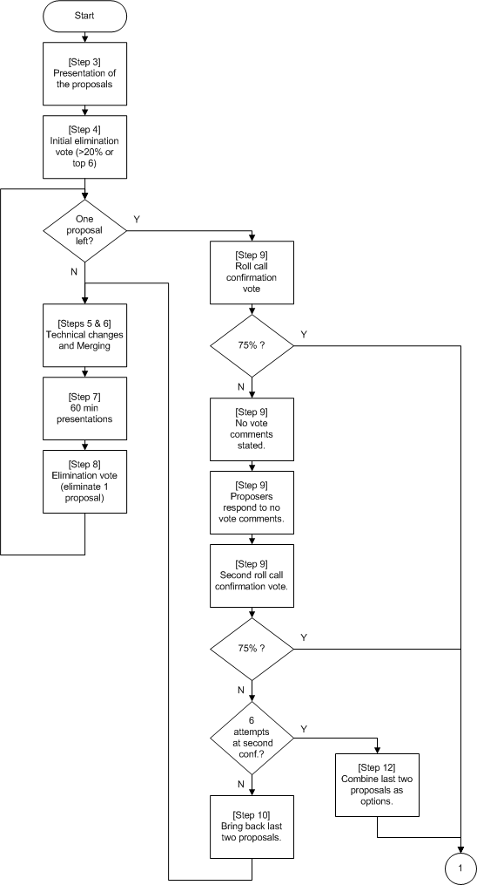
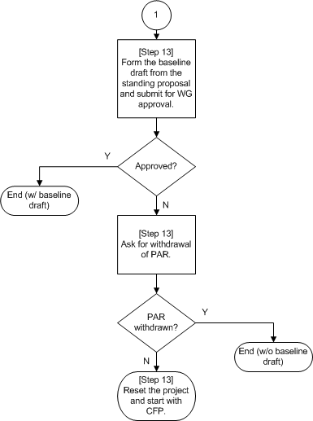

[POISON PILL]
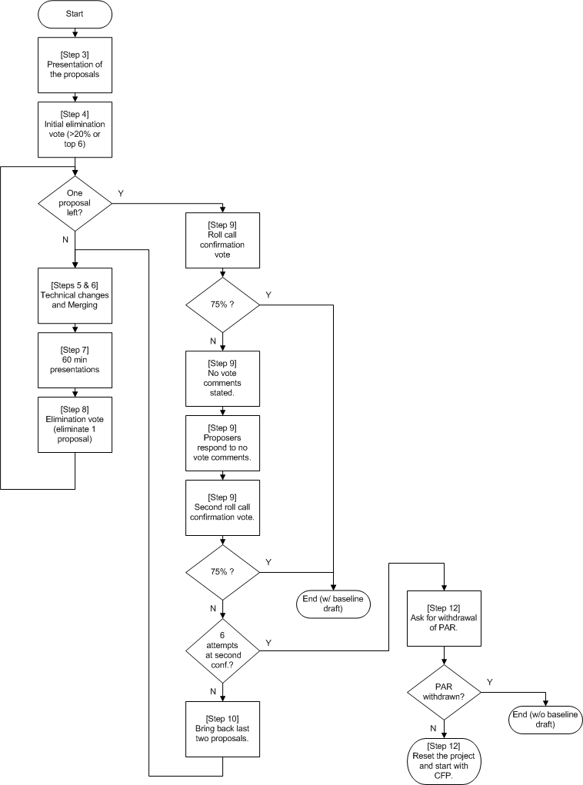

Millimeter wave alternate PHY for IEEE 802.15.3-2003 standard.

