IEEE P802.15
Wireless Personal Area Networks

Project | IEEE P802.15 Working Group for Wireless Personal Area Networks (WPANs)
Title | Sub GHz FCC Part 15.205 Restricted Bands
Date Submitted | July 20, 2005
Source | [Rick Roberts]  [Harris Corporation]  [] | Voice: [321-729-3018]  Fax: []  E-mail: [rrober14@harris.com]
Re:
Abstract
Purpose
Notice | This document has been prepared to assist the IEEE P802.15. It is offered as a basis for discussion and is not binding on the contributing individual(s) or organization(s). The material in this document is subject to change in form and content after further study. The contributor(s) reserve(s) the right to add, amend or withdraw material contained herein.
Release | The contributor acknowledges and accepts that this contribution becomes the property of IEEE and may be made publicly available by P802.15.

There was discussion during the San Francisco meeting (reference document 15-05-0390-00-004a) in regards to sub-GHz UWB operation and the issue of FCC Part 15.205 restricted bands and the Part 15.209 footnote. For information purposes, the restricted bands between 100 MHz and 1000 MHz are shown below, including the excluded bands in the 15.209 footnote. Also included is the text from FCC Part 15, clause 15.205 and clause 15.209.
FCC PART 15.205 EXTRACT

Section 15.205 Restricted bands of operation.

(a) Except as shown in paragraph (d) of this section, only spurious emissions are permitted in any
of the frequency bands listed below:

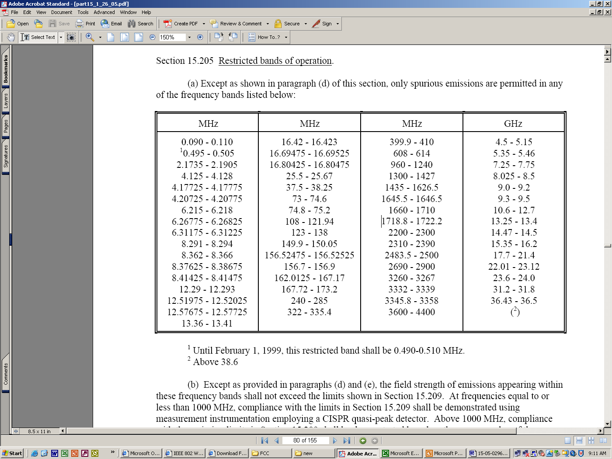

1 Until February 1, 1999, this restricted band shall be 0.490-0.510 MHz.
2 Above 38.6

(b) Except as provided in paragraphs (d) and (e), the field strength of emissions appearing within
these frequency bands shall not exceed the limits shown in Section 15.209. At frequencies equal to or
less than 1000 MHz, compliance with the limits in Section 15.209 shall be demonstrated using
measurement instrumentation employing a CISPR quasi-peak detector. Above 1000 MHz, compliance
with the emission limits in Section 15.209 shall be demonstrated based on the average value of the
measured emissions. The provisions in Section 15.35 apply to these measurements.

(c) Except as provided in paragraphs (d) and (e), regardless of the field strength limits specified
elsewhere in this Subpart, the provisions of this Section apply to emissions from any intentional radiator.

(d) The following devices are exempt from the requirements of this Section:

(1) Swept frequency field disturbance sensors operating between 1.705 and 37 MHz provided their emissions only sweep through the bands listed in paragraph (a), the sweep is never stopped
with the fundamental emission within the bands listed in paragraph (a), and the fundamental emission is outside of the bands listed in paragraph (a) more than 99% of the time the device is actively transmitting, without compensation for duty cycle.

(2) Transmitters used to detect buried electronic markers at 101.4 kHz which are
employed by telephone companies.

(3) Cable locating equipment operated pursuant to Section 15.213.

(4) Any equipment operated under the provisions of § 15.253, § 15.255 or § 15.257 of
this part.

(5) Biomedical telemetry devices operating under the provisions of Section 15.242 of
this part are not subject to the restricted band 608-614 MHz but are subject to compliance within the other restricted bands.

(6) Transmitters operating under the provisions of Subpart D or F of this Part.
(note from Rick Roberts – Subpart D is PCS rules at 1900 MHz and Subpart F is UWB rules)

(7) Devices operated pursuant to § 15.225 are exempt from complying with this section
for the 13.36-13.41 MHz band only.

(8) Devices operated in the 24.075-24.175 GHz band under § 15.245 are exempt from complying with the requirements of this section for the 48.15-48.35 GHz and 72.225-72.525 GHz bands
only, and shall not exceed the limits specified in § 15.245(b).

(9) Devices operated in the 24.0-24.25 GHz band under § 15.249 are exempt from
complying with the requirements of this section for the 48.0-48.5 GHz and 72.0-72.75 GHz bands only, and shall not exceed the limits specified in § 15.249(a).

(e) Harmonic emissions appearing in the restricted bands above 17.7 GHz from field disturbance
sensors operating under the provisions of Section 15.245 shall not exceed the limits specified in Section
15.245(b).

Section 15.209 Radiated emission limits, general requirements.

(a) Except as provided elsewhere in this Subpart, the emissions from an intentional radiator shall
not exceed the field strength levels specified in the following table:

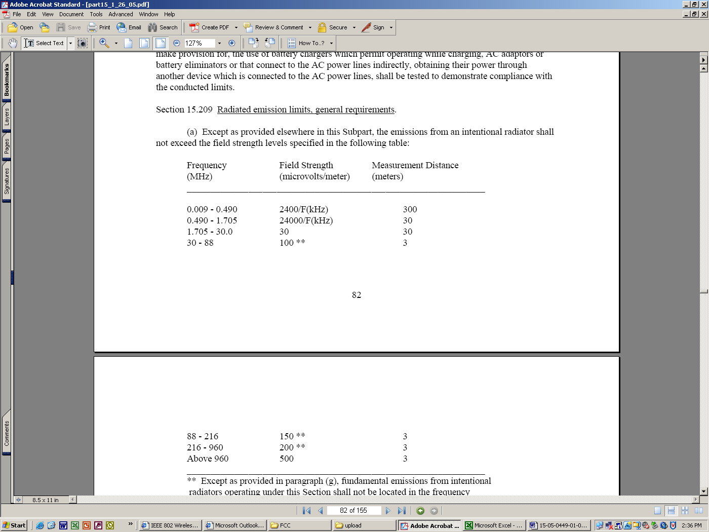
_______________________________________________________________
** Except as provided in paragraph (g), fundamental emissions from intentional radiators operating under this Section shall not be located in the frequency bands 54-72 MHz, 76-88 MHz, 174-216 MHz or 470-806 MHz. However, operation within these frequency bands is permitted under other sections of this Part, e.g., Sections 15.231 and 15.241.

(note from Rick Roberts – 15.231 concerns applications like garage door openers and 15.241 concerns biomedical telemetry device applications).

(b) In the emission table above, the tighter limit applies at the band edges.

(c) The level of any unwanted emissions from an intentional radiator operating under these
general provisions shall not exceed the level of the fundamental emission. For intentional radiators which
operate under the provisions of other Sections within this Part and which are required to reduce their
unwanted emissions to the limits specified in this table, the limits in this table are based on the frequency
of the unwanted emission and not the fundamental frequency. However, the level of any unwanted
emissions shall not exceed the level of the fundamental frequency.

(d) The emission limits shown in the above table are based on measurements employing a CISPR
quasi-peak detector except for the frequency bands 9-90 kHz, 110-490 kHz and above 1000 MHz.
Radiated emission limits in these three bands are based on measurements employing an average detector.

(e) The provisions in Sections 15.31, 15.33, and 15.35 for measuring emissions at distances other
than the distances specified in the above table, determining the frequency range over which radiated
emissions are to be measured, and limiting peak emissions apply to all devices operated under this Part.

(f) In accordance with Section 15.33(a), in some cases the emissions from an intentional radiator
must be measured to beyond the tenth harmonic of the highest fundamental frequency designed to be
emitted by the intentional radiator because of the incorporation of a digital device. If measurements
above the tenth harmonic are so required, the radiated emissions above the tenth harmonic shall comply
with the general radiated emission limits applicable to the incorporated digital device, as shown in Section 15.109 and as based on the frequency of the emission being measured, or, except for emissions contained in the restricted frequency bands shown in Section 15.205, the limit on spurious emissions specified for the intentional radiator, whichever is the higher limit. Emissions which must be measured above the tenth harmonic of the highest fundamental frequency designed to be emitted by the intentional radiator and which fall within the restricted bands shall comply with the general radiated emission limits in Section 15.109 that are applicable to the incorporated digital device.

(g) Perimeter protection systems may operate in the 54-72 MHz and 76-88 MHz bands under the
provisions of this section. The use of such perimeter protection systems is limited to industrial, business
and commercial applications.

