IEEE P802.15
Wireless Personal Area Networks

Project | IEEE P802.15 Working Group for Wireless Personal Area Networks (WPANs)
Title | Sub GHz FCC Part 15.205 Restricted Bands
Date Submitted | July 20, 2005
Source | [Rick Roberts]  [Harris Corporation]  [] | Voice: [321-729-3018]  Fax: []  E-mail: [rrober14@harris.com]
Re:
Abstract
Purpose
Notice | This document has been prepared to assist the IEEE P802.15. It is offered as a basis for discussion and is not binding on the contributing individual(s) or organization(s). The material in this document is subject to change in form and content after further study. The contributor(s) reserve(s) the right to add, amend or withdraw material contained herein.
Release | The contributor acknowledges and accepts that this contribution becomes the property of IEEE and may be made publicly available by P802.15.

There was discussion during the San Francisco meeting (reference document 15-05-0390-00-004a) in regards to sub-GHz UWB operation and the issue of FCC Part 15.205 restricted bands. The topic is still under investigation as to the applicability of 15.205 to sub-GHz UWB. For information purposes, the restricted bands between 100 MHz and 1000 MHz are shown below. Also included is the text from FCC Part 15, clause 15.205.
FCC PART 15.205 EXTRACT

Section 15.205 Restricted bands of operation.

(a) Except as shown in paragraph (d) of this section, only spurious emissions are permitted in any
of the frequency bands listed below:

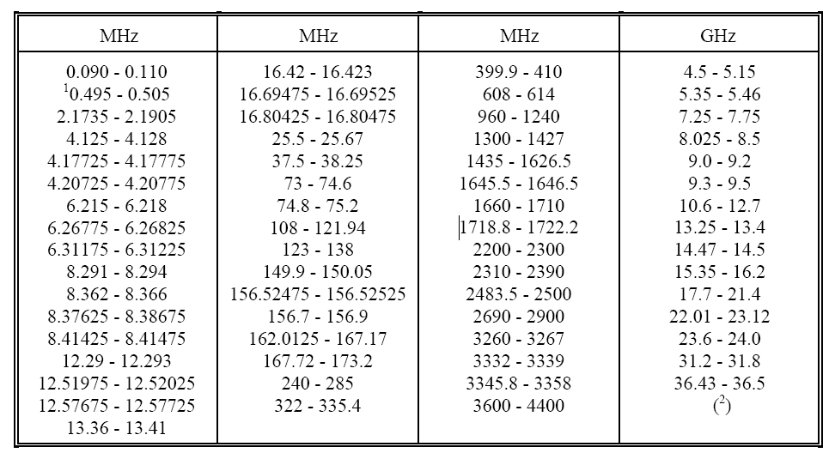

1 Until February 1, 1999, this restricted band shall be 0.490-0.510 MHz.
2 Above 38.6

(b) Except as provided in paragraphs (d) and (e), the field strength of emissions appearing within
these frequency bands shall not exceed the limits shown in Section 15.209. At frequencies equal to or
less than 1000 MHz, compliance with the limits in Section 15.209 shall be demonstrated using
measurement instrumentation employing a CISPR quasi-peak detector. Above 1000 MHz, compliance
with the emission limits in Section 15.209 shall be demonstrated based on the average value of the
measured emissions. The provisions in Section 15.35 apply to these measurements.

(c) Except as provided in paragraphs (d) and (e), regardless of the field strength limits specified
elsewhere in this Subpart, the provisions of this Section apply to emissions from any intentional radiator.

(d) The following devices are exempt from the requirements of this Section:

(1) Swept frequency field disturbance sensors operating between 1.705 and 37 MHz provided their emissions only sweep through the bands listed in paragraph (a), the sweep is never stopped
with the fundamental emission within the bands listed in paragraph (a), and the fundamental emission is outside of the bands listed in paragraph (a) more than 99% of the time the device is actively transmitting, without compensation for duty cycle.

(2) Transmitters used to detect buried electronic markers at 101.4 kHz which are
employed by telephone companies.

(3) Cable locating equipment operated pursuant to Section 15.213.

(4) Any equipment operated under the provisions of § 15.253, § 15.255 or § 15.257 of
this part.

(5) Biomedical telemetry devices operating under the provisions of Section 15.242 of
this part are not subject to the restricted band 608-614 MHz but are subject to compliance within the other restricted bands.

(6) Transmitters operating under the provisions of Subpart D or F of this Part.
(note from Rick Roberts – Subpart D is PCS rules at 1900 MHz and Subpart F is UWB rules)

(7) Devices operated pursuant to § 15.225 are exempt from complying with this section
for the 13.36-13.41 MHz band only.

(8) Devices operated in the 24.075-24.175 GHz band under § 15.245 are exempt from complying with the requirements of this section for the 48.15-48.35 GHz and 72.225-72.525 GHz bands
only, and shall not exceed the limits specified in § 15.245(b).

(9) Devices operated in the 24.0-24.25 GHz band under § 15.249 are exempt from
complying with the requirements of this section for the 48.0-48.5 GHz and 72.0-72.75 GHz bands only, and shall not exceed the limits specified in § 15.249(a).

(e) Harmonic emissions appearing in the restricted bands above 17.7 GHz from field disturbance
sensors operating under the provisions of Section 15.245 shall not exceed the limits specified in Section
15.245(b).

