Project | IEEE 15.4a
Title | Draft for CSS PHY
Date Submitted | [Juli 18, 2005]
Source | [Rainer Hach]  [Nanotron Technologies GmbH  Alt-Moabit 61, 10555 Berlin, Germany]  [Kyung-Kuk Lee ]  [Orthotron Co., Ltd.  709 Kranz Techno, 5442-1 Sangdaewon-dong, Jungwon-gu, Sungnam-si, Kyungki-do, Korea 462-120] | Voice : [+49 30 399 954 0]  Fax : [+49 30 399 954 288]  E-mail : [r.hach@nanotron.com]  Voice : [+82 31 777 8198]  Fax : [+82 31 777 8199]  E-mail : [kyunglee@orthotron.com]
Re: | [Preliminary CSS PHY draft for further editing ]
Abstract | [Definition of the CSS PHY]
Purpose | [Document to be discussed and edited]
Notice | This document has been prepared to assist the IEEE P802.15. It is offered as a basis for discussion and is not binding on the contributing individual(s) or organization(s). The material in this document is subject to change in form and content after further study. The contributor(s) reserve(s) the right to add, amend or withdraw material contained herein.
Release | The contributor acknowledges and accepts that this contribution becomes the property of IEEE and may be made publicly available by P802.15.

Draft for CSS PHY

General Description
This PHY uses Chirp Spread Spectrum (CSS) techniques in combination with differential phase shift keying (DPSK). By using time alternating time gaps in conjunction with sequences of chirp signals (sub chirps) in different frequency sub bands with different chirp directions this CSS PHY utilizes Code Devision as well as frequency devision.

Frequencies
A total of 14 frequency channels, numbered 1 to 14, are available across the 2.4 GHz band. Different subsets of these frequency channels are available in different regions of the world. In North America and Europe 3 frequency channels can be selected such that three nonoverlapping frequency bands are used.
Frequency channel  number | Frequency  [GHz]
1 | 2.412
2 | 2.417
3 | 2.422
4 | 2.427
5 | 2.432
6 | 2.437
7 | 2.442
8 | 2.447
9 | 2.452
10 | 2.457
11 | 2.462
12 | 2.467
13 | 2.472
14 | 2-482

Waveforms and Code sequences
Four individual chirp signals, called sub-chirps in the following, are concatenated to form a full chirp symbol occupying two adjacent frequency sub-bands. Four different sub-chirp sequences are defined. Each sub-chirp is weighted with a raised cosine window in the time domain

Graphical presentation of sub-chirp sequences

Four possible sequences of sub-chirps

Separation of Piconets by time gaps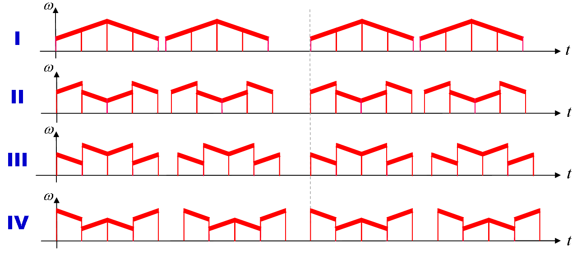

Mathematical presentation of sub-chirp sequences
$$\begin{aligned}{\tilde{s}}^{m}(t)=\sum_{n=0}^{∞}{{\tilde{s}}^{m}(t,n)} \\ \sum_{n=0}^{∞}{\sum_{k=0}^{3}{{\tilde{c}}_{n,k}\text{exp}\left[j\left({\hat{ω}}_{k,m}+\frac{μ}{2}ξ_{k,m}\left(t−T_{n,k,m}\right)\right)\left(t−T_{n,k,m}\right)\right]⋅P_{\text{RC}}\left(t−T_{n,k,m}\right)}}\end{aligned}$$
$${\hat{ω}}_{k,m}=2π f_{k,n}$$
$$T_{n,k,m}=\left(k+\frac{1}{2}\right) T_{\text{sub}}+{\text{nT}}_{\text{chirp}}−\left(1−{\left(−1\right)}^{n}\right)τ_{m}$$

The Raised Cosine Window
$$P_{\text{RC}}(t)=\left\{\begin{matrix}1, & |t|< \frac{\left(1−α\right)}{\left(1+α\right)}\frac{T_{\text{sub}}}{2} \\ \frac{1}{2}\left\{1+\text{cos}\left[\frac{\left(1+α\right)}{{αT}_{\text{sub}}}π\left(|t|−\frac{\left(1−α\right)}{\left(1+α\right)}\frac{T_{\text{sub}}}{2}\right)\right]\right\}, & \frac{\left(1−α\right)}{\left(1+α\right)}\frac{T_{\text{sub}}}{2} < |t|<\frac{T_{\text{sub}}}{2} \\ 0, & |t|>\frac{T_{\text{sub}}}{2}\end{matrix}\right.$$

Numerical Parameters
Sub-band center frequencies, f_{k,m} [Mhz]
m\k | 1 | 2 | 3 | 4
1 | fc-3.15 | fc+3.15 | fc+3.15 | fc-3.15
2 | fc+3.15 | fc-3.15 | fc-3.15 | fc+3.15
3 | fc-3.15 | fc+3.15 | fc+3.15 | fc-3.15
4 | fc+3.15 | fc-3.15 | fc-3.15 | fc+3.15

Sub-band sub-chirp directions, $ξ$_{k,m}
m\k | 1 | 2 | 3 | 4
1 | +1 | +1 | -1 | -1
2 | +1 | -1 | +1 | -1
3 | -1 | -1 | +1 | +1
4 | -1 | +1 | -1 | +1

Timing values
(subject to fine adjustment)
T_{chirp} | 4.8
T_{sub} | 1.2
$τ$₁ | 450 ns
$τ$₂ | 300 ns
$τ$₃ | 150 ns
$τ$₄ | 0 ns

Other Parameters
α | 0.25

Transmit power spectral density (PSD) mask

DBPSK and DQPSK

QPSK Symbol Mapping
Input bits (b₀,b₁) | Phase Value
0,0 | π
0,1 | 1/2 π
1,0 | 3/2 π
1,1 | 0

Reference Modulator for 1 MBit/s

BPSK Symbol Mapping
Input bit | Phase Value
0 | Π
1 | 0

Reference Modulator for 250 kBit/s

Coding and data rates
The mandatory data rate of 1Mbit/s is achived by using QPSK and biorthogonal ¾ block coding
Biorthogonal ¾ Code
Code word number | Information Bits | Code Bits
0 | 0,0,0 | 1, 1, 1, 1
1 | 0,0,1 | 1,-1, 1,-1
2 | 0,1,0 | 1, 1,-1,-1
3 | 0,1,1 | 1,-1,-1, 1
4 | 1,0,0 | -1,-1,-1,-1
5 | 1,0,1 | 1,-1, 1,-1
6 | 1,1,0 | -1, 1,-1, 1
7 | 1,1,1 | -1, 1, 1,-1

The optional data rate of 250kBit/s is achieved by using BPSK and a performant ½ code.

PHY constants and PIB atributes
PHY constants
Constant | Description | Value
aMaxPHYPacketSize | The maximum PSDU size (in octets) the PHY shall  be able to receive. | 255

phyPage
Bit 0..13 | Bit 14 ..17 | Bit 18 | Bit 27..31
Frequency band | Sub chirp sequence | Data rate | PhyPage

PPDU
Chirp Symbols: 8 | 4 | 8 | variable
Preamble | SFD |  | PSDU
SHR |  | PHR | PHY payload

The preamble consists of 8 unmodulated (phase zero) chirp symbol

