IEEE P802.15
Wireless Personal Area Networks

Project | IEEE P802.15 Working Group for Wireless Personal Area Networks (WPANs)
Title | Transmission and Reflection Measurements of Safety Glass at 60GHz
Date Submitted | [9 July, 2005]
Source | [A. Liu, E. Skafidas, K. Saleem, T. Pollock]  [NICTA]  [Dept of Electrical and Electronic Engineering, University of Melbourne, Parkville, 3010] | Voice:[+61-3-83448407 ]  Email:[(stan.skafidas,tony.pollock,khusro.saleem@nicta.com.au,c.liu@ee.unimelb.edu.au]
Re: | [Transmission Reflection Measurements of Safety Glass at 60GHz]
Abstract | [In this document measurements of the transmission and reflection measurements of safety glass at 60GHz are presented]
Purpose | [General guidelines for measurement techniques and procedures]
Notice | This document has been prepared to assist the IEEE P802.15. It is offered as a basis for discussion and is not binding on the contributing individual(s) or organization(s). The material in this document is subject to change in form and content after further study. The contributor(s) reserve(s) the right to add, amend or withdraw material contained herein.
Release | The contributor acknowledges and accepts that this contribution becomes the property of IEEE and may be made publicly available by P802.15.

Aim
The aim of these experiments is to measure the transmission and reflection of safety glass at 60GHz. These measurements will help in determining the backscatter interference generated by a high power transmitter aimed at a window.

Experimental Set Up

Figure 1
VNA setup showing the relative distance between the two antenna (monopoles). This experiment was used to determine the path loss between the two antennas at the specified distance and the reflected power due to antenna impedance mismatches

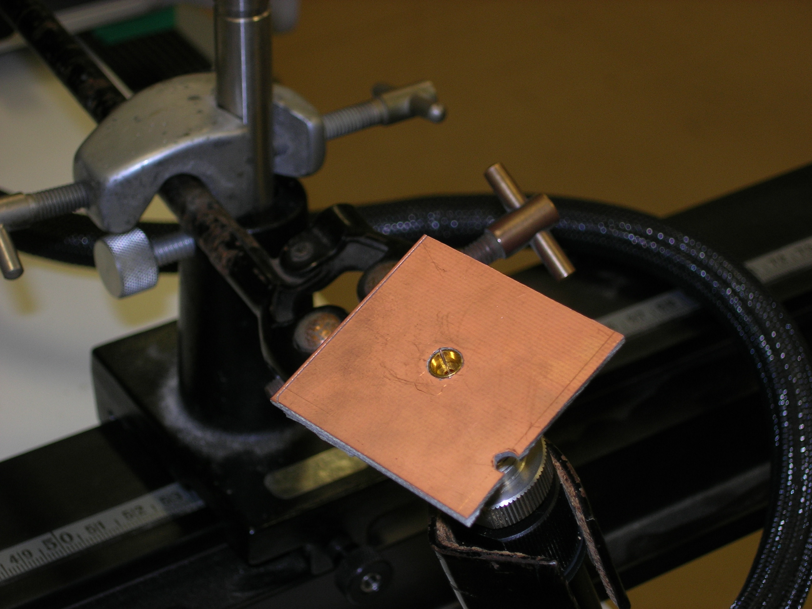
Figure 2
Picture of monopole antenna

Figure 3
VNA setup showing the relative distance between the two antenna (monopoles) and 5.7mm safety glass inserted at the specified location. This experiment was used to determine the reduction in power between the two antennas with the glass inserted. Furthermore the reflection coefficients were also recorded on Antenna 1 to establish that no antenna detuning occurred due to the introduction of the glass pane.

Figure 4
VNA setup showing the relative distance between the two antennas (Antenna 1 is a 21dB horn antenna and Antenna 2 is a monopole) and 5.7mm safety glass inserted at the specified location. This experiment was used to determine the reflected power between the two antennas with the glass inserted as shown.

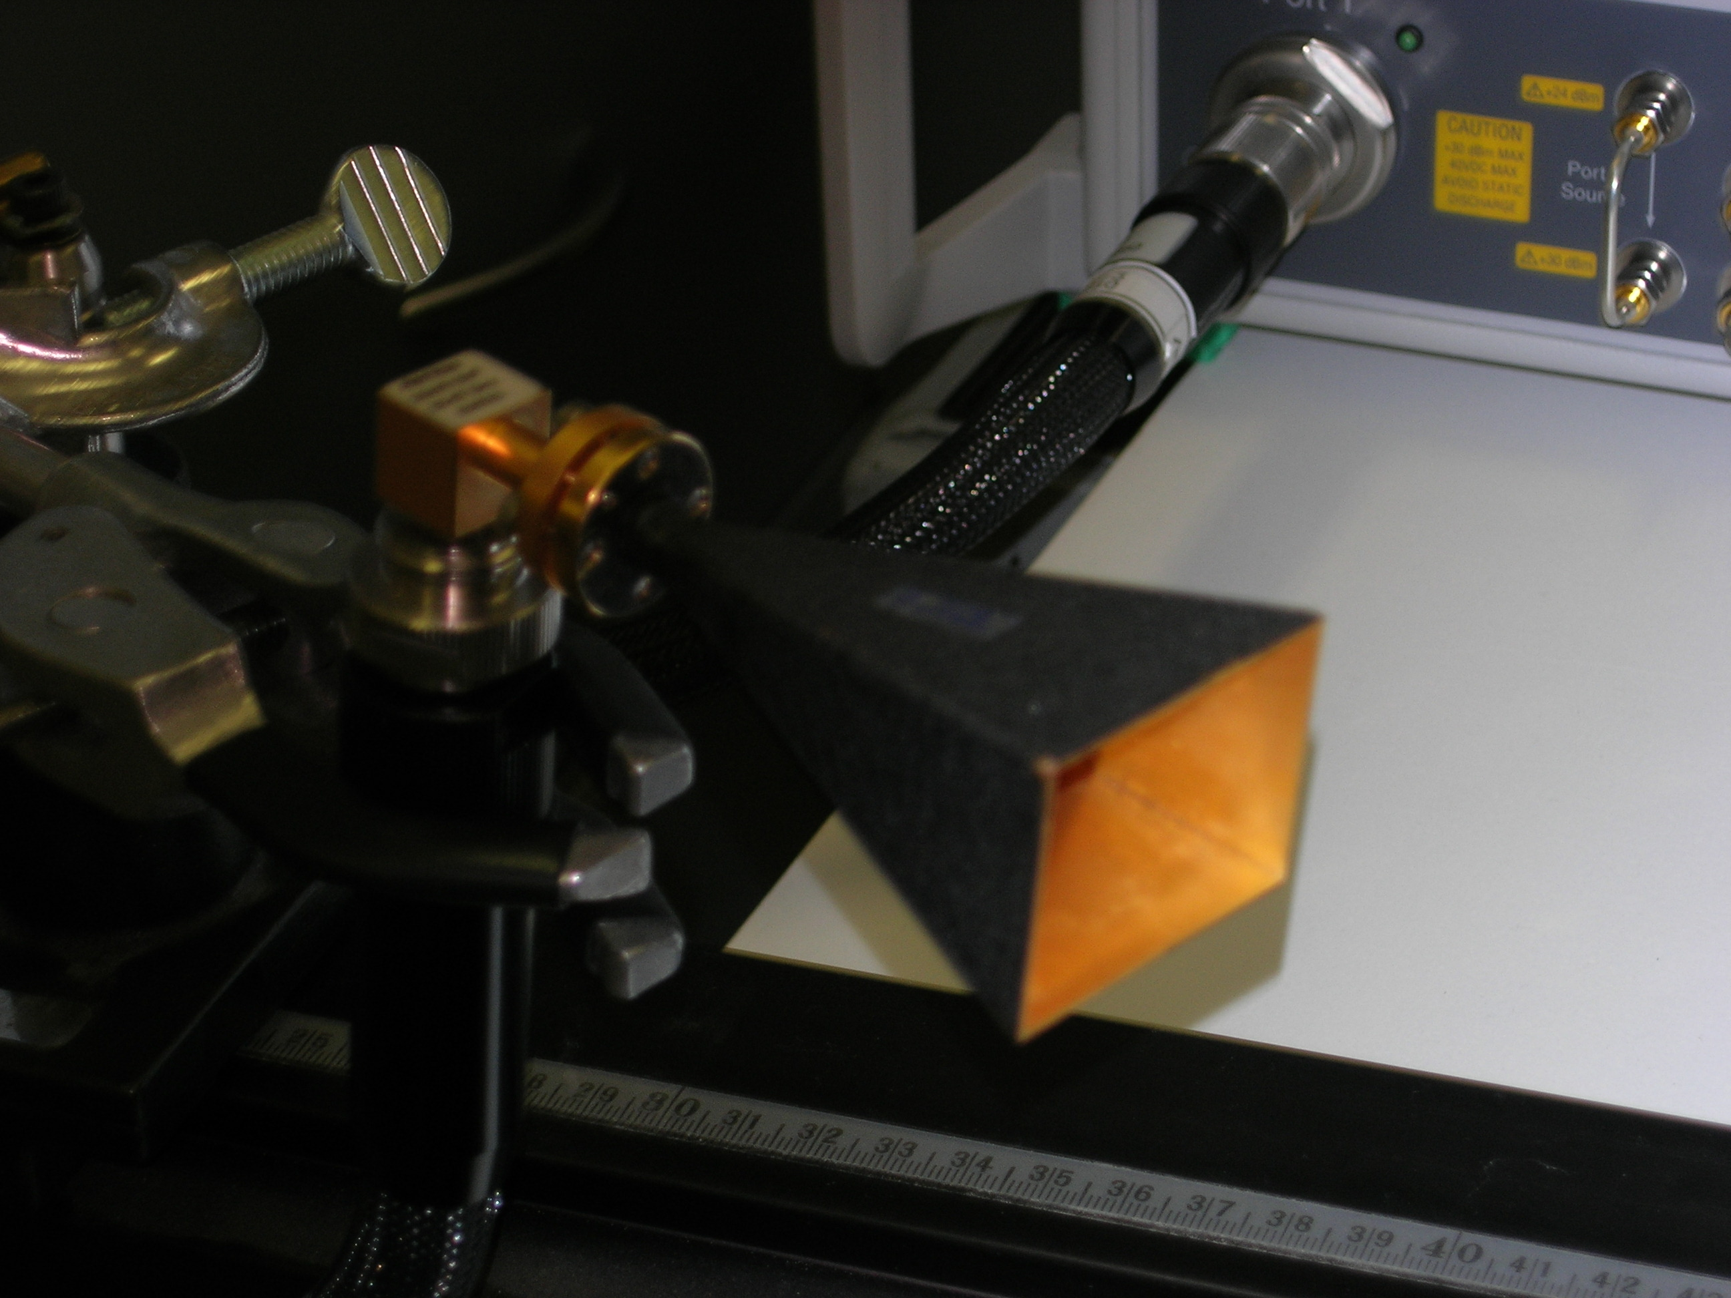
Figure 5
Picture of horn antenna

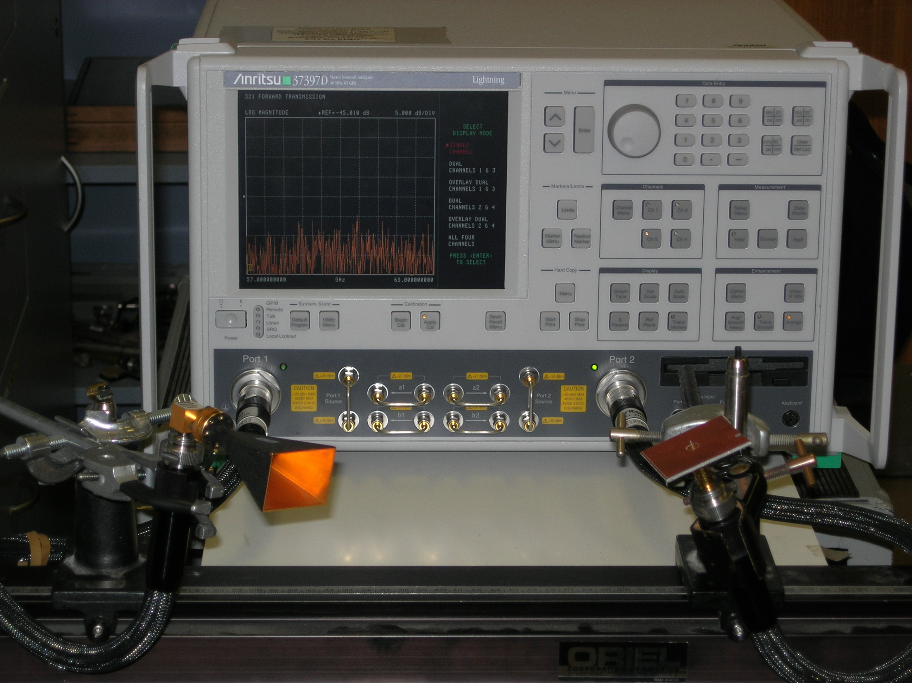
Figure 6
Picture of experimental set up used to measure reflection coefficient

Measurement Technique

VNA Settings
In the setup the swept frequency was 57-64GHz. The IF bandwidth of the instrument was set at 10Hz.

VNA Calibration

The system was calibrated using the SOLT procedure. The 12 correction coefficients were loaded to the VNA and served to calibrate and remove any losses and mismatches.

Antenna Configuration

- Transmission Experiment
In the set of glass transmission experiments two monopole antennas, shown in Figure 2, where used to make the measurements.

- Reflection Experiment
For the reflection measurement a 21dBi pyramidal horn antenna, shown in Figure 5, was used as the transmit antenna. The horn was angled at approximately 30 degrees to normal. The E-plane of the Horn was perpendicular to the plane of incidence. The receive antenna was a one wavelength monopole, shown in Figure 2, trimmed to resonance. The reflection coefficient of the monopoles was better than -10dB equating to a VSWR of better than 1:1.85. As monopoles are essentially omnidirectional in azimuth a monopole receive antenna was used for this experiment. This was to capture as much of the reflected energy with minimal angular dependence.

Before the glass was inserted the horn antenna was orientated such that minimum received power was observed at the monopole. This corresponds to a minimum sidelobe of the transmit antenna and ensures that an accurate representation of the reflected energy was achieved.

Safety Glass
The glass used in this experiment was a pane 0.3 m x 0.8 m of 5.7 mm safety glass used for windows at NICTA VRL, Department of Electrical and Electronic Engineering, University of Melbourne.

Measurements

- Transmission Experiment

Results for the transmission through glass at normal incidence using a monopole transmit and receive antennas. Setup as shown in Figure 1 and Figure 3.

Frequency (GHz) | S11 (dB) | S11 (Glass)(dB) | S21 (dB) | S21 (Glass)(dB)
60.22 | -15.976 | -15.971 | -44.39 | -56
60.22125 | -12.843 | -12.6 | -40.8 | -58
60.2225 | -18.59 | -18.6 | -46.94 | -59
60.22375 | -10.482 | -10.2 | -50 | -58
60.225 | -11.563 | -11.7 | -49 | -63
60.22625 | -11.325 | -11.4 | -51 | -62
60.2275 | -10.674 | -10.73 | -48 | -60.1
60.22575 | -18.16 | -18.367 | -47 | -57
60.23 | -15.95 | -16.03 | -45 | -63
Table 1
Measured path loss between the two antennas at the specified distance and the reflected power due to antenna impedance mismatches for the setups shown in figure 1 and figure 2, with and without the glass present.

- Reflection Experiment

Results for the reflection from through air glass using a horn transmit and a monopole receive antenna. Setup as shown in Figure 3. When the transmit and receive antenna are orientated as to achieve maximum S21 the maximum value of S21 is approximately -35dB.

Frequency (GHz) | S11 (dB) | S11 (Glass)(dB) | S21 (dB) | S21 (Glass)(dB)
57 | -16.2 | -16.4 | -63.65 | -39.9
57.5 | -17.5 | -17.3 | -79 | -41.2
58 | -19.4 | -19.6 | -63.3 | -39.5
58.5 | -21.9 | -21.9 | -69.1 | -40.8
59 | -17.6 | -17.5 | -72.8 | -41.7
59.5 | -18 | -18 | -76.2 | -42.2
60 | -16.2 | -16.3 | -66.7 | -43.5
60.5 | -17.8 | -17.8 | -65.2 | -48.7
61 | -17.9 | -17.9 | -80 | -49.2
61.5 | -24.1 | -23.7 | -70.5 | -51.5
62 | -19.6 | -19.6 | -60 | -45.3
62.5 | -18.2 | -18.3 | -63.8 | -43.7
63 | -16.1 | -16.3 | -75.3 | -43.8
63.5 | -17.9 | -17.8 | -70.3 | -42.6
64 | -20.2 | -20.5 | -74 | -42
64.5 | -20.4 | -20.5 | -65.3 | -41.7
65 | -18.7 | -18.6 | -71.1 | -42.8
Table 2
Measurements performed using the set up described in figure 3 with and without the glass present. The measurements show the increase in received power at antenna 2 due to the increase in reflected power between the two antennas with the glass inserted as shown.

Conclusions
The transparency loss of 5.7mm safety glass is approximately 12dB in the range (60.22-60.23)GHz. This figure is slightly higher than what is predicted using a relative complex permittivity of 6.24+0.17i [1]. (4.8dB reflection loss due to reflection at the air glass interface and 2.1dB loss through the glass. Total Expected loss of 6.9dB) . The measured reflected power varies from approximately 4.9dB to approximately 30dB depending on the frequency.

Acknowledgements
NICTA VRL would like to thank Anritsu for their support

