IEEE P802.15
Wireless Personal Area Networks

Project | IEEE P802.15 Working Group for Wireless Personal Area Networks (WPANs)
Title | Minutes of the conference calls TG3c Technical Requirements Sub-Group
Date Submitted | [7 October, 2005]
Source | [Alireza Seyedi]  [Philips]  [345 Scarborough Rd., Briarcliff Manor, NY, 10510, USA] | Voice: [+1-914-945-6318]  Fax: [+1-914-945-6580]  E-mail: [alireza.seyedi@philips.com]
Re: | []
Abstract | [This document contains the minutes of the conference calls of the TG3c Technical Requirements sub-group]
Purpose | []
Notice | This document has been prepared to assist the IEEE P802.15. It is offered as a basis for discussion and is not binding on the contributing individual(s) or organization(s). The material in this document is subject to change in form and content after further study. The contributor(s) reserve(s) the right to add, amend or withdraw material contained herein.
Release | The contributor acknowledges and accepts that this contribution becomes the property of IEEE and may be made publicly available by P802.15.

Sixteenth conference call
Date and Time
The 16th conference call was held on October 6th at 8PM Eastern US time.

Attendees:
- Chang Soon Choi
- Nobujiko Kuribayashi
- Abbie Mathew
- Tony Pollock
- Alireza Seyedi
- Yozo Shoji
- Hirokazu Tada
- Kazuhaki Takahashi

Issues discussed and decisions made:
- Section 3.2 was reviewed and modified as below:

3.2. E_{b}/N₀ reference point
E_{b} is defined as the average energy per information bit calculated at the transmitter antenna connector. For the systems without an antenna connector, the calculations shall be interpreted as equivalent isotropic radiated energy (i.e. a 0dBi gain antenna) and any radiated measurements/calculations shall be corrected to compensate for the antenna gain in the system.
N₀ should be injected at the receiver antenna connector. For the systems without an antenna connector, any measurements/calculations shall be corrected to compensate for the antenna gain in the system.
For purposes of converting E_{b}/N₀ to range (meters) an exponent of 2 shall be used (i.e. r² propagation loss). The related performance results shall include implementation losses as indicated in the link budget table. Oxygen absorption losses (15dB per km) must also be taken into account.

- “Evaluation geometry and procedure” in Section 6.3.2 was reviewed and modified as follows. The details of the use of channel model for performance simulations are left to be edited after the completion of the channel model work.
Evaluation geometry and procedure:
The proposers should evaluate the performance of their proposal in presence of other uncoordinated piconets for two different geometries:
- Test geometry A: The victim receiver, the desired transmitter and the interfering transmitter are located along a straight line. All transmitters and receivers have equal antenna gain equal to xdBi. The directional antennas of the victim receiver and both the interfering and desired transmitters are perfectly aimed at each other (Figure 1). It is assumed that the desired and the interfering transmitters operate in two different channels and have equal transmit powers. It is also assumed that the two transmitters do not shadow each other.
- Test geometry B: The victim receiver, the desired transmitter and the interfering transmitter are located along a straight line. All transmitters and receivers have equal antenna gain equal to xdBi. The directional antennas of the victim receiver and the desired transmitter are perfectly aimed at each other. However, the antenna of the interfering transmitter is aimed away from the victim receiver. It is assumed that a side lobe of the antenna of the interfering transmitter is perfectly aimed at the victim receiver and has a gain of ydBi (Figure 2). It is assumed that the desired and the interfering transmitters operate in the same channel and have equal transmit powers. It is assumed that the two transmitters do not shadow each other.

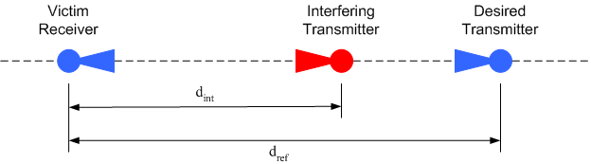
Figure 1. Test geometry A for simultaneously operating piconets
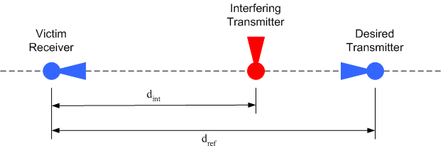
Figure 2. Test geometry B for simultaneously operating piconets
Figures 3 and 4 show the general geometry. They are not meant to imply that d_{int} is necessarily smaller than d_{ref}.

If the interfering PHY would have a different impact on the receiver at different supported data rates, the PHY proposer should quantify this.

An “interfering transmitter” is an uncoordinated transmitter operating at the same power as the reference transmitter. “Multiple piconet interference separation distance” is defined as the threshold distance separation (d_{int}) of multiple interfering transmittersequidistant from the test receiver such that the test receiver PER degrades to a specified error rate.

Multiple Piconet interference separation distance test procedure

1. Establish a test link with a test receiver at a fixed distance from the reference transmitter, such that the distance from the transmitter to the receiver is 0.707 of the 90% link success probability distance. Continue by sending packets to the test receiver for a specified modulation format and data rate. For the N=1 case, the proposer is to use the first 5 channels from each required channel model for the reference and the next 5 channels (6 through 10) from each required channel model for the interferer. The energy of each realization is normalized to unity. For the N=2 and N=3 the first interfere shall use channels 6 through 10, the second interfere shall use 99, and the third interferer shall use 100. All distance computations are made with a path loss exponent of 2.
2. Verify PER at the test receiver.
- Begin transmitting continuous packets on the reference link with N different interfering alt-PHY transmitters at a distance from the test receiver. The synchronization between piconets must be random for each transmitted packet on the reference link. At a minimum, the proposer should consider the case where N equals 1. As indicated in step 1, for the N=1 case the proposer is to use the first 5 channels from each required channel model for the reference and the next 5 channels (6 through 10) from each required channel model for the interferer. The energy of each realization is normalized to unity. For the N=2 and N=3 the first interfere shall use channels 6 through 10, the second interfere shall use 99, and the third interferer shall use 100. The interferers shall all be selected from the same channel environment as the reference link and shall be normalized to unit power. The reference link is to use the previously mentioned first 5 normalized channels.
4. Continue PER verification at the test receiver.
5. Incrementally move the N different interfering alt-PHY transmitters closer to the test receiver until the test link PER exceeds 8%. At each incremental distance, the link must transfer at least 100 packets.
6. Record the distance associated with the last acceptable PER as the multi-channel separation distance (d_{int}) for the selected test receiver.
7. Since the proposals may include multiple data rates and may include multiple modulation types or other factors that may affect close proximity operation of uncoordinated piconets, the proposer should repeat the test procedures and include sufficient test combinations to characterize system operation under these conditions.

Action Items:
None

Next Conference Call:
Agenda:
- Attendance
- Review of action items
- Continue reviewing the remaining of the document, starting with Section 6.6.
- Adjourn
Date:
Thursday October 13th / Friday October 14th
Times:
US Eastern Time: 8.00 PM Thursday
US Mountain Time: 6.00 PM Thursday
US Pacific Time: 5.00 PM Thursday
Japan/South Korea Time: 9.00 AM Friday
Eastern Australia Time: 10.00 AM Friday
Please check the time conversion for your region. The reference is the US eastern time.
Call-in Number: +1-319-256-0200
Passcode: 151442#

See Section 3.2 for definition of E_{b}/N₀.

