IEEE P802.15
Wireless Personal Area Networks

Project | IEEE P802.15 Working Group for Wireless Personal Area Networks (WPANs)
Title | Proposed-May12-Revisions-to-802.15-Create-Stream-At-PM.doc
Date Submitted | [May 12, 2005]
Source | [Chieh-Ying Kan]  [ITRI]  [M100/CCL, Bldg 14, 195-11 Sec. 4, Chung Hsing Rd. Chutung, Hsinchu, Taiwan R.O.C.] | Voice: [+886-3-5917821 ]  Fax: [+886-3-5829733]  E-mail: [ cykan@itri.org.tw ]
Re: | [Enclosed please find the proposed revision in the following pages.]
Abstract | [Proposing a change request to the IEEE Standard 802.15.3. Because, it neglects to specify the procedure of establishing the isochronous stream for devices in the same set of DSPS mode.]
Purpose | [The change request documents the specification of the procedure of establishing the isochronous stream for devices in the same set of DSPS mode. The new procedure is distinguished in red color. In the mean time, I have provide related specification for your reference.]
Notice | This document has been prepared to assist the IEEE P802.15. It is offered as a basis for discussion and is not binding on the contributing individual(s) or organization(s). The material in this document is subject to change in form and content after further study. The contributor(s) reserve(s) the right to add, amend or withdraw material contained herein.
Release | The contributor acknowledges and accepts that this contribution becomes the property of IEEE and may be made publicly available by P802.15.

7.5.6.1 Channel time request

Each Channel Time Request block (CTRqB) corresponds to a channel time request. If the DEV is making a request for asynchronous channel time where the destinations share CTAs, then there shall be only one asynchronous CTRqB in the command and it shall be the last CTRqB in the CTRq command. The Channel Time Request block for a given CTRq shall be formatted as illustrated in Figure 73.

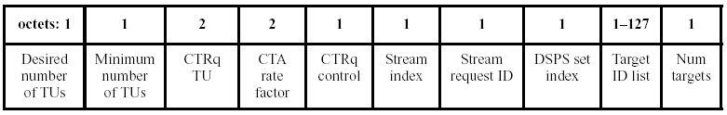
Figure 73—Channel time request block field format

The DSPS Set Index field is used to identify the DSPS set with which the CTRq corresponds, if the CTRq is for a DSPS allocation. Only valid DSPS set indices, as described in 7.5.8.3, are allowed for a DSPS allocation request. Otherwise, the field shall be set to zero and shall be ignored on reception.

7.5.6.2 Channel time response

The Channel Time Response command shall be formatted as illustrated in Figure 75.

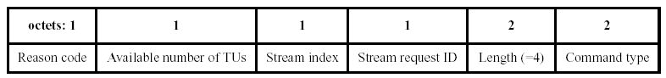
Figure 75—Channel time response command format

The Reason Code field indicates whether a channel time request was successful or unsuccessful. The codes assignable to this field are:
0–> Success
1–> Success, DEV in PS mode
2–> Target DEV unassociated
3–> Target DEV not a member
4–> Priority unsupported
5–> Stream terminated by PNC
6–> Stream terminated by target DEV
7–> Channel time unavailable
8–> Destination DEV in power save mode
9–> Unable to allocate as pseudo-static CTA

7.5.8.3 SPS configuration request

The SPS Configuration Request command is used to set up and manage SPS set memberships for SPS DEVs currently participating or requesting to participate in one or more SPS modes.

8.5.1.1 Isochronous stream creation

DEVs perform multicast negotiations at a higher layer. A DEV sets up a multicast stream at the request of the upper layer by sending a request to the PNC for a stream with the multicast ID as the destination. A DEV enables reception of a multicast stream by using the MLME-MULTICAST-RX-SETUP.request. This tells the MAC to receive frames from a particular source DEV with the DestD set to the McstID and with the stream index specified in the MLME.

(Note: proposed change request is distinguished in red color )
The procedure of establishing the isochronous stream for devices in the same set of DSPS mode shall be as follows:
- The DSPS set shall be configure as described in 7.5.8.3, the step 2 and 3 shall transmit/receive command as indicated by Wake Beacon Interval of the DSPS set,
- The Channel Time Request shall be sent with the DSPS Set Index as described in 7.5.6.1,
- The Channel Time Response shall be received with the Reason Code field set to the value: 1–> Success, DEV in PS mode (as described in 7.5.6.2), and
- If the power save DEV is going to listen to the new allocation, they can remain in the same set of DSPS mode and transmit/receive data as indicated by Wake Beacon Interval of the DSPS set.

If the target DEV is in either DSPS or APS mode and the PNC grants the channel time request and the source and target devices are not in the same DSPS set. The PNC shall set the Reason Code in the Channel Time Response command to “Success, DEV in PS mode.” The PNC shall place the PCTM IE in the beacon with a bit set for the target DEV, as described in 7.4.8.

When the Target DEV in DSPS or APS mode receives a beacon with its bit set in the PCTM IE, it shall send a PM Mode Change command to the PNC. If the DEV is going to remain in a power save mode it shall set the PM Mode field in the PM Mode Change command to the appropriate value, either ‘SPS’ or ‘APS.’ The PNC shall then terminate the stream, as described in 8.5.1.3.

If the power save DEV is going to listen to the new allocation, it shall set the PM Mode field in the PM Mode Change command to ‘ACTIVE.’ The PNC shall then begin allocating the channel time in the beacon for the stream. The PNC shall no longer set the bits for the DEV in the PS Status IEs.

8.13.2.2 Changing DSPS mode and operation

It is possible that DEVs in DSPS mode will not receive broadcast messages. If a DEV requires the opportunity to receive all of the broadcast streams, it should not use DSPS mode. If a source DEV needs that the DEVs in DSPS mode have an opportunity to receive the broadcast frame, then the source DEV should send the frame in all of the superframes required to reach the DSPS DEVs in their wake beacons.

