IEEE P802.15
Wireless Personal Area Networks

Project | IEEE P802.15 Working Group for Wireless Personal Area Networks (WPANs)
Title | <title> DBO-CSK Proposal for IEEE802.15.4a
Date Submitted | [04 January, 2005]
Source | [(1) Kyung-Kuk Lee, (2) J.W.Chong, S.H.Yoon, J.D.Jeong, S.D.Kim, H.U.Lee]  [(1)Orthotron Co.,Ltd. (2) Hanyang Univ.]  [address] (1) 709 Kranz Techono, 5442-1 Sangdaewon-dong, Jungwon-gu, Sungnam-si, Kyungki-do, Korea 462-120 | Voice: [82-31-777-8198]  Fax: [82-31-777-8199]  E-mail: [kyunglee@orthotron.com]
Re:
Abstract | [This document has been submitted for an official proposal in January 2005. DBO-CSK Technology is proposed.]
Purpose | [Proposal for the IEEE802.15.4a standard]
Notice | This document has been prepared to assist the IEEE P802.15. It is offered as a basis for discussion and is not binding on the contributing individual(s) or organization(s). The material in this document is subject to change in form and content after further study. The contributor(s) reserve(s) the right to add, amend or withdraw material contained herein.
Release | The contributor acknowledges and accepts that this contribution becomes the property of IEEE and may be made publicly available by P802.15.

< TABLE OF CONTENTS >
1. Introduction 3
2. M-ary DBO-CSK Technology 4
2.1. Introduction to Chirp Signal 4
2.2. Proposed Chirp Signal 6
2.3. Chirp-Shift-Keying (CSK) Signal Sets for SOP 8
2.4. Differentially Bi-Orthogonal CSK (DBO-CSK) Modulation 9
3. General Solution Criteria 10
3.1. Unit Manufacturing Cost/Complexity (UMC) 10
3.2. General Definitions 11
3.3. Signal Robustness 11
3.4. Technical Feasibility 12
3.5. Scalability 13
4. MAC Protocol Supplement 14
4.1. MAC Enhancements and Modifications 14
5. PHY Layer Criteria 15
5.1. Channel Models and Payload Data 15
5.2. Size and Form Factor 15
5.3. PHY-SAP Payload Bit Rate and Data Throughput 16
5.4. Simultaneously Operating Piconets 17
5.5. Signal Acquisition 22
5.6. System Performance 23
5.7. Ranging 24
5.8. Link Budget 25
5.9. Sensitivity 26
5.10. Power Management Mode 26
5.11. Power Consumption 27
5.12. Antenna Practicality 27

Introduction

- Low Power Consumption: Digital Tx 0.65mW, Rx 61.6mW

- Signal Robustness:
- Orthogonal / Quasi-Orthogonal Signal Set
- Robustness: Heavy Multi-path, SOP,
- Low Correlation with Existing Air-Interfaces

- Feasibility: 2.4GHz ISM Band
- Existing commercial RF Solutions

- Ranging: Based on Chirp Signal (TDOA)
- Precision: less then x cm (Standard Deviation)

- Size & Form Factor: Less than SD-Memory size

- Low Cost / Low Complexity: Tx +Rx Baseband Digital (54K gates)

- Advanced Sleep/Wake-up Capability

M-ary DBO-CSK Technology

Introduction to Chirp Signal

- Linear Chirp: Rectangular Window

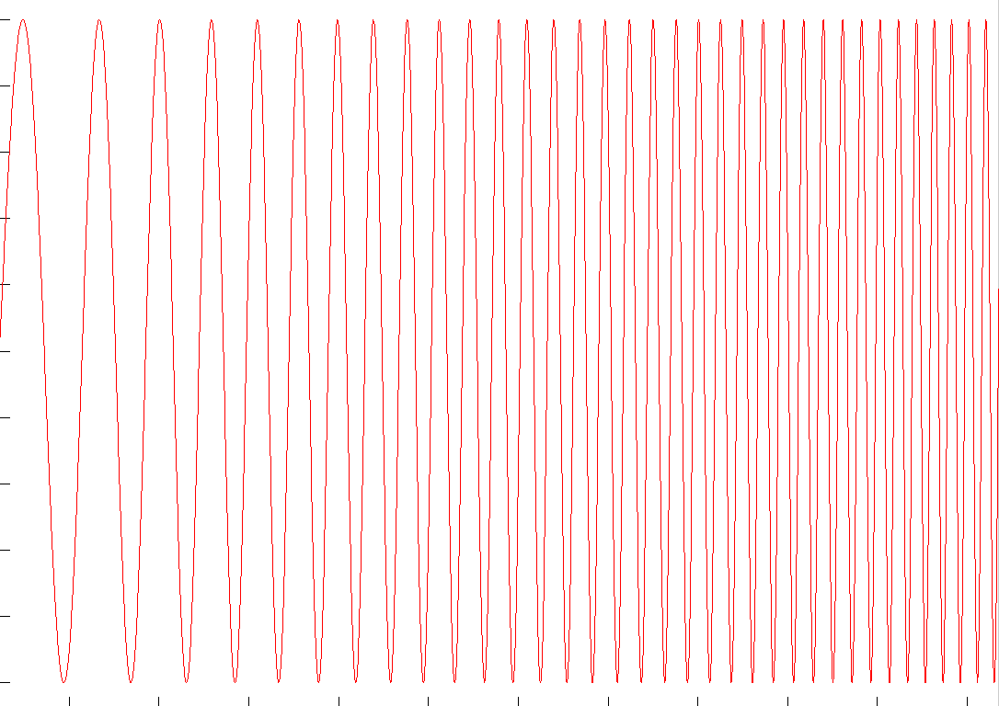
t

t

- Linear Chirp: Raised-Cosine Window

0
0.2
0.4
0.6
0.8
1
1.2
1.4
-1
-0.8
-0.6
-0.4
-0.2
0
0.2
0.4
0.6
0.8
1

Auto-Correlation Property

Proposed Chirp Signal

- Waveform of Chirp-Shift-Keying (CSK) Signals

- Spectrum of Sub-Chirp Signals

fC1 = 2.41775GHz
fC2 = 2.43375GHz
fC3 = 2.44975GHz
fC4 = 2.46575GHz
2.4
2.39
2.4835
2.4935
0dBr
-30dBr
-30dBr
-50dBr
-50dBr
f (GHz)
fc1
fc2
fc3
fc4
64MHz

Chirp-Shift-Keying (CSK) Signal Sets for SOP

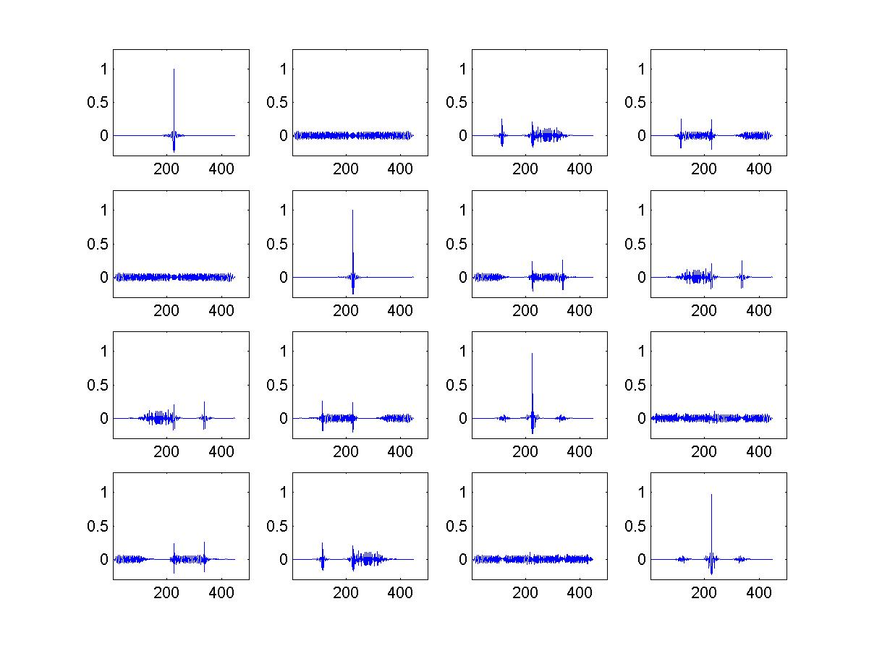
I

II

III

IV

Each of CSK Signal consists of 4 sub-chirp signals.
Correlation Property between different Chirp-signals

Differentially Bi-Orthogonal CSK (DBO-CSK) Modulation

- Bi-Orthogonal Modulation

3 bits/symbol
Bi-Orthogonal Symbol
Mapping Table (M = 8)
Bi-Orthogonal Code
(01,02,03,04)
Binary
(b0,b1,b2)
Decimal
(m)
1 1 1 1
1 -1 1 -1
1 1 -1 -1
1 -1 -1 1
-1 -1 -1 -1
-1 1 -1 1
-1 -1 1 1
-1 1 1 -1
0 000
1 001
2 010
3 011
4 100
5 101
6 110
7 111

- 8-ary DBO-CSK Modulator

Chirp-Shift-Keying
(CSK)
Generator
S/P
Symbol
Mapper
Binary Data
…010011100110001101…
P/S
Binary Symbol
Bi-Orthogonal
Symbol
Differentially
Bi-Orthogonal
Symbol
8-ary DBO-CSK

General Solution Criteria

Unit Manufacturing Cost/Complexity (UMC)

- Transmitter Baseband ≤ 3k gates
  - Scrambler : 15bit register and 1bit XOR => 154 gates
  - Block Encoder : 300 gates
  - 1X3 S/P and 4X1 P/S : 2bit register and 3bit register => 50 gates
  - Symbol Mapper : 3X8 address decoder with hard-wire table => 13 gates
  - Differential Encoder : 4bit XOR and 4bit register => 56 gates
  - Chirp-pulse Modulator : eight 6X56 address decoder with hard-wire table
and four 4bit adder => 1680 gates
  - Other blocks : 700 gates

- Receiver Baseband ≤ 51k gates
  - Differential Detector : 3240 registers, complex multiplier and four adders
=> 38960 gates
  - Symbol Demapper : (ten 1bit XORs + four 3bit adders) X 2 => 200 gates
  - Max Selector : 3bit two-step comparator X 2 => 54 gates
  - Two 1X4 S/P and one 3X1 P/S: 3bit register X 2 and 2bit register => 80 gates
  - Block Decoder : 3k gates
  - Descrambler : 15bit register (≈ 10 gates/register) and 1bit XOR => 154 gates
  - Other blocks : 7k gates

- Analogue ≤ 5.6 mm² Die (for 0.18 um library)

General Definitions

- Payload bit rate and throughput
- 1Mbps throughput: 618Kbps
- 250Kbps throughput: 216Kbps

- Error rate: see sub-section 5.6

- Receiver sensitivity: see sub-section 5.11

- Antenna gain: 0dBi

- Band in use:
- 2.4GHz ISM Band
- 64MHz Bandwidth: Consists of 4 sub-chirp signals

Signal Robustness

- Co-existence / Interference Mitigation Technique
- Orthogonal / Quasi-Orthogonal Signal Set
- High Spectral Processing Gain: Chirp

- Interference Susceptibility
- Low Cross-Correlation property with Existing Signal

- Robustness:
- Heavy Multi-path Environment
- SOP

- Low Sensitivity for Component Tolerance
- Crystal : ± 40ppm

- Mobility
- Wide-band Chirp: Insensitive for Fading & Doppler Shift

Technical Feasibility

- Manufacturability
- Baseband Digital Chip area: 0.7 mm2 (0.18um Technology)

- Time-to-Market
- 2005. 5. Proto-type DEMO (FPGA)
- 2006. 1. Digital ASIC

- Regulatory Impact
- 2.4GHz ISM Band: Globally Allowed to use
- Tx Power: 0.1mW / 1.0mW / 10mW optional class
- Some Critical Frequency Band within 2.4GHz: Can avoid Tx Power by Skip

- Modulator Block Diagram

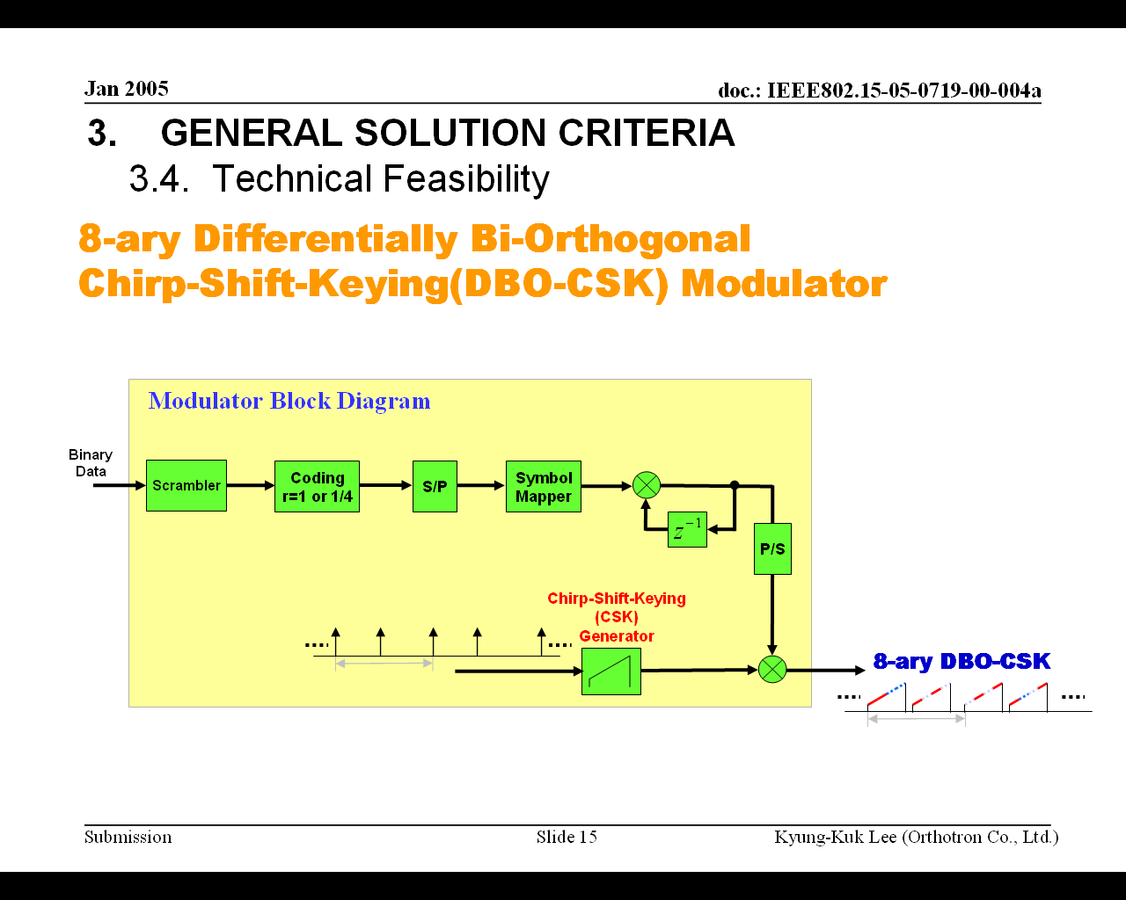
< The proposed 8-ary DBO-CSK Modulator >

Scalability

- Data-Rate:
- 2 rates: 1Mbps or 250Kbps

- RF Tx Power:
- 3 classes: 0.1mW / 1.0mW / 10mW

- Mobility Value:
- Data: Link Margin >= 30dB
- Ranging: Preamble Duration < 800usec
- Chirp is insensitive for Doppler Shift
- Can detect signal from the mode of high-speed moving

MAC Protocol Supplement

MAC Enhancements and Modifications

- Supplement for Scalability
- The proposed PHY has scalability for channelization
- Scalability which is included in PHY should be added to MAC for 15.4a PHY layer
(Ex. Data-rate Assignment per Packet)

- Wake-up Mode for Power Consumption Consideration
- Power consumption is of significant concern
- The proposed PHY can support advanced wake-up mode with superior SOP performance
- Needing supplement to 15.4 MAC to advanced wake-up mode for low-power consumption

PHY Layer Criteria

Channel Models and Payload Data

- Channel models and payload data
- CM1, CM2, & CM3
- Payload Data: 32bytes per Packet
- Data-rate: 1Mbps

Size and Form Factor

Base
band
RF
Battery
Pattern Antenna (24mm X 20)
SD Memory Size (32mm X 24 mm)

PHY-SAP Payload Bit Rate and Data Throughput

- Relation between Payload Bit-rate and Throughput
  - Payload bit-rate 1 Mbps : Throughput 618 Kbps
  - Payload bit-rate 250 Kbps : Throughput 216 Kbps

- Proposed PLCP Frame Format

Preamble
Delim
-iter
Length
+
Rate
32Chirp 8Chirp 12Chirp 86chirp (1Mbps) or 342chirp(250Kbps)
MPDU
(8+1)bit 32X8 bit
414 usec (1Mbps) or 1182 usec (250Kbps)

Simultaneously Operating Piconets

- Multiple Piconets

Duration of 2 Symbols (6microsec)
I

II

III

IV

- Simulation Results for SOP Performance in AWGN

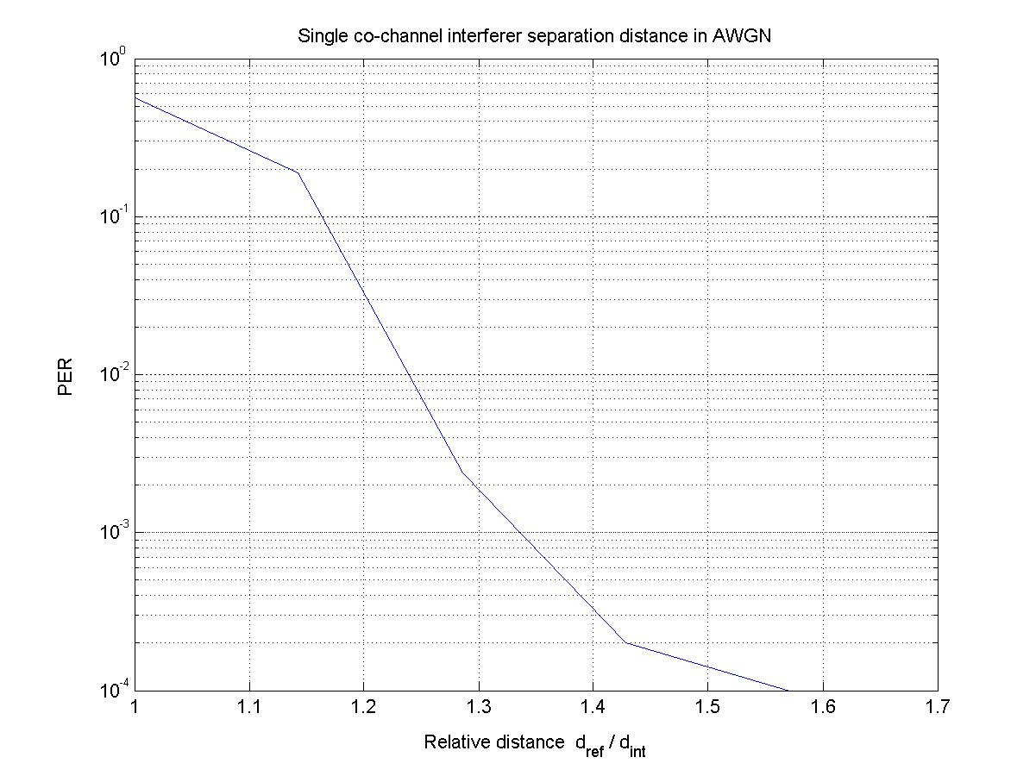
Single Co-Channel Interferer Separation Distance

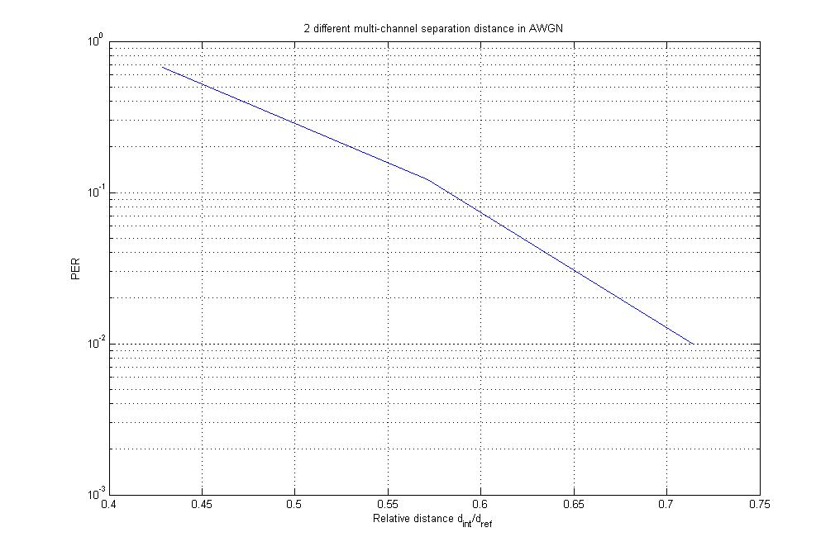
2 Adjacent Channel Interferers Separation Distance

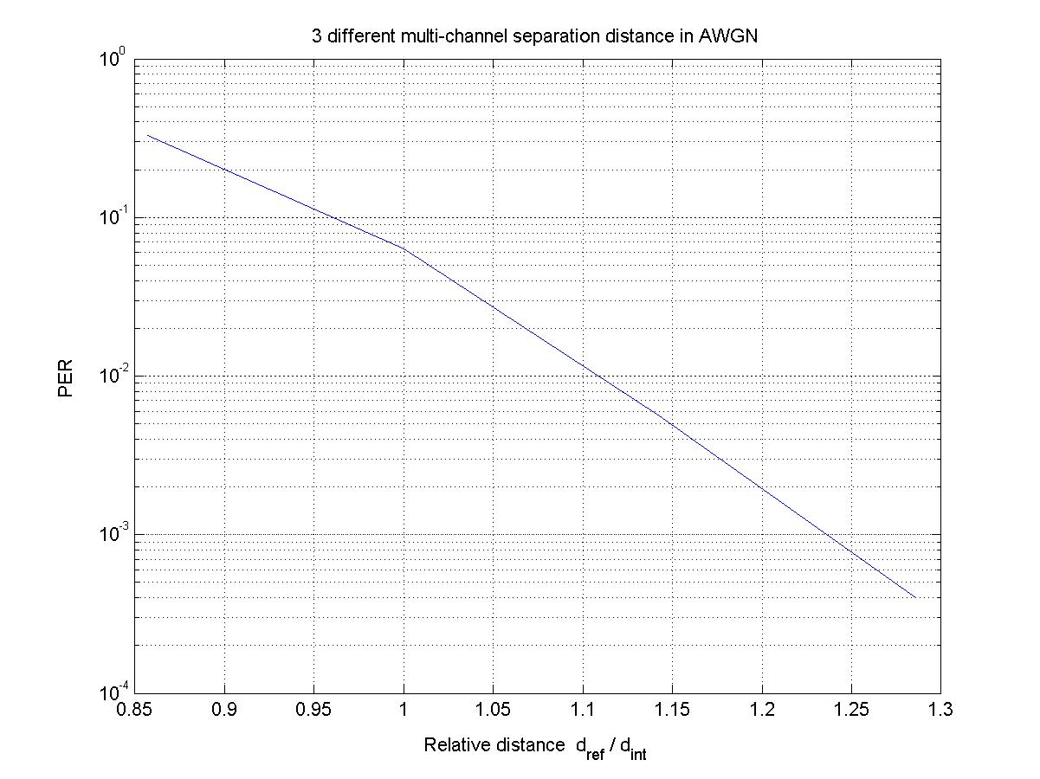
3 Adjacent Channel Interferers Separation Distance

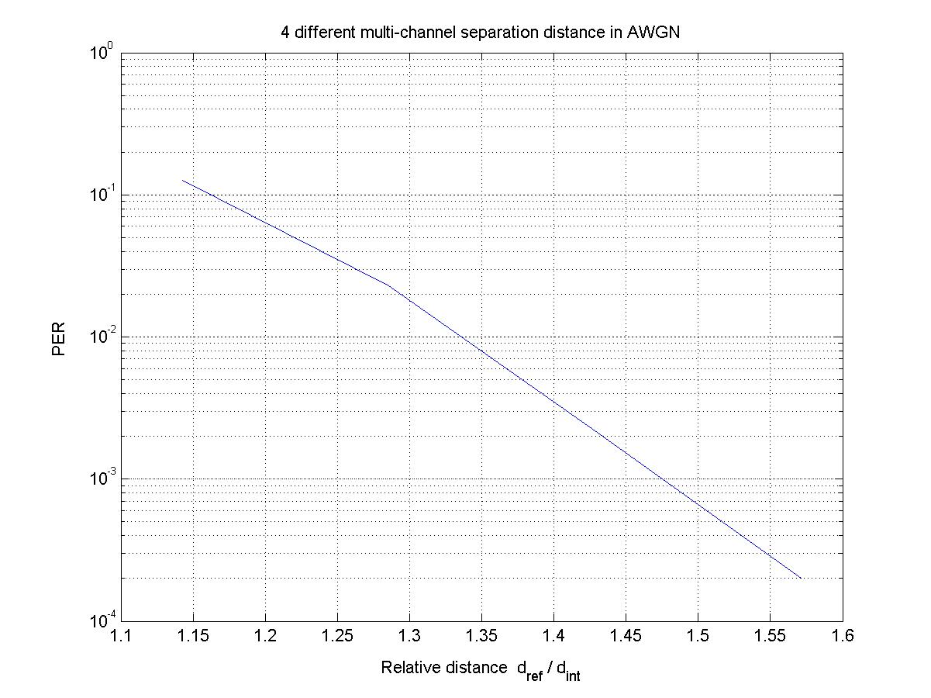
4 Adjacent Channel Interferers Separation Distance

- Simulation Results for SOP Performance in CM 1

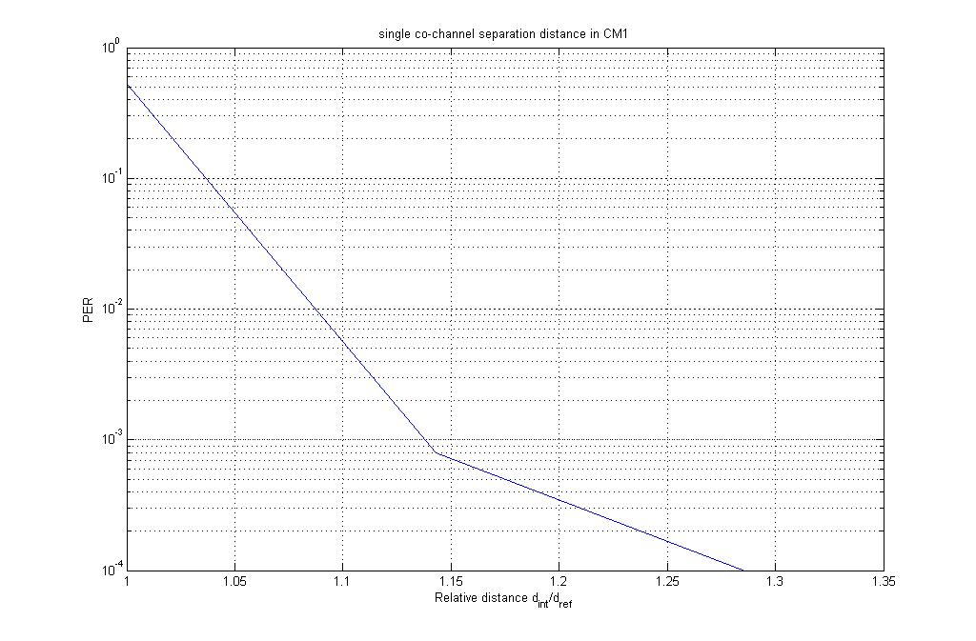
Single Co-Channel Interferer Separation Distance

2 Adjacent Channel Interferers Separation Distance

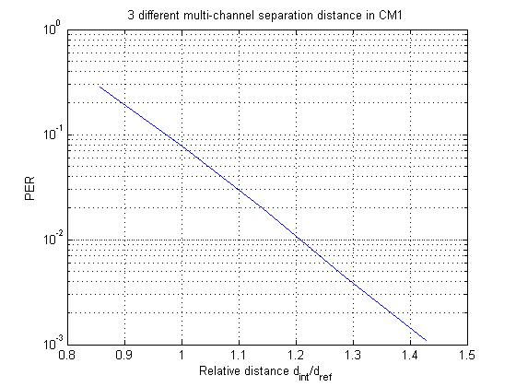
3 Adjacent Channel Interferers Separation Distance

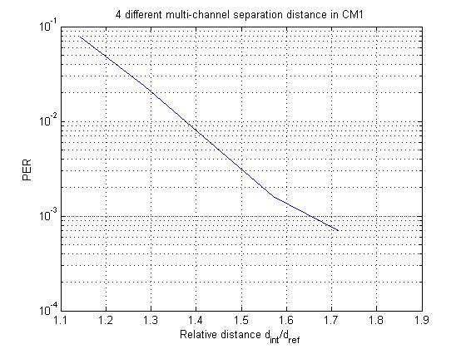
4 Adjacent Channel Interferers Separation Distance

Signal Acquisition

- Signal Acquisition Method

Differential
Detector
(T1)
Symbol
De-Mapper

Select
Largest
Data
A/D
Differential
Detector
(T2)

- Miss Detection Probability
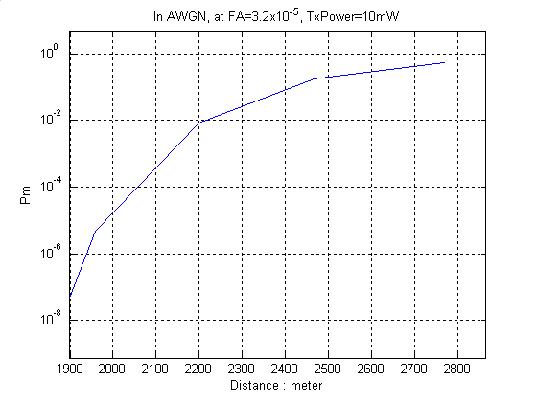

System Performance

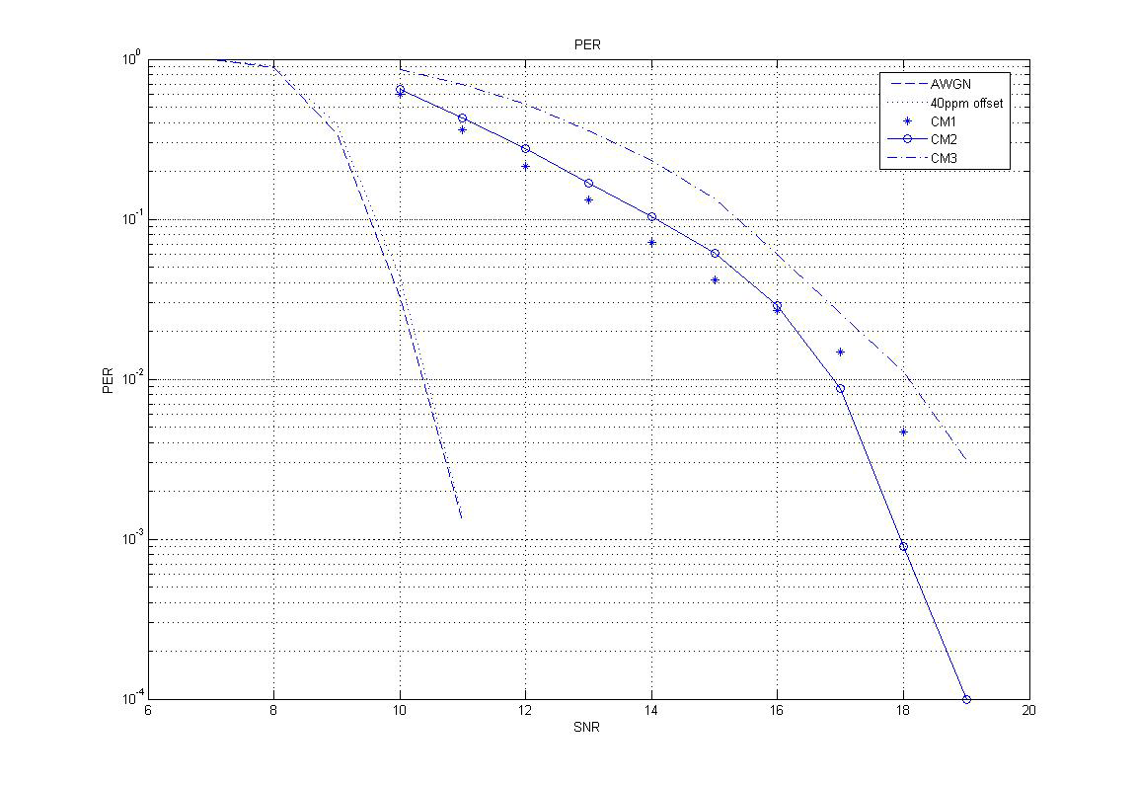
Data Rate : 1Mbps
Eb/No
Effect of Crystal
Tolerance (± 40ppm) :
➔ Negligible
PER

Ranging

- TDOA Based Ranging with Chirp Signal

- Estimation Precision: < 1m @ Eb/No greater than 22dB

Link Budget

Parameter | Mandatory  value |  | optional  value
peak payload bit rate(Rb) | 250 | kbps | 1000 | kbps
Average Tx Power(Pt) | 10 | dBm | 10 | dBm
Tx antenna gain(Gt) | 0 | dBi | 0 | dBi
fc' = sqrt(fminfmax) -10dB | 2.44 | GHz | 2.44 | GHz
Path loss at 1meter(L1=20log10(4pifc'/c)) | 40.2 | dB | 40.2 | dB
distance | 30 | m | 30 | m
path loss at d m(L2=20log10(d)) | 29.5 |  | 29.5
Rx antenna gain(Gr) | 0 | dBi | 0 | dBi
Rx power(Pr = Pt+Gt+Gr-L1-L2(dB)) | -59.7 | dBm | -59.7 | dBm
Average noise power per bit | -120.0 | dBm | -114.0 | dBm
Rx Noise Figure(Nf) | 7 | dB | 7 | dB
Average noise power per bit(Pn=N+Nf) | -113.0 | dBm | -107.0 | dBm
Minimum Eb/No(S) | 11 | dB | 11 | dB
Implementation Loss(I) | 3 | dB | 3 | dB
Link Margin(M=Pr-Pn-S-I) | 39.3 | dB | 33.3 | dB
Proposed Min. Rx Sensitivity Level | -99.0 | dBm | -93.0 | dBm

Sensitivity

 | Rx Sensitivity level  (250kbps) | Rx Sensitivity level  (1000kbps)
AWGN | -99dBm | -93dBm
CM1 | -93dBm | -87dBm
CM2 | -93.5dBm | -87.5dBm
CM3 | -92.5dBm | -86.5dBm

Power Management Mode

- Low-power Mode with Selection Wake-up
  - The proposed PHY has differentially bi-orthogonal detection and correlatively independent chirp-pulse waveform for multiple piconet

=> Superior SOP (Simultaneously Operating Piconets) performance

=> Low-power is achieved by advanced wake-up that the only desired piconets or group of nodes are called and the other piconets or nodes can estimate wake-up time from sleep state

=> Reducing Duty-Cycle and Extending Battery-life

  - This is compliant to “power consumption considerations” of 802.15.4 standard, and the mode operation for advanced wake-up may be added to this standard

Power Consumption

 | Gate  Equiv. | Die Area  (mm²) | Power Consumption
RF Section | - | 5.6 | 60 mW @ Tx 10mW
Baseband  @ Tx | 3k | 0.04 | 0.65 mW
Baseband  @ Rx | 51k | 0.63 | 61.6 mW
Deep Sleep |  |  | 12 uW

Antenna Practicality

- Antenna Size
- less than SD-Memory size

- Frequency / Impulse Response

- Radiation Characteristics
- Isotropic: 0dBi

