IEEE P802.15
Wireless Personal Area Networks

Project | IEEE P802.15 Working Group for Wireless Personal Area Networks (WPANs)
Title | Nanotron Chirp Spread Spectrum Proposal
Date Submitted | [4 January, 2005]
Source | [John Lampe]  [<Nanotron Technologies>]  [Alt-Moabit 61  10555 Berlin, Germany]  Rainer Hach – same address  Lars Menzer – same address | Voice: [49 30 399954-135 ]  Fax: [49 30 399954-188 ]  E-mail: [J.Lampe@nanotron.com]  E-mail: R.Hach@nanotron.com  E-mail: L.Menzer@nanotron.com
Re: | This is in response to the TG4a Call for Proposals, 04/0380r2.
Abstract | [The Nanotron Technologies Chirp Spread Spectrum is described and the detailed response to the Selection Criteria document is provided.]
Purpose | Submitted as the candidate proposal for TG4a Alt-PHY
Notice | This document has been prepared to assist the IEEE P802.15. It is offered as a basis for discussion and is not binding on the contributing individual(s) or organization(s). The material in this document is subject to change in form and content after further study. The contributor(s) reserve(s) the right to add, amend or withdraw material contained herein.
Release | The contributor acknowledges and accepts that this contribution becomes the property of IEEE and may be made publicly available by P802.15.
Nanotron CSS proposal

General properties of Chirp Signals
In following some general properties of linear frequency modulated signals, commonly known as chirp signals, will be mentioned.
1) Chirp signals show very good joint flatness of their envelope in time domain and their power spectral density (PSD) in frequency domain. This makes them the number one choice when a given resource like maximum PSD is to be utilized with minimum cost like PA linearity.
2) The cross correlation function between an upchirp and a downchirp signal has a constantly flat envelope. This property makes the interference between unsynchronized systems very predictable and thus manageable.
3) Any real world RF transmission system will have to cope with the fact that receiver oscillators are independent from transmitter oscillators. Like other spreading signals used for frequency spreading chirp signals provide a certain processing gain. Unlike other spreading signals this processing gain is found to be very robust against carrier frequency shifts.
4) Since one chirp sounds the whole frequency band available fast and reliable channel estimation is possible with only one or very few chirp symbols.

Structure of the system proposed
The System we propose is extremely simple.
The figure below shows the structure of the system. This structure which is basically a 2 ary baseband transmission system has been used for all subsequent simulations.
Since the processing gain of chirp signals is highly tolerant to frequency offsets between Tx and Rx Lo it seems valid to use this structure for calculations and simulations of coherent as well as noncoherent processing of the signals Sig A, Sig B.
The ‘windowed chirp’ is a linear frequency sweep with a total duration of 1 us. The signal is windowed with a function which is basically the magnitude of the frequency response of the sqrt raised cosine rolloff pulse with a rolloff factor of 0.25

The following figure shows the real part, imaginary part and the magnitude of a a normalized windowed upchirp signal with a total duration of 1us. 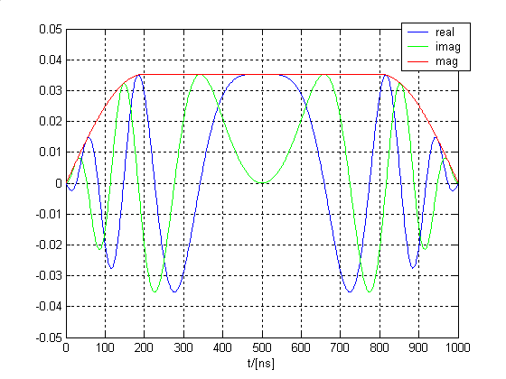
The following figure shows the auto correlation function and cross correlation function of the chirp signal described above. Please note that the cross correlation function has a constant low value (in difference to other DSS sequences).
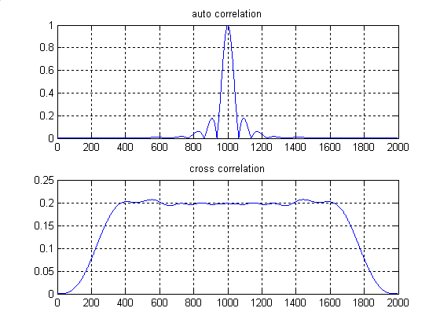
The following figure shows the PSD of the signal above after being adjusted to have a power of 10 dBm. By padding the with zeros the ‘frequency resolution’ has been set to 100 kHz. This makes the plot comparable to what a spectrum analyzer with a resolution bandwidth of 100 kHz would show. It is worth mentioning that the level at 12 MHz offset from the center is below -30dBm (which is the ETSI requirement for emissions at the borders of the 2.44 GHz ISM band).
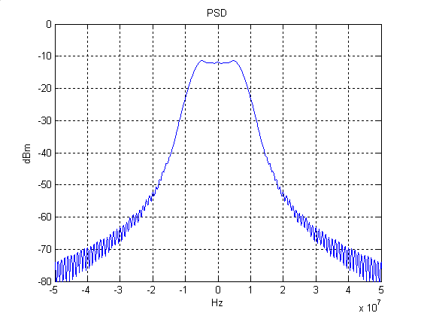
The further processing of the signals Sig A and Sig B for symbol detection could be done assuming coherent detection (process only the real part) or assuming non coherent detection (process the envelope).
The figure below shows the analytical BER values for 2 ary orthogonal coherent and non coherent detection and the corresponding simulation resultsfor a binary up/down chirp (using the chirp signals defined above). We see that the performance loss due to the nonorthogonality of up and down chirp is very small.
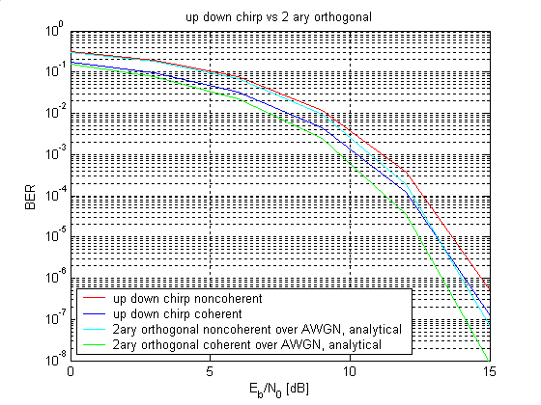

Subsequent simulations over other channels will all refer to the non coherent system as drawn below.

Response to Selection Criteria Document

3.1. UNIT MANUFACTURING COST/COMPLEXITY (UMC)

Estimation of the chip complexity

The following is an estimated silicon area occupied by the fundamental block of the transceiver chip utilizing CSS technology.

Target process: RF-CMOS, 0.18 µm feature size

Pos. | Block description | Estimated Area | Unit
1 | Receiver with high-end LNA | 2,00 | mm²
2 | Transmitter, Pout = + 10 dBm | 1.85 | mm²
3 | Digitally Controllled Oscillator + miscelaneous blocks | 0.62 | mm²
4 | Digital and MAC support | 0.60 | mm²
5 | Digital Dispersive Delay Line for selected maximum chirp duration | 0.32 | mm²
6 | Chirp generator for selected maximum chirp duration | 0.08 | mm²
7 | Occupied chip area for all major blocks required to build complete transceiver chip utilizing CSS technology | 5.47 | mm²

Target process: RF-CMOS, 0.13 µm feature size

Pos. | Block description | Estimated Area | Unit
1 | Receiver with high-end LNA | 1.90 | mm²
2 | Transmitter, Pout = + 10 dBm | 1.71 | mm²
3 | Digitally Controllled Oscillator + miscelaneous blocks | 0.59 | mm²
4 | Digital and MAC support | 0.38 | mm²
5 | DDDL for selected maximum chirp duration | 0.21 | mm²
6 | Chirp generator for selected maximum chirp duration | 0.06 | mm²
7 | Occupied chip area for all major blocks required to build complete transceiver chip utilizing CSS technology | 4.85 | mm²

3.2.1. Payload bit rate and throughput
The proposed PHY-SAP bit rate for the nominal bit rate, X₀ is 1,000 kb/s. Additionally, the proposal includes an additional bit rate, X₁ of 267 kb/s.
The proposed technology does not have a reduction in capacity due to aggregation from many devices. Thus, Y₀ and Y₁ are 1,000 kb/s and 267 kb/s respectively.
The PHY-SAP peer-to-peer throughput is given below.
The following table provides the effective throughput as a function of PPDU length. The SCD calls for 32 octets and additional values through the proposed 256 octet PPDU are shown. Following the table is a chart of the same information shown in the table. Both include the use of IFS.

throughput for varying frame lengths with ack and SIFS added
 | 32 | 64 | 128 | 256
1,000,000 | 329896.9 | 496124 | 663212.4 | 797507.8
267,000 | 155289 | 196368.7 | 226301.2 | 244971.7

There is no impact of a PHY specific duty cycle factor in considering useable peer-to-peer data throughput. MAC considerations as stated in IEEE standard 802.15.4 would provide such a restriction.
Additional throughput information is provided for a frame only and for a frame followed by and ACK turnaround and an ACK frame.
Information frame only table

throughput for varying frame lengths without acks or SIFS
 | 32 | 64 | 128 | 256
1,000,000 | 842105.3 | 914285.7 | 955223.9 | 977099.2
267,000 | 246922.1 | 256568.9 | 261680.5 | 264313.5

Information, ACK turnaround, ACK frame table

throughput for varying frame lengths with ack added
 | 32 | 64 | 128 | 256
1,000,000 | 438356.2 | 609523.8 | 757396.4 | 861952.9
267,000 | 175759.1 | 211978.4 | 236328.9 | 250730

3.2.2. Error rate

3.2.3. Receiver sensitivity

The sensitivity for the proposal’s mandatory bit rate of 1 Mb/s is -93 dBm while the sensitivity of the optional data rate of 267 kb/s is -98 dBm; as stated in section 5.8.

3.2.5. Band in use
The proposed CSS PHY operates in the 2.400 to 2.483 GHz global, unlicensed ISM band.

3.3. SIGNAL ROBUSTNESS
3.3.1. Coexistence and interference mitigation techniques.
The proposed CSS PHY is designed to operate in a hostile environment including such elements as multipath, and narrow and broadband intentional and unintentional interferers. Since a chirp transverses a relatively wide bandwidth it has an inherent immunity to narrow band interferers. Multipath is mitigated with the natural frequency diversity of the waveform. Broadband interferer effects are reduced by the receiver’s correlator. Additionally this proposal includes a Forward Error Correction (FEC) to further reduce interference and multipath effects.
Finally, this proposal allows for three non-overlapping frequency channels in the 2.4 GHz ISM band. This channelization allows this proposal to coexist with other wireless systems such as 802.11 b, g and even Bluetooth (v1.2 has adaptive hopping) via DFS. In addition to this channelization, the CSS proposal utilizes CCA mechanisms of Energy Detection (ED) and Carrier Detection. These CCA mechanisms are similar to those used in IEEE 802.15.4-2003; which in addition to the low duty cycle for the applications served by this standard were sufficient arguments to convince the IEEE 802 sponsor ballot community that coexistence was not an issue.
The following is an example of support for this proposal’s claim for interference ingress:
Example (w/o FEC):

Bandwidth B of the chirp 20 MHz
Duration time T of the chirp 1 µs
Center frequency of the chirp (ISM band) 2.442 GHz
Processing gain, BT product of the chirp 13 dB
Eb/N0 at detector input (BER=10⁻⁴) 12dB
Implementation Loss 2 dB
In-band carrier to interferer ratio (C/I @ BER=10⁻⁴) 1 dB

In support for this proposal’s claim for low interference egress, it can be seen from the following graph that an IEEE 802.11b receiver will have more than 30 dB of protection in an adjacent channel and almost 60 dB in the alternate channel (these numbers are similar for the 802.11g receiver).
Receive mask for 802.11b

3.4. TECHNICAL FEASIBILITY

3.4.1. Manufacturability
This proposal requires no new technology and all major transmitter and receiver sections have been implemented in CMOS as evidenced by Bluetooth and 802.15.4 devices.

    - Time to Market
The time to market with this proposal is believed to be the quickest of any of the proposals for TG4a due to:
- There are no regulatory hurdles, i.e. no delay time till these devices could be offered in Europe, Japan, China, etc.
- There are no research barriers – i.e. no unknown blocks as evidenced by the fact that CSS chips are available in the market
In summary normal design and product cycles are the only restrictions on time to market

3.4.3. Regulatory Impact.
The CSS proposal is permitted in all significant regions of the world including but not limited to North and South America, Europe, Japan, China, Korea, and most other areas. Additionally, there is no known limitation to this proposal as to indoors or outdoors as there is with UWB devices.
The CSS proposal would adhere to the following worldwide regulations:

United States | Part 15.247 or 15.249
Canada | DOC RSS-210
Europe | ETS 300-328
Japan | ARIB STD T-66

3.5. SCALABILITY
3.5.2. Values

This CSS proposal is rich in scalability parameters such as data rate, power levels, frequency bands, bandwidth, data whitener, and backward compatibility.
The data rates included in this proposal are the 1 Mb/s mandatory rate, and an optional 267 kb/s rate. Other possible data rates include 2 Mb/s to allow better performance in a burst type, interference limited environment or a very low energy consumption application. Additionally, lower data rates by using interleaved FEC and lower chirp rates would yield better performance (longer range, less retries, etc.) in an AWGN environment or a multipath limited environment. It should be noted that if these data rates are only discussed here to show scalability, if these rates are to be included in the draft standard the group must revisit the PHY header such as the SFD.

The proposer is confident that the CSS proposal would also work well in other frequency bands including the 5975 to 7250 MHz band mentioned in the new FCC operating rules “SECOND REPORT AND ORDER AND SECOND MEMORANDUM OPINION AND ORDER” released December 16, 2004. Here is a brief list of the restrictions:
- These devices can operate ONLY between 5975 and 7250 MHz, 50 MHz minimum bandwidth (not 500 MHz as for UWB) at the Class B limits.
- These devices can have higher peak limits than previous non-UWB Part 15 (now similar to peak limits for UWB systems)
These non-UWB devices can operate with frequency hopping, gating or stepped frequency characteristics.
It should be noted that while operation in this new band would provide greater bandwidth and perhaps less interference and coexistence constraints; the link margin would suffer due to the greater losses due to the higher frequencies. Current drain could also increase due to the higher operating frequencies.
Additionally, the group may consider the use of a data whitener, similar to those used by Bluetooth and IEEE 802.11 to produce a more “noise-like” spectrum and allow better performance in synchronization and ranging.
Finally, for extremely long ranges the transmit power may allowed to rise to each country’s regulatory limit, for example the US would allow 30 dBm of output power with up to a 6 dB gain antenna, while the European ETS limits would specify 20 dBm of output power with a 0 dB gain antenna. It should be noted that even though higher transmit requires significantly higher current it doesn’t significantly degrade battery life since the transmitter has a much lower duty cycle than the receiver, typically 10% or less of the receive duty cycle. In this manner the averaged transmitter current drain will be less than the averaged receiver current drain.

Due to some of the similarities with DSSS it is possible to implement this proposal in a manner that will allow backward compatibility with the 802.15.4 2.4 GHz standard. The transmitter changes are relatively straightforward. Changes to the receiver would include either dual correlators or a superset of CSS and DSSS correlators. It is anticipated that this backward compatibility would be achieved via mode switching versus a dynamic change on-the-fly technique; however that fact is left up to the implementer. This backward compatibility would be a significant advantage to the marketplace by allowing these devices to communicate with existing 802.15.4 infrastructure and eliminating customer confusion.

3.5.3. Mobility Values

Communication

No system inherent restrictions are seen for this proposal, since the processing gain of chirp signals is extremely robust against frequency offsets such as those caused by the doppler effect due to high relative speed v_{rel} between two devices. Such situations also occur when one device is mounted on a rotating machine. The limits will be determined by other, general processing modules (AGC, symbol synchronization,...)

Ranging
The ranging scheme proposed in this document relies on the exchange of two hardware acknowledged data packets (one for each direction) between two nodes.
We assume that the longest time in this procedure is the turnaround time t_{turn} between the two nodes which will be determined by the respective uC performance. During this time the change of distance should stay below the accuracy d_{a} required by the application.
$$v_{\text{rel}}\text{<<}\frac{d_{a}}{t_{\text{turn}}}$$

For d_{a} =1m, t_{turn} =10 ms this yields v_{rel} << 100m/s

4.1. ALTERNATE PHY REQUIRED MAC ENHANCEMENTS AND MODIFICATIONS

There are no anticipated changes to the 15.4 MAC to support the proposed Alt-PHY. Three channels are called for with this proposal and it is recommended that the mechanism of channel bands from the proposed methods of TG4b be used to support the new channels. There will be an addition to the PHY-SAP primitive to include the choice of data rate to be used for the next packet. This is a new field.
Ranging calls for new PHY-PIB primitives that are expected to be developed by the Ranging subcommittee.

5.1 Channel models and payload data to be used in the simulations

Since this proposal refers to the 2.4GHz ISM band only channel models with complete parameter set covering this frequency range can be considered. At the time being these are LOS Residential (CM1) and NLOS Residential (CM2).
The 100 realizations for each channel model were bandpass filtered with +-15MHz around 2.437GHz which corresponds to the second of the three subbands proposed.
The filtered impulse responses were down converted to complex baseband.
The magnitudes over time are shown in the following plots. Furthermore some graphs of the function H_tilde as described and required in the SCD are shown.
For now we assume that the neighbour subbands will not differ significantly from the center subband and that we restrict simulations on the center subband

The SCD requirements on the payload size to be simulated seem to be somewhat inconsistent. At some point 10 packets with 32 bytes are mentioned which would be a total of 2560 bits. On the other hand a PER of 1% is required which mean simulating more than 100 packets or 25600 bits.

Since the delay spread and thus the time in which subsequent symbols can influence each other of all given channel impulse responses is well below the symbol duration of 1us suggested by this proposal we believe that we get the best results when we simulate a large number of independent transmissions of symbols.
Assuming an equal probability of error for all bits of a packet we can give the relationship between the BER and PER by
$$1−\text{PER}=(1−\text{BER})^{N}$$
With N being the number of payload bits.
Thus we can calculate the BER which is required for any PER:
$$\text{BER}=1−\sqrt[N]{1−\text{PER}}$$
For PER=1% and N=256 we get BER=3.9258E-5
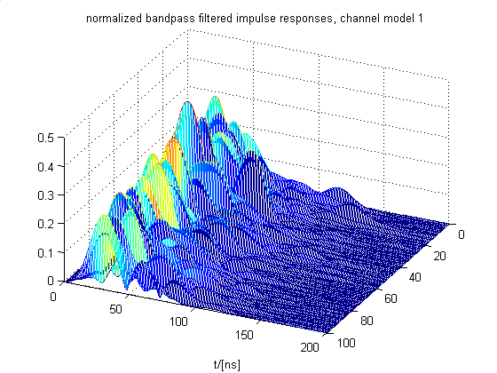

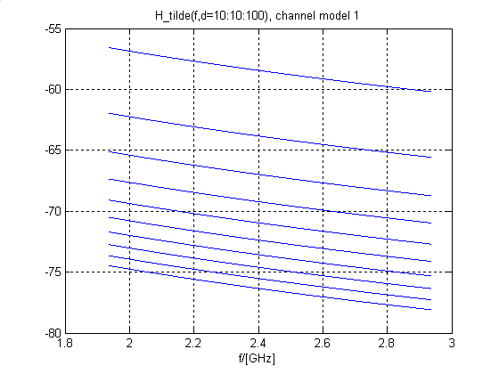

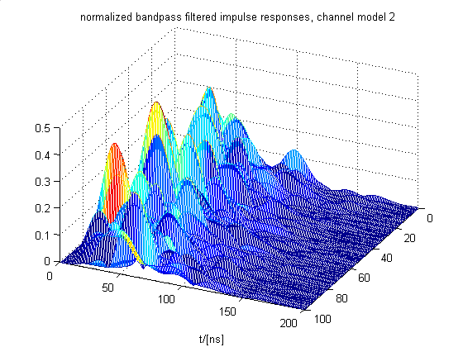
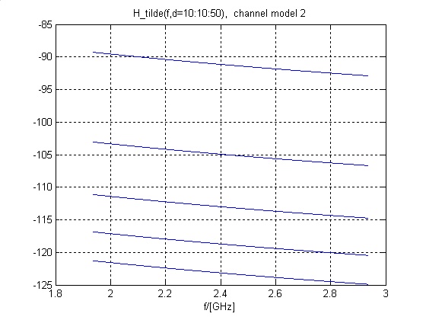

5.2. SIZE AND FORM FACTOR
The implementation of the CSS proposal will be much less than SD Memory at the onset following the form factors of Bluetooth and IEEE 802.15.4/ZigBee. As evidenced in section 3.1 the implementation of this device into a single chip is relatively straightforward and will therefore facilitate the SD Memory form factor.

5.3. PHY-SAP PAYLOAD BIT RATE AND DATA THROUGHPUT
The PPDU is composed of several components as shown in the figure below

The following figure shows in greater detail, the component parts of each PPDU.

Octets: 4 | 1 | 1 | Variable (up to 256)
Preamble | SFD | Frame length (8 bits) | PHY payload
SHR |  | PHR | PSDU

The SFD structure is described in section 5.4 as it has different values for and determines the effective data rate for PHR and PSDU.
The Preamble is 32 bits in duration (a bit time is 1 us).
In this proposal, the PHR field is used to describe the length of the PSDU that may be up to 256 octets in length.

In addition to the structure of each frame, the following shows the structure and values for frames including overhead not in the information carrying frame.
The figures following show the structure, as defined in the IEEE Standard 802.15.4 and the SCD, cases of acknowledged transmissions as used in section 3.2.1 values and for unacknowledged transmissions.
For this proposal, the value of T_{ack} and SIFS are retained from the IEEE Standard 802.15.4 and are each 192 microseconds. The value of LIFS is also shown as 192 microseconds. Additional revisions of this proposal may show a different value as the authors discuss the need for longer LIFS values with members of TG4b. The values of SIFS and LIFS have a MAC dependency above the value of 192uS required for PHY turn around. SIFS has a value of 192us (12 symbols) in the current standard and LIFS has a value of 40 symbols.

5.4. SIMULTANEOUSLY OPERATING PICONETS

Separating Piconets by code division
For any code division system, codes with zero cross-correlation products at sampling time are desired.
When the systems operate independently (unsynchronized and no Tx power control with respect to each other) the cross correlation must be as low as possible over its full duration. As was shown above the up down chirp pair provides such cross correlation. Thus if Up/Off chirp and Down/Off chirp are used it would be possible to have two code devised channels in each frequency band.
As with any other code division scheme however, perfect orthogonality is not practical. When the Piconets are spatially interleaved (which has to be assumed) the ratio of signal powers (near-far effect) from different nodes will exceed the coding gain at a receiving node with high probability. Due to the near-far effect, this proposal is not based upon CDMA.

Separating Piconets by frequency division
This CSS proposal includes a mechanism for FDMA by including the three frequency bands used by 802.11 b, g and also 802.15.3. It is believed that the use of these bands will provide sufficient orthogonality. The chirp signal defined earlier has a rolloff factor of 0.25 which in conjunction with the space between the adjacent frequency bands allows filtering out of band emissions easily and inexpensively.

5.5. SIGNAL ACQUISITION
5.5.2
The signal acquisition is basically determined by the structure and duration of the preamble. In contrast to ‘always on’ systems like DECT or GSM; low duty rate systems must be able to acquire a signal without any prior knowledge about that signal’s level or timing. 2 us. While the IEEE 802.15.4-2003 uses a preamble duration of 32 symbols (128 µs at 2.4 GHz) other commercially available transceiver chips (e.g. nanoNET TRX from Nanotron) use 30 symbols at 1MS/s (i.e. 30µs).
For consistency with IEEE 802.15.4-2003 this CSS proposal is based upon a preamble of 32 symbols which at 1MS/s turns out as 32 µs. Existing implementations demonstrate that modules which might be required to be adjusted for reception (Gain Control, Frequency Control, Peak Value Estimation, etc..) can be setup in such a time duration. The probability of missing a packet is then simply determined by the probability that the SFD is received correctly.
As shown before the BER required for a PER of 1% is BER=3.9258E-5.
Since the SFD consists of 1 octet for the 1MS/s mode, the miss probability P_{miss} is
$P_{\text{miss}}=1−(1−\text{BER})^{8}=$3.1402e-004; which is sufficiently low for this design. The SFD for the optional 267 kb/s mode (w/FEC) however needs to be longer to keep the miss probability from driving the sensitivity. The authors suggest a two octet value to either allow some bit errors or to include FEC to reduce the miss probability.

5.5.3 Clear Channel Assessment

A combination of symbol detection (SD) and energy detection (ED) has proven to be useful in practice. The duration of the preamble can be used as upper bound for the duration for both detection mechanism. By providing access to the threshold for ED the system allows the application to adjust its behaviour (false alarm vs. miss probability) according to its needs.

5.6. SYSTEM PERFORMANCE

Simulation over 100 channel impulse responses ( as required in the SCD) were performed for channel model 1 and channel model 2.

No bit errors could be observed on channel model 1 (simulated range was 10 to 2000m). This is not really surprising because this model has a very moderate increase of attenuation over range (n=1.79)

The results for channel model 2 are displayed below. The parameter n=4.48 indicates a very high attenuation for higher ranges. The results were interpreted as BER and PER respectively and for convenience were plotted twice (linear and log y scale).

Simulation results over channel model 2, 100 realizations, 1E5 Symbols
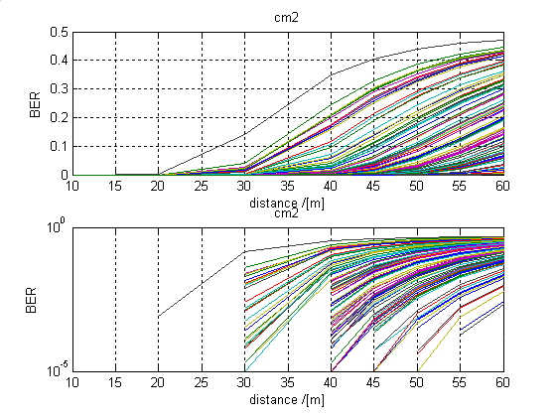
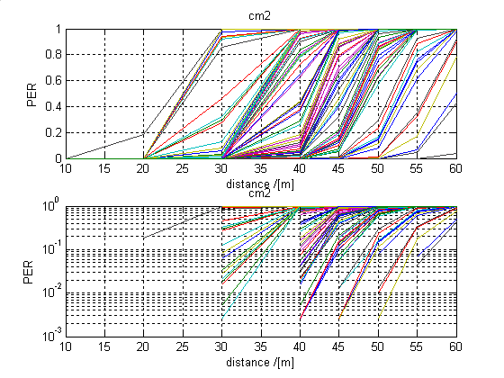
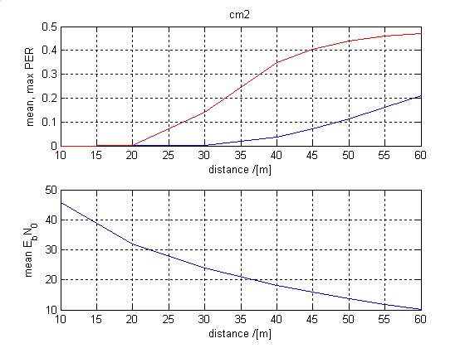

5.7. RANGING

SCD Section 5.7 Ranging

Symmetrical Double-Sided Two-Way Ranging

TOA Estimation

This proposal suggests to use TOA measurements as a base for ranging calculations. Since in the commonly used scenario only one node transmits at a time the situation is somewhat different from classical radar applications in which reflections from multiple targets are to be resolved at a time.
Certainly a high signal bandwidth allows a high rise speed of its correlation pulse and thus a good time resolution.
On the other increasing the signal to noise ratio increases the timing accuracy with which pulse can be detected as shown in [The Effect of AWGN on the Accuracy of Time of Arrival Detection, Rick Enns, doc 15-04-0335-00-004a ]
Thus, a system with reduced bandwidth can compensate its bandwidth reduction be increased the signal to noise ratio which for example can be achieved by using a higher Tx power. A simple formula for this relationship is derived in the following:
Given a band limited pulse with noise σu we want to estimate how the jitter (timing error) σt with which the passing of the rising edge of the pulse through a given threshold can be detected is effected by the bandwidth B.

We approximate the impact of σ_{u} by the simple formula: $v_{r}=\frac{σ_{u}}{σ_{t}}=\frac{u_{\text{peak}}}{t_{\text{rise}}}$
which can be rearranged as:
$$σ_{t}=\frac{σ_{u}}{v_{r}}=\sqrt{\frac{σ_{u^{2}}}{u_{{\text{peak}}^{2}}}}⋅t_{\text{rise}}$$
We now assume a pulse which is the output of the receiver (matched) filter.
The SN of such a pulse is known to be 2Es/N0.
If we further assume a pulse with a rise time t_{rise} which is the inverse of the pulse bandwidth B (t_{rise}= 1/B) we can write:
$$σ_{t}\text{==}\sqrt{\frac{N_{0}}{2E_{s}}}⋅\frac{1}{B}$$

The following table shows that even for a 20 MHz system a very reasonable timing resolution and thus ranging accuracy can be expected.
Es/N0  [dB] | B  [MHz] | σ t  [ns] | σt x 3e8[m/s]  [m]
15 | 7000 | 0.018 | 0.005
27.5 | 20 | 1.493 | 0.448

TOA Processing
Proposed is the ranging technique Symmetrical Double-Sided Two-Way Ranging (SDS TWR) . The characteristics and benefits of this technique are:
- No additional overhead on PHY for ranging (random data symbols used for ranging).
- No impact of packet length or data rate (since no impact of round trip & reply time) on distance accuracy (allows flexible adoption of ranging method).
- No meaningful overhead on channel for ranging, since range can be determined by utilization of packets from application messages/communication (only exchange of some additional bytes ranging information).
- Single shot capable (est.: accuracy = better than 1 m, low time effort = 2 ms @ MBit per distance measurement, low energy consumption = 360 µJ per distance measurement)
- Existing PHY/MAC features improve ranging properties significantly without overhead (double used, see slide before).
- Easy adoption of ranging method on existing MAC protocols possible (DATA-ACK, DATA-DATA, TDMA). Only symmetry properties must be guaranteed by e.g. DATA-ACK timing (DATA-ACK SIFS uncertainty below 10 µs, but need not to be very precise).
- Clock synchronization not required. Even cheap commercial quartz crystals allow excellent accuracy (despite clock error of ±40 ppm accuracy impact = ±12 cm @ 1 km).
- About the same accuracy with broadband signals (64 MHz) as UWB signals (7 GHz) allows cheaper transceiver implementations.
- Method scalable for required accuracy & available bandwidth (accuracy is proportional to the amount of timing information transmitted -> Shannon C = BTln2(SNR)).
- Simple calculation of distance (only +-*/ operations, no sophisticated algorithms are required).
- Low resolution of single ToA measurements sufficient (e.g. 8 ns = 125 MHz counter).
- It should be noted that the ranging technique discussed in this proposal is believed to be applicable to any bi-directional system; i.e. it is not peculiar to CSS.
- The high resolution timer does not have to run all of the time.

The following figure and text describe the SDS TWR operation:
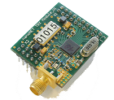
T_{roundA}
T_{prop}
T_{replyA}
t
T_{prop}
T_{prop}
t
T_{roundB}
T_{replyB}
Node A
Node B
T_{prop}

Tround ... round trip time
Treply ... reply time
Tprop ... propagation of pulse

Double-Sided: Each node executes a round trip measurement.
Symmetrical: Reply Times of both nodes are identical (TreplyA =TreplyB).
Results of both round trip measurements are used to calculate the distance.

Node A sends a first request message to Node B. After reception the message is checked. If the check succeeds, a first reply message is sent back to node A after a predetermined delay. This message sequence is repeated a second time, but initiated from the other node. Node B sends a second request message to node A, where a second reply message is sent back to node B after the successful check and the predetermined delay. The detected departure and arrival times of the request and reply messages are used to count the precise round trip (Tround) the reply times (Treply). The time from the transmission of the request message to the arrival of the reply message is the round trip time. The time from the arrival of the request message to the transmission of the reply message is the reply time. The distance between node A and B can be calculated from the measured round trip and reply times and the speed of light. The two round trip and the two reply times determine an average air propagation time. As known the distance can be calculated by multiplication of the air propagation time and the speed of light. To achieve the highest accuracy of the distance despite the presence of unsynchronized an imprecise time bases (clock errors) in nodes A and B, the reply times of the two message sequences should be almost identical. This double message exchange sequence with the identical reply times we call the Symmetrical Double-Sided Two Way Ranging (SDS TWR). In real implementations identical reply times are not possible, but the method allows a good margin for the differences of the reply times (symmetry error = ∆Treply) and achieves still a very high accuracy.

The accuracy of SDS TWR is shown:

Calculation of Distance d:

Calculation of Distance Error EAB:

- Result: Distance accuracy is equivalent to the average of time base accuracies (some tens ppm of distance only) ! Distance accuracy is independent of round trip & reply time !

c = speed of light, EtA ... error of time base at node A, EtB ... error of time base at node B

Symmetry Error of SDS TWR

Symmetry Error is Present in Practical Implementations:

Calculation of Distance Error EAB :

Result: Distance accuracy is independent of round trip & reply time ! Distance accuracy increases with decreasing of the Symmetry Error ∆Treply !

c = speed of light, EtA ... error of time base at node A, EtB ... error of time base at node B

Influence of Symmetry Error: Calculation of an SDS TWR Example System
Example System EtA = ±40 ppm, EtB = ± 40 ppm (worst case combination selected):

d | ∆d  (ΔTreply  = 20 ns) | ∆d  (ΔTreply  = 200 ns) | ∆d  (ΔTreply  = 2 µs) | ∆d  (ΔTreply  = 20 µs) | ∆d  (ΔTreply  = 200 µs)
10 cm | ± 0.012 cm | ± 0.12 cm | ± 1.2 cm | ± 12 cm | ± 120 cm
1 m | ± 0.012 cm | ± 0.12 cm | ± 1.2 cm | ± 12 cm | ± 120 cm
10 m | ± 0.05 cm | ± 0.12 cm | ± 1.2 cm | ± 12 cm | ± 120 cm
100 m | ± 0.4 cm | ± 0.4 cm | ± 1.2 cm | ± 12 cm | ± 120 cm
1 km | ± 4 cm | ± 4 cm | ± 4 cm | ± 12 cm | ± 120 cm
10 km | ± 40 cm | ± 40 cm | ± 40 cm | ± 40 cm | ± 120 cm

Conclusion: Even 20 µs Symmetry Error allows excellent accuracy of distance ! Symmetry Error below 2 µs can be guaranteed in real implementations !

Accuracy of Time of Arrival Measurement (ToA)
- How to measure the time of arrival and achieve better than nanoseconds-accuracy ?
- 1 ns is equal to 1 GHz and 100 ps is equal to 10 GHz !
- 1 ns is equal to a distance of 30 cm (1 foot) !
- A counter for 1 GHz is very challenging and consumes to much energy with standard technologies (e.g. Standard Cells, 0.18 µ CMOS) !

Solution: Dithering and Averaging of Multiple Pulses
- Round trip protocol is implemented with PHY packets instead single pulses
- Determination of round trip & reply time is based on ToA measurement of multiple pulses
- Advantage of Chirps: Each pulse (symbol) contains timing and data. Timing of a pulse is always available and independent of transmitted data !
- Dithering: Each pulse of a PHY packet is shifted differently by a pseudo-random time (equally distributed) before transmission
- Averaging: ToA measurements of multiple pulses are regarded at the receiver
- As known Dithering & Averaging improves the accuracy above the measurement resolution of a single measurement
- Equally distributed noise on the transmission channel and the receiver improves the transmitter dithering (equal distribution) and is an advantage rather than a disadvantage

Principle of Dithering and Averaging

Dithering:

T_{i}
ΔT_{i2}
ΔT_{i3}
ΔT_{in}
pulse to transmit
PHY packet to transmit
ΔT_{i1}
transmitted pulse
PHY packet transmitted
T_{i}
t

Averaging:
T_{i}
ΔT_{iRX3}
ΔT_{iRXn}
T_{i}
T_{i}
T_{i}
ΔT_{iRX2}
ΔT_{iRX1}
t_{ToA}’
t
Dithering and Averaging described
For the precise measurement of the arrival time of a message (ToA) a bunch of pulses rather than a single pulse can be measured. By application of the well known Dithering & Averaging technique, the resulting resolution of the arrival time is much better than the resolution of a single measurement. This approach is very suitable for the proposed Chirp Spread Spectrum modulation, since each Chirp symbol detection delivers a quite precise timing information in addition to a date. Dithering shifts each symbol in time a little bit on the transmission path, but the average symbol period is constant and known. The maximum shifting range is only a very small portion of the symbol period, but the shifting range must be at least equal to the single measurement resolution. The negative effect on the link budget (losses due to gaps between Chirp symbols) is negligible. The sum of the shifting times are kept close to zero and all shifts are kept equally distributed. Under those conditions the resolution of the averaged arrival time is much better than the single measurement (order of magnitudes). The dithering (time shifts) can be introduced deliberately on the transmitter, the receiver or on both simultaneously. In addition noise on the transmission channel (air) and background noise in the implementation (e.g. LNA noise) adds additional time shifts to the symbols, which improves the equal distribution of the dithering. Noise is rather an advantage than a disadvantage. In addition the resolution of the averaged ToA measurement can be adjusted to accuracy requirements or available frequency bandwidth of the transmission channel by changing the number of single ToA measurements.

Simulation of a SDS TWR system

Example system:
Simulates SDS TWR +
Dithering & Averaging
Crystal Errors ±40 ppm
Single shot measurements
@ 1 MBit/s data rate (DATA-ACK)
Transmit Jitter = ± 4 ns (systematic/pseudo RN-Sequence)
Pulse detection resolution = 4 ns
Pulses averaged per packet = 32
Symmetry error = 4 µs (average)
Distance = 100 m
Results of Distance Error ∆d:
|∆dWC| < 50 cm
|∆dRMS| < 20 cm
(ideal channel without noise)
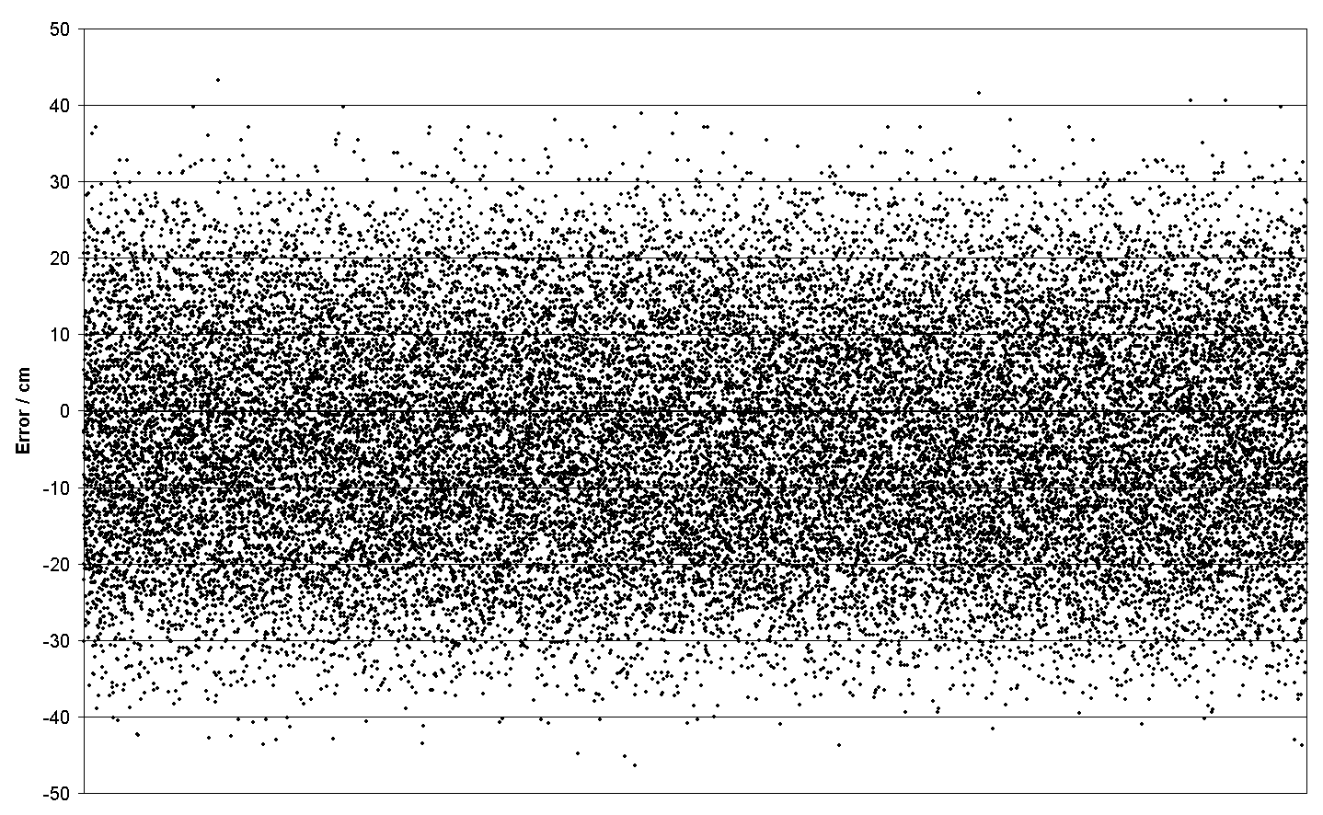

5.8. LINK BUDGET

Parameter | (mandatory)  Value | (optional) Value
peak payload bit rate (R_{b}) | 1000 kb/s | 267 Kb/s
Average Tx power ($P_{T}$) | 10 dBm | 10 dBm
Tx antenna gain ($G_{T}$) | 0 dBi | 0 dBi
$f_{c}^{'}=\sqrt{f_{\text{min}}f_{\text{max}}}$: geometric center frequency of waveform ($f_{\text{min}}$ and $f_{\text{max}}$ are the -10 dB edges of the waveform spectrum) | 2.442 GHz | 2.442 GHz
Path loss at 1 meter ($L_{1}=\text{20}{\text{log}}_{\text{10}}(4{{πf}_{c}^{'}}/c)$)  $c=3×{\text{10}}^{8}$ m/s | 40.2 dB | 40.2 dB
Path loss at d m ($L_{2}=\text{20}{\text{log}}_{\text{10}}(d)$) | 29.54 dB at d=30 meters | 40 dB at d=100 meters
Rx antenna gain ($G_{R}$) | 0 dBi | 0 dBi
Rx power ($P_{R}=P_{T}+G_{T}+G_{R}−L_{1}−L_{2}$ (dB)) | -60 dBm | -70 dBm
Average noise power per bit ($N=−\text{174}+\text{10}{\text{*log}}_{\text{10}}(R_{b})$) | -114 dBm | -120dBm
Rx Noise Figure ($N_{F}$) note | 7 dB | 7 dB
Average noise power per bit ($P_{N}=N+N_{F}$) | -114 dBm | -120 dBm
Minimum E_{b}/N₀ (S) | 12 dB | 7dB
Implementation Loss¹ (I) | 3 dB | 3 dB
Link Margin ($M=P_{R}−P_{N}−S−I$) | 33 dB | 33 dB
Proposed Min. Rx Sensitivity Level² | -92dBm | -97 dBm

Rx noise figure: in addition the proposer can select other values for special purpose (e.g. 15 dB for lower cost lower performance system).

5.9. SENSITIVITY
The sensitivity to which this CSS proposal refers is based upon non-coherent detection. It is understood that coherent detection will allow two to three dB better sensitivity but at the cost of higher complexity (higher cost?) and poorer performance in some multipath limited environments.
The sensitivity for the 1 Mb/s mandatory data rate is -93 dBm for a 1% PER in an AWGN environment with a front end NF of 7 dB. The sensitivity for the optional 267 kb/s data rate is -98 dBm for a 1% PER in an AWGN environment with a front end NF of 7 dB.

5.10. POWER MANAGEMENT MODES
Power management aspects of this proposal are consistent with the modes identified in the IEEE 802.15.4: 2003 standard. There are no modes lacking nor added. Once again, attention is called to the 1 Mbit/s basic rate of this proposal and resulting shorter “on” times for operation.
5.10.1. Definition
5.11. POWER CONSUMPTION

Although the proposer’s affiliated company (Nanotron) has developed numerous ICs based on this technology, this proposal is sufficiently different from its past developments that power consumptions from these previous developments may not be relevant. Therefore to address the power consumption this proposal will reference the power consumptions verified by current 802.15.4 devices.
The typical DSSS receivers used by 802.15.4 are very similar to the envisioned CSS receiver. The two major differences are the modulator and demodulator. The modulator of the CSS is much simpler than the DSSS however since the major power consumption is the transmitter this difference is negligible. Therefore the power consumption for a 10 dBm transmitter is 198 mW or less.
The receiver for the CSS is remarkably similar to that of the DSS with the major difference being the correlator. The correlator for the CSS uses a frequency dispersive mechanism while the DSSS uses a chip additive correlator. It is believed that the difference in power consumptions between these correlators is negligible so the power consumption for a 6 dB NF receiver should be 40 mW or less.
The power consumed during the CCA is basically similar to the receiver power consumption since all of the receiver circuits are being used during the CCA (correlator is used for the carrier detect function).
The power save mode is used most of the time for this device and has the lowest power consumption. Typical power consumptions for 802.15.4 devices are 3 µW or less.

The energy per bit is merely the power consumption divided by the bit rate. The energy per bit for the 10 dBm transmitter is less than 0.2 µJ. The energy per bit for the receiver is 40 nanoJoules.
The energy consumed during an exchange of the 32 octet PDU would be transmission of 304 bits or 60 µJ along with the other device’s reception of same PDU or 12 µJ; followed by t_{ack} of 202 µS or 8 µJ; concluded by the first device’s reception of the act from the other device or 2.6 µJ and the other device’s transmission of the ack or 13.2 µJ. To conclude the sender device consumed 60 + 8 + 2.6 = 70.6 µJ during this transaction while the receiving device consumed 12 + 8 + 13.2 = 33.2 µJ. As a reference point it should be noted that according to the Duracell web site, a Duracell AA alkaline cell contains more than 12,000 Joules of energy.

5.12. ANTENNA PRACTICALITY

The antenna for this CSS proposal is a standard 2.4 GHz antenna such as widely used for 802.11b,g devices and Bluetooth devices. These antennas are very well characterized, widely available, and extremely low cost. Additionally there are a multitude of antennas appropriate for widely different applications. The size for these antennae is consistent with the SCD requirement.

6.0 Best mode solution

The proposers will summarize here their “best mode solution”, using the criteria they estimate appropriate for the main set of applications they target, and taking into account the PAR and five criteria (doc. Ref. [10]). These criteria must include the power consumption, ranging performance, gate count etc.

The summary will be given in a table listing the selected parameters and results delivered by the proposers in sections 3 (general solution criteria) and 5 (PHY layer criteria) for their “best mode solution”.

It is of the highest importance to put together in the table a coherent set of information, for example the data rate, preamble definition, form factor, power consumption, etc., which provide a given set of performance results including distance to interferers, ranging, link budget, sensitivity, probability of average PER etc…
Data Rate | 1 Mb/s
PHY Header | 6 octets
Sensitivity | -92 dBm
Transmit Power Out | 10 dBm
Range | 1246 m (n=2.0)
Power Consumption
Rcvr | 40 mW
Xmit | 198 mW
Ranging Performance | As per section 5.7
Gate count | 4.85 mm² @0.13µM

