IEEE P802.15
Wireless Personal Area Networks

Project | IEEE P802.15 Working Group for Wireless Personal Area Networks (WPANs)
Title | Technical Specification Draft for COBI scheme
Date Submitted | 28 Oct, 2004
Source | [Francois Chin]  [Institute for Infocomm Research, Singapore]  [21 Heng Mui Keng Terrace, Singapore 119613] | Voice:[(65)6874-5687]  Fax: [(65) 6774-4990]  E-mail: [chinfrancois@i2r.a-star.edu.sg]
Re:
Abstract | 16 chip Cyclic and Odd Bit Inversion (COBI) scheme for IEEE 802.15.4b Technical Specification is described
Purpose | Discussion
Notice | This document has been prepared to assist the IEEE P802.15. It is offered as a basis for discussion and is not binding on the contributing individual(s) or organization(s). The material in this document is subject to change in form and content after further study. The contributor(s) reserve(s) the right to add, amend or withdraw material contained herein.
Release | The contributor acknowledges and accepts that this contribution becomes the property of IEEE and may be made publicly available by P802.15.
IEEE 802.15.4b Draft
Section 6.8

6.8 enhanced COBI PHY specifications

The requirements for the enhanced COBI PHY are specified in 6.8.1 through 6.8.3.

6.8.1 Data rate
The data rate of the IEEE 802.15.4b enhanced COBI PHY shall be 250 kb/s.

6.8.2 Modulation and spreading
The enhanced COBI PHY employs a 16-ary quasi-orthogonal modulation technique. During each data symbol period, four information bits are used to select one of 16 nearly orthogonal pseudo-random noise (PN) sequences to be transmitted. The PN sequences for successive data symbols are concatenated, and the aggregate chip sequence is modulated onto the carrier using offset quadrature phase-shift keying (O-QPSK).

6.8.2.1 Reference modulator diagram
The functional block diagram in Figure 18 is provided as a reference for specifying the enhanced COBI PHY modulation and spreading functions. The number in each block refers to the subclause that describes that function.

Figure 18 – Modulation and Spreading Functions

6.8.2.2 Bit-to-symbol mapping
All binary data contained in the PPDU shall be encoded using the modulation and spreading functions shown in Figure 18. This subclause describes how binary information is mapped into data symbols. The 4 LSBs (b0, b1, b2, b3) of each octet shall map into one data symbol, and the 4 MSBs (b4, b5, b6, b7) of each octet shall map into the next data symbol. Each octet of the PPDU is processed through the modulation and spreading functions (see Figure 18) sequentially, beginning with the preamble field and ending with the last octet of the PSDU. Within each octet, the least significant symbol (b0, b1, b2, b3) is processed first and the most significant symbol (b4, b5, b6, b7) is processed second.

6.8.2.3 Symbol-to-chip mapping
Each data symbol shall be mapped into a 16-chip PN sequence as specified in Table 20. The PN sequences are related to each other through cyclic shifts and/or conjugation (i.e., inversion of odd-indexed chip values).

Table 20 – Symbol-to-chip mapping

Decimal Value | Binary Symbol | Chip Value
0 | 0000 | 0 0 1 0 1 1 1 1 0 1 0 1 0 0 1 1
1 | 1000 | 1 1 0 0 1 0 1 1 1 1 0 1 0 1 0 0
2 | 0100 | 0 0 1 1 0 0 1 0 1 1 1 1 0 1 0 1
3 | 1100 | 0 1 0 0 1 1 0 0 1 0 1 1 1 1 0 1
4 | 0010 | 0 1 0 1 0 0 1 1 0 0 1 0 1 1 1 1
5 | 1010 | 1 1 0 1 0 1 0 0 1 1 0 0 1 0 1 1
6 | 0110 | 1 1 1 1 0 1 0 1 0 0 1 1 0 0 1 0
7 | 1110 | 1 0 1 1 1 1 0 1 0 1 0 0 1 1 0 0
8 | 0001 | 0 1 1 1 1 0 1 0 0 0 0 0 0 1 1 0
9 | 1001 | 1 0 0 1 1 1 1 0 1 0 0 0 0 0 0 1
10 | 0101 | 0 1 1 0 0 1 1 1 1 0 1 0 0 0 0 0
11 | 1101 | 0 0 0 1 1 0 0 1 1 1 1 0 1 0 0 0
12 | 0011 | 0 0 0 0 0 1 1 0 0 1 1 1 1 0 1 0
13 | 1011 | 1 0 0 0 0 0 0 1 1 0 0 1 1 1 1 0
14 | 0111 | 1 0 1 0 0 0 0 0 0 1 1 0 0 1 1 1
15 | 1111 | 1 1 1 0 1 0 0 0 0 0 0 1 1 0 0 1

6.8.2.4 O-QPSK modulation
The chip sequences representing each data symbol are modulated onto the carrier using O-QPSK with halfsine pulse shaping. Even-indexed chips are modulated onto the in-phase (I) carrier and odd-indexed chips are modulated onto the quadrature-phase (Q) carrier. Because each data symbol is represented by a 16-chip sequence, the chip rate (nominally 1.0 Mchip/s) is 16 times the symbol rate. To form the offset between I-phase and Q-phase chip modulation, the Q-phase chips shall be delayed by Tc with respect to the I-phase chips (see Figure 19), where Tc is the inverse of the chip rate.

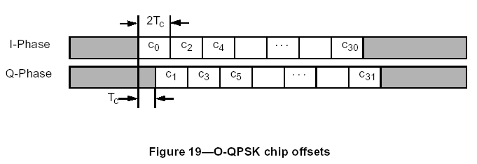
FIGURE NEED MODIFICATION [the last chip is c₁₅]

6.8.2.5 Pulse shape
The half-sine pulse shape used to represent each baseband chip is described by 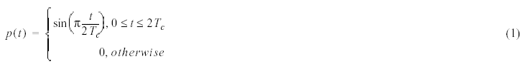
Figure 20 shows a sample baseband chip sequence with half-sine pulse shaping.

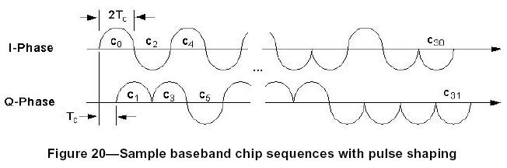
FIGURE NEED MODIFICATION [the last chip is c₁₅]

6.8.2.6 Chip transmission order
During each symbol period the least significant chip, c₀, is transmitted first and the most significant chip, c₁₅, is transmitted last.

6.8.3 915 MHz band radio specification
In addition to meeting regional regulatory requirements, devices operating in the 868/915 MHz band shall also meet the radio requirements in 6.8.3.1 through 6.8.3.5.

6.6.3.1 Operating frequency range
The 915 MHz PHY operates in the 902–928 MHz frequency band.

6.8.3.2 Transmit power spectral density (PSD) mask
The transmitted spectral products shall be less than the limits specified in Table 24. For both relative and absolute limits, average spectral power shall be measured using a 100 kHz resolution bandwidth. For the relative limit, the reference level shall be the highest average spectral power measured within ± 600 kHz of the carrier frequency.
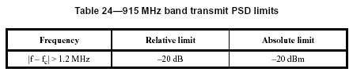

6.8.3.3 Symbol rate
The enhanced COBI PHY symbol rate shall be 62.5 ksymbol/s ± 40 ppm.

6.8.3.4 Receiver sensitivity
Under the conditions specified in 6.1.6, a compliant device shall be capable of achieving a sensitivity of –85 dBm [yet TBD] or better.

6.8.3.5 Receiver jamming resistance
The minimum jamming resistance levels are given in Table 25. The adjacent channel is one on either side of the desired channel that is closest in frequency to the desired channel, and the alternate channel is one more removed from the adjacent channel. For example, when channel 5 is the desired channel, channel 4 and channel 6 are the adjacent channels and channel 3 and channel 7 are the alternate channels.

Table 25—Minimum receiver jamming resistance requirements for COBI enhanced PHY

Adjacent channel rejection | Alternate channel rejection
0 dB | 30 dB
[FIGURE in table yet to finalized]

The adjacent channel rejection shall be measured as follows: The desired signal shall be a compliant 915 MHz IEEE 802.15.4b signal of pseudo-random data. The desired signal is input to the receiver at a level 3 dB above the maximum allowed receiver sensitivity given in 6.8.3.4. In either the adjacent or the alternate channel, an IEEE 802.15.4 signal is input at the relative level specified in Table 25. The test shall be performed for only one interfering signal at a time. The receiver shall meet the error rate criteria defined in 6.1.6 under these conditions.

Synchronisation related sections

6.3.1.1 Preamble field
The preamble field is used by the transceiver to obtain chip and symbol synchronization with an incoming message. The preamble field shall be composed of 32 binary zeros [to be finalized].

6.3.1.2 SFD field
The SFD is an 8 bit field indicating the end of the synchronization (preamble) field and the start of the packet data. The SFD shall be formatted as illustrated in Figure 17.

