IEEE P802.15
Wireless Personal Area Networks

Project | IEEE P802.15 Working Group for Wireless Personal Area Networks (WPANs)
Title | Ranging Subcommittee Final Report
Date Submitted | 18 October 2004
Source | Rick Roberts | Voice:  Fax: [ ]  E-mail: rrober14@harris.com
Re: | Ranging Subcommittee of TG4a
Abstract
Purpose | Provided in support of the activities of TG4a concerning location / ranging.
Notice | This document has been prepared to assist the IEEE P802.15. It is offered as a basis for discussion and is not binding on the contributing individual(s) or organization(s). The material in this document is subject to change in form and content after further study. The contributor(s) reserve(s) the right to add, amend or withdraw material contained herein.
Release | The contributor acknowledges and accepts that this contribution becomes the property of IEEE and may be made publicly available by P802.15.
Table of Contents
1. Introduction 2
2. TOA Ranging 3
3. TDOA Ranging 6
4. SSR Ranging 9
5. NFER Ranging 11
6. AOA Localization 13
7. MAC and PHY Interfaces 16
8. Interface Comments 18
9. PHY Sublayer 20
10. MAC Sublayer 23
11. References 27

Introduction

The ranging subcommittee identified 5 different ranging algorithms:

- Time-of-Arrival (TOA)
- Time-Difference-of-Arrival (TDOA)
- Signal Strength Ranging (SSR)
- Near-Field EM Ranging (NFER)
- Angle-of-Arrival (AOA)

This report opens with a brief discussion of each type of ranging and then suggests text to describe the interfaces associated with each of these ranging techniques. We do not make any recommendations as to a preferred ranging methodology since ranging algorithms themselves are anticipated to run at the application layer. In fact, it is likely that hybrid ranging algorithms will emerge that use a combination of ranging techniques so as to have multiple degrees of freedom in an attempt to improve the calculated range estimate.

TOA Ranging

TOA ranging is discussed in references [2], [3], [9], [12], [13], [15], [18].

Classical ranging transactions (namely the Two Way Ranging -TWR- and the One Way Ranging -OWR- schemes), and the corresponding synchronization requirements, are highly dependant on the communication protocol and the network topology.

The first technique enabling to measure the signal round-trip Time-Of-Flight (TOF) between two asynchronous transceivers consists in using a classical two-way remote synchronization technique.

Device A
Device B
Two equations in two unknowns yield:
* US Naval Observatory, Telstar Satellite, circa 1962
http://www.boulder.nist.gov/timefreq/time/twoway.htm
Unmatched detect-delays in the two devices may require one-time offset calibration.
Unknown propagation delay
Unknown clock offset
Message 1
Message 2
Multiple measurements of t_{p} and t_{o} yield finer precision & accuracy, and allow frequency offset correction.
Figure 1 Two-Way Time Transfer Model

A pair of terminals are time-multiplexed with half-duplex packet exchanges. This procedure relies on a typical mechanism for fused location and communication: a requestor sends packets to a responder which replies after synchronizing with packets containing synchronous timing information. The reception of this response allows the requestor to determine the round-trip TOF information (Figure 2). This solution seems to be particularly adapted for distributed networks (a fortiori in the lack of coordination) .
A
B
TOF
TOF
Channel
Acquisition
Synchro H
Communication Payload
Preamble Acquisition Header
Tround
Response Delay
Elapsed times measured by the system

Transmitted packets

Received packets

Figure 2: Two Way Ranging (TWR) transaction enabling to estimate the round-trip Time-OF-Flight between two asynchronous terminals (feeding TOA-based positioning algorithms)

Now, if two terminals are synchronized to a common clock (i.e. sharing the same time reference and time base), it is clear that the TOF information can be directly obtained from a simple OWR transaction (not detailed here).

The two previous transactions provide so-called TOA location metrics corresponding to the relative distance between terminals. For the considered scenarios (TOA/TWR and TOA/OWR), slot lengths and procedures fixed by a pre-existing communication standard represent drastic constraints for the maximum and minimum (blind distances) relative measurable distances, and the ranging accuracy.

A straightforward approach to calculate the position of a mobile terminal based upon TOA uses a geometric interpretation to calculate the intersection of circles for TOA-based algorithms. Indeed, if three TOA are measured between a mobile terminal and three (or more) distinct anchors (note that anchors should be considered as nodes doted with a prior knowledge of their relative positions), the mobile position can be easily computed in the 2-D plane. These solutions (geometrical solutions or solutions based on optimization procedures) correspond to popular radiolocation methods.

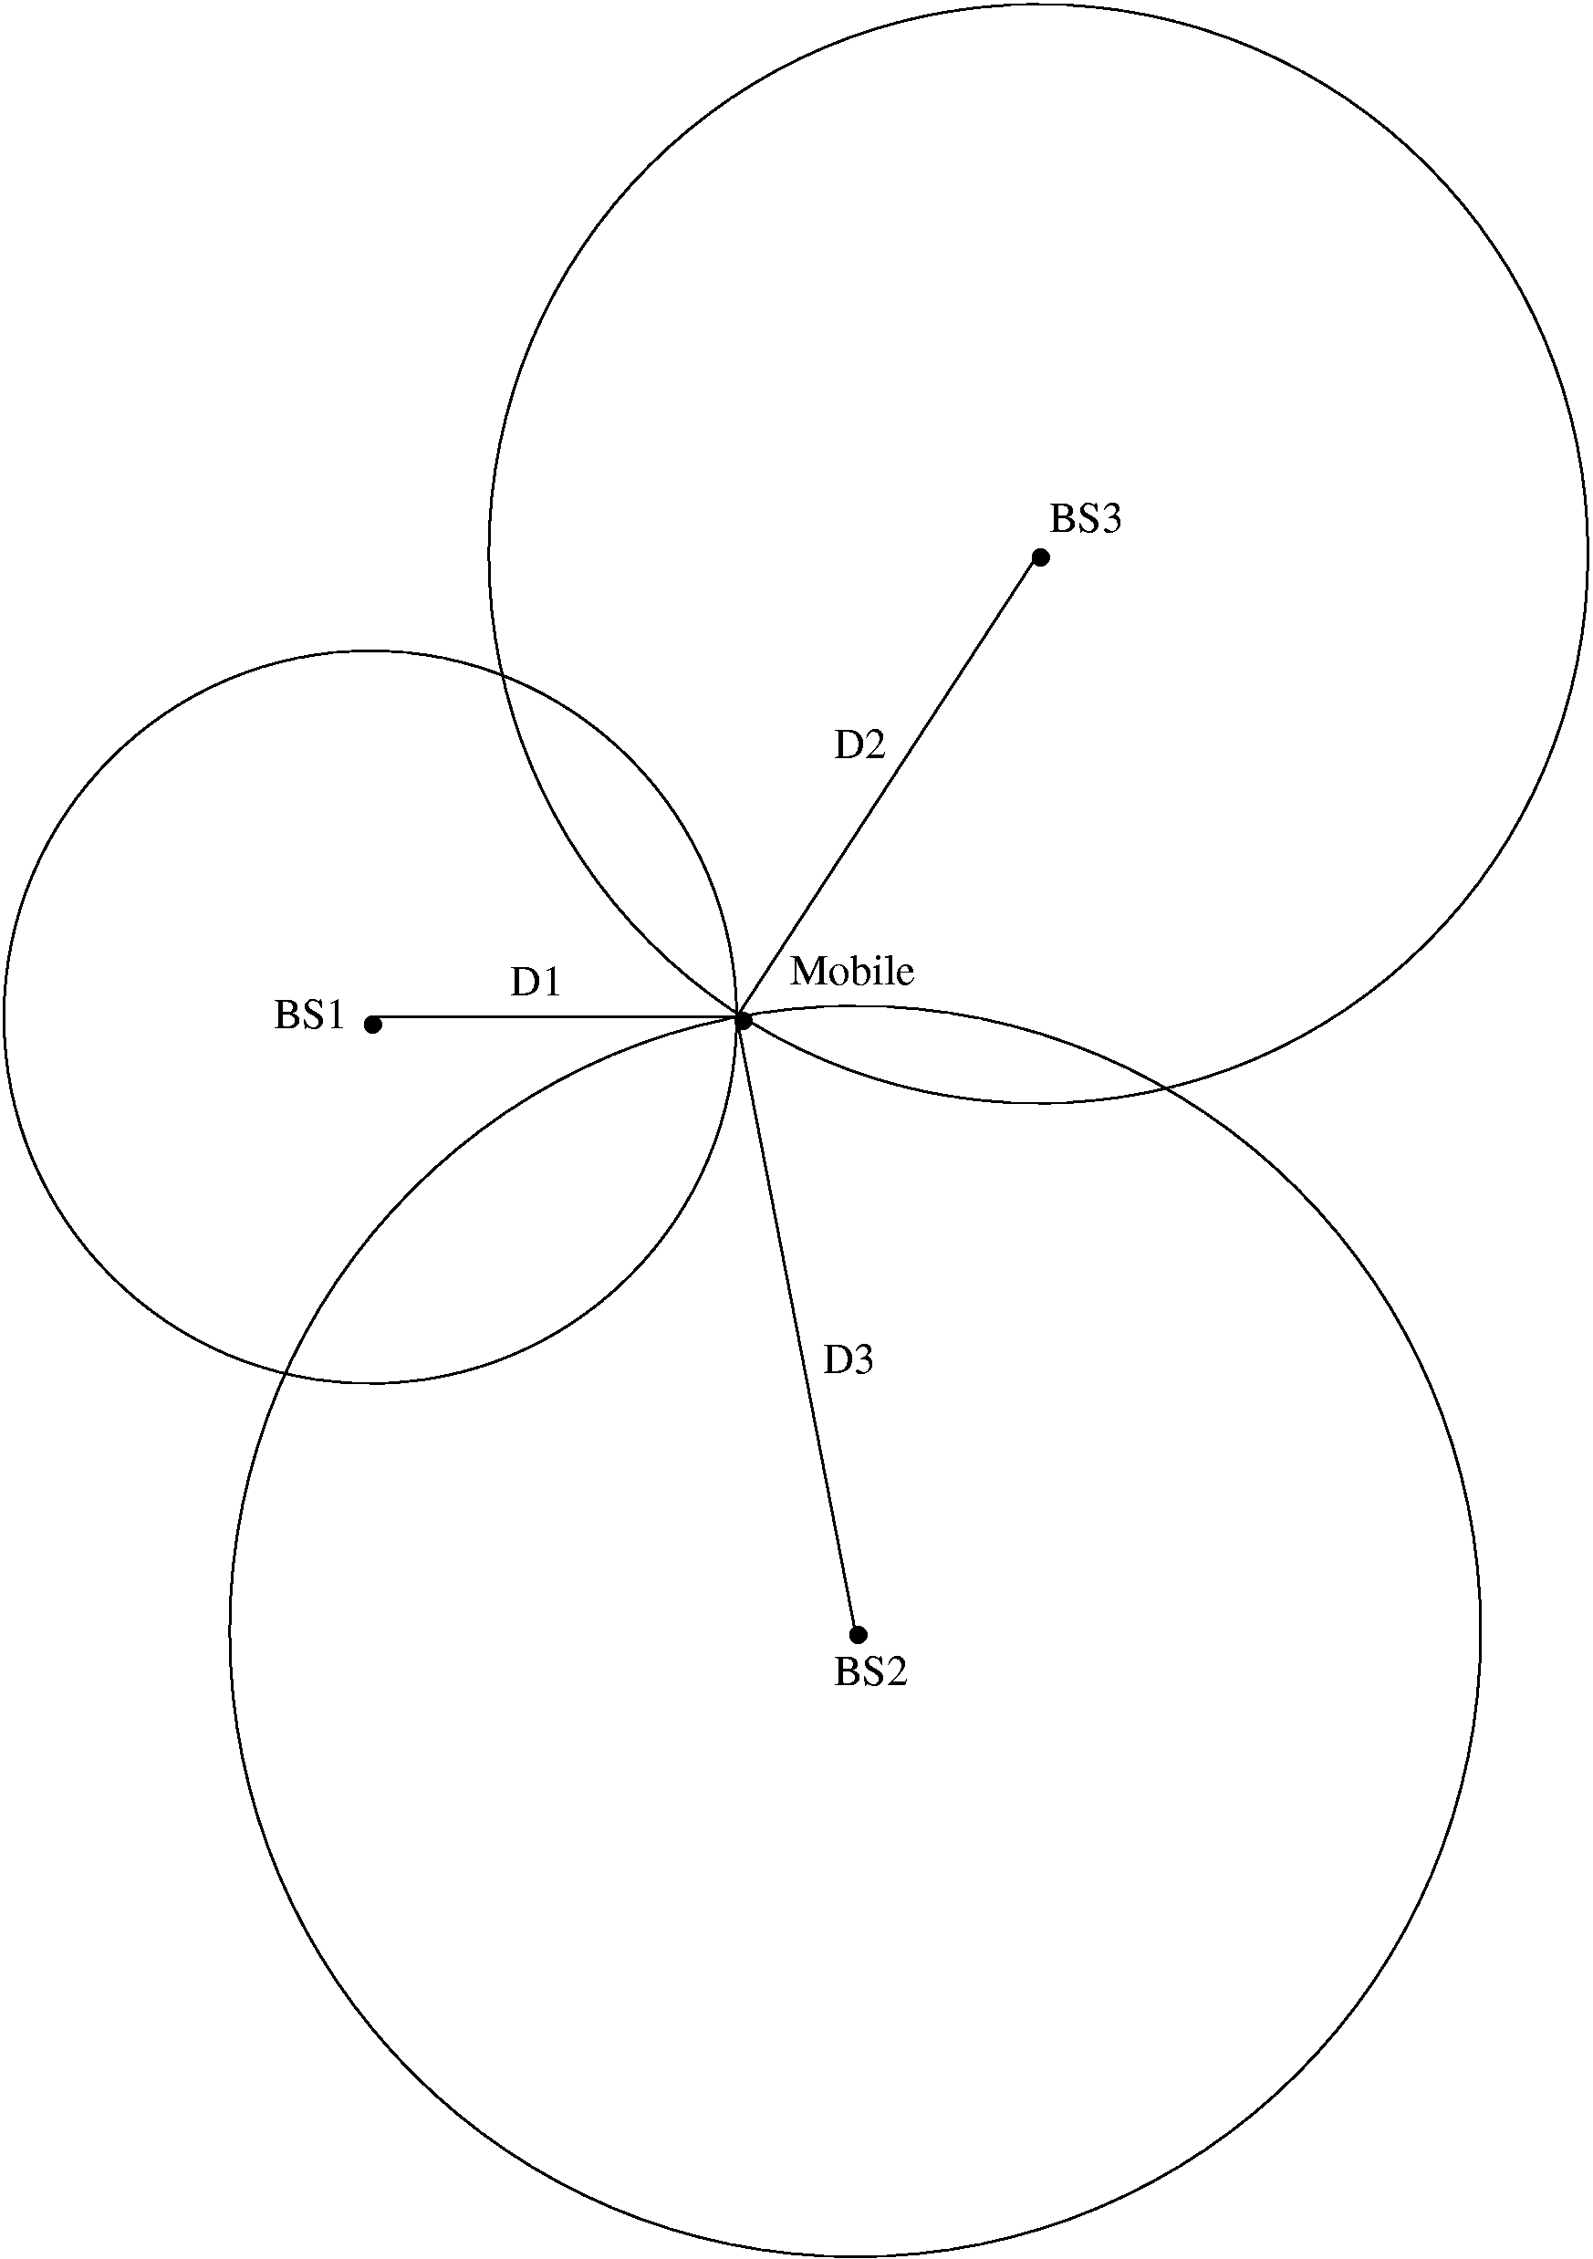
Mobile (x_{m},y_{m})
Anchor 2 (x_{A2},y_{A2})
Anchor 3 (x_{A3},y_{A3})
Anchor 1 (x_{A1},y_{A1})
Positioning from TOA
3 anchors with known positions (at least) are required to retrieve a 2D-position from 3 TOAs
Measurements
Estimated Position
Specific Positioning Algorithms
Figure 3 – Positioning from TOA

2.1 Double Token Exchange TOA (sometimes called DTOA)

A variant of TOA discussed in [15] is the token exchange method which is intended to accomplish ranging without synchronization of the local clocks. This method only requires that a ranging token be exchanged twice between two units in the following manner:

1) DEV A sends a ranging token to DEV B
2) DEV B holds onto the token for a time t and then sends the token back to DEV A
3) Next DEV A sends a second ranging token to DEV B
4) DEV B holds onto the token for a time 2t and then sends the token back to DEV A
5) DEV A calculates the ranging information as discussed above

Figure 4 illustrates the message sequence involved when requesting a range measurement. The ranging command initiates the precise exchange of a ranging token between the source DEV and the destination DEV as shown in the message sequence chart below.

Figure 4— MSC for ranging token exchange

The time of flight between the two devices is then calculated as

T_{flight} = {T¹(3)- T¹(0)} - [{T²(3)- T²(0)}/2]

where the time epochs are defined in Figure 4.

TDOA Ranging

TDOA ranging is discussed in references [2], [3], [8].

TDOA is related to TOA inasmuch as the time difference between synchronized reference anchor terminals is calculated and used for the localization calculations. The TDOA is traditionally obtained through OWR transactions (Figure 6). In this scheme, a pair of isochronous terminals, viewed as anchors, preliminary detect the TOA associated with packets emitted by the mobile. The TOAs are estimated relative to a common reference time (shared among references) but independent on the actual transmission time.

Time Difference Of Arrival (TDOA) & One Way Ranging (OWR)
T_{o}
Mobile TX
Anchor 1 RX
T_{OF,1}
T₁
Anchor 2 RX
T_{OF,2}
T₂
Anchor 3 RX
T_{OF,3}
T₃
Anchor 1
Anchor 2
Anchor 3
Mobile
Isochronous
Info T₂
Info T₃
Info T₂
Info T₃
TOA Estimation
TDOA Estimation
TDOA Estimation
Passive Location
TOA Estimation
Isochronous
Figure 5 – TDOA and OWR

Anchors have to be re-synchronized with an external clock or by a beacon signal periodically broadcasting packets to all the fixed references. This beacon signal may come from a coordinator or a dedicated terminal. Note that “synchronization” means “absolute synchronization” here, and implies that anchors know their relative distance to the beacon provider.

Reference Time

A
Mobile Terminal

TOF(A-B)

B

Isochronous Terminals
Transmitted packets
TOA_{B}

C
Received packets
Elapsed times measured by the system
TOF(A-C)
TOA_{C}

Figure 6: One Way Ranging (OWR) Protocol allowing to estimate differential Time of Arrival at a couple of two isochronous terminals (feeding TDOA-based positioning algorithms)

Finally, the approach taken to calculate the position of a mobile terminal for TDOA location metrics involves making two or more TDOA measurements. A straightforward approach uses a geometric interpretation to calculate the intersection of two or more hyperbolas for TDOA-based algorithms. If two or more TDOA measurements can be formed at a set of three or more distinct anchors, the mobile position can be easily computed in the 2-D plane.

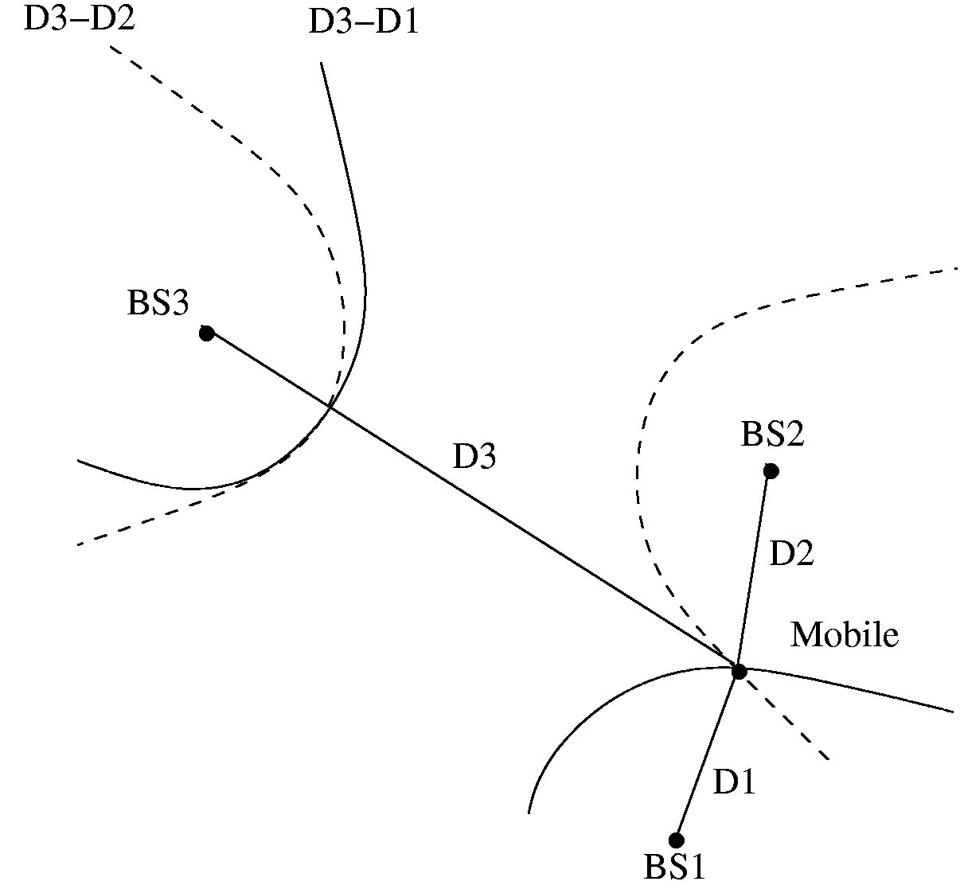
Mobile (x_{m},y_{m})
Anchor 1 (x_{A1},y_{A1})
Anchor 2 (x_{A2},y_{A2})
Anchor 3 (x_{A3},y_{A3})
Positioning from TDOA
3 anchors with known positions (at least) are required to find a 2D-position from a couple of TDOAs
Measurements
Estimated Position
Specific Positioning Algorithms

Figure 7 – Positioning from TDOA

Note that the basis for TDOA is one-way ranging (OWR). The implementation of OWR can be done in one of two forms; that is, either active OWR where the unknown station is transmitting or passive where the unknown stations is receiving. The primary implication is where the TDOA hyperbolas are collected for processing.

TDOA can operate in one of two modes …

Mode 1 – The station of interest (SOI) receives multiple reference pulses and calculates the TDOA
LORAN-C type operation and the processing burden is on the receiver to run the hyperbolic location algorithms

Mode 2 – The station of interest transmits a reference pulse which is received by multiple fixed nodes
The fixed nodes must forward the TDOA information to a workstation which then runs the hyperbolic location algorithms²
Key:
Sync Pulse
Location Pulse
Position Report
Mode 1 - Passive
Key:
Sync Pulse
Location Pulse
TDOA backhaul
Mode 2 - Active
controller
controller
reference node
reference node
SOI
SOI
Note: The sync pulse accuracy determines the TDOA accuracy and hence the sync pulse requires a wideband transmission
Figure 8 – Passive and Active TDOA OWR

SSR Ranging

SSR ranging is discussed in references [7], [17].

SSR ranging is already supported by the 802.15.4 standard because it runs off the RSSI. SSR ranging is simple and does not require the synchronization needed for TOA and TDOA based ranging; however, there are issues with attenuation variance due to multipath, etc, which require multiple measurements and measurement averaging.

We start our analysis by considering the case of free space propagation. In free space propagation, the received power, as a function of distance, is given as $P_{r}(d)=P_{t}G_{t}G_{r}{\left(\frac{λ}{4πd}\right)}^{2}\text{ Watts}$. In free space, the “large-scale” energy attenuation obeys an inverse square law relationship $L\left(d\right)=\text{10}\text{log}\text{10}\left(\frac{\text{Pr}}{\text{Pt}}\right)=\text{10}\text{log}\text{10}\left(\frac{(4πd)^{2}}{G_{t}G_{r}λ^{2}}\right)$. In practice, the far field received power is reference to a distance d₀ as $P_{r}(d)=P_{r}(d_{0}){\left(\frac{d_{0}}{d}\right)}^{2}$. In terrestrial settings, additional mechanisms such reflection, diffraction and scattering affect wave propagation and causing “small-scale” slow and fast fading components. For ranging we’d like to extract the large-scale attenuation from the combined large and small scale attenuation.

Figure 9 – Large-scale Fading

With wideband signals the mean received power can be calculated by summing the powers of the multipath in the power delay profile. With narrowband signals, received power experiences large fluctuations over a local area and averaging must be used to estimate the mean received power. Range can be estimated via $\hat{d}=d_{0}{\text{10}}^{\frac{p_{0}−\hat{p}(d)}{\text{10}n}}=d{\text{10}}^{\frac{X_{σ}}{\text{10}n}}$. The range estimation distribution variance decreases with decreasing distance.

Devices calculate ranges to their neighbors

Location is jointly estimated using collective information

Benefits
Location Accuracy/Range Extension
Architectural Blueprint
d
z₉
d
d
d
d
d
d
d
d
d
d
d
d
d
d
d
data
link
central
computer
‘Blind’
NeuRFons
‘Reference’

Figure 10 – Relative Location

NFER Ranging

NFER ranging is discussed in references [4], [10], [14].

Most RF systems operate in the “far-field” with distances between transmitters and receivers typically many wavelengths. The detailed behavior of RF signals in the “near-field” region, within about a half wavelength (0.50 λ) of an antenna is usually ignored, because the subtleties of near-field behavior do not affect most RF systems. Dr. Hans Schantz has discovered that this often overlooked domain of RF science can be used to make simple, high precision distance measurements.

RF or radio signals are electromagnetic waves which are a combination of an electric (E-field) wave and a magnetic (H-field) wave. Close to a transmit antenna, the electric and magnetic waves are in “phase quadrature,” approximately 90º out of phase with each other. By the time these waves have traveled about a half wavelength (0.50 λ) from an antenna, however, the electric and magnetic waves are nearly synchronous, i.e. 0º phase difference. The phase quadrature between the electric and magnetic fields gradually vanishes as the waves move away from the transmit antenna.
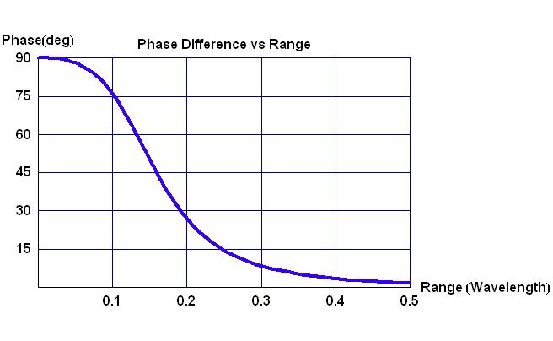
Figure 11 – Phase Difference vs. Range

By tracking this phase quadrature, precise distance measurements may be made from about 0.05 λ to 0.50 λ with best performance between about 0.08 λ to 0.30 λ. The effective range for a NFER™ system depends on the operating frequency (i.e. the lower the frequency, the longer the range).

In practice, a near field tag or beacon transmitter emits an unmodulated RF tone. A near field locator receiver compares the phase of the electric and magnetic fields to determine the range.

Figure 12 – Near-Field TX Beacon and RX Locator

The implications of the low frequency Near-Field ranging approach are numerous. The wavelengths of a near field system are long compared to the propagation environment; hence, the ranging results are basically unaffected by multipath. In addition, the low frequencies have superior propagation penetration properties with regards to buildings, etc. Phase offsets can be introduced by gross features such as the building frame and the building wiring or plumbing. However, these phase offsets are relatively gradual and may be dealt with by calibration.

AOA Localization

AOA ranging is discussed in reference [6].

AOA, by itself, is a localization technique as opposed to a ranging technique; however, AOA does not require the precise synchronization needed for TOA and TDOA methods. When combined with a viable ranging technique, AOA allows vector ranging which opens up interesting possibilities.

The angle of arrival is the direction to the source of an incoming wave field as measured by an array of antenna elements. The planar wave front models the incoming wave far field by measuring the phase (time) difference of the wave front at different array elements.

Y
(x,y)
Source
X
R
Range
θ
Azimuth
2D model
Array
Elements
X
R
φ
θ
(x,y,z)
Z
Y
Azimuth
Elevation
Range
Source
Array Elements
3D model
Figure 13 – 3D and 2D Localization

A phase array antenna system consists of any number of antenna elements distributed in a particular geometrical pattern, with the output of all the antenna elements vectorially added to synthesize a particular antenna pattern in the direction of the incoming source fields.

Figure 14 – Phased Array Antenna

As long as the spatial sampling requirement is met, larger arrays generally provide better resolution of the source field, but with increasing size and cost. In the case of UWB, the maturity of UWB antenna array technology must be taken into consideration.

Special consideration is needed for multipath environments and for multi-source cases since sources can be closely spaced. In non-line-of-sight environments, the measured AOA might not correspond to the direct path component of the incoming wave field which can lead to large positioning errors.

Two dimensional positioning requires measurement of the AOA by at least two antenna array systems. In practice, measurement errors due to: imperfect array phase and gain calibration, improper modeling of the mutual coupling between elements, and error due to the presence of a strong indirect path.

True line of position
Measurement error
DEV-A
DEV-B
DEV-C
Figure 15 – Two Dimensional Positioning

At the PHY sub-layer, the PHY would notify the MAC protocol of the signal reception information (for example, AOA and reception power) and the higher layers would make the complex decisions and range bearing calculations. The MAC would assign time slots to be used for AOA measurements and the total number of measurement periods required to make one position estimate would depend on the accuracy requirement of the application.

At MAC sub-layer, each device could maintain a cache table to keep the AOA, reception time, reception power, etc. of the last signal from each neighboring device. In practice, each device may update the AOA and reception time that corresponds to a neighboring device even when overhearing any signal, regardless of whether the signal is sent to that device. ACK frames may be used as measurement frames to conserve power and MAC resources.

MAC and PHY Interfaces

7.1 MAC sublayer service specification

The MAC sublayer provides an interface between the SSCS and the PHY. The MAC sublayer conceptually includes a management entity called the MLME. This entity provides the service interfaces through which layer management functions may be invoked. The MLME is also responsible for maintaining a database of managed objects pertaining to the MAC sublayer. This database is referred to as the MAC sublayer PIB.
Figure 16 depicts the components and interfaces of the MAC sublayer.
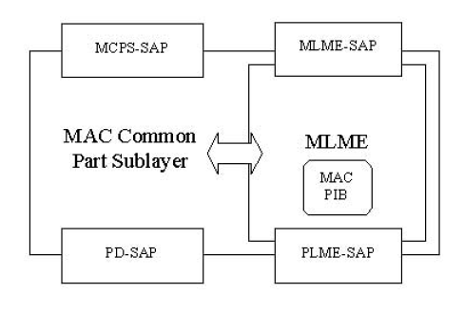
Figure 16—The MAC sublayer reference model

The MAC sublayer provides two services, accessed through two SAPs:
- The MAC data service, accessed through the MAC common part sublayer (MCPS) data SAP (MCPS-SAP)
- The MAC management service, accessed through the MLME-SAP.

These two services provide the interface between the SSCS and the PHY, via the PD-SAP and PLME-SAP interfaces (see 6.2). In addition to these external interfaces, an implicit interface also exists between the MLME and the MCPS that allows the MLME to use the MAC data service.

7.2 PHY service specifications

The PHY provides an interface between the MAC sublayer and the physical radio channel, via the RF firmware and RF hardware. The PHY conceptually includes a management entity called the PLME. This entity provides the layer management service interfaces through which layer management functions may be invoked. The PLME is also responsible for maintaining a database of managed objects pertaining to the PHY. This database is referred to as the PHY PAN information base (PIB). Figure 17 depicts the components and interfaces of the PHY.
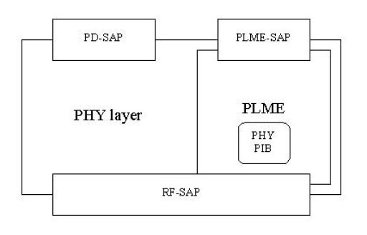
Figure 17 – The PHY reference model

The PHY provides two services, accessed through two SAPs: the PHY data service, accessed through the PHY data SAP (PD-SAP), and the PHY management service, accessed through the PLME’s SAP (PLMESAP).

Figure 18 – stacked reference models with DME interface

Interface Comments

8.1 TOA and TDOA

TOA requires that packets be exchanged between devices. The DME access to the MAC and the PHY is through the MLME and the PLME. The packet exchange is as follows:

- Device A MAC layer notifies Device B MAC layer of the desire to do a ranging
  - Needs to include type of TOA ranging
    - One Way Ranging
    - Two Way Ranging
    - Double Exchange Two Way Ranging

- Device B MAC layer responses back to Device A MAC layer that it is ready or not for ranging
  - Device B MAC layer needs to indicate it supports the requested type of ranging

- Device A then sends the ranging token to Device B, and if needed Device B sends it back. If this is a double packet exchange then this action happens twice in an autonomous manner.

8.2 SSR (signal strength ranging)

At this time it is believed everything needed for SSR is already included in 802.15.4 and not additional is needed.

8.3 AOA

(notes from Marilynn Green’s presentation – need to do more work here)

- MAC will have to adapt to different capabilities of the local and remote devices.
  - For example: One type of device may be fully equipped with GPS, a compass, and an antenna array to measure AOA…but another device may only be able to measure AOA.
- In the simplest case, the PHY passes AOA results to the MAC and the MAC leaves more complex decisions to higher layers, like…
  - Need for repeated measurements.
  - Calculation of position.
- MAC can reserve the time needed to make the AOA measurements.
- Guaranteed time slots may be required for:
  - ARQ: Initiator’s AOA request.
  - ACK: Responder’s acknowledgement.
  - AM: Responder’s AOA measurement frame.
  - AMR: Responder’s AOA measurement report.
- MAC may need to have pre-programmed constants to correct for device-specific measurement errors (ex.: drift in the phase and gain of the antenna elements).
- Power efficiency:
  - Power control to conserve battery power during device idle periods.
  - Reply frame with measurement results can be sent in the same frame as the request so that the device does not have to store measurement reports for a long time and can more quickly return to idle mode.
  - In some cases, ACK frame may be used to obtain the AOA measurements.
- MAC measurement report to higher layers may contain:
  - AOA.
  - Success or failure.
  - Quality of measurement.
- Number of measurement periods required to satisfy accuracy requirements can be decided by higher layers.

8.4 Near-Field Ranging

TBD

PHY Sublayer

9.1 High Rate Clock Option for Time of Arrival (TOA/TDOA) Support

A PHY that supports either TOA or TDOA shall have a high rate clock located at the PHY layer.
High Rate Clock

Counter
start
stop
count
PHY SAP - START CLOCK COMMAND
PHY Correlator
Vthresh
Figure 19 – High Rate PHY Clock

The two parameters that shall be reported to the PHY PIB is the count value and the frequency of the high rate clock.

9.2 PHY data service

The PD-SAP supports the transport of MPDUs between peer MAC sublayer entities. Table 1 lists the primitives supported by the PD-SAP. These primitives are discussed in the subclauses referenced in the table.

Table 1—PD-SAP primitives

PD-SAP primitive | Request | Confirm | Indication
PD-RANGE

9.2.1 PD-RANGE.request

9.2.1.1 Semantics of the service primitive

9.2.1.2 When generated

9.2.1.3 Effect on receipt

9.2.2 PD-RANGE.confirm

9.2.2.1 Semantics of the service primitive

9.2.2.2 When generated

9.2.2.3 Effect on receipt

9.2.3 PD-RANGE.indication

9.2.3.1 Semantics of the service primitive

9.2.3.2 When generated

9.2.3.3 Effect on receipt

9.3 PHY management service

The PLME-SAP allows the transport of management commands between the MLME and the PLME.
Table 2 lists the primitives supported by the PLME-SAP. These primitives are discussed in the clauses
referenced in the table.

Table 2—PLME-SAP Primitives
PLME-SAP primitive | Request | Confirm

9.4 PHY constants and PIB attributes
This subclause specifies the constants and attributes required by the PHY.

9.4.1 PHY PIB attributes
The PHY PIB comprises the attributes required to manage the PHY of a device. Each of these attributes can be read or written using the PLME-GET.request and PLME-SET.request primitives, respectively. The attributes contained in the PHY PIB are presented in Table 3.

Table 3—PHY PIB attributes
Attribute | Identifier | Type | Range | Description

MAC Sublayer

10.1 MAC management service – TOA/TDOA Ranging

Table 4 - Additional MLME

Name | Request | Indication | Response | Confirm
MLME-RANGE | 9.1.1 | 9.1.2 | 9.1.3 | 9.1.4

This mechanism supports range determination between two DEVs. The primitive's parameters are defined in Table 5.

Table 5— MLME-RANGE primitive parameters

Name | Type | Valid Range | Description
SrcID | Integer | Any valid DEVID as defined in 7.2.3 | The device ID of the source
DestID | Integer | Any valid DEVID as defined in 7.2.3 | The device ID of the destination
Timeout | Integer | As defined in 6.3.23.4.2 | The time limit for the reception of the returned range token #2 as shown in clause TBD
Reason Code | Integer | As defined in 6.3.23.4.2 | Indicates the result of the command

10.1.1 MLME-RANGE.request
This primitive is used to request that the range between two devices be mesured. The semantics of the primitive are as follows:
MLME-RANGE.request (DestID, SrcID, Timeout)
The parameters are defined in Table 5.
10.1.1.1 When generated
This primitive is generated by the source DME to request a range measurement.
10.1.1.2 Effect of receipt
When a DEV MLME receives this primitive from its DME, it will generate a RANGE command, which it will send to the Destination PNID. The Destination PNID, upon receiving the RANGE command, will generate an MLME-RANGE.indication.
10.1.2 MLME-RANGE.indication
This primitive is used to indicate a received RANGE command. The semantics of the primitive are as follows:
MLME-RANGE.indication (DestID, SrcID, Timeout)
The parameters are defined in Table 5.
10.1.2.1 When generated
This primitive is sent by the non-initiating MLME to its DME upon receiving a RANGE command.
10.1. 2.2 Effect upon receipt
When the Destination DME receives this primitive, it will determine whether to accept or reject the source DEV request for a range measurement. The Destination DME will then send a MLME-RANGE.response with appropriate parameter values to its MLME via the MLME-SAP.
10.1.3 MLME-RANGE.response
This primitive is used to initiate a response to an MLME-RANGE.indication. The semantics of the primitive are as follows:
MLME-RANGE.response (DestID, SrcID, ReasonCode)
The parameters are defined in Table 5.
10.1.3.1 When generated
This primitive is generated by the Destination DME upon receiving an MLME-RANGE.indication.
10.1.3.2 Effect upon receipt
When the destination MLME receives this primitive from its DME, it will either initialize the ranging state machine in anticipation of exchanging ranging tokens or it will reject the ranging request with a ReasonCode indicating the reason for the request being denied.
10.1.4 MLME-RANGE.confirm
This primitive is used to inform the initiating source DME whether the requested ranging token exchange will commence or was the ranging request rejected. The semantics of the primitive are as follows:
MLME-RANGE.confirm (DestID, SrcID, ReasonCode)
The parameters are defined in Table 5.
10.1.4.1 When generated
The initiating source MLME sends this primitive to its DME to confirm whether a ranging token exchange is pending.
10.1.4.2 Effect upon receipt
When the initiating source MLME receives a ReasonCode = ExchangeTokens it shall initiate the ranging token exchange as per clause TBD. When the ReasonCode = DoNotExchangeTokens the source MLME shall terminate the ranging token exchange procedure and perhaps attempt ranging later. When the ReasonCode = RangingNotSupported the source MLME shall terminate the ranging token exchange and shall not initiate another range measurement with that particular destination DEV. If the second token is not received by the source DEV within the time specified by parameter "Timeout" then the ReasonCode shall be set to ReasonCode=TimeoutFailure.

10.2 MAC command types
Table 6— Addition to table of clause TBD

Command type hex value b15-b0 | Command name | Sub-clause | Associated | Secure membership (if requred)
0x001D | Ranging | 9.2.1 | X

10.2.1 Ranging
The ranging command is used to initiate a ranging token exchange between two devices. The issuance of a ranging command shall result in the following activity between DEV A and DEV B:
1) DEV A sends a ranging token to DEV B
2) DEV B holds onto the token for a time t and then sends the token back to DEV A
3) Next DEV A sends a second ranging token to DEV B
4) DEV B holds onto the token for a time 2t and then sends the token back to DEV A
5) DEV A calculates the ranging information as discussed above
The source device calculates the ranging information. If the destination device wants range information it will have to send a ranging command in the reverse direction. The command structure is shown below.
Table 7— Ranging Command

Octets 2 | 2 | 2 | 2 | 1 | 1
Command Type | Length | Source PNID | Destination PNID | Timeout uS | Reason Code

The Timeout field has the resolution of uS and is used to timeout the ranging process.
The reason code field has the following values:
ExchangeTokens = 0x01
DoNotExchangeTokens = 0x02
RangingNotSupported = 0x03
TimeoutFailure = 0x04
The definition of the reason codes is presented in clause TBD.
10.3 MAC Command Description - Ranging and Ranging Token Exchange
Figure 20 illustrates the message sequence involved when requesting a range measurement. The ranging command initiates the precise exchange of a ranging token between the source DEV and the destination DEV as shown in the message sequence chart below.
Figure 20— MSC for ranging token exchange
Device A must receive the second token from device B within the amount of time indicated in the command Timout field. The ranging token itself is PHY dependent and is described in clause TBD. The time of flight between the two devices is then calculated as
T_{flight} = {T¹(3)- T¹(0)} - [{T²(3)- T²(0)}/2]
where the time epochs are defined in Figure 1. The calculated range is then stored as PHY Management object PHYPIB_Range (clause TBD).

References

[1] Cumulative Minutes TG4a Ranging Subcommittee, Colin Lanzl, Vern Brethour, Patrick Houghton, doc 15-04-0411-xx-004a

[2] UWB Localization Techniques, Benoit Denis, STMicroelectronics, doc 15-04-0418-00-004a

[3] Ranging Protocols and Network Organization, Benoit Denis, STMicroelectronics, doc 15-04-0427-00-004a

[4] Near Field Ranging Algorithm, Hans Schantz, Q-Track Corporation, doc 15-04-0438-00-004a

[5] Berlin Ranging Subcommittee Report, Rick Roberts, Harris Corporation, doc 15-04-0477-01-004a

[6] Sample MAC Requirements for Angle of Arrival Based Ranging, Marilynn P. Green, Nokia, doc 15-04-0563-00-004a

[7] Signal Strength Based Ranging, Neiyer Correal, Motorola, doc 15-04-0564-00-004a

[8] TDOA Localization Techniques, Rick Roberts, Harris Corporation, doc 15-04-0572-00-004a

[9] Two Way Time Transfer Based Ranging, Joes Decuir, MCCI, doc 15-04-0573-00-004a

[10] Technical Introduction to Near Field Electromagnetic Ranging, Hans Schantz, Q-Track Corporation, www.Q-Track.com

[11] P802.15.4a Alt Phy Selection Criteria, doc 15-04-0232-12-004a

[12] Ranging, RF Signature and Adaptability, Rick Roberts, Harris Corporation, doc 15-04-0300-00-004a

[13] The Effect of AWGN on the Accuracy of Time of Arrival Detection, Rick Enns, doc 15-04-0335-00-004a

[14] Near Field Electromagnetic Ranging, Kai Siwiak, Time Derivative, doc 15-04-0360-00-004a

[15] Technical Editor Contribution of IEEE Formatted Draft Text for MB-OFDM Proposal, Rick Roberts, Harris Corporation, doc 15-03-0541-01-003a

[16] Introduction to Chirp Spread Spectrum (CSS) Technology, John Lampe, Nanotron Technologies, doc 15-04-0353-00-004a

[17] IEEE802.15.4 Relative Location, Neiyer Correal and Fred Martin, Motorola, doc 15-04-0228-01-004a

[18] Intel CFP Presentation for a UWB PHY, Foerster, et al, Intel Corporation, doc 03109r1P802-15-3a

[19] Wireless Medium Access Control (MAC) and Physical Layer (PHY) Specifications for Low-Rate Wireless Personal Area Networks (LR-WPANs), IEEE802.15.4, 1 October 2003

The term NFER is a trademark of the Q-Track corporation
A variation of this packet exchange technique mentioned, in [15], uses dual packet exchanges and measures the difference of TOA in an attempt to calibrate out the clock drift from the other cooperating device. In principle, this technique does not require precise clock calibration between the two ranging devices. This technique has been called Differential-Time-of-Arrival (DTOA), but in general we reframe from this nomenclature to avoid confusion with TDOA (Time-Difference-of-Arrival). Instead we’ll call it the “double token exchange” method and it is covered in section 2.1.
The source device calculates the ranging information. If the destination device wants range information it will have to send a ranging command in the reverse direction.
It is similar to SSR (signal strength ranging) in this sense.
Whether or not the far-field planar wave approximation holds well will depend on the array aperture and the minimum wavelength of the source signal. In the near field, the phase (time) difference at different array elements becomes a non-linear function of the source’s position.
There is a spatial sampling requirement that limits the inter-element spacing of antenna elements to be ≤½ minimum source wavelength.

