IEEE 802.15 Wireless Personal Area Networks™

Project | IEEE 802.15 Working Group for WPANs™
Title | Responses to “In-Band Interference Properties of MB-OFDM”
Date Submitted | [September 16, 2004]
Sources | Celestino Corral, Gregg Rasor, Shahriar Emami  Freescale Semiconductor  8000 W. Sunrise Blvd.  Plantation, FL 33322 USA | Voice:  Fax:  E-mail:
Re: | []
Abstract | [Response to MB-OFDM interference analysis]
Purpose | [Inform members of 802.15.3a about inaccurate assumptions and conclusions in the presentation titled “In-band interference properties of MB-OFDM” by C. Razzel, Doc. IEEE 802.15-04/0412r0.]
Notice | This document has been prepared to assist the IEEE P802.15. It is offered as a basis for discussion and is not binding on the contributing individual(s) or organization(s). The material in this document is subject to change in form and content after further study. The contributor(s) reserve(s) the right to add, amend or withdraw material contained herein.
Release | The contributor acknowledges and accepts that this contribution becomes the property of IEEE and may be made publicly available by P802.15.

Responses to “In-Band Interference Properties of MB-OFDM”

RE: This is a response to a presentation titled “In-band interference properties of MB-OFDM” by C. Razzel, Doc. IEEE 802.15-04/0412r0, submitted for consideration in IEEE 802.15 TG3a.

Introduction:

A presentation titled “In-band interference properties of MB-OFDM” by C. Razzel was submitted for consideration in IEEE TG3a standard for an alternative physical layer based on ultra-wideband (UWB) at the IEEE interim meeting in Berlin, Germany. It was a response to the presentation titled “Multi-band OFDM interference on in-band QPSK receivers,” by C. A. Corral, S. Emami, and G. Rasor, Doc. IEEE 802.15-04/0315r0, submitted for consideration to the same body in Portland, Oregon, in July. In that work, some preliminary information was provided that showed that MB-OFDM resulted in significant QPSK system performance degradation under the constraint of equal effective isotropic radiated power (EIRP).

A follow-up presentation by the same authors titled “Multi-band OFDM interference on in-band QPSK receivers revisited,” Doc. IEEE 802.15-04/0451r0, was submitted for presentation in Berlin, but has not received a time slot. In that presentation, many of the assumptions of the 412r0 work are shown to be flawed. In this response, we seek to detail the most questionable items.

Points:

The original work by the authors considered an evaluation of the interference levels of all UWB sources under the constraint of equal EIRP. This approach is not considered in any portion of the 412r0 presentation, as shall now be treated. All following slide references are to IEEE document number 15-04-0412-00-003a titled “In-band interference properties of MB-OFDM.”

- Slide 3: The caveats for APD analysis are provided in the last bullet. APD methodology fails to take receiver characteristics into account, including data rate, modulation type, etc. APD results in “information compression” as it collapses signal characteristics to single-dimensional measures. It is an analysis tool, but it is incomplete for a thorough analysis of system susceptibility to interference.
- Slide 8: Normalization is performed to unit power with 2σ² = 1. This assumption forces OFDM to have the same power spectral density (PSD) as additive white Gaussian noise (AWGN). This is not possible under equal EIRP. The case for equal EIRP results in non-unit power as shown in Doc. 451r0 (hereafter referred to as “BP” for Berlin presentation), slide 9. The analytical support is provided in BP, slide 6. Hence, the results for slide 8 are for gated AWGN process, not MB-OFDM.
- Slide 9: Again, the results are for gated AWGN. The duty cycle is also different from that considered in BP, slide 14. In that effort, the OFDM symbol length was taken to be 242.42 nsec (i.e., cyclic prefix was removed) but the duty cycle was 33% (1 hop out of 3). In the 412r0 presentation, the duty cycle is 26% as the signal is “off” during the time of the cyclic prefix. This can result in slightly different values for the symbol error rates in the original work, as considered in a separate section of this response.
- Slide 10: Continuous OFDM is equated with AWGN, which is not true. There are two factors here. First, all systems are analyzed in terms of equal EIRP and the point regarding Slide 8 holds (i.e., continuous OFDM results in higher PSD with respect to AWGN). Second, OFDM is additive and Gaussian, but it is not white. This is borne out by the correlation results shown in BP, slides 24 through 26.
- Slide 11: Considering that the results are still for gated AWGN processes, this is borne out by the considerations of filter bandwidths in the original work. In effect, narrowband filters “favor” short-time pulses. If anything, slide 11 should also support impulse radio to a greater degree, because very narrow pulses will not be “seen” by the detector circuitry after the filtering operation. Slides 18 to 20 in BP show that there is some slight improvement (about 1 dB) over the unfiltered case, but this is under the idealization that all other subcarriers are infinitely rejected.
- Slide 12: The impulse radio (IR) results are plotted here, but it is not clear under what conditions. In an internal report titled “Interference of multi-band OFDM and impulse radio on in-band broadband QPSK receivers” it is shown that at very high pulse repetition frequency (PRF), the interference of IR when modeled as gated AWGN process with 2nsec pulse widths and equal EIRP condition result in performance similar to that of AWGN. As the bandwidth of the filter increases, the pulses become distinct and do not smear into each other [1]. For very high PRFs, the pulses get very close to each other, so it approaches a continuous AWGN process. The APD results are not reflecting this phenomenon.
- Slide 13: It is counterintuitive to consider two pulsed systems as having different peak power performance. Multi-band OFDM—when modeled as a gated AWGN process as considered in the 412r0 work—is a pulsed interference with a longer pulse time (242 nsec), and an equivalent PRF of 1.07MHz (936nsec period). Why should a gated noise process of 2nsec length and 1000nsec period (1MHz PRF) be so different, especially under equal PSD constraint? The only explanation is that the IR source is being modeled differently, as a non-Gaussian process, and with scaled power. This is an unfair comparison, and persists throughout the work.
- Slide 16: In BP slide 16 it is shown that SER performance at 7dB Eb/No for gated AWGN at +5dB INR is approximately 4dB from theory (at 10⁻³). In 412r0, the results show only a modest 2.5dB difference. This difference must be reconciled. Since we are not privy to the details of the 412r0 simulations and analyses, we can only surmise as to the discrepancy. One possible culprit is the fact that the gating and scaling of the AWGN process is not done properly. Another possible issue is the use of APD methodology that masks true receiver performance. Regardless of the reason, the modest results are suspect, especially in relation to the analytical results provided in BP slide 15. (Another explanation may be the 27% duty cycle as related to our 33% duty cycle considerations.)
- Slide 17: Conclusions are incorrect relative to the type of analysis performed. Neglects actual PSD of MB-OFDM and the material in relation to filtering is inappropriate as treated in [1].
- Slide 21: We need to distinguish our respective assumptions for the systems we simulated. In BP, the QPSK system used a rectangular matched filter, perfect phase estimation and synchronization. In the 412r0 work, the filter was a root raised cosine (RRC) filter with α = 0.5. It is not clear whether the system was idealized, but we may assume this to be the case.
- Slides 23—25: The results of these slides are expected but fail to reflect many of the factors considered in the original analysis and BP. Consider that the EIRP are not equal (cf., point on Slide 8): The results presented in these slides are the case of equal PSD, which means the AWGN process can be at higher power as shown in BP slide 10. Under equal PSD, the Gaussian tail does result in lower bit error rate (BER) and symbol error rate (SER) because there is simply less power there, while the AWGN tail extends to infinity theoretically.
- Slides 28—29: These are the same results as in our presentations, at least when MB-OFDM is modeled by a gated AWGN process.
- Slide 30: We acknowledge the fact that the system was quite idealized; the original work and BP correspond to a system with noise figure NF = 0 and background noise also to be zero. (This is actually favorable to the MB-OFDM analysis, but its main purpose was to allow us to simplify the analysis and provide quick theoretical results.) It is not too far removed from an actual TVRO system, which employs an LNA with NF approximately 2dB and the satellite dish pointing to a satellite so the background noise is very low. The 412r0 work assumes an Eb/No of 10dB which is not unreasonable.
- Slide 31: These results are incorrect, especially in light of the analysis in BP slide 15, which are applicable under the case of modeling MB-OFDM as a gated AWGN process and equal EIRP. The results presented here assume equal PSD, and since the tail of the Gaussian amplitude does not apply under low error region we get the soft tail-off under high SNR. But consider this: Should the tail-off occur when we are considering interference plus noise? In other words, when the interference is zero, should not the tail-off be that for AWGN? Unfortunately, the results go only to Eb/No = 10dB, but the trend seems to be that the curves would intersect beyond 10dB and then the result would be better than AWGN! This is impossible! The whole is not less than the sum of its parts.

First Conclusion:

The material of BP is consistent with document 315r0 and serves to highlight the characteristics of OFDM modulation as well as the gating and scaling as applied to generate MB-OFDM. In BP, there are significant analytical results that completely contradict the material in the 412r0 work. Indeed, it has been shown that document 412r0 is not under the case of equal EIRP, but rather, equal PSD, and said PSD is made equal to that of an AWGN process. This is an unfair comparison because the two systems are not transmitting at the same average power, or EIRP.

The implications of equal EIRP are significant and need further consideration. Under equal EIRP, all systems are equivalent relative to the victim receiver. This means that if we put a single interference source at some distance d from a victim receiver and take a power meter and measure its power, this power setting is set to be constant for all sources. Hence, AWGN, MB-OFDM, direct-sequence UWB (DS-UWB) and IR are all forced to have equal average power. However, their respective impact on victim receivers is not the same due to the following factors:

- Power spreading: DS-UWB and IR spread their power over a significant portion of the available UWB spectrum. This means that the power spectral density of such interference is lower, and so is the average power as seen in the bandwidth of a victim receiver. MB-OFDM concentrates its power over a narrower bandwidth than DS-UWB, so its PSD is correspondingly higher depending on the DS-UWB bandwidth.
- Gating and scaling: The PSD of MB-OFDM is averaged over the hop depth. This means that the already-higher PSD due to the equal EIRP constraint is further increased by the hop factor so that when averaged over the hop we obtain a desired PSD level. This results in significantly higher interference that scales as considered in the original work (i.e., the characteristics of the Q(x) function).

If MB-OFDM transmissions are made at the same PSD as DS-UWB (i.e., the PSD established by the FCC), then we cannot compare both systems under equal EIRP because MB-OFDM is spread over a narrower bandwidth. Under equal PSD, the EIRP of MB-OFDM is much lower, and this is reflected in the 412r0 results. However, we already noted that EIRP is the parameter that is most significant to evaluate the potential interference to an in-band victim receiver, and this results in PSD scaling in the victim receiver’s bandwidth and correspondingly higher interference.

Resorting to APD analysis represents only a single viewpoint of possible victim receiver performance degradation, and still indicates that MB-OFDM is a worse interferer than AWGN-like processes such as DS-UWB. The APD analysis seems to indicate that MB-OFDM is no worse interferer than IR. By neglecting the PSD rise of continuous OFDM under equal EIRP constraint, and the additional PSD scaling for the hopping operation, the APD analysis does not reflect the greater deviation of the APD plot for MB-OFDM beyond that of the IR systems for the PRFs considered.

The most suspect results of the 412r0 presentation are for the case of S/(I + N). From these results, it seems that the performance of a system with interference plus noise would be superior to that of a system with only noise present under high SNR. This is completely false. Indeed, there is no known model for BER curve bumps of the type shown by the 412r0 analysis. If anything, non-Gaussian interference sources should result in higher receiver performance degradation because the matched filter is not operating optimally on the noise source. The results are not just counterintuitive, they are unreasonable and unsupported.

Signal-to-Interference-Plus-Noise:

In the 412r0 presentation, slide 31 seems to indicate that the interference by MB-OFDM is modest at best and approaches (and ultimately surpasses) those of the AWGN channel. It should be noted that the results provided in slide 31 are only to Eb/No = 10dB, but it is precisely at this point that the simulation results converge and ultimately seem to intersect the AWGN curve. As stated before, there is no known phenomenon in the literature that results in such “bumps” on the bit-error-rate (BER) curves, so the results require explanations.

As already stated, the condition for these results are based on equal PSD and not equal EIRP. This comparison is unfair because it does not reflect equal average power transmissions of both systems and their impact on a victim receiver at some fixed distance from the interference source. Furthermore, the PSD is made equal to that of additive white Gaussian noise (AWGN), or more specifically, a thermal noise process for systems with filters having small bandwidths relative to the interference spectrum [2]. This is also somewhat unfair because it has been shown that OFDM, while additive and Gaussian, has poor correlation properties and is not white [3]. Hence, we expect that the results are favorable to MB-OFDM under those conditions because the EIRP is significantly lower in order to match the PSD to AWGN.

The other sources of questionable assumptions and results stems from the fact that OFDM has a finite peak value, that is, its peak-to-average power (PAP) is bound to 10log(M) where M is the number of subcarriers used in the OFDM modulation. Hence, for OFDM, the amplitude distribution is Gaussian, but with finite tails. For AWGN, the tails are infinite, although attaining those extremely large offsets is extremely unlikely.

Following this train of thought, consider that the MB-OFDM system consists of 128 subcarriers, so the worst-case PAP is 10log(128) = 21dB. This worst-case PAP is very unlikely, but it can result in large outliers from the main Gaussian lobe [4]. However, the PAP is defined as the peak averaged over the total time the signal is present. For the MB-OFDM system, the duty cycle is 26% corresponding to a PAP of 21dB + 10log(3.85) = 26.85dB for 3 hops since the peak is invariant but the average occurs over the hop depth. This means that the signal appears more impulsive to a receiver because it is not present for 74% of the time; by the hopping operation, we obtain a theoretical 5.85dB of peak-to-average power “gain” relative to a continuous interference source. In Figure 1, we show this PAP growth under the case of 33% duty cycle to be consistent with [4].

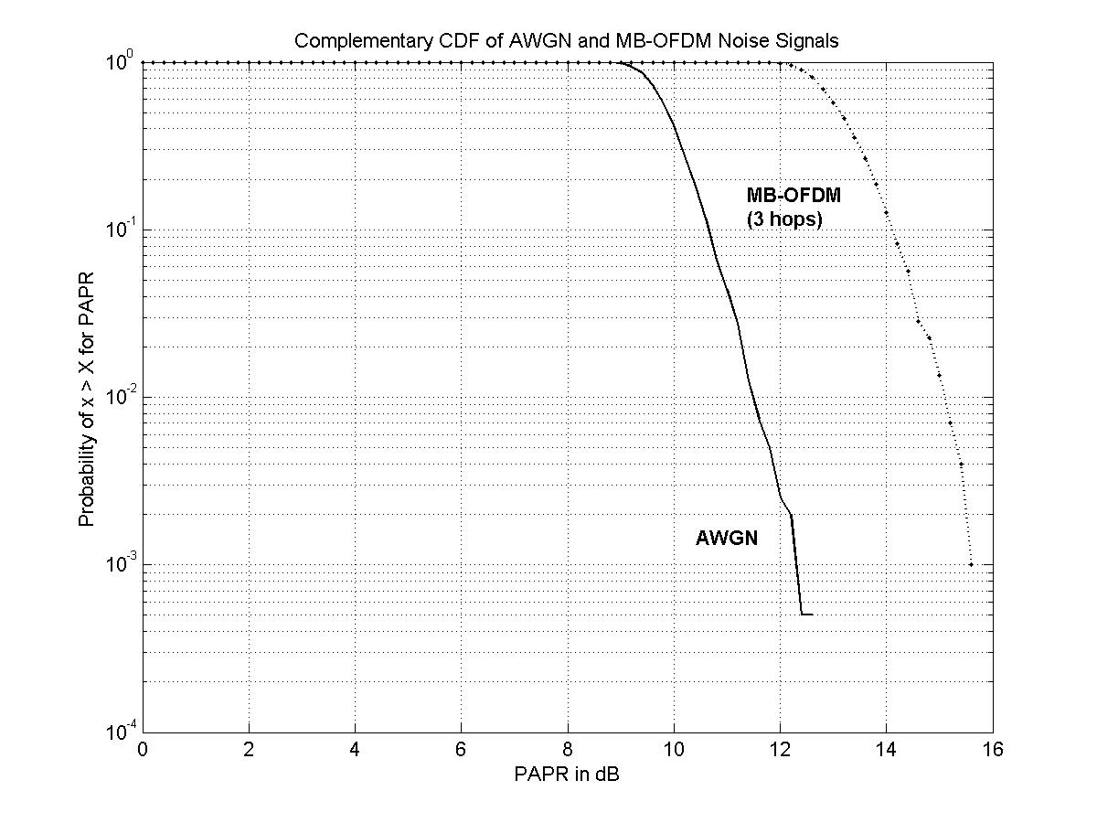
4dB
Figure 1. Peak-to-average power ratio for AWGN and MB-OFDM with 3 hops. Packet length for averaging was 100 symbols. Number of runs was 2000.

Of course, peak-to-average is only one aspect of the characteristics of MB-OFDM, the other deals with the OFDM modulation itself as considered in 412r0. Returning to the finite tails of the Gaussian distribution, it should be noted that those finite tails are further manipulated under the consideration of possible output values. In other words, the output values are limited to a range from 0 to 2¹⁶ – 1 (65535) for 4-QAM. The implications of this consideration are two-fold, namely:

- Under high SNR, the very low noise power under those finite values would result in zero actual received noise due to the discrete value range considered. This may be the main reason for the results of Slides 23—25 and, by inference, slide 31 of the 412r0 presentation.
- It indirectly considers the quantization by the receiver, because what is received by the victim receiver is a continuum of signal resulting from the discrete values of the OFDM signal. (The receiver operates on continuous representation of the discrete values prior to sampling.)

For each case, it can be determined that quantization effects are relevant to all forms of interference, including AWGN. For example, if the victim receiver had some analog-to-digital converter (ADC) with a certain resolution, any interference level below that resolution would not be quantized, including AWGN, direct sequence UWB (DS-UWB), impulse radio, etc. This means that if we apply the quantization reasoning used in 412r0, AWGN would also have a soft tail-off because the bits are not being toggled above the threshold as established by the ADC. Granted, AWGN will still have infinite tails (with corresponding infinitesimally small probability), but all other interference sources do not, so all would benefit from the quantization effect described in 412r0.

This last point cannot be overemphasized. In [3] [4] the quantization effects were not considered as all waveforms were related to an AWGN process having infinite tails. If we were to apply the 412r0 reasoning, DS-UWB, being continuous and having low PAP (especially relative to the PAP analysis provided here), would benefit from the quantization effects more than MB-OFDM and result in lower interference still. In the case of impulse radio (considered in a separate section), the same principle would hold. Thus, the tail-off in the performance of all systems would be evident due to the finite quantization of each signal, and the outright elimination of the interference under very high SNR cases.

The analysis in [3] [4] for the idealized case is confirmed by the results in the 412r0 presentation, slides 28 and 29, for the gated AWGN process. However, the work of [3] [4] also provide an extensive analysis for different interference-to-noise ratios for gated AWGN process from an analytical framework under the condition of equal EIRP. The results shall be presented in the next section and will confirm a larger difference than that captured by the 412r0 presentation.

Additional Theoretical Results:

In the 412r0 work, the duty cycle was set to 26% as opposed to 33% as treated in our own contribution. We therefore generate some new results for this duty cycle under the constraint of equal EIRP. In Figure 2, we see a plot of the theoretical results under the idealized condition that the interference is present over a portion of the duty cycle and then there is no noise for the rest of the duty cycle. As is evident, the case originally considered in [3] [4] are optimistic, as a smaller duty cycle results in greater interference (about 1 dB) difference.

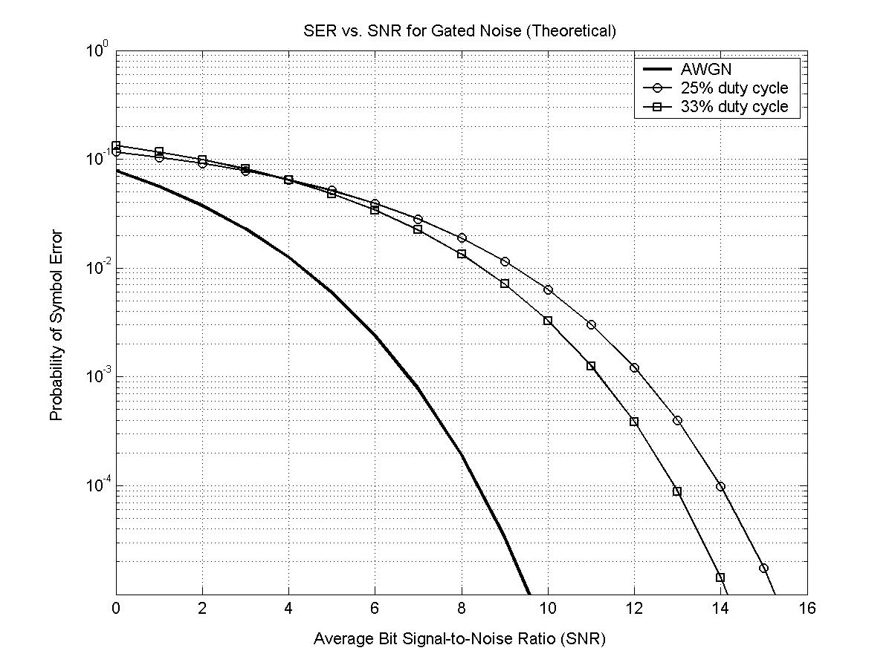

Figure 2. Theoretical SER results for 25% and 33% duty cycle under the assumption of equal EIRP.

In Figure 3 we plot the case for various impulse-to-noise ratios and only 3 hops; the duty cycle was set to 33% and 26% to highlight any differences. From these plots we can observe that under smaller duty cycles with equal EIRP constraint the BER (and symbol error rate) rise slightly. This is also consistent with the results of Figure 2. Thus, it is apparent that the results presented in [3] [4] are actually slightly optimistic, even under the gated AWGN process model.

In slide 30 of the 412r0 presentation, a “more realistic” scenario for the receiver is operation at Eb/No = 10dB. Slide 31 of 412r0 then presents the gated AWGN case showing nearly 0dB performance degradation with the gated AWGN process. Based on the analytical results of [3] [4], we can observe that the actual performance degradation is almost 6dB when INR = 0dB. Hence, the 412r0 results are not only misleading, but fail to accurately capture the actual degradation phenomenon.

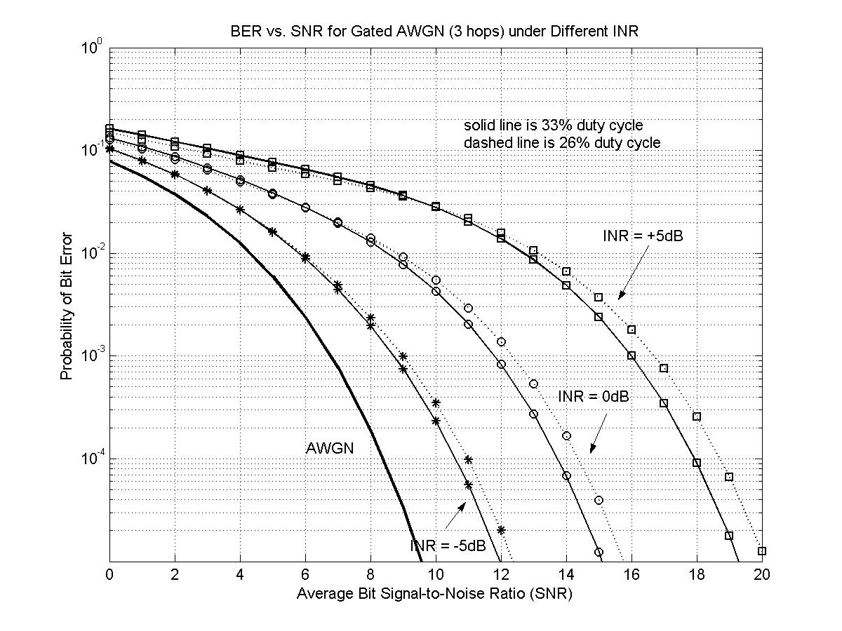

Figure 3. Theoretical BER results for 25% and 33% duty cycle under the assumption of equal EIRP and various interference-to-noise ratios (INR).

Evaluations with Respect to Impulse Radio:

The assumption of equal PSD is particularly relevant in relation to the simulation results provided for impulse radio (IR) systems. Impulse radios do not scale and gate, but rather, spread their power over large bandwidths that result in very short-time pulses at some pulse repetition frequency (PRF). Under the equal EIRP constraint, the power of the IR system is made equal to that of AWGN over some defined (and finite) temporal window. This equates the average power of each signal with resulting PSD scaling for IR as for all other interference sources under this constraint. Under equal PSD, the IR systems would be much more benign than MB-OFDM unless the peaks of the signal exceed those of OFDM in the APD plot, which is what is being presented.

Again, the 412r0 analysis does not apply the same methodology equally to the different interference sources. For example, there is no quantization effect accounted for in the impulse radio results provided in the APD results. In addition, impulse radio does not seem to be modeled as having equal PSD to the MB-OFDM signal modeled as a gated AWGN process. This is why the authors chose to compare everything in terms of EIRP; equating average power allows us to circumvent specifics of modulation, PRF, etc.

Second Conclusion:

In this addendum we have provided additional results and analysis that in effect contradict the results of the 412r0 presentation before the audience in Berlin. It is the intention of the authors to generate another presentation that incorporates a point-by-point analysis of the 412r0 presentation. It is the intention of this along with the work of [5] that we seek to inform the IEEE and other interested parties of the fact that MB-OFDM is a very harmful interference to in-band high data rate receivers.

References:

[1] E. A. Quiney, “Victim receiver response to ultrawideband signals,” Proc. MILCOM, vol. 1, pp. 20—24, 2001.

[2] J. Brandao, “Interference effect on the performance of PSK and QAM systems,” IEE Proceedings I, vol. 138, pp. 331—337, Aug. 1991.

[3] C. A. Corral, S. Emami, and G. Rasor, “The interference of multi-band OFDM systems on in-band broadband QPSK receivers,” internal Motorola report, Sept. 9, 2004.

[4] C. A. Corral, S. Emami, and G. Rasor, “Multi-band OFDM interference on in-band QPSK receivers,” Doc. IEEE 802.15-04/315r0, July 2004.

[5] C. A. Corral, S. Emami, and G. Rasor, “Multi-band OFDM interference on in-band QPSK receivers revisited,” Doc. IEEE 802.15-04/451r0, Sept. 2004.

Initial simulations under equal PSD considerations resulted in curves similar to those provided by 412r0, that is, the SER performance for OFDM was better than AWGN.
Reference 412r0 presentation, slide 8, where power is normalized to unity.
Reference 412r0 presentation, slide 10.

