IEEE P802.15
Wireless Personal Area Networks

Project | IEEE P802.15 Working Group for Wireless Personal Area Networks (WPANs)
Title | Consolidation of Questions on Responses of No Vote Explanations
Date Submitted | 14 September 2004
Source | [Gerald W. Wineinger]  [TI]  [Dallas, Texas] | Voice: [214 480 1013]  Fax: [214 480 6662]  E-mail: [gww@ieee.org]
Re: | 802.15.3a Task Group Questions on Responses of No Vote Explanations
Abstract | Questions on Responses of No Vote Explanations Task Group 3a in Berlin
Purpose | Consolidate Questions on Responses of No Vote Explanations Task Group 3a in Berlin
Notice | This document has been prepared to assist the IEEE P802.15. It is offered as a basis for discussion and is not binding on the contributing individual(s) or organization(s). The material in this document is subject to change in form and content after further study. The contributor(s) reserve(s) the right to add, amend or withdraw material contained herein.
Release | The contributor acknowledges and accepts that this contribution becomes the property of IEEE and may be made publicly available by P802.15.

CONTENTS

Consolidation of Questions on Responses of No Vote Explanations in Alphabetical Order

The following are the Questions from the No Vote authors concerning the response they were given on their explanation

Roberto Aiello:
Here are some questions referring to doc 513.

1. which silicon manufacturers will start interoperability in Q4 04? Is interoperability based on the IEEE proposal or on a different specification? If it is a different specification, what are the differences and does is meet the PAR?
2. please explain what you mean with Bluetooth philosophy? If the UWB forum also includes the MAC, what is the IP situation? My understanding is that companies have submitted RAND statement for the 15.3 MAC when used with IEEE PHY, not without. Which industry alliances are currently working with UWB Forum (WiMedia, 1394TA, WUSB, etc.)? These Alliances are already working with the MBOA.
3. we have heard yesterday that the currently certified UWB transmitter is an evaluation system, but you called it “product ready form”. I am still confused. Can you please explain what you mean by product ready?
4: will DS-UWB products based on 1394 have the 1394 logo so that consumer experience can be “exceedingly easy”? My understanding is that the 1394 is working on a PAL for WiMedia, which has adopted the MBOA
5: please indicate which major CE companies are members of the UWB Forum. All major CE companies are members of the MBOA

My question is: why is the spectrum shown here so choppy? More specifically, the plot in Fig 4.1 doesn’t appear to meet the minimum 500MHz bandwidth and the total power seems to be at least 5dB lower than the ideal case in both cases. Is this taken care in the proposal presentation?

FCC Certification Test Report
for
Motorola Corporation
FCC ID: RUN-XSUWBWDK

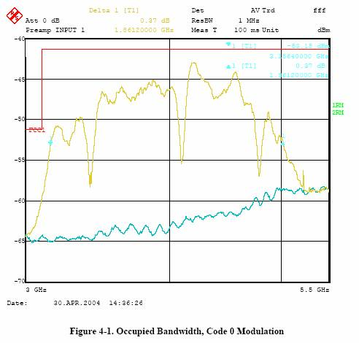
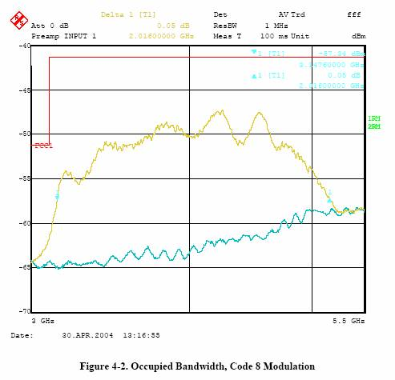

Chuck Brabenac:

Bill, In this evening's TG3a discussion on "no vote" comments, you and I briefly digressed into some discussion on your notion of using only preamble-based CSMA-CA techniques, vs. an additional "energy-based"
capability where CCA can be performed anywhere within a packet.

In addition to the (marginally) interesting power conservation considerations I mentioned for some applications, there is the much more important/fundamental consideration that preamble detection sometimes doesn't work (missed detections). In that case, it is desirable to have the "energy based" CCA capability in order to avoid collisions with other CAP and TDMA (co-channel on different piconet) traffic of nearby devices.

To be sure, when you have successfully detected preamble you can use preferred techniques such as virtual carrier sense (based on PLCP header len & rate), and failing that, continuous decode of symbols when you have already established channel coherency, but again those things are not available when you miss the preamble. This is why other standards (e.g., 802.11a) specify/require an "energy based" CCA for CSMA/CA.

For a high level tutorial on the flavors/considerations of CCA, and why the DS-UWB proposal shouldn't now discount the value of an "energy based" CCA (the kind that DS-UWB proposal has showed in the form of a squaring circuit that we identified problems with), please check out the Sept. '03 Singapore presentation I contributed to (03-0343-01, slides 91 to 113, and also 114 to 144). I made reference to this material in my no vote reason, and I'd really like to see the DS-UWB proposers study that content (we truly put a lot of work into it), and fully address those concerns.

Ron Brown:
Based on the presentation by Michael Mc Laughlin, It seems that the DS-UWB proposal promoters still advocate a design that uses convolutional encoding with different constraint-lengths for different rates.

Please explain how requiring a receiver to implement multiple decoder trellis widths results in a complexity and power consumption advantage.

Thomas Kuehnel:
1.) Can you provide a pointer to the IPR statement of the UWB Forum?
2.) Can you provide a pointer to the Interop and testplan for UWB Forum test and certification?
3.) Can you outline the adaptation of the DS-UWB solution wrt. to its higher layer interfaces such as OHCI for USB, 1394
4.) How does DS-UWB integrate with Internet Protocol suite considering that the current 802.15 MAC does not integrate well with IP?

A response is greatly appreciated.

Knut Odman:
This comment applies to both the MBOA and DSUWB proposals.
There is obviously different opinions about when the two teams will have shippable silicon that conforms with their proposals. Understandably, when a proposal is enhanced there will be some latency before the product is updated. I would propose the following way of addressing this issue
in a uniform way:
Each proposal submits a PICS proforma. The PICS shall list all features that is considered mandatory to build a product that is conformant with the respective proposal.
The PICS should also list all major features that are optional, but that the proposal authors regard as recommended for an efficient implementation In the right column of the PICS shall be listed a date. This date would be the best estimate by the proposal writers when a certain feature will be available in silicon The dates could be "Available Now", "Q1/2005" or any date format as exact as can be estimated as this time.
This method would put a stringent and uniform method of addressing the time-to-market issue and eliminate the perceived uncertainty in the current presentations.
I would urge both camps to present this as soon as possible. If not practically possible in Berlin, at the very least this information could be presented in San Antonio (assuming of course that both proposals remain for consideration).
Charles Razzell:
I have studied 137r3 in an attempt to understand which elements of the technology are proposed to be used to support different PHY SAP data rates. The fact that I was unsuccessful gives rise to this question.
I notice that 4-BOK and BPSK modulation modes are able to support the same data rates. I also notice that K=6 and K=4 convolutional codes are available .
At a minimum, I would like to know for each available data rate, which modulation mode and which coding mode is expected to be used. This seems to be a minimum requirement for having something that qualifies as a proposal.
As a supplementary, related question I would like to know why SSA is not mentioned and why CSM is not mentioned in the official proposal text? It seems inconsistent (and confusing) that your proposal updates and previous contribution presenations focus heavily on these items and yet they are not part of your official proposal. If you are in favor of these technologies, why not make them part of your official proposal that is being voted on? As you have observed many people who have not read your official document think (wrongly) that they are included. I could understand that you would want as many people as possible to *think* that their ideas are included since this broadens your support base. I request that there be the utmost clarity as to what a vote for merged proposal #2 means.
with respect to slide 13 of 0516r0, I notice that low pass filters are employed after the down-conversion mixers, which would be expected by most of us familiar with the art. Can we assume that the majority of the channel selectivity is provided by these filters? Since you only have 3-bit ADC converters, running at the chip rate (according to previous information you presented to TG3a), I would assume that this must be the case. Please confirm.
Please can you comment on the feasibility of creating such channel selectivity to combat strong OOB interferers such as may be expected in the UN-II band? Do you consider it feasible to provide such selectivity on-chip in a high volume/low cost (e.g., CMOS) IC process? Can you comment on the relative difficulty of providing such on-chip selectivity for a chip rate of 1320Mcps i.e., a corner frequency of ~660MHz as compared to what might be required for a MB-OFDM signal i.e., a corner frequency of ~260MHz?
Finally, can you please comment on the relative channel filter selectivity requirement for an analog implementation where the correlators are placed before the ADC converters as compared with the channel filter selectivity requirement for a digital implementation, where the digital contribution to selectivity is fundamentally limited by the 3-bit / 18dB dynamic range of the converters? Is it true that in an implementation using analog correlators, the correlators themselves can provide a significant contribution to selectivity? Does this advantage carry over to a system using digital correlators, when 3-bit Nyquist sampling rate ADCs are used?

Erik Schylander:
I would like to know / understand what the exact difference is between the Freescale implementation approved by FCC, and the DSS proposal under voting, as well as what parts of the proposal has been implemented.

Alireza Seyedi:
I have a comment about the narrowband interference mitigation, as described today, which is posted below.
Comment: As described during presentation on Monday (document 0504r1), first the narrowband interference is estimated using an FFT. This estimate is then subtracted from the signal.
This approach has desirable performance when the interferer has a single, fixed frequency, which is aligned with one of the FFT bins. However, it does not have good performance when the either the frequency of the narrowband interferer is not fixed, or the interference has more than one significant tone, or the frequency of the interferer is not aligned with the FFT bins. This bad performance is well documented in the literature discussing the narrowband jamming mitigation. In these cases the interference power spills over to many FFT bins, and the residual interference, which can have significant power greatly diminishes the performance. To remedy this a large FFT together with windowing must be used. Which significantly increases the complexity.

Matthew Shoemake:
With respect to FCC certification, please answer the following two questions:

1) What are the technical differences between what was certified by the FCC and what is proposed to the IEEE in document 15-04-0137-03, i.e the current DS-UWB proposal?
2) Does the DS-UWB solution that obtained FCC certification meet all requirements of the IEEE 802.15.3a PAR?

In examining Table 7, Piconet Channel Numbers, Chip Rates and Spreading Code Sets, I see that there are basically two chip rate ranges, i.e. 1313-1365 MHz and 2600-2730 MHz.

Did you consider using just two chip rates, i.e. just on in the lower range and one in the higher range, or is there some good reason for having some many chip rates?

The DS-UWB proposal contains an 8-state and a 32-state binary convolutional code.

1) Are they both mandatory?
2) If so, why would you ever use the 8-state code?
3) If the answer is that the 8-state code is used at higher rates, please clarify at which rates the 8-state code should be used and at which the 32-state code should be used

This question relates to the mapping in 4-BOK. Your current proposal allows for the natural mapping, i.e. {00, 01, 10, 11} and a Gray mapping, i.e. {00, 01, 11, 10}. The mapping is selectable and indicated to the receiver in the Modulation Type field.

I assumed that the PER does not vary between these two mappings but the BER may. I would assume the Gray mapping may have superior BER. If so, please confirm. If confirmed, please eliminate the natural mapping and recover one bit from the Modulation Type field.

Do you have ideal floating point simulations of PER vs. Es/No in AWGN for the two BCCs and for 4-BOK in your proposal? Please provide and/or include in your proposal.

Do the BCCs always outperform 4-BOK? If not, please show a realistic situation where 4-BOK outperforms the BCCs at the same data rate. Otherwise, eliminate 4-BOK from the proposal.

Stephen Woods:
1) Regarding the regulatory presentation that I saw last night, it appears that your regulatory strategy assumes the success of the FCC mask in other regulatory domains. As I am actively contributing to the ITU process, I would say that this represents a rather substantial risk. There is almost a 100% chance that the ITU will make changes despite our collective best efforts. Assume that the changes involve the steeper OOB emission limits and a notch for the radio astronomy.
a) What changes will be required to an implementation to handle changes of this type if the DS approach is selected and also assuming a design implementation equivalent to the one used by Freescale.
b) Please offer general comments on how an implementer would be required to deal with a world that has a higher degree of variability than you have assumed. This is obviously not your current expectation, but is a contengiency that needs to be anticipated.

2) There has repeatedly been requests to get a comparison of what Freescale is shipping vs the proposal. The proposers have continuously used the Freescale shipment to indicate the viability of manufacture and the ability to build the proposal. This is impossible for reviewers to assess without a moderate degree of detail. To date, no detail has been provided and there is substantial ambiguity even among the Freescale team on whether the design complies. May I suggest that you consider a simple table showing exactly what has been implemented and what has not. As the product has been publicly announced, this should not be a material imposition. The answers provided by Matt this morning added no clarification to the question.

3) A statement was made that the Freescale product would support 1394. I assume that this means that it has a 1394 wired interface. As I understand it, wireless 1394 has endorsed the WiMedia work which would exclude the DS approach. Could you clarify?

4) I recognize that there is a clear differentiation between what is required for the selection criteria and what is required to build product. Building product is a superset. It is a disservice to voters to use the selection criteria to limit responses. We need to understand the factors related to building products as well and yes, it will affect our voting even if it is not within the selection criteria.
a) Regarding IPR, should we be concerned about IP being held by Qualcomm and other CDMA patent holders or not. Considering prior CDMA patent activity, implementers need to know. Just to make sure that you don't expose yourself excessively, would you describe the risk as High, Medium, Low, None?
b) Do you have any support from major organizations who will be the primary promoters of this technology and is there any likelihood of obtaining this support (USB, 1394, Bluetooth, WiMedia). Is it your opinion that the support of these organizations is not necessary for a successful market? How will you deal with these support for these application stacks? At this time, USB and WiMedia have already established positions for MBOA and 1394 has established support for WiMedia.
c) You describe multiple tier 1 support from CE, PC and others. But not one of these companies is willing to be visible publicly. To credibly make a claim, it would seem necessary to provide at least one or two names. The MBOA has provided this level of detail.

