IEEE P802.15
Wireless Personal Area Networks
Project | IEEE P802.15 Working Group for Wireless Personal Area Networks (WPANs)
Title | Performance Analysis of Modified Delayed ACK
Date Submitted | [September 3rd, 2004]
Source | [Sanjeev K. Sharma, Huaning Niu]  [Samsung Electronics]  [75 W. Plumeria Dr., San Jose, CA, 95134] | Voice: [408-544-5978]  E-mail:  [sk.sharma@samsung.com  huaning.niu@samsung.com]
Re: | [IEEE 802.15-04/299-r0]
Abstract | [This document describes the performance analysis of the proposed changes to improve the delayed Ack as described in 04/299r0]
Purpose | [The purpose of this document is to propose changes to IEEE Std 802.15.3 to improve the Delayed ACK mechanism]
Notice | This document has been prepared to assist the IEEE P802.15. It is offered as a basis for discussion and is not binding on the contributing individual(s) or organization(s). The material in this document is subject to change in form and content after further study. The contributor(s) reserve(s) the right to add, amend or withdraw material contained herein.
Release | The contributor acknowledges and accepts that this contribution becomes the property of IEEE and may be made publicly available by P802.15.

Introduction

In 04/299r0 [1], we highlighted the weak point of the current delayed ACK in 802.15.3 [2] and proposed modification to the delayed ACK based on bitmap. This document is a follow-up analysis on comparing the performance between these two delayed ACK schemes. Throughput is analyzed based on the packet size and number of MPDU blocks for each delayed ACK.

Analysis

We consider two delayed ACK schemes for 802.15.3 MAC:

- Current Delayed ACK as in 802.15.3
- Samsung’s Proposed Modified Delayed ACK

With the following assumptions:

- No packet retransmission
- Equal size MPDUs

Figure 1 shows an example of 802.15.3 delayed ACK data transmission. A transmitter can request a Delayed ACK by setting “ACK policy” bit in the MAC header.

Figure 1: Usage of Delayed ACK for 802.15.3 Systems

As observed from Figure 1, throughput (TP) of the 802.15.3 system with current delayed ACK can be calculated by the following equation.

${\text{TP}}_{\text{DA}}=\frac{n∗8L_{\text{DATA}}}{n∗T_{D_{\text{Data}}}+T_{D_{{\text{Delay}}_{\text{ACK}}}}+2n∗τ+n∗T_{\text{SIFS}}}$ ------------------------------ (1)

Where n is the number of MPDUs. L_{DATA} is MPDU length in bytes, T_{D_Data} is duration for an MPDU transmission, T_{D_Delay_ACK} is duration for Delayed ACK transmission, T_{SIFS} is inter frame space (IFS) between two consecutive MPDUs called as shortest (S)IFS, and $τ$ is air propagation time. Since $τ$ is very small, it can be ignored. Hence, TP__{DA} can be approximated as follows:

$\text{TP}\text{DA}≈\frac{n∗8L_{\text{DATA}}}{n∗T_{D_{\text{Data}}}+T_{D_{{\text{Delay}}_{\text{ACK}}}}+n∗T_{\text{SIFS}}}$ ---------------------------------------- (2)
By rearranging (2), we get.

$\text{TP}\text{DA}≈\frac{8L_{\text{DATA}}}{T_{D_{\text{Data}}}+{T_{D_{{\text{Delay}}_{\text{ACK}}}}}/n+T_{\text{SIFS}}}$ -------------------------------------------- (3)

Similarly, the throughput for proposed modified delayed ACK is given by the equation below.

$\text{TP}\text{MDA}≈\frac{8L_{\text{DATA}}}{T_{D_{\text{Data}}}+{T_{D_{{\text{Mod}}_{{\text{Delay}}_{\text{ACK}}}}}}/n+T_{\text{SIFS}}}$ -------------------------------------- (4)

To proceed with our analysis, let us first consider the MAC and PHY header fields in details as shown in Figure 2.

Figure 2: PHY frame formatting for 22, 33, 44 and 55 Mb/s modes

The header and the ACK are transmitted at the Base Rate which is 22Mbps.

T_{D_Data} = T_{Preamble} +T_{H} +T_{D_Pkt}

T_{D_Delay_ACK} = T_{Preamble} + T_{H} +T_{Delay_ACK_Pkt}

T_{H} = (L_{PHY_Header} + L_{MAC_Header} + L_{HCS})*8/Base_Rate;

Since L_{PHY_Header} = 2 bytes, L_{MAC_Header} = 10 bytes, and L_{HCS} = 2 bytes,

Therefore, T_{H} = 14*8/22 = 5$μs$. T_{Preamble} = 16*10/11 = 15$μs$ ; T_{SIFS} =10$μs$;

T_{D_Pkt} = (8*L_{Data})/Tx_Rate; Where Tx_Rate is for the transmission rate of the data part of the frames.
T_{D_Delay_ACK} = [7+ (n*2)]*8/Base_Rate;

T_{D_Mod_Delay_ACK} = [7+ (2+ceil (n/8))]*8/Base_Rate; if n<=128

T_{D_Mod_Delay_ACK} = [7+ (4+ceil (n/8))]*8/Base_Rate; if n>128

Throughput gain can be realized by the following.

Throughput (TP) gain = (TP_{_MDA} – TP_{_DA})

Using equation (3) and (4), we get the following

Throughput gain = $\frac{8L_{\text{DATA}}}{T_{D_{\text{Data}}}+{T_{D_{{\text{Mod}}_{{\text{Delay}}_{\text{ACK}}}}}}/n+T_{\text{SIFS}}}−\frac{8L_{\text{DATA}}}{T_{D_{\text{Data}}}+{T_{D_{{\text{Delay}}_{\text{ACK}}}}}/n+T_{\text{SIFS}}}$ ---- (5)

Throughput (TP) gain (%) = (TP_{_MDA} – TP_{_DA})*100/TP_{_DA}

₌ $\frac{(T_{D_{{\text{Delay}}_{\text{ACK}}}}−T_{D_{{\text{Mod}}_{{\text{Delay}}_{\text{ACK}}}}})}{n(T_{D_{\text{Data}}}+{T_{D_{{\text{Mod}}_{{\text{Delay}}_{\text{ACK}}}}}}/n+T_{\text{SIFS}})}∗\text{100}$ -------------------------------- (6)

The above equation (6) can be simplified as given below.

₌ $\frac{8∗[2−2/n−\text{ceil}(n/8)/n]}{{\text{Base}}_{\text{Rate}}∗(T_{D_{\text{Data}}}+{T_{D_{{\text{Mod}}_{{\text{Delay}}_{\text{ACK}}}}}}/n+T_{\text{SIFS}})}∗\text{100}$ ------------------ (7)

The above equation can be approximated for larger values of n, as given below. From the equation (7), n needs to be larger in order to get optimal throughput gains.

$\frac{8∗2}{{\text{Base}}_{\text{Rate}}∗(T_{D_{\text{Data}}}+T_{\text{SIFS}})}∗\text{100}$ ----------------------------------------- (8)

The above equation (8) can be further simplified as given below.

$\frac{8∗2}{{\text{Base}}_{\text{Rate}}∗[T_{\text{Pr}\text{eamble}}+TH+(8∗L{\text{Daata}}/{{\text{Tx}}_{\text{Rate}}})+T_{\text{SIFS}}]}∗\text{100}$ ------ (9)

Therefore, for throughput (TP) gain to be larger L_{Data} needs to be smaller and Tx_Rate needs to be larger. For a case of MPDU size of 200 Bytes and Tx_Rate of 480Mbps, T_{D_Data} = 3.34$μs$, Base_Rate of 22Mbps, throughput gain (%) is 2.2%.

Performance Results

Based on the Throughput calculation equations, we have plotted the graphs to show the throughput versus the number of MPDUs per delayed/modified delayed ACK and the size of MPDU (varying from 200 bytes to 1000 bytes)

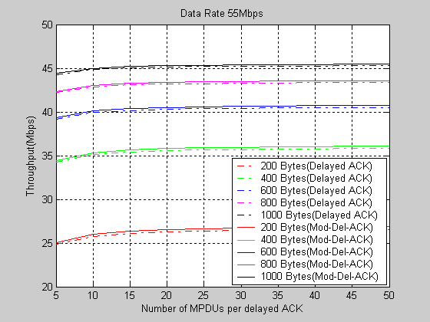

Figure 3: Throughput versus Number of MPDU Blocks at 55Mbps

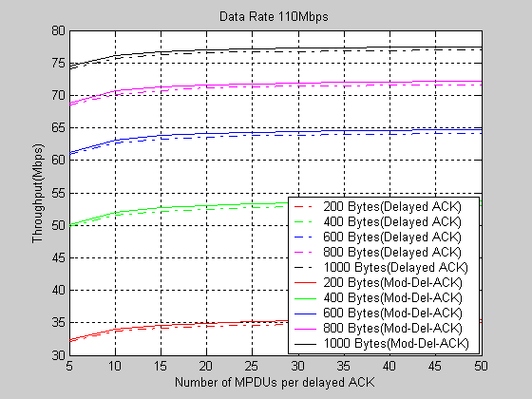

Figure 4: Throughput versus Number of MPDU Blocks at 110 Mbps

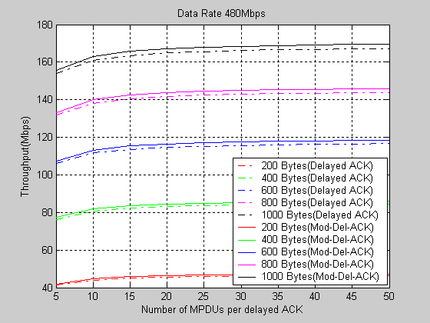

Figure 5: Throughput versus Number of MPDU Blocks at 480 Mbps

Conclusions

We can clearly observe that proposed modified delayed ACK outperforms the current delayed ACK. This becomes clearer when the transmission rate is higher, which is a target support for 802.15.3 based ultra wide band (UWB) systems. At 480Mbps of transmission rate and MPDU size of 200 bytes, our proposed delayed Ack provides 2.2% throughput gain over the current delayed Ack mechanism. This performance improvement does not cost anything in terms of the processing and/or creating the modified delayed Ack frame. However, the transmitter of modified delayed Ack will need to calculate the length of bitmap field based on the first and last MPDUs to be delayed ACKed using the proposal scheme.

References

- Sanjeev K. Sharma and Jinwoo Hong, “Modified Delayed (Dly) ACK for IEEE 802.15.3 Systems” IEEE 802.15-04/299-r0.
- Draft Standard for High-Rate Wireless Personal Area Networks, Draft P802.15.3TM-2003.

