IEEE P802.15
Wireless Personal Area Networks
Project | IEEE P802.15 Working Group for Wireless Personal Area Networks (WPANs)
Title | Dynamic Beacon Alignment in Simultaneously Operating Piconets (SOP) using the Heart beat approach
Date Submitted | [16, March 2004]
Source | [Francis daCosta]  [MeshDynamics]  [1299 Parkmoor Ave, San Jose, CA 95126] | Voice: [(408) 373-7700]  Fax: [(408) 516-8987]  E-mail: [fdacosta@meshdynamics.com]
Re: | [802.15 Study Group 5 mesh development.]
Abstract | [An approach to align beacons in an 802.15 WPAN is presented. The approach is dynamic and ensures that beacons align – do not interfere with each other’s transmissions – in a maximum of 6 superframes and a minimum of 1 superframe. In the event that a beacon slot reservation scheme is adopted, the beacon alignment process will take no more than 1 superframe.  The algorithms for aligning beacons with a slot reservation scheme in place and also without any slot reservation in place have been developed and tested in simulation. The algorithms uses “heart beats” – information transmitted by devices during their CAP period to inform PNCs in the vicinity of other PNCs that it may not hear directly.  Appendix A describes the protocols developed to test the algorithms. Appendix B describes preliminary work in determining the overall effectiveness of this approach in terms of overhead.]
Purpose | [To present methods for syncrhonizing piconets.]
Notice | This document has been prepared to assist the IEEE P802.15. It is offered as a basis for discussion and is not binding on the contributing individual(s) or organization(s). The material in this document is subject to change in form and content after further study. The contributor(s) reserve(s) the right to add, amend or withdraw material contained herein.
Release | The contributor acknowledges and accepts that this contribution becomes the property of IEEE and may be made publicly available by P802.15.
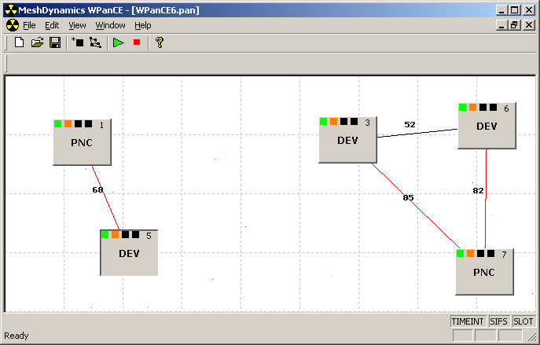
PROBLEM STATEMENT
Fig. 1: Two Piconets operating - but not interfering - in the same area.

Fig. 1 shows two Pico Net Controllers (PNC) operating simultaneously in a Wireless Personal Area Network (PAN). In their current configuration, they are not interfering with each other’s transmissions. However since PAN devices support mobility, one could move into the airspace of the other. Even if it is temporary, this affects the transmission quality of both piconets. Problems associated with Simultaneously Operating Piconets (SOP) are endemic to home networking applications where both mobility and the ability to provide isochronous transmissions are core requirements.
PAN devices use a beacon to ensure isochronous transmissions. In the IEEE 802.15.3 standard, depicted in Fig. 2, CTA time slots are channel time allocation slots for regular transmissions of latency sensitive information e.g. video streams. A beacon synchronization pulse, assures synchronicity. The PNC sends a beacon pulse marked B in Fig. 2. Devices synchronize their transmissions by the beacon pulse.
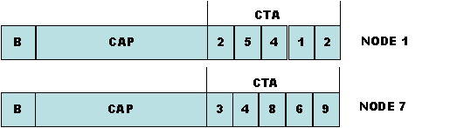
Fig. 2: Beacons are in interference with each other.
A device cannot effectively communicate if it loses the beacon synchronization pulse because of radio interference from devices in other Piconets. Such is the case when two piconets are sending beacons at the same time. Accordingly, there exists a need to coordinate between PNCs and their devices ensuring that beacons are sent at times when there is no interference from other devices.

Solutions to the Beacon interference problems are complicated by the fact that interference can occur at anytime- during the beaconing period (B), the Contention Access Period (CAP) or the CTA period. In the CAP, collision avoidance rules of CSMA will ensure eventual transmission – but with delay. However interference in either the beaconing period or CTA period results in faulty transmissions. For high quality video, this is unacceptable.
LOGICAL PICONET APPROACH
Our approach centers on the concept of a logical piconet. We define as a logical piconet as one grouping of devices with associated PNCs. The logical piconet may contain one or more PNCs, which agree to align their transmission patterns to engender interference-free co-existence.
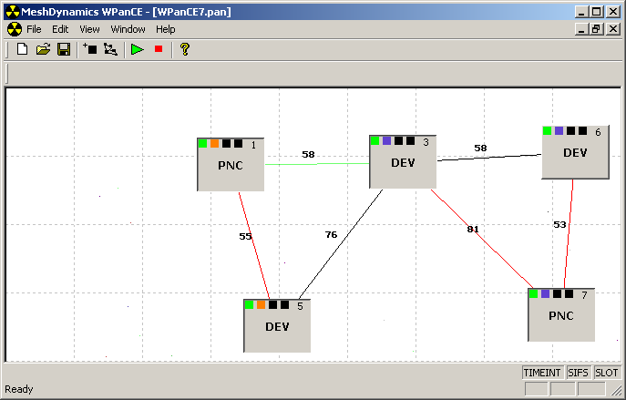
Fig. 3: A logical piconet is a grouping of piconets that support interference-free coexistence.

Fig. 3 depicts a change from Fig 1, when one piconet has moved closer to the other. Potential interference is avoided by aligning the beacon transmissions and channel time allocation – see Fig 4 – that engenders interference free coexistence. The logical piconet is formed by mediation between the piconets that agree to support coexistence.
B
CAP
NODE 1
B
CAP
NODE 7
Fig. 4: Beaconing period staggered and CTA periods aligned to avoid interference.

To address issues of mobility and requirements for isochronous transmission in Simultaneous Operating Piconets in a robust and scalable manner, we have developed and implemented software for managing beacon alignment issues in dynamic environments. Our software only approach is layered on the MAC- no changes to be made to the existing IEEE standard.
Other driving factors that influenced our design approach to beacon alignment and channel time allocation include:
Robust Operation In addition to addressing beacon alignment and judicious channel time allocation issues, the system must be demonstrably robust, stable and scalable. Mobility is essential in personal area networks: both PNC and devices are moving and causing interference. Beacons could be affecting transmissions in a) beacon time slots b) CAP and c) CTA time slots. In all cases, the system must recover from changes in network topology swiftly and in a stable manner.
Interference effects may also be caused by external events e.g. the opening and shutting of doors changes the network topology suddenly. Algorithms that are proactive but not stable will generate unacceptable oscillatory behavior
Hidden Node Problem Fig. 5 is a snap shot from our simulation depicts a 4 node SOP problem. PNC nodes 1 and 5 cannot hear each other but device 2 hears both. Interference from the beacons sent by PNC nodes 1,5 can jam transmissions to Device 2 – but neither PNC is aware of the other.
The PNCs therefore need to be made aware of each other’s existence for both beacon alignment and coordination of channel time allocations. In our approach, the intermediary Device 2 performs this, on hearing both PNCs transmits a “heart beat”. This is a retransmission of ASIE based information included in PNC beacons intended for use by other PNCs. The intermediary device also ensures that the handshaking between the two PNCs is performed in a stable manner
Mesh Networking The first applications of personal area networking, such as USB wire replacements, may not require mesh networking, but there is general consensus in the industry that mesh networking is needed to address the range limitations of UWB and managing complex interactions between multiple piconets. Mesh networking is also desirable where transmit power control is required, especially for battery operated devices. With a mesh in place, devices may route, at lower power, through nearby devices, as opposed to using more power to reach devices directly.

DYNAMIC BEACON ALIGNMENT
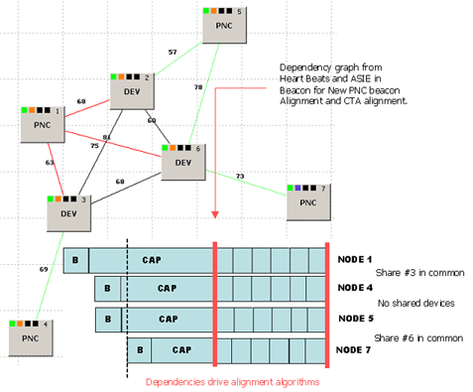
Fig. 5: Dynamic Beacon Alignment in Simultaneously Operating Piconets
Referring to Fig. 5, Node 1 and Node 4 do not hear each other, but cannot transmit without restriction because Node 2 is in hearing distance from both of them. Conversely, Nodes 4 and 5 can transmit simultaneously as they do not have any common node in their “reachable” list of neighbors.
One approach to determining when beacons can be transmitted simultaneously is to apply set theory in determining if there is a NULL set of common reachable nodes. For example, Nodes 4 and 5 have no common nodes in their reachable list. Hence they can transmit at the same time as shown. We have implemented one such approach.

When PNC Nodes do have nodes in common in their reachable list then simultaneous transmission is not permissible. Then one beacon transmission must be staggered as shown in Fig. 5. Node 7 sends its beacon a short time after the beacon from Node 5 has concluded.
Set theory may aid us in determining which beacons need to be staggered. However, how do PNC nodes know that they need to stagger their beacons when they cannot hear each other? Consider the case when PNC node 7. It cannot hear any of the other PNC nodes. How can it determine what a safe beacon alignment slot should be? One means available is to help PNC node 7 align its beacon is through a re-transmission of beacon information by a device node (Node 6 in Fig. 5) that hears Node 7’s beacon and appraise it of its surroundings. As such, this device acts as an intermediary or repeater node on behalf of the PNC node it belongs to. We refer to this re-transmission as a “heart beat”.

Heartbeats are thus re-transmissions sent by devices while PNCs sent beacons. Both Heart beats and beacons use ASIE information elements to relay information needed to perform beacon alignment. Appendix A shows the protocol used.
While devices generally send heartbeats on a periodic basis they also send a heart beat if they hear a request for information on its surroundings (e.g. “Where am I? Who are my neighbors?”) When it hears such a request the device will relay the last beacon information it received from its PNC.
The beacon information, contained in ASIE information elements, informs the new PNC of other PNCs that the device’s PNC knows of and also information on the current ordering of the PNC beacons. For example, Device 6 will relay the following information to Node 7:

- I am Device 6 and I belong to PNC node 1. I can also hear PNC Node 5.
- PNC node 1 belongs to a logical piconet- a family of aligned piconets.
- There are 3 piconets currently in this family and two beacon slots
- The beacon slot order of PNC node 1 is 1 of 2; That of PNC Nodes 4 and 5 is 2 of 2. (Node 7 has not yet joined).

Based in this information, Node 7 has limited options. It cannot take a used beacon slot either 1 or 2 - Device 6 can hear both 1 and 5. It must therefore request a new beacon slot, which when granted, places its beacon alignment position as shown in Fig. 5.
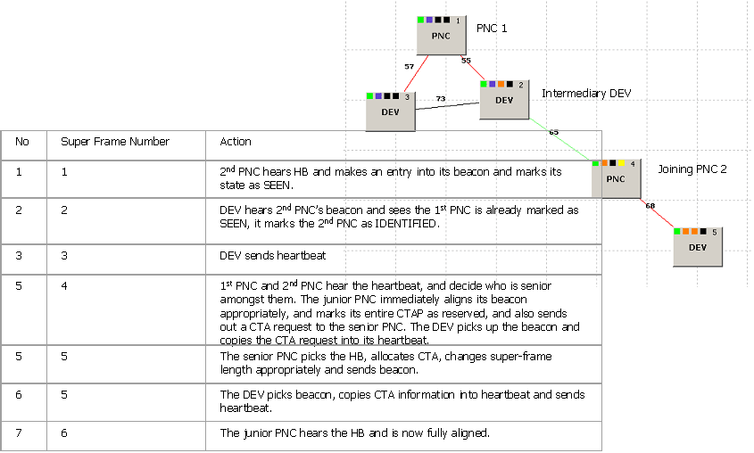

Fig. 6: Takes 6 super frames when beacon slot reservation is not applied.

Despite the fact that the information transmitted is compact (see Appendix A for details) mediation needed to get a beacon slot allocated may require up to 6 super frames, as shown in Fig. 6. 6 super frames are needed because the process described above requires the joining PNC to request and be granted a beacon slot not interfering with other PNCs. The request needs to be sent to a coordinator PNC to make the allocation and back to the requesting PNC.

A simpler alternative is to allocate a small portion of the super frame for PNC beacon slots. For example, suppose we set the allocated (reserved) portion to four beacon slots. The super frame format would look like:

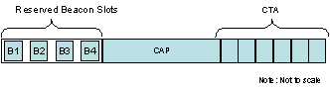
Fig. 7: A 4-beacon slot reservation accelerates beacon slot assignment

Returning to Fig. 5 for a brief moment, when joining PNC node 7 requests information about its surroundings, it is informed that there are 2 slots taken (PNC node 1 and 4,5 respectively) and 2 vacant. Then Node 7 would take the 3rd slot and update its beacon ASIE. Complete alignment – and jitter free transmission – was achieved within 1 super frame.

(Note: Fig. 7 is not to scale. Let us consider the time slot allocation for each beacon. Our heart beat protocol is compact –8 bytes for the protocol header and 16 bytes of information for each PNC in the logical group. Thus, a 5 PNC logical piconet implies a Beacon ASIE to be 8 + 5*16= 88 bytes. Clearly even with a large beacon size of 1024 bytes, the total time at a (low) throughput of 55mb/sec is: 1024* 8 / (55 * 10⁶) = 148 * 10-⁶ = 148 microseconds.)
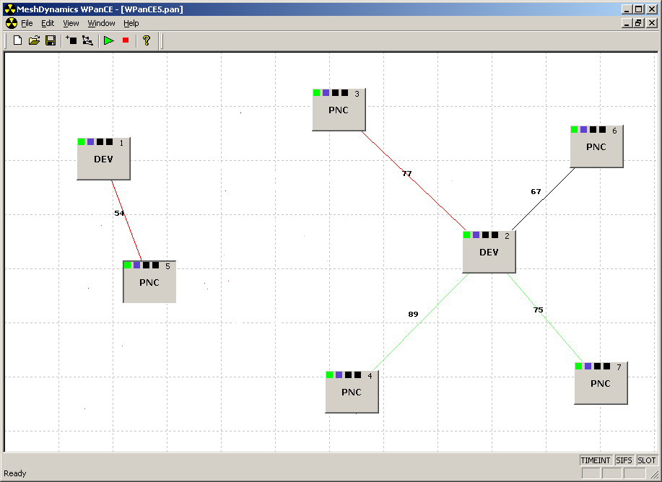
Fig. 7: Joining PNC needs to request a new beacon slot (four PNCs surround Dev 2).

Note: situations will occur when a request to increase the beacon slot size is required- if all 4 slots have been taken more slot allocations would be needed. However, it is unlikely that this will happen often. Bear in mind that the joining PNC will request a new slot - as opposed to sharing a slot with another PNC - because devices in its vicinity collectively hear all 4 other PNCs.

For example, in Fig. 7 above, the joining PNC-DEV pair 5,1 would require another beacon slot assignment – Device 4 hears all 4 PNCS in its vicinity, each of which has therefore taken up a distinct slot. The probability of this occurrence is low but in those cases the request for more slots will require a realignment of beacons for all PNCs – the process shown in Fig 6 applies.

Even if the beacon slot reservation sizes chosen is smaller than the situation warrants, each additional beacon slot reservation increase will dramatically reduce the need to require another increase in the reservation size – the probability of needing increased reservations rapidly decreases with larger beacon reservation slots.

A reasonable beacon slot reservation size, such as 4, should therefore ensure that a request for an enlargement of the beacon slot reservation section is unlikely to happen under normal circumstances. The upside is assured jitter free alignment. The down side is (a small) un-used bandwidth if less than 4 PNCs are inter-operating.

In our implementation of this approach, the beacon reservation slot size is configurable stating from zero (no reservation) to any number less than 255. Based on extensive simulations of use cases provided to us, we anticipate an initial beacon slot reservation size of 4 to be sufficient for typical home networking applications. The next (increased) size would be 8 as part of the series: 4,8,12,16…

To determine if our approach is both stable and scalable, simulations have been implemented and are demonstrable. Our simulations demonstrate dynamic recovery from a) mobility issues – devices will move around and leave/join other piconets, b) Hidden nodes – where one PNC is not aware of another PNC interfering with its transmissions, but a device hears both PNCS and c) perturbations caused by opening or shutting a door, resulting in a sudden change in network topology.
DYNAMIC CTA PERIOD ALLOCATION

Figs. 8 and 9 show two strategies for CAP alignment. Both strategies make the secondary PNC (node 7) begin its super-frame SIFS time units after the completion of the primary PNC’s beacon. The SIFS wait ensures that Node 7 will get access to the medium before other devices - as they would normally wait for BIFS time units.
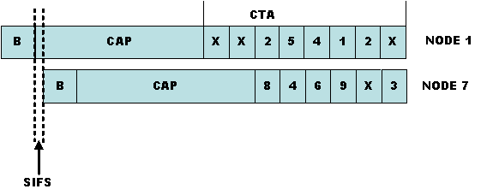
Fig. 8. Staggered but equal CAP for nodes 1,7

In Fig. 8, the CAP duration for both Nodes 1 and Node 7 is unchanged. Since the CAP of Node 7 interferes with CTA period o f Node 1, some time slots may need to be marked private or be added to the CAP for node 1. After the completion of Node 7’s CAP, both Node 1 and Node 7 begin their CTA Period.
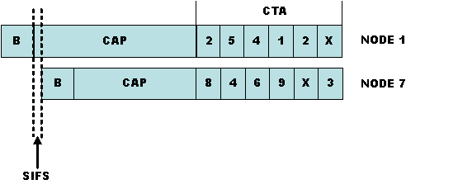
Fig. 9. Alignment of CTA Period for Nodes 1,7

In Fig. 9, the CAP duration for Node 7 is reduced so that its CAP end is aligned with Node 1’s CAP end, after which both nodes begin their CTA periods. By the same token, Node 1 could have also increased its CAP duration so that its end is aligned with Node 7’s CAP end. In this case Node 1 does not need to mark its first two CTA slots as private.

The two methods for CAP alignment depicted above are two approaches to allocating time slots ensuring that devices can talk with each other in specific time slots without stepping on each others toes. Both strategies need to be supported, based on the situation. For example, if the CAP is not being used or there are many devices requiring the CTA allocations, this would favor reducing the CAP over overlapping CAP and CTA - which results in two slots in Node 1 becoming unusable. Conversely, if applications require more CAP than CTA, this drives the algorithms towards favoring Fig. 8 over to Fig. 9.
The point being made here is that the system must be adaptive: brute force algorithms are inappropriate. Consider the case where there are five Piconets in the same vicinity. If the choice is to align the CTA periods always it will result in progressive deterioration of CAP bandwidth for each PNC. The converse – as shown in Fig. 8, will result in reduced bandwidth for the CTA period. Clearly, neither approach is a one size fits all.

Fig. 10: Alignment of CTA period progressively reduces CAP.
Our approach provides configurable parameters for managing CAP and CTA periods, based on application requirements. The CTA allocation system is driven by these parameters to make time slot assignments optimally.
APPENDIX A - BEACON ALIGNMENT PROTOCOL

The data format described below is an extension to our heart beat approach described in U.S. Patent Application No. 10/434,948, filed May 8, 2003 and incorporated by reference. The packet format described below is an extension to that protocol. It is described here to indicate how beacon data transmitted in the heart beat and used to align the beacons.

Compact protocol. The Heartbeat header is 8 bytes and each payload 16 bytes. Transmission of ASIE in beacons for a 5 PNC logical Piconet is 8 + 5* 16 = 88 Bytes total.

Main Heart Beat Header: The heartbeat is information broadcast by a DEV to its surroundings. The intent of the heartbeat is to help a neighboring PNC – that cannot hear the DEV’s PNC directly – to receive the information needed to align itself to the “head” PNC. Since alignment of beacons requires accurate timing information – of a beacon that has not been heard by the aligning PNC – the timestamp information attached by the DEV indicates the time elapsed since the DEV heard its PNC’s beacon and transmits it in a heartbeat.
2 1 1 4
+----+----+----+----+----+----+----+----+
|TIMESTAMP|PNCC| TB | PNC CAPABILITY | 8 octets
+----+----+----+----+----+----+----+----+

TIMESTAMP | Time, in micro-seconds since main PNC’s beacon, this heartbeat was transmitted (including BIFS and back-off time)
PNCC | Number of PNCs in Payload
TB | Device’s own Tie breaker value to be used in case of a tie
PNC CAPABILITY | PNC CAPABILITY FIELD AS DESCRIBED IN 802.15.3
Table A1: Heat Beat Header fields

Main Heart Beat Payload: Inside the PNC heart beat payload is information of ALL the PNCs that the DEV either has heard or is re-transmitting. Part of this information is important for determining whom the Aligning PNC should be aligning with. In table A2, the align count and position is needed because define the delay required by the aligning PNC based on the formula: (Count-Position) * Min. IFS +Beacon Transmit Time.
Example: If A PNC states that it is 2 (position) out of 3 (count) then the beacon sent by the aligning PNC should be 2+1 out of the new proposed aligned group of 3+1. Note that this information is also transmitted to the DEV because they cannot use the CAP that was previously allocated to them – that CAP has been reduced and there are also reserved or unused CTA time slots in the group so as to ensure that the Beacon transmissions are not interfered with.
2 2 1 1 2 2 2 1 1 1 1
+----+----+----+----+----+----+----+----+----+----+----+----+----+----+----+----+
| PNID | SPNID |TDC | DC | LBT | CET | SFDUR | AL | FL | TB |BSSC|
+----+----+----+----+----+----+----+----+----+----+----+----+----+----+----+----+
16 octets

PNID | PICONET Identifier
SNPID | The Head PICONET Identifier, if aligned, or same as PNID otherwise
TDC | Total count of associated devices for an aligned PNC system
DC | Count of associated devices
LBT | Last beacon time (relative to heartbeat transmission)
CET | CAP end time
SFDUR | Super-frame duration
AL | Alignment information octet formatted as  7 6 5 4 3 2 1 0  +----+----+----+----+----+----+----+----+  | ALIGN COUNT | ALIGN POS |  +----+----+----+----+----+----+----+----+
FL | State/Hops/Announcement flags  7 6 5 4 3 2 1 0  +----+----+----+----+----+----+----+----+  | STATE | HOPS | U | A |  +----+----+----+----+----+----+----+----+
  A | Announcement bit, set to 1 to indicate an announcement
  U | Urgent announcement bit, set to 1 if immediate action is needed
  HOPS | The minimum number of hops for the PNC
  STATE | The current state encoded as
    0 0 0 | NOT SEEN
    0 0 1 | SEEN IRRELEVANT
    0 1 0 | SEEN
    0 1 1 | IDENTIFIED IRRELEVANT
    1 0 0 | IDENTIFIED
    1 0 1 | ALIGNED IRRELEVANT
    1 1 0 | ALIGNED
    1 1 1 | ASSOCIATED (AS REPORTED BY DEVS)
TB | PNC’s tie breaker value
BSSC | Beacon shift super frame count, number of super frames after which the Beacon will be shifted MIFS units to the right.
Table A2: Heart Beat payload information fields
Heart beat Announcements: Once the alignment is executed successfully, the PNCs are transmitting beacons containing information related to seen, identified, or aligned PNCs. Based on this information, the alignment control is maintained by the head PNC. The system is logically one Piconet and will remain that way as long as the PNCs do not have to re-align to another head PNC.

The Head PNC now has to allocate CTA slots for each of the PNCs aligned with it. The CTA period allocations are based on requests made by an aligned PNC to the head PNC via a device. Allocation of CTA slots is based on the needs of that PNC and devices under it, sharing time slots other devices. CTA grants and requests are made via heart beat information transmitted to the head PNC via devices that hear the PNC making a request (in its beacon message). Announcements may be present in the heartbeat after the main heartbeat payload. The announcements are formatted as shown below.

1
+----+----+----+----+
| AC |ANNOUNCEMENTS | where AC = Announcement Count
+----+----+----+----+

The announcement format is:

2 2 2 1 1 1 AIS
+----+----+----+----+----+----+----+----+----+----+----+
| IMM DST | DST | SRC |AID | AT |AIS | INFO | 9 + AIS octets
+----+----+----+----+----+----+----+----+----+----+----+

IMM DST | Immediate PNC ID
DST | Destination PNC ID
SRC | Source PNC ID
AID | ANNOUNCEMENT Identifier
AT | Announcement Type
AIS | Announcement Information Size
INFO | The announcement information depending on the announcement type
Table A3: Heart Beat announcement fields

The following are the announcement types.

AT | AIS | Description
0x00 | 4 | CTA change/grant, format  1 2 2  +----+----+----+----+----+  |SFC | START | LEN | 5 octets  +----+----+----+----+----+
  SFC | Number of super-frames for change to take effect (0 for immediate)
  START | Starting position in the CTAP
  LEN | Duration of allocation
0x01 | 2 | CTA request format:  2  +----+----+  | TOTAL | 2 octets  +----+----+
0x02 | 7 | PNC information, format:  2 1 1 1 1 1  +----+----+----+----+----+----+----+  | SPNID |TDC | DC |BSSC| AL | TB | 7 Octets  +----+----+----+----+----+----+----+
  SPNID | Senior PNCID
  TDC | Total device count for an aligned PNC system
  DC | Count of associated devices
  BSSC | Beacon shift super-frame count
  AL | Alignment information as shown in Table 2
  TB | PNCs tie-breaker value
0x03 | 0 | Change Tie-breaker value
0x04 | 6 | Parameter change announcement format  1 1 2 2  +----+----+----+----+----+----+  | SFC| AL | SFDUR | CAP ET | 6 octets  +----+----+----+----+----+----+
  SFC | Number of super-frames left for the change to take effect
  AL | Alignment information octet formatted as  7 6 5 4 3 2 1 0  +----+----+----+----+----+----+----+----+  | ALIGN COUNT | ALIGN BASE POS |  +----+----+----+----+----+----+----+----+
  SFDUR | New super-frame duration
  CAP ET | New CAP End Time relative to the Beacon
0x05 | 16 | Aligned PNC information formatted as shown in Fig. A2
Table A4: heart beat announcement types.

APPENDIX B HEARTBEAT OVERHEAD ESTIMATES

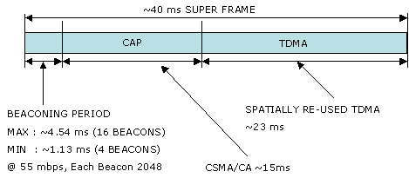
Fig B1: Beaconing period for 4 PNC is approx 1.13 ms (with a beacon of 2048 bytes).

The heart beat header is 8 bytes and each PNC information block is 16 bytes. A five PNC logical piconet beacon ASIE will therefore require 8+ 16*5= 88 bytes. For the purposes of the

Based on a generous beacon size of 2048 bytes, the unused bandwidth ranges from 1.13 ms to 4.54 ms. This is in comparison to approx 15 ms for CAP and 23 ms for TDMA is the case of a typical superframe of 40ms.

Our sample case study makes the following assumptions:

• Video streams encoded @ 19.2 mbps TX @ 200 mbps
• Need to transmit 800 KB per super-frame of ~40 ms i.e. 4 ms per super-frame of TDMA time.

• Audio streams encoded @ 256 kbps TX @ 100 mbps
• Need to transmit 10 KB per super-frame of ~ 40 ms i.e. 0.1 ms per super-frame of TDMA time

Hence:

1. 4 video streams need 16 ms per super-frame of TDMA time
2. 10 audio streams need 1 ms per super-frame of TDMA time
Heartbeat overhead estimates:

• Heartbeats are sent during CAP
• Heartbeat frequency can be chosen by device depending on power, mobility, etc
• Heartbeat size as shown in Fig. B2.
• Heartbeat uses less than 0.28 ms at a transmission rate of 55 Mbps

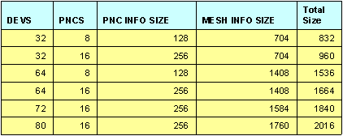
Fig. B2: Heart beat overhead (bytes) for PNC/DEV configurations.

