IEEE P802.11  
Wireless LANs

|  |  |  |  |  |
| --- | --- | --- | --- | --- |
| CC50 CR for CIDs 1550, 1551 and 1553 (TGbn D0.1) | | | | |
| Date: March 31, 2025 | | | | |
| Author(s): | | | | |
| Name | Affiliation | Address | Phone | email |
| Yajun Cheng | Xiaomi |  |  | chengyajun@xiaomi.com |
| Xiandong Dong |  |  |  |
| Tong Xiao |  |  |  |
| Wei Lin |  |  |  |
| Xu Chen |  |  |  |

Abstract

This submission proposes resolutions for following 3 CIDs received for CC50:

CID1550, CID1551, CID1553

**Revisions:**

* Rev 0: Initial version of the document.

***TGbn editor: The baseline for this document is P802.11bn D0.1 and P802.11REVmeD7.0***

***TGbn Editor: Editing instructions preceded by “TGbn Editor” are instructions to the TGbn editor to modify existing material in the TGbn draft. As a result of adopting the changes, the TGbn editor will execute the instructions rather than copy them to the TGbn Draft.***

|  |  |  |  |  |  |  |
| --- | --- | --- | --- | --- | --- | --- |
| **CID** | **Commenter** | **Clause** | **Page.line** | **Comment** | **Proposed Change** | **Resolution** |
| 1550 | Yajun Cheng | 37.10 | 78.19 | Based on the definition of the NPCA Supported field in Table 9-130a, the NPCA Supported field is applicable to non-AP STA and AP. Hence, the sentence ''A non-AP NPCA STA shall set the NPCA Supported field ... to 1." should be changed to "A NPCA STA shall set the NPCA Supported field ... to 1." | Please delete the "non-AP" in this sentence. | **Accepted**  Agree with the comment. The proposed resolution replaces “A non-AP NPCA STA” with “An NPCA STA” in the corresponding sentence.  **TGbn editor, please incorporate changes tagged with 1550 in this document.** |
| 1551 | Yajun Cheng | 37.10 | 78.27 | The description of how the AP announces the NPCA Primary Channel is missing from the current text. | Please add normative text for NPCA Primary Channel signaling. For example, An NPCA AP that has enabled NPCA operation shall include the NPCA Operation Information field in its UHR Operation element and indicate the NPCA Primary Channel in TBD frames. | **Accepted**  Agree with the comment. The proposed resolution adds normative text for NPCA Primary Channel signaling.  **TGbn editor, please incorporate changes tagged with 1551 in this document.** |
| 1553 | Yajun Cheng | 37.10 | 78.29 | According to the description in the above two paragraphs, the fact that an AP that supports NPCA operation does not mean the AP has NPCA mode enabled. Therefore, we should add normative text to describe how an NPCA AP enables NPCA mode. | Please add normative text to describe how an NPCA AP enables NPCA mode. | **Accepted**  Agree with the comment. The proposed resolution adds normative text for NPCA AP to enable or disable NPCA mode.  **TGbn editor, please incorporate changes tagged with 1553 in this document.** |
|  |  |  |  |  |  |  |

Discussion for CID 150:

**9.4.2.aa2.2 UHR MAC Capabilities Information field**

|  |  |  |  |  |  |  |  |
| --- | --- | --- | --- | --- | --- | --- | --- |
|  | DPS Support | DPS Assisting Support | Multi-Link Power Management | NPCA Supported | BSR Enhancement Support | Additional Mapped TID Support | Reserved |
| Bits: | 1 | 1 | 1 | 1 | 1 | 1 | x |

**Figure 9-aa5 —UHR MAC Capabilities Information field format**

Discussion for CID 151:

**9.4.2.aa1 UHR Operation Element**

|  |  |  |  |  |
| --- | --- | --- | --- | --- |
|  | B0 B7 | B8 Bx | Bx+1 Bx+6 | Bx+7  B Bx+12 |
|  | NPCA Primary  Channel | NPCA Minimum  Duration  Threshold | NPCA Switching  Delay | NPCA Switch  Back Delay |
| Bits: | 8 | TBD | 6 | 6 |

**Figure 9-aa3 —NPCA Operation Information field format**

Discussion for CID 1553:

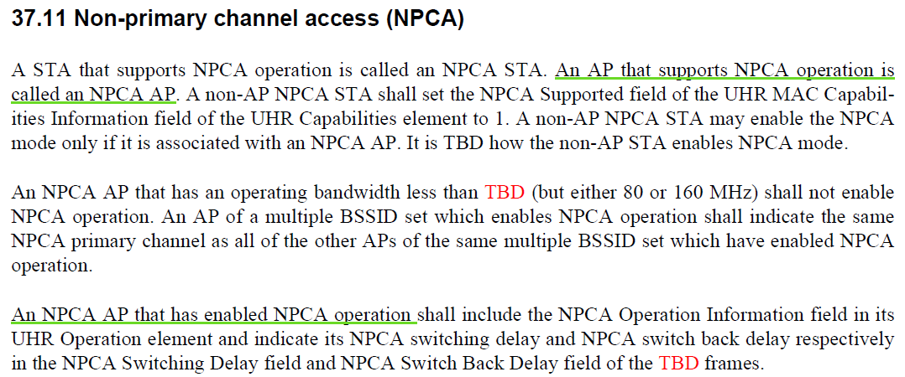

**9.4.2.aa1 UHR Operation Element**

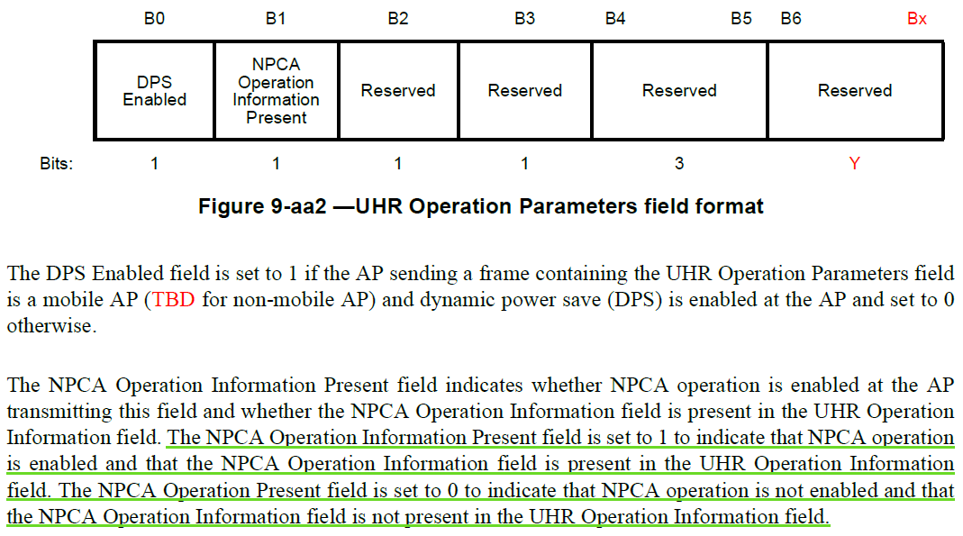

**Proposed Texts:**

TGbn editor: please insert the following proposed changes (CID #1550, CID #1551, CID #1553).

***TGbn editor: please replace “A non-AP NPCA STA” with “An NPCA STA” (i.e., delete “non-AP”) in the 3 sentence of the first paragraphs in Subclause 37.10 Non-primary channel access (NPCA) “A non-AP NPCA STA shall set the ...”***

A STA that supports NPCA operation is called an NPCA STA. An AP that supports NPCA operation is called an NPCA AP. ~~A non-AP~~An[1550] NPCA STA shall set the NPCA Supported field of the UHR MAC Capabilities Information field of the UHR Capabilities element to 1. A non-AP NPCA STA may enable the NPCA mode only if it is associated with an NPCA AP. It is TBD how the non-AP STA enables NPCA mode.

Option 1:

***TGbn editor: please insert the following paragraphs after the 3 paragraph in Subclause 37.10 Non-primary channel access (NPCA) “An NPCA AP that has enabled NPCA operation shall include...”***

[1551]An NPCA AP that has enabled NPCA mode shall indicate NPCA primary channel in the NPCA Primary Channel field of NPCA Operation Information field in its UHR Operation element.

***Or***

Option 2:

***TGbn editor: please add the normative text of NPCA primary channel signaling in the 3 paragraph in Subclause 37.10 Non-primary channel access (NPCA) “An NPCA AP that has enabled NPCA operation shall include....”***

An NPCA AP that has enabled NPCA operation shall include the NPCA Operation Information field in its UHR Operation element and indicate NPCA primary channel, [1551] its NPCA switching delay and NPCA switch back delay respectively in the NPCA Primary Channel field, [1551] NPCA Switching Delay field and NPCA Switch Back Delay field of the TBD frames.

***TGbn editor: please insert the following sentence at the end of the 1 paragraph in Subclause 37.10 Non-primary channel access (NPCA) “It is TBD how the non-AP STA enables NPCA mode.”***

[1553]An NPCA AP shall set the NPCA Operation Information Present field to value 1 in its UHR Operation Parameters field to announce that it has enabled NPCA mode and value 0 otherwise.