IEEE P802.11  
Wireless LANs

|  |  |  |  |  |
| --- | --- | --- | --- | --- |
| 11bi D0.4 Simplified aligned epoch operation in different links | | | | |
| Date: 2025-01-13 | | | | |
| Author(s): | | | | |
| Name | Affiliation | Address | Phone | Email |
| Po-Kai Huang | Intel |  |  | po-kai.huang@intel.com |

Abstract

This submission presents simplified aligned epoch operation in different links

Revisions:

* Rev 0: Initial version of the document.

Interpretation of a Motion to Adopt

A motion to approve this submission means that the editing instructions and any changed or added material are actioned in the TGbi D0.7 Draft. This introduction is not part of the adopted material.

***Editing instructions formatted like this are intended to be copied into the TGbi D0.7 Draft. (i.e. they are instructions to the 802.11 editor on how to merge the text with the baseline documents). TGbi Editor: Editing instructions preceded by “TGbi Editor” are instructions to the TGbi editor to modify existing material in the TGbi draft. As a result of adopting the changes, the TGbi editor will execute the instructions rather than copy them to the TGbi Draft.***

**Discussion:**

For an MLD, there are different TSF values in each link, and those are the only TSF values that are maintained by an MLD. However, it is not clear that based on the current texts in the epoch operation which link that the TSF that the indication is referring to.

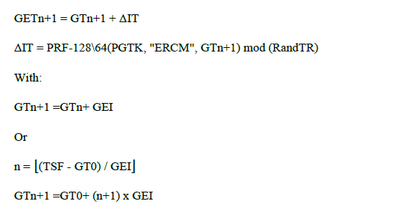

There are proposals that the indication of the current spec is actually based on a centralized reference timer, but it is important to note that for an MLD, it likely will not maintain an additional centralized time.

Fundamentally, epoch operation in each link is like TWT, and we should continue to have operations that can be done independently in each link so that the operations will be independent of reconfigurations.

**Proposed standardization direction:**

The proposal here provides simplified version of operation below without the need to refer back to the centralized timer and align with existing TWT operation so that we have aligned EPOCH across links

Step 1:

An AP MLD selects one of its links, sends directly the next planned Epoch Start time based on the TSF of the link for the exchange, epoch interval, and the index for the next epoch in the EDP epoch setup frame.

Upon reception of the EDP epoch setup frame, the non-AP STA of a non-AP MLD will store the Next planned epoch start time, the epoch interval, and the received Epoch number n for that link.

Note that today, all the timing indication is based on the indication of the TSF of a link, and this operation aligns with existing indication.



Step 2:

Non-AP MLD then constructs the corresponding time of other links.

The next planned epoch start time of link 1 and link 2 for epoch number n is as follows.

Next planned epoch start time_link_1 = Next epoch start time_link_0 + TSF difference of link 1 and link 0

Next planned epoch start time_link_2 = Next epoch start time_link_0 + TSF difference of link 2 and link 0

Note that TSF difference is calculated based on the TSF offset indicated by AP MLD across links



Step 3:

From now on, the non-AP STAs of each link can compute epoch value independently.

For a link, future epoch number and start time is the following.

Planned EpochStartTime(m) for the link = Planned EpochStartTime(n) for the link + (m-n)EpochInterval

Actual EpochStartTime(m) of the link = Planned EpochStartTime(m) for the link + ΔIT

With:

ΔIT = int (#1249) (KDF-Hash*-Length* (PGTK, "ERCM", m)) mod RandTR.

Note that if client wakes up from power save, client can continue to compute the next planned Epoch start time until the next epoch start time is larger than the current time.