IEEE P802.11  
Wireless LANs

|  |  |  |  |  |
| --- | --- | --- | --- | --- |
| Initial thoughts on ARC misc 802 topics | | | | |
| Date: 2025-01-13 | | | | |
| Author(s): | | | | |
| Name | Affiliation | Address | Phone | email |
| Mark Hamilton | Ruckus/CommScope | **350 W Java Dr.**  Sunnyvale, CA 94089 | +1-303-818-8472 | mark.hamilton2152@gmail.com |
|  |  |  |  |  |

Abstract

This document presents some thoughts and discussion items related to the topics on the ARC agenda deck (<https://mentor.ieee.org/802.11/dcn/24/11-24-2095-02-0arc-arc-sc-agenda-january-2025.pptx>) slide 19.

**Background:**

As follow-on work, as IEEE Std 802 revision is reaching completion, the following topics have been identified as areas where maintenance work within 802.11 is possibly/likely needed (this is from the ARC agenda deck, being tracked for many months leading up to this week’s (January 2025) session:

* EPD and LPD terms are going away – we need to update 802.11 to align
* Review MAC address ordering discussion, and 802.11 assumptions
  + <https://mentor.ieee.org/802.1/dcn/24/1-24-0034-00-Mntg-proposal-to-revise-bit-ordering-material-in-p802revc-d2-0.docx>
* Review 802.1AC mapping from ISS to 802.11 MAC SAP interface
* Consider any changes to remove 802.2/LLC terms?
* 802.11’s “Portal”, and mapping to/usage of IEEE Std 802 terminology
* Access Domains: “802 Access Domains”?
  + Interconnection of Access Domains?
  + In 802.11, Access Domain is BSS. Is that still the view, for 802.11be/MLD?
  + Other 802s? 802.3 Multi-carrier fiber – 1 Access Domain, or many? We think it’s 1. But, there are multiple transmitters, in parallel.
  + [Per discussion in November session] How does beamforming relate to the Access Domain concept? (Is there discussion needed about the relationship between “BSS” and beamforming?)
* What if we make the DS a bridge (small ‘b’)?
* Consider adding something about VLANs (just informational?) into 802.11? Relationship (if we talk about it) to security domains (e.g. Authenticator relationship)? VLAN-aware STAs? What about GLK/non-GLK STAs? (cf 11-08/0114r0)

FYI: The latest IEEE Std 802 draft can be found here: <https://www.ieee802.org/1/files/private/802-REVc-drafts/d2/>

(This is a members’ area, you’ll need the password to log in – if you are least an aspirant member, you can log in using your 802.11 members credentials.)

**Discussion:**

Taking the above topics, one at a time:

**EPD and LPD terms are going away – we need to update 802.11 to align**

In IEEE Std 802 REVc, the definitions of the protocol identifers has been changed to a much more rich structure, where the prior concepts of LPD and EPD are now more specifically described as multiple types/methods for identification. This new structure is in a new clause, clause 9 of the draft.

The main discussion of the MSDU format in 802.11 is in subclause 5.1.4 (REVme D7.0 numbering).

That subclause declares that the “default” MSDU format is LPD, which is specified as “LLC Protocol Discrimination (LPD)”, quoting (the older) IEEE Std 802 and ISO/IEC 8802-2:1998. In the updated IEEE Std 802, this is known as “Type 2 PIF encoding of an E-Type protocol identifier” per 9.5.1.2 (of IEEE Std 802REVc D2.2). Thus, it seems that wherever 802.11 uses the term “LPD” it needs to be replaced with “Type 2 PIF encoding of an E-Type protocol identifier” (which we many want to create an acronym to say more easily).

Text from IEEE Std 802 REVc D2.2, 9.5.1.2, for reference:

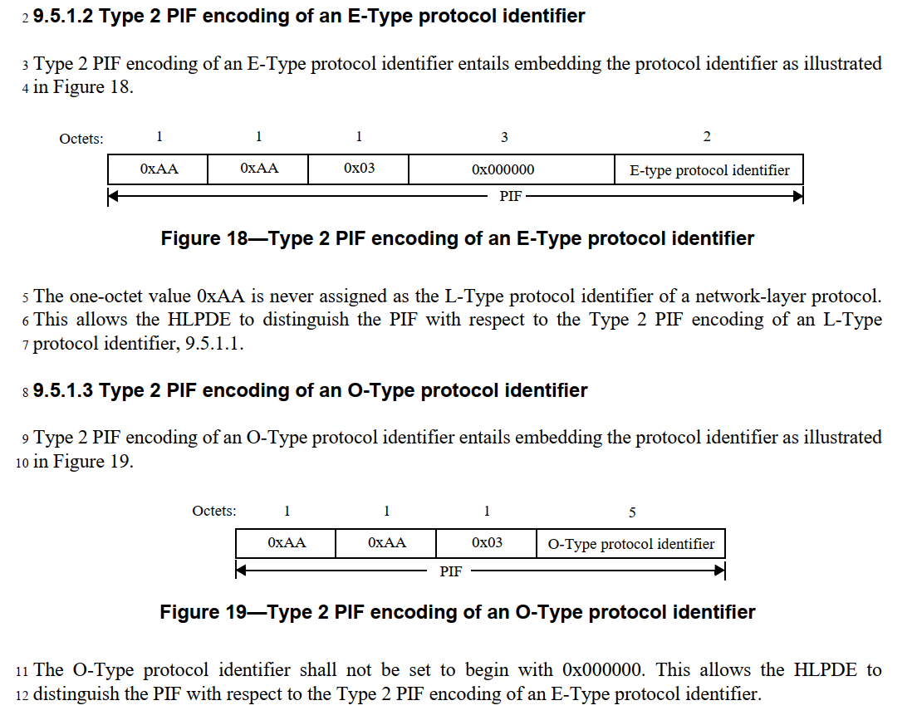

Note that 9.5.1.3 of 802 REVc has similar structure, but with flexibility to use a locally defined protol identifier preceeded by an OUI or CID. I don’t see any evidence that 802.11 supports (or intends to support) this format. This should be discussed/confirmed with experts.

Also, note that there a few references in 802.11 to “SNAP” as well, which is effectively assuming this same LPD concept, and those locations need to be evaluated to see if they should be changed similarly to “LPD”, of it they are okay as implicit references to IEEE Std 802 subclause 9.5.1.4.

The other option, per 802.11 subclause 5.1.4, is to use EPD for MSDU format in some certain situations. EPD is specified in 802.11 as being “EtherType Protocol Discrimination (EPD)” per IEEE Std 802.3-2022. However, this is messy, as 802.3-2022 defines “EPD” to mean “End_of_Packet Delimiter” (a completely irrelvent, different concept). The “EtherType Protocol Discrimination” concept turns out to be a rather implied rather than explicit (and therefore hard to find) reference to 802.3-2022 subclause 3.2.6, as copied here:

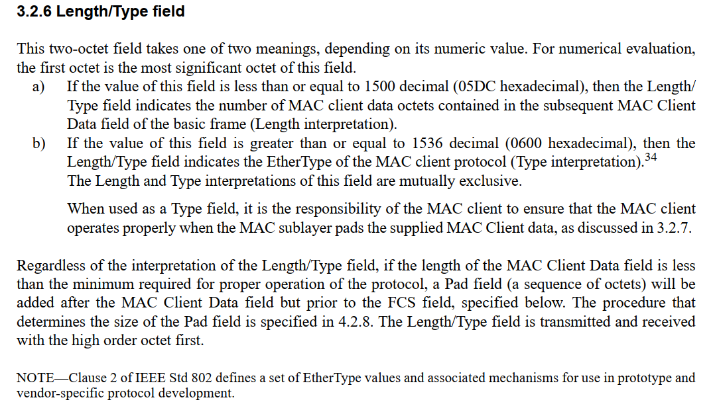

Note that 802.3 describes this field as a Length/Type – and it can contain either an EtherType or a Length.

IEEE Std 802 REVc D2.2 brings this concept into that Standard, and makes this explicit, as “Type 3 PIF encoding of an E-Type protocol identifier”, per subclause 9.5.2.1, or “Type 3 PIF encoding of an L-Type protocol identifier” (which could be/likely is a SNAP header) as shown here:

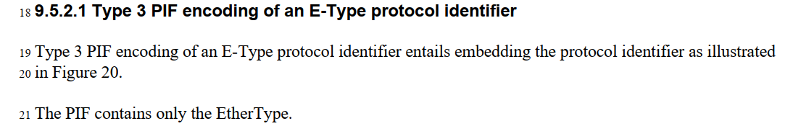

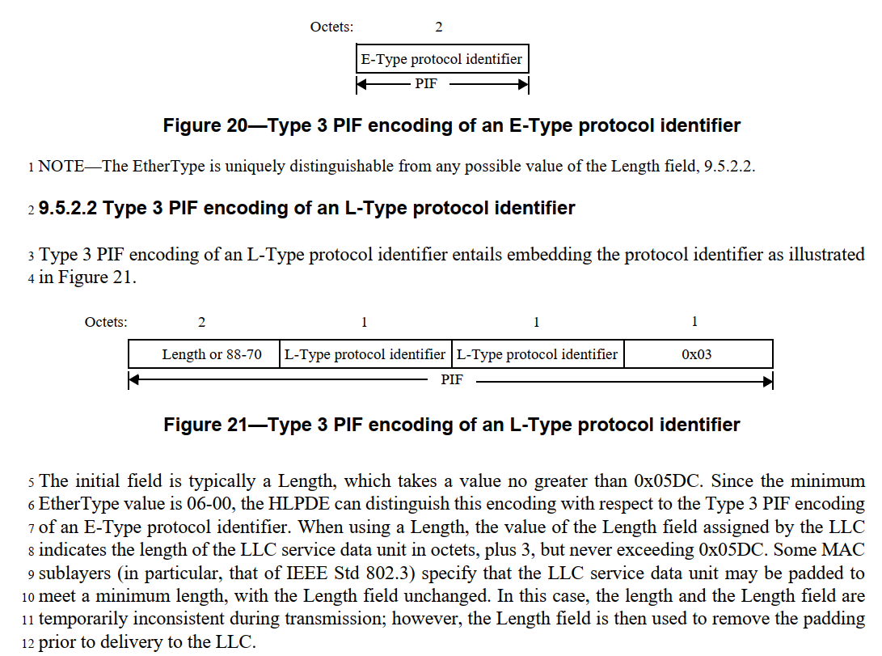

Thus, similarly to the LPD replacement discussed above, it seems that the term “EPD” in 802.11 needs to be replaced with “Type 3 PIF encoding of an E-Type protocol identifier or Type 3 PIF encoding of an L-Type protocol identifier” (which, again, we probably want to create an acronym to say more easily). This also implies that the normative reference to 802.3 in 5.1.4 can be removed, which leaves only (I believe) non-normative references to 802.3, so that can also be simplified/cleaned-up.

Again, like 9.5.1.3 in 802 REVc, there is also 9.5.2.3 with “Type 3 PIF encoding of an O-Type protocol identifier” with flexibility to use a locally defined protol identifier preceeded by an OUI or CID. And, again, I don’t see any evidence that 802.11 supports (or intends to support) this format. This should be discussed/confirmed with experts.

As a practical matter, there are 45 instances of “LPD” and 100 instances of “EPD” in REVme D7.0. It is for futher study to review each of these and provide specific editing instructions to make these replacements. A submission would be appreciated.

**Review MAC address ordering discussion, and 802.11 assumptions**

* <https://mentor.ieee.org/802.1/dcn/24/1-24-0034-00-Mntg-proposal-to-revise-bit-ordering-material-in-p802revc-d2-0.docx>

The referenced document has discussion about the use and bit-ordering of MAC address written representation. In particular, it sets a convention for 802 standards that the:

* “Hexadecimal representation” is a sequence of octet values in which the values of the individual octets are displayed in order from left to right, with each octet value represented as a 2-digit hexadecimal numeral and with the resulting pairs of hexadecimal digits separated by hyphens. And,
* “Bit-reversed representation” is a sequence of octet values in which the values of the individual octets are displayed in order from left to right, with each octet value represented as a 2-digit hexadecimal numeral and with the resulting pairs of hexadecimal digits separated by colons.

Annex J.6.3 (CCMP test vectors) lists many test vector values with colon notation. Per our conventions (quoted above) this implies that these are “bit-reversed” values. It is for future study to confirm if these values are in fact bit-reversed in these test vectors. Similarly, for J.10. J.11 has addresses with hyphen notation, and similarly, these should be confirmed that they are not bit-reversed.

These appear to be the only use of colon notation. I assume that all the hyphen notation occurrences are correct, as is.

It is for further study to confirm the above.

**Consider any changes to remove 802.2/LLC terms?**

and

**Review 802.1AC mapping from ISS to 802.11 MAC SAP interface**

Note, 802.11 REVme D7.0 does not actually contain any occurrences of “802.2”. However, there are occurrences of “ISO/IEC 8802-2” which is roughly equivalent.

The term “LLC” is still valid and used, in IEEE Std 802 (REVc). However, the meaning has been softened to not refer explicitly to the LLC protocol (i.e. ISO/IEC 8802-2, or the (no longer valid) IEEE 802.2). There are 97 occurences of “LLC” in REVme D7.0. These will need to be checked, to ensure they reference the general concept as used in IEEE Std 802 REVc, and if any refer to specific details (such as protocol) from IEEE 802.2, those need to be fixed. This is for further study.

One of the occurrences of 8802-2 is in 5.1.4, which can be changed to reference IEEE Std 802 (REVc), like the change to remove the use of “EPD” and the normative reference to 802.3 in that subclause (described in the EPD/LPD section of this document).

Another occurrence of ISO/IEC 8802-2 is in 5.2, where 802.11 REVme D7.0 says, “The IEEE 802.11 MAC supports the following service primitives as defined in ISO/IEC 8802-2:1998”, and then lists MA-UNITDATA primitives. There is a very subtle (probably too subtle) spelling here – IEEE 802.11 discusses the MA-UNITDATA primitives (with a hyphen). 802.1AC-2016 defines the MAC Service as the set of MA_UNITDATA primtives (with an underscore). 802.1AC goes on to define a set of M_UNITDATA primtives as the Service offered by the ISS (only used within a bridge, as defined in 802.1Q). 802.1AC, in clause 13, further specifies a “convergence function” for 802.11 that maps between the ISS’s M_UNITDATA and 802.11’s MA-UNITDATA interfaces, which makes sense for a bridge, using an ISS.

However, 802.1AC also specifies an 802.11 convergence function in Annex B.1.3 that maps between M_UNITDATA and MA-UNITDATA for an end station. But, end stations don’t have a M_UNITDATA service interface, as they don’t have an ISS (or such use of an ISS is not defined, anyway). B.1.3 should probably define a convergence function between MA-UNITDATA and MA_UNITDATA, although that sublte difference of hyphen versus underscore that would appear in such a subclause would surely be confusing and subject to spec rot. This is for further study.

There is a direct reference to ISO/IEC 8802-2 XID null frame in subclause 7.2.3.2.4 (part of how the DS get updated when client devices do a BSS transition). This needs to be investigated, and probably replaced with something more modern.

Subclause 9.4.2.152 has a NOTE, trying to direct the reader to where the LLC header and SNAP header formats are defined, which is currently pointing to ISO/IEC 8802-2 (for both). With the IEEE Std 802 updates, we can (and probably should) now refer to a combination of IEEE Std 802 and a general pointer to 802.1 standards for the definition of the LLC sublayer protocol(s). Suggested change:

NOTE—The LLC sublayer protocols and structure of the LLC sublayer header(s) aredefined in IEEE Std 802 and various IEEE 802.1 standards. The structure of the SNAP encoding is described in IEEE Std 802

Annex H (which describes 802.11’s Usage of EtherType 89-0d for some MSDU signaling between 802.11-defined components) has a statement that “LLC is defined in ISO/IEC 8802-2-1988”. This can be changed to say “LLC is defined in IEEE Std 802. (Note that in this context, “LLC” is specified to be a simple 3 octet LLC header, as can be found in IEEE Std 802, and there is no provision for using any 802.1 standards in the LLC sublayer in this context.)

The above removes all occurrences of 8802-2 in 802.11, so the normative reference in clause 2 can be deleted.

**References:**