IEEE P802.11
Wireless LANs
PDT Joint MLME SAP
Date: 2025-01-14
Author(s):
Name | Affiliation | Address | Phone | email
Brian Hart | Cisco Systems |  |  | brianh@cisco.com
Yan Li | ZTE
Arik Klein | Huawei

Abstract
This document contains Proposed Draft Text (PDT) for the MLME interface for the Multi-AP Coordination (MAPC) feature of TGbn amendment to the 802.11 standard.

Revisions:
- Rev 0: Initial version of the document.
- Rev 1: Incorporating offline feedback related to MLME interface

Relevant passing motion (with green tags added for context):

Motion 185 (MAC)
Move to add to the TGbn SFD the following:
- Define a mechanism in 11bn that defines:
  - (#M185.1)AP-to-AP frame formats to enable interoperable MAPC across APs and including MLME primitive(s) so that a pair of AP’s SMEs can orchestrate the over-the-air transmission and reception of these frames
  - (#M185.2)MLME primitive(s) so that a pair of AP’s SMEs may send the content of the non-real-time instances of such AP-to-AP frames over-the-DS between peer AP-MLMEs (rather than over-the-air via peer AP MACs)
Result: Approved with unanimous consent.

Background
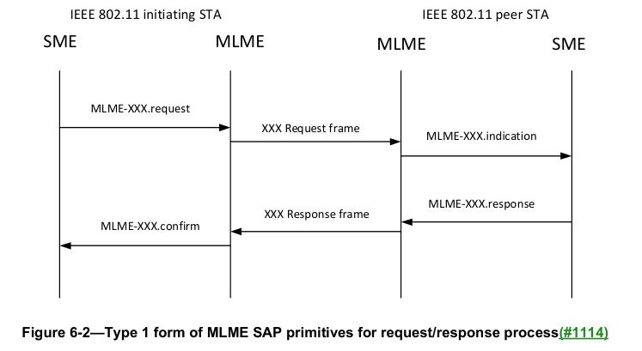

TGbn editor: please make the following changes, identified by Word track changes.

6.3.7 Type 6
Figure 6-7 (Type 6 form of MLME SAP primitives for SME requesting MLME to perform a process not requiring a confirmation(#1114)) depicts Type 6. The Type 6 general form is used when the SME requests a process to be initiated by the MLME and the SME does not require a confirmation.
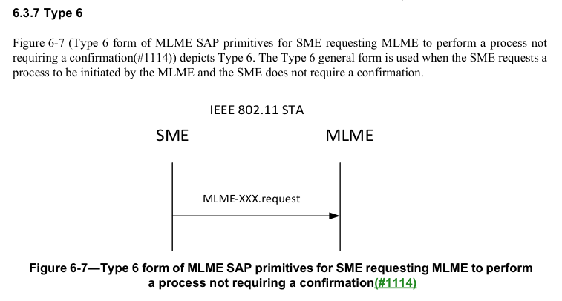
NOTE: One usage of the Type 6 form is shown in Figure 6-7a (Example usage of the Type 6 form of MLME SAP primitives, to notify the MLMEs, of an initiating STA and peer STA, of communications between the SMEs of the STAs)
Figure 6-7a – Example usage of the Type 6 form of MLME SAP primitives, to notify the MLMEs, of an initiating STA and peer STA, of communications between the SMEs of the STAs

Table 6-1— MLME SAP interface(#1114)(#7082)
Service Name | MLME-XXX | Type | References | Comments
(#M185.1)Multi-AP Coordination Over-the-Air | MULTIAPCOORD-OVERTHEAIR | 1 | 9.6.35a.2 MAPC (Request frame format) and 9.6.35a.3 (MAPC Response frame format) | See 37.7 (Multi-AP Coordination framework)
(#M185.2)Multi-AP Coordination Over-the-DS | MULTIAPCOORD-OVERTHEDS | 6 | 9.6.35a.2 MAPC (Request frame format) and 9.6.35a.3 (MAPC Response frame format) | See 37.7 (Multi-AP Coordination framework). After SMEs at initiating and peer APs establish an agreement, each SME uses the MLME interface of Type 6 to report the agreement (expressed as the union of the contents of the request and response frames) to its respective MLME.

Note to 11bn editor, not for inclusion in the draft. Please merge this action frame material with other PDTs that also create content related to UHR action frames. Probably all are a copy-paste from EHT, so the merge should be straightforward.
9.4.1.11 Action field
Table 9-81—Category values
Code | Meaning | See subclause | Robust | Group addressed privacy
(#M185.1)<ANA> | UHR | 9.6.35a (UHR Action frame details) | Yes | No

TGbn editor: please insert a new section (labeled 9.6.35a below) after 9.6.3.35:
9.6.35a (#M185.1)UHR Action frame details
9.6.35a.1 (#M185.1)UHR Action field

(#M185.1)TBD Action frame formats are defined to support UHR functionalities. The UHR Action field, in the octet field immediately after the Category field, differentiates the formats. The UHR Action field values associated with each frame format are defined in Table TBD.

Note to TGbn editor and readers: the following placeholder sections are introduced due to Motion 185, so that related clause 6 material has somewhere to cross reference. It is assumed that these placeholder sections will be evolve into specific sections based the future and more-specific motions:
9.6.35a.2 (#M185.1)MAPC Request frame format [Name and semantics are TBD]
TBD

9.6.35a.3 (#M185.1)MAPC Response frame format [Name and semantics are TBD]
TBD

